
Occupational Lung Disease Bulletin
SENSOR
September 2009

Massachusetts Department of Public Health

Occupational Health Surveillance Program, 250 Washington Street, 6th Floor, Boston, MA 02108

Tel: (617) 624-5632 Fax: (617) 624-5696 www.mass.gov/dph/workrelatedasthma

Burden of Asthma in Massachusetts Adults
Asthma is a significant and growing public health problem in both Massachusetts and the U.S. The Massachusetts Department of Public Health (MDPH) Asthma Prevention and Control Program (APCP) works with partners throughout the state to improve the quality of life for all Massachusetts residents with asthma and to reduce disparities in asthma outcomes. APCP is funded by the Centers for Disease Control and Prevention, which places special emphasis on reducing the rate of hospitalizations due to asthma as a measure of success. APCP, in collaboration with the MDPH Occupational Health Surveillance Program and many others, recently developed two important documents to guide efforts to address asthma across the state:

- Burden of Asthma in Massachusetts
- Strategic Plan for Asthma in Massachusetts, 2009-2014

The Burden report summarizes current surveillance findings on asthma prevalence, morbidity and mortality. Recommendations for improving asthma outcomes are outlined in the companion Strategic Plan. Both documents are available online at www.mass.gov/dph/asthma.

While asthma in children is a critical concern, the majority of persons with asthma are adults. This issue of the Bulletin highlights key findings from the Burden report on asthma in Massachusetts adults. Findings are based on data from the Behavioral Risk Factor Surveillance System Core and Asthma Call-back surveys and statewide hospital and mortality datasets. (More information about data sources is included on page 4.)

Key Findings

Asthma Prevalence

From 2000-2007, the prevalence of current asthma in adults was consistently higher in Massachusetts than the U.S. (Figure 1). During this period, the prevalence increased 16.5% among Massachusetts adults from 8.5% to 9.9%. Nationally, the prevalence increased 13.7% from 7.3% to 8.3%.

Figure 1. Trends in Prevalence of Current Asthma among Massachusetts and U.S. Adults, 2000-2007
Data Source: 2000-2007 Massachusetts and U.S. Behavioral Risk Factor Surveillance System

Among Massachusetts adults:
- Nearly 10% - an estimated 496,700 individuals - have asthma. Of these, almost half (48.9%) were first diagnosed as an adult.
- 12.1% of females and 7.4% of males have asthma.
- Asthma prevalence estimates for Blacks (10.4%) and Hispanics (10.5%) are not significantly different from the estimate for Whites (9.8%).
- 12.9% of smokers have asthma, compared to 8.9% of non-smokers.
- As educational level increases, the prevalence of asthma among adults decreases.
- Asthma prevalence is higher among those living in households with incomes less than $75,000 (11%) compared to those with incomes of $75,000 or more (8.3%).
- 18.7% of those with a disability have asthma, compared to 7.3% of those without a disability.

Hospital Treatment for Asthma (All Ages)

In 2005, there were 36,146 emergency department visits, 2,101 observation stays, and 9,457 hospitalizations (in 2006) due to asthma for residents of all ages in Massachusetts. The highest frequency of hospitalizations was during the fall/winter months. From 2000-2006, the age-adjusted asthma hospitalization rate remained relatively stable despite an increase in asthma prevalence.
While the prevalence of asthma in adults did not vary significantly by race and ethnicity, communities of color had higher asthma morbidity. During this period, Blacks and Hispanics consistently had substantially higher rates of hospitalizations than Whites. In 2006, the rates for Blacks and Hispanics were 3.1 and 2.7 times higher than the rate for Whites (10.7 per 10,000 residents), respectively.

The rates of asthma hospitalizations varied throughout the state (Figure 2). Seven Community Health Network Areas (CHNA) had rates significantly higher than the statewide rate of 14.1 per 10,000 residents:
- CHNA 25: Fall River (29.3)
- CHNA 19: Boston/Chelsea/Revere/Winthrop (25.5)
- CHNA 26: Greater New Bedford (22.5)
- CHNA 22: Greater Brockton (19.0)
- CHNA 8: Worcester (16.6)
- CHNA 4: Springfield (16.1)
- CHNA 5: Southern Worcester County (16.0)

For a complete list of rates by CHNA, refer to Section 4 of the Burden report.
Figure 2. Age-adjusted Rates of Hospitalizations for Asthma by CHNA of Residence, Massachusetts, 2004-2006

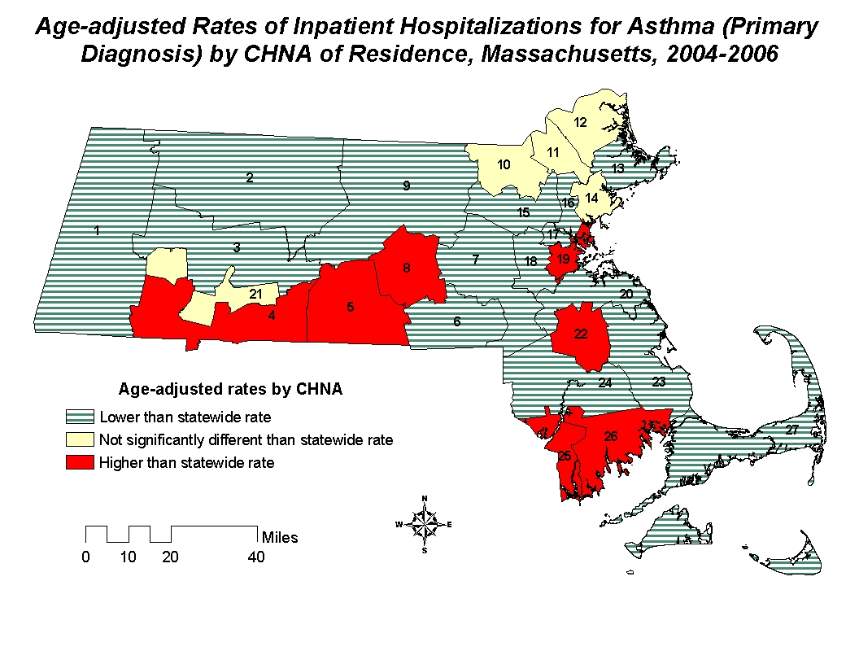
Data Source: CY2004-2006 Massachusetts Inpatient Hospital
Discharge Database
Poor asthma outcomes, such as hospitalizations, are considered largely preventable with access to high quality healthcare, appropriate asthma management, and adequate education about the disease.

Asthma Mortality (All Ages)

In Massachusetts, from 2002-2006, the average annual age-adjusted death rate due to asthma was 10.5 per 1,000,000 residents. The rates for Blacks (29.8) and Hispanics (23.5) were 3.4 and 2.7 times the rate for Whites (8.8), respectively. The rate of death due to asthma increased with age to a high of 46.9 per 1,000,000 in adults ages 65 and older. Still, almost half (47%) of the 378 deaths due to asthma were among individuals under 65 years of age; 166 individuals were aged 18 to 64 years.
While death due to asthma is a rare event, each of these deaths is potentially avoidable and indicative of missed opportunities for appropriate diagnosis, management and treatment.

Asthma Symptoms and Control

In most cases of asthma, the etiology of the disease is unknown. While the exact cause of asthma may not be known and no cure exists, asthma can be controlled. When asthma is well controlled, people can sleep through the night, go to work and school, and live normal, active lives. However, according to 2006-2007 findings, only 1 in 4 Massachusetts adults describe their asthma as well controlled (Figure 3).

Figure 3. Level of Asthma Control among Adults with Current Asthma, Massachusetts, 2006-2007
Data Source: 2006-2007 Massachusetts Adult Asthma Call-back Survey

Among Massachusetts adults with asthma:
- 7 in 10 (67.6%) reported having symptoms of asthma in the past month.
- 6 in 10 (62.5%) limited their usual activities because of their asthma in the past year.
- More than 2 in 10 (24.0%) had their sleep disrupted due to asthma symptoms in the past month.
- 2 in 10 (21.9%) missed work at least once due to their asthma in the past year.
- More than 1 in 10 (14.9%) reported taking their rescue medications at least once a day for the past 3 months.

Furthermore, over one-third (35.2%) reported a diagnosis of depression. While not necessarily caused by asthma, depression may contribute to loss of work and disruption of usual activities.

The National Asthma Education and Prevention Program’s Expert Panel Report 3: Guidelines for the Diagnosis and Management of Asthma (EPR-3) establish guidance for asthma control. For more information on the EPR-3 guidelines, visit www.nhlbi.nih.gov.

Environmental Factors

There are over 300 substances known to cause asthma or exacerbate asthma symptoms.^{1, 2} Reducing harmful exposures in the places where adults spend most of their time – work and home – is necessary to control, and in some cases, prevent, asthma. According to the EPR-3, providers should work with patients to reduce exposure to allergens and irritants that have been linked to asthma.

Exposures in the workplace are important contributing factors to asthma in adults. In Massachusetts, all healthcare providers are required by law to report cases of work-related asthma to MDPH.

Among Massachusetts adults with asthma in 2006-2007:
- 40% reported that their asthma was either caused or aggravated by exposures at their current or previous job.
- 10% reported ever discussing work–relatedness with a healthcare provider.
- 5% reported changing or quitting their job because of their work-related asthma.

Exposures at home can also affect people with asthma. Many adults with asthma are exposed to triggers that may be modified to reduce symptoms (Table 1).

Table 1. Environmental Triggers in Homes of Adults with Current Asthma, Massachusetts, 2006-2007

Exposure | Percent (%)
Furry or feathered pets inside home | 59.3
Carpeting or rugs in bedroom | 58.5
Pets allowed in bedroom | 48.8
Gas used for cooking | 41.8
Wood burning fireplace/stove | 24.0
Smoking inside the home, past week | 18.2
Mold inside home, past 30 days | 16.4
Mice or rats inside home, past 30 days | 7.9

Data Source: 2006-2007 Massachusetts Adult Asthma Call-back Survey

Standards of Care

The EPR-3 report provides recommendations for making appropriate clinical decisions about asthma care. Adoption of these recommendations will standardize care and improve patient outcomes. As indicated by 2006-2007 findings, care for many Massachusetts adults with asthma fails to meet these standards:

- Persons with mild or moderate persistent asthma should have 2 or more visits per year with a healthcare professional for routine asthma care. In Massachusetts, 30.0% of adults with asthma reported having the recommended number of routine checkups in the past year (Figure 4).

Figure 4. Frequency of Routine Asthma Checkups Over 12 Months for Adults with Current Asthma, Massachusetts, 2006-2007
Data Source: 2006-2007 Massachusetts Adult Asthma Call-back Survey

- Persons should have minimal to no emergency department visits for asthma. In Massachusetts, 14.3% of adults with asthma reported one or more emergency department visits due to asthma in the past 12 months.
- Adults with asthma should receive an influenza vaccination each year. In Massachusetts, 50.6% of adults with asthma reported having an influenza vaccination in the past 12 months.
- Persons with asthma should have an Asthma Action Plan. In Massachusetts, 33.4% of adults with asthma have an Asthma Action Plan.
- Persons with asthma should receive instruction on how to recognize signs and symptoms of an attack. In Massachusetts, 65.5% of adults with asthma were taught how to recognize signs and symptoms of an asthma attack. The guidelines also suggest the use of peak flow monitoring for some patients with asthma. In Massachusetts, 50.7% were taught how to use a peak flow meter to adjust daily medications.
- Persons with asthma should have a discussion with their healthcare provider about environmental exposures at their home and work. In Massachusetts, 46.5% adults with asthma were advised by a healthcare provider to change aspects of their home or work to improve their asthma.

National Objectives

Healthy People 2010 identifies public health priorities and specific, measurable objectives related to asthma. Massachusetts can use these objectives to assess the asthma burden in comparison to national targets, direct efforts and benchmark progress over time (Table 2). While these data show that Massachusetts is demonstrating progress towards meeting several Healthy People 2010 targets for asthma, there are still many areas for improvement.

Table 2. Comparing Massachusetts (MA) to Healthy People 2010 (HP2010) Targets for Asthma

Strategic Plan for Asthma
Measure |  |  | MA¹ | HP2010 Target² |  | Target Met?
Hospitalizations  for asthma  (rate per 10,000)³ | Age (Years) |  | 34.8 | 25.0 | No
Hospitalizations  for asthma  (rate per 10,000)³ | 0 - 4 |  | 34.8 | 25.0
Hospitalizations  for asthma  (rate per 10,000)³ | 5 - 64 |  | 10.4 | 7.7 | No
Hospitalizations  for asthma  (rate per 10,000)³ | 65+ |  | 25.6 | 11.0 | No
Emergency dept. visits for asthma (rate per 10,000)⁴ | Age (Years) | 115.4 |  | 80.0 | No
Emergency dept. visits for asthma (rate per 10,000)⁴ | 0 - 4 |  |  | 80.0
Emergency dept. visits for asthma (rate per 10,000)⁴ | 5 - 64 |  | 57.9 | 50.0 | No
Emergency dept. visits for asthma (rate per 10,000)⁴ | 65+ |  | 18.0 | 15.0 | No
Taken a class on asthma management (%)⁵ |  |  | 5.1 | 30.0 | No
Received an asthma action plan (%)⁵ |  |  | 33.4 | 38.0 | No
Taught to use a peak flow meter, recognize early signs of an asthma attack, or respond to an asthma attack (%)⁵ |  |  | 89.7 | 71.0 | Yes
Taught how to use a prescribed inhaler (%)⁵ |  |  | 97.6 | 98.8 | No
Advised to change aspects of home, school or work (%)⁵ |  |  | 46.5 | 50.0 | No
1 MA estimates are for adults aged 18+ years unless otherwise noted.
2 Healthy People 2010: www.healthypeople.gov.
3 MA Data Source: CY2006 Massachusetts Inpatient Hospital
Discharge Database.
4 MA Data Source: CY2005 Massachusetts Emergency Department
Discharge Database.
5 MA Data source: 2006-2007 Massachusetts Adult Asthma Call-back
Survey.
Data Sources
Behavioral Risk Factor Surveillance System (BRFSS) This population-based random telephone survey is a commonly accepted source for information on a variety of health topics. The BRFSS is administered to adults aged 18 years and older throughout the US. State results can be compared with national estimates. In Massachusetts, the survey is conducted in English, Spanish and Portuguese. The BRFSS Asthma Call-back Survey is a standardized questionnaire on asthma developed by the CDC. Respondents to the BRFSS who report that they have ever been diagnosed with asthma are asked to participate. Those who agree are called back within 2 weeks and administered the survey. Percentages were weighted to the total Massachusetts population for the corresponding year in order to reflect both the probability that an individual is selected to participate in the survey and the differential participation by sex, age, and race/ethnicity. Calculations were performed using SAS version 9.1. Adults with current asthma were defined as those respondents who reported that in their lifetime a healthcare provider told them that they have asthma and answered “yes” to: Do you still have asthma? The algorithm classifying asthma control was derived from criteria set forth by the EPR-3 Report and involves responses to survey questions including: daytime symptoms, nighttime awakenings, use of an inhaled short-acting beta agonist, and interference with normal activities.
Statewide Hospital Database Data on hospitalizations due to asthma were from the Massachusetts Inpatient Hospital Discharge Database, maintained by the Massachusetts Division of Health Care Finance and Policy. An asthma hospitalization was defined as any case having an International Classification of Disease, (ICD-9-CM) diagnosis code of 493.0-493.9 assigned to the primary diagnosis field.
Death Certificate Data Data on deaths due to asthma were obtained from the Massachusetts Registry of Vital Records and Statistics within the Massachusetts Department of Public Health. An asthma death was defined as any case of an ICD-10 code of J45.0-J45.9 in the underlying cause of death field.
The BRFSS, hospitalization, emergency department visit, observation stay and mortality data as well as analytical methods are described in more detail in the Burden of Asthma in Massachusetts report.

Asthma is a prevalent chronic condition in Massachusetts, affecting an estimated 496,700 adults, many of whom were first diagnosed with asthma as an adult. There are disparities in asthma by sex, education, income, race/ethnicity, and smoking status. Many adults do not have well-controlled asthma. Aggressive action is needed
to prevent asthma, improve asthma outcomes and reduce asthma disparities in the Commonwealth.

The prevention and control of asthma requires a multifaceted and coordinated approach that involves all stakeholders – individuals, healthcare providers, families, communities, employers, unions, housing providers and government. The Strategic Plan for Asthma in Massachusetts, 2009-2014 includes the collective work of partners throughout the state to determine what is needed and achievable to address asthma in the next five years.
To learn more about and become involved in this effort, contact Jean Zotter, Director of APCP at 617-624-5070 or visit www.mass.gov/dph/asthma. Asthma Action Plans, along with hard copies of both Burden of Asthma in Massachusetts and Strategic Plan for Asthma in Massachusetts, 2009-2014 are available upon request.

This Occupational Lung Disease Bulletin was prepared by Carrie Huisingh and Kathleen Fitzsimmons, with assistance from Elise Pechter, Jean Zotter and Letitia Davis. The work was supported by Cooperative Agreement Numbers U60OH008490 and U59EH123176 from the CDC. Contents do not necessarily represent official views of the CDC.

The Association of Occupational and Environmental Clinics: www.aoec.org.
Jacobs et al. Asthma-related chemicals in Massachusetts: an analysis of Toxic Use Reduction Act data. 2009.
Healthy People 2010: www.healthypeople.gov.

