Summary of EIM/ESM UR/SDR Reference Guide
You use UR/Service Delivery Reports (SDRs) to bill against Unit Rate contracts. The SDR contains a roster of clients, each with a calendar for each service delivered for the month. You can bill for more than one Core Service or Add-on Service on the same day by using the multiple calendar functionality in the SDR. Billing for clients is completed by filling out attendance information for each month.
When the information is complete, the provider authorizes and submits the SDR to EIM, where the service lines are validated, approved, and then paid.
This reference guide provides users with the steps to successfully bill for UR/SDR contracts in EIM/ESM.
Note: This job aid has been updated to reflected EIM/ESM system enhancements that will become effective as of May 19, 2013.
Table of Contents
UR/SDR Monthly Billing Process 2
Create an SDR 2
Access an Existing SDR 3
Searching with SDR Reference Number (if applicable) 4
Searching on SDR Mode (DMH Community Based Flexible Supports Providers ONLY) 4
Record Service Delivery Information 5
Record Service Information for Multiple Clients at one time 6
Entering Services at the Client Level – Core Service 8
Entering Services at the Client Level – Add-on Service 9
Client Form (Progress Documentation Form) 11
Add an SDR Note (if applicable) 11
Copy Service Delivery Information 12
Enter an Offset at the Client-Level (if applicable) 12
Enter an Offset at the SDR Header - Level (if applicable) 13
Unlock All Enrollments 14
Release an SDR 15
Authorize an SDR 15
Create a Supplemental SDR 16
Enter Services on a Supplemental SDR 17
Void Services on a Supplemental SDR 18
Copy Services 18
Delete an SDR 19
Search for a PRC 19
Generate, View and Save an SDR Report 20
Additional Learning Opportunities 23
EIM/ESM Assistance 23

UR/SDR Monthly Billing Process
- Create a new SDR.
- Enter the following:
  - SDR reference number, if applicable
  - SDR mode, if applicable
  - Service delivery information
    - Core
    - Add-On, if applicable
  - Client or Header level offsets, if applicable
  - SDR notes, if applicable
  - Client forms, if applicable
Important Reminder: After accessing the SDR, remember to unlock all enrollments before exiting.
- Release the SDR.
- Authorize the SDR.
- Create a Supplemental if corrections to billing are needed.

Create an SDR
- Select the [Billing] module.
- Select [Service Delivery Report Search] from the navigation bar.
The Service Delivery Report Search page appears.
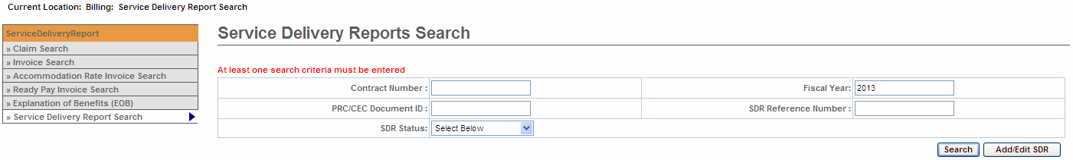
- Select the [Add/Edit SDR] button.
The Service Delivery Report page appears.
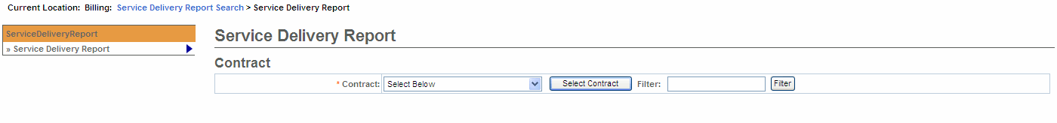
- Select a contract from the drop down box; select the [Select Contract] button.
Reminder: If you manage a large number of contracts, you might find the Filter field helpful. It restricts the Contract listing to only those that meet your filter criteria. For example, you could enter “%DMH% in the Filter field and select the [Filter] button if you wanted to show only DMH contracts in the drop-down box.) You can also type in the contract number and select the filter button and it will only display the contract number you filtered on.
- Select an activity from the drop down box; select the [Select Activity] button.
- Select the [Select Month and Year] from the Service Periods drop down box.
- Select the [Location] from the Location drop down box.
- Select the [View Service Period] button.
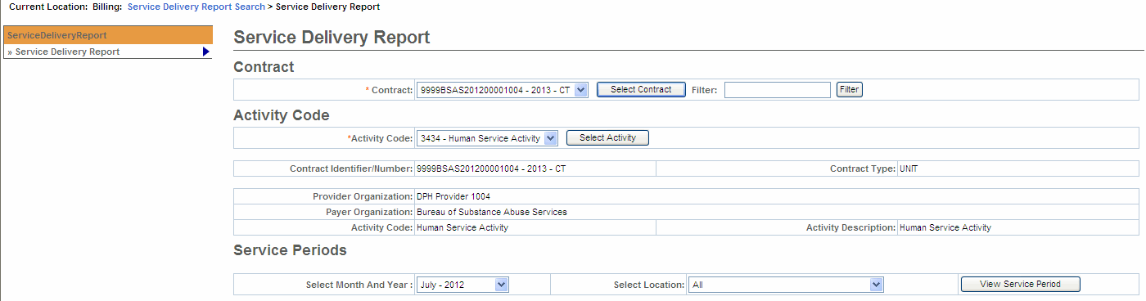
Note: An SDR for the current month cannot be created until all previous months on the contract have been Authorized. (If the previous month is in Draft or Released Status, a new SDR can’t be added)
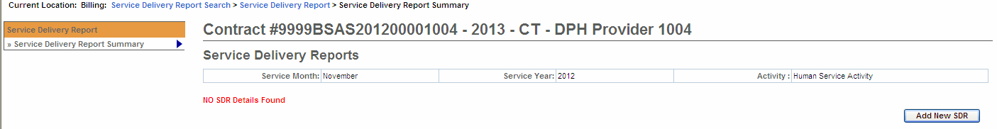
- If you receive the message ‘No SDR Details Found’, select the [Add New SDR] button.
The page reappears with a Regular SDR Draft link.
- To begin billing on the SDR, select the [Draft] link.
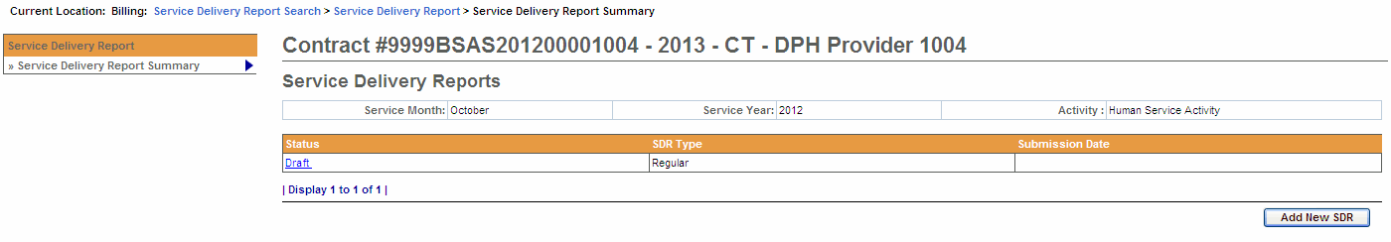

Access an Existing SDR
- Access the Service Delivery Report Search page.
- Enter search criteria. (Reminder: At least one search criteria must be entered to execute a search; The EIM/ESM wildcard symbol is the percentage sign - %.)
- Select the [Search] button. The search results appear.
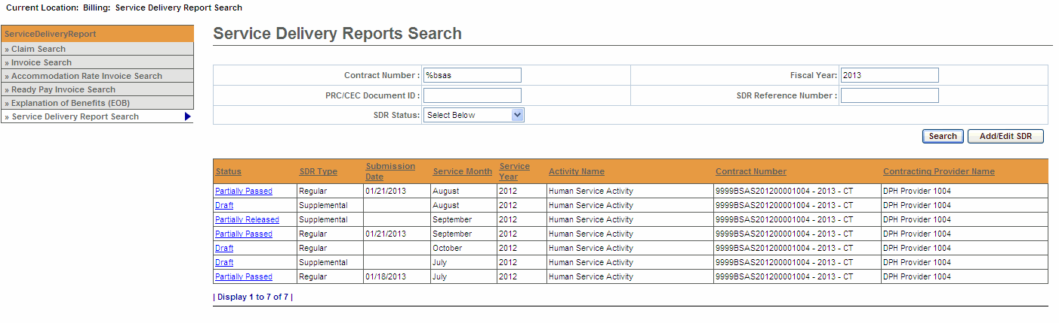
- Select an SDR by selecting the [Status] link.
The Service Delivery Summary page appears with the roster of clients.

Enter SDR Reference Number (if applicable)
- Access the Service Delivery Summary page.
- Enter the [SDR Reference Number].
- Select the [Save Changes] button.
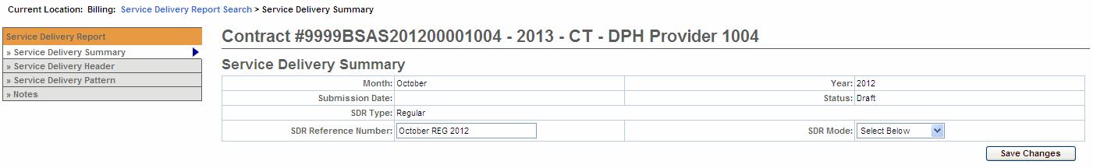
Important Notes:
- The SDR Reference Number may only be edited when the SDR is in Draft status.
- The SDR Reference Number may be used to conduct a PRC search and determine payment status. To learn more, consult the Payment Tracking Job Aid. You might also find the Status Job Aid helpful.

Enter the SDR Mode (DMH Community Based Flexible Supports Providers ONLY)
The SDR Mode is a required field for providers who are part of the Community Based Flexible Supports contracts with the Department of Mental Health. All other providers may ignore this field.
- Access the Service Delivery Summary page.
- Enter the [SDR Mode]:
  - Payment for invoicing
  - Service Reporting for claiming
- Select the [Save Changes] button.
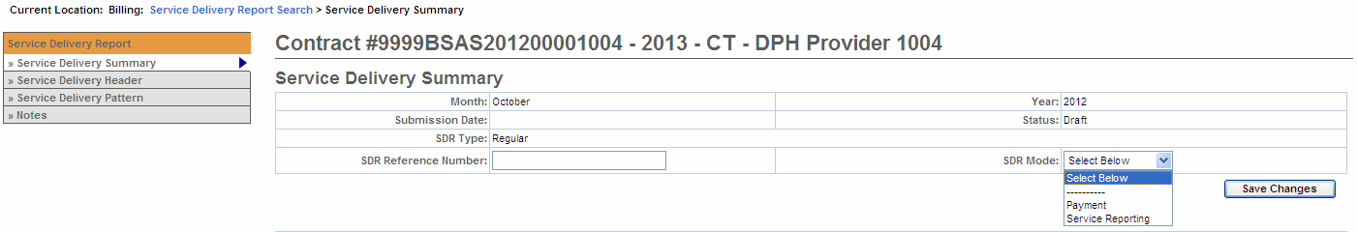

Record Service Delivery Information
Service delivery information may be entered in a single session or throughout the billing period and released at the end of the month.
Important Tips:
- For Providers using Client Interfaces (Meditech): You can sort the SDR by Client ID, Enrollment ID, Client Name, and Provider Location. If sorting by Provider Location and you do not see a client record, check the Provider Organization Parent level location. All new or updated interfaced client enrollment records come into EIM at the Parent level of the organization from the agency enrolling system, i.e. Meditech. To learn more about Manage Enrollment Locations functionality, take online course 159: Manage Enrollment Locations in PACE (www.pace.state.ma.us/vg).
- If you want to go to a page containing a specific client record, you can use the [Go To Page Containing Client Last Name Starting With] field. Simply enter all or part of a client’s last name, click [Go], and you will be brought to the page containing that record. You may need to scroll down to see it. Using this feature will “over-ride” any previous sorts.
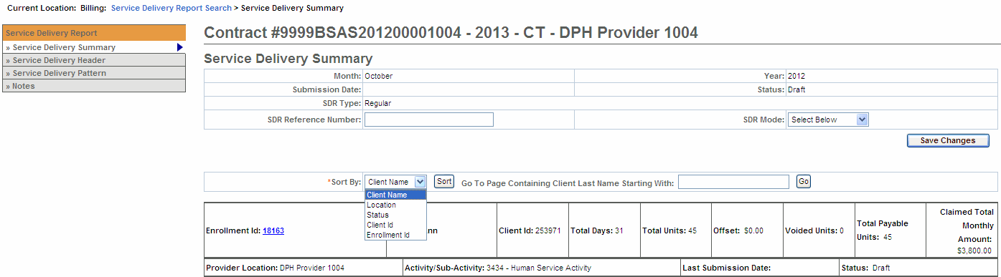
- You can use the Comments field on the Record Service Delivery page to enter a note at the client-level.
- From the Record Service Delivery page, you can record or edit information for the next client in the list, click [Next Client] or to return to the previous client use [Previous Client]. To clear the Service Delivery Report Calendar, click [Clear All].
- When you are finished entering information, always click [Save Changes]. If you do not save changes you will lose the data you’ve just entered.
- When you are finished with a session, click the [Unlock All Enrollments] button on the SDR Summary page. If you do not unlock the enrollments, other staff users may not be able to access the SDR.

Record Service Information for Multiple Clients at one time
Apply a Service Delivery Pattern to Core Service Delivery Pattern #1:
- Select Service Delivery Pattern from the navigation bar.
- Select the [Activity Code] from the drop-down menu options and select the [Select Activity] button. If only one activity code exists, the system will default to it, but you need to still select the [Select Activity] button.
- Under the Core Service Delivery Pattern #1,
- Place a checkmark next to the [Pattern Preference] field to indicate the days of the week that you wish to report billing on. If you bill for all seven days, you can click the [Select All] button and it places checkmarks in all the checkboxes for you.
- Select the [Service Code] drop down menu to choose the service code and select the [Select] button.
- Enter the [Unit(s)].
- Select the [Attendance Status] from the drop down menu options.
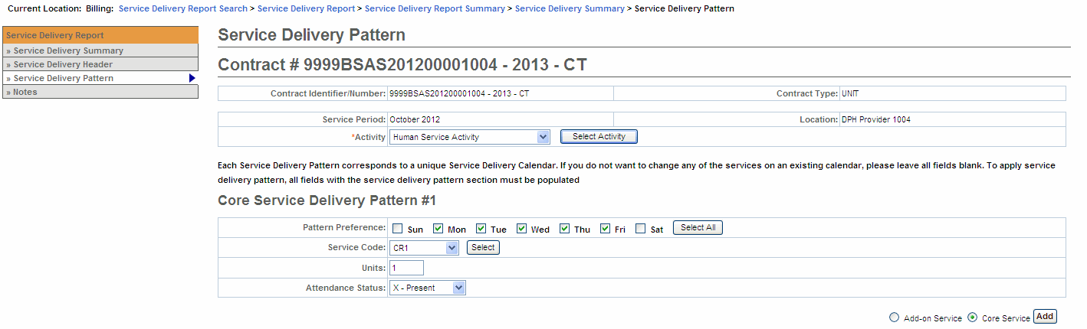
- Under Client Selection,
- Select the [Select All] if all clients on this SDR are reporting the same attendance pattern.
OR
- Place a checkmark next to each client that is reporting the same attendance pattern.
- Select the [Apply Pattern] button. EIM/ESM will display the Service Delivery Apply Pattern In Progress bar. Once the pattern has been applied, the system returns you to the Service Delivery Summary page.
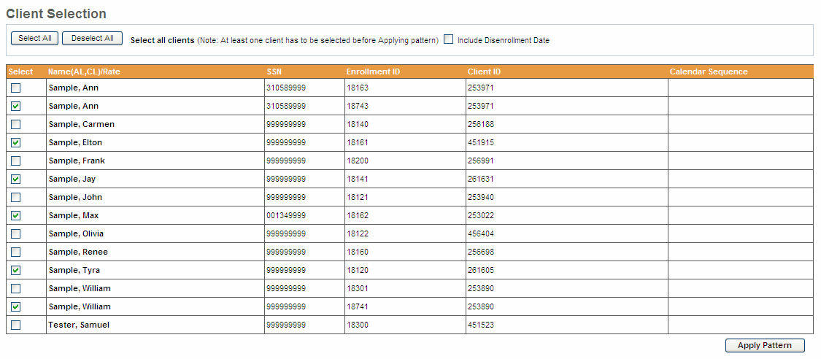
Important Note: After applying a pattern, services can never be removed as a group, they can only be added. The pattern is irreversible. To adjust services, you must edit client records individually.
Note: The Include disenrollment date checkbox allows the user to bill for the disenrollment date. This is determined by each individual agency. Please be sure to confirm with your Agency Contract Manager.
Apply a Service Delivery Pattern to Core Service Delivery Pattern #2:
Apply a Service Delivery Pattern:
- Select Service Delivery Pattern from the navigation bar.
- Select the [Activity Code] from the drop-down menu options and select the [Select Activity] button. If only one activity code exists, the system will default to it, but you need to still select the [Select Activity] button.
- Select the [Core Service] radio button and then select the [Add] button. This will add in a second Core calendar.
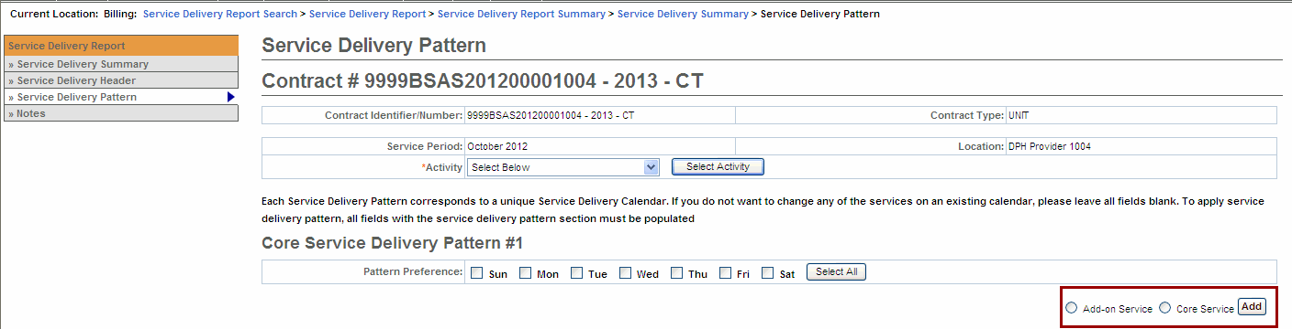
- Under the Core Service Delivery Pattern #2,
Reminder: Remember to complete the Core Service Delivery Pattern #2 options and not the #1 option. You do not want to overwrite a previously applied service pattern.
- Place a checkmark next to the [Pattern Preference] field to indicate the days of the week that you wish to report billing on. If you bill for all seven days, you can click the [Select All] button and it places checkmarks in all the checkboxes for you.
- Select the [Service Code] drop down menu to choose the service code and select the [Select] button.
- Enter the [Unit(s)].
- Select the [Attendance Status] from the drop down menu options.
- Under Client Selection,
- Select the [Select All] if all clients on this SDR are reporting the same attendance pattern.
OR
- Place a checkmark next to each client that is reporting the same attendance pattern.
- Select the [Apply Pattern] button. EIM/ESM will display the Service Delivery Apply Pattern In Progress bar. Once the pattern has been applied, the system returns you to the Service Delivery Summary page.
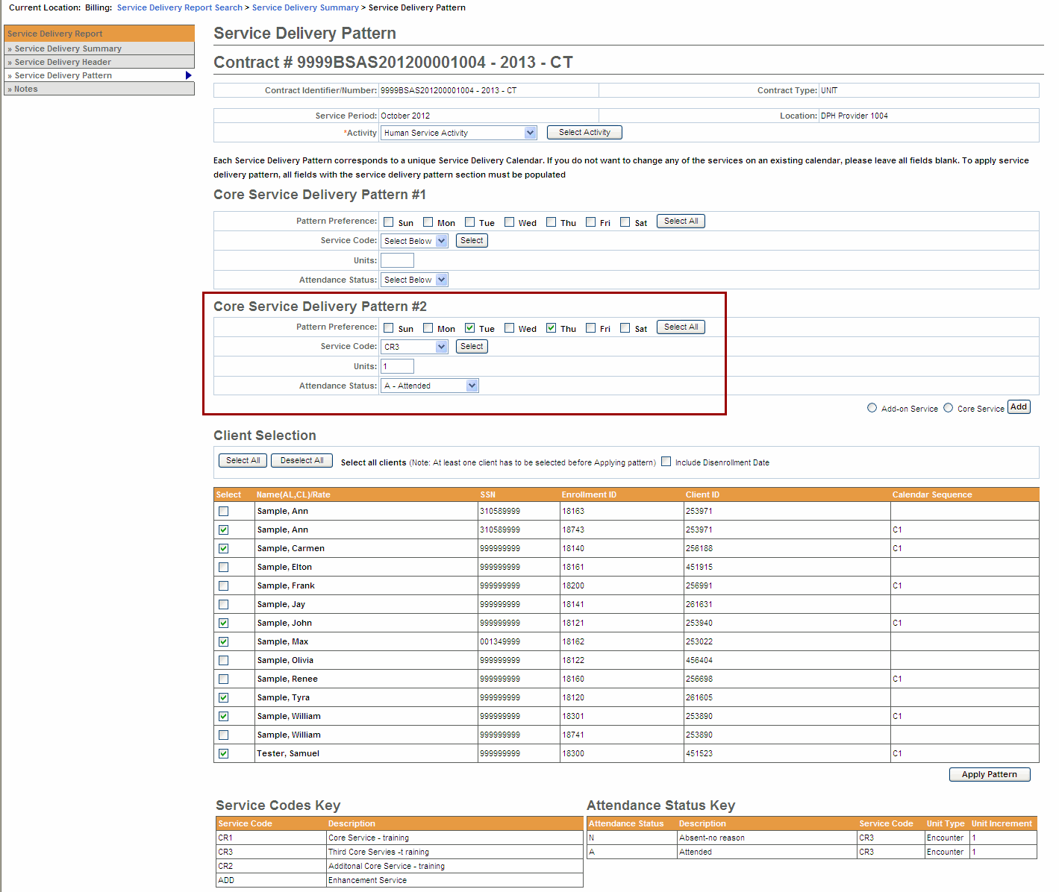

Entering Services at the Client Level – Core Service
Note: Up to 4 Core calendars can be added per billing month per client. If additional calendars are needed, submit a Supplemental.
- Access the Service Delivery Summary page.
- Select the [Enrollment Id] link for a client.
The Record Service Delivery page appears with client details.
- Enter services/resubmit correct information on the client record.
- Using the Apply Service Pattern, Select Date section,
    - Select the [Select All], [Deselect All] or check off the specific dates on the calendar that services were provided for selected client, by checking the checkboxes.
    - Select the [Service Code] drop down menu to choose the service code and select the [Select] button. (Selecting this button is required to generate the correct list of Attendance Codes)
    - Enter the [Unit(s)].
    - Select the [Attendance Status] from the drop down menu options.
    - Select the [Apply] button.
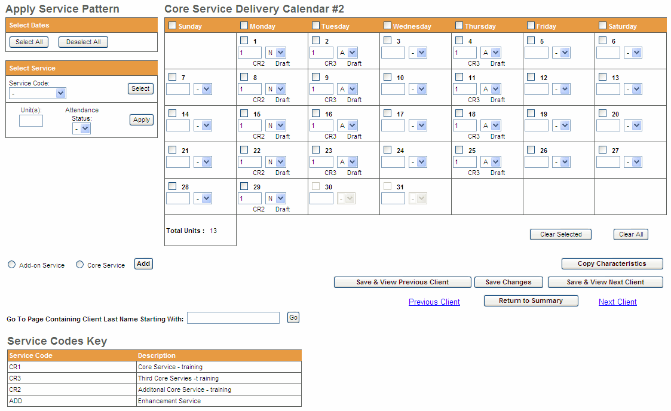
- Select the [Save Changes] button. A message appears, “Record has been updated successfully.”
If additional Core calendars are needed,
- Select the radio button next to [Core Service] and select the [Add] button.
- Repeat above steps if additional calendars are needed for a client.

Entering Services at the Client Level – Add-on Service
Note: Core services should be added first and then Add-on Services.
- Access the Service Delivery Summary page.
- Click the Enrollment Id link for a client.
- The Record Service Delivery page appears with client details.
- Select the radio button next to [Add-on Service] and select the [Add] button.
- Enter services/resubmit correct information on the client record.
  - Using the Apply Service Pattern, Select Date section,
- Select the [Select All], [Deselect All] or check off the specific dates on the calendar that services were provided for selected client, by checking the checkboxes.
- Select the [Service Code] drop down menu to choose the service code and select the [Select] button. (Selecting this button is required to generate the correct list of Attendance Codes)
- Enter the [Unit(s)].
- Select the [Attendance Status] from the drop down menu options.
- Select the [Apply] button.
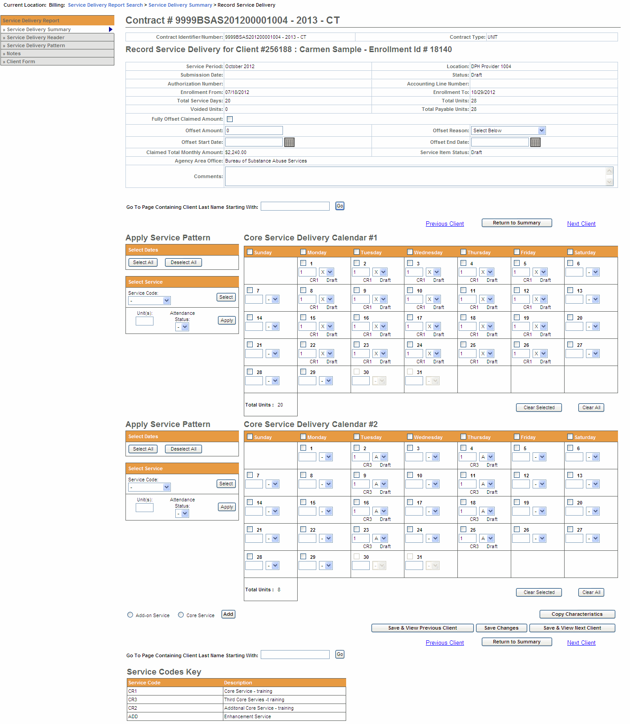
- Select the [Save Changes] button. A message appears, “Record has been updated successfully.”
If additional Add On calendars are needed,
- Select the radio button next to [Add-On Service] and select the [Add] button.
- Repeat above steps if additional calendars are needed for a client.

Client Form (Progress Documentation Form)
(Required for Competitive Integrated Employment Services (CIES) providers only)
The Client Form (also known as the Progress Documentation Forms) is required by providers who are part of the Competitive Integrated Employment Services (CIES) programs with the Department of Developmental Services (DDS), Department of Transitional Assistance (DTA) and/or Massachusetts Rehabilitation Commission (MRC).
This section is only applicable to providers participating in the CIES program..
- Access the Service Delivery Summary page.
- Select the Enrollment Id link for a specific client.
The Record Service Delivery page appears with client details.
- Select [Client Form] on the left navigation menu.
The SDR Client Form page appears.
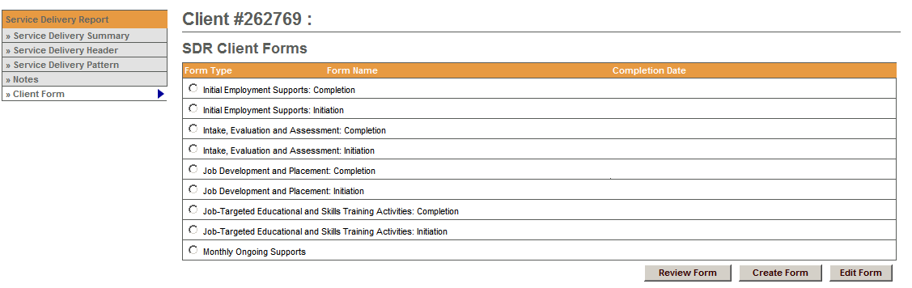
- Select the radio button next to client form that needs to be completed for billing.
- Select the [Create Form] button.
- Complete all required fields as indicated on client form.
- Select the [Submit] button.
The Record Service Delivery page appears with client details.
Important Information for CIES Providers – Hourly-based Component Billing and On Going Support: After submitting the Client Form, you are also required to add SDR Notes. See “Add an SDR Note” section within this job aid for steps on adding an SDR Note.
Note: The Client Form page displays a [Review Form] and [Edit Form] button, if needed.
To learn more on completion of Client Forms, consult the CIES Progress Documentation Job Aid.

Add an SDR Note (if applicable)
- Access the Service Delivery Summary page.
- Select [SDR Notes] from the left navigation bar.
The Service Delivery Notes page appears.
- Click Add SDR note link if no SDR information was found or [Add SDR Note].
The Service Delivery Note Add page appears.
- Enter note. (*See “Note for CIES Providers” for guidance on completing this field.)
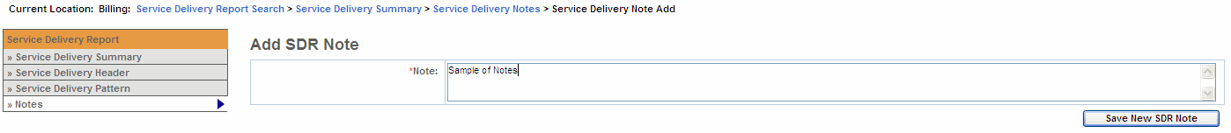
*Note for CIES Providers that record hourly services and/or Ongoing Support:
For clients who have completed and initiated a component in a given month, providers are required to enter the client name(s) in the SDR Notes field.
Providers will need to enter the following text in the SDR Notes field:
Completion: [list names] and Initiation [list names].
- Select the [Save New SDR Note] button. The Service Delivery Notes page appears with the entered note.
Note to all other Providers: The SDR Notes field should be used as directed by your Contract Manager.

Copy Service Delivery Information
- Access the Record Service Delivery page for a client.
- Enter service delivery information if needed. If changes were made select the [Save Changes] button.
- Select the [Copy Characteristics] button.
- Select one or more clients and select the [Apply Pattern] button.
The Service Delivery Summary page appears with the newly entered information.
Tip: Use [Select All] and [Deselect All] buttons to select or deselect all clients.

Enter an Offset at the Client-Level (if applicable)
- Access the Service Delivery Summary page.
- Select the Record Service Delivery record for a client.
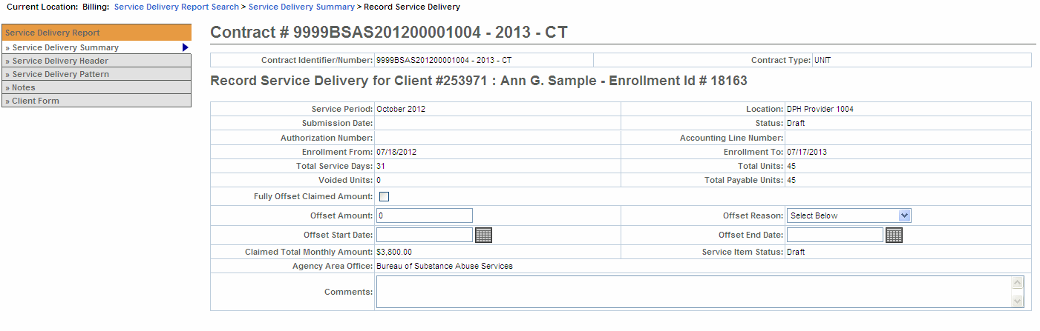
- Enter offset amount. (Only when it is a partial offset)
- Select an [Offset Reason] from the drop down box.
- If the entire charged amount is to be offset, you MUST check the [Fully Offset Claimed Amount] checkbox.
- Select the [Save Changes] button.
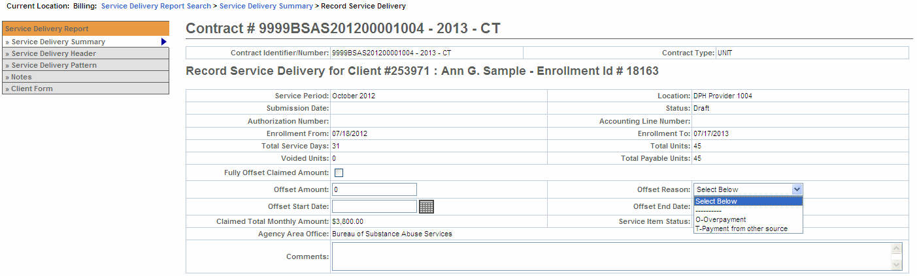
A message appears, “Record has been updated successfully” will appear.
Note that if the Fully Offset Claimed Amount checkbox was checked, the Offset Amount displays the claimed value and the Claimed Total Monthly Amount updates to $0.
Important: If you apply an offset at the client-level, you cannot enter an offset at the header-level.

Enter an Offset at the SDR Header - Level (if applicable)
- Access the Service Delivery Summary page.
- Select [Service Delivery Header] from the left navigation bar.
The Service Delivery Header page appears.
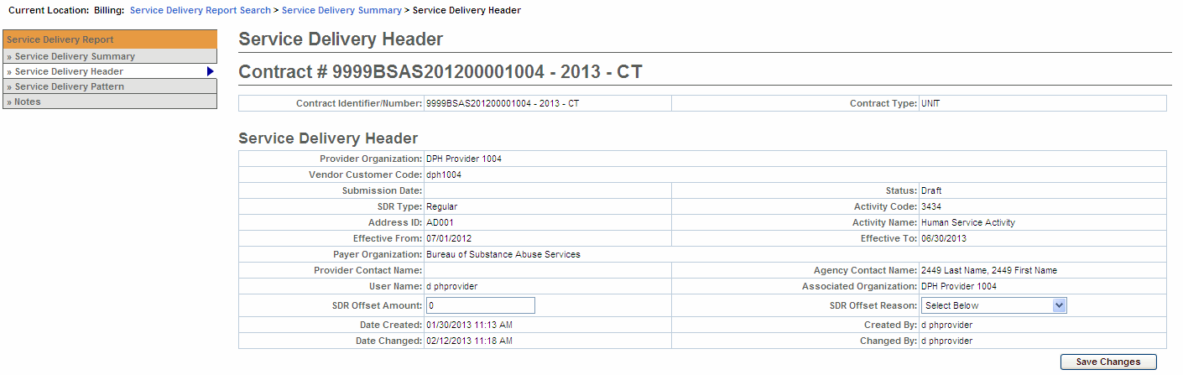
- Enter offset amount.
- Select an [Offset Reason] from the drop down box.
- Select the [Save Changes] button.
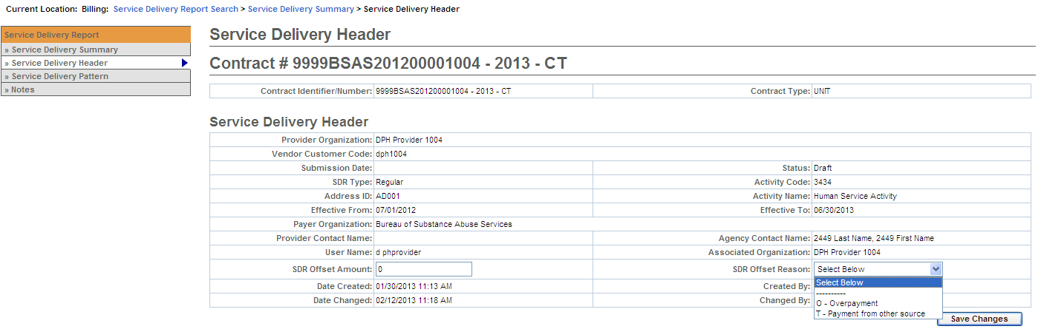
A message appears, “You have successfully updated the record” will appear.
Important: If you apply an offset at the header-level, you cannot enter an offset at the client-level.

Unlock All Enrollments
- Access the Service Delivery Summary page.
- Click [Unlock All Enrollments] button.
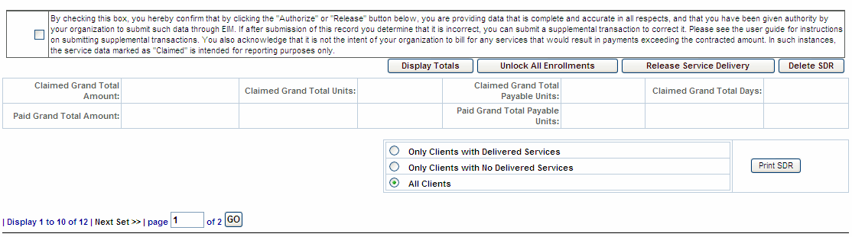
The Service Delivery Report Summary page appears.
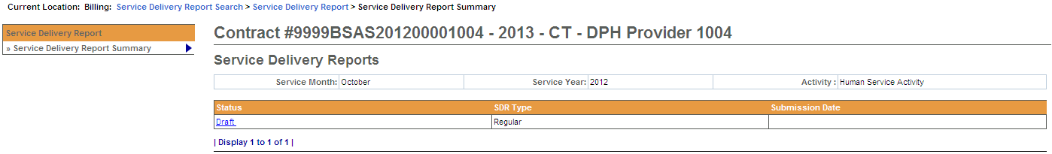
Important: Remember to unlock the SDR when you are done editing to allow users access to the clients.

Release an SDR
- Access the Service Delivery Summary page.
- Click the checkbox to confirm data is accurate and complete.
By selecting the checkbox you are complying with legal requirements on releasing a service delivery report.
- Select the [Release Service Delivery] button.
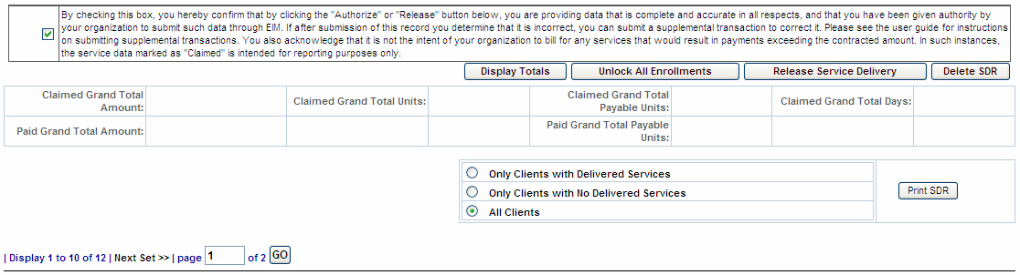
- Select the [Check SDR Release Status] button.
By selecting the 'Check SDR Release Status' button on the Service Delivery Release Progress screen, the SDR Release Progress bar updates.
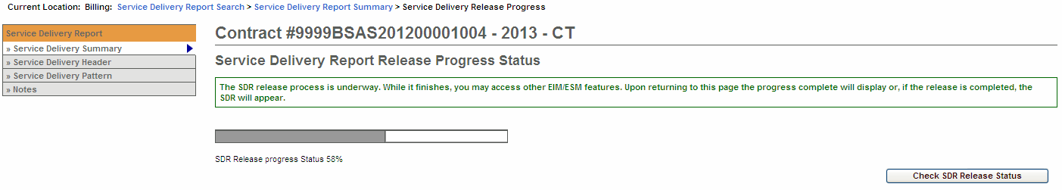

Authorize an SDR
- Access the Service Delivery Summary page of a released SDR.
- Confirm SDR totals by selecting the [Display Totals] button and viewing the values that result.
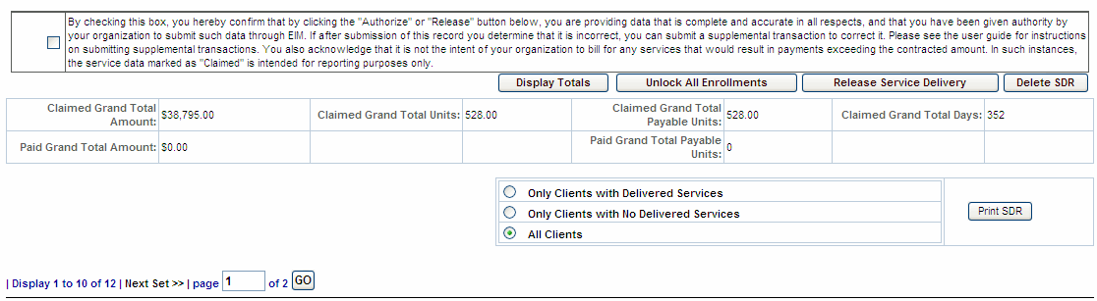
- Select the checkbox to confirm data is accurate and complete.
By clicking the checkbox you are complying with legal requirements on authorizing a service delivery report.
- Select the [Authorize Service Delivery] button. A reminder that this process takes some time to run in EIM and a message will appear once the process has begun and that you can leave EIM and the process will continue until completed.
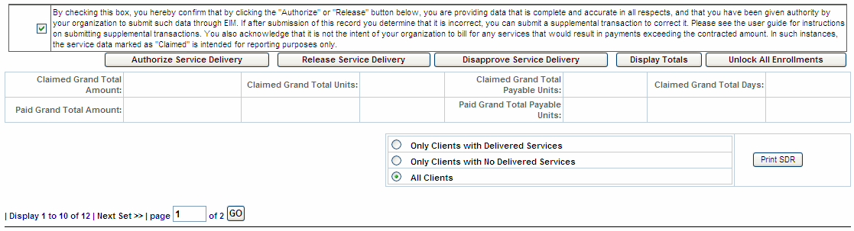
Once the adjudication is complete, the Service Delivery Report Summary page appears.
Note: If the SDR Authorizer finds an error, the SDR can be disapproved by selecting the [Disapprove Service Delivery Report] button. Disapproving the SDR changes the status from Released to Draft so the error can be corrected. You can disapprove an SDR in Released or Partially Released status (when any one of the clients on the SDR is with out any services).

Create a Supplemental SDR
- Access the Service Delivery Report Search page.
- Select the [Add/Edit SDR] button. The page reappears with a supplemental SDR Draft link.
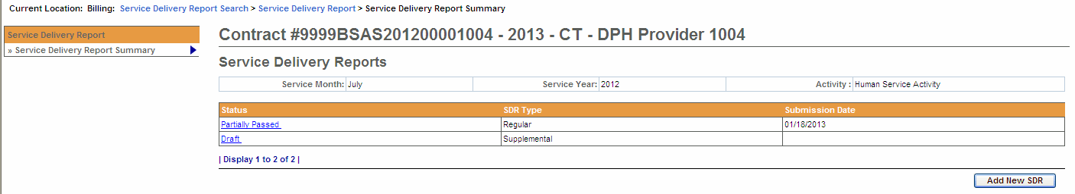
- Select the Draft link. The Service Delivery Summary page appears with a roster of clients.
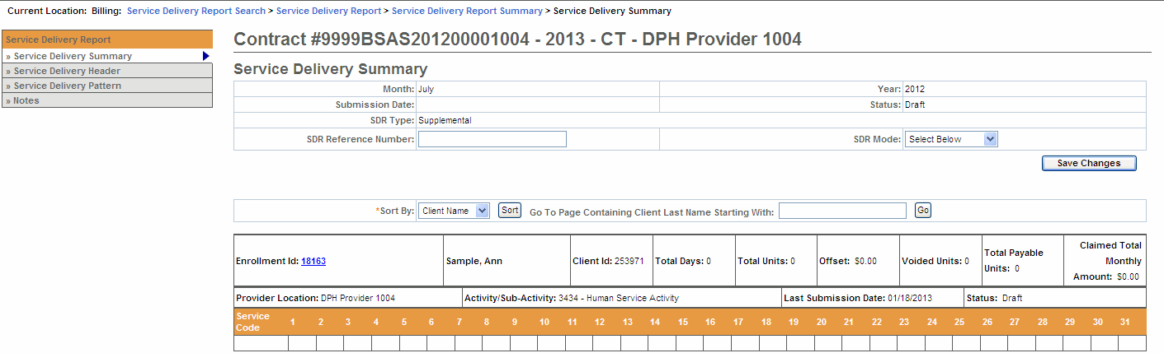

Enter Services on a Supplemental SDR
You may need to enter services that were omitted from regular SDR or, if the clients on the SDR have been denied, you may need to resubmit the correct information.
- Access the Service Delivery Summary page.
- Select the Enrollment ID link for a client. The Record Service Delivery page appears.
- Select the [View Previous Service Delivery Reports] button.
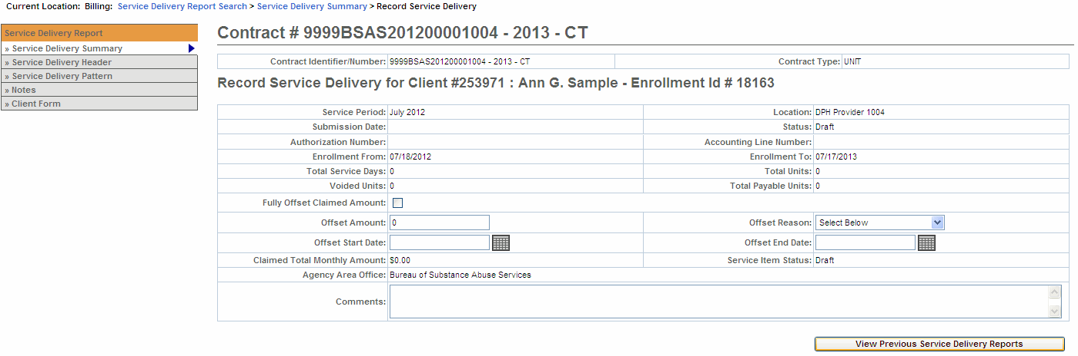
The system will display the previous SDR and indicate the status that it is in.
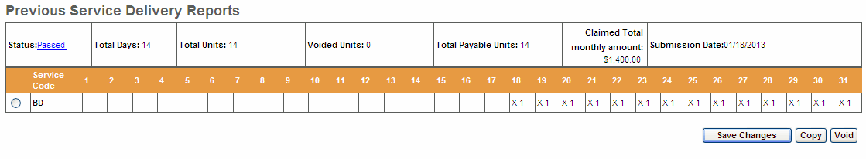
If prior record is Rejected:
  - If you are resubmitting services that were previously rejected, you must first void those services. (See following section)
  - If the prior record includes more than one Service Code, the void will be applied to all codes, including those that were not rejected. All service codes will have to be re-billed.
If prior record is Denied
- If the prior services are denied, there is no need to void those services.
Tip: See the Copy section for steps to copy the prior services to the supplemental calendar.
- Enter services/resubmit correct information on the client record.
  - Using the Apply Service Pattern, Select Date section,
    - Select the [Select All], [Deselect All] or check off the specific dates on the calendar that services were provided for selected client, by checking the checkboxes.
    - Select the [Service Code] drop down menu to choose the service code and select the [Select] button. (Selecting this button is required to generate the correct list of Attendance Codes)
    - Enter the [Unit(s)].
    - Select the [Attendance Status] from the drop down menu options.
    - Select the [Apply] button.
    - Select the [Save Changes] button. A message appears, “Record has been updated successfully.”
- Repeat above steps if there are additional calendars that need updating for the selected client.
Reminder: Once all of the billing information has been updated remember to Release and Authorize this Supplemental SDR.

Void Services on a Supplemental SDR
Note: If the SDR has been Rejected or Paid and services were incorrectly submitted, use the Void button to void the entire previous month’s record. You can then resubmit the correct information.
- Access the Service Delivery Summary page.
- Select the Enrollment ID link for a client. The Record Service Delivery page appears.
- Select the [View Previous Service Delivery Reports] button.
The system will display the previous SDR and indicate the status that it is in.
- Select the radio button under the Previous Service Delivery Reports heading.
- Select the [Void] button and then select the [Save Changes] button. The claim is now voided.
Reminder: Once all of the billing information has been updated remember to Release and Authorize this Supplemental SDR.

Copy Services
Instead of re-entering information, you can copy the Previous Service Delivery information and, if necessary correct any days that are in error.
  - Select the radio button under the Previous Service Delivery Reports heading.
  - Select the [Copy] button. The previous month’s regular SDR has been copied over.
  - Edit service information on the calendar, if needed.
  - Select the [Save Changes] button. A message appears, “Record has been updated successfully.”
Reminder: Once all of the billing information has been updated remember to Release and Authorize this Supplemental SDR.

Delete an SDR
In rare circumstances, it might be necessary to delete an SDR created in error. Only an SDR in Draft status without any voided services associated with it may be deleted.
- Access the Service Delivery Summary page.
- Select the [Delete SDR] button.
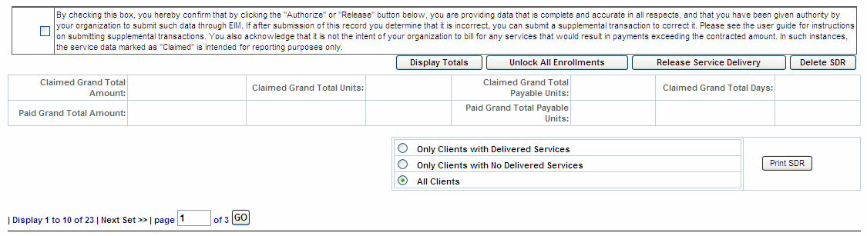
- Select the [Confirm Delete] button to proceed.
Note: The Delete SDR button will only appear if your role allows you access to perform that function.

Search for a PRC
Track a Payment Request for Commodity (PRC):
- Select the Billing module.
- Select PRC Search from the left navigation bar. The PRC Search page appears.
- Enter search criteria.
- Select the [Search] button.
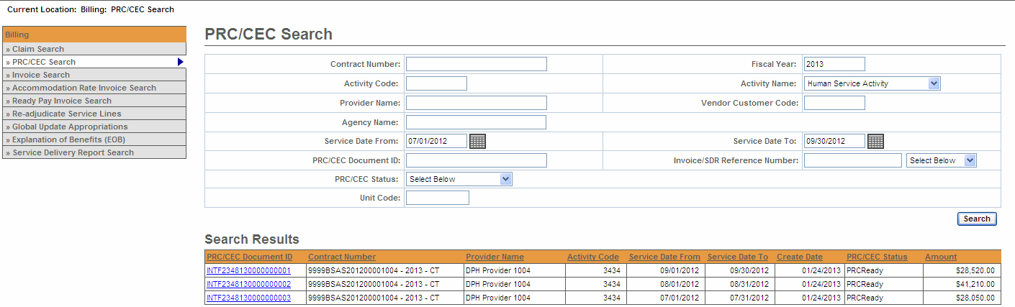
- Select the Activity Name link. The Update PRC page appears to view payment information.
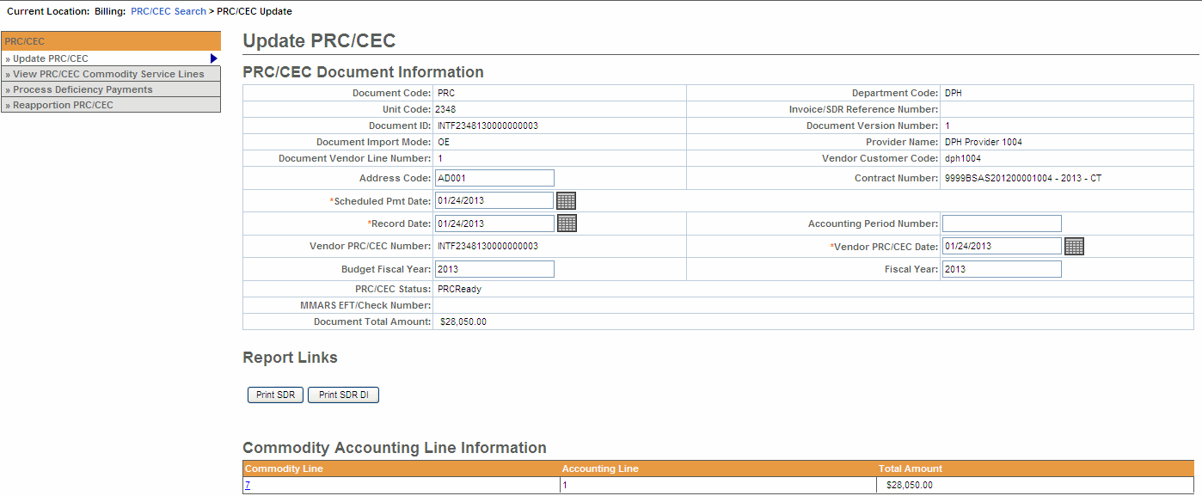
Note: You may not see the PRC you are searching for appear as a search result. Nightly system jobs will turn SDRs into electronic PRCs for Agency approval.
Tip: Providers can use the Invoice/SDR Reference Number field to search against a particular SDR Reference Number. An SDR Reference Number must be entered prior to SDR authorization to allow tracking via a provider-specific reference number.

Generate, View and Save an SDR Report
An SDR may be printed from the Report module or from the Service Delivery Summary page.
Notes to follow regarding how the two options differ:
- SDR Summary page: Printing from the Service Delivery Summary infers from the screen the SDR you want to print. Users may also select whether to include clients with delivered services, clients with no delivered services, or all clients.
- Report Module: Printing from the Report module allows the user to select input criteria and report output format. Users may also select whether to include clients with delivered services, clients with no delivered services, or all clients.
- Service Delivery Report may be printed by authorized users depending on their access level.
To generate and view from the SDR Summary page:
- Access the Service Delivery Summary page.
At the bottom of the SDR Summary page you will see the Print SDR button and three options:
- Only Clients with Delivered Services
- Only Clients with No Delivered Services
- All Clients (Default)
All Clients is the default. It you only want to see clients with delivered services or clients with no delivered services, you will need to select the appropriate radio button.
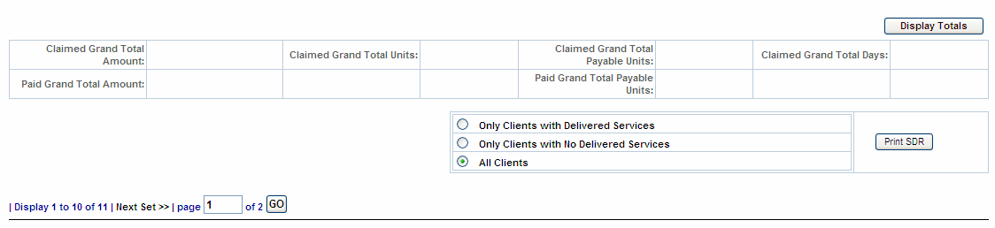
- Select the [Print SDR] button.
The Print SDR in Progress message will open in a secondary window. If the SDR is large it may take some time to generate the report. While the report is generating you can access other EIM/ESM features in another browser window. When the report is finished running this window will automatically refresh and display the report.
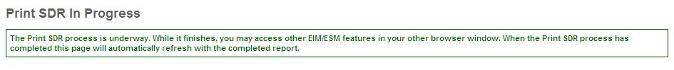
This is a sample of the SDR Report.
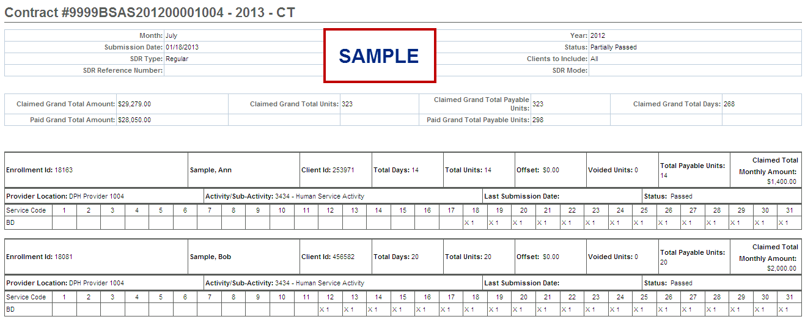
Note that the report generates as a view only file. If you want to save the Print SDR Report, you can by using the Adobe PDF toolbar.
- Locate the Adobe PDF toolbar from the menu at the top of the page, select Convert Webpage to PDF from the available options on the toolbar.
- Select the location you wish to save file in; modify file name, if desired and select the [Save] button.
To generate and view from the Reports module:
- Select the Reports module and select the Service Delivery Report link.
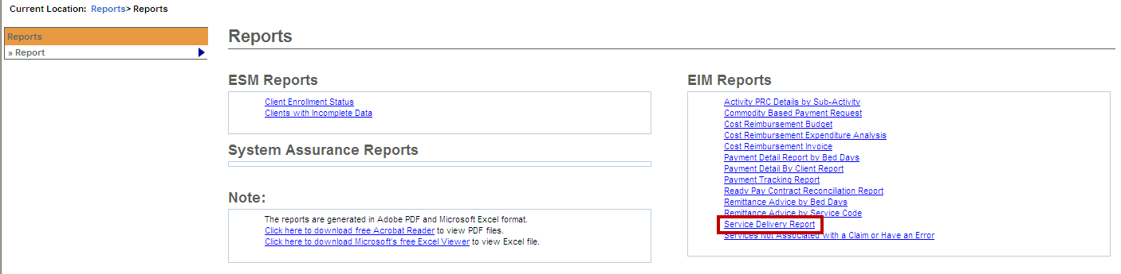
- Enter criteria.
- Select the [Print Report] button.
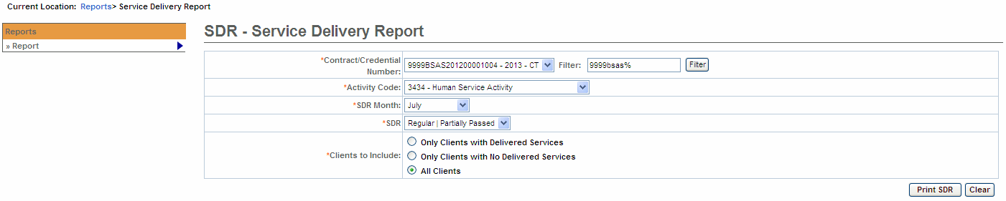
- The Print SDR in Progress message will open in a secondary window. If the SDR is large it may take some time to generate the report. While the report is generating you can access other EIM/ESM features in another browser window. When the report is finished running this window will automatically refresh and display the report.
This is a sample of the SDR Report.
Note that the report generates as a view only file. If you want to save the Print SDR Report, you can by using the Adobe PDF toolbar.
- Locate the Adobe PDF toolbar from the menu at the top of the page, select Convert Webpage to PDF from the available options on the toolbar.
- Select the location you wish to save file in; modify file name, if desired and select the [Save] button.

Additional Learning Opportunities
- Online Learning: To take online course, log into PACE (www.pace.state.ma.us/vg).
  - 155 Unit Rate Billing – Part 1
  - 156 Unit Rate Billing – Part 2
  - 159 Manage Enrollment Location
- Additional EIM/ESM Provider Job Aids are found at:
  - Virtual Gateway URL: www.mass.gov/vg/eimesm
    - EIM/ESM Provider User Manuals and Instructional Materials

EIM/ESM Assistance
- Email the Virtual Gateway Business Operations Unit for assistance:
  - EHS-DL-EIM-ESMBusinessOperations@massmail.state.ma.us
- Call the Virtual Gateway Customer Service for assistance:
  - (800) 421-0938
  - 617-847-6578 (TTY people who are deaf, hard of hearing, or speech disabled)
  - Monday – Friday: 8:30am - 5:00pm

