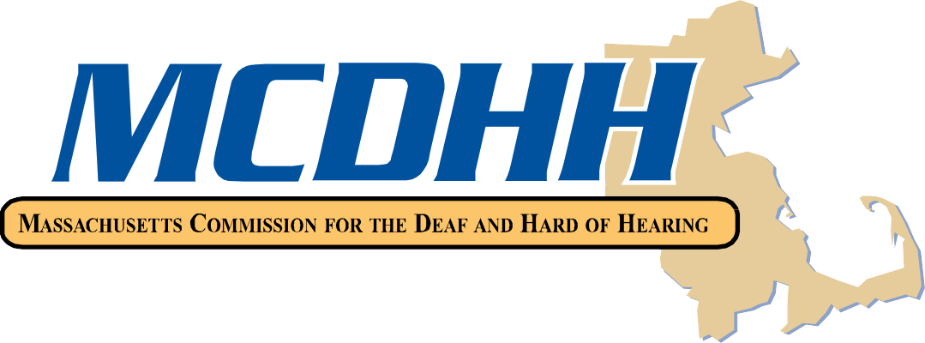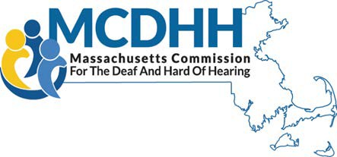

***www.mass.gov/mcdhh***



**Service Navigators**

**Northeast Region**

Carol Menton, MSW Text 857-488-5483

600 Washington Street VP 617-275-4815

Boston, MA 02111

[carol.menton@mass.gov](mailto:carol.menton@mass.gov)

**Boston Metro Region**

Kellynette Gomez, LCSW Text 617-821-3516

600 Washington Street VP 978-636-5845

Boston, MA 02111

[kellynette.m.gomez@mass.gov](mailto:kellynette.m.gomez@mass.gov)

**Southeastern, Cape, and the Islands Region**

April Smith, LCSW Text 857-319-3287

38 Industrial Park Road VP 617-862-0833

Plymouth, MA 02360

[april.n.smith@mass.gov](mailto:april.n.smith@mass.gov)

**Central Region**

Sharon MacLean Cell/Text 857-488-5461

167 Lyman Street VP 508-762-1124

Westborough, MA 01581

[sharon.maclean@mass.gov](mailto:sharon.maclean@mass.gov)

**Berkshires/Western Region**

Alysha Nuttall Text 857-208-2977

436 Dwight Street, Suite 204 VP 413-264-0468

Springfield, MA 01103

[alysha.nuttall@mass.gov](mailto:alysha.nuttall@mass.gov)

**Director**

Peggy Lee, Ed.M. Text 617-894-4169

[margaret.lee@mass.gov](mailto:margaret.lee@mass.gov) VP 617-275-7883

**Administrative Assistant**

Bonnie Lincoln Cell/Text 857-248-7783

[bonnie.lincoln@mass.gov](mailto:bonnie.lincoln@state.ma.us) Voice 617-740-1651

VP 857-288-1998

Updated 12/27/2023 Fax 617-740-1830

**Massachusetts Commission for the Deaf and Hard of Hearing**

**600 Washington Street, Boston, MA 02111**

**Toll free numbers: 800-882-1155 (V) 617-326-7546 (VP)**