Sewage Notification Data System:
How to Register

If you have any questions, please email massdep.sewagenotification@mass.gov or call 781-540-7787.

Overview
- User Request Form
  - Someone from your facility should have received a link to the User Request Form. They should fill out the form for each user that MassDEP should later authorize in the Data System.
- Each user must register
  - Follow the Registration Instructions below to become a Registered User
- MassDEP will authorize the Registered Users
  - MassDEP will authorize the Registered Users based on responses to the User Request Form. After MassDEP authorization, these users are Authorized Users.
  - Authorized Users will receive a confirmation email, and can enter data into the Data System.

Registration Instructions
- Go to the Sewage Notification Data System web page:
https://eeaonline.eea.state.ma.us/dep/cso-portal/
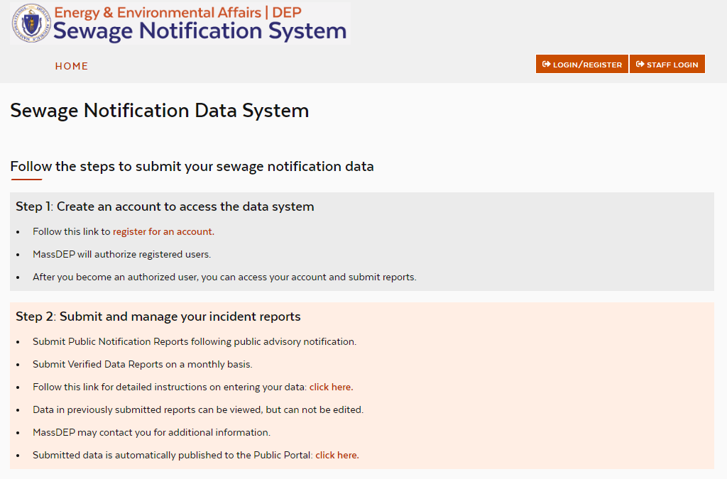
- Click Login/Register
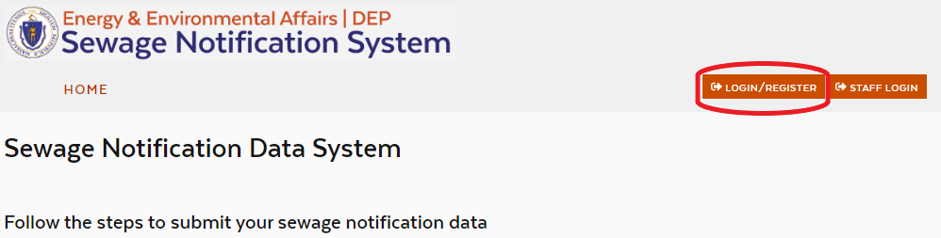
- Click Create an Account
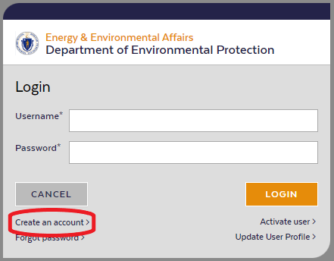
- Enter your account information, and click Sign Up
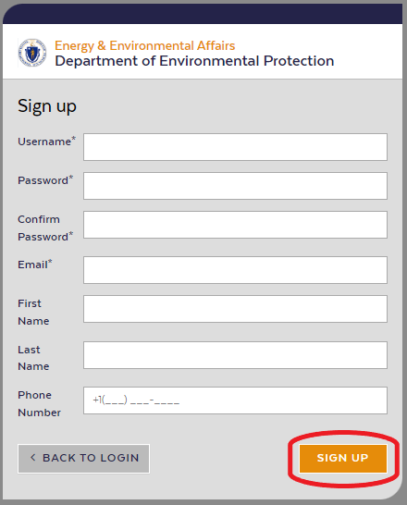
- An Activate User screen will display, asking for an Activation Code
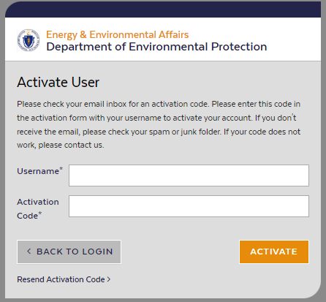
- Go to the email inbox for the account you used to register. You should receive an Activation Code from sender EEA-Apps-NoReply@Mass.gov. Copy the Activation Code.
- Return to the Activate User screen. Enter your Username and paste the Activation Code, then click Activate.
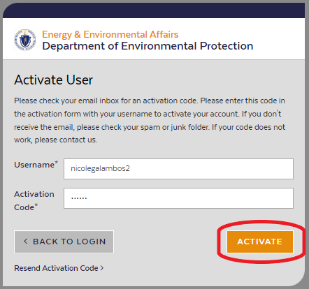
- Wait to receive a confirmation email from MassDEP saying that your account has been authorized.
- After your account has been authorized, you can log in to the Sewage Notification Data System and begin to enter reports.

