Sewage Notification Data System Instructions
Contents
Quick Tips for reports 1
Instructions 2
More Tips 7
Definitions 8

Quick Tips for reports
- Fill out each field in order: left to right, top to bottom.
- As you go through the form, fill out any editable fields.
You do not need to fill out pre-filled or grayed-out fields.
- Once all fields are filled out or gray, click Next.
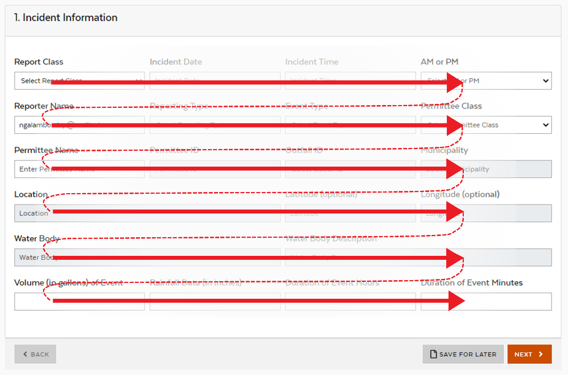

Instructions
- My Incidents
This is where you can view all of your submitted and saved reports.
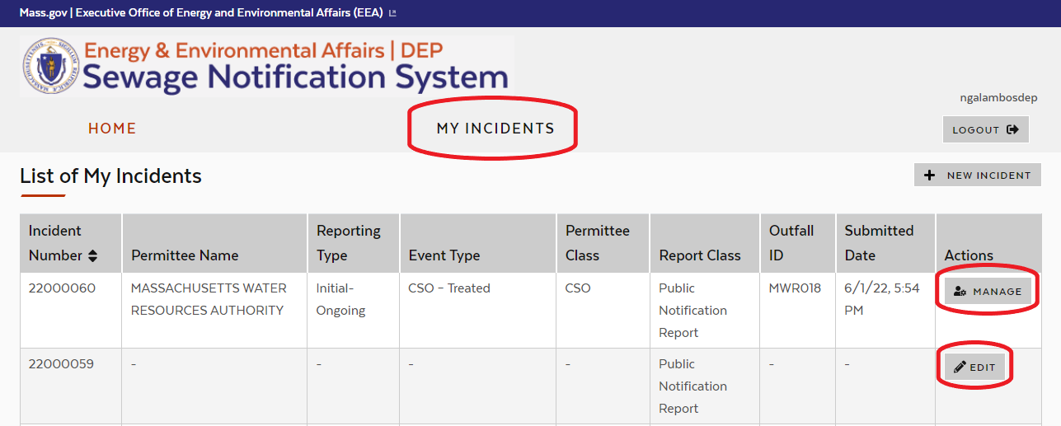
  - Saved Incident Reports can be edited
  - Submitted Incident Reports can be viewed, but not edited
  - Reports must be submitted to satisfy the regulatory requirements
  - Columns can be sorted by clicking on the column title
- New Incident
Click New Incident to add the first Public Notification Report for an event (soon after the event), or to add a Verified Event Data report (to satisfy the monthly reporting requirement).
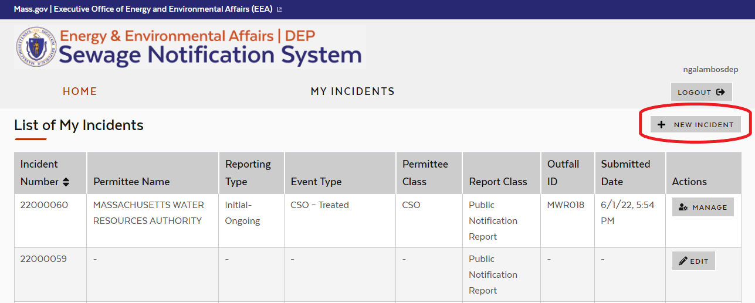
  - Incident Information
Fill out each field left to right, top to bottom, then hit Next. Based on your inputs, subsequent fields may become pre-filled or grayed out – these are not required to be entered by hand. Look at the Definitions section of this document for explanations of what each field means.
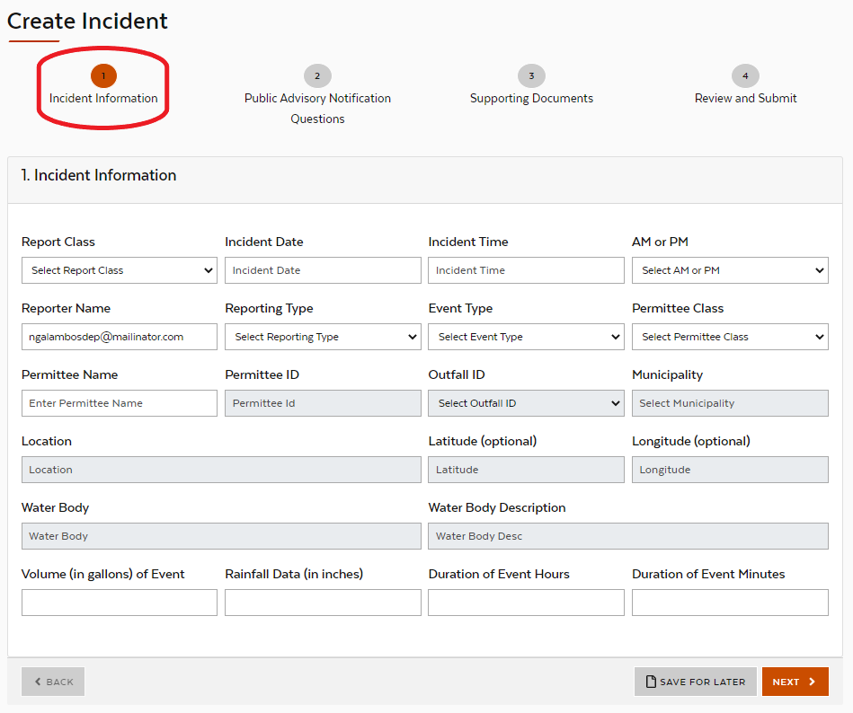
  - Public Advisory Notification Questions
Answer each of the questions if you are submitting a Public Notification Report. These are to confirm whether you have complied with all notification requirements. Include an explanation if you answered “No” for any question.
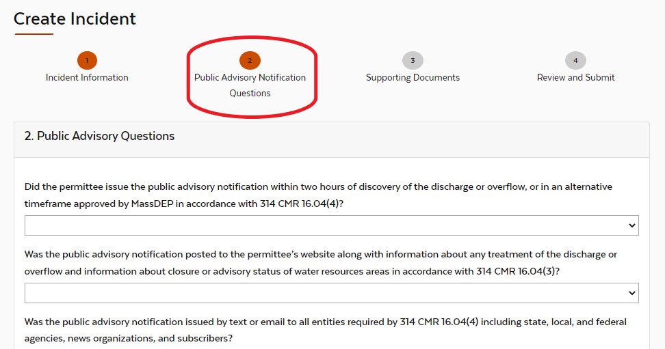
  - Supporting Documents
For Public Notification Reports, you must attach a copy of your Public Advisory Notification. Depending on the timing of your data entry, you may need to attach multiple Public Advisory Notifications.
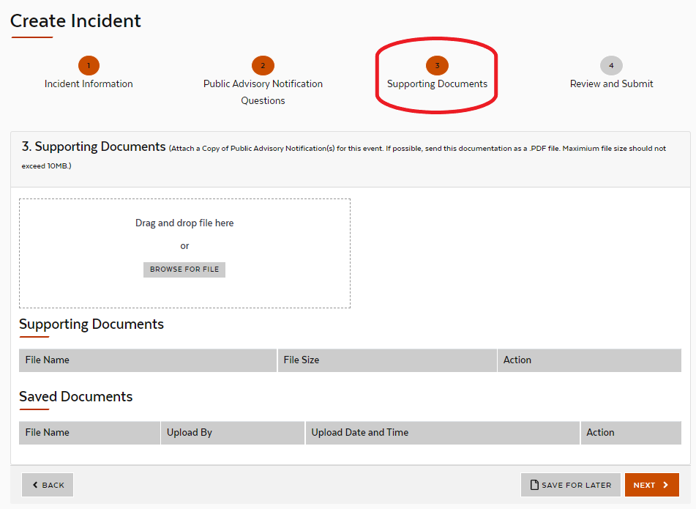
  - Review and Submit
Click Save for later to return later and finalize the report.
Click Submit to submit the report and satisfy regulatory requirements. Submitted reports can be viewed on the public database.
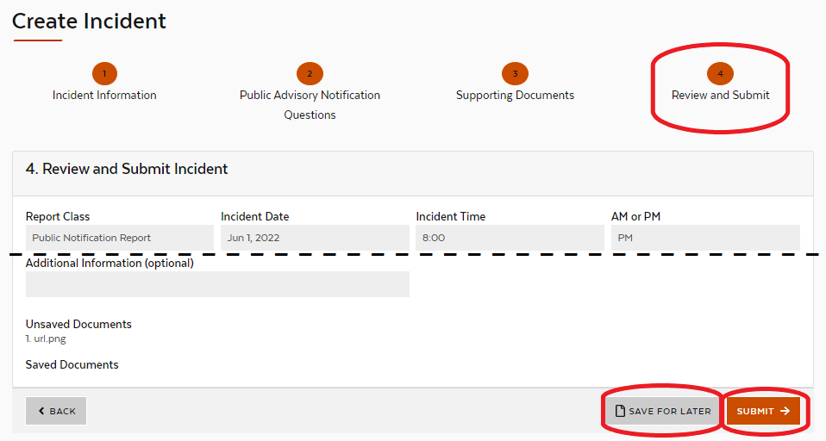
- Click Manage to view details on submitted reports
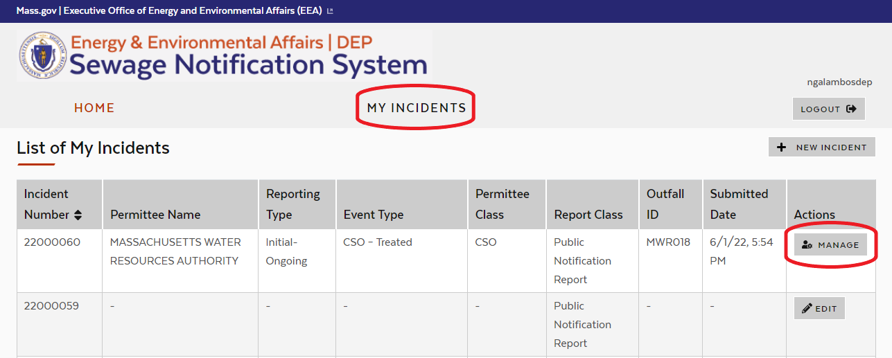
  - Details can be viewed under Incident Details and Supporting Documents
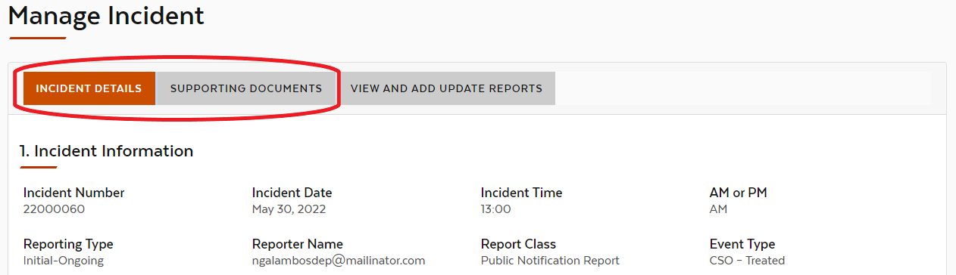
- Add Update Reports if applicable
If the event is still ongoing at the time of the first Public Notification Report, an Update Report must be added if there are additional updates associated with the event. In the Data System, the Public Notification Report is a parent report, and the Update Report is a child report.
  - Go to My Incidents. Find the Initial Notification Report associated with the event, and click Manage
  - Go to Update Reports
View previously saved or submitted Update Reports in the table.
Click New Update Report to add a new Update Report as a child report.
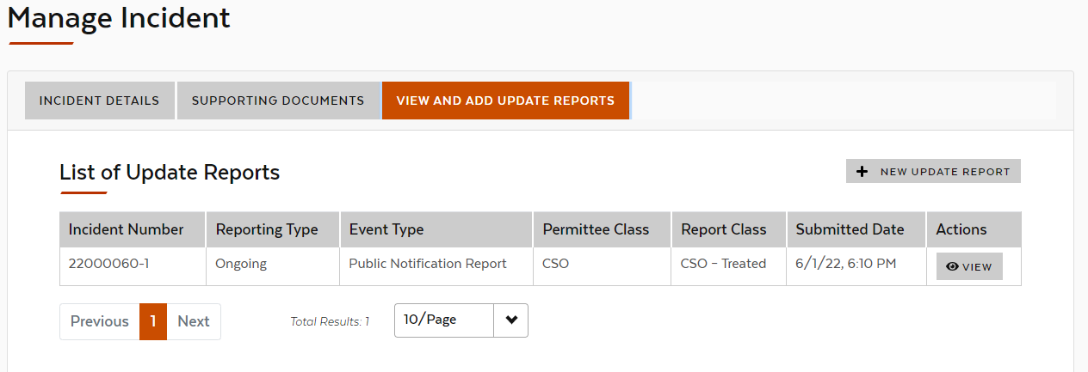
  - Fill out each field left to right, top to bottom, then hit Next. Based on your inputs, subsequent fields may become pre-filled or grayed out – these are not required to be entered by hand.
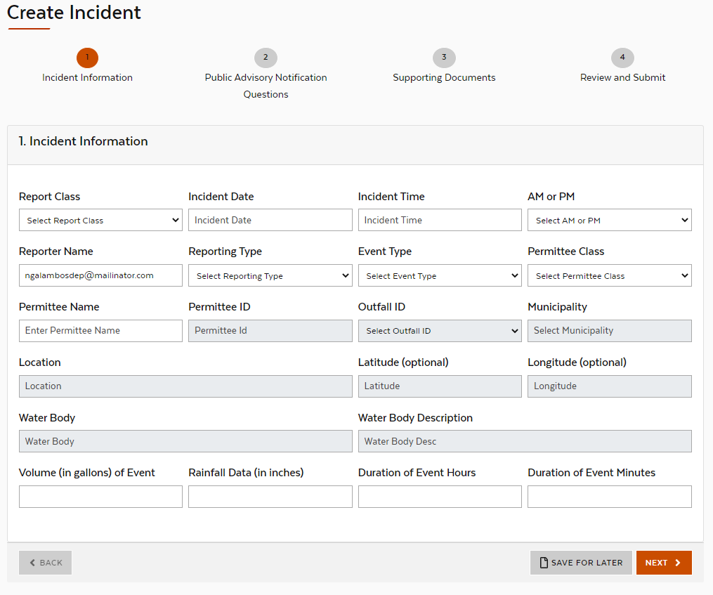
  - Continue to add Update Reports for each 8-hour update until the event has ceased.
More Tips
- If your system has any CSOs, the Permittee Class is CSO, even if you are reporting a non-CSO event.
- You are able to view the reports that you have saved or submitted. If someone else has submitted an event for your facility through a different account, you will not be able to view it in your account.
- Permittees have up to 18 hours after the Public Advisory Notification is issued to submit the Public Notification Report. See also the Sewage Notification Timeline document for help understanding the required timelines.
- If you have issued multiple Public Advisory Notifications by the time you submit a report into the Data System, you can combine them into one Public Notification Report. You should attach all of the Public Advisory Notifications in the report, either as separate attachments or one combined attachment.
- If the first Public Notification Report is Initial-Ongoing, you should add Update Reports until the event ceases. Below is an example for an event that was ongoing at the time of the first Public Notification Report, ongoing at the time of the next Public Notification Report, and ceased by the time of the third Public Notification Report:
  - First report: Public Notification Report, Initial-Ongoing
  - Update Report: Public Notification Report, Ongoing
  - Update Report: Public Notification Report, Ceased
- If the first Public Notification Report is Initial-Ceased, you do not need to add any Update Reports.
- Each Verified Data Report includes details for the entire discharge or overflow event. Update Reports are not applicable to Verified Data Reports.
- Report a retraction into the Data System as a Verified Data Report with Volume = 0, Rainfall = 0, and Duration = 0.
- Below are how the different Report Classes and Report Types relate to each other:
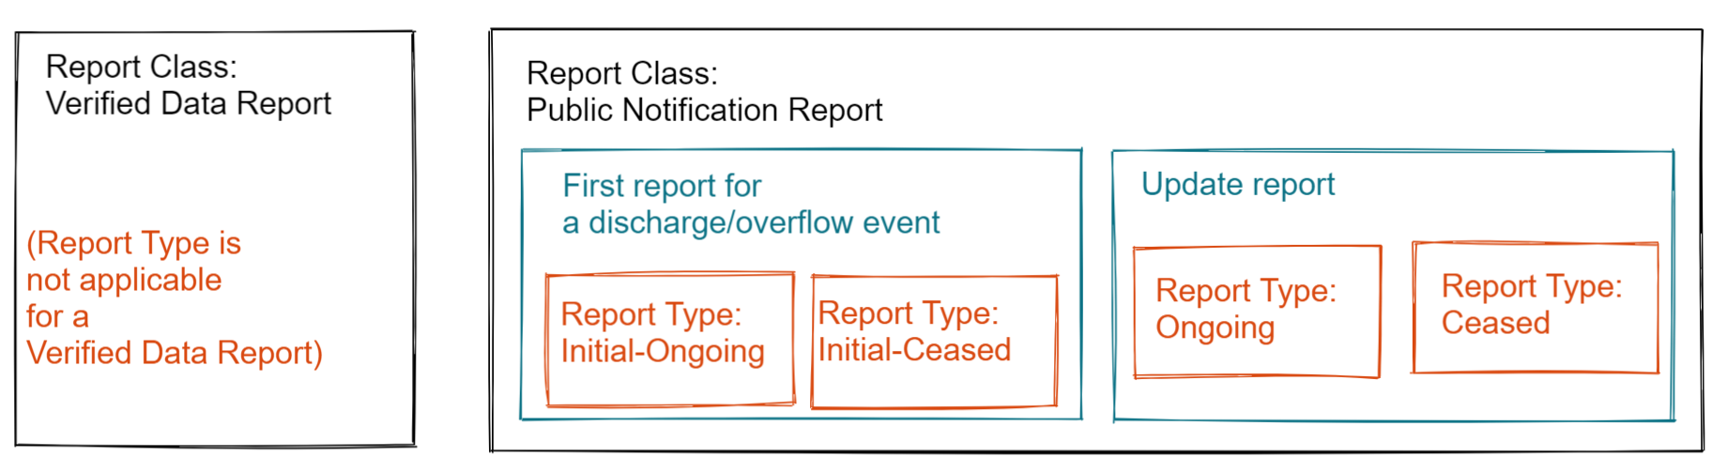

Definitions
- Report Class
  - Public Notification Report is submitted after issuing the Public Advisory Notification, soon after discovering the discharge or overflow event. Permittees have up to 18 hours after the Public Advisory Notification is issued to submit the Public Notification Report.
  - Verified Data Report is submitted during the month following the event by the 15th of the month, and includes updated data compared with the Public Notification Report.
- Incident Date, Incident Time, AM or PM
  - Date and time the event began. Update Reports should use the same date and time as the first Public Notification Report.
- Reporter Name
  - The account used to submit the report. This field is pre-populated based on the account used to submit the report.
- Report Type
  - For a Public Notification Report, this describes the status of the discharge or overflow event. This is not applicable for Verified Data Report.
  - For the first Public Notification Report submitted for an event, there are two options:
    - Initial-Ongoing should be used when the event is ongoing at the time the data is entered into the system.
    - Initial-Ceased should be used when the event has ceased by the time the data is entered into the system.
  - If any further data reports are entered into the system for a given event, an Update Report must be submitted. There are two types of Update Reports:
    - Ongoing should be used when the event is ongoing at the time the data is entered into the system.
    - Ceased should be used when the event has ceased by the time the data is entered into the system.
- Event Type
  - The type of discharge or overflow event. For help deciding which Event Type to choose, see the Reportable Events Flowchart.
    - CSO (Combined Sewer Overflow) is discharge from a sewer system that conveys sanitary wastewater and stormwater mixed together. There are two CSO Event Types:
      - CSO – Treated
      - CSO – Untreated
    - Partially Treated discharge is sanitary wastewater that has not received full treatment. There are two Partially Treated Event Types:
      - Partially Treated – Blended events are when treatment plant receives water from a combined sewer system, and intentionally diverts part of the stream around secondary treatment units during wet weather events. This water counts as “blended” even if it meets effluent limits. This option should only be selected for systems with CSOs.
      - Partially Treated – Other
    - SSO (Sanitary Sewer Overflow) is any discharge or overflow of untreated or partially treated wastewater from a sanitary sewer system. There are three SSO Event Types:
      - SSO – Discharge Through Wastewater Outfall
      - SSO – System Surcharging Under High Flow Conditions
      - SSO – Failure of Pump Station or Associated Force Main
- Permittee Class
  - CSO permittees hold permits for outfalls connected to systems that convey both sanitary wastewater and stormwater. CSO permittees may also hold permits for wastewater treatment facilities​.
  - Non-CSO permittees hold permits for wastewater treatment facilities ​and/or own or operate sanitary sewer systems.
- Permittee Name
  - The entity responsible for the discharge or overflow event.
- Permittee ID
  - The permittee's NPDES or Groundwater Discharge permit number, where applicable. Sewer systems without a treatment plant or CSO will not have a permit number.
- Outfall ID
  - The permittee's ID for the outlet from which the discharge or overflow flowed into the water body, where applicable.
- Municipality
  - The city or town where the discharge or overflow occurred.
- Location
  - A description of the location where the discharge or overflow event occurred.
- Latitude, Longitude
  - Coordinates of the location where the discharge or overflow event occurred.
- Water Body
  - Water body where the discharge or overflow occurred.
- Water Body Description
  - Water body where the discharge or overflow occurred. Manually enter this field if Water Body prefills as Other
- Volume (in gallons) of Event
  - Volume of the discharge or overflow.
  - This field is only applicable for Verified Data Reports. For Public Notification Reports, volume information should be included in the attached public advisory notification document.
- Rainfall Data (in inches)
  - Rainfall data for the storm event associated with the discharge or overflow event, if applicable.
  - This field is only applicable for Verified Data Reports.
  - For SSO events unrelated to wet weather, Rainfall Data can be input as “0”.
- Duration of Event Hours and Duration of Event Minutes
  - Duration of the discharge or overflow.
  - This field is only applicable for Verified Data Reports. For Public Notification Reports, duration should be included in the attached public advisory notification document.
  - For an event that lasted one and a half hours, this would be input as:
    - Duration of Event Hours: 1
    - Duration of Event Minutes: 30

