INDOOR AIR QUALITY ASSESSMENT

Sex Offenders Registry Board
Shetland Park Office Complex
45 Congress Street
Salem, MA

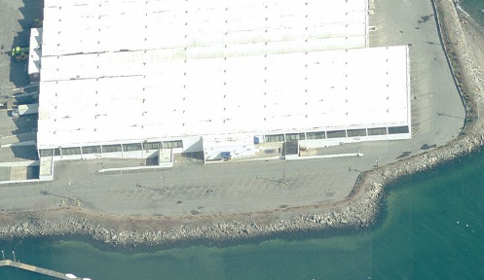

Prepared by:
Massachusetts Department of Public Health
Bureau of Environmental Health
Indoor Air Quality Program
October 2010

Background/Introduction
At the request of Virginia Platt, a Project Manager within the Division of Capital Asset Management (DCAM) Office of Leasing and State Office Planning, the Massachusetts Department of Public Health (MDPH), Bureau of Environmental Health (BEH) conducted an indoor air quality (IAQ) assessment at the Massachusetts Sex Offender Registry Board (SORB) located at the Shetland Park Office Complex, 45 Congress Street, Salem, Massachusetts. The SORB has occupied space on the top floor of the south-facing portion of the building since 2001. On September 9, 2010, a visit was made to this building by Sharon Lee, an Environmental Analyst/Inspector within BEH’s Indoor Air Quality (IAQ) Program. The purpose of the assessment was to aid DCAM in identifying building related issues/concerns for remediation/correction as part of a lease renewal process.

Methods
Tests for carbon dioxide, carbon monoxide, temperature and relative humidity were conducted with a TSI, Q-Trak, IAQ Monitor, Model 7565. Screening for total volatile organic compounds (TVOCs) was conducted using a MiniRAE 2000 Photo Ionization Detector (PID). Air tests for airborne particle matter with a diameter less than 2.5 micrometers (PM2.5) were taken with the TSI, DUSTTRAK™ Aerosol Monitor Model 8520. BEH staff also performed visual inspection of building materials for water damage and/or microbial growth.

Results
The SORB houses approximately 50 employees. Tests were taken during normal operations (i.e. during the work day). Results appear in Table 1.

Discussion

Ventilation
It can be seen from Table 1 that carbon dioxide levels were below 800 parts per million (ppm) in all but one of thirty-seven areas surveyed, indicating adequate air exchange throughout the majority of the SORB offices. The SORB’s heating, ventilation and air-conditioning (HVAC) system consists of a gas heating/electric cooling split system. Gas-fired air-handling units (AHUs) suspended from the ceiling system provide heated air to the space. Chilled air is provided by condensers located on the roof (Picture 1). Fresh air is drawn into air intakes located on rooftop of the building (Picture 2). Ceiling-mounted air diffusers ducted to the AHUs distribute fresh tempered air to occupied areas (Picture 3). Return air is drawn into ceiling-mounted vents, which are equipped with pleated filters (Picture 4). Some return air is ducted back to AHUs, where it is mixed with fresh air and redistributed to the office space. Air is also exhausted out of the building through vents located on the exterior of the building (Picture 2). Exhaust flues on the exterior of the building are equipped with wind shields to help prevent re-entrainment of exhaust air once it leaves the building.
Please note, the opening for each fresh air intake is in close proximity to the terminus of the corresponding exhaust flue. Under certain weather conditions (i.e. temperature inversion, winds), air exhausted from the flue can be captured by the fresh air intake, then re-introduced into occupied spaces. Consideration should be given to extending the height of the intakes to prevent entrainment of exhaust air.
Also of note is the configuration of the exhaust ventilation. Each AHU ceiling suspended from the ceiling is fueled by natural gas, which allows the AHU to warm the air and subsequently provide it to the occupied space. The exhaust from the firebox is vented into a duct equipped with a flue damper, which is connected to ductwork connected to a power vent. Power vents aid in expelling products of combustion through the exhaust flue located on the saw-tooth roof of the building.
Digital wall-mounted thermostats control the HVAC system. Each thermostat has fan settings of “on” and “automatic”. The automatic setting on the thermostat activates the HVAC system at a preset temperature. Once the preset temperature is reached, the HVAC system is deactivated. Therefore, no mechanical ventilation is provided until the thermostat re-activates the system. At the time of assessment, all but one thermostat was programmed for the fan “on” setting. The thermostat for the file room was set in the “automatic” setting (Picture 5). Without a continuous source of fresh outside air and removal via the exhaust/return system, indoor environmental pollutants can build-up and lead to indoor air quality/comfort complaints.
A passive vent is located between the local area network (LAN) room and the hallway. The purpose of this passive vent is likely to provide makeup air for the wall-mounted air conditioning (WAC) system located at near the doorway of the room. This passive vent was blocked by cardboard inhibiting airflow (Picture 6). At the time of assessment, the entrance to the LAN room was open. It’s likely that since the door to the LAN room is typically open, the WAC draws makeup air from the adjacent office. The positive pressure created by the WAC likely pushes conditioned air (rather than drawing it) through the passive vent.
To maximize air exchange, the MDPH recommends that both supply and exhaust ventilation operate continuously during periods of occupancy. In order to have proper ventilation with a mechanical supply and exhaust system, the systems must be balanced to provide an adequate amount of fresh air to the interior of a room while removing stale air from the room. It is recommended that HVAC systems be re-balanced every five years to ensure adequate air systems function (SMACNA, 1994). The date of the last balancing of these systems was not available at the time of the assessment.
The Massachusetts Building Code requires that each area have a minimum ventilation rate of 20 cubic feet per minute (cfm) per occupant of fresh outside air or openable windows (SBBRS, 1997; BOCA, 1993). The ventilation must be on at all times that the room is occupied. Providing adequate fresh air ventilation with open windows and maintaining the temperature in the comfort range during the cold weather season is impractical. Mechanical ventilation is usually required to provide adequate fresh air ventilation.
Carbon dioxide is not a problem in and of itself. It is used as an indicator of the adequacy of the fresh air ventilation. As carbon dioxide levels rise, it indicates that the ventilating system is malfunctioning or the design occupancy of the room is being exceeded. When this happens, a buildup of common indoor air pollutants can occur, leading to discomfort or health complaints. The Occupational Safety and Health Administration (OSHA) standard for carbon dioxide is 5,000 parts per million parts of air (ppm). Workers may be exposed to this level for 40 hours/week, based on a time-weighted average (OSHA, 1997).
The MDPH uses a guideline of 800 ppm for publicly occupied buildings. A guideline of 600 ppm or less is preferred in schools due to the fact that the majority of occupants are young and considered to be a more sensitive population in the evaluation of environmental health status. Inadequate ventilation and/or elevated temperatures are major causes of complaints such as respiratory, eye, nose and throat irritation, lethargy and headaches. For information concerning carbon dioxide, please see Appendix A.
Indoor temperature measurements ranged from 70º F to 79º F, which were within or very close to the upper end of the MDPH recommended comfort guidelines (Table 1). The MDPH recommends that indoor air temperatures be maintained in a range of 70 º F to 78 º F in order to provide for the comfort of building occupants. In many cases concerning indoor air quality, fluctuations of temperature in occupied spaces are typically experienced, even in a building with an adequate fresh air supply.
Indoor relative humidity levels ranged from 38 to 51 percent, which were within or close to the lower end of the MDPH recommended comfort range (Table 1). The MDPH recommends a comfort range of 40 to 60 percent for indoor air relative humidity. Relative humidity levels in the building would be expected to drop during the winter months due to heating. The sensation of dryness and irritation is common in a low relative humidity environment. Low relative humidity is a very common problem during the heating season in the northeast part of the United States.

Microbial/Moisture Concerns
Water-damaged ceiling tiles and building materials were observed in a number of areas (Pictures 7 and 8), many of which were near columns through which roof drains traverse the building. The water-damaged ceiling tile observed in the records room may have mold growth (Picture 8). Based on reports from David Raines of SORB, Shetland Park Management indicated that roof drain pipes were damaged and failing at the base. Plans to replace the roof drainage system are reportedly underway. BEH also noted that roof drains lacked cages/strainers to prevent materials from falling in and collecting at the base of the system (Picture 9). Materials collected at the base of the drainage system can prevent proper drainage and ultimately damage the system.
Damage to the rooftop coating and membrane is also likely to be contributing to water-damaged ceiling tiles. BEH staff examined one section of the saw-tooth roof and observed a number of issues. The white membrane observed on the roof appeared cracked and damaged (Pictures 10 and 11). Water was observed collected in areas where the roof coating was missing, and plants were growing in cracks (Pictures 12 and 13). Water trapped beneath the membrane bubbled out from breaches in the coating when pressure was applied (Picture 14). In some areas, a material resembling roof insulation was exposed (Pictures 9 and 15). According to Ms. Platt, Shetland Park Management is aware of roof issues and has indicated that existing issues would be addressed, likely through roof replacement.
Window ledges at the SORB consist of pressed wood materials with a laminate coating; these ledges also appeared water-damaged at the time of assessment (Pictures 16 and 17). While these ledges may be sustaining some damage via the previously discussed roof drain system leaks, it is more likely that water penetrating from the window system is wetting these ledges. BEH staff observed the conditions of the windows and found failing gaskets and caulking, which can cause water to penetrate the building during wind-driven rains (Pictures 18 and 19). Water staining of glass windowpanes is a further indication of water penetration through failing gaskets (Picture 20). Measures should be taken to repair/replace failing gasket/caulking materials. Damage to these window ledges should also be examined and, if warranted removed and replaced with new ledges to prevent the potential for microbial growth.
The US Environmental Protection Agency (US EPA) and the American Conference of Governmental Industrial Hygienists (ACGIH) recommends that porous materials be dried with fans and heating within 24 to 48 hours of becoming wet (US EPA, 2001; ACGIH, 1989). If porous materials are not dried within this time frame, mold growth may occur. Water-damaged porous materials cannot be adequately cleaned to remove mold growth. The application of a mildewcide to moldy porous materials is not recommended.
Plants were observed in a number of offices. Plants, soil and drip pans can serve as sources of mold growth and should be properly maintained. Over-watering of plants should be avoided and drip pans should be inspected periodically for mold growth. Flowering plants can be a source of pollen. Therefore, plants should be located away from ventilation sources to prevent aerosolization of mold, pollen and particulate matter.
The SORB space has wall-to-wall carpeting. While no water damage was observed on carpeting, the potential exists considering the leakages occurring from the window system and the roof drain system. Consideration should be given to removing carpeting and coving along the exterior wall/window system to prevent moistening of carpet and replacing with non-porous materials (i.e. floor tiles).

Other Indoor Air Evaluations
Indoor air quality can be negatively influenced by the presence of respiratory irritants, such as products of combustion. The process of combustion produces a number of pollutants. Common combustion emissions include carbon monoxide, carbon dioxide, water vapor, and smoke (fine airborne particle material). Of these materials, exposure to carbon monoxide and particulate matter with a diameter of 2.5 micrometers (μm) or less (PM2.5) can produce immediate, acute health effects upon exposure. To determine whether combustion products were present in the indoor environment, BEH staff obtained measurements for carbon monoxide and PM2.5.

Carbon Monoxide
Carbon monoxide is a by-product of incomplete combustion of organic matter (e.g., gasoline, wood and tobacco). Exposure to carbon monoxide can produce immediate and acute health affects. Several air quality standards have been established to address carbon monoxide and prevent symptoms from exposure to these substances. The MDPH established a corrective action level concerning carbon monoxide in ice skating rinks that use fossil-fueled ice resurfacing equipment. If an operator of an indoor ice rink measures a carbon monoxide level over 30 ppm, taken 20 minutes after resurfacing within a rink, that operator must take actions to reduce carbon monoxide levels (MDPH, 1997).
The American Society of Heating Refrigeration and Air-Conditioning Engineers (ASHRAE) has adopted the National Ambient Air Quality Standards (NAAQS) as one set of criteria for assessing indoor air quality and monitoring of fresh air introduced by HVAC systems (ASHRAE, 1989). The NAAQS are standards established by the US EPA to protect the public health from six criteria pollutants, including carbon monoxide and particulate matter (US EPA, 2006). As recommended by ASHRAE, pollutant levels of fresh air introduced to a building should not exceed the NAAQS levels (ASHRAE, 1989). The NAAQS were adopted by reference in the Building Officials & Code Administrators (BOCA) National Mechanical Code of 1993 (BOCA, 1993), which is now an HVAC standard included in the Massachusetts State Building Code (SBBRS, 1997). According to the NAAQS, carbon monoxide levels in outdoor air should not exceed 9 ppm in an eight-hour average (US EPA, 2006).
Carbon monoxide should not be present in a typical, indoor environment. If it is present, indoor carbon monoxide levels should be less than or equal to outdoor levels. The day of the assessment, outdoor carbon monoxide concentrations were non-detect (ND) (Table 1). No measureable levels of carbon monoxide were detected in the building during the assessment (Table 1).

Particulate Matter
The US EPA has established NAAQS limits for exposure to particulate matter. Particulate matter is airborne solids that can be irritating to the eyes, nose and throat. The NAAQS originally established exposure limits to particulate matter with a diameter of 10 μm or less (PM10). According to the NAAQS, PM10 levels should not exceed 150 micrograms per cubic meter (μg/m³) in a 24-hour average (US EPA, 2006). These standards were adopted by both ASHRAE and BOCA. Since the issuance of the ASHRAE standard and BOCA Code, US EPA established a more protective standard for fine airborne particles. This more stringent PM2.5 standard requires outdoor air particle levels be maintained below 35 μg/m³ over a 24-hour average (US EPA, 2006). Although both the ASHRAE standard and BOCA Code adopted the PM10 standard for evaluating air quality, MDPH uses the more protective PM2.5 standard for evaluating airborne particulate matter concentrations in the indoor environment.
Outdoor PM2.5 was measured at 5 μg/m³ (Table 1). PM2.5 levels measured indoors ranged from 4 to 8 μg/m³ (Table 1), which were below the NAAQS PM2.5 level of 35 μg/m³. Frequently, indoor air levels of particulates (including PM2.5) can be at higher levels than those measured outdoors. A number of mechanical devices and/or activities that occur in buildings can generate particulate during normal operations. Sources of indoor airborne particulates may include but are not limited to particles generated during the operation of fan belts in the HVAC system, use of stoves and/or microwave ovens in kitchen areas; use of photocopiers, fax machines and computer printing devices; operation of an ordinary vacuum cleaner and heavy foot traffic indoors.
At the time of assessment, one office occupant had just lit a candle minutes prior to the BEH assessment. While the PM2.5 level for this room was not particularly elevated, overtime particulates (i.e. soot) produced from burning a candle can buildup.

TVOCs
Indoor air quality can also be negatively influenced by the presence of materials containing volatile organic compounds (VOCs). VOCs are carbon-containing substances that have the ability to evaporate at room temperature. Frequently, exposure to low levels of total VOCs (TVOCs) may produce eye, nose, throat and/or respiratory irritation in some sensitive individuals. Typical sources of VOCs from indoor sources include photocopiers, cleaners, health care/beauty products, dry erase materials, permanent markers, combustion sources, fabrics/textiles and paints.
In an effort to determine whether VOCs were present in the building, air monitoring for TVOCs was conducted. Outdoor TVOC concentrations on the day of the assessment were ND (Table 1). Real-time measurements taken during the assessment for indoor TVOCs were also ND (Table 1).
In additional to the aforementioned candle, a scented oil reed diffuser was also observed in use. Air deodorizers contain chemicals that can be irritating to the eyes, nose and throat of sensitive individuals. Many air fresheners contain 1,4-dichlorobenzene, a VOC which may cause reductions in lung function (NIH, 2006). Furthermore, deodorizing agents do not remove materials causing odors, but rather mask odors that may be present in the area.

Conclusions/Recommendations
As discussed, a number of concerns relating to water leakage from the roof drain system, roof and window system were indentified. Measures should be taken to replace the roof and its drainage system to prevent future leaks. Similarly, issues concern failing rubber gaskets and caulking should be addressed to prevent future water penetration issues. In view of the findings at the time of the visit, the following recommendations are made:
- Extending the height of the fresh air intake to prevent entrainment of exhaust air.
- Continue to coordinate with building management, administration, HVAC vendor and SORB staff to achieve/maintain optimal comfort levels.
- Set the thermostat to the fan “on” position to operate the ventilation system continuously during business hours.
- Keep door to LAN room shut and remove cardboard from passive vent to facilitate airflow as designed.
- Consider having HVAC system balanced by an HVAC engineering firm prior to lease renewal. Adopt a balancing schedule of every 5 years for all mechanical ventilation systems, as recommended by ventilation industrial standards (SMACNA, 1994).
- Continue to plans to repair/replace roof drain system.
- Install cages/strainers on roof drains to prevent materials from falling in and lodging at the base of the drainage system.
- Continue with plans to repair/replace the roof membrane system. Such work should be conducted during off-work hours to prevent entrainment of materials and odors related to roof repairs/replacement.
- Repair damaged gaskets and caulking around window system to prevent water penetration.
- Consider replacing damaged window ledges once repairs to the window system have been made.
- Consider removing carpet and coving along all exterior walls. Carpeting should be removed in a manner consistent with recommendations in “Mold Remediation in Schools and Commercial Buildings” published by the US Environmental Protection Agency (US EPA, 2001). This document is available from the US EPA website: http://www.epa.gov/iaq/molds/mold_remediation.html. Replace with a non-porous material (e.g., non-slip tile).
- Contact the building’s HVAC consultant to inspect interior components of the AC system susceptible to mold growth (e.g., drip pans, condensate pumps and hoses). Clean, disinfect and/or replace as necessary. This should be done as part of a preventative maintenance program prior to the start of the cooling season.
- Ensure plants have drip pans and avoid over-watering. Examine drip pans periodically for mold growth. Disinfect with an appropriate antimicrobial where necessary.
- Discontinue the use of air deodorizers/fresheners and burning of candles in the building.
- Refer to resource manuals and other related indoor air quality documents for further building-wide evaluations and advice on maintaining public buildings. Copies of these materials are located on the MDPH’s website: http://www.mass.gov/dph/iaq.

References
ACGIH. 1989. Guidelines for the Assessment of Bioaerosols in the Indoor Environment. American Conference of Governmental Industrial Hygienists, Cincinnati, OH.
ASHRAE. 1989. Ventilation for Acceptable Indoor Air Quality. American Society of Heating, Refrigeration and Air Conditioning Engineers. ANSI/ASHRAE 62-1989.
BOCA. 1993. The BOCA National Mechanical Code/1993. 8th ed. Building Officials and Code Administrators International, Inc., Country Club Hill, IL. Section M-308.1.1.
MDPH. 1997. Requirements to Maintain Air Quality in Indoor Skating Rinks (State Sanitary Code, Chapter XI). 105 CMR 675.000. Massachusetts Department of Public Health, Boston, MA.
NIH. 2006. Chemical in Many Air Fresheners May Reduce Lung Function. NIH News. National Institute of Health. July 27, 2006. http://www.nih.gov/news/pr/jul2006/niehs-27.htm
OSHA. 1997. Limits for Air Contaminants. Occupational Safety and Health Administration. Code of Federal Regulations. 29 C.F.R 1910.1000 Table Z-1-A.
SBBRS. 1997. Mechanical Ventilation. State Board of Building Regulations and Standards. Code of Massachusetts Regulations. 780 CMR 1209.0
SMACNA. 1994. HVAC Systems Commissioning Manual. 1st ed. Sheet Metal and Air Conditioning Contractors’ National Association, Inc., Chantilly, VA.
US EPA. 2001. Mold Remediation in Schools and Commercial Buildings. US Environmental Protection Agency, Office of Air and Radiation, Indoor Environments Division, Washington, D.C. EPA 402-K-01-001. March 2001.
US EPA. 2006. National Ambient Air Quality Standards (NAAQS). US Environmental Protection Agency, Office of Air Quality Planning and Standards, Washington, DC. http://www.epa.gov/air/criteria.html.
Picture 1

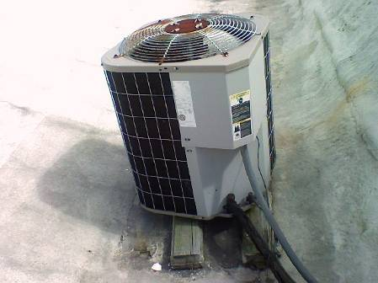

Rooftop condensing unit

Picture 2

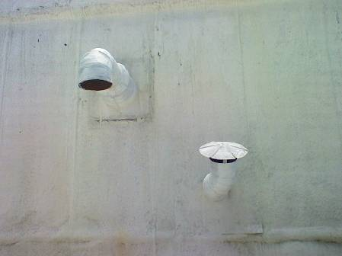

Fresh air intake on the left, exhaust on the right

Picture 3

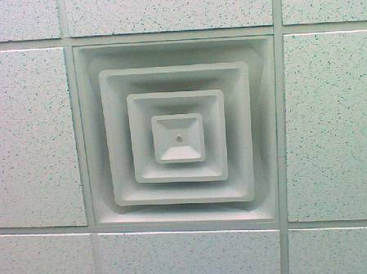

Air supply diffuser

Picture 4

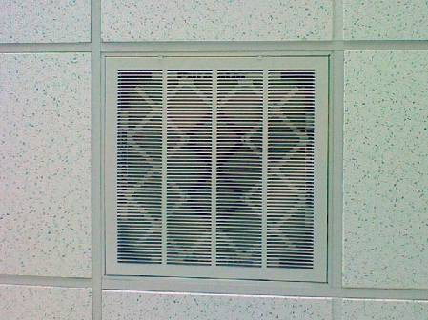

Return vent with pleated filter

Picture 5

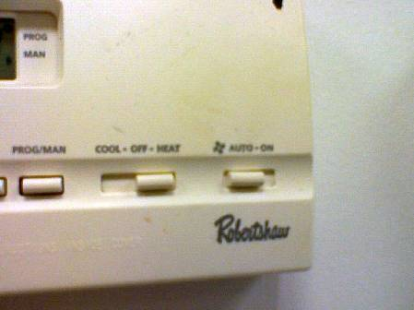

Thermostat fan setting in the auto position

Picture 6

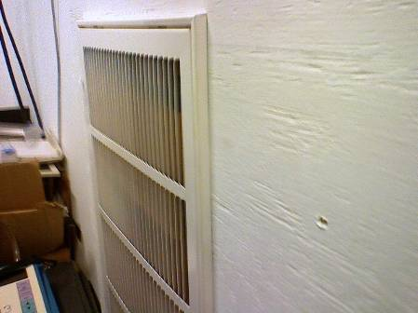

Passive vent with cardboard

Picture 7

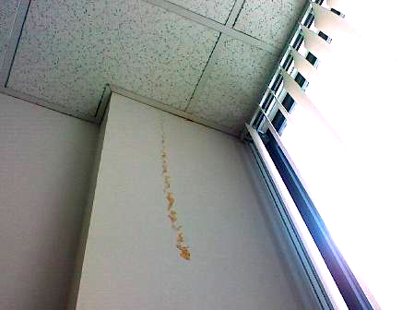

Water stain/drip on wall column

Picture 8

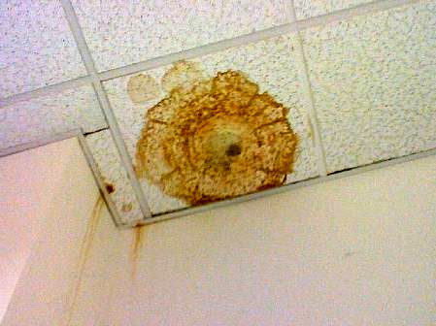

Water stain/drips on wall column; water-damaged ceiling tile with
potential mold growth
Picture 9

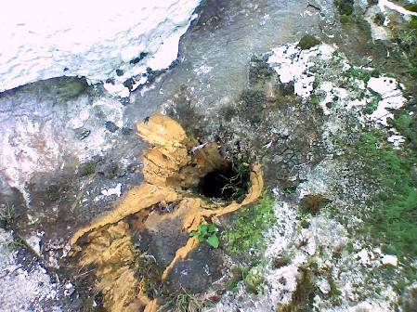

Roof drain lacking cage/strainer; note exposed insulation and plant growth

Picture 10

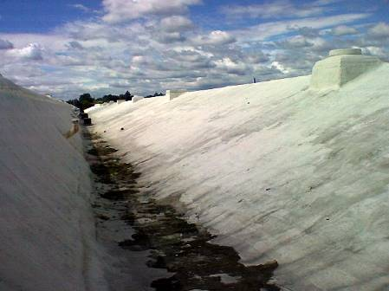

Breaches/missing roof membrane and plant growth

Picture 11

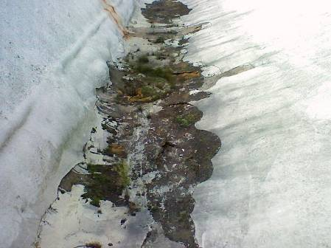

Plant and moss growth on roof

Picture 12

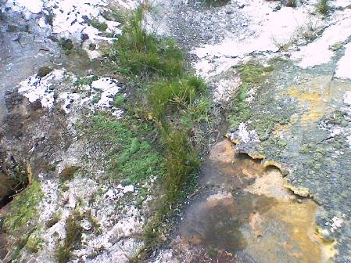

Damaged roof membrane with plant growth

Picture 13

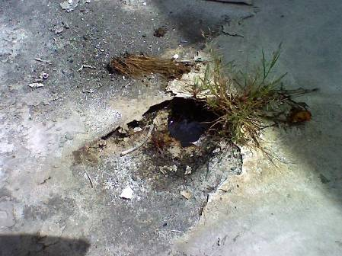

Collected water and plant growth in damaged roof

Picture 14

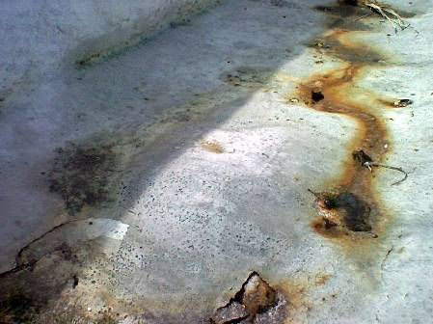

Blister in roof membrane holding water; note water leaking from pocket

Picture 15

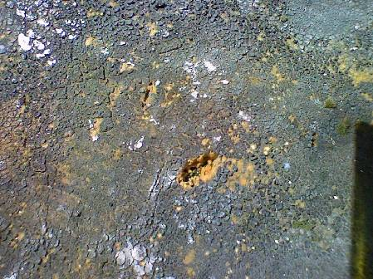

Exposed roof insulation

Picture 16

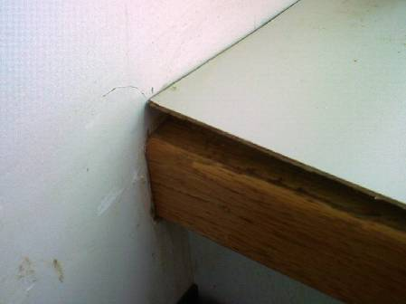

Water-damaged pressed wood ledge

Picture 17

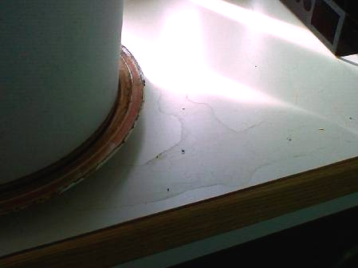

Water staining on wood ledge

Picture 18

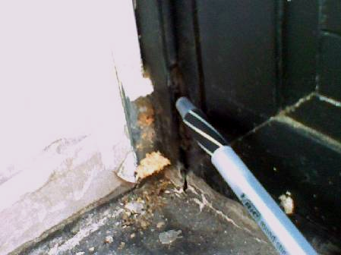

Missing gasket and caulking

Picture 19

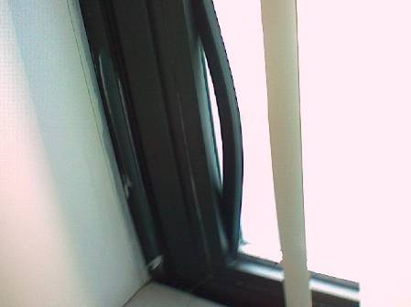

Failing gasket

Picture 20

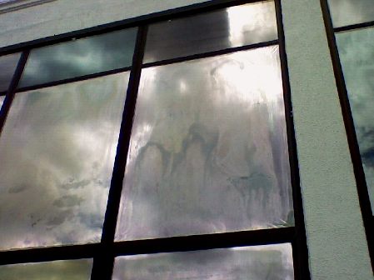

Water staining between window pane
Location | Carbon  Dioxide  (ppm) | Carbon Monoxide  (ppm) | Temp  (°F) | Relative  Humidity  (%) | TVOCs  (ppm) | PM2.5 (ug/m3) | Occupants  in Room | Windows  Openable | Ventilation |  | Remarks
Outside  (Background) | 285 | ND | 74 | 49 | ND | 5
Allen/Hall | 667 | ND | 73 | 46 | ND | 5 | 4 | Y | Y | Y
Board Member  Nuon | 607 | ND | 75 | 40 | ND | 6 | 1 | N | Y | Y | DO
Board Member  Downs | 585 | ND | 76 | 41 | ND | 5 | 1 | N | Y | Y | DO, plants, reed diffuser
Board Member Gobourne | 612 | ND | 77 | 40 | ND | 6 | 1 | N | Y | Y | DO
Board Member Humbert | 592 | ND | 72 | 44 | ND | 5 | 1 | N | Y | Y | DO, space heater, indicated often too cold
Board Member Walsh | 590 | ND | 72 | 45 | ND | 4 | 1 | N | Y | Y | DO, plants
Casey | 591 | ND | 73 | 43 | ND | 5 | 1 | N | Y | Y | 1 WD-CT
Chairperson Edwards | 604 | ND | 79 | 40 | ND | 5 | 0 | Y | Y | Y | DO, plants, Failing window gaskets, water staining on windows and wall
Communications Director, McDonald | 615 | ND | 74 | 48 | ND | 4 | 1 | N | Y | N | DO
Copy room | 561 | ND | 74 | 43 | ND | 6 | 1 | N | Y | Y | DO, 2 copiers
Director of Classification, Pepe | 589 | ND | 74 | 44 | ND | 5 | 1 | N | Y | N | DO, PF
Director of Registration and Community, Mercurio | 742 | ND | 74 | 43 | ND | 8 | 1 | N | Y | N | DO, Burning scented candle
Director of Victim Services, Norton | 837 | ND | 75 | 48 | ND | 4 | 0 | N | Y | N | DO
Executive Assistant Colletti | 563 | ND | 78 | 40 | ND | 5 | 1 | N | Y | N | DO
Executive Director  Holmes | 567 | ND | 73 | 46 | ND | 5 | 1 | N | Y | Y | DO
File Room | 564 | ND | 75 | 47 | ND | 5 | 2 | N | Y | Y  Dust | 2 WD-CT/potential mold growth
Fish Bowl | 576 | ND | 74 | 48 | ND | 4 | 2 | N | Y | N | DO, 3 WD-CT
Grant/Dimarino | 533 | ND | 74 | 43 | ND | 5 | 2 | N | Y | Y
Hearings File Room | 651 | ND | 75 | 47 | ND | 5 | 0 | N | Y | Y  Dusty | 1 WD-CT
Kitchen | 462 | ND | 70 | 45 | ND | 5 | 2 | N | Y | Y | DO
LAN Manager’s Office | 592 | ND | 74 | 42 | ND | 4 | 0 | N | Y | N | DO
LAN Room | 603 | ND | 71 | 42 | ND | 5 | 1 | N | N | N | Passive vents blocked
Large Conference | 560 | ND | 75 | 42 | ND | 5 | 0 | Y | Y | Y | DO, Plants
Lauro | 618 | ND | 74 | 46 | ND | 4 | 0 | Y | Y | Y | Water staining on walls and windows; failing window gasket
Library | 514 | ND | 73 | 42 | ND | 4 | 0 | N | U | N | DO
Lynch Room Workstation | 575 | ND | 75 | 38 | ND | 5 | 1 | N | Y | N | DO, 1 WD-CT
Mail Room | 466 | ND | 72 | 44 | ND | 4 | 0 | N | Y | Y | DO, 2 WD-CT
Neves/Santa Anna | 518 | ND | 74 | 42 | ND | 5 | 2 | N | Y | Y
O’Neil/Garrin/  Santiago | 624 | ND | 74 | 42 | ND | 6 | 3 | N | Y | Y | Plants
Padellaro, Hearing Examiner | 619 | ND | 73 | 44 | ND | 5 | 1 | N | Y | N | DO
Raines, Program Services | 595 | ND | 73 | 49 | ND | 4 | 0 | N | Y | N | DO
Reception/Wilson/  Fisher | 593 | ND | 74 | 47 | ND | 4 | 3 | Y | Y | Y
Training Room | 501 | ND | 72 | 45 | ND | 5 | 0 | N | Y | Y | Cleaners
Victim Advocate  Abreu | 608 | ND | 74 | 47 | ND | 5 | 1 | N | Y | N | DO
Video Conference Room | 569 | ND | 74 | 51 | ND | 5 | 0 | N | Y | N | DO
Whitkin, Hearings Examiner | 471 | ND | 75 | 44 | ND | 4 | 0 | N | Y | N | Items
Women’s Room |  |  |  |  |  |  |  | N | Y | Y
Zalnasky/Greenway | 556 | ND | 72 | 43 | ND | 5 | 3 | N | Y | Y

