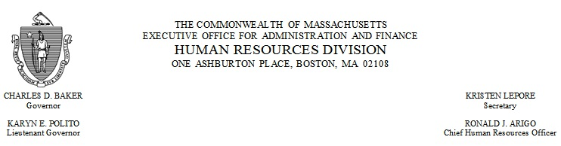
memorandum

TO: Executive Branch Employees
DATE: February 7, 2017
RE: Action Required: Sexual Harassment Policy for Commonwealth of Massachusetts Employees –
Review
It is the goal of the Commonwealth of Massachusetts to promote a workplace that is free of sexual harassment. To that end, I ask that all Executive Branch employees review the Sexual Harassment Policy for Commonwealth of Massachusetts Employees within the next 30 days so that all employees will fully understand their responsibilities to maintain a workplace free from sexual harassment.

The Sexual Harassment Policy has been made available through the PACE Learning Management System (LMS). Log into PACE. Go to the Student Learning Center and search the Course Catalog using the keywords “Sexual Harassment Policy 2017”. If you are logging into PACE for the first time and need assistance, view PACE job aids. If you are unable to access the Policy through PACE, your agency will provide you with a printed copy.

To find the Sexual Harassment Officer for your agency, view the Sexual Harassment Officer List.

If you have questions, contact Melissa Thomson at (617-878-9888) or by email at Melissa.Thomson@MassMail.State.MA.US.

