Commonwealth of Massachusetts
State Fiscal Recovery Funds
Recovery Plan Performance Report
August 2021

Table of Contents
Table of Contents 1
Executive Summary 1
Chronology of the Commonwealth’s Response to COVID-19 1
Phased Recovery Projects 2
Massachusetts’ Response to COVID-19 4
Emergency Measures to Mitigate the Pandemic’s Impact, March through December 2020 4
Reopening and Beginning Recovery, January through March 2021 6
Recovery Projects to Meet Urgent Needs and Planning for More, April through July 2021 7
Phase I – Recovery Projects to Meet Urgent Needs 10
Project Funding and Expenditure Categories 10
Aid to Disproportionately Impacted Communities 10
COVID-19 Temporary Emergency Paid Sick Leave Program 11
VaxMillions Giveaway 12
Phase II – Additional Recovery Projects to Be Launched by January 2022 14
Project Funding and Expenditure Categories 14
Workforce Development I 14
Health and Human Services Workforce Stabilization Payments 15
Funding for Fiscally Distressed Hospitals 16
Phase III – Proposed Multi-Year Recovery Projects 18
Project Funding and Expenditure Categories 18
First-time Homebuyer Assistance Program 18
CommonWealth Builder Program 19
Rental Housing Production 20
Senior and Veteran Housing 21
Downtown Development 21
Statewide Downtowns 22
Tourism and Cultural Assets 23
Workforce Development II 23
Behavioral Health and Addiction Services 24
Water and Sewer 24
Environmental Infrastructure 25
State Parks and Trails 25
Broadband Internet Access 26
Marine Port Infrastructure 26
Appendix I: Project Expenses to Date by Expenditure Category 27
Appendix II: Project Inventory 28
Appendix III: Communities Disproportionately Impacted by the COVID-19 Public Health Emergency 32
Appendix IV: Framework for Use of Evidence-Based Interventions 40
Framework Themes 40
Framework Application Examples 43
Appendix V: Required Information Related to the Tax Offset Provision 44

Executive Summary
The Commonwealth of Massachusetts is pleased to submit our 2021 Recovery Plan Performance Report. This report presents information on the projects we have undertaken and plan to undertake as part of the Commonwealth’s Recovery Plan using our Coronavirus State Fiscal Recovery Fund (“CSFRF”) allocation. In addition, the report describes Massachusetts’ ongoing efforts to ensure program outcomes are achieved in an effective, efficient, and equitable manner.

Chronology of the Commonwealth’s Response to COVID-19
The World Health Organization declared an international Public Health Emergency on January 30, 2020, and the US declared a national public health emergency the following day. By early March 2020, more than 600 cases of COVID-19 had been confirmed in the US, of which 91 were in Massachusetts. On March 10, 2020, Governor Charlie Baker declared a state of emergency in the Commonwealth. Since the Governor’s declaration, the Commonwealth’s response to COVID-19 has unfolded in three distinct periods:
- Emergency Measures to Mitigate the Pandemic’s Impact, March through December 2020
- Reopening and Beginning Recovery, January through March 2021
- Recovery Projects to Meet Urgent Needs and Planning for More, April through July 2021

Emergency Measures to Mitigate the Pandemic’s Impact, March through December 2020
To address the immediate impact of the pandemic on public health and the economy, in March and April 2020 the Baker-Polito Administration implemented key measures, including: emergency orders closing certain education programs and non-essential businesses; social distancing mandates, travel advisories, and eviction moratoriums; and tax relief postponing the collection of certain taxes due in fiscal 2020. In May, the Governor announced a four-phase plan to reopening the Commonwealth. Between May and October, as public health metrics improved, the Commonwealth progressed through the plan, gradually reopening industries and decreasing restrictions. In December 2020, however, in response to an increase in new COVID-19 infections and hospitalizations following the Thanksgiving holiday, the Administration took the necessary actions to again reduce indoor capacity across a broad range of sectors, tighten workplace restrictions, and close certain businesses, including indoor performance venues and indoor recreational businesses.

Reopening and Beginning Recovery, January through March 2021
In January 2021, the Commonwealth began to experience significant declines in average daily COVID-19 cases and hospitalizations, and vaccination efforts began. Accordingly, the Administration resumed implementation of the reopening plan and began the final phase of the plan on March 22, 2021. On April 1, 2021, the Governor signed legislation to help speed businesses’ recovery as the Commonwealth reopens; the legislation created several tax relief measures, including limited exemption of unemployment compensation from 2020 and 2021 income tax, exclusion of federal Paycheck Protection Program loans and Economic Injury Disaster Loan advances from individuals’ 2020 taxable income, waiver of penalties for failure to timely remit taxes on 2020 unemployment compensation, and extension of the 2020 tax filing deadline for individual taxpayers.

Recovery Projects to Meet Urgent Needs and Planning for More, April through July 2021
Following passage of the American Rescue Plan Act on March 11, 2021, the Commonwealth began to plan and implement Massachusetts’ recovery from the ongoing public health and economic effects of the pandemic. As currently planned, the Commonwealth’s Recovery Plan is rolling out in three phases:
- Phase I – Recovery Projects to Meet Urgent Needs
- Phase II – Additional Recovery Projects to Be Launched by January 2022
- Phase III – Proposed Multi-Year Recovery Projects

Phased Recovery Projects
The following table lists 21 projects currently included in Massachusetts’ Recovery Plan and their proposed allocations of CSFRF aid. Only Phase I projects are fully obligated and underway as of July 31, 2021. Projects and allocation amounts included in the Recovery Plan may be modified or expanded in the coming months as projects are evaluated and refined. Details of the projects are presented in separate sections of this report describing each Recovery Plan implementation phase.

Currently Planned Massachusetts’ Recovery Projects and CSFRF Allocations
Implementation Phase | Project | CSFRF Amount
Phase I – Recovery Projects to Meet Urgent Needs | Aid to Disproportionately Impacted Communities | $109,080,277
Phase I – Recovery Projects to Meet Urgent Needs | COVID-19 Temporary Emergency Paid Sick Leave Program | $75,000,000
Phase I – Recovery Projects to Meet Urgent Needs | VaxMillions Giveaway | $10,000,000
Phase II – Additional Recovery Projects to Be Launched by January 2022 | Workforce Development I | $50,000,000
Phase II – Additional Recovery Projects to Be Launched by January 2022 | Health and Human Services Workforce Stabilization Payments | $55,000,000
Phase II – Additional Recovery Projects to Be Launched by January 2022 | Funding for Fiscally Distressed Hospitals | $50,000,000
Phase II – Additional Recovery Projects to Be Launched by January 2022 | In-Patient Psychiatric Direct Care Workforce Support Payments | $31,000,000
Phase III – Proposed Multi-Year Recovery Projects | First-time Homebuyer Assistance Program | $300,000,000
Phase III – Proposed Multi-Year Recovery Projects | CommonWealth Builder Program | $200,000,000
Phase III – Proposed Multi-Year Recovery Projects | Rental Housing Production | $200,000,000
Phase III – Proposed Multi-Year Recovery Projects | Senior and Veteran Housing | $300,000,000
Phase III – Proposed Multi-Year Recovery Projects | Downtown Development | $100,000,000
Phase III – Proposed Multi-Year Recovery Projects | Statewide Downtowns | $250,000,000
Phase III – Proposed Multi-Year Recovery Projects | Tourism and Cultural Assets | $100,000,000
Phase III – Proposed Multi-Year Recovery Projects | Workforce Development II | $190,000,000
Phase III – Proposed Multi-Year Recovery Projects | Behavioral Health and Addiction Services | $175,000,000
Phase III – Proposed Multi-Year Recovery Projects | Water and Sewer | $400,000,000
Phase III – Proposed Multi-Year Recovery Projects | Environmental Infrastructure | $300,000,000
Phase III – Proposed Multi-Year Recovery Projects | State Parks and Trails | $100,000,000
Phase III – Proposed Multi-Year Recovery Projects | Broadband Internet Access | $100,000,000
Phase III – Proposed Multi-Year Recovery Projects | Marine Port Infrastructure | $100,000,000
 | Total | $3,195,080,277

Massachusetts’ Response to COVID-19
In early 2020, the outbreak of COVID-19, a respiratory disease caused by a new strain of coronavirus, spread globally, including throughout the United States and in Massachusetts. On March 11, 2020, the outbreak was declared a pandemic by the World Health Organization. In response to the pandemic, international, federal, state and local governments, as well as private businesses, organizations and individuals, implemented numerous policy measures and altered their behavior to mitigate the spread and effects of COVID-19. The ongoing transmission of COVID-19, the mitigation measures implemented, and these behavioral adaptations had and continue to have a significant impact on global, national, and local public health and economies.
To provide context for our report on Massachusetts’ Recovery Plan Performance, this section presents a brief chronology of the Commonwealth’s response to COVID-19 and the federal fiscal aid it has received to support the response. Starting in March 2020, the Commonwealth’s response has unfolded in three periods:
- Emergency Measures to Mitigate the Pandemic’s Impact, March through December 2020
- Reopening and Beginning Recovery, January through March 2021
- Recovery Projects to Meet Urgent Needs and Planning for More, April through July 2021
The Commonwealth’s key actions and the major sources of federal fiscal aid it received during each period are summarized in the sections that follow.

Emergency Measures to Mitigate the Pandemic’s Impact, March through December 2020

Emergency State Actions
Emergency Declaration – On January 30, 2020, the World Health Organization designated the 2019 novel Coronavirus outbreak as an international Public Health Emergency. US Health and Human Services Secretary Alex Azar declared a public health emergency for the entire United States the following day.
By March 10, 2020, according to the Centers for Disease Control and Prevention, more than 114,000 cases of COVID-19 had been confirmed worldwide, and over 4,000 of those cases resulted in death. In the US, more than 600 cases of COVID-19 had been confirmed, and 25 resulted in death. In Massachusetts, 91 presumed positive cases of COVID-19 had been identified; travel-related and community transmission of the disease was occurring throughout the Commonwealth, and public health authorities expected it to increase rapidly.
Given these circumstances, on March 10, 2020, Governor Charlie Baker declared a state of emergency in the Commonwealth. Over the following eight weeks, the Baker-Polito Administration undertook a number of mitigation measures in response to COVID-19, including emergency orders closing certain education programs and non-essential businesses; a number of social distancing mandates, travel advisories and eviction moratoriums; and tax relief measures postponing the collection of certain taxes due in fiscal 2020. All of these measures resulted in widespread economic disruption throughout the Commonwealth.
Reopening Planning and Execution – As the ongoing COVID-19 pandemic evolved, Governor Baker’s administration modified certain measures while retaining flexibility to address future waves of the pandemic. In May 2020, the Governor announced a four-phase approach to reopening the Commonwealth, with each phase having multiple steps. The timing and details of each phase and step of the reopening process was to be influenced by public health metrics. Between May and October, as public health metrics improved, the Commonwealth progressed through the plan, gradually reopening industries and decreasing restrictions. By October, the Commonwealth had advanced to Phase III, Step 2 of the plan.
In December 2020, the Commonwealth rolled back its reopening to Step 1 of Phase III in response to an increase in new COVID-19 infections and hospitalizations following the Thanksgiving holiday. Indoor capacity across a broad range of sectors was reduced, several workplace restrictions were tightened, and certain businesses were required to close, including indoor performance venues and certain high-contact indoor recreational businesses.

Federal Fiscal Aid
Families First Act – On March 18, 2020, the federal Families First Coronavirus Response Act (Families First Act) was enacted into law. The Act provided paid leave for reasons related to COVID-19, established free coronavirus testing, increased unemployment benefits and food assistance, and increased protections for health workers. The Families First Act also included an emergency 6.2% increase to the Medicaid Federal Medical Assistance Percentage (FMAP), the federal matching rate for states and territories, during the public health emergency. Enhanced FMAP provided the Commonwealth with $570 million in additional revenue during fiscal year 2020.
CARES Act – On March 27, 2020, the federal Coronavirus Aid, Relief and Economic Security Act (CARES Act) was enacted. The CARES Act provided $2 trillion of aid across a wide range of programs, including market stabilization efforts; expanded unemployment insurance; loans and grants to small businesses; direct payments to certain individuals; loans to corporations, businesses and health care systems; and aid for state and local governments in the form of a new Coronavirus Relief Fund. Of the approximately $150 billion in Coronavirus Relief Fund aid, the Commonwealth received $2.46 billion, and two local government units in Massachusetts received a total of $212 million. The Commonwealth has used funding from the CARES Act and other available federal funds to make emergency expenditures relating to COVID-19, including personal protective equipment, medical equipment, and support for hospitals in caring for COVID-19 patients; and to provide necessary services to vulnerable populations, such as supporting food banks and seniors who might not be able to obtain sufficient food and supplies.
Federal Disaster Declaration – On March 27, 2020, President Donald Trump issued a major disaster declaration for the Commonwealth, superseding an earlier emergency declaration. The declaration made new forms of federal funding available to the Commonwealth and eligible local entities, including reimbursement from the Federal Emergency Management Agency's Public Assistance program (FEMA PA) for the costs of emergency protective measures. As of July 31, 2021, the Commonwealth has been awarded over $424 million in reimbursement grants.
Consolidated Appropriations Act – On December 27, 2020, the Consolidated Appropriations Act, 2021 (CAA) was signed into law. The CAA is a $2.3 trillion spending bill that combines $900 billion in stimulus relief for the COVID-19 pandemic in the United States with a $1.4 trillion omnibus spending bill for the 2021 federal fiscal year. The $900 billion in stimulus relief included small business assistance through additional funding for forgivable Paycheck Protection Program loans; funding for Economic Injury Disaster Loans (EIDL) and Small Business Administration debt relief; a continuation of expanded and enhanced unemployment insurance; and funding to support education, public health, transportation, rental assistance, food security needs, and other items. While the CAA did not provide direct funding to state and local governments, its enactment provided the Commonwealth with additional financial flexibility by extending the deadline for spending funds available through the CARES Act Coronavirus Relief Fund from December 30, 2020 to December 31, 2021.

Timeline of Emergency Measures to Mitigate the Pandemic’s Impact, March through December 2020
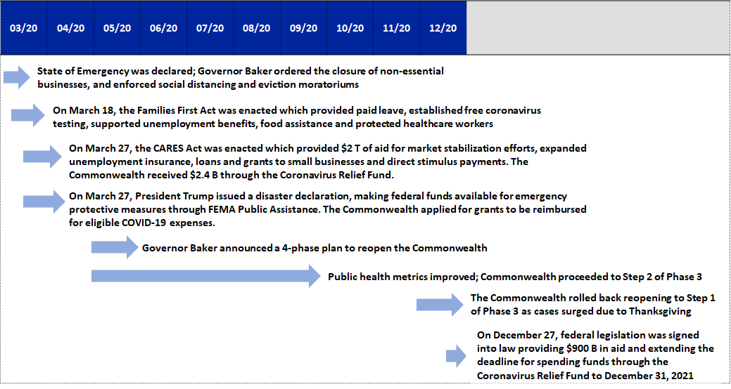

Reopening and Beginning Recovery, January through March 2021

Initial Recovery Actions
Reopening – Following the rollback in the reopening plan in December 2020, public health measures began to trend in a positive direction again. The Commonwealth experienced significant declines in average daily COVID-19 cases and hospitalizations, and vaccination efforts began. Accordingly, the Administration continued to implement the reopening plan, and on March 18, 2021 the Administration announced the transition to step 1 of the final phase of the plan, effective March 22, 2021.
Tax Relief Measures – The COVID-19 pandemic has adversely impacted the Commonwealth’s economy in a number of ways. Many businesses have experienced and may continue to experience decreases in operations and revenues. Due to the temporary closure of non-essential business, indoor capacity restrictions and the stay-at-home advisory, there was a significant reduction in traffic volume, travel and tourism, and other commercial activity. To help speed businesses’ recovery as the Commonwealth reopens, Governor Baker signed legislation on April 1, 2021 that created a number of tax relief measures, such as making the first $10,200 in unemployment compensation received in each of tax years 2020 and 2021 exempt from income tax for taxpayers below 200% of the Federal Poverty Level; excluding federal Paycheck Protection Program loans and Economic Injury Disaster Loan advances from taxable income for individual taxpayers in tax year 2020; waiving penalties for failure to timely remit taxes on UI compensation received in tax year 2020; and extending the 2020 tax filing deadline for individual taxpayers from April 15, 2021 to May 17, 2021, consistent with the federal government's extension for filing individual federal tax returns.

Federal Fiscal Aid
Presidential Executive Orders – In January and February of 2021, President Biden issued Executive Orders that increased the FEMA PA reimbursement rate from 75% to 100% for eligible costs incurred during the COVID-19 emergency. The orders also expanded the scope of eligible costs for certain activities, such as school reopening costs. Additionally, FEMA approved the Commonwealth’s expedited application for approximately $427 million related to COVID-19 vaccine distribution costs and provided an advance of $213 million for these costs.
American Rescue Plan Act – On March 11, 2021, the American Rescue Plan Act of 2021 (ARPA) was signed into law. ARPA is a $1.9 trillion economic stimulus bill to speed up the United States' recovery from the economic and health effects of the COVID-19 pandemic and the ongoing recession. Among its provisions, ARPA includes an allocation of $350 billion to the Coronavirus State and Local Fiscal Recovery Funds to help states, tribes, territories, counties, municipalities and the District of Columbia bridge budget shortfalls and mitigate the pandemic’s fiscal shock. From the CSFRF, the Commonwealth has been allocated approximately $5.3 billion to help fund Massachusetts’ Recovery Plan. Separately, Massachusetts county and municipal governments have been allocated $3.4 billion from the Coronavirus Local Fiscal Recovery Fund (CLFRF).

Timeline of Reopening and Beginning Recovery, January through March 2021
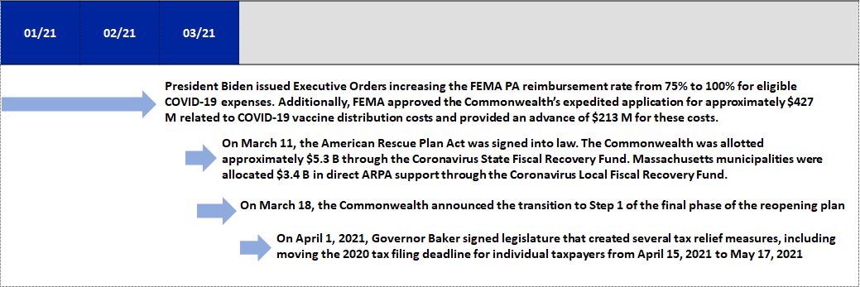

Recovery Projects to Meet Urgent Needs and Planning for More, April through July 2021

Massachusetts’ Recovery Planning Approach to Ensuring Equitable Outcomes
Identifying Disproportionately Impacted Communities – In the Interim Final Rule (IFR) related to CSFRF (31 CFR Part 35), Treasury explicitly “encourages recipients to provide assistance to those households, businesses, and non-profits in communities most disproportionately impacted by the pandemic.” To provide assistance to these groups, Treasury will not require that the Commonwealth assess whether there has been an economic harm that resulted from the COVID-19 public health emergency and whether the use of CSFRF aid would respond or address this harm in areas that have been designated as disproportionately impacted. Rather, the following services will be presumed to be eligible when provided in disproportionately impacted communities: services to address homelessness, affordable housing development, housing vouchers, expanded early learning services, assistance to high poverty school districts, educational services, high-quality childcare, home visiting programs for children, and enhanced services for Massachusetts DCF-involved families.
To identify households, businesses, and non-profits in communities most disproportionately impacted by the pandemic, Treasury advises recipients to either use Qualified Census Tracts (QCTs) or “identify other populations, households, or geographic areas disproportionately impacted by the pandemic.” Treasury allows recipients the freedom to use their own definition of “define disproportionately impacted communities” so long as they are “able to support their determination that the pandemic resulted in disproportionate public health or economic outcomes to the specific populations, households, or geographic areas to be served.”
The Commonwealth has identified three metrics that are indicative of housing insecurity, job insecurity, and low-wage employment. These metrics are: severely cost-burdened renters; employment in COVID-19 impacted industries; and lack of internet access. For consistency with US Treasury guidance, these metrics align with statistics in the Commonwealth’s QCTs. The designated communities that result from this proxy analysis align with the Massachusetts Department of Public Health’s “Hardest Hit Communities” designation and the Commonwealth’s existing “Gateway Cities” designation and encompass 29 municipalities.
By virtue of their underlying demographics, these 29 Hardest Hit Communities are more likely to have residents who were negatively impacted by the public health emergency. To ensure that equitable outcomes consistently result from recovery, the Commonwealth will utilize CSFRF aid for disproportionately impacted communities in these 29 municipalities in accordance with Treasury’s guidance.
A detailed description of the Commonwealth’s analysis and rationale for designating certain communities as disproportionately impacted by the COVID-19 public health emergency is presented in Appendix III.
Using Evidence-Based Interventions – In the CSFRF Guidance on Recipient Compliance and Reporting Responsibilities, Treasury states that “[A recipient’s] Recovery Plan should identify whether [CSFRF] funds are being used for evidence-based interventions and/or if projects are being evaluated through rigorous program evaluations designed to build evidence.” To provide a framework for use of evidence-based interventions in its Recovery Plan, the Commonwealth will emphasize two strategic themes based on the Results for America 2020 State Standard of Excellence:
- Using project budgets to build and focus state evaluation capacity and resources on evidence-based investments
- Directing grant and contract spending towards interventions with evidence of effectiveness to deliver results and encourage innovation
Balancing the need for expedited implementation of Recovery Plan projects with the inherent challenges of major institutional process changes, a project budgeting process that emphasizes evidence-based investments will be integrated as much as possible into the Commonwealth’s broader systematic approach to managing results. In directing grants and contracts as part of project planning and implementation, the Commonwealth will look for programs that could deliver services or support that is critical to achieving Recovery Plan outcomes by evaluating each program’s:
- Purpose – What is provided through the program?
- Target Population – To which communities will the program’s support/funds go directly?
- Equity Focus – Does the program specifically and intentionally focus on underserved populations?
- Potential Evidence Base – What program outputs are measured? What is the program’s intended outcome, and is it measured?
A detailed description of the Commonwealth’s framework for use of evidence-based interventions is presented in Appendix IV.

First Phase of Recovery Projects
After passage of the American Rescue Plan Act, the Commonwealth undertook three projects to meet urgent COVID-19-related needs. Since April 1, 2021, the Commonwealth has applied $194.1 million of its CSFRF aid to:
- Provide additional federal aid to four of the Commonwealth’s hardest-hit communities ($109 million)
- Create a temporary COVID-19 Emergency Paid Sick Leave program to eliminate job-related obstacles to recovering from, quarantining for, and/or being vaccinated against COVID-19 for all residents ($75 million)
- Fund a lottery to motivate all Massachusetts residents to be vaccinated against COVID-19 ($10 million)
Each of these projects was launched and underway as of July 31, 2021, and is described in more detail in the section below entitled “Phase I – Recovery Projects to Meet Urgent Needs”.

Second Phase of Recovery Projects
On June 28, 2021, Governor Baker signed legislation to move most of Massachusetts’ unspent CSFRF allocation – approximately $4.9 billion – into a separate state fund requiring legislative appropriation. Under the legislation, the remaining $200 million of CSFRF aid was reserved in a non-appropriated federal grant account. The Governor was authorized to deploy this aid as soon as possible to address critical priorities related to the recovery from the effects of the pandemic. For this second phase of recovery projects, the Governor has allocated $186 million of the $200 million to four more projects that will be implemented by January 2022. These projects will provide support for hospitals, health and human services, mental health, and workforce development. Each of these projects was in the final planning stage as of July 31, 2021, and is described in more detail in the section below entitled “Phase II – Additional Recovery Projects to Be Launched by January 2022”.

Third Phase of Recovery Projects
The Governor has proposed 14 additional projects to the Legislature that would use $2.9 billion of CSFRF aid to support other key priorities related to the Commonwealth’s recovery, including housing and homeownership, economic development and local downtowns, job training and workforce development, health care, and infrastructure.
The Legislature has begun evaluating the Governor’s $2.9 billion proposal, as well as considering additional recovery priorities to fund with the other $2 billion of CSFRF aid for which specific projects have not yet been defined. This evaluation process includes a series of public hearings which began in July 2021 and will continue into the fall. Each of the Governor’s proposed projects was in the preliminary planning stage as of July 31, 2021, and is described in the section below entitled “Phase III – Proposed Multi-Year Recovery Projects”.

Timeline of Recovery Projects to Meet Urgent Needs and Planning for More, April through July 2021
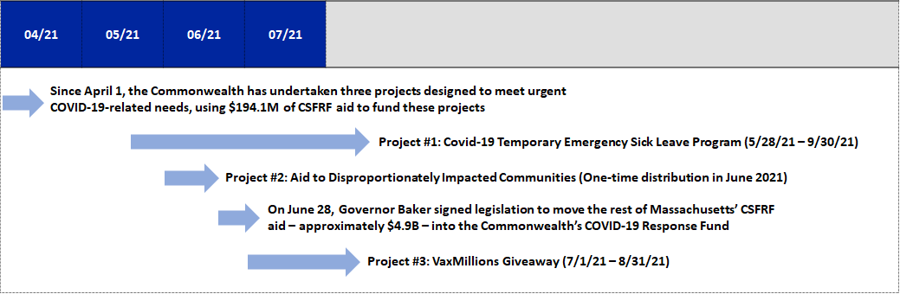

Phase I – Recovery Projects to Meet Urgent Needs

Project Funding and Expenditure Categories
The following table summarizes required information about Massachusetts’ Phase I projects. These projects were implemented and underway as of July 31, 2021. Expenditure Categories proposed for projects may change as project planning and implementation evolves in the coming months.
Project | CSFRF Funding Amount | Expenditure Category
Aid to Disproportionately Impacted Communities | $109,080,277 | 7.3
COVID-19 Temporary Emergency Paid Sick Leave Program | $75,000,000 | 1.8
VaxMillions Giveaway | $10,000,000 | 1.1
Total | $194,080,277

Aid to Disproportionately Impacted Communities

Background
The ARPA Coronavirus Local Fiscal Recovery Fund (CLFRF) provides nearly $3.4 billion to counties, cities, and towns in Massachusetts to respond to and recover from the COVID-19 outbreak. This funding was allocated to municipalities using two different formulas: 1) $1.7 billion was allocated to the 38 cities and towns classified as "entitlement communities", usually metropolitan cities with a population of more than 50,000 residents (Most of these cities received at least $200 per capita, and some received more than $700 per capita.); and
2) another $385 million was directed to the Commonwealth’s remaining 313 municipalities, designated “non-entitlement units of local government” (NEUs), at a flat rate of approximately $105 per capita.
To ensure all Commonwealth communities received a fair and adequate share of federal aid, on June 4, 2021, Governor Baker announced that $109.1 million of CSFRF funds would be allocated to four communities that were defined as NEUs for the CLFRF allocation, but are among the communities most disproportionately impacted by the pandemic in Massachusetts, and therefore most in need of funding to support critical local response and recovery efforts.

Project Description/Uses of Funds
The Commonwealth has allocated $109.1 million from the Coronavirus State Fiscal Recovery Fund to provide Aid to Disproportionately Impacted Communities.
These four communities – Chelsea, Everett, Methuen, and Randolph – have been designated as “Hardest Hit” communities by the Massachusetts Department of Public Health. However, due to shortcomings in the CLFRF funding formula for local governments, they were set to receive disproportionately smaller amounts of federal funding compared to other hard-hit communities. Additional funds from the state's CSFRF allocation were distributed to these communities, as follows:
- Chelsea – $28.5 million
- Everett – $33.3 million
- Methuen – $26.3 million
- Randolph – $21.0 million
These four municipalities will be able to use this funding to support costs related to the COVID-19 pandemic, including direct response efforts, addressing negative economic impacts, replacing revenue lost during the pandemic, making investments in water, sewer, broadband infrastructure, and other eligible needs.

Efforts to Promote Equitable Outcomes
CLFRF allocated direct aid to some municipalities based on the federal Community Development Block Grant program formula, while assistance to other communities was allocated on a per-capita basis. The use of these two different allocation formulas created disparities in distributions among cities and towns in Massachusetts. Chelsea, Everett, Methuen, and Randolph are the four communities designated hardest hit with disproportionately smaller levels of federal funding compared to other hard-hit communities.

Community Engagement
The Administration worked closely with key state and local stakeholders to determine the necessary additional resources given federal funding levels and local needs. The funding has been transferred under the terms of a memorandum of understanding between the Commonwealth and the receiving communities that provides for comprehensive and timely accounting of their uses of the funds.

COVID-19 Temporary Emergency Paid Sick Leave Program

Background
A new law establishing the COVID-19 Temporary Emergency Paid Sick Leave Program (“Paid Sick Leave Program”) was passed by the Legislature and signed by the Governor on May 28, 2021. The law created the COVID-19 Emergency Paid Sick Leave Fund to reimburse eligible employers for the cost of providing COVID-19-related paid sick leave. Under the Paid Sick Leave Program, beginning May 28, 2021, employers are required to make paid leave time available to employees for COVID-related illnesses, quarantine, and vaccinations, and then may apply for reimbursement from the state. The program will continue until the total cost is expected to exceed $75 million, or until September 30, 2021, whichever is sooner.
Employers must cover 40 hours of COVID-19 emergency paid sick leave for their employees who work 40 or more hours per week. If an employee works fewer than 40 hours per week or a variable schedule, employers must use averages to determine the amount of paid sick leave for the employee. Employers may seek a maximum sick leave reimbursement per employee of $850 (including cost of benefits).

Project Description/Uses of Funds
Massachusetts has allocated $75 million from the Coronavirus State Fiscal Recovery Fund to the Paid Sick Leave Program to respond to COVID-19 and the broader impacts of COVID-19 and the COVID-19 public health emergency. The aim of this allocation is to eliminate job-related obstacles to recovering from, quarantining for, and/or being vaccinated against COVID-19 for all Massachusetts residents. In particular, the program is intended to support lower-wage workers who may not otherwise have access to paid sick leave.
$75 million was transferred to the COVID-19 Massachusetts Emergency Paid Sick Leave Fund in June of 2021. After the program has concluded and all employer reimbursements have been paid, any remaining funds will be reallocated to other eligible uses.

Efforts to Promote Equitable Outcomes
The law establishing the Paid Sick Leave Program effectively mandates equitable treatment and outcomes by ensuring that all employees in Massachusetts have access to paid sick leave if they need it. Such access is especially important for lower-wage workers. The program includes aggressive outreach to employers, employees, and healthcare providers, to ensure that all workers are aware of this temporary entitlement (as described under “Community Engagement” below).

Community Engagement
To ensure full awareness of the Paid Sick Leave Program among employers and employees, especially lower-wage and frontline workers, the program requires that all employers notify their employees of the program by posting a program notice to all employees at their worksite, online, and/or via electronic channels. In addition, the Massachusetts Executive Office for Administration and Finance (A&F) and the Executive Office of Health and Human Services (EOHHS) have created a comprehensive website for the program that includes detailed information for employers and employees, notices about the program in 13 languages, and a regularly updated list of Frequently Asked Questions.

Performance Indicators
On or before January 1, 2022, A&F will issue a report to the Massachusetts Legislature on the efficacy and impact of this program. The report will include information on:
- Number of employees provided emergency paid sick leave under the program
- Reasons employees received emergency paid sick leave
- Average amount paid to employees who were provided emergency paid sick leave
- Average length of emergency paid sick leave
- Employers who received reimbursements under the program
- Average employee reimbursement received by each employer
- Total employee reimbursements received by each employer
Highlights from this report will be included in Massachusetts' 2022 Recovery Plan Performance Report.

VaxMillions Giveaway

Background
On July 1, 2021, the Commonwealth launched the Massachusetts VaxMillions Giveaway (VaxMillions) as one of many strategies to increase awareness of the availability and efficacy of the COVID-19 vaccines and to encourage residents to get vaccinated. The main goal of the VaxMillions is to increase the number of fully vaccinated individuals within the Commonwealth. VaxMillions supports this effort in two ways by:
- Attracting public attention to and excitement about the Commonwealth’s ongoing vaccination efforts
- Offering potentially life-changing prizes as incentives for individuals who have been hesitant or unenthusiastic about receiving vaccination or about returning for their second vaccine dose
VaxMillions is just one of a range of initiatives the Commonwealth has undertaken to incentivize COVID-19 vaccination. Other initiatives (not funded by CSFRF) include:
- Red Sox Week – a week of vaccination events with Red Sox themed attractions, a display of the team's trophies, and a raffle to win tickets to a Red Sox game
- Dunkin Week – a week of vaccination events offering free coffee and chances to win free coffee for a year
- Mobile pop-up clinics – offering grocery gift cards or passes to museums and other attractions
- The Vax Bus tour – which drove through more than 15 cities and towns throughout the month of July

Project Description/Uses of Funds
The Commonwealth has allocated $10 million from the Coronavirus State Fiscal Recovery Fund to the VaxMillions Giveaway to increase awareness of the availability and efficacy of the COVID-19 vaccines and to encourage residents to get vaccinated. Funds will be used to award five $1 million cash prizes to fully vaccinated adults and five $300,000 scholarship grants to fully vaccinated residents between 12-17 years of age. The remainder of the funds will be used for program administration and outreach.

Efforts to Promote Equitable Outcomes
VaxMillions is open to Massachusetts residents ages 12 and up who are fully vaccinated prior to each giveaway drawing. Eligible residents can enter the giveaway at VaxMillionsGiveaway.com. To ensure equal access to VaxMillions for all eligible residents, a call center is available daily to help anyone who does not have access to the internet or requires assistance with registration. The call center is reached by calling 2-1-1 and staffed with live workers who speak English and Spanish. Translators are available to handle calls in 100 other languages.

Community Engagement
The Commonwealth is promoting the VaxMillions Giveaway using the same techniques and media channels used to advertise and engage participants in other Massachusetts Lottery products. A Media Toolkit has been made available that includes materials for use by individuals, community-based organizations, state and local governments, and others in their public outreach and messaging efforts. This toolkit is designed to ensure these individuals and organizations have the latest state-approved VaxMillions materials.
Significant effort has been made to engage the community. Paid advertising has been purchased on social media, radio and billboards, while organic media and hashtag targeting has been used to reach residents who are 12-17 years of age. Additional channels such as text message alerts and advertising on mobile vaccination buses have been used to increase geographic reach. To ensure equitable outcomes, Facebook Live events have been hosted with Spanish language outlets, and diverse outside groups have been engaged to do outreach including: convenience store groups; local boards of health; the Massachusetts Medical Society and Massachusetts Hospital Association; and employers.

Performance Indicators
For output indicators, Massachusetts' 2022 Recovery Plan Performance Report will include final figures and analysis on enrollments and website traffic through the lottery’s completion. As of August 2, 2021, lottery enrollments totaled 2.41 million residents, including 2.25 million adults and 156,000 residents ages 12-17.
For outcome indicators, Massachusetts' 2022 Recovery Plan Performance Report will include final figures on vaccine doses administered before the program was announced, during the program period, and after the program's conclusion. Since the VaxMillions program was announced on June 15, 2021, over 235,000 residents received their first vaccine doses and over 370,000 have become fully vaccinated. Since vaccination administration began in the Commonwealth, Massachusetts has been a national leader in vaccinations with over 4.3 million residents becoming fully vaccinated and over 4.8 million receiving at least one dose.

Phase II – Additional Recovery Projects to Be Launched by January 2022

Project Funding and Expenditure Categories
The following tables summarize required information about Massachusetts’ Phase II projects. These projects are planned for implementation by January 2022. Expenditure Categories proposed for projects may change as project planning and implementation evolves in the coming months.
Project | CSFRF Funding Amount | Expenditure Category
Workforce Development I | $50,000,000 | 2.7
Health and Human Services Workforce Stabilization Payments | $55,000,000 | 1.12
Funding for Fiscally Distressed Hospitals | $50,000,000 | 1.12
In-Patient Psychiatric Direct Care Workforce Support Payments | $31,000,000 | 1.12
Total | $186,000,000

Workforce Development I

Background
The COVID-19 pandemic has had and will continue to have significant impacts on Massachusetts’ workforce. As of June 2021, the state's unemployment rate stood at 4.9 percent, down from a peak of 16.4 percent in April 2020, but still 80 percent higher than the pre-pandemic rate of 2.7 percent. A new report commissioned by the Baker-Polito Administration on the Future of Work in Massachusetts found that 300,000 to 400,000 workers may need new skills and training to transition to new occupations in the next ten years.
To help Massachusetts residents get back to work and prepare for the economy of the future, the Commonwealth is investing resources across a portfolio of existing programs that provide education, training, and upskilling for unemployed individuals. The programs have been designed and implemented by the Governor's Workforce Skills Cabinet, and have a track record of producing positive outcomes for program participants. The additional funding will help train an estimated 15,000 unemployed or underemployed individuals across Massachusetts.

Project Description/Uses of Funds
The Commonwealth allocated $50 million from the Coronavirus State Fiscal Recovery Fund to Workforce Development programs in response to COVID-19 and the broader impacts of the COVID-19 public health emergency. These programs will focus on recruiting and training individuals who experienced interruption in work due to COVID-19. Specific programs funded under this investment may include:
- Rapid Reemployment – supports Massachusetts-based training providers with experience and existing training capacity to deliver occupational training. These providers work with local businesses as employer partners to place trainees.
- Career Technical Initiative (CTI) – supports programs at vocational technical high schools across the Commonwealth to recruit, train, and place students in high-wage jobs.
- Learn to Earn (LTE) – supports cohort-based, occupationally specific programs designed and managed by regional industry sector partnerships. Funding would provide additional grants to training and placement partnerships across the Commonwealth to benefit those currently receiving public benefits.
- English to Speakers of Other Languages (ESOL) – supports individuals with high school or limited education in need of coaching, work readiness, or English to Speakers of Other Languages training.
By building additional capacity for these existing programs, this funding will help train individuals for careers in priority sectors in the Massachusetts economy such as advanced manufacturing, health care, information technology, and construction. Funding models directly support business-driven partnerships comprised of employers, education organizations, workforce development and community organizations. These partnerships receive grant funding to design training models that address hiring demands and offer support services to the participants to increase the success rate of completing the program and getting hired. The investment framework was informed by various stakeholder groups, several of which published white papers to provide recommendations to the Administration on priority investments to assist unemployed workers.
The Workforce Skills Cabinet (WSC) has analyzed data on individuals who lost their jobs due to COVID to understand which populations were disproportionally impacted. This additional funding will focus outreach and enrollment on these populations, including women (especially with children), people of color, and entry level and minimum wage workers with a high school diploma or less.
Performance indicators for the Workforce Development program may include: number of workers enrolled in sectoral job training programs; number of individuals completing sectoral job programs; wage level of those who complete sectoral job programs; and employee retention. Program performance outcomes will be tracked quarterly beginning in January 2022 and included in future Recovery Plan Performance Reports.

Health and Human Services Workforce Stabilization Payments

Background
The U.S. is currently suffering a workforce crisis, as declared by the U.S Chamber of Commerce on June 1, 2021. The health sector is particularly affected and is among the few sectors in which there are more job postings than available workers to fill them. A 2021 survey among nurses in Massachusetts found that 30 percent of nurses reported the biggest obstacle to providing quality care to patients is understaffing. Nurses also reported that 65 percent of Registered Nurse positions have been left vacant, compared to 50 percent in 2019.
The Massachusetts Executive Office of Health and Human Services (EOHHS) and its agencies have received feedback from the provider community that there is a shortage of available and qualified direct care workers due to economic and public health conditions brought on by the COVID-19 public health emergency. To address the ongoing crisis and incentive barriers, the Commonwealth is making an investment in the development of its health and human services workforce through direct payments to service providers.

Project Description/Uses of Funds
Massachusetts is allocating $55 million from the Coronavirus State Fiscal Recovery Fund to support health and human services workforce development in response to the COVID-19 public health emergency and the broader economic impacts of the pandemic. This funding will enable EOHHS to provide a temporary 10 percent increase in rates paid to service providers from July 2021 through January 2022. The goal of this temporary increase is to strengthen and stabilize the state’s provider networks’ workforce as it continues to combat and recover from the COVID-19 public health emergency.
Providers will receive funds directly from the agency purchasing their services as a one-time, lump sum payment calculated based on recent actual spending. As a condition of the receipt of these additional funds, eligible provider agencies must use at least 90 percent of the funds for direct care workforce development, which could include hiring and retention bonuses and other categories of worker compensation. Provider agencies will report to EOHHS on their uses of funds.
EOHHS agencies and programs provide critical support and resources for Massachusetts’ most vulnerable residents. The health and human services workforce targeted by this investment has a higher rate of workers living below 150 percent of the federal poverty level compared to the workforce at large, and 70 percent of health workers are women.
Performance indicators for the Health and Human Services Workforce Stabilization Payments program may include: number of payments made; number of workers who received retention or recruitment bonuses; change in total workforce numbers; change in retention ratios; change in open job postings; and reduction in overtime billing. Metrics will be tracked annually and included in future Recovery Plan Performance Reports.

Funding for Fiscally Distressed Hospitals

Background
The COVID-19 pandemic has had major financial impacts on hospitals, especially hospitals that serve a disproportionate number of low-income patients on MassHealth, the Commonwealth's Medicaid program. In February 2021, hospitals reported that operating in "survival mode" for an extended period of time has created new and different problems than they experienced earlier in the pandemic and has exacerbated longstanding challenges in health care delivery, access, and health outcomes.
EOHHS and its agencies have received feedback from the hospital community that the COVID-19 pandemic has had direct and continuing financial impacts and currently threatens the ongoing operations of some providers that are critical to MassHealth members, particularly those that serve disproportionately impacted populations. Some hospitals have already taken actions to guarantee short-term continued operations that will ultimately impact MassHealth members. Preventing further such actions and supporting “safety net hospitals” in finding long-term financial stability as the Commonwealth transitions out of the public health emergency is critical to supporting MassHealth members.
To alleviate the financial stress of COVID-19 faced by hospitals, the Commonwealth is providing aid to distressed hospitals throughout Massachusetts, especially in disproportionately impacted communities.

Project Description/Uses of Funds
EOHHS is providing $50 million of supplemental CSFRF funding to help stabilize safety net hospital systems that have experienced significant financial shortfalls, and those serving communities that were disproportionately impacted by COVID-19. The predominance of funding is targeted towards “safety net hospitals” – providers that serve a significantly disproportionate number of low-income patients in the Commonwealth of Massachusetts. Qualification for funding will be determined through a detailed analysis of several criteria, including hospital share of gross revenues that comes from MassHealth; demonstrated financial losses (per data collected and reported by the Center for Health Information and Analysis); demonstrated impact of COVID-19 in provider locale (per data collected and reported by the Commonwealth of Massachusetts).
Performance indicators for the Funding for Fiscally Distressed Hospitals program may include: number of hospitals receiving payments; total value of payments made; continued operations of at-risk hospitals; and medium-term improvement in reported operating margins and total margins. These metrics will be collected on a quarterly or annual basis and will be included in future Recovery Plan Performance Reports.

In-Patient Psychiatric Direct Care Workforce Support Payments

Background
EOHHS and its agencies have received feedback from the provider community that there is a shortage of available and qualified direct care workers due to economic and public health conditions brought on by the COVID-19 public health emergency. The Commonwealth is directing funding to providers for recruitment and retention bonuses that will flow directly to these workers. Payments will be tied to a detailed analysis of hospitals’ historical payor-mix and the total amount of and changes to the number of Department of Mental Health-licensed and operational In-Patient Psychiatric beds. This ensures that funds will be going to support Massachusetts’ low-income residents and those who are most vulnerable to the workforce crisis.

Project Description/Uses of Funds
Massachusetts is allocating $31 million from the Coronavirus State Fiscal Recovery Fund to provide supplemental payments to address the current workforce crisis in In Patient Psychiatric settings as a result of the COVID-19 public health emergency. The funding also addresses the downstream impact that the workforce crisis has had on access to In Patient Psychiatric treatment, especially among low income MassHealth (Medicaid) members. This investment is aimed at strengthening and stabilizing the state's In Patient Psychiatric direct care workforce of acute and freestanding hospitals in response to the COVID-19 public health emergency.
Providers will receive funds directly from EOHHS as two lump sum payments calculated based on their licensed and operational Department of Mental Health-licensed In-Patient Psychiatric beds and Geriatric beds. As a condition of receipt of these additional funds, eligible providers will be contractually required to use at least 90% of the funds for direct care workforce development, which could include hiring and retention bonuses and other categories of worker compensation. Additionally, providers that receive enhanced funds are required to submit a spending report to EOHHS that accounts for how the enhanced funds were used. EOHHS plans to make an initial distribution of funds in August 2021, and a second distribution in January 2022.
Performance indicators for the In-Patient Psychiatric Direct Care Workforce Support Payments program may include the number of payments made; total value of payments made; information on the number of workers who received retention or recruitment bonuses; change in total workforce numbers; change in retention ratios; change in licensed and operational In-Patient Psychiatric beds.

Phase III – Proposed Multi-Year Recovery Projects

Project Funding and Expenditure Categories
The following tables summarize required information about Massachusetts’ Phase III projects. These projects are being planned and will be implemented when approved by the Legislature. Expenditure Categories proposed for projects may change as project planning and implementation evolves in the coming months.
Project | CSFRF Funding Amount | Expenditure Category
First-time Homebuyer Assistance Program | $300,000,000 | 3.12
CommonWealth Builder Program | $200,000,000 | 3.10
Rental Housing Production | $200,000,000 | 3.10
Senior and Veteran Housing | $300,000,000 | 3.12
Downtown Development | $100,000,000 | 2.13
Statewide Downtowns | $250,000,000 | 2.13
Tourism and Cultural Assets | $100,000,000 | 2.11
Workforce Development II | $190,000,000 | 2.7
Behavioral Health and Addiction Services | $175,000,000 | 1.10
Water and Sewer | $400,000,000 | 5.5
Environmental Infrastructure | $300,000,000 | 6.1
State Parks and Trails | $100,000,000 | 6.1
Broadband Internet Access | $100,000,000 | 5.17
Marine Port Infrastructure | $100,000,000 | 6.1
Total | $2,815,000,000

First-time Homebuyer Assistance Program

Background
The high cost of housing in Massachusetts forms a barrier to stability and wealth creation for many households, and the uncertainties of COVID exacerbated this challenge for some families. Even before the pandemic, low income was the most significant barrier to buying a home, particularly among minority populations. In addition, Massachusetts currently has one of the largest racial homeownership gaps in the country, a problem that has been exacerbated by the disproportionate financial impacts of COVID-19. As a result of the generational wealth gap, minority populations face significant barriers to buying a home. To address the challenges of buying a home, the Governor proposed a first-time homebuyer assistance program to support expanded homeownership opportunities. The program would invest $300 million in the MassHousing Down Payment Assistance Program, which has issued over 4,000 loans totaling $40.3 million since 2018.

Project Description/Uses of Funds
Governor Baker proposed the allocation of $300 million from the CSFRF to the First-time Homebuyer Assistance Program to respond to COVID-19 and the broader impacts of the COVID-19 public health emergency. The goal of the program is to reduce barriers to homeownership by offering services that improve outcomes and access, and that are targeted to residents of disproportionately impacted communities. Services may include down payment assistance, mortgage interest rate subsidies, mortgage insurance assistance, first-time homebuyer counseling, and financial literacy programs.
The First-time Homebuyer Assistance Program focuses on residents of disproportionately impacted communities. This program aims to foster a strong, inclusive, and equitable recovery with long-term benefits for housing security, health, and economic outcomes, addressing the systemic homeownership gap that contributed to more severe impacts of the pandemic for socially disadvantaged communities and populations. Additionally, by providing financial support to buy a home, this program addresses the generational wealth gap, enabling more Americans to build wealth, equity, and security.
Performance indicators for the First-time Homebuyer Assistance Program evaluation have not been developed pending legislative action. Potential metrics may include: rates of home ownership among socially disadvantaged and minority populations; rates of home ownership in QCTs and other targeted municipalities; rates of home ownership among people who moved with consideration of where they moved from; measures of housing affordability and housing security; percentage of homeowners below 100 percent of Area Median Income; percentage of socially disadvantaged homeowners supported by the program; and number of people who started owning homes and achieved lower costs from making the transition.

CommonWealth Builder Program

Background
The residential real estate market in Massachusetts is one of the most expensive in the country. In addition to the supply-side barriers to homeownership discussed above, Massachusetts' high property prices and occupancy rates make it difficult for would-be homeowners to find homes that fit their budget and their needs. The lack of housing stability for many Massachusetts residents exacerbates the uneven impact of public health crises and impedes the state's economic recovery.
To address these needs, the Commonwealth is considering the use of CSFRF funds to support housing production through the MassHousing CommonWealth Builder Program and similar efforts. These efforts promote home ownership, and therefore wealth creation, among residents of disproportionately impacted communities. Investments in homeownership represent the Commonwealth’s vision for helping potentially tens of thousands of non-white households become homeowners, ultimately helping to close the racial homeownership gap.

Project Description/Uses of Funds
Governor Baker proposed the allocation of $200 million from the Coronavirus State Fiscal Recovery Fund to the CommonWealth Builder Program to respond to COVID-19 and the broader impacts of the COVID-19 public health emergency. Funds are to be expended for the CommonWealth Builder Program and other programs and for grants and loans to developers to facilitate the production of affordable homeownership units. The goals of this program are to fund the production of for-sale homes (i.e., single family homes, condos, etc.) and to create homeownership opportunities for people of color. The addition of CSFRF funds to the CommonWealth Builder Program would increase the number of units built by approximately 333 percent compared to the program's existing funding level.
The CommonWealth Builder Program promotes equitable outcomes across Massachusetts through its focus on creating homeownership opportunities for people of color. The program offers for-sale homeownership units for middle-income residents through the following principles:
- Building in key communities including the City of Boston, Gateway Cities, and Qualified Census Tracts (QCTs). Boston and Gateway Cities across the Commonwealth are home to 50 percent of the state’s population but 75 percent of all residents of color
- Helping to create much-needed supply with a minimum of 20 units per subsidized project (with at least 10 affordable units), up to $150,000 in potential subsidy per unit for a maximum total of $5 million, and new construction or adaptive reuse
- Increasing minority homeownership opportunities (currently, the homeownership rate for non-white residents is about half that of white residents.)
Performance indicators for the CommonWealth Builder Program evaluation have not been developed pending legislative action. Metrics may include: number of affordable housing units built; rates of home ownership among socially disadvantaged and minority populations; measures of housing affordability and housing security; percentage of socially disadvantaged homeowners supported by the program; and number of people who started owning homes and achieved lower costs from making the transition.

Rental Housing Production

Background
In addition to would-be homeowners, the COVID-19 pandemic has created major challenges for renters in Massachusetts and throughout the nation. In the five months coinciding with the onset of the pandemic in February-March 2020, the average number of rental applications per property increased by over 14 percent (after a period of stable application rates for the previous six months), meaning that more renters were competing for each available unit.
Like the homebuyer market, the rental housing market in Massachusetts is one of the least affordable in the country, particularly in the Boston area. The average renter in the City of Boston paid just over 30 percent of their income in rent in 2017, with higher rent burdens concentrated in less wealthy neighborhoods. To address these problems, the Commonwealth is considering the use of CSFRF aid for rental housing production and to increase housing options for workers and residents of disproportionately impacted communities.

Project Description/Uses of Funds
The Commonwealth is considering allocating $200 million from the CSFRF to support the production of rental housing units to mitigate the broader impacts of the COVID-19 public health emergency. Funds are to be used for grants, loans, or other financial assistance to projects receiving federal or state low-income housing tax credits, state tax-exempt bond financing, or other state financial assistance in the form of grants or loans.
The goal of this funding is to support the creation of 2,400 more units of affordable rental housing via existing state funding processes. This has the potential to increase affordable units by up to 50 percent over five years, compared to existing state resources. The Rental Housing Production program also promotes equity by providing affordable rental housing to minority populations and those living in disproportionately impacted communities.
Performance indicators for the Rental Housing Production program evaluation have not been developed pending legislative action. Metrics may include: level of affordability for renters in comparison to previous payments; new units funded relative to past years; percentage of renters below 100 percent of Area Median Income; and percentage of socially disadvantaged renters supported by the program.

Senior and Veteran Housing

Background
The COVID-19 public health emergency has had an especially large impact on the health and well-being of seniors and veterans. Since the beginning of the pandemic, outbreaks of COVID-19 have been a particular concern in congregate care settings such as veteran's homes and nursing facilities, where living conditions are close and residents are especially vulnerable. Supportive housing can help seniors, veterans and other high-needs residents to get the services and health care they need while remaining in more spacious communities where they can be independent and maintain their social connections.
The Commonwealth is considering the use of CSFRF funds to support statewide production of senior and veteran housing. These funds would be combined with other resources including Low-Income Housing Tax Credits, rental payments, and, in the case of veteran housing, VA health care to produce new housing options with supportive services.

Project Description/Uses of Funds
Governor Baker has proposed the allocation of $300 million from the Coronavirus State Fiscal Recovery Fund to fund the production of senior and veteran supportive housing in response to COVID-19 and the broader impacts of the COVID-19 public health emergency. Funds are to be used in the form of grants, loans, or other financial assistance to projects that will provide supportive services to enable the targeted population to live in a community-based setting.
The goal of this program is to fund the production of an additional 3,600 units for seniors and veterans. In addition, the Senior and Veteran Housing program promotes equity by providing affordable rental housing and services to seniors and veterans, who are among the groups most disproportionately impacted by COVID-19.
Performance indicators for the Senior and Veteran Housing Program evaluation have not been developed pending legislative action. Potential metrics may include: number of housing units built; number of grants, loans, and tax credits provided; percentage of residents below 100 percent of Area Median Income; and percentage of socially disadvantaged residents supported by the program.

Downtown Development

Background
The Commonwealth is considering additional funding to promote downtown recovery and revitalization in communities disproportionally impacted by the pandemic. The Commonwealth’s recent Future of Work report found that downtowns will need to adapt to changing workforce patterns as the region recovers from the pandemic, with the center of gravity for economic recovery moving away from urban centers. This funding proposal would address needed investments to support economic growth in Massachusetts downtowns.
The Commonwealth has pending funding requests for the Massachusetts Downtown Initiative and similar programs totaling approximately $300 million. Existing state resources can fund only about a third of these.

Project Description/Uses of Funds
The Commonwealth is considering allocating $100 million from the Coronavirus State Fiscal Recovery Fund to aid the recovery and revitalization of downtowns disproportionally impacted by the pandemic.
These funds may be used to acquire and improve, or to facilitate the private improvement or redevelopment of abandoned, vacant, or underutilized properties in downtown areas. These funds may also be granted to public entities for recovery planning and recovery plan implementation, community planning, and other technical assistance needed to achieve these goals. Public and non-profit entities may also be granted these funds for programs and services that aid business disproportionately impacted by the pandemic and located in these downtown areas.
Like the Commonwealth’s Shared Streets Initiative, this funding would be awarded to cities, towns, and transit authorities that develop proposals featuring equal access and benefits for those traditionally excluded.
Performance indicators for the Downtown Development Program evaluation have not been developed pending legislative action. Potential metrics may include: number of repurposed streets, plazas, sidewalks, curbs, and parking areas for outdoor activities and programming; change in usage of public transit; change in usage of bikeshare and micro-mobility programs; change in crime rates; change in number of pedestrian and bicyclist crash clusters; and change in number of high-risk locations for pedestrians and bicyclists.

Statewide Downtowns

Background
The Commonwealth is considering further funding efforts to promote downtown recovery and revitalization in municipalities that have disproportionally impacted by the pandemic but are not eligible for the funds in the Downtown Development program, particularly small towns and rural areas. As stated above, the Commonwealth has roughly $300 million of pending funding requests for existing downtown development programs, but existing resources would only be able to fund about one-third of these projects.

Project Description/Uses of Funds
The Commonwealth is considering allocating $250 million CSFRF aid to the recovery and revitalization of downtowns in small towns and rural areas in response to COVID-19. These funds could be expended to acquire and improve, or facilitate the private improvement or redevelopment of abandoned, vacant, or underutilized properties in downtown areas. These funds may also be granted to public entities for recovery planning and recovery plan implementation, community planning, and other technical assistance needed to achieve these goals. Public and non-profit entities may also be granted these funds for programs and services that aid business disproportionately impacted by the pandemic and located in these downtown areas. Like the Commonwealth’s Shared Streets Initiative, this funding would be awarded to cities, towns, and transit authorities that offer proposals focusing on equal access and benefits for those traditionally excluded and emphasizing community input and stakeholder engagement.
Performance indicators for the Statewide Downtowns Program evaluation have not been developed pending legislative action. Potential metrics may include: number of repurposed streets, plazas, sidewalks, curbs, and parking areas to facilitate outdoor activities and programming; change in usage of public transit; change in usage of bikeshare and micro-mobility programs; change in crime rates; change in pedestrian and bicyclist crash clusters; and change in high-risk locations for pedestrians and bicyclists.

Tourism and Cultural Assets

Background
The COVID-19 pandemic has significantly disrupted the Massachusetts tourism industry, as in the rest of the country and across the world. Sectors such as hospitality and retail which rely heavily on travel and tourism make up about 20 percent of jobs in Massachusetts, and the state is home to major leisure travel destinations such as the Berkshires and Cape Cod. The Commonwealth is considering a significant investment in its tourism industry and cultural assets, which would help these industries kickstart their summer and fall seasons and do the work many need to do to attract visitors and customers and restore their brands.

Project Description/Uses of Funds
The Commonwealth is considering allocating $100 million from the Coronavirus State Fiscal Recovery Fund to aid the tourism industry in response to COVID-19 and the broader impacts of the COVID-19 public health emergency. The funds would be used to promote and advertise in-state tourism to create jobs, support tourism-related businesses, and stimulate the state and local economies of the Commonwealth. The funds would also be issued as grants to improve facilities and destinations visited by in-state and out-of-state travelers to boost visitation and increase the direct and indirect economic impacts of the tourism industry in all regions of the Commonwealth. Grants could also be used to support the design, repair, renovation, improvement, expansion, and construction of cultural facilities owned by municipalities and non-profit entities which have been negatively impacted by the economic effects of COVID-19.
Performance indicators for the Tourism and Cultural Assets Program evaluation have not been developed pending legislative action. Potential metrics may include: visitation numbers from in-state and out-of-state visitors at tourism and cultural centers; and spending at tourism and cultural centers.

Workforce Development II

Background
As discussed in Phase II above, the Commonwealth’s Future of Work Report found that over the next decade, between 300,000-400,000 workers in Massachusetts may need to transition to different occupations as trends like automation and e-commerce accelerate and displace certain types of jobs. In the immediate term, more than 400,000 residents of the Commonwealth are due to lose their enhanced unemployment benefits in the first week of September. It is critical that the state invest in workforce training to help the unemployed get back to work and to meet the workforce needs of in-demand industries.
In addition to the $50 million initial investment in Phase II, the Commonwealth is considering a major investment in the medium term to expand workforce training quickly to connect workers with the skills that are needed for the future economy. The proposal would fund a variety of workforce development programs including vocational schools, community-based organizations, and higher education institutions, with the goal of reaching 52,000 workers.

Project Description/Uses of Funds
The Commonwealth is considering allocating an additional $190 million of CSFRF aid to accelerate workforce development in response to COVID-19 and the broader impacts of the COVID-19 public health emergency. This includes $130 million to help train and provide industry credentials to unemployed or underemployed individuals. These credentials will be in critical areas of our economy like advanced manufacturing, health care, information technology and construction. Programs that could be funded through this investment include Career Technical Institutes, apprenticeship programs, rapid reemployment grants and the Workforce Competitive Trust Fund Program. The proposal also includes $35 million to fund English for Speakers of Other Languages programs and Adult Basic Education and $25 million for work readiness and essential skill programs.
This comprehensive approach to workforce development is aimed at employing the long-term unemployed and underemployed populations in the Commonwealth, which are disproportionately people of color and women. The program would include funding for increased community engagement to recruit program participants as well as trainers and credentialing staff. Outreach for trainees would include engagement with community groups, faith-based organizations, and other entities. Recruitment for program staff would leverage community-based organizations, public education partners, and MassHire, the state's career services program. Finally, additional capacity would be developed and funding would be made available for those trainees who need subsidized childcare, which will lower the barrier to entry for parents with this need.
Performance indicators for the Workforce Development Program evaluation have not been developed pending legislative action. Potential metrics may include: number of residents trained; number of residents placed in higher paying jobs; average salary of residents who completed training program; percentage of trainees placed in high wage careers; and retention rate in jobs for recently trained residents.

Behavioral Health and Addiction Services

Background
Continuing a pattern from the past few decades, a majority of individuals served by the Commonwealth’s mental health in patient system present complex, unique treatment challenges. The Commonwealth often encounters individuals who have co-occurring mental health and substance use disorders, which has only been complicated by the escalated substance use crisis during the COVID-19 pandemic. The impact of COVID-19 has also made it more challenging for providers to staff a workforce equipped to meet the needs of this population.

Project Description/Uses of Funds
The intended use of these funds is to address workforce shortages and expand mental health and addiction services, including increasing residential and clinical services. The overall objective of deploying these funds is to ensure all residents of the Commonwealth can access services and receive comprehensive, integrated behavioral health treatment that takes a holistic view; and to contribute to employment pipelines for those working in behavioral health settings.
The Commonwealth has a long history of engaging addiction recovery and mental health stakeholders to collaboratively provide solutions to the unique needs of some of our most vulnerable citizens. This program would continue the approach of working closely with these partners, both in and outside of government, to identify the best uses of funds.
Performance indicators for the Behavioral Health and Addiction Services Program evaluation have not been developed pending legislative action.

Water and Sewer

Background
The Commonwealth is considering a plan to modernize water and sewer infrastructure, to be administered through the Clean Water Trust. In the most recent fiscal year alone, the Trust received requests for $1 billion in funding for clean water projects, but only had the budget to award $620 million. Similarly, the Trust received more than $450 million in requests for drinking water projects but could only award $195 million. The addition of CSFRF aid would allow more of these critical projects to move forward while reducing the need for costly debt financing. Improving and ensuring the continued quality of our water resources is vital for our public health and safety, and the protection of our environment.

Project Description/Uses of Funds
The Commonwealth is considering allocating $400 million from the Coronavirus State Fiscal Recovery Fund to construct water and sewer infrastructure. Performance indicators for the Water and Sewer Program evaluation have not been developed pending legislative action. Potential metrics may include: water quality in regions across the Commonwealth; principal cost of water quality improvements; and interest cost of water quality improvements.

Environmental Infrastructure

Background
The Commonwealth is considering a plan to invest in environmental infrastructure projects identified through local vulnerability assessments and consistent with the priorities identified in the Massachusetts State Hazard Mitigation and Climate Adaption Plan. The investment would emphasize those projects that would facilitate statewide and local adaption and resilience outcomes, including nature-based solutions. This funding would be distributed through programs like the Municipal Vulnerability Preparedness Program, Coastal Resilience Grant Program, and Resilient Lands Initiative.
There are over 1,400 state-regulated dams across Massachusetts, with 198 classified as significant or high hazard structures that are in poor or unsafe condition. Of the 198 dams, only 13 are currently being addressed. With current resources, only 8-10 dams can be addressed every 3-5 years. At the local level there are over 1,100 municipally owned coastal structures in 62 coastal communities that need significant funding to bring these deficient structures back to their operational levels. In addition, more than half of the state's 25,000 small bridges and culverts are estimated to be undersized or deteriorating. Replacement costs, on average, are approximately $1 million per project. With existing capital resources, the Commonwealth can only address about 25 of these projects every fiscal year.

Project Description/Uses of Funds
The Commonwealth is considering allocating $300 million from the Coronavirus State Fiscal Recovery Fund to aid environmental infrastructure. This program would be administered by the Massachusetts Executive Office of Energy and Environmental Affairs. The funds also may be transferred to regional municipal partnerships, regional planning bodies, watershed associations, non-profit corporations, and other similar entities. Performance indicators for the Environmental Infrastructure Program evaluation have not been developed pending legislative action. Potential metrics may include: number of improved dams; number of improved coastal structures; and number of improved small bridges and culverts.

State Parks and Trails

Background
The Commonwealth is considering investments in public lands and public access. Many state parks saw record visitation during the pandemic, and the Commonwealth expects demand for outdoor recreation space to continue to grow in the coming years. This investment will allow all residents, particularly children, families, and underserved communities, to have equitable access to nature and recreation opportunities.

Project Description/Uses of Funds
The Commonwealth is considering allocating $100 million from the Coronavirus State Fiscal Recovery Fund to modernize state parks and trails in response to COVID-19 and the broader impacts of the COVID-19 public health emergency. This program would be administered by the Massachusetts Executive Office of Energy and Environmental Affairs, in conjunction with the Department of Conservation and Recreation, the Department of Agricultural Resources, and the Department of Fish and Game.
This investment will target public lands including: reservations; parks; rivers, lakes, and other waterways; trails; beaches; fishing piers; boat ramps; and other recreational facilities and spaces. The funds will be expended to enhance and modernize park facilities and other public or private facilities for outdoor recreation, steward and conserve natural resources, or improve the resilience of natural and working lands, plants, and wildlife. Performance indicators for the State Parks and Trails Program evaluation have not been developed pending legislative action. Potential metrics may include: number of visitors to state parks and trails.

Broadband Internet Access

Background
The COVID-19 pandemic highlighted the challenges that many Massachusetts individuals and families face in accessing the internet. Lack of or poor-quality internet access is an especially acute issue in areas of the state that have been disproportionately impacted by COVID-19; as recently as 2018, nearly a quarter of households in Massachusetts' Gateway Cities lacked internet access at home. The Commonwealth is considering an investment in increased broadband internet access to help communities close this digital divide by specifically targeting infrastructure projects to improve service in underserved areas. Funds would also provide devices, digital literary services, and internet service plan support to targeted populations.

Project Description/Uses of Funds
The Commonwealth is considering allocating $100 million of CSFRF aid to developing Broadband Internet Access in response to COVID-19 and the broader impacts of the COVID-19 public health emergency. The goal of this funding is to reduce barriers to education, work and civic life caused by lack of internet connectivity, which is particularly pronounced in traditionally underserved populations in the Commonwealth. Performance indicators for the Broadband Internet Access Program evaluation have not been developed pending legislative action. Potential metrics may include: number of residents with access to a network; number of residents with access to a device that uses a network; and number of residents completing digital literacy courses.

Marine Port Infrastructure

Background
As we emerge from the pandemic, the Commonwealth is considering investments in marine port development to both better position coastal cities vulnerable to sea-level rise resulting from climate change and make our energy infrastructure cleaner, especially for communities disproportionately impacted by COVID-19. These investments would be used to rehabilitate or expand port areas across the Commonwealth and support new developments in the offshore wind industry.

Project Description/Uses of Funds
The Commonwealth is considering allocating $100 million from the Coronavirus State Fiscal Recovery Fund for Marine Port Infrastructure. This funding would support the deployment, construction, manufacturing, or operation and maintenance of offshore wind for the purpose of promoting both short-term and long-term economic development in the Commonwealth. Performance indicators for the Marine Port Infrastructure Program evaluation have not been developed pending legislative action. Potential metrics may include: megawatts generated from offshore wind; and number of running offshore wind turbines.

Appendix I: Project Expenses to Date by Expenditure Category
The following table lists expenses to date by Expenditure Category for Massachusetts’ Phase I projects.
Expenditure Category | Amount Allocated | Amount Spent as of 7/31/21
1.1 COVID-19 Vaccination | $10,000,000 | $47,750
1.8 Other COVID-19 Public Health Expenses | $75,000,000 | $0
7.3 Transfers to Other Units of Government | $109,080,277 | $109,080,277
Total | $194,080,277 | $109,128,027

Appendix II: Project Inventory
Project | Massachusetts’  ID Number | Description | Approx. Timeline | Delivery Approach  (if applicable)
Aid to Disproportionately Impacted Communities | CSFDORADIC | - Distribute $109.1M of CSFRF aid to four communities that were designated “Hardest Hit” by the pandemic  - Goal: To ensure all communities receive a fair and adequate share of federal relief aid | One-time distribution June 2021 | Administered by A&F
COVID-19 Temporary Emergency Paid Sick Leave Program | CSFDOREPSL | - Employers to cover up to 40 hours/ employee of COVID-19 sick leave; state to reimburse expenses up to $850 per employee  - Goal: To eliminate job-related obstacles to vaccination and thereby increase employee vaccination rates | 5/28/21 – 9/30/21 | Administered by A&F and EOHHS
VaxMillions Giveaway | CSFANFVAXM | - Eligible residents encouraged to register for five $1M drawings  - Goal: To raise awareness of vaccine availability and vaccination rate | 7/1/21 – 8/31/21 | Administered by MA Lottery Commission
Workforce Development I | TBD | - Distribute $50M of CSFRF aid to existing programs that provide education, training, and upskilling for unemployed individuals  - Goal: To help train an estimated 15,000 unemployed or underemployed individuals across Massachusetts | 8/1/21 – 1/31/22 | TBD
Health and Human Services Workforce Stabilization Payments | CSFEHSWF01 | - Use $55M of CSFRF aid to support health and human services workforce development through temporary 10 percent increase in rates paid to service providers  - Goal: To strengthen and stabilize provider networks’ workforce | 8/1/21 – 1/31/22 | TBD
Funding for Fiscally Distressed Hospitals | CSFEHSFD01 | - Stabilize safety net hospital systems that have experienced significant financial shortfalls, and those serving communities that were disproportionately impacted by COVID-19  - Goal: To alleviate financial distress faced by hospitals due to COVID-19 | 8/1/21 – 1/31/22 | TBD
In-Patient Psychiatric Direct Care Workforce Support Payments | CSFEHSBH01 | - Provide temporary supplemental payments to recruit critically needed clinical/direct-care staff to strengthen and stabilize In-Patient Psychiatric direct care workforce of acute and freestanding hospitals  - Goal: To bridge a large staffing gap that has resulted in a lack of care for the most vulnerable | 8/1/21 – 1/31/22 | TBD
First-time Homebuyer Assistance Program | TBD | - Provide down payment assistance, mortgage interest rate subsidies, mortgage insurance assistance, homebuyer counseling, and financial literacy programs to first-time homebuyers  - Goal: To reduce barriers to homeownership for residents of disproportionately impacted communities | TBD | TBD
CommonWealth Builder Program | TBD | - Provide grants and loans to developers to facilitate the production of affordable homeownership units (i.e., single family homes, condos, etc.) to promote homeownership  - Goal: To help communities of color build wealth by promoting home ownership among residents of disproportionately impacted communities | TBD | TBD
Rental Housing Production | TBD | - Grants, loans, and other federal aid to be used for production of 2,400 rental housing units for workers and residents of disproportionately impacted communities  - Goal: To provide affordable renting housing units for minority populations and those in disproportionately impacted communities | TBD | TBD
Senior and Veteran Housing | TBD | - Distribute funding to support the statewide production of senior and veteran housing  - Goal: To provide affordable rental housing and services to seniors and veterans disproportionately impacted by COVID-19 | TBD | TBD
Downtown Development | TBD | - Further fund efforts to promote downtown recovery and revitalization in municipalities that have been disproportionately impacted by the pandemic  - Goal: To increase economic activity and promote public safety in the Commonwealth’s hardest-hit municipalities | TBD | TBD
Statewide Downtowns | TBD | - Further fund efforts to promote downtown recovery and revitalization in small towns and rural areas  - Goal: To increase economic activity and promote public safety in small towns and rural areas across Massachusetts | TBD | TBD
Tourism and Cultural Assets | TBD | - Promote and advertise in-state and out-of-state tourism; make grants to improve facilities and destinations visited by tourists  - Goal: To increase direct and indirect economic impacts of tourism industry in all regions of the Commonwealth | TBD | TBD
Workforce Development II | TBD | - Support a variety of job training programs to credential unemployed or underemployed individuals  - Goal: To credential 52,000 workers | TBD | TBD
Behavioral Health and Addiction Services | TBD | - Address workforce shortages and expand mental health and addiction services, including increasing residential and clinical services  - Goal: To ensure residents have access to services and are able to receive comprehensive, integrated behavioral health treatment and to contribute to employment pipelines for those working in behavioral health settings | TBD | TBD
Water and Sewer | TBD | - Fund modernization of water and sewer infrastructure through the Clean Water Trust  - Goal: To improve the quality of Massachusetts’ water resources | TBD | TBD
Environmental Infrastructure | TBD | - Fund projects to facilitate statewide and local adaption and resilience outcomes, including nature-based solutions; this funding would be distributed through programs like the Municipal Vulnerability Preparedness Program, Coastal Resilience Grant Program, and Resilient Lands Initiative  - Goal: To improve the Commonwealth’s dams, coastal structures, small bridges, and culverts | TBD | TBD
State Parks and Trails | TBD | - Invest in modernization of park facilities and other public or private facilities for outdoor recreation; the funding would also help steward and conserve natural resources  - Goal: To preserve, protect, and enhance natural resources and outdoor recreation experiences | TBD | TBD
Broadband/Internet Access | TBD | - Fund infrastructure projects to improve broadband access in underserved areas; provide devices, digital literacy services, and internet service plans to support target populations  - Goal: To close the digital divide by providing broadband access, literacy, and usage to communities across Massachusetts | TBD | TBD
Marine Port Infrastructure | TBD | - Invest in marine port redevelopment to rehabilitate or expand port areas across Massachusetts and support economic development in the offshore wind industry  - Goal: To support offshore wind industry and increase production of offshore wind energy | TBD | TBD

Appendix III: Communities Disproportionately Impacted by the COVID-19 Public Health Emergency

MEMORANDUM

TO: Interested Parties
FR: A&F FFO
DT: June 10, 2021
RE: Designation of Certain Communities as Disproportionately Impacted by the COVID-19 Public Health Emergency

Executive Summary

The Commonwealth of Massachusetts received approximately $5.3 billion from the Coronavirus State Fiscal Recovery Fund (CSFRF). The program guidance designates “disproportionately impacted populations and communities” as an eligible use of the CSFRF and provides flexibility in how states and cities define “disproportionately impacted.” This memorandum documents Massachusetts’ definition of “disproportionately impacted” in a way that aligns with the Commonwealth’s experience managing the public health emergency and working with communities facing disproportionate challenges due to COVID-19.

The key takeaways of this memo include:

- The Commonwealth has identified three metrics that are indicative of housing insecurity, job insecurity, and low-wage employment. These metrics are severely cost-burdened renters, employment in COVID-19 impacted industries, and lack of internet access.
- For consistency with US Treasury guidance these metrics align with statistics in the Commonwealth’s QCTs.
- The designated communities that result from this analysis align with the Department of Public Health’s Hardest Hit Communities designation and the Commonwealth’s existing Gateway Cities designation, allowing the state to build on investments in these areas.
- This definition encompasses 29 Massachusetts municipalities.

Background

On March 11, 2021, the President of the United States signed into law the American Rescue Plan Act of 2021, Pub. L. 117-2 (March 11, 2021) (ARPA). Among many new funding programs, ARPA created the Coronavirus State and Local Fiscal Recovery Funds (CSLFRF), allocating a total of $350 billion to support COVID-19 response and recovery efforts by state and local governments. The Commonwealth received approximately $5.3 billion from this source. Units of local government, including counties and municipalities, expect to receive approximately $3.4 billion.

The CSLFRF program is administered by the US Department of the Treasury. It is anticipated that the Department of the Treasury Office of Inspector General (OIG) will be responsible for monitoring and oversight of the receipt, disbursement, and use of CSLFRF.

Among other uses, CSLFRF funds may be used to respond to the negative economic impacts of the public health emergency caused by COVID-19. Specifically, CSLFRF was designed to “address an economic harm resulting from or exacerbated by the public health emergency.” To be eligible under this use, the Commonwealth must assess whether, and the extent to which, there has been an economic harm that resulted from the COVID-19 public health emergency and whether, and the extent to which, the use would respond or address this harm. In this way, CSLFRF funded assistance must be narrowly tailored to the harm being addressed.

Aid to Disproportionately Impacted Populations and Communities

In the forthcoming 31 CFR Part 35, also known as the “Interim Final Rule” (IFR) related to CSLFRF, Treasury explicitly “encourages recipients to provide assistance to those households, businesses, and non-profits in communities most disproportionately impacted by the pandemic.” In order to provide assistance to these groups, Treasury will not require that the Commonwealth assess whether, and the extent to which, there has been an economic harm that resulted from the COVID-19 public health emergency and whether, and the extent to which, the use would respond or address this harm in areas that have been designated as disproportionately impacted. Rather, the following services will be presumed to be eligible when provided in disproportionately impacted communities: services to address homelessness, affordable housing development, housing vouchers, expanded early learning services, assistance to high poverty school districts, educational services, high-quality childcare, home visiting programs for children, and enhanced services for DCF involved families.

By allowing enhanced interventions for certain populations, Treasury recognized that “the COVID-19 public health emergency may have lasting negative effects on economic outcomes, particularly in exacerbating disparities that existed prior to the pandemic.” Treasury also recognizes that certain communities have faced extraordinary challenges during the public health emergency, as they were more likely to lose employment and more likely to be exposed to COVID-19. This reflects a trend from the Great Recession that saw concentrations of poverty increase which may have exacerbated the disproportionate outcomes during the public health emergency.

QCTs, Gateway Cities, and Hardest Hit Communities

As discussed above, Treasury recognizes that the public health emergency has had an outsized impact in areas of concentrated poverty and on low-income and minority groups. To identify these populations, Treasury advises recipients to use Qualified Census Tracts (QCTs) or “identify other populations, households, or geographic areas disproportionately impacted by the pandemic.”

QCTs are designated by the US Department of Housing and Urban Development (HUD) as geographic areas in which 50% of households have incomes less than 60% of Area Medium Gross Income (AMGI) or have a poverty rate of 25% or more. In Massachusetts, the AMGI is $106,200. Using this QCT definition of disproportionate impact would reach parts of 49 municipalities and approximately 1.3 million Massachusetts residents.

While the QCT designation may be a useful framework for identifying disproportionately impacted populations or communities in other jurisdictions, the Commonwealth has long recognized the need to invest in areas of concentrated poverty and limited economic opportunity. In 2007, eleven executives from “urban centers that anchor regional economies” while facing “stubborn social and economic challenges” signed a Gateway Cities compact to work together on economic and community development. In 2009, the Massachusetts Legislature formally recognized 26 communities in the Commonwealth as Gateway Cities for additional investment in economic development. By any metric these communities have been among the hardest hit by the pandemic. Research has shown that since the creation of the Gateway Cities designation, residents in these cities have been less likely to move to low-poverty neighborhoods than their counterparts in other areas.

Further, during the pandemic the Commonwealth leveraged the US Centers for Disease Control and Prevention’s Social Vulnerability Index and other public health data to identify 20 “hardest hit” communities. In many cases, these communities overlap with Gateway Cities, but this metric also captures communities with smaller populations who have been equally hard hit by the pandemic with especially high numbers of cases and people of color. This designation specifically accounted for the role social vulnerability and race played in COVID-19 outcomes.

Treasury’s purpose in creating the QCT designation was to increase economic opportunity for historically disadvantaged populations and reduce areas of concentrated poverty. Given the Commonwealth’s awareness of these problems and investment in these already identified communities, the Commonwealth can best achieve Treasury’s desired outcomes by using the Gateway Cities and Hardest Hit Communities frameworks instead of QCTs.

Defining Disproportionately Impacted Communities

Treasury’s IFR relies on the QCT designation described earlier to define disproportionately impacted communities but allows recipients the freedom to use their own definition so long as they are “able to support their determination that the pandemic resulted in disproportionate public health or economic outcomes to the specific populations, households, or geographic areas to be served.” Using Treasury’s rationale for designating QCTs as disproportionately impacted, the Commonwealth was able to identify a definition of “disproportionate impact” that better reflects the ways that the public health emergency has disproportionately impacted communities in the Commonwealth. Treasury’s rationale in designating disproportionately impacted populations is that “the COVID-19 public health emergency amplified the impact of the pandemic among low-income and minority groups.” Specifically, “these families were more likely to face housing, food, and financial insecurity" while being “overrepresented among low-wage workers.”

To identify communities where families are most likely to face housing insecurity, the Commonwealth identified those communities whose percentage of severely cost-burdened renters was greater than 25% which matches that metric in the QCTs designated by Treasury. Severely cost-burdened renters are those who pay more than 50 percent of their income in rent. The United States Department of Housing and Urban Development (HUD) views these families as having severe “difficulty affording necessities such as food, clothing, transportation, and medical care.” The Commonwealth views this metric to accurately reflect the risk of housing insecurity intended to be captured by Treasury’s definition.

To capture the risk of financial insecurity faced by a household, the Commonwealth identified those communities where greater than 25% of residents were employed in a pandemic-affected industry. This metric identifies households whose livelihood was dependent on an extremely unreliable source of income over the last 18 months and includes the arts and entertainment, accommodations and food services, retail trade, and other services industries. These industries saw the greatest reductions in workforce reflecting the likelihood that these households were likely to have lost work at some point. By using this metric, the Commonwealth also seeks to represent households who may not have lost their jobs but faced reduced incomes due to lost hours or slower traffic in certain industries. By requiring greater than 25% of residents in a community, the Commonwealth effectively matches the rate of residents in QCTs who are employed in a COVID-19 impacted industry and accurately reflects job insecurity in communities the federal aid aims to reach.

In identifying communities with a high percentage of low wage workers the Commonwealth seeks to identify barriers to economic and career mobility. One of Treasury’s priorities, mentioned earlier, is to provide families greater ability to access economic opportunity. One of the greatest barriers the Commonwealth has faced in providing access to higher paying jobs and educational opportunities is access to the internet. To that end, we are prioritizing communities where at least 18% of residents have no access to the internet. This is in line with the percentage of residents who cannot access the internet in the Commonwealth’s QCTs. Using this metric we can identify those communities most likely to have a low-wage workforce which would have been more vulnerable to the pandemic.

Conclusion

Applying these criteria, the Commonwealth has identified 29 communities that were disproportionately impacted by the pandemic and by virtue of their underlying demographics more likely to have residents who were negatively impacted by the public health emergency. The Commonwealth will utilize funds earmarked for disproportionately impacted communities in these 29 municipalities in accordance with the enhanced interventions identified above and Treasury’s guidance on disproportionately impacted communities.

Supporting Data and Analyses
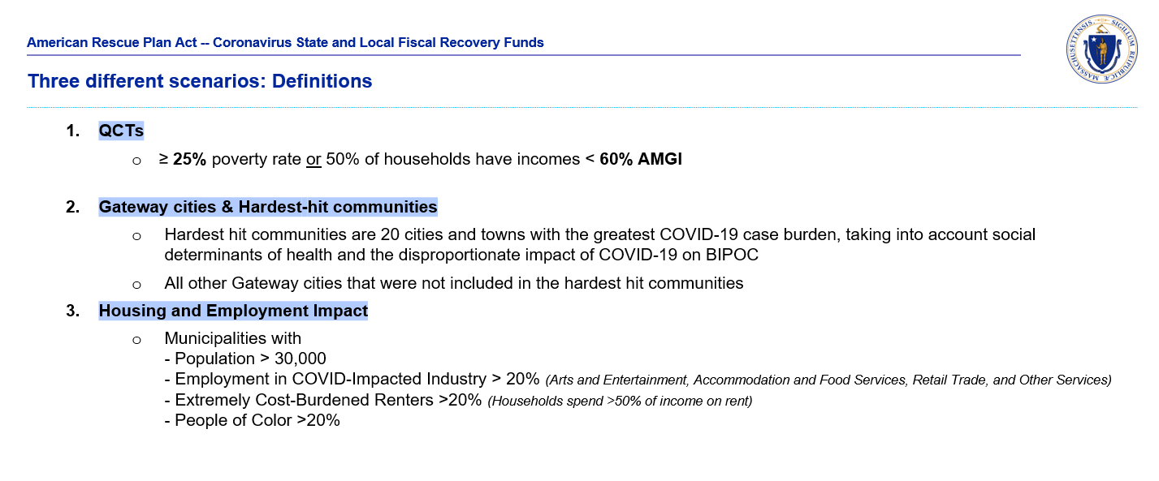
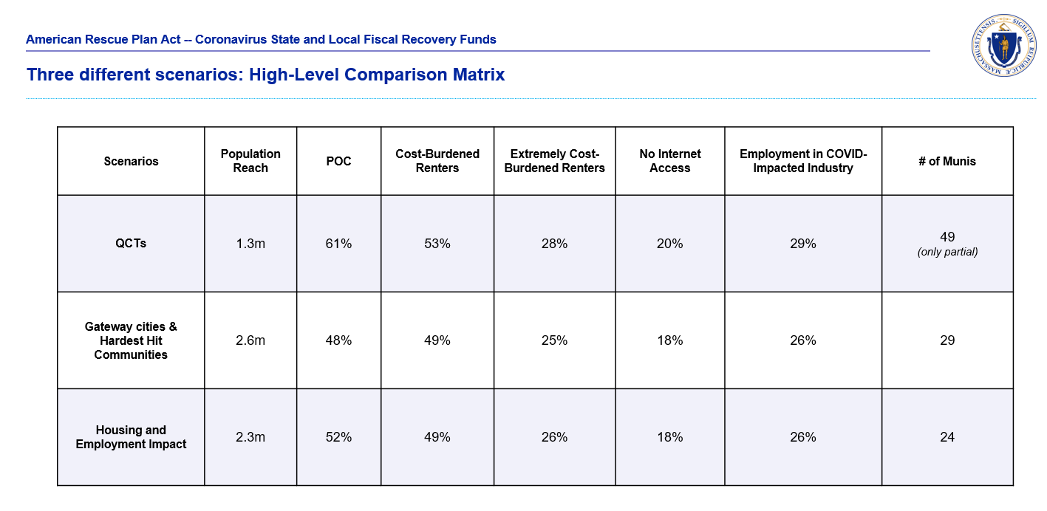

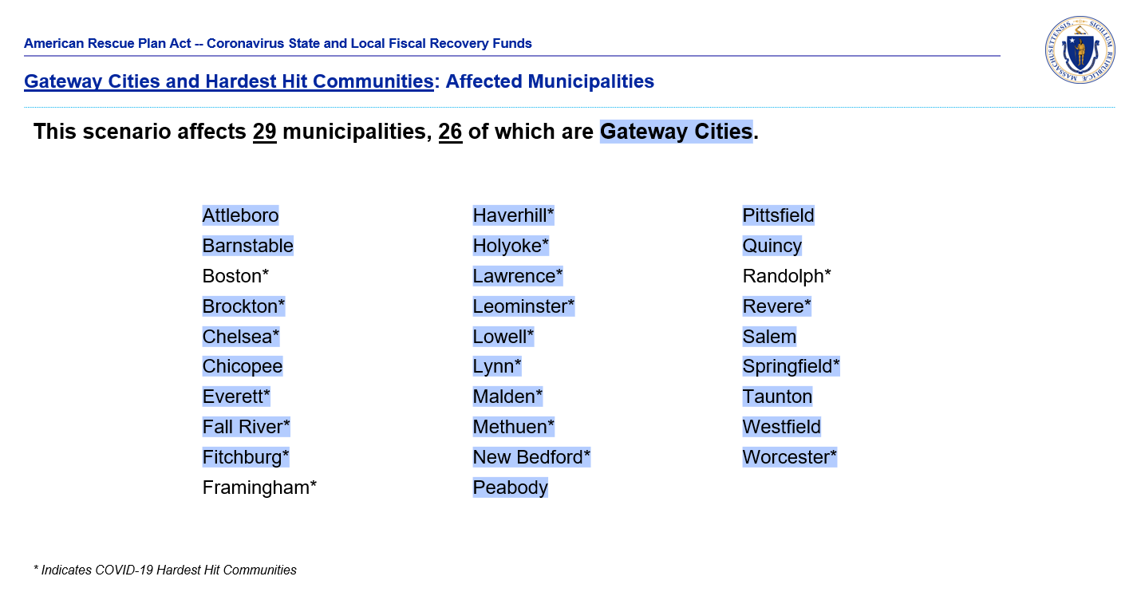
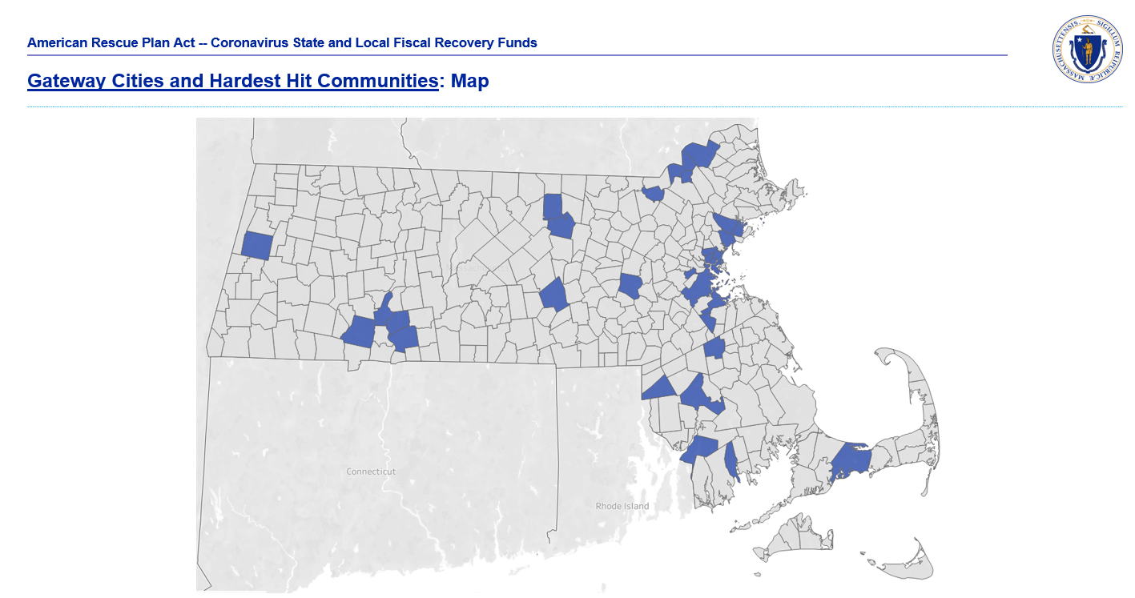

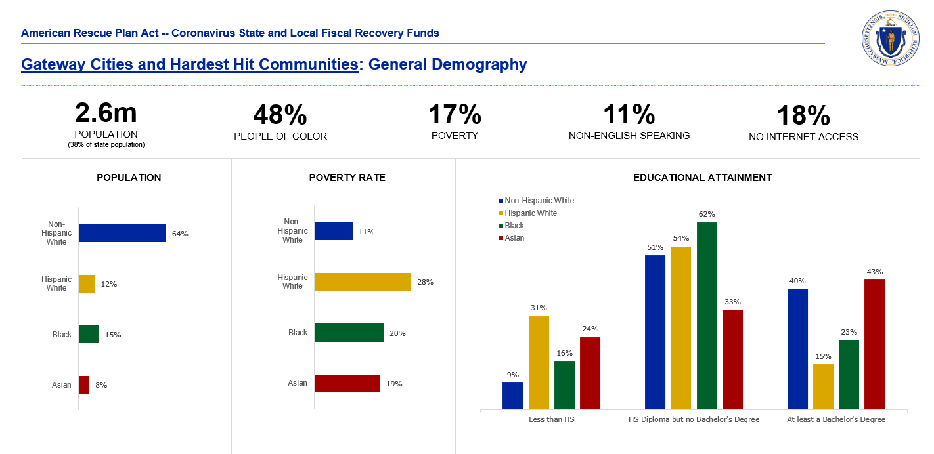

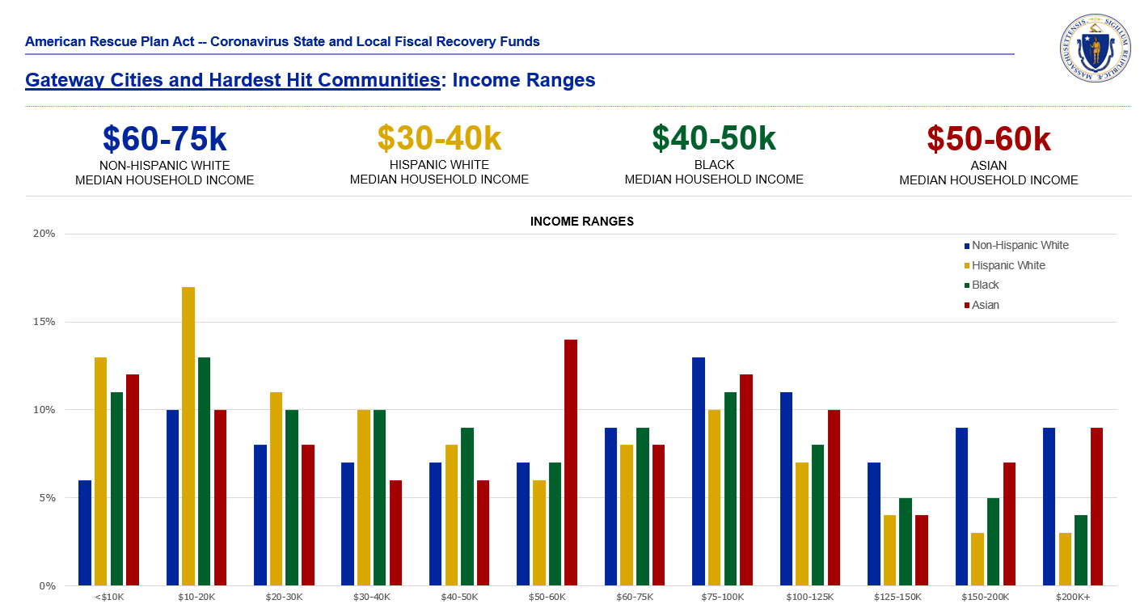

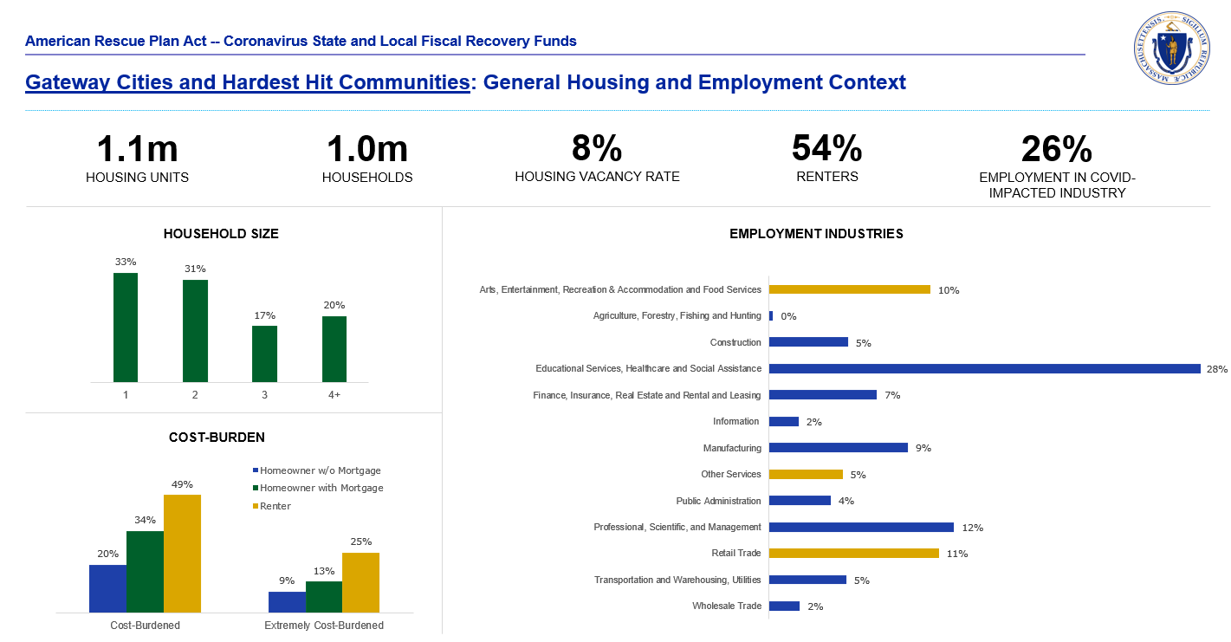

Appendix IV: Framework for Use of Evidence-Based Interventions
In developing Massachusetts' proposed Recovery Plan, the Commonwealth has focused on directing funds to existing programs that have a track record of strong implementation and outcomes, but that lack sufficient resources to meet demand and need for their services. As the Administration and the Legislature work together to refine and implement Massachusetts’ Recovery Plan, the Commonwealth will develop a plan for project selection and performance monitoring in which, wherever possible, the Commonwealth will apply CSFRF funds to projects that are evidence-based interventions designed to achieve defined, measurable outcomes that materially support our communities’ recovery from the effects of the COVID-19 pandemic. Such evidence-based projects will:
- Demonstrate statistically significant effects on improving relevant community outcomes based on evidence from well-designed and well-implemented experimental studies;
or
- Demonstrate a rationale based on high-quality research findings or positive evaluation that such interventions are likely to improve relevant community outcomes;
and
- Include ongoing efforts to examine the effects of such interventions.
For all projects identified as “evidence-based” in the Public Health (Expenditure Category 1), Negative Economic Impacts (Expenditure Category 2), and Services to Disproportionately Impacted Communities (Expenditure Category 3) Categories, the Commonwealth will specify clear project goals, evidence bases, and the dollar amounts of total project spending allocated towards evidence-based interventions.

Framework Themes
To provide a framework for use of evidence-based interventions in its Recovery Plan, the Commonwealth will emphasize two strategic themes described in the Results for America 2020 State Standard of Excellence:
- Using project budgets to build and focus state evaluation capacity and resources on evidence-based investments
- Directing grant and contract spending towards interventions with evidence of effectiveness to deliver results and encourage innovation
Key actions related to these strategic themes are described briefly below.

Using Project Budgets to Build and Focus Evaluation Capacity
When evaluating and approving Recovery Plan project proposals, the Commonwealth will aim to follow a budget decision-making process that gives preference to requests with evidence and data related to quantifiable material outcomes (i.e., not just counts of inputs and outputs). As part of this process, the Commonwealth will give higher priority to requests that are supported by higher tiers of evidence following
a model similar to that developed by the Colorado Evidence-Based Policy Collaborative (depicted below).

Colorado Evidence Continuum
The project budget decision-making process also will give preference to new programs that do not yet have an evidence base, but that do have strong data that demonstrates quantifiable outcomes.
Beyond giving preference to requests with evidence, the Commonwealth’s Recovery Plan project budgeting may establish a standard funding allocation to build agencies’/recipients’ capacity to evaluate programs (e.g., 1% with a cap on the total amount). This is especially relevant for new programs where it is important to design the evaluations and metrics that will be used to measure the success of proposed initiatives.
Balancing the need for expedited implementation of Recovery Plan projects with the inherent challenges of major institutional process changes, the project budgeting process will be integrated as much as possible into the Commonwealth’s broader systematic approach to managing results.

Directing Grants and Contracts Towards Interventions with Evidence of Effectiveness
As part of the implementation of its Recovery Plan, the Commonwealth also will seek to identify relevant existing programs where results could be improved, including those not achieving desired policy outcomes or equity goals. When evaluating existing programs for inclusion in the Recovery Plan – including those run by grantees and contractors – the Commonwealth will determine if program outcomes can be improved by using evidence of effectiveness to allocate funds to more effective practices or providers. If this cannot be accomplished within the Recovery Plan timeline, CSFRF aid will be directed to other programs that are more likely to achieve the desired outcomes within the desired timeframe.
As part of this evaluation process, state agencies and programs may be assessed for their potential to successfully redirect funding themselves when outcomes are not achieved. Incentives may be provided to promote innovation in program development and overall operational improvement. For example, departments may be encouraged and authorized to shift CSFRF funds away from non-performing programs to automatically keep a percentage of their original funding to spend on other innovative programs, especially those that help community organizations build their evidence bases.
In identifying candidates for inclusion in the Recovery Plan among existing programs, the Commonwealth will look for programs that could deliver services or support critical to plan and consider each program’s:
- Purpose – What is provided through the program?
- Target Population – To which communities will the program’s support/funds go directly?
- Equity Focus – Does the program specifically and intentionally focus on underserved populations?
- Potential Evidence Base – What program outputs are measured? What is the program’s intended outcome, and is it measured?
Examples of the types of program purpose, target population, equity focus, and evidence base characteristics to be considered when evaluating existing programs for the Recovery Plan are presented in the following table.

Characteristics to Be Considered When Evaluating Recovery Plan Candidate Programs
Program Purpose | Target Population | Equity Focus on  Underserved Populations | Potential  Evidence Base
- Provision of Capital  - Equity investment  - Grants  - Loans/guarantees  - Capacity Development  - Technical assistance  - Skills development  - Other Technical Support  - Real estate development  - Resource sharing/ networking | - Private Sector  - Tech, innovation, life science businesses  - Developers  - Manufacturers  - Neighborhood small businesses  - Other small businesses  - Civic Sector  - Educational institutions  - Hospitals/medical centers  - Research institutions  - Arts/culture centers  - Other community organizations  - Other Constituents  - Municipalities  - Individuals | - Low-to-moderate income residents and communities  - Underrepresented racial/ ethnic minorities  - Women  - Youth  - LGBTQ  - Veterans | - Measurement of outputs  - Definition and measurement of outcomes  - Established measurement systems  - Track record of measurement and reporting

Framework Application Examples
Representative examples of the Commonwealth’s experience applying the Evidence-Based Intervention Framework described in this appendix are presented below.

School Redesign Grant Program
The Massachusetts Department of Elementary and Secondary Education distributes competitive federal funds through the School Redesign Grant to help districts improve their lowest-performing schools. The schools and districts, in partnership with the state, develop a sustainable improvement plan, which guides the approach to rapid school improvement. The state requires that the plan, in order to meet both state and federal requirements, must incorporate at least one strategy backed by evidence that meets the criteria from one of the top three evidence tiers as defined by ESSA. The Department provides support to potential applicants on using evidence-based practices through its How Do We Know Initiative.

Pathways to Economic Advancement Program
The Commonwealth's Pathways to Economic Advancement program uses an innovative “Pay for Success” funding model in which private sector investors provide upfront capital to scale promising programs, and the government pays back the investors only if the programs achieve predetermined outcomes. This was the first Pay for Success project in the country to focus exclusively on workforce development, specifically on increasing access to programs that assist adult English-language learners in making successful transitions to employment, higher wage jobs, and higher education. Through the Pathways to Economic Advancement, in 2016 the Commonwealth contracted with Jewish Vocational Service (JVS) and Social Finance to conduct an evaluation of JVS' English for Advancement program (EfA). EfA provides adult English-language learners in the Boston area with employment-focused language instruction, career coaching, and job placement assistance to help them obtain employment or advance to a better job. A report on the evaluation was released in November 2020 and found that EfA had a significant impact on annual earnings for program participants over the two years after entering the program.

Student Learning Time Program Support
For the vast majority of students, in-person learning is a critical component of their academic growth and social-emotional wellbeing. However, because of the COVID-19 pandemic, many Massachusetts school districts had to provide virtual learning environments during the 2020-2021 school year. To help these districts successfully provide virtual learning for students and inform the public of the results of their efforts, the Massachusetts Department of Elementary and Secondary Education developed the Student Learning Time dashboard. The dashboard provides information about how districts and schools are meeting student learning requirements for students during the pandemic.

Appendix V: Required Information Related to the Tax Offset Provision
As shown below, for Fiscal Year 2021 the Commonwealth made no Revenue-reducing Covered Changes that had the effect of reducing tax revenue as defined in the Tax Offset Provision 31 CFR 35.8.
Item | Amount
a. Revenue-reducing Covered Changes | $0
As shown in the following table, from FY19 to FY20 the Commonwealth’s revenue receipts from all sources decreased by $108.4 million (0.4%). This decrease was driven by a reduction of $530.2 million in Corporate Tax, Motor Fuels Tax, Cigarette Tax, Financial Institution Tax, Public Utilities Tax, Room Occupancy Tax, and Deeds Tax collections stemming from the economic recession. These recession-related decreases were offset by an increase of $421.8 million in Income Tax, Sales Tax, Insurance Tax, Estate Tax, Alcoholic Beverages Tax, and Miscellaneous Fee and Tax collections. From FY19 to FY21, the Commonwealth’s revenue receipts increased by $4.4 billion (14.9%) as a result of federal aid to individuals and communities received throughout FY21 and increased economic activity as the Massachusetts economy reopened in the second half of FY21.
Massachusetts’ Actual Revenue Collections by Source, FY19 – FY21*
Source ($000s) | FY19 | FY20 | FY21 | FY19-FY20 Change |  | FY19-FY21 Change
 |  |  |  | $ | % | $ | %
Income Tax (Net) | $17,109,244 | $17,360,822 | $19,592,944 | $251,578 | 1.5% | $2,483,700 | 14.5%
Sales Taxes | $6,798,287 | $6,810,319 | $7,833,758 | $12,032 | 0.2% | $1,035,471 | 15.2%
Corporate Taxes (Net) | $2,927,015 | $2,523,446 | $3,622,510 | ($403,568) | -13.8% | $695,496 | 23.8%
Motor Fuels Tax | $775,463 | $707,877 | $662,288 | ($67,586) | -8.7% | ($113,175) | -14.6%
Cigarette Tax | $439,822 | $416,257 | $315,845 | ($23,565) | -5.4% | ($123,976) | -28.2%
Insurance Taxes (Net) | $400,597 | $415,459 | $480,460 | $14,863 | 3.7% | $79,863 | 19.9%
Estate Tax | $601,306 | $699,555 | $786,905 | $98,249 | 16.3% | $185,599 | 30.9%
Alcoholic Beverages Tax | $86,195 | $87,621 | $92,656 | $1,426 | 1.7% | $6,461 | 7.5%
Financial Institution Taxes (Net) | $19,467 | $9,311 | $44,839 | ($10,157) | -52.2% | $25,371 | 130.3%
Public Utilities Taxes (Net) | $40 | ($346) | $1,472 | ($386) | -964.4% | $1,432 | 3579.1%
Room Occupancy Tax | $168,835 | $146,648 | $98,341 | ($22,186) | -13.1% | ($70,494) | -41.8%
Deeds Tax | $218,532 | $215,812 | $278,550 | ($2,720) | -1.2% | $60,018 | 27.5%
Misc. Department Fees and Taxes | $25,072 | $60,262 | $162,151 | $35,190 | 140.4% | $137,079 | 546.7%
Misc. Non-Department Fees and Taxes | $171,616 | $180,080 | $197,489 | $8,464 | 4.9% | $25,874 | 15.1%
Total, All Sources | $29,741,489 | $29,633,124 | $34,170,208 | ($108,365) | -0.4% | $4,428,719 | 14.9%
*Including tax settlements.
Source: Massachusetts Department of Revenue

https://lmi.dua.eol.mass.gov/LMI/LaborForceAndUnemployment/LURResults?A=01&GA=000025&TF=3&Y=2021|2020|2019&Sopt=Y&Dopt=TEXT
https://www.mass.gov/news/baker-polito-administration-releases-future-of-work-report-outlines-ongoing-steps-to-address-findings
“The America Works Report: Quantifying the Nation's Workforce Crisis”, US Chamber of Commerce, June 1, 2021, The America Works Report: Quantifying the Nation's Workforce Crisis | U.S. Chamber of Commerce (uschamber.com)
“As National Nurses Week Begins, ‘State of Nursing in Massachusetts’ Survey Shows Existing Quality of Care, Staffing and Safety Problems Worsened by Inadequate COVID-19 Preparedness and Lack of Support for Frontline Healthcare Workers”, Massachusetts Nurses Association, May 6, 2021, https://www.massnurses.org/news-and-events/p/openItem/12063
”The Future of the Human Services Workforce in Massachusetts”, Donahue Institute, The Massachusetts Council of Human Service Providers, Inc., 2006, https://donahue.umass.edu/documents/future-human-services.pdf.
“Hospitals Reported That the COVID-19 Pandemic Has Significantly Strained Health Care Delivery”, US Department of Health and Human Services, Office of the Inspector General, March 23, 2021, https://oig.hhs.gov/oei/reports/OEI-09-21-00140.asp
Priyanka Dayal McCluskey, “Lawrence General Hospital cuts staff, citing COVID-19 losses”, The Boston Globe, May 25, 2021, https://www.bostonglobe.com/2021/05/25/business/lawrence-general-hospital-cuts-staff-citing-covid-losses/
“The Future of the Human Services Workforce in Massachusetts”, Donahue Institute, The Massachusetts Council of Human Service Providers, Inc., 2006, https://donahue.umass.edu/documents/future-human-services.pdf.
Michael Lucarelli, “How COVID-19 Will Shape the Future of Homeownership”, Milken Institute, September 9, 2020, (online article).
Michael Lucarelli, “How COVID-19 Will Shape the Future of Homeownership”, Milken Institute, September 9, 2020, online article
Isaiah Thompson, "In Massachusetts, An Uneven Impact from Rising Rents", WGBH, July 11, 2029, https://www.wgbh.org/news/local-news/2019/07/11/in-massachusetts-an-uneven-impact-from-rising-rents
The Future of Work Advisory Council, “Preparing for the Future of Work in the Commonwealth of Massachusetts”, Commonwealth of Massachusetts, July 13, 2021, https://www.mass.gov/doc/future-of-work-in-massachusetts-report/download
Adrian Ma, "Mass. Hospitality and Travel Estimated to Lose $15.7 Billion This Year", WBUR, July 28, 2020, https://www.wbur.org/news/2020/07/28/mass-hospitality-will-lose-billions
The Future of Work Advisory Council, “Preparing for the Future of Work in the Commonwealth of Massachusetts”, Commonwealth of Massachusetts, July 13, 2021, https://www.mass.gov/doc/future-of-work-in-massachusetts-report/download
Ben Forman, "Gateway Cities at the center of the digital divide in Massachusetts", MassINC, May 5, 2020, https://massinc.org/2020/05/05/gateway-cities-at-the-center-of-the-digital-divide-in-massachusetts/
Forthcoming 31 CFR 35, Federal Register, Vol. 86, No. 93, May 17, 2021. Pg. 26822.
Forthcoming 31 CFR 35, Federal Register, Vol. 86, No. 93, May 17, 2021. Pg. 26796
Forthcoming 31 CFR 35, Federal Register, Vol. 86, No. 93, May 17, 2021. Pg. 26793
Kim Parker et al., Economic Fallout from COVID-19 Continues to Hit Lower-Income Americans the Hardest, Pew Research Center (Sept. 24, 2020), https://www.pewresearch.org/socialtrends/2020/09/24/economic-fallout-from-covid-19-continues-to-hit-lower-income-americans-thehardest/; Gould, supra note 55.
Elizabeth Kneebone & Natalie Holmes, U.S. concentrated poverty in the wake of the Great Recession, Brookings Institution (Mar. 31, 2016), https://www.brookings.edu/research/u-s-concentrated-poverty-inthe-wake-of-the-great-recession/.
Forthcoming 31 CFR 35, Federal Register, Vol. 86, No. 93, May 17, 2021. Pg. 26795
MassInc, About the Gateway Cities (2021), https://massinc.org/our-work/policy-center/gateway-cities/about-the-gateway-cities/.
See M.G.L. Ch. 23A §3A, ''Gateway municipality'', a municipality with a population greater than 35,000 and less than 250,000 with a median household income below the commonwealth's average and a rate of educational attainment of a bachelor's degree or above that is below the commonwealth's average.
Madeleine I. G. Daepp, Erin Michelle Graves, and Mariana C. Arcaya, Gateways to Opportunity? Neighborhood Trajectories of Massachusetts Residents (Dec 2020), https://www.bostonfed.org/publications/community-development-issue-briefs/2020/gateways-to-opportunity-neighborhood-trajectories-of-massachusetts-residents.aspx.
Forthcoming 31 CFR 35, Federal Register, Vol. 86, No. 93, May 17, 2021. Pg. 26795
Ibid.
Census ACS 5-year estimates (2015-2019)
U.S. Department of Housing and Urban Development's (HUD's) Office of Policy Development and Research (PD&R), Rental Burdens: Rethinking Affordability Measures, https://www.huduser.gov/portal/pdredge/pdr_edge_featd_article_092214.html#:~:text=HUD%20defines%20cost%2Dburdened%20families,of%20one's%20income%20on%20rent.
Census ACS 5-year estimates (2015-2019)
Census ACS 5-year estimates (2015-2019)
Valid evidence includes: i) strong evidence from at least one well-designed, well-implemented experimental study; ii) moderate evidence from at least one well-designed, well-implemented experimental study; or iii) promising evidence from at least one well-designed, well-implemented correlational study with statistical controls for selection bias. [Derived from the definition of “evidence-based intervention” included in Title VIII of the Elementary and Secondary Education Act of 1965 (ESEA), as amended by the Every Student Succeeds Act of 2015 (ESSA).]
Anne Roder and Mark Elliot, Stepping Up: Interim Findings on JVS Boston's English for Advancement Show Large Earnings Gains (Economic Mobility Corporation, 2020)

