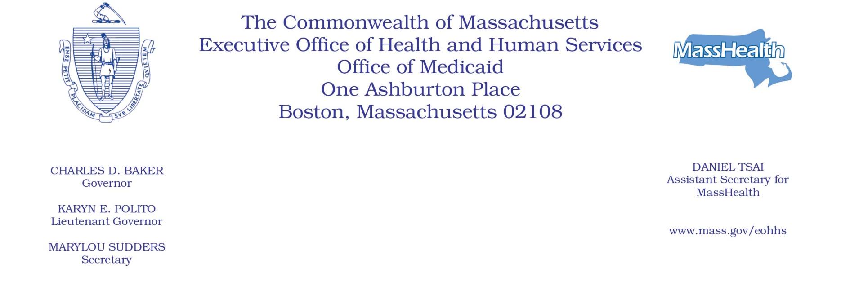

Administrative Bulletin 19-13
101 CMR 701.00: Community Hospital Reinvestment Trust Fund Payments and Funding

Effective July 1, 2019

Allocation and Requirements of Trust Fund Payments

The Executive Office of Health and Human Services (EOHHS) is issuing this Administrative Bulletin pursuant to 101 CMR 701.01(2) to:
• identify amounts and recipients of payments from the Community Hospital Reinvestment Trust Fund (the “Trust Fund”) for state fiscal year 2019 (SFY2019); and
• set forth compliance criteria and reporting requirements relating to Trust Fund payments.

Payment amounts are determined by EOHHS, using the methodology described in 101 CMR 701.04(4), based on data reported to the Center for Health Information and Analysis (CHIA).

1. State Fiscal Year 2019 Payments by Eligible Acute Care Hospital
a. Anticipated SFY2019 payments to eligible acute care hospitals are identified in the table below.
Eligible Acute Care Hospital | SFY2019 Payment
Anna Jaques Hospital | $417,694
Athol Memorial Hospital | $196,383
Baystate Franklin Medical Center | $45,038
Baystate Medical Center | $75,952
Baystate Noble Hospital | $544,600
Baystate Wing Hospital | $277,458
Beth Israel Deaconess Hospital - Milton | $395,348
Beth Israel Deaconess Hospital - Needham | $236,703
Beth Israel Deaconess Hospital - Plymouth | $239,633
Beth Israel Deaconess Medical Center | $45,325
Brigham and Women's Faulkner Hospital | $45,326
Cambridge Health Alliance | $372,691
Clinton Hospital | $255,445
Cooley Dickinson Hospital | $26,509
Emerson Hospital | $238,569
Harrington Memorial Hospital | $205,739
HealthAlliance Hospital | $297,099
Heywood Hospital | $489,389
Holyoke Medical Center | $308,691
Lahey Health - Winchester Hospital | $275,148
Lahey Hospital & Medical Center | $125,794
Lawrence General Hospital | $441,985
Lowell General Hospital | $361,785
Marlborough Hospital | $226,375
Massachusetts Eye and Ear Infirmary | $386,268
Melrose Wakefield Health | $181,476
Mercy Medical Center | $362,602
MetroWest Medical Center | $204,323
Milford Regional Medical Center | $305,501
Morton Hospital | $265,832
Mount Auburn Hospital | $148,350
Nashoba Valley Medical Center | $138,198
New England Baptist Hospital | $193,473
Newton-Wellesley Hospital | $89,297
North Shore Medical Center | $91,186
Northeast Hospital | $271,117
Saint Vincent Hospital | $150,136
Shriners Hospitals for Children Boston | $196,908
Signature Healthcare Brockton Hospital | $343,187
South Shore Hospital | $45,021
Southcoast Hospitals Group | $250,499
Steward Carney Hospital, Inc. | $206,886
Steward Good Samaritan Medical Center | $180,782
Steward Holy Family Hospital, Inc. | $234,139
Steward Norwood Hospital, Inc. | $176,459
Steward Saint Anne's Hospital, Inc. | $137,133
Steward Saint Elizabeth's Medical Center | $9,690
Sturdy Memorial Hospital | $67,322
Tufts Medical Center | $25,303
UMass Memorial Medical Center | $29,000

- EOHHS anticipates that SFY2019 payments will be disbursed during or around July 2019. Once EOHHS distributes SFY2019 payments, those payment amounts will be deemed final and will not be revised by EOHHS.

- Although EOHHS has elected not to require acute care hospitals receiving SFY19 payments from the Trust Fund to submit reports to EOHHS describing their activities supported by those payments, acute care hospitals that received payments from the Trust Fund in prior state fiscal years must continue to comply with any reporting requirements that EOHHS attached to those payments. See Administrative Bulletin 18-05(4).

- Noncompliance
EOHHS may deny, reduce, or withhold payment to an eligible acute care hospital that fails to comply with any condition of payment or reporting requirement set forth in 101 CMR 701.00 or this Administrative Bulletin. EOHHS will notify the acute care hospital of its intention to deny, reduce, or withhold payment.

Payment amounts are subject to budget appropriation and availability of funds.

