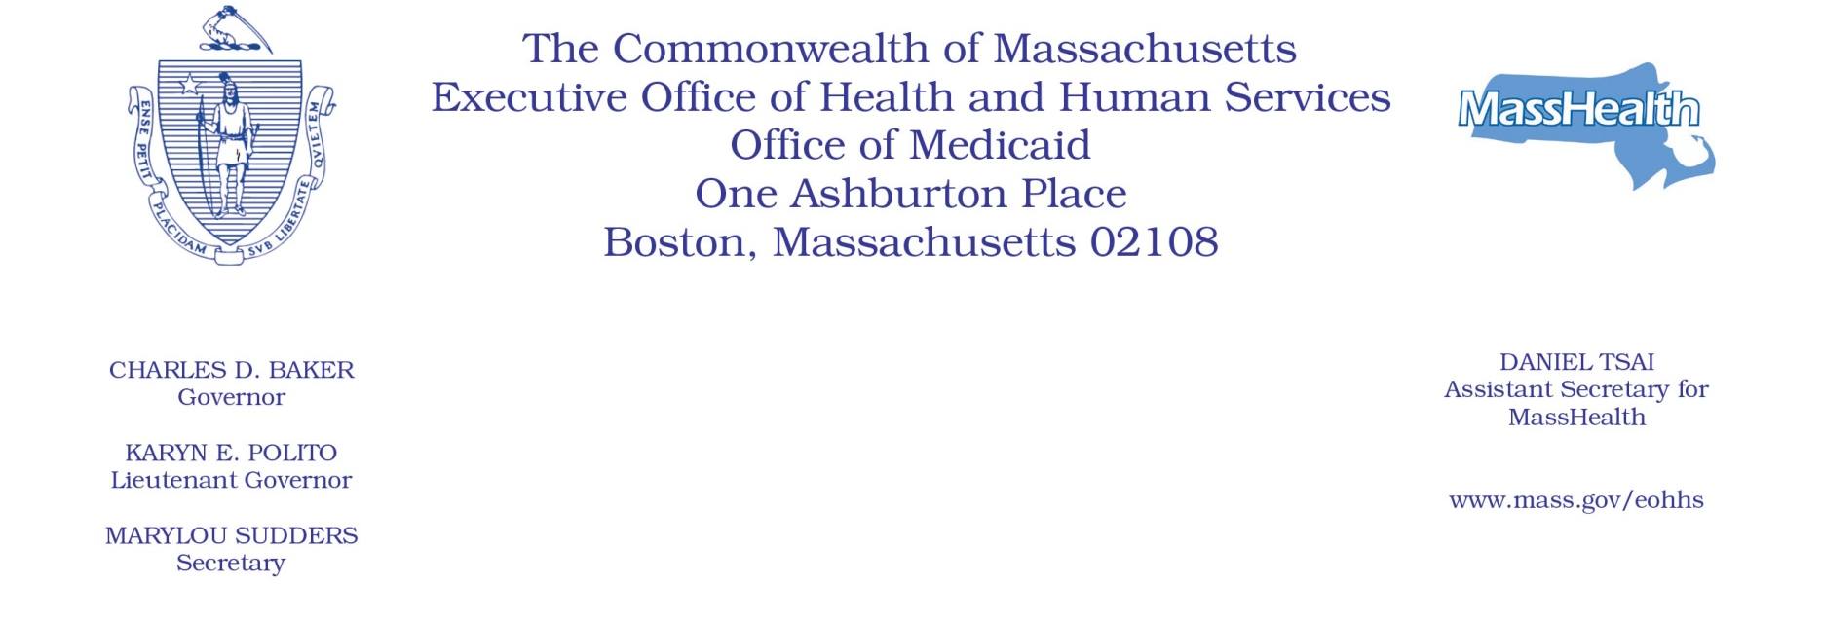

Administrative Bulletin 20-77
101 CMR 701.00: Community Hospital Reinvestment Trust Fund Payments and Funding

Effective September 1, 2020

Allocation and Requirements of Trust Fund Payments

The Executive Office of Health and Human Services (EOHHS) is issuing this Administrative Bulletin pursuant to 101 CMR 701.01(2) to
• identify amounts and recipients of payments from the Community Hospital Reinvestment Trust Fund (the “Trust Fund”) for state fiscal year 2020 (SFY2020); and
• set forth compliance criteria and reporting requirements relating to Trust Fund payments.

Payment amounts are determined by EOHHS, using the methodology described in 101 CMR 701.04(4), based on data reported to the Center for Health Information and Analysis (CHIA).

1. State Fiscal Year 2020 Payments by Eligible Acute Care Hospital
a. Anticipated SFY2020 payments to eligible acute care hospitals are identified in the table below.

Eligible Acute Care Hospital | SFY2020 Payment
Anna Jaques Hospital | $358,812
Athol Memorial Hospital | $318,203
Baystate Medical Center | $81,885
Baystate Noble Hospital | $446,775
Baystate Wing Hospital | $336,331
Beth Israel Deaconess Hospital - Milton | $359,205
Beth Israel Deaconess Hospital - Needham | $167,705
Beth Israel Deaconess Hospital - Plymouth | $182,405
Beth Israel Deaconess Medical Center | $19,936
Brigham and Women's Faulkner Hospital | $26,497
Cambridge Health Alliance | $298,894
Cooley Dickinson Hospital | $24,305
Emerson Hospital | $186,488
Harrington Memorial Hospital | $244,411
HealthAlliance-Clinton Hospital | $228,258
Heywood Hospital | $430,093
Holyoke Medical Center | $360,317
Lahey Health - Winchester Hospital | $202,089
Lahey Hospital & Medical Center | $104,282
Lawrence General Hospital | $332,911
Lowell General Hospital | $285,656
Marlborough Hospital | $213,953
Massachusetts Eye and Ear Infirmary | $331,046
MelroseWakefield Healthcare | $170,741
Mercy Medical Center | $330,671
MetroWest Medical Center | $129,622
Milford Regional Medical Center | $235,262
Morton Hospital | $266,001
Mount Auburn Hospital | $127,400
Nashoba Valley Medical Center | $225,504
New England Baptist Hospital | $253,312
Newton-Wellesley Hospital | $78,278
North Shore Medical Center | $85,002
Northeast Hospital | $241,957
Saint Vincent Hospital | $130,301
Shriners Hospitals for Children Boston | $561,051
Shriners Hospitals for Children Springfield | $138,696
Signature Healthcare Brockton Hospital | $307,469
South Shore Hospital | $49,864
Southcoast Hospitals Group | $224,805
Steward Carney Hospital | $193,261
Steward Good Samaritan Medical Center | $221,675
Steward Holy Family Hospital | $245,085
Steward Norwood Hospital | $176,018
Steward Saint Anne's Hospital | $95,241
Steward Saint Elizabeth's Medical Center | $119,638
Tufts Medical Center | $3,078
UMass Memorial Medical Center | $4,977

- EOHHS anticipates that SFY2020 payments will be disbursed during or around September 2020. Once EOHHS distributes SFY2020 payments, those payment amounts will be deemed final and will not be revised by EOHHS.

- Although EOHHS has elected not to require acute care hospitals receiving SFY2020 payments from the Trust Fund to submit reports to EOHHS describing their activities supported by those payments, acute care hospitals that received payments from the Trust Fund in prior state fiscal years must continue to comply with any reporting requirements that EOHHS attached to those payments. See Administrative Bulletin 18-05(4).

- Noncompliance
EOHHS may deny, reduce, or withhold payment to an eligible acute care hospital that fails to comply with any condition of payment or reporting requirement set forth in 101 CMR 701.00 or this Administrative Bulletin. EOHHS will notify the acute care hospital of its intention to deny, reduce, or withhold payment.

Payment amounts are subject to budget appropriation and availability of funds.

