INDOOR AIR QUALITY ASSESSMENT
INCIDENT RESPONSE

Sgt. William H. Carney Memorial Academy
247 Elm Street
New Bedford, Massachusetts

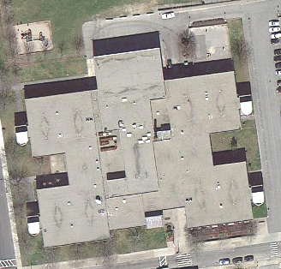

Prepared by:
Massachusetts Department of Public Health
Bureau of Environmental Health
Indoor Air Quality Program
August 2012

Background/Introduction
On Wednesday July 25, 2012, the Massachusetts Department of Public Health (MDPH), Bureau of Environmental Health (BEH), Indoor Air Quality (IAQ) Program was contacted by Deb Brown, Business Manager, New Bedford Public Schools, regarding a fire at the Sgt. William H. Carney Memorial Academy (CMA) located at 247 Elm Street, New Bedford Massachusetts. On July 26, 2012, Cory Holmes an Environmental Analyst/Regional Inspector for BEH’s Indoor Air Quality (IAQ) Program, made a visit to the CMA to conduct an IAQ assessment.
At the time of the July 25th contact with the MDPH, it was reported that a fire that was believed to have been caused by a malfunctioning power strip in a first floor classroom occurred at approximately 5:00 AM on July 19, 2012. The classroom reportedly had severe fire and smoke damage (Pictures 1 through 3). Classrooms adjacent to and above (totaling four) were damaged by smoke. The exterior wall along the outside of this fire was charred/smoke-damaged (Pictures 4 and 5), resulting in damage to fresh air intakes for unit ventilators and rendering them unusable. As a result, all school activities were cancelled for the rest of the week, as well as the following week in order to conduct remediation/restoration work.

Methods
To determine whether combustion products/particulates from fire/smoke in the building had been removed sufficiently, BEH staff conducted air sampling for carbon monoxide, particulate matter with a diameter of 2.5 micrometers (μm) or less (PM2.5), and volatile organic compounds (VOCs). Tests for carbon monoxide were conducted with the TSI, Q-Trak, IAQ Monitor, Model 7565. Tests for airborne particle matter with a diameter less than 2.5 micrometers were taken with the TSI, DUSTTRAK™ Aerosol Monitor Model 8520. Air testing for total volatile organic compounds (TVOCs) was conducted using a Thermo Environmental Instruments Inc., Model 580 Series Photo Ionization Detector (PID).

Results
Tests were taken during remediation efforts while the school was unoccupied. Results appear in Table 1.

Discussion

IAQ Evaluations
At the time of the BEH assessment, ServPro, a fire/flooding restoration specialist, was on scene conducting remediation efforts. The fire-damaged area had been sealed off with plastic-poly sheeting on the 1st and 2nd floors. As mentioned previously, to determine any residual impacts from malfunctioning electrical equipment and/or related smoke/odors in the building, BEH staff took measurements for carbon monoxide, particulate matter and TVOCs. Indoor air quality can be negatively influenced by the presence of respiratory irritants, such as products of combustion. The process of combustion produces a number of pollutants. Common combustion emissions include carbon monoxide, carbon dioxide, water vapor, and smoke (fine airborne particle material). Of these materials, exposure to carbon monoxide and PM2.5 can produce immediate, acute health effects upon exposure.

Carbon Monoxide
Carbon monoxide is a by-product of incomplete combustion of organic matter (e.g., gasoline, wood and tobacco). Exposure to carbon monoxide can produce immediate and acute health effects. Several air quality standards have been established to address carbon monoxide and prevent symptoms from exposure to these substances. The MDPH established a corrective action level concerning carbon monoxide in ice skating rinks that use fossil-fueled ice resurfacing equipment. If an operator of an indoor ice rink measures a carbon monoxide level over 30 ppm, taken 20 minutes after resurfacing within a rink, that operator must take actions to reduce carbon monoxide levels (MDPH, 1997).
The American Society of Heating Refrigeration and Air-Conditioning Engineers (ASHRAE) has adopted the National Ambient Air Quality Standards (NAAQS) as one set of criteria for assessing indoor air quality and monitoring of fresh air introduced by HVAC systems (ASHRAE, 1989). The NAAQS are standards established by the US EPA to protect the public health from six criteria pollutants, including carbon monoxide and particulate matter (US EPA, 2006). As recommended by ASHRAE, pollutant levels of fresh air introduced to a building should not exceed the NAAQS levels (ASHRAE, 1989). The NAAQS were adopted by reference in the Building Officials & Code Administrators (BOCA) National Mechanical Code of 1993 (BOCA, 1993), which is now an HVAC standard included in the Massachusetts State Building Code (SBBRS, 1997). According to the NAAQS, carbon monoxide levels in outdoor air should not exceed 9 ppm in an eight-hour average (US EPA, 2006).
Carbon monoxide should not be present in a typical, indoor environment. If it is present, indoor carbon monoxide levels should be less than or equal to outdoor levels. On the day of assessment, outdoor carbon monoxide concentrations were non-detect (ND) (Table 1). No measureable levels of carbon monoxide were detected inside the building during the assessment (Table 1).

Particulate Matter
The US EPA has established NAAQS limits for exposure to particulate matter. Particulate matter is airborne solids that can be irritating to the eyes, nose and throat. The NAAQS originally established exposure limits to particulate matter with a diameter of 10 μm or less (PM10). According to the NAAQS, PM10 levels should not exceed 150 micrograms per cubic meter (μg/m³) in a 24-hour average (US EPA, 2006). These standards were adopted by both ASHRAE and BOCA. Since the issuance of the ASHRAE standard and BOCA Code, US EPA established a more protective standard for fine airborne particles. This more stringent PM2.5 standard requires outdoor air particle levels be maintained below 35 μg/m³ over a 24-hour average (US EPA, 2006). Although both the ASHRAE standard and BOCA Code adopted the PM10 standard for evaluating air quality, MDPH uses the more protective PM2.5 standard for evaluating airborne particulate matter concentrations in the indoor environment.
Outdoor PM2.5 concentrations the day of the assessment were measured at 20-40 μg/m³. PM2.5 levels measured inside the building ranged from 15 to 21 μg/m³ in unaffected areas (Table 1) and up to a high reading of 49 μg/m³ in affected areas, which was above the NAAQS PM2.5 level of 35 μg/m³. At the conclusion of the testing it was observed that the double doors separating the remediation zone from the main office areas were open (Picture 6). BEH staff recommended keeping these doors shut and using them as the containment wall and to enhance the efficacy by sealing them with plastic and duct tape. In addition, it was recommended that exhaust fans be placed on the opposite side of the containment barrier to draw odors/particulates away from the occupied areas. ServPro sealed the doors (Picture 7) and stationed exhaust fans and shortly after this was done, elevated PM2.5 levels dropped to near or below the NAAQS PM2.5 level of 35 μg/m³ (Table 1).
It was also recommended that a 2nd set of double doors leading to the stairwell be sealed with plastic and duct tape (Picture 8), to prevent odors/particulates from migrating into the stairwell where they can be transported to open areas of the 2nd floor. At the time of the assessment, BEH staff also recommended the activation of mechanical ventilation for the remainder of the week and over the weekend (with the exception of the 5 rooms directly impacted by the fire). This action serves to both bring in fresh/outside air to dilute airborne pollutants and to exhaust environmental pollutants to the outdoors.

Volatile Organic Compounds (VOCs)
In an effort to determine whether lingering VOCs were present in the building from burning materials, BEH staff conducted VOC screening. Outdoor air samples were also taken for comparison. On the day of assessment, outdoor TVOC concentrations were non-detect (ND) (Table 1). No measureable levels of TVOCs were detected inside the building during the assessment (Table 1).

Conclusions/Recommendations
The air testing results indicated that at the time of the assessment, carbon monoxide and TVOCs were non-detectable within all areas tested. In addition, after enhancements to containment efforts and ventilation of the remediation area, elevated PM2.5 levels measured were reduced to near/below the NAAQS PM2.5 level of 35 μg/m³. However, because the exterior wall and several univent air intakes were impacted, these rooms should remain unoccupied until the wall is cleaned and the univents/air intakes can be thoroughly cleaned or replaced as needed. Since the fire-damaged area will be undergoing restoration over the next several weeks/months, please refer to the MDPH guidance “Methods Used to Reduce/Prevent Exposure to Construction/Renovation Generated Pollutants in Occupied Buildings” (Appendix A). The MDPH has prepared this guidance document in order to reduce or minimize exposure opportunities and to prevent/reduce the migration of renovation-generated pollutants into occupied areas.
In view of the findings at the time of the visit, the following recommendations are made:
- Continue to conduct remediation/restoration activities under containment and negative pressure ventilation conditions (see Appendix A).
- Ensure containment walls are inspected daily for structural integrity.
- Establish communications between all parties involved with remediation/renovation activities to prevent potential IAQ problems.
- Refer to resource manuals and other related indoor air quality documents for further building-wide evaluations and advice on maintaining public buildings. Copies of these materials are located on the MDPH’s website: http://mass.gov/dph/iaq.

References
ASHRAE. 1989. Ventilation for Acceptable Indoor Air Quality. American Society of Heating, Refrigeration and Air Conditioning Engineers. ANSI/ASHRAE 62-1989.
BOCA. 1993. The BOCA National Mechanical Code/1993. 8th ed. Building Officials and Code Administrators International, Inc., Country Club Hill, IL.
MDPH. 1997. Requirements to Maintain Air Quality in Indoor Skating Rinks (State Sanitary Code, Chapter XI). 105 CMR 675.000. Massachusetts Department of Public Health, Boston, MA.
SBBRS. 1997. Mechanical Ventilation. State Board of Building Regulations and Standards. Code of Massachusetts Regulations. 780 CMR 1209.0.
US EPA. 2006. National Ambient Air Quality Standards (NAAQS). US Environmental Protection Agency, Office of Air Quality Planning and Standards, Washington, DC. http://www.epa.gov/air/criteria.html
Picture 1

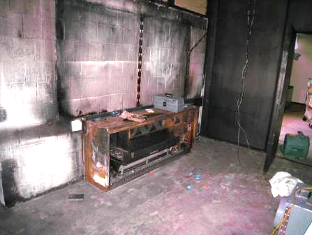

Fire/Smoke Damage to 1st Floor Classroom

Picture 2

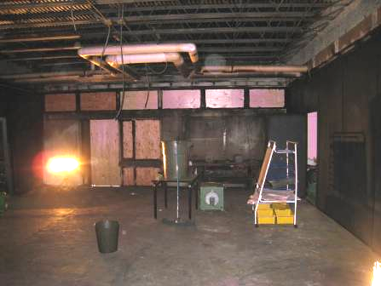

Fire/Smoke Damage to 1st Floor Classroom

Picture 3

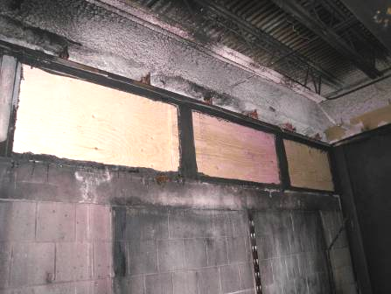

Fire/Smoke Damage to 1st Floor Classroom

Picture 4

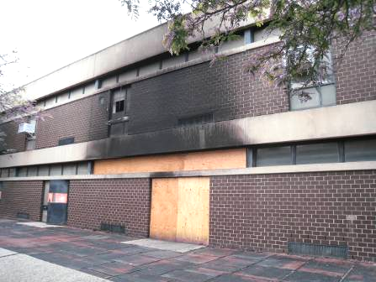

Fire/Smoke Damage to Exterior Wall, Note Univent Fresh Air Intake (Arrow)

Picture 5

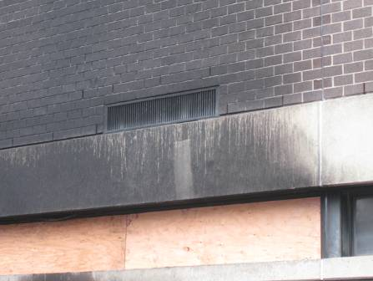

Close-Up of Fire/Smoke-Damaged Univent Fresh Air Intake

Picture 6

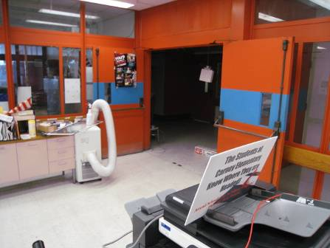

Double Doors Open between the Remediation Zone and Occupied Areas of the Main Office

Picture 7

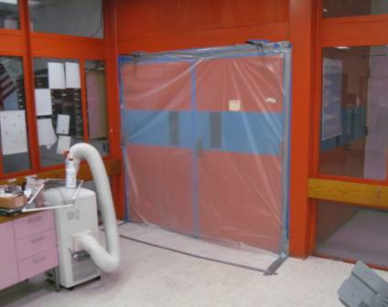

Double Doors to Remediation Zone Sealed with Plastic and Duct Tape

Picture 8

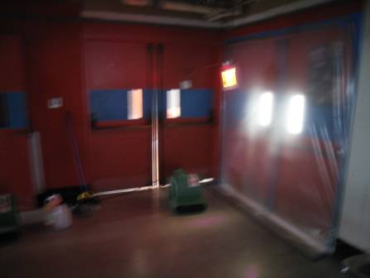

Double Doors Recommended by BEH to be Sealed, Note Light Penetration around Doors
Location/ Room | Carbon Monoxide | TVOCs  (ppm) | PM2.5  (µg/m³) | PM2.5  (µg/m³)  (After containment wall relocated/negative ventilation employed) | Remarks
Location/ Room | (ppm)
Background | ND | ND | 20-40 |  | Wind/Weather conditions: overcast, humid, storms expected, winds SW 6-16 mph, gusts up to 21 mph
1st Floor
Teachers Room | ND | ND | 18
Nurse | ND | ND | 18-21
Career Awareness | ND | ND | 15
Main office: Special Services | ND | ND | 45 | 28
Principal’s Office | ND | ND | 49 | 26
Main Office | ND | ND | 50 | 33
Cafeteria | ND | ND | 14
A 101 | ND | ND | 16
A 103 | ND | ND | 16
A 104 | ND | ND | 16
A 106 | ND | ND | 17
A 107 | ND | ND | 15
A 111 | ND | ND | 16
A 115 | ND | ND | 16
A 128 | ND | ND | 17
A 129 | ND | ND | 29 |  | Being cleaned
A 133 | ND | ND | 23
A 135 | ND | ND | 15
A 136 | ND | ND | 18
A 138 | ND | ND | 17
Gym | ND | ND | 19
Councilor’s Office | ND | ND | 22
Lower Computer Lab | ND | ND | 20
Library | ND | ND | 21
Science Lab | ND | ND | 17
Art | ND | ND | 16
Forum | ND | ND | 20
Forum (Upper) | ND | ND | 16
2nd Floor
A 228 | ND | ND | 16
A 233 | ND | ND | 16
A 236 | ND | ND | 15
C 202 | ND | ND | 38
C 203 | ND | ND | 33
C204/205 | ND | ND | 35 | 30 | Slight odors, directly above fire
C 207/208 | ND | ND | 39 | 30
Lobby Area | ND | ND | 47-49 | 38
Sensory Room | ND | ND | 19
Computer Lab | ND | ND | 16
Upper Conference Room | ND | ND | 15

