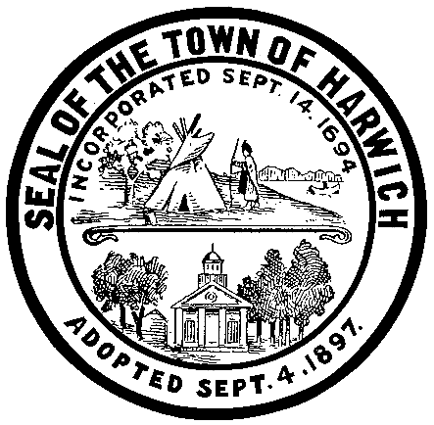

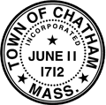

Municipal
Portable Closed Loop Pressure Wash Water Recycle System

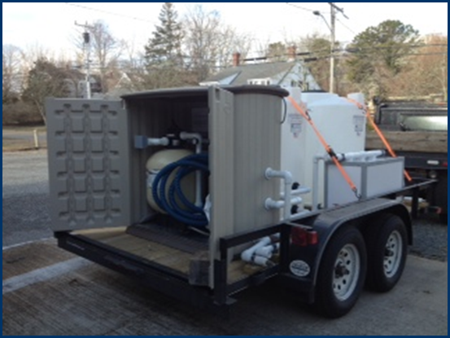
Harbormaster
Town of Chatham
&
Harbormaster
Town of Harwich

TABLE OF CONTENTS

INTRODUCTORY LETTER 3
EXECUTIVE SUMMARY 4
PARTNER COMMUNITIES 4
PROJECT GOALS 5
IMPLEMENTATION PLAN 5
BUDGET 6
CHALLENGES AND SOLUTIONS 6
OUTCOMES 6
CONTACT INFORMATION 7
REFERENCES 7

INTRODUCTORY LETTER

Project Title: Municipal Portable Closed Loop Pressure Wash Water Recycle

The Towns of Chatham and Harwich received a Community Innovation Challenge (CIC) Grant in the amount of $25,500 for the purchase of a Portable Closed Loop Pressure Wash Water Recycle System. The system is designed to eliminate potential discharge of contaminated wash water into coastal waters and ground water during the cleaning and power washing of boat hulls. Pressure washing of boat hulls creates contaminated wash water that may contain heavy metals from the hull paint, oil, grease and other pollutants. The closed loop system, which will be used primarily by the approximate 80 commercial fishing boats home ported in Harwich and Chatham, will capture the harmful contaminates while recycling the wash water.

After a significant amount of research on various Portable Closed Loop Recycle Systems currently on the market, and complying with municipal procurement rules, the Next Generation in Waste Water Treatment Technology, Model CL-300-BF was selected for purchase. The portable system is mounted on a trailer for transport between the Towns of Harwich and Chatham and will be used in conjunction with a 20’ x 50’ Wash Pad that was purchased from Pressure Washer Warehouse.

Because the warmer weather that comes with the arrival of Spring has yet to be realized, there have been no commercial fishing boats that have hauled out for maintenance since receiving the Closed Loop System. While we have not had the opportunity to use the system to date, there is no question that it will meet the intended outcomes of the project; that is it will serve to protect the environment and minimize costs to the commercial fishing fleet for the proper containment and recovery of hazardous waste water and pollutants that result from hull cleanings.

Respectfully Submitted,

John C. Rendon Stuart F.X. Smith
Harbormaster Harbormaster
Town of Harwich Town of Chatham

EXECUTIVE SUMMARY

The Towns of Chatham and Harwich Harbormaster Departments often perform regional and joint public safety and harbor management functions. Each Town has a significant commercial fishing fleet that operates year-round from its harbors, and as such there are similar support functions that are required and/or desired of each community. One such support function is providing an avenue for the commercial fishing fleets to haul their boats in the off-season to clean the hulls without contaminating coastal waters and productive habitats, hence the Municipal Portable Closed Loop Wash Water Recycle System.

The Closed Loop Wash Water Recycle System purchased with Community Innovation Challenge grant funds for the Towns of Chatham and Harwich is a portable, trailer mounted unit that comes ready to use. The unit uses a single tank to store and treat waste water produced from pressure washing boat hulls. Waste water is collected in the treatment/recycle tank via the sump pump. The waste water is continuously pumped through a filter system that removes solids to 20 microns and then returned to the treatment tank through an air injector to aerate the water, thereby controlling odors and removing volatile organic compounds, such as gasoline, diesel fuel and solvents.

While we have not had the opportunity to use the system to date due to winter temperatures, we have seen firsthand how the system works at a local marina. There is no question we will achieve the project outcomes as stated in our application. One of the challenges that we anticipate is in the deployment and recovery of the portable 20’x 50’ wash pad that was purchased along with the unit. The portable wash pad is bulky, heavy and cumbersome to deploy and store. The desired state will be to have a permanent concrete wash pad with an installed sump box.

PARTNER COMMUNITIES

The application for the Community Innovation Challenge grant was jointly produced by the Chatham and Harwich Harbormasters. A collaborative Inter-Municipal Agreement was established between the Towns of Chatham and Harwich which specifies that all costs related to the operation, maintenance, training, and staff work will be shared equally among each respective Town. The Lead Applicant was the Town of Chatham and the Secondary Applicant was the Town of Harwich. Responsibilities throughout the grant process have been equally shared by the Chatham and Harwich Harbormasters; thorough research on available portable closed loop water wash recycle systems was conducted, site visits were made to various facilities to see the operation of closed loop systems, administrative reports and proper procurement requirements were completed, registration of trailer and insurance of unit was done, and joint training on the operation of the system is ongoing.

PROJECT GOALS

With the implementation of the Portable Closed Loop Wash Water Recycle System, the Towns of Chatham and Harwich hope to achieve the following goals as outlined in the grant application:

Cost Saving Goals:
- Eliminate the cost of a discharge permit incurred with a permanent recycle system.
- Reduce the amount/costs of fresh water use at town harbor facilities.
- Minimize the cost of waste water contaminate disposal from multiple times per season to one disposal per season
- Reduce the costs incurred by the commercial fishing fleet by eliminating the need to hire a commercial facility equipped with a recycle system to pressure wash and clean their boat hull.

Environmental Goals:
- Improve water quality protection to ground water and coastal waterways
- Improve method of toxic paint removal from boat hulls and disposal of hazardous waste water.
- Reduce fresh water demand.

Improved Access:
- Improved access for commercial fisherman to affordable and environmentally safe pressure washing services.

IMPLEMENTATION PLAN

The implementation plan for this project was very straightforward. An Inter-Municipal Agreement between the Towns of Chatham and Harwich was prepared by respective Harbormasters and approved by Town Manager/Administrator. The Agreement defined roles and responsibilities for the shared use and maintenance of the Closed Loop Pressure Wash Recycle System, and outlined specific terms of the Agreement. Significant research into different types and models of Closed Loop Recycle Systems, which included several site visits, was conducted by Chatham and Harwich Harbormasters. The System had to be portable, to be transported between the two towns, so that narrowed the search. A bid specification spreadsheet was prepared for both the Closed Loop Recycle System and the Wash Pad that outlined three potential options for each; the lowest bid was selected. Purchases were made, and upon delivery of the Portable Closed Loop Recycle System, the trailer was properly registered and the entire unit was insured. Site locations for the cleaning of boat hulls using the Portable Closed Loop Recycle System have been identified by each Harbormaster within their respective harbors.

BUDGET

Grant Award – $25,500

Funds Expended:
$14,300 – Portable (Trailer Mounted) Closed Loop Pressure Wash Water Recycle System
$6,080 – (2) Modular Catchment Systems (Wash Pads)
$1960 – (2) Storm water drain covers
$1800 – Pressure Washer (mounted to trailer)

Total – $24,140

There were no unexpected issues that required a change to our original budget request.

CHALLENGES AND SOLUTIONS

To date, there have been no real challenges in the execution of the project. That said, we have not had the opportunity to use the Closed Loop Pressure Wash Water Recycle System yet due to the cold winter temperatures; operating the system during periods of freezing temps runs the risk of damage to the PVC pipes, hoses and pumps. Once the warmer weather arrives, the commercial fishing fleet will start to haul their boats for routine maintenance prior to the summer season.

OUTCOMES

The measures of success listed below for the Municipal Portable Closed Loop Pressure Wash Water Recycle System project have yet to be realized, as we have not commissioned the unit to date, as previously explained.

- Number of boats utilizing the Portable Closed Loop Recycle System – this will be measured through a usage log where commercial fisherman must document their use of the unit with the Harbormaster office.

- Amount of wash water collected and disposed of at the end of the fishing season – Harbormaster will document the gallons of waste water recycled using the Closed Loop System.

CONTACT INFORMATION

Stuart F.X. Smith John C. Rendon
Harbormaster Harbormaster
Town of Chatham Town of Harwich
549 Main Street 715 Main Street (PO Box 207)
Chatham, MA 02633 Harwich, MA 02646
(508) 945-5185 (508) 430-7532
ssmith@chatham-ma.gov jrendon@town.harwich.ma.us

REFERENCES

The Next Generation in Waste Water Treatment Technology

Wash Pads
Ken@pressurewasherwarehouse.net

Inter-Municipal Agreement between The Towns of Chatham and Harwich

Intermunicipal Agreement
Between
The Towns of Chatham and Harwich
For a Municipal Portable Closed Loop Pressure Wash Water Recycle System

This Intermunicipal Agreement (“IMA”) is entered into this 15th day of October, 2012, between the Towns of Harwich and Chatham as duly authorized by their respective Boards of Selectmen pursuant to G.L. c.40, sec. 4A.

WHEREAS, the Town of Chatham, intended to make an application for the Executive Office of Administration and Finance Community Innovation Challenge Grant- Municipal Portable Closed Loop Pressure Wash Water Recycle System “Wash Water Recycle System;” and

WHEREAS, the parties herein desire to enter into the IMA setting forth the services to be provided by each; and

WHEREAS, the parties herein desire to enter into the IMA setting forth the services to be provided by each; and

WHEREAS, the application prepared and approved by parties is to be submitted to the Executive Office of Administration and Finance.

WHEREAS, the Town of Chatham and Harwich Harbormaster Departments are responsible for maritime public safety and harbor management, including the protection of natural resources.

- History of Relationship

-The Towns of Chatham and Harwich Harbormaster Departments often perform regional and join public safety operations and harbor management functions. Each respective Department Assistant Harbormasters are deputized to perform Harbormaster duties within the neighboring communities (Harwich, Chatham, and Orleans). These collaborative operations occur on a routine basis and needs dictate.
-The critical and long-range goals of this collaboration are to enhance and protect the natural resources of each community through the sharing of this Wash Water Recycle System for Commercial Fishing Fleets in Harwich and Chatham.

- Development of Application
-The Massachusetts Department of Environmental Protection requires the containment of all run-off and particulates that are produced during the bottom cleaning of vessels. Each Town has a significant commercial fishing fleet that operates from its harbors and therefore a Wash Water Recycle System is needed.
-The application for the grant was jointly produced by the Chatham and Harwich Harbormasters.

- Roles and Responsibilities

- The Towns of Chatham and Harwich will, subject to appropriation and the availability of funds, share equally all costs to operate, maintain, train, and staff for the operation of the Wash Water Recycle System, net of revenue received by the Town of Chatham from boat washing fees.
- As per boat operations fee of $25.00 will be charged for the use of the Wash Water Recycle System. These fees will be managed by the Town of Chatham and used solely for the maintenance and up keep of the system.
- The operation, maintenance, and storage of the system will be jointly managed by the Town of Chatham and Town of Harwich Harbormasters.
- The system shall be owned jointly by the parties.
- The roles and responsibilities described above are contingent on the Town of Chatham receiving funds requested for the project described in the Community Innovation Challenge (CIC) grant application. Responsibilities under this IMA would coincide with the grant that commenced on April 27, 2012.

- Area of Service and Restriction on Use

- The service area includes the Town of Chatham and the Town of Harwich.
- The Town of Chatham and the Town of Harwich Harbormaster departments shall make available the Wash Water Recycle System to all vessel owner/operators within their respective communities. Vessel owner/ operators must abide by all terms, conditions, and restrictions of the Harbormasters.

- Term of Agreement

- This IMA shall commence upon execution by and shall continue for as long as the Wash Water Recycle system remains operational, but in no event shall this IMA exceed a term of 25 years pursuant to G.L. c.40, Sec. 4A.
- The participating Towns may mutually agree any time to terminate this IMA prior to the date of expiration.
- In the event that either party fails to appropriate or otherwise make available the funds necessary to operate and maintain the Wash Water Recycle System, ether party may terminate this IMA.
- Upon expiration or termination of this IMA any funds left in the account established and managed by the Town of Chatham shall be allocated to the participating Towns equally.
- If this IMA is terminated for any reason, the parties shall meet for the purpose of agreeing on an appropriate disposition of the Wash Water Recycle System.

By _________________ By __________________
Jill R. Goldsmith James R. Merriam
Town Manager, Chatham Town Administrator, Harwich

Date: _______________ Date: ________________

