Massachusetts Community Transportation Series December 2012

Sharing Community Vehicles:

A Promising Practice from Northern Berkshire County, Massachusetts

Many human service agencies and community organizations provide transportation to individuals who use their services. Vehicles used by these organizations often run with empty seats or sit unused for some portion of the day. When these organizations partner to share a vehicle, they may be able to reduce their expenses and serve more people.

This brief describes a vehicle share model using an example from a partnership serving seven rural communities with a combined population of 33,500 in Northern Berkshire County, Massachusetts. The purpose of this document is two-fold: 1) to describe how a vehicle share model can benefit participating organizations and provide mobility to more people and 2) to discuss issues for consideration to leaders and staff of human service agencies and community-based organizations that may want to implement such a model. While this model can work anywhere in the country, this brief focuses on the legal landscape and practical considerations for vehicle share in Massachusetts. A toolkit with additional resources complements this brief.

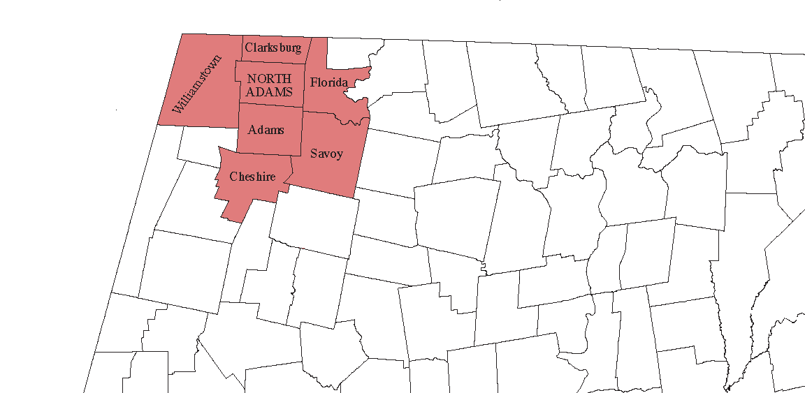

The seven towns in the partnership in Northwestern Massachusetts are Adams, Cheshire, Clarksburg, Florida, North Adams, Savoy, and Williamstown.

Background
Community transportation refers to the transportation resources in a community that are available to help meet community mobility needs. These services may be operated by transit authorities, human or social service agencies, Councils on Aging (COA), faith-based organizations, daycare centers, or youth or veterans’ organizations. Community transportation serves the elderly, people with disabilities, youth, veterans, low income individuals, and sometimes the general public on an as-needed basis.

In most cases, demand for community transportation services is sporadic, and the number of people riding at any one point in time is relatively small. As a result, services are typically delivered by vans that can carry 8 to 15 passengers, although both larger and smaller vehicles may be used as well. In this brief on vehicle share, we use the term community vehicle to refer to vans with 8 to 15 seat capacity.

Why share community vehicles?
When community partners share their vehicles, mobility options in the community can be enriched in many ways. Sharing can:
- Serve more people – Since community vehicles often have empty seats, opening vehicles to individuals who are not a particular organization’s target clientele can provide a valuable service to other area residents. With more riders on board, vehicles are better utilized, and additional fare revenue helps offset operating costs.
  - Example: A local COA runs a weekly van to the nearby shopping center and takes both members of the senior center and non-members as passengers.
- Eliminate the need for each organization to buy and maintain its own vehicle while retaining the same level of service – Similar providers can provide consolidated service while using fewer vehicles.
- Example: Several churches – instead of each running a van to transport parishioners to services – could pool their funding and jointly purchase and dispatch one or two vans to pick up all of the parishioners. Rather than duplicating service, this approach has a cost savings potential for participating organizations while leaving the level of service intact.
- Reduce operating expenses by short-term renting of vehicles – Many community organizations operate their vehicles a few days per week and for a limited number of hours per day, after which time the vehicles sit unused. Organizations may find complementary uses for their vehicles. The rent charged for vehicle use can be used to defray maintenance and other operating costs.
  - Example: A daycare center operates a van on weekdays but can rent the same van to a church that transports parishioners to services on Sundays. The church pays the daycare a user fee, which the daycare uses to defray its operating costs.
- Help fill gaps in service – Public transit services do not exist along all routes that people need to access. Even where public transit is available, operating hours may not extend into the night or start early enough for employees working the second or third shifts to use the service. Community organizations may wish to fill this gap by providing transportation to under-served populations.
  - Example – Vans operated by a senior center during the day can be rented by the local career center to operate a shuttle for low income workers who work outside regular 9 am to 5 pm business hours. Rental fees help the senior center with its vehicle operating expenses, while fare box revenue defrays the career center’s rental and driver costs.
- Provide feeder service to public transit – Many individuals who would otherwise use public transportation cannot access it because they live or work too far from a bus stop or train station. Using a community van to pick up riders in their neighborhoods and take them to a station can facilitate access to public transit.
  - Example – Vans operated by a COA may only be used for senior transportation in the middle of the day. The same vehicles can be dispatched during rush hour to pick up workers in residential areas and drop them off at the nearest bus stop or train station. Fare box revenue helps the COA defray the cost of vehicle, dispatch, and driver.
- Cooperation among partner organizations lessens competitive pressure – By working closely to develop a shared vehicle program, participating organizations build relationships that encourage good communication and open up more opportunities to collaborate.
  - Example – A youth serving organization makes a change to the start or end time of its program to accommodate the schedule of another organization’s program so that clients of both organizations can use the same vehicle at the same time.

Elements of a Promising Practice
This section describes in depth the process that the organizations in the Berkshires went through to create their vehicle sharing partnership. Six community organizations in Northern Berkshire County applied individually to the Berkshire United Way in 2007 for funding to purchase vans for transporting school-age children to various youth development programs. Since limited resources prevented Berkshire United Way from funding each individual application, the United Way suggested that applicants come together and jointly apply. Under the leadership of Berkshire Rides, a non-profit community transportation organization that has played a lead role in partner engagement and resource coordination in the region, the Northern Berkshire Youth and Community Transportation Network (Network) was formed with six youth-serving community partners and Berkshire Rides as the lead agency.

Partnership building
In 2007, partners met several times to discuss their respective organizations’ grant application objectives. They agreed that the transportation needs of their populations could be met by coordinated scheduling of fewer vehicles. Partners signed a binding agreement that spelled out partner rights and responsibilities. On behalf of the partners, Berkshire Rides applied for and received funding for three eight-seat passenger vans. In addition, one twelve-seat van was acquired with a different private grant from Berkshire Taconic Foundation, and a fifth vehicle (nine-passenger lift equipped van) was sold to the partners for $1 by the Berkshire Regional Transit Authority.

Populations served
In this case, partner organizations include a church, a YMCA, area public schools, a community coalition, a youth center, and a youth coalition that all provide after school and summer programs for children under the age of 18. Berkshire Rides, which provides community and employee transportation primarily to adults, is the only organization in the coalition whose main function is transportation. In this model, youth transportation has priority, after which Berkshire Rides schedules the vans for employee transportation or rents them to non-member organizations to serve their own populations. While vehicles are shared for youth transportation, children do not share rides with adults while traveling to and from school programs.

Sources of Funds
Two private grants paid for the capital expenses of the vehicle fleet: Berkshire United Way paid for three eight-passenger vans, and the fourth vehicle (a twelve-seater) was purchased from a grant provided by the Berkshire Taconic Foundation. The fifth vehicle with a chair lift was donated by the Berkshire RTA for $1. Member organizations pay fees that help defray operating expenses. Unlike federal transportation grants, the Berkshire United Way does not require grantees to provide matching funds.

Under the two private grants, the owner of the newly acquired vehicles is Berkshire Rides. Participating organizations pay Berkshire Rides an annual membership fee, which covers the cost of vehicle registration, liability insurance, inspection, and maintenance. Berkshire Rides currently provides network administration at no cost to members. In addition to expenses listed above, each member organization pays for its own fuel, driver’s insurance, training, and salary. There may also be unexpected expenses that Berkshire Rides incurs on behalf of the Network during the year. These are shared equally by all members at the end of the year. Non-member organizations that rent vehicles after priority scheduling is met pay a daily user fee of $100 per vehicle.

Operations
Before jointly applying for funding, the Network developed and signed an agreement that specifies how the vehicle share program operates and the rights and responsibilities of each member in detail. In this case, the lead agency registers and insures the vehicles, provides periodic inspection and maintenance, maintains safe driver policies, schedules vans for member use, rents them to non-members, and administers the network. The agreement also has detailed provisions about program cost calculation, membership fees, vehicle scheduling parameters for members and non-members alike, daily user fee for non-members and provisions for breach of contract (see details in the Massachusetts Community Transportation Resource: Vehicle Share Agreement).

Adapting this Model for Your Needs
The following table outlines some strategies, issues, and considerations that practitioners who want to build a vehicle share model may find useful. Information in the table is organized by major elements of the model and contains mostly Massachusetts-specific information. We include a link to online resources where available.

Partnership Building
In order to learn about available vehicle capacity in your area and identify potential community organizations to partner with in a vehicle share program, please consider the following strategies:
- Review the latest coordinated human service transportation plan for your region. These plans provide information on service gaps and unmet community needs and may offer strategies on how to meet those needs. Massachusetts’ regional plans are available at www.mass.gov/eohhs/provider/guidelines-resources/services-planning/hst/mobility-manage/chst-plans.html.
- Use the Commonwealth’s database of financial reports to find out whether social service organizations in your area use state funding to provide or purchase transportation services for their consumers. Anyone can look up a specific organization’s record for free at ufr.osd.state.ma.us/home.asp and click on “basic UFR search.” Advanced searches are available for an annual membership fee of $150.
- Non-profit organizations may also report transportation expenses on their IRS 990 forms. Form 990 is an annual reporting tool that federally tax-exempt organizations must file with the government to provide information on their mission, programs, and finances. This document can help you identify organizations that spend money on transportation: in particular, refer to Section 3, question 4 and section 9, question 24. However, organizations that do not report transportation or vehicle expenses on their 990 forms may still be interested in partnering on a vehicle share model. For more information on how to access Form 990 information, please see www.guidestar.org/rxg/help/faqs/form-990/index.aspx.
- Hold face-to-face meetings with interested partner organizations and discuss commonalities between your respective organizations’ missions, visions, and goals.
- Look for opportunities to accommodate another organization’s program schedule whenever possible, so that both organizations can serve more people and provide better access to existing programs while fully utilizing vehicles.

Populations Served
Check federal or state regulations associated with transporting your target population before purchasing a vehicle.
- If you will be transporting children under the age of 18 as is the case in the Northern Berkshire County example, you may fall under the provisions of additional regulations. For more information about laws that regulate the transportation of youth in Massachusetts, refer to Massachusetts Community Transportation Resource: Community Transportation of School-Age Youth. Check for additional regulations that may affect other populations you are transporting.
According to federal and state regulations, grant recipients are allowed to develop shared rides among the various populations being served. For instance, seniors riding to a senior center could ride on the same van as individuals on their way to work. This is called “commingling.”
- Federal regulations do not prohibit shared rides (Office of Management and Budget circulars [OMB A-21, A-87, A-122], www.whitehouse.gov/omb/circulars_default) unless the federal program’s own statutory provisions specifically restrict program funds for shared transportation services. In other words, equipment can be shared, but sharing cannot interfere with the work of the program for which the grant was originally provided; nor can vehicle sharing compete unfairly with private companies that provide equivalent service. For details, see Vehicle Resource Sharing Final Policy Statement, October 2006 at wdr.doleta.gov/directives/attach/TEN/TEN36-06a1.pdf.
- In Massachusetts, the Human Service Transportation Office’s brokerage system encourages providers of non-emergency transportation services to develop shared rides or grouped trips to the maximum extent possible. However, there are restrictions based on particular consumer needs, such as the rule that young children traveling to Early Intervention programs can only be grouped with children of similar ages. Shared rides are also limited by the maximum amount of time allowed in transit. Although no state regulations prohibit commingling of passengers of various human service agencies with each other or the general public, it is always important to review any contractual requirements regarding the parameters for ride sharing.

Considerations for Sources of Funds
While private funding may not require a local match, federal grants do. Check your funding agency’s match requirements and restrictions on uses of funds before applying.
The Massachusetts Department of Transportation (MassDOT) is responsible for administering federal DOT grants for public transportation programs serving the elderly, people with disabilities, and people with low income. These formula grants have local match requirements: 50% for operating costs and 20% for capital equipment. Mobility management activities require a 20% local match. For more information, see www.massdot.state.ma.us/transit/CommunityTransitGrantProgram.aspx.
Search community philanthropic foundations for grant opportunities that focus on the particular population you serve and/or the service you provide.
- For an extended list of community foundations in Massachusetts, see www.tgci.com/funding/cfs.asp?statename=Massachusetts&statecode=MA.
Think creatively about funding sources that could be available to you.
- Municipal funds from your town may be available if you speak with city officials or present at town meetings.
- Consider allowing advertising or sponsorship signs on the vans for additional revenue.

Considerations for Operations
Negotiate and sign a vehicle share agreement
- See Massachusetts Community Transportation Resource: Vehicle Share Agreement for more details.
- In addition to standard contract terms that apply to your individual project, come to an agreement on the decision making mechanism that best fits your group. Add that provision to the agreement. This will make your group work more effectively.
It is likely that partners will want to elect an agency to administer the network. Network administration responsibilities can range from few to numerous.
- We suggest identifying responsibilities upfront and agreeing on a network administration fee to be paid by members. Expecting network administration for free may compromise your project’s long-term viability.
Depending on your project’s needs, consider purchasing a scheduling or dispatch software and allowing members to book their trips online. This will reduce administrative burden and streamline operations.
Conduct periodic member meetings including one budget negotiation per year. During budget negotiation, discuss annual membership fees, network maintenance fees, and any additional expenses that may have been incurred during the previous year.
Insurance needs of non-profit, public, and commercial service organizations providing human service transportation are different from those of private vehicles. Relevant information about insurance issues can be found in a forthcoming brief.
Does your service cross state lines? Under federal law, any transit provider that uses buses or vans – designed for or seating more than eight passengers – that cross state lines should understand and comply with Federal Motor Carrier Safety Administration regulations. More information about crossing state lines can be found at web1.ctaa.org/webmodules/webarticles/articlefiles/FMCSA_MythsAndRealities_20100713.pdf

Getting Started
The first steps in facilitating the use of community vehicles are to assess your own organization’s vehicle usage or need for a vehicle, collect information about organizations that provide or contract for transportation in your area, and determine whether those organizations could be open to sharing vehicles. Massachusetts Community Transportation Resource: Creating an Inventory of Community Vehicles offers you questions to ask when developing information about existing resources in your neighborhood. Answering these questions will help you determine if the potential exists for sharing community vehicles and whether it is feasible for your organization to participate. The next step is to work with potential partners and develop your Vehicle Share Agreement. Finally, once you have your partners aligned, start marketing your service. The more people know about it, the more will ride!

Outcomes and Summary
In its first five years of operation, the vehicle share model in Northern Berkshire County has served both youth and other community members and has provided 25,530 rides, covering 97,698 miles in 12,100 vehicle hours.

Please note that while this model can be replicated as described, elements including populations served, funding sources, partnership building, operational set-up, and other aspects of the project can vary based on your region and on the specific needs of your population, your organization, and your partners.

This brief was researched and written by Aniko Laszlo of Work Without Limits.

This project was funded by a Federal Transit Administration grant to the Massachusetts Executive Office of Health and Human Services’ Human Service Transportation Office.

Reference: Aniko Laszlo. (2012) Sharing Community Vehicles: A Promising Practice from Northern Berkshire County, Massachusetts, University of Massachusetts Medical School, Center for Health Policy and Research, Shrewsbury, MA.

For additional briefs, resources, and information related to community transportation in Massachusetts, please visit www.mass.gov/hst.

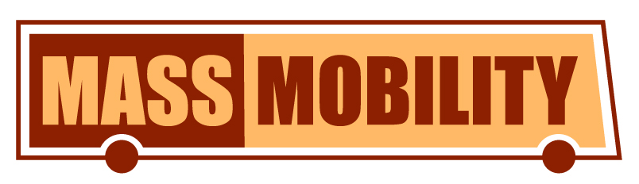

Source of population data for Adams, Clarksburg, Cheshire, Florida, North Adams, Savoy, and Williamstown is the 2010 Census, U.S. Bureau of the Census.

