Silviculture Prescription
Shear Pin

Massachusetts Department of Conservation and Recreation
Bureau of Forestry

Northern Berkshire District
Savoy Mountain State Forest
Savoy, MA

Prepared by:

Kevin Podkowka – Management Forester – Northern Berkshire District
Massachusetts Department of Conservation and Recreation
P.O. Box 1433, 740 South Street, Pittsfield - MA 01202
kevin.podkowka@state.ma.us – 413-442-8928 ext. 125

Date

Approved by:

Management Forestry
Program Supervisor ______________________________ Date:___________
William N. Hill, CF

Site Data
Geology
This project is located within the Hoosic Mountain Range between Lewis Hill to the north and Borden Mountain to the south. The portions of the project area north of Adams Road, slope downhill between 5% and 10% to Ross Brook. The area on the south side of Adams Road is between 15% and 25% slope on an eastern aspect of a small hill. The parent material is generally a glacial till derived from granite, mica schist, or phyllite. This project area is at elevations between 1,900’ and 2,500’.
Soils
There are 3 primary soil associations within the project area, and are as follows: 69% in the Marlow series, 18.7% in the Lyman series, and 12% in the Pillsbury series. These series have several elements in common such as: they are moderately deep to deep (28”– 65” + to bedrock), all the textures contain a significant loam component, and all are very stony. These soils are also moderate to highly erodible and have high rutting potentials. Strict adherence the Massachusetts Forestry Best Management Practices, and potentially extra measures, will be required to minimize the potential for site degradation due to erosion and/or rutting. The site index for sugar maple (Acer saccharum) is 55 – 61, while the site index for white pine (Pinus strobus) is 60-75.
According to the Forest Productivity and Stand Complexity Model (Goodwin, Hill. 2012) approximately 80% of the project area is within the highest tiers of the productivity model, while all but 2 acres of the remaining 20% of the area are within the upper half of the productivity scale. The 2 acres is located at the very top of a large hill which would typically have shallower soils and more extreme weather conditions. Highly productive sites typically have higher rates of recruitment in both tree and ground cover species, lower mortality rates post-harvest in the residual stand, and the residual trees are quicker to utilize the more abundant resources by increasing health, vigor, and growth in both height and diameter; when compared to low productivity sites. A complete soil map, MAP 2, is attached.
Climate
The mean annual temperature for the sale area is 41⁰F with an average of 46” of preciptation per year. Tropical storm systems do not routinely affect this area, but do occasionally move through, with the most recent being Tropical Storm Irene in 2008. Nor’easters and strong cold fronts from Canada have the potential for major impacts and occur more regularly. Other erratic weather events such as ice storms, early season blizzards, microbursts, and even tornados are not uncommon. Fires are also known to occur during times of drought or extended periods of dry and windy conditions and may increase in frequency and severity in the future. This is because winters are expected to be shorter, warmer, and with less precipitation potentially lengthening spring and fall, which is when most fires occur in the northeast. The frequency of storms and the amount of precipitation is also expected to increase in the future during the summer months. According to the US Forest Service Climate Change Tree Atlas northern hardwoods and spruce/fir stands will most likely decrease. Savoy Mountain State Forest may have several natural communities and tree species that will exist within current ranges well into the future, due to the mitigating properties of elevation on warming temperatures. Another issue that comes with warmer, shorter winters; pests such as hemlock wooly adelgid will become more destructive, as cold winters are required to moderate their populations.
Hydrology
The wetland resources indicated on MAP 1 have been located. They currently consist of a mixture of both perennial and intermittent streams serving as boundaries for all sale areas on the north side of Adams Road. There are not any water resources currently identified on the south side of Adams Road within the sale area. Also indicated on MAP 1, are the potential locations of filter strips that will be used for water and wetland resource protection. All activities conducted within, or near, delineated filter strips and wetlands will be compliant with current Massachusetts Forestry Best Management Practices. Water resources encountered during the marking phase of the project, that do not currently appear on MAP 1, include small intermittent streams and wooded wetlands that were too small to detect during the initial DEP wetland mapping project. If additional wetlands such as non-certified vernal pools, additional intermittent streams, upland wetlands, etc. are encountered; standards outlined in the most recent edition (currently 2013 2nd edition) of the Massachusetts Forestry Best Practices Manual will be followed as they relate to harvesting requirements, filter strips, water bars, slash management, etc. The recommendations submitted by the DCR Ecologist will be adhered to as applicable. The comments are as follows: “Due to the sensitivity of the site and the probability of additional seeps and 1’st order streams onsite that may not be shown on the DEP layer, I recommend that all seeps, springs, and small streams observed in springtime onsite be flagged and protected from heavy equipment. In filter strips, cutting and skidding of timber should also be very limited, in order to reduce impacts to moist or erodible soils, existing hydrology associated with seeps and springs, and species of conservation concern that may depend on these sensitive areas and microhabitats.”
Potential Vegetation
The project area currently supports most of the potential vegetation that is typical to the respective natural communities and forest cover types. Based on the productivity of soils, and the prevailing topography, the area was most likely cleared for agriculture; but it did not persist for an extended period of time. The five acres of hemlock was likely to have been planted in Norway spruce by the Civilian Conservation Corps, as Savoy Mountain State Forest in general, and other plantations in this area particularly, are the sites of similar types of work. Overstory tree species present include sugar maple, red maple (Acer rubrum), white birch (Betula papyrifera), yellow birch (Betula alleghaniensis), white ash (Fraxinus americana), eastern white pine (Pinus strobus), black cherry (Prunus serotina), black birch (Betula lenta), Eastern Hemlock (Tsuga canadensis), balsam fir (Abies balsamea) and American beech (Fagus grandifolia). Ground cover, shrubs, and small tree species include princess pine (Lycopodium spp.), various ferns, Canada mayflower (Maianthemum canadense), serviceberry (Amelanchier spp.), striped maple (Acer pensylvanicum), hobblebush (Vibernum lantanoides), trillium (Trillium spp.), rubus (Rubus spp.), Indian cucumber (Medeola virginiana), and trout lily (Erythronium americanum).
Site Productivity
An analysis was conducted across all properties managed by the Bureau of Forestry to assess site productivity and complexity using Geographic Information System (GIS) data layers of Prime Forest Soils, Potential Vegetation Complexity, Late Successional potential, Forest Diversity, Early Successional potential, CFI Site Index, and CFI Stand Structure (Goodwin, Hill, 2012). The analysis found that there is a very close correlation between the stands present and the productivity of the sites. Generally, the sugar maple dominated stands are the most productive and complex, followed by the beech-birch-maple, the hemlock stand, and finally the mixed northern hardwood stand is the least productive and complex.

Archeological and Cultural Resources
The DCR archeologist noted that there are “No known or significant historic or archaeological resources in the project parcel. “ Any cultural resource features located before or during the forestry project will be protected according to guidelines set forth in the Bureau of Forestry Cultural Resource Management Protection Standards and Guidelines and indicated on harvest maps accordingly. All cultural resources will be staked and flagged prior to harvesting.
Additional actions that are intended to protect cultural resources include:
- GPS, photograph, flag/protect and avoid cellar holes, stone walls, wells, trash pits and other associated cultural features located within the project area.
- Existing breaks in stone walls will be utilized to protect the integrity of the stone walls.
- Existing roads, landing areas and skid trails will be re-used during operations.
- Trees will be felled away from the road.
- Timber Sale Contract language designed to protect cultural resources requires timber harvesters immediately report any undocumented cultural resources.

Stand Data
The Shear Pin Forest Management Project is approximately 75 +/- acres in size with 4 +/- acres of beech-birch-maple, 20 +/- acres of sugar maple, 3 +/- acres of hemlock, and 5 +/-acres of mixed northern hardwoods. As the sale is marked the final project acreage will most likely change to some degree due to areas that are inoperable, skips in treatment the create internal reserves, currently unidentified hydrologic resources, etc.
Stand and Parcel History

The hemlock portion of the sale area was most likely planted by the Civilian Conservation Corps, as it appears to be a continuation of previously identified plantations. However, unlike most of the remaining plantation, the Norway spruce died and were naturally replaced with hemlock and a small component of balsam fir. The areas to the south and west of the plantation were most likely cleared for building materials and/or agriculture. Based on the richness of the site, the condition of the soils, and topology; these prior activities did not last long. Areas that were in agricultural production or grazing for long periods of time are usually lacking in topsoil, have groundcover species associated with old fields, and many times lack trees such as ash and sugar maple that require deep and rich soils. Based on the stand and parcel history the vast majority of trees within the project area are young mature to mature trees that are anticipated to respond well to silvicultural treatments. Cellar holes have been located along Bannis Road and on the north side of Adams Road as further evidence of previous occupation.

Forest Stand Attributes
Beech – Birch – Maple Stand
This is generally a single-aged stand, with an overall density of approximately 110 ft²/acre of basal area. The primary composition of this stand is red maple, yellow birch, sugar maple, American beech, and white ash. There are also minor components of white birch, black cherry, and black birch. North of Adams Road the stand becomes richer with increasing densities of white ash and sugar maple north and downhill of the road. The stands within the project area that are located on the south side of Adams Road transition into a sugar maple dominated stand near the center, with species compositions and densities mimicking the transitions north of the road. There is minimal ground cover due to the high shading within the stand. Silvicultural treatments will focus on creating new age classes and increasing diversity within the ground cover.
Hemlock Stand
This stand was originally typed and proposed as a spruce-fir stand, but upon conducting the stand exam, the forest type has been updated to an eastern hemlock stand with a small balsam fir component. The stand has an approximate density of 120 ft²/acre of basal area and is dominated by a single age class. This stand is the wettest and most poorly drained of all the stands located in the project area. Ground cover includes princess pine, Indian cucumber, and Canada mayflower. Silvicultural treatments will be designed to recruit more balsam fir and allocate more growing resources for residual hemlocks.
Sugar Maple Stand
Sugar maple stands generally share the same species composition as a beech-birch-maple stand, with the exception that sugar maple will constitute at least 30% of the stand and have the highest density of any single species. As with the previously mentioned beech-birch-maple stand densities are approximately 110 ft²/acre of basal area. Within the project area the Sugar Maple Stand is dominated by sugar maple and white ash with lower densities of American beech, red maple, and yellow birch. The primary reason for the existence of the sugar maple stand is that they are located on rich mesic sites, with little to no previous long-term agricultural use.

Farming and grazing practices employed until the early 1900’s usually left areas lacking in topsoil, depleted of nutrients, and were generally compacted due to plowing and livestock. The project site in general, and the sugar maple stands in particular, exhibit no such signs of degradation.

Mixed Northern Hardwoods

During the proposal process the area was identified as Upland Birch-Red Maple, however, during the stand exam it was determined to be a 5-acre clearcut installed in 1998 as part of a larger 60-acre project that included single tree selection. The 5-acre clearcut is in the process of regenerating while the remaining 55 acres treated with a single tree selection system has grown and recovered to a point where another entry is appropriate, and is a component of this management project. The species that were most abundant within the 5-acre mixed northern hardwoods stand include: striped maple, yellow birch, white birch, and red maple. The 5-acre mixed northern hardwood stand will not have any silvicultural treatments included as part of this project.

Stand Exam
A stand exam of the project area was completed in June of 2019. For the purposes of this prescription all stands within the project will be considered as a single population because the beech-birch-maple stand and sugar maple stand account for 94% of the project area. These stands have similar soils, species composition, hydrology, etc. The hemlock stand accounts for only 6% of the total project area and silvicultural activities will be the same as those found in the Beech-Birch-Maple stand. The results of the stand exam are as follows:
Figure 1 – Species Composition of the Project Area Overstory (5”+ dbh)

Table 1 – Stocking Diagnostics of the Project Area

Stocking Diagnostics
 |  |  |  |  | % | Relative
Species |  |  | Total | Total | BA/ac | Density
 |  |  | Trees/Acre | BA/Acre | by Species
Hemlock |  |  | 19.6 | 13.0 | 12% | 5.9
Balsam Fir |  |  | 6.9 | 3.0 | 3% | 1.4
Sugar Maple |  |  | 41.0 | 32.5 | 29% | 26.1
Red Maple |  |  | 27.9 | 25.0 | 23% | 20.1
White Ash |  |  | 6.9 | 10.0 | 9% | 7.8
Black Cherry |  |  | 3.3 | 2.5 | 2% | 2.0
White Birch |  |  | 2.1 | 4.0 | 4% | 3.9
Yellow Birch |  |  | 26.3 | 9.0 | 8% | 7.7
Black Birch |  |  | 3.2 | 2.0 | 2% | 0.0
American Beech |  |  | 42.1 | 8.5 | 8% | 7.8
Norway Spruce |  |  | 1.6 | 1.0 | 1% | 0.4
Total |  |  | 180.9 | 110.5 | 100% | 83
  Median Stand Diameter ->> | 14.3 | 85% | <<- Estimated Relative Density

Table 2 – Advanced Regeneration Table 3 - Ground Cover within the Project Area
SPECIES | AVG. % COVER
Christmas Fern | 0.02
Trout Lily | 0.10
Lycopodium | 0.32
Elderberry | 0.05
Ground Cedar | 0.15
Starflower | 0.02
Partridge Berry | 0.13
Clover | 0.25
Goldthread | 0.13
Celandine | 0.05
Unidentified Herbs | 0.02
Sensitive Fern | 0.02
Turtlehead | 0.07
False Heleborne | 0.05
SPECIES | Stems/Acres
American Beech | 1028
Red Maple | 120
Yellow Birch | 428
Sugar Maple | 68
White Ash | 6
Grey Birch | 9
Hemlock | 58
Red Spruce | 13
Balsam Fir | 6
Musclewood | 2
White Birch | 4
SPECIES | AVG. % COVER
Hay-Scented FERN | 13.63
Canada Mayflower | 1.15
False Solomon Seal | 0.32
Grasses | 0.35
Rubus | 2.08
Witch Hazel | 0.42
Sarsasparilla | 1.05
Trillium | 0.52
Wood Aster | 0.18
Hobble Bush | 9.92
Mountain Maple | 0.13
Bindweed | 3.00
Indian Cucumber | 0.37
Figure 2 – Harvest and Residual Volumes Using Thinning and Group Selection

Harvest Volumes Residual Volumes
Species | Sawtimber | Cords
Hemlock | 12,468 | 4
Balsam Fir | 1,776 | 2
Sugar Maple | 12,742 | 6
Red Maple | 103,319 | 43
White Ash | 63,222 | 57
Black Cherry | 2,064 | 1
White Birch | 7,880 | 5
Yellow Birch | 17,648 | 18
Black Birch | 5,253
American Beech | 51,222 | 31
Norway Spruce | 4,378 | 10
Total | 281,972 | 175

Species | Sawtimber | Cords
Hemlock | 112,214 | 32.8
Balsam Fir | 15,985 | 16.2
Sugar Maple | 242,089 | 112.6
Red Maple | 103,319 | 42.6
White Ash | 7,025 | 6.3
Black Cherry | 4,815 | 2.8
White Birch | 18,387 | 10.5
Yellow Birch | 41,180 | 40.9
Black Birch | 12,258
American Beech | 5,691 | 3.4
Norway Spruce | 0 | 0.0
Total | 562,964 | 268.1

Within the Shear Pin forest management project area, it is estimated that there is 458 ft³/ac of course woody debris (CWD) on the ground. The minimum retention guideline listed in the DCR Management Guidelines (2012) is 256 ft³/ac. As such this project is well within the established standards and practices of CWD retention..
Aesthetic Resources
Roads and trails that will be impacted by the harvest are Adams Road, Bannis Road, Lewis Hill Snowmobile Trail, and Balance Rock Trail. Though none of these are designated scenic byways, maintaining the visual experience for the users of these roads and trails is a high priority. In order to ensure that this occurs, slash management and harvest guidelines outlined in the 2013 2nd Edition of the Massachusetts Forestry Best Management Practices Manual will be followed.
Recreation Resources
The resource based recreational activities that most forest users participate in throughout the sale area, are hiking, hunting, snowmobiling, and wildlife viewing. Adams Road and Lewis Hill Snowmobile Trail both serve snowmobiles during the winter, and Balance Rock Trail is currently only used for hiking but was also a snowmobile trail prior to Tropical Storm Irene. Snowmobiles will most likely be restricted from using Lewis Hill Snowmobile Trail during logging operations in order to protect state threatened plants located on the trail. Portions the Lewis Hill Snowmobile Trail will be utilized for skidding, but there are areas that were identified during the rare plant survey that are required to have the trail moved outside of the current footprint. The portions of the skid trail that will be created for operations will most likely become the new trail in order to continue the protection of the plant. Natural Heritage also noted that by moving the skid trail, and as a result increasing sunlight, that there is a high potential for increasing the size of the current population of the threatened plants. In order to mitigate the seasonal loss of Lewis Hill Snowmobile Trail to the snowmobile user group, a permanent bridge will be placed over Ross Brook on the Balance Rock Trail prior to the start of harvesting. The permanent bridge is to replace the culvert that was lost during Tropical Storm Irene. Both Lewis Hill Snowmobile Trail and Balance Rock Trail intersect Tannery Road. Measures will also be taken to improve the approaches to the current snowmobile bridge on Lewis Hill Snowmobile Trail, as they are causing the sensitive wetland area around the bridge to significantly erode.

Threatened and Endangered Species

There were multiple populations of threatened plants located within the project area. A survey and pre-filing review were conducted by Department of Fish and Wildlife Natural Heritage Program and the DCR in July of 2019. Maps and requirements have been submitted and will be followed during this operation. The main requirements that were generated are as follows: logging must take place during frozen conditions, the skid trail planned for Lewis Hill Snowmobile Trail must be routed around the identified threatened plant populations (which is no longer necessary based on the layout of the sale), the landing located near the intersection of Lewis Hill Snowmobile Trail and Adams Road must be removed and the skid trail routed to the west, there will be no slash disposal in the areas of the identified populations of threatened plants.
Wildlife
Species

The wildlife occurring in this area is typical of northern forests. Observed species include black-capped chickadee, ruffed grouse, blue jay, and common crow. Other species expected to occur are black bear, various songbirds, raccoon, various fur bearers, grey squirrel, various raptors, and other small mammals such as bats and rodents.

The Massachusetts Division of Fish and Wildlife (DFW) commented that “The proposed Irregular shelterwood with group selection and variable density thinning within the 55- acre stand of beech-birch-maple makes good sense and should enhance wildlife food production through retention and release of >14" dbh disease free beech. The proposed clearcut with clustered reserves within the 5-acre Norway spruce stand should provide a meaningful patch of young forest habitat with excellent cover resources from retention groups featuring native red spruce, Eastern hemlock and balsam fir. The proposed thinning to regenerate/release sugar maple using openings of up to 1/3 acre in the 5 acres of sugar maple makes good sense. Short term wildlife habitat impacts from the thinning will likely be negligible, but that's fine - keeping sugar maple on the landscape is meaningful in and of itself. MassWildlife suggests that DCR actively determine if any of the sugar maple area on the east slope of Borden Mountain supports Rich Mesic Forest. The proposed clearcut of the 5-acre, low site quality stand of birch-red maple should provide a meaningful patch of young forest habitat that will benefit several species of conservation need identified in the State Wildlife Action Plan (SWAP).”
The DCR will alter the DFW recommendations particular to the clearcut with reserves in the Norway spruce, and the clearcut within the birch-red maple stand because the stands have been ground truthed as hemlock instead of Norway spruce, and the previously identified stand of birch-red maple stand is actually a regenerating clearcut.
Snags and Retained Live Trees
All snags will be retained on-site provided they do not pose a hazard to humans during or after operations. Live trees that appear to be a den or nest site either currently or in the recent past will also be retained. Trees that are evaluated to have potential future value as a den or nest site will be retained at a rate of approximately 5 trees per acre per Bureau of Forestry Guidelines.

Evaluation of the Data and Projected Results

The Massachusetts Department of Conservation and Recreation has developed a list of ecological services and benefits derived from active forest management of Woodland Zones (Exhibit 1). The following are lists of goals and objectives for the Shear Pin Forest Management Project and the associated ecological services and benefits that are satisfied.

Goals and Objectives of the Shear Pin Forest Management Project
Goal 1: Successful Implementation of Silvicultural Prescription (MA DCR Goal – Production of Wood Products, Diversified Habitats, Carbon Stock Management, Water, Recreational Opportunities).
Objectives
      - Residual relative density of 65% within the entire project area. Basal areas between 53 ft² and 75 ft² BA/ac within the beech-birch-maple stand, between 50 ft² and 60 ft² within the sugar maple stand, and between 80 ft² and 100 ft² within the hemlock stand.
      - No cutting or harvesting within filter strips.
      - No cutting or harvesting within 75’ of cemeteries
      - No loss of undesignated wood
      - Ensure harvesting contractor compliance with all BMP’s.
      - Frequently monitor operations to minimize and/or mitigate damage to the site.
      - Ensure full understanding of contractual requirements by the harvesting contractor.
Residual basal area ranges provided within the objectives and the Silvicultural Prescription section were determined using the Fox DS Cruiser version 2007.2 Workhorse (New Hampshire Forests & Lands Staff, 2009) which analyzes inventory data gathered in the field, and comparing those results with stocking tables located in the Silvicultural Guide for Northern Hardwoods in the Northeast (Leak et al., 2014)
Goal 2: Adequate Stocking in Single Tree and Group Selection Areas (MA DCR Goal – Diverse Habitats & Carbon Stock Management).

Objectives

- 500+ stems per acre of healthy native hardwood or softwood regeneration across the stand, except those species which can dominate a site; i.e.: striped maple, pin cherry, etc.; at 5 years post-harvest.

Goal 3: Increase biological diversity and introduce more complexity into existing stands (MA DCR Goal – Diverse Habitats & Water).

Objectives

- Install gaps within the beech-birch-maple stand and hemlock stand in order to create early successional habitat and begin a new age class of trees.

Silvicultural Prescriptions
Emerald Ash Borer Mitigation
White ash trees greater than 10” in diameter will be biased for harvest due to the presence of emerald ash borer (EAB) in Berkshire County and specifically the Town of Windsor. This forest pest has an approximate mortality rate of 99% on infested ash trees.
Beech Bark Disease Complex Mitigation
Beech greater than 6” in diameter and showing signs of BBD will be biased for removal. Healthy beech trees with no signs of infection and 10” + in diameter will be biased for retention. Reduction of beech within the stand may be upward of 80% and will be conducted as a low density shelterwood residual basal area of approximately 20 ft² of basal area per acre while retaining live tree guidelines present in the 2012 DCR Management Guidelines. The increased light conditions will create a situation where species with lesser shade tolerances will be able to establish and grow faster than the beech. Post-harvest, the entire project area will be monitored for potential beech expansion into areas that currently have beech at low densities, or increased proliferation. Herbicide treatments may be necessary in order to reduce beech densities and increase the diversity of tree, shrub, and herbaceous species.
Beech – Birch – Maple Stand
An expanding-gap variant of the irregular shelterwood system (Raymond et al., 2009) will be used. This type of system works by creating gaps in the forest canopy through harvesting and expanding those gaps through each successive entry. In order to facilitate future entries and perpetuate the system, gaps will be installed systematically throughout the sale area. Installed gaps will be no less than 1/10 of an acre and will not exceed 1/3 of an acre; however, the final size of each gap will be determined according to the conditions present on the ground. The stand will also be thinned between the installed gaps using variable density thinning within the range identified.
The purpose of this system will be to maintain diversity; i.e.: biological, density, age, size, and successional; manage for superior crop trees; pre-salvage white ash; create horizontal and vertical structural complexity; and control understory beech. This will be accomplished by:
- The introduction of a new cohort of regeneration by expanding initial gaps with each successive entry
- Retaining legacy trees in the overstory;
- Varying thinning densities which will create a range of tree densities and light conditions in the understory
- Removing trees that are not expected to survive until the next silvicultural entry, freeing up resources and growing space
- Promoting crop trees that are financially and ecologically desirable

The target residual basal areas for those areas that are selected as groups will be between 0 ft² and 20 ft² per acre, while retaining advanced regeneration of tree and ground cover species that do not tend to dominate a site. Those areas that are thinned between gaps will have a target between 53 ft² BA/ac and 75 ft² BA/ac.
Hemlock Stand
Variable density thinning will be used to target trees with poor form, poor health, and/or poor vigor of all species within the stand. Red spruce and balsam fir will be targeted for release, and very small group selection openings will be utilized to encouraging the recruitment of balsam fir and red spruce without encouraging hardwood. Surviving Norway spruce will be removed to the extent possible without exceeding a 1/3 acre opening. The silvicultural techniques employed within this stand are designed to increase the diversity of the overstory while retaining the best growing stock. Residual basal area targets will be between 80 ft² and 100 ft².
Sugar Maple Stand
Thinning will be used to increase the density of sugar maple relative to all other species within the stand and encourage growth on residual trees. Target densities will be between 50 ft² and 60 ft² of basal area with the intention of maximizing crown development and diameter growth without encouraging epicormic sprouting. The policy of the DCR is to where feasible, manage forest stands for an uneven-age distribution, however, the occurrence of sugar maple dominated stands on the landscape is uncommon. This stand is approximately 100 – 120 years old which is mature for sugar maple, but far from the ages associated with natural mortality. As such, the need to begin a new age class is not pressing. Also, since sugar maple has an intermediate tolerance to shade there will be saplings and small pole sized trees in the understory. With the decrease in competition that follows thinnings, these poles and saplings will be released and become components of the next age class even though this is not a specific goal of the treatment.

Short Term and Long Term Desired Future Conditions

Short Term (Present – 100 years)

Beech-Birch-Maple

Ground cover density, diversity, and distribution are expected to increase. Advance regeneration will develop into desirable growing stock, most likely: birches, maples, beech, white ash, and possibly oak. Sun exposure should limit the growth of beech and provide the opportunity for more tree and ground cover species to escape beech brush shading prior to crown closure.

Sugar Maple Stand

Sugar maple densities are increased, and residual trees begin to significantly increase in diameter and crown area. Understory groundcover, especially shade-loving plants, is increased in both density and distribution. Understory sugar maple saplings and poles are released and gradually fill in around the more advanced age classes.

Hemlock Stand

Large hemlocks will continue to mature and age, and the densities and distribution of both balsam fir and red spruce will increase. Once the combined densities of red spruce and balsam fir exceed 50% a transition to an irregular shelterwood method with rotational targets will be examined. Ground cover density, diversity, and distribution will increase, especially those that prefer acidic soils. Hardwood encroachment will be minimal.

Long Term (100 years +)
Ground cover densities, distribution, and diversity will be maintained through subsequent silvicultural entries. Gap-expansion will be used in those areas that had gaps established in the previous entries. Sugar maple, balsam fir, and red spruce should become more plentiful as competition is reduced and cutting practices that recruit and promote these species are implemented. An uneven-aged condition, representing the entire spectrum of natural community development from early successional to old growth, will be found throughout the area.

Logging System Requirements
Conventional and mechanical harvesting equipment will be permitted. All delimbing will occur in the woods. Equipment should not exceed 6 psi ground pressure. Adams Road will be used for hauling designated timber off state-owned lands and portions of the Lewis Hill Snowmobile Trail will be used for forwarding and/or skidding. Harvesting will only occur under frozen or dry conditions, as per the requirements stipulated by Natural Heritage. Generally, all trees will be felled into the stand and slash will remain in that location unless required for the skid trail stabilization. Deviations from this will be reviewed on a case-by-case basis by the forester-in-charge or their designee. Currently, 2 stream crossings are anticipated which may increase or decrease during marking operations.
Haul Roads
The haul road for the sale is Adams Road and potentially Bannis Road.
Skid Trails
Primary skid trails have been identified in MAP 1. No previous skid trails were located during the stand exam so the installation of additional skid trails will be required. Skid trails will be marked prior to the start of harvesting activities, and it is understood that minor changes to the routes may be required during operations. All proposed changes will be reviewed on a case-by-case basis by the forester-in-charge and/or Program Supervisor as required. Prior to leaving the harvest areas all skid trails will have water bars installed, and excess disturbance will be mitigated.
Landings
Preliminary landings have been located and are shown on MAP 1. Additional landings may be required but are not anticipated. Any additional landings that may be required will use existing openings or gaps when possible. Prior to leaving the sale, all landings will be smoothed, logging residue will be moved into the woods, and the landings will be seeded.

REFERENCES
Goodwin, D.W. and W.N. Hill. 2012. Forest Productivity and Stand Complexity Model [A GIS Grid Analysis using ArcGIS®]. Massachusetts Department of Conservation and Recreation, Amherst, MA.
Soil Survey Staff, Natural Resources Conservation Service, United States Department of Agriculture. Official Soil Series Descriptions. Available online. Accessed [11/30/2017]
Natural Heritage & Endangered Species Program Staff. Massachusetts Division of Fisheries and Wildlife. NHESP Priority Habitats of Rare Species. Available Online. Accessed [11/30/2017]
Leak, Yamasaki, Holleran. 2014. Silvicultural Guide for Northern Hardwoods in the Northeast. US Forest Service Northern Research Station.
New Hampshire Forests & Lands Staff. 2009. Fox DS Cruiser ver 2007.2 Workhorse. New Hampshire Forests and Lands, Concord, NH.
Massachusetts Department of Conservation and Recreation Staff. 2012. Landscape Designations for DCR Parks & Forests: Selection Criteria and Management Guidelines. Massachusetts Department of Conservation and Recreation, Boston, MA.
Raymond, Bèdard, Roy, Larouche, Tremblay. 2009. The Irregular Shelterwood System: Review, Classification, and Potential Application to Forests Affected by Partial Disturbances. Society of American Foresters Journal of Forestry.
Prasad, A. M., L. R. Iverson., S. Matthews., M. Peters. 2007-ongoing. A Climate Change Atlas for 134 Forest Tree Species of the Eastern United States [database]. https://www.nrs.fs.fed.us/atlas/tree, Northern Research Station, USDA Forest Service, Delaware, Ohio.

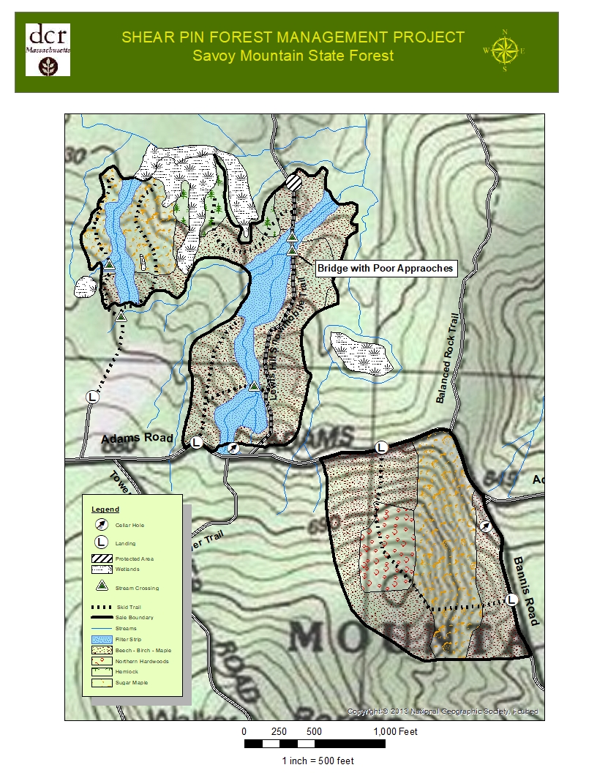
MAP 1

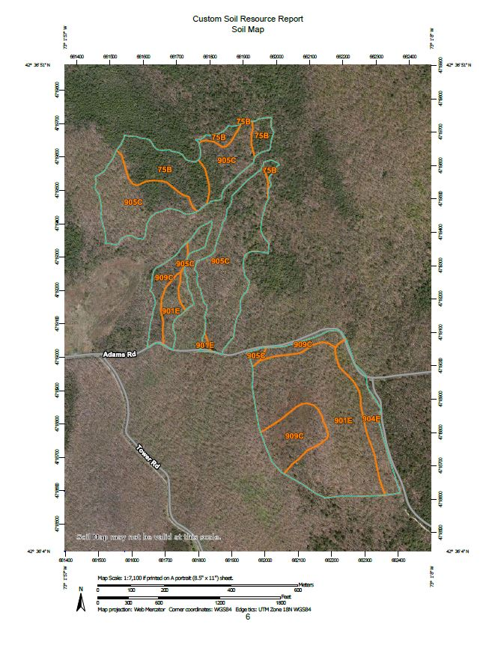
MAP 2

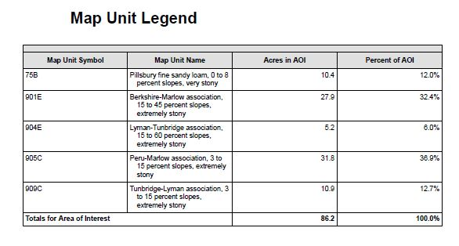

MA Department of Conservation and Recreation
Division of State Parks and Recreation
Woodland Zone

The Mission of the Bureau of Forestry Management Forestry Program in lands designated as Woodland on State Forests, Parks and Reservations is to provide ecosystem services and benefits associated with active forest management.
Ecosystem services that are provided through active forest management on the Woodland landscape are:
- Production of wood products that is ecologically and economically sustainable benefiting local economies.

- Water quality protection and enhancement of water supply.

- Diverse habitats that range from early seral vegetation to late successional forest encompassing many structural components and provide protection from extreme disturbance events.

- Recreational opportunities that are safe and fitting for their location determined in conjunction with the Operations staff of the Division of Parks and Recreation

- Carbon stock management using innovative and scientific forest management methods for increasing sequestration.

- Forest management on DCR forests, parks, and reservations endeavors to demonstrate excellent forestry practices to private landowners and the public.

- The ecosystem services that state lands provide will be balanced across the landscape and the scale of time where they are deemed appropriate.

Basal Area is the cross-sectional area of a tree 4.5 feet above ground. The basal area of all trees in a given land area describes the degree to which an area is occupied by trees.

