INDOOR AIR QUALITY ASSESSMENT

Sheffield Town Hall
21 Depot Square
Sheffield, Massachusetts

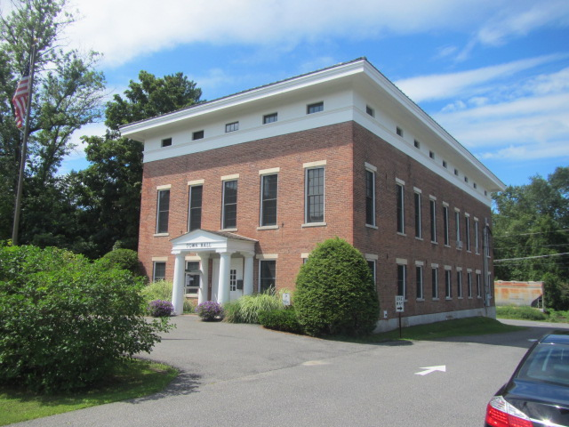

Prepared by:
Massachusetts Department of Public Health
Bureau of Environmental Health
Indoor Air Quality Program
November 2015

Background
Date of Assessment: | August 21, 2015
Building: | Sheffield Town Hall (STH)
Address: | 21 Depot Square, Sheffield, Massachusetts
Assessment Requested by: | Rhonda LaBombard, Town Administrator
Massachusetts Department of Public Health/Bureau of Environmental Health (MDPH/BEH) Staff Conducting Assessment: | Michael Feeney, Director, Indoor Air Quality (IAQ) Program  Stefanie Santora, Research Analyst, IAQ/Radon Unit
Date Building Constructed: | 1800s, with renovations in the 1990s
Reason for Request: | Concerns related to general air quality

Building Description

The STH is a three-story brick and wood building originally constructed in the early 1800s. It has a basement with a fieldstone foundation that is partially below grade. Building renovations in the 1990s included the addition of an elevator, which was constructed inside the southwest corner of the original building. The basement contains a vault, the mechanical room for the elevator, a combination furnace/air handling unit (AHU) system, oil tank, and space for utilities. The STH utilizes both the third floor and basement as storage space. Windows in the building are openable.
Note that the first floor is supported from the basement with a combination of wood pillars (Picture 1), brick columns (Picture 2), house jacks (Picture 3), and steel I-beams connected to permanent metal columns (Picture 4).

Methods
Please refer to the IAQ Manual for methods, sampling procedures, and interpretation of results (MDPH, 2015).

Results
This space is occupied by approximately 15 employees. Members of the public also visit daily. Test results are presented in Table 1.

Discussion

Ventilation
It can be seen from Table 1 that carbon dioxide levels were below 800 parts per million (ppm) in all areas measured, indicating adequate air exchange at the time of the assessment. It should be noted that most areas of the STH were sparsely occupied and that carbon dioxide levels would be expected to rise with increased occupancy (e.g., meetings). The first floor of the STH is connected to the AHU system located in the basement. This AHU provides recirculated air that is heated/cooled, but does not have a source of fresh air. Return air is drawn into floor-mounted vents (Picture 5) and returned to the AHU unit. MDPH recommends HVAC system have a fresh air supply and that the unit operates continuously during periods of occupancy.
The second floor of the STH is not ventilated by the AHU located in the basement. Windows are openable, and window-mounted air conditioners are used to provide cooling during hot weather.

Temperature and Relative Humidity
Temperature measurements in occupied areas at the time of the assessment ranged from 74°F to 79°F (Table 1), which were mostly within the MDPH recommended comfort range. Relative humidity measurements in occupied areas at the time of the assessment ranged from 52 to 60 percent (Table 1), which were within the MDPH recommended comfort range. The MDPH recommends a comfort range of 40 to 60 percent for indoor air relative humidity. Relative humidity was above 60 percent in unoccupied spaces (the basement and third floor).

Microbial/Moisture Concerns
The basement of the STH has signs of significant water penetration through the basement walls. Water was noted on the floor near the front of the east wall (Picture 6). Staining on the floor indicates that water flows from the east wall towards the north wall, passing beneath a wall in the rear of the building near the northwest corner (Picture 7). The source of water entering the basement appears to originate from watering of plants in a garden around the front of the building (Picture 8). It is recommended that shrubbery and gardens be located at least five feet from a building’s exterior wall. Water from the garden can readily pass through the flagstone foundation, since it generally consists of piled stones with no mortar (Picture 9).
A second location at the base of the rear stairwell, near the elevator, had heavy accumulation of silt. The wall in this area had sunlight streaming in through a large gap near the building sill, corresponding to a cracked cement slab above the exterior south wall of the building (Picture 10). The purpose of the cement slab appears to have included support for a removed fire escape (Picture 11).
An access door was installed in the rear of the STH, which also appears to have repeated water penetration (Picture 12) due to lack of drainage for the exterior door well (Picture 13).
Water penetration has led to extensive water damage to gypsum wallboard that was installed in the basement as part of the 1990s renovation. Heavily mold-contaminated GW is present at the base of the front stairwell (Pictures 14 through 16). In addition, numerous water-damaged boxes containing records were noted on pallets in an area of water penetration (Picture 7). Mold contaminated GW and cardboard/paper cannot be cleaned and must be removed in a manner consistent with the US EPA document “Mold Remediation in Schools and Commercial Buildings” (US EPA, 2001).
The US EPA and the American Conference of Governmental Industrial Hygienists (ACGIH) recommend that porous materials be dried with fans and heating within 24 to 48 hours of becoming wet (US EPA, 2001; ACGIH, 1989). If porous materials are not dried within this time frame, mold growth may occur. Once mold has colonized porous materials, they are difficult to clean and should be removed and discarded.
Indoor plants were noted in some areas. Plants can be a source of pollen and mold, which can be respiratory irritants to some individuals. Plants should be properly maintained and equipped with non-porous drip pans. Plants should also be located away from ventilation sources to prevent the entrainment and/or aerosolization of dirt, pollen, or mold.

Other IAQ Evaluations
Indoor air quality can be negatively influenced by the presence of respiratory irritants, such as products of combustion. The process of combustion produces a number of pollutants. Common combustion emissions include carbon monoxide, carbon dioxide, water vapor, and smoke (fine airborne particle material). Of these materials, exposure to carbon monoxide and particulate matter with a diameter of 2.5 micrometers (μm) or less (PM2.5) can produce immediate, acute health effects upon exposure. To determine whether combustion products were present in the indoor environment, BEH/IAQ staff obtained measurements for carbon monoxide and PM2.5.

Carbon Monoxide
Carbon monoxide should not be present in a typical, indoor environment. If it is present, indoor carbon monoxide levels should be less than or equal to outdoor levels. On the day of the assessment, outdoor carbon monoxide concentrations were non-detect (ND) (Table 1). No measurable levels of carbon monoxide were detected inside the building (Table 1). Of note is the condition of the flue connecting the furnace to the chimney, which is open to the basement (Picture 17). It is likely this opening is missing a barometric (pressure-controlled) damper. In this condition, products of combustion (including carbon monoxide) can readily enter the basement as the furnace operates.

Particulate Matter
Outdoor PM2.5 was measured at 17 μg/m³ (Table 1). PM2.5 levels measured in occupied areas indoors ranged from 15 to 17 μg/m³ (Table 1), which were below the NAAQS PM2.5 level of 35 μg/m³. Elevated PM2.5 levels were measured in the basement and on the 3rd floor (77 μg/m³ and 60 μg/m³, respectively).

Volatile Organic Compounds
In order to determine if VOCs were present, BEH/IAQ staff inspected areas for items containing VOCs. BEH/IAQ staff noted hand sanitizer, cleaners, and air fresheners at the time of the assessment. All of these have the potential to be irritants to the eyes, nose, throat and respiratory system of sensitive individuals.

Other Conditions
Other conditions that can affect IAQ were observed during the assessment. Of note are the conditions of brick walls and support pillars in the basement, which are part of the original construction on the building. When the AHU system ductwork was installed, bricks were removed from brick support walls to create an opening that accommodates the ductwork; these brick walls supports the first floor (Pictures 18 and 19). At the base of these support walls is a large amount of red brick dust (Picture 20). In the experience of BEH staff, brick deterioration is often attributable to exposure of brick to moisture. Water penetration over time causes both brick and mortar to disintegrate, resulting in the production of mortar and brick chips, red brick and white mortar dust, water staining, and efflorescence. Condensation from chilled air generated by the basement AHU may be contributing to increased moisture. Cold air flowing from open supply vents in the basement was noted during the visit. These supply vents should be closed during summer months to prevent condensation on the floor.
Because this dust appears to be exclusively red brick, forces other than water, such as friction from shifting of weight, is creating this fine brick powder. The openings cut into the brick wall likely created additional stresses on the remaining bricks. As the bricks deteriorate, an additional loss of brick cohesion may result in shifting of load, which may stress the bricks further as well as the support structures. A number of wooden support beams were found split in half (Picture 21), indicating that the supports are under excess stress and that their ability to carry loads has been reduced. The BEH/IAQ recommends that the Sheffield building inspector examine the integrity of these basement structures.
Signs of rodent infestation were observed throughout the STH. Mice footprints were found in red brick dust in the basement (Picture 22). There were holes/gaps around doors and in between fieldstone, which allow for easy access for rodents to enter the building. It is recommended that a comprehensive integrated pest management plan (IPM) be implemented to more effectively control rodents and other pests.
Many areas of the STH are carpeted. The Institute of Inspection, Cleaning and Restoration Certification (IICRC) recommends that carpeting be cleaned annually (or semi-annually in soiled high traffic areas) (IICRC, 2012). Regular cleaning with a high efficiency particulate air (HEPA) filtered vacuum in combination with an annual cleaning will help to reduce accumulation and potential aerosolization of materials from carpeting.

Conclusions/Recommendations
The conditions observed in the STH are somewhat complicated. The installation of a garden along the front of the building creates a condition for water to readily enter the basement, resulting in chronic moistening of GW. This and other water sources noted create conditions for porous materials (e.g., GW, cardboard, paper) to be chronically moistened, resulting in mold growth.
Short-term and long-term recommendations are provide to address the conditions described in this assessment and improve indoor air quality. The short-term recommendations can be implemented as soon as practicable. Long-term measures are more complex and will require planning and resources to adequately address the overall indoor air quality concerns within the building.

Short-term Recommendations
- Operate the AHU during all occupied hours. Use openable windows to supply fresh air to the first floor during clement weather, ensuring that all windows are close tightly at the end of each day.
- Operate the window-mounted air conditioners on fan-only mode when not needed for cooling to supply fresh air to second floor areas. Ensure they are maintained, including cleaning of filters, on a regular basis.
- Close vents from the AHU into the basement during the cooling season to prevent condensation on floors.
- Remove all mold-contaminated GW in a manner consistent with recommendations made in “Mold Remediation in Schools and Commercial Buildings” published by the US Environmental Protection Agency (US EPA, 2001). This document can be downloaded from the US EPA website at: http://www.epa.gov/mold/mold_remediation.html.
- Discontinue watering the garden in the front of the building.
- Consider relocating records stored in the basement to another location.
  - Note that these boxes, documents, books and other stored materials, in their current state, will continue to be a source of mold-associated particulates.
  - Since many of these materials appear to be public records, an evaluation concerning disposition of these materials must be made. Some items are required to be kept by law, and others may be valuable enough to be worthy of preservation/restoration.
  - Consider transferring items to electronic media if the physical items are not needed.
  - An evaluation should be done by a professional book/records conservator for items for which physical preservation is required. This process is expensive and specialized work and should be reserved for only the most valuable/irreplaceable items.
- Temporarily seal the hole in the exterior wall along the cement slab in the elevator stairwell to prevent water penetration.
- Clean the door well in Picture 13 as needed to reduce water penetration. Clean the door well drain if one exists.
- Maintain all indoor plants to prevent accumulations of debris and mold growth.
- Seal the open flue in the basement with a barometric damper or another appropriate method.
- For buildings in New England, periods of low relative humidity during the winter are often unavoidable. Therefore, scrupulous cleaning practices should be adopted to minimize common indoor air contaminants whose irritant effects can be enhanced when the relative humidity is low. To control for dusts, a high efficiency particulate arrestance (HEPA) filter equipped vacuum cleaner in conjunction with wet wiping of all surfaces is recommended. Avoid the use of feather dusters. Drinking water during the day can help ease some symptoms associated with a dry environment (throat and sinus irritations).
- An integrated Pest Management (IPM) plan should be developed for this building to address rodent issues in the basement.
- Refer to resource manual and other related indoor air quality documents located on the MDPH’s website for further building-wide evaluations and advice on maintaining public buildings. These documents are available at http://mass.gov/dph/iaq.

Long-term Recommendations
- Consider if it is feasible to add a fresh air make-up vent to the basement AHU.
- Consider removing the garden at the front of the building.
- Consider installing a water impermeable surface over the garden to limit water penetration into the basement. This surface should be sloped to drain away from the building.
- Replace water-damaged GW with cement board as was done in the elevator stairwell walls.
- Consult a building engineer as to the best method for preventing or minimizing water penetration through the foundation.
- Consult with a building engineer regarding replacing split wood support beams and house jacks with a permanent support system. Additionally, consult about the structural integrity of walls where the brick is significantly deteriorated.
- Examine the feasibility of either installing a drain in the floor of the rear exterior door well or installing a roof over the exterior door to prevent water penetration in the basement.

References
ACGIH. 1989. Guidelines for the Assessment of Bioaerosols in the Indoor Environment. American Conference of Governmental Industrial Hygienists, Cincinnati, OH.
IICRC. 2012. Carpet Cleaning FAQ 4 Institute of Inspection, Cleaning and Restoration Certification. Institute of Inspection Cleaning and Restoration, Vancouver, WA.
Massachusetts Department of Public Health. (MDPH). 2015. “Indoor Air Quality Manual: Chapters I-III”. Available from http://www.mass.gov/eohhs/gov/departments/dph/programs/environmental-health/exposure-topics/iaq/iaq-manual/
US EPA. 2001. “Mold Remediation in Schools and Commercial Buildings”. Office of Air and Radiation, Indoor Environments Division, Washington, DC. EPA 402-K-01-001. March 2001. Available at: http://www.epa.gov/mold/mold_remediation.html.

Picture 1
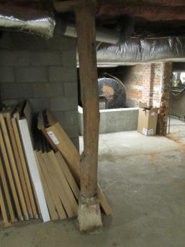
Wooden support pillar in basement
Picture 2
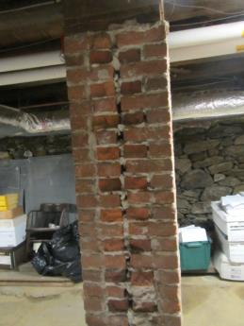
Brick support column
Picture 3
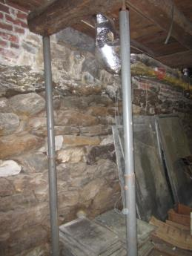
House jack
Picture 4
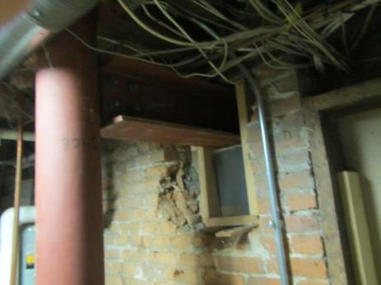
Steel I-beam and permanent metal column
Picture 5
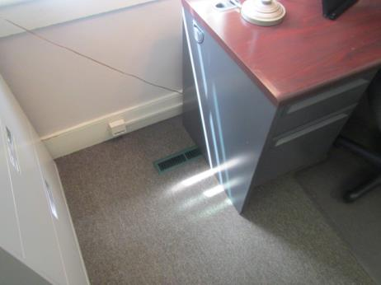
Floor-mounted vent on first floor
Picture 6
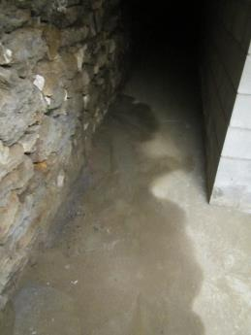
Water from foundation wall
Picture 7
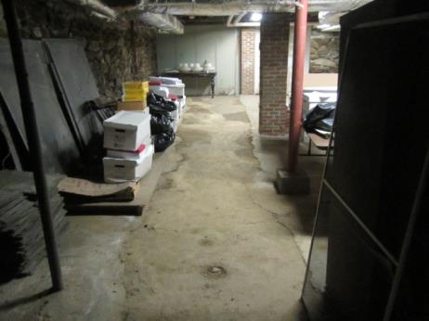
Signs of water flow beneath stored boxes toward northwest corner of basement
Picture 8
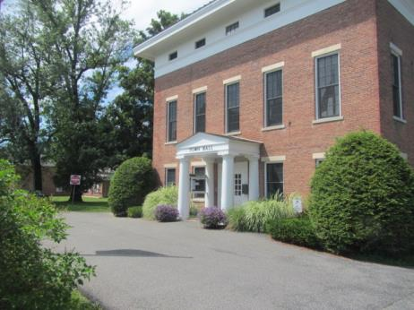
Garden above foundation where water enters the basement
Picture 9
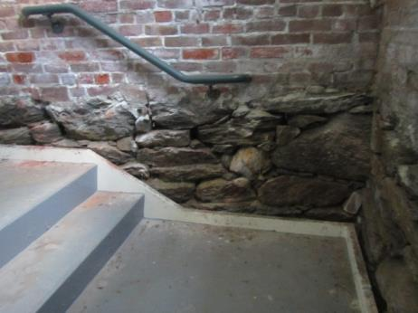
Field stone foundation with no mortar
Picture 10
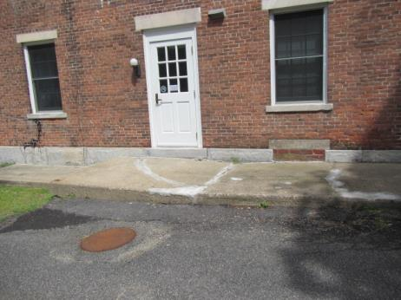
Cracked cement slab on exterior of the building
Picture 11
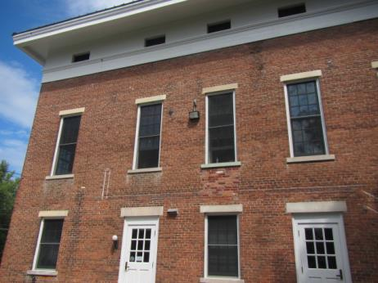
Wall with removed fire escape (Note white lines on wall)
Picture 12
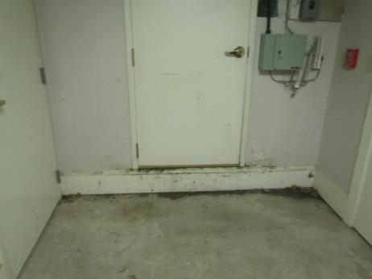
Water damage on inside of basement access door
Picture 13
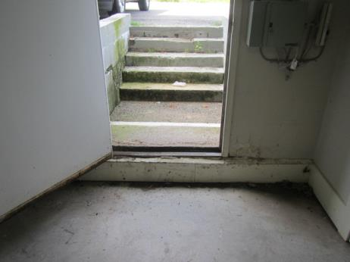
Door well with no drain
Picture 14
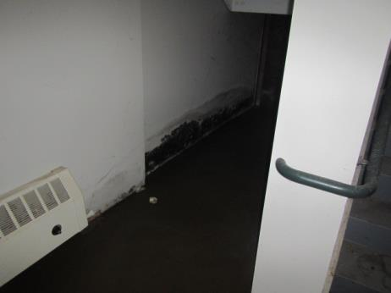
Mold colonization from chronic water damage to GW at front stairwell base
Picture 15
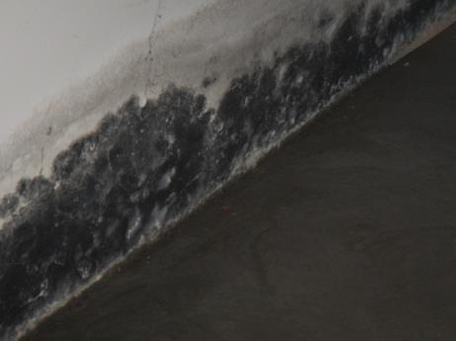
Close-up of GW shown in Picture 14
Picture 16
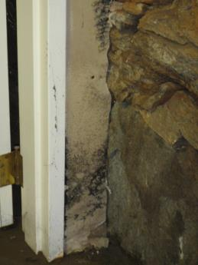
Mold colonized GW
Picture 17
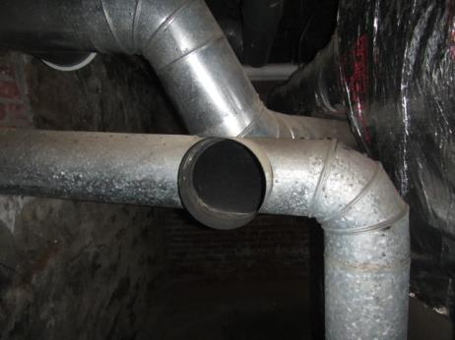
Open flue duct
Picture 18
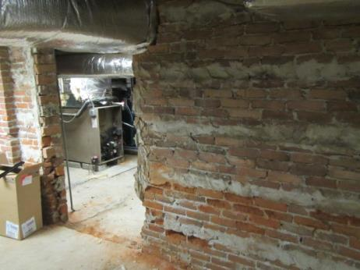
Opening in brick support wall
Picture 19
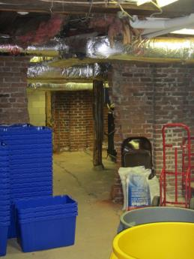
Opening in brick support wall
Picture 20
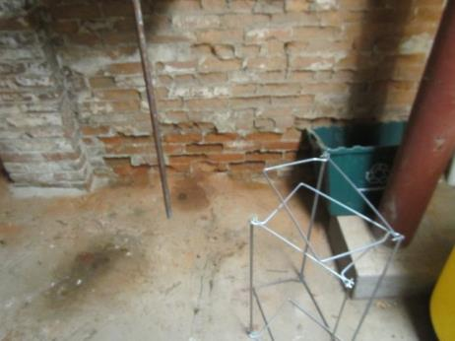
Red dust from bricks (Note brick condition)
Picture 21
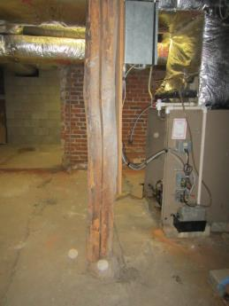
Example of a split wood support pillar
Picture 22
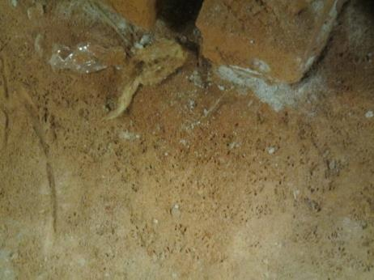
Rodent foot prints in brick dust
Location | Carbon  Dioxide  (ppm) | Carbon Monoxide  (ppm) | Temp  (°F) | Relative  Humidity  (%) | PM2.5  (µg/m3) | Occupants  in Room | Windows  Openable | Ventilation |  | Remarks
 |  |  |  |  |  |  |  | Supply | Exhaust
Background (outdoors) | 433 | ND | 75 | 57 | 17
Basement | 600 | ND | 70 | 62 | 77 | 0 | N | Y | N
Utility room | 593 | ND | 76 | 54 | 29 | 0 | N | N | N
Front basement hallway | 593 | ND | 70 | 68 | 36 | 0 | N | N | N
1st floor hall | 600 | ND | 75 | 57 | 17 | 0 | Y | Y | Y
1st floor meeting room | 558 | ND | 75 | 56 | 13 | 0 | Y | Y | Y
Tax collector | 543 | ND | 75 | 59 | 15 | 1 | Y | Y | Y
Building inspector | 625 | ND | 75 | 56 | 16 | 0 | Y | Y | Y
Bathroom | 627 | ND | 74 | 56 | 15 | 0 | N | Y | Y
Clerk’s office | 635 | ND | 74 | 60 | 13 | 1 | Y | Y | Y
Copy room | 533 | ND | 78 | 52 | 14 | 0 | Y | Y | Y
Town administrator | 504 | ND | 78 | 59 | 16 | 1 | Y | N | N | Window-mounted air conditioner
Town administrator common area | 437 | ND | 77 | 59 | 16 | 2 | Y | N | N | Window-mounted air conditioner
Bathroom | 450 | ND | 77 | 59 | 17 | 0 | Y | N | N
Copy room | 505 | ND | 78 | 60 | 17 | 0 | Y | N | N
2nd floor hallway | 528 | ND | 78 | 58 | 16 | 0 | N | N | N
2nd floor meeting room | 554 | ND | 78 | 55 | 15 | 0 | Y | N | N
Kitchen | 628 | ND | 79 | 55 | 15 | 0 | Y | N | N
3rd floor elevator lobby | 443 | ND | 74 | 71 | 60 | 0 | Y | N | N

