INDOOR AIR QUALITY ASSESSMENT

Shelburne Senior Center
7 Main Street
Shelburne Falls, Massachusetts 01370

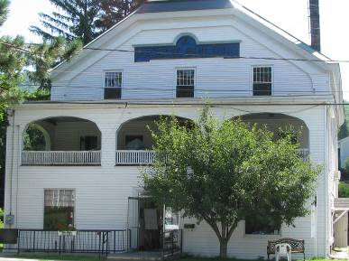

Prepared by:
Massachusetts Department of Public Health
Bureau of Environmental Health
Indoor Air Quality Program
October 2008

Background/Introduction
At the request of Jamie Godfrey, Director, Shelburne Senior Center, the Massachusetts Department of Public Health (MDPH), Bureau of Environmental Health (BEH) provided assistance and consultation regarding indoor air quality concerns at Shelburne Senior Center (SSC), 7 Main Street , Shelburne Falls, Massachusetts. The request was prompted by occupant complaints of odors, mold growth and other air quality and sanitary conditions in the building.
On July 15, 2008, a visit to conduct an assessment was made to the SSC by Lisa Hébert, Inspector within BEH’s Indoor Air Quality (IAQ) Program. This report describes general IAQ conditions observed in the building at the time of the assessment.
The first floor of this two story building is leased by the Shelburne Senior Center. BEH was informed that the building was believed to be originally built as a Unitarian Church in the late 1800’s. In 2001, renovations were made to the building in the basement and on the second floor. Storage space was created for the SSC in a portion of the basement on the west side of the building. The second floor serves as a meeting space for local organizations. The remainder of the building appears to be located above a crawlspace. The SSC contains offices, a kitchen, an activity/computer room and a large cafeteria/entertainment room.

Methods
Air tests for carbon monoxide, carbon dioxide, temperature and relative humidity were conducted with the TSI, Q-TRAK™, IAQ Monitor, Model 8551. Air tests for airborne particle matter with a diameter less than 2.5 micrometers were taken with the TSI, DUSTTRAK™ Aerosol Monitor Model 8520. BEH staff also performed visual inspection of building materials for water damage and/or microbial growth.

Results
The SSC houses approximately 20-30 seniors daily and has a staff of 10. The SSC sees approximately 15 visitors daily. Tests were taken during normal operations at the building and results appear in Table 1.

Discussion
Ventilation
It can be seen from Table 1 that carbon dioxide levels were below 800 parts per million (ppm) in all of the areas surveyed, indicating adequate air exchange in the building at the time of the assessment. It is important to note that the SSC does not have mechanical ventilation; rather, fresh air is supplied to occupied space by openable windows. Without adequate supply and exhaust ventilation, excess heat and environmental pollutants can build up leading to indoor air/comfort complaints.
To maximize air exchange, the MDPH recommends that both supply and exhaust ventilation operate continuously during periods of occupancy. In order to have proper ventilation with a mechanical supply and exhaust system, the systems must be balanced to provide an adequate amount of fresh air to the interior of a room while removing stale air from the room. It is recommended that HVAC systems be re-balanced every five years to ensure adequate air systems function (SMACNA, 1994).
The Massachusetts Building Code requires a minimum ventilation rate of 20 cubic feet per minute (cfm) per occupant of fresh outside air or have openable windows in each room (SBBRS, 1997; BOCA, 1993). The ventilation must be on at all times that the room is occupied. Providing adequate fresh air ventilation with open windows and maintaining the temperature in the comfort range during the cold weather season is impractical. Mechanical ventilation is usually required to provide adequate fresh air ventilation.
Carbon dioxide is not a problem in and of itself. It is used as an indicator of the adequacy of the fresh air ventilation. As carbon dioxide levels rise, it indicates that the ventilating system is malfunctioning or the design occupancy of the room is being exceeded. When this happens, a buildup of common indoor air pollutants can occur, leading to discomfort or health complaints. The Occupational Safety and Health Administration (OSHA) standard for carbon dioxide is 5,000 parts per million parts of air (ppm). Workers may be exposed to this level for 40 hours/week, based on a time-weighted average (OSHA, 1997).
The MDPH uses a guideline of 800 ppm for publicly occupied buildings. A guideline of 600 ppm or less is preferred in schools due to the fact that the majority of occupants are young and considered to be a more sensitive population in the evaluation of environmental health status. Inadequate ventilation and/or elevated temperatures are major causes of complaints such as respiratory, eye, nose and throat irritation, lethargy and headaches. For more information concerning carbon dioxide, consult Appendix A.
Temperature measurements in the building ranged from 77° F to 80° F, which were within the MDPH recommended range in the majority of areas surveyed (Table 1). The MDPH recommends that indoor air temperatures be maintained in a range of 70º F to 78º F in order to provide for the comfort of building occupants. In many cases concerning indoor air quality, fluctuations of temperature in occupied spaces are typically experienced, even in a building with an adequate fresh air supply.
The relative humidity measured in the building ranged from 40 to 49 percent at the time of the assessment, which was within the MDPH recommended comfort range (Table 1). The MDPH recommends a comfort range of 40 to 60 percent for indoor air relative humidity. It is important to note however, that relative humidity measured indoors exceeded outdoor measurements (range +3-9 percent). This increase in relative humidity is due to the lack of a mechanical exhaust ventilation system to remove moisture and normal indoor air pollutants (e.g., water vapor from respiration). Moisture removal is important since the sensation of heat conditions increases as relative humidity increases (the relationship between temperature and relative humidity is called the heat index). As indoor temperature rises, the addition of more relative humidity will make occupants feel hotter. If moisture is removed, the comfort of the individuals is increased. Removal of moisture from the air, however, can have some negative effects. The sensation of dryness and irritation is common in a low relative humidity environment. Relative humidity levels in the building would be expected to drop during the winter months due to heating. Low relative humidity is a very common problem during the heating season in the northeast part of the United States.

Microbial/Moisture Concerns
Several potential sources of water damage and /or mold growth were observed in the building. The exterior perimeter of the building exhibited broken asphalt shingles, which have presumably fallen off the roof to the ground below. Broken/missing shingles may allow water penetration to the interior of the building, creating conditions conducive for mold colonization to occur. It would be prudent to investigate the integrity of the roofing system in order to remove the potential of water damage to the building.
In the activity room, a stained section of carpet was observed that had been saturated due to a past plumbing leak. The US Environmental Protection Agency (US EPA) and the American Conference of Governmental Industrial Hygienists (ACGIH) recommend that porous materials be dried with fans and heating within 24 to 48 hours of becoming wet (US EPA, 2001; ACGIH, 1989). If not dried within this time frame, mold growth may occur. Once mold has colonized porous materials, they are difficult to clean and should be removed/discarded. It is unknown whether the carpet was dried within the recommended time frame.
Plant drip pans were observed with accumulations of soil and organic material. Plant soil and drip pans can serve as a source of mold growth. They should be examined routinely and cleaned as necessary.
The basement of the SSC exhibited the effects of chronic dampness. The wooden landing at the top of the basement stairs exhibited signs of moisture (Picture 1). Water stains were also evident adjacent to the exterior door’s threshold. BEH was informed that the Director did store his boots on this landing throughout the winter. The exterior door at the top of these stairs did not appear weathertight as daylight was visible from the landing.
The basement walls in the boiler room exhibited numerous areas of efflorescence (Picture 2). Efflorescence is a characteristic sign of water damage to cement, but it is not mold growth. As moisture penetrates and works its way through seams in the cement, water-soluble compounds in the cement dissolve, creating a solution. As this solution moves to the surface of the cement, the water evaporates, leaving behind white, powdery mineral deposits.
The corner of the wall near the entrance to the crawlspace was moist. An old glass pitcher was placed beneath a water line in the same area (Pictures 3 and 4). No appreciable amount of water was observed in the pitcher at the time of the assessment.
Some of the walls in the boiler room were covered with thin wallboard that appeared to have moisture damage and probable mold formation. Since this material may contain asbestos, prior to removal, a licensed asbestos inspector should be contacted in order to make a determination as to the presence of asbestos in the material. Cardboard boxes and other materials capable of supporting mold growth were stored on the floor of the boiler room. Additionally, a frog was noted near the floor drain in the boiler room indicating moist conditions may be present in the room (Picture 5). Many metal components within the boiler room, including pipes and ducts, exhibited substantial oxidation, indicating that moist conditions are or have been a regular occurrence in this room.
In the basement storage room, the stone wall adjacent to the crawlspace exhibits peeling paint and discoloration from water intrusion (Picture 6). The gypsum wallboard (GW) in this area was heavily colonized with mold (Picture 7). Wooden shelves utilized for storage of cardboard boxes exhibited moisture in the areas that had contact with the floor. The GW at floor level beneath these shelving units exhibited mold colonization as well. Additionally, a soft-sided cooler in the storage room demonstrated heavy mold colonization (Picture 8). Of note is a white powdery material (e.g., efflorescence) on the floor of the storage area. This condition indicates that moisture is migrating through the foundation floor in this area.
BEH staff examined the exterior of the building to identify breaches in the building envelope that could provide a source of water penetration. Several potential sources were identified:
- Vinyl siding is cracked, broken or missing in several areas of the building.
- Rear gable end of building exhibits a penetration where the lower gable end meets the fascia board.
- Storm windows on second floor are broken and in disrepair.
- Windows of the SSC exhibit cracked panes of glass. Some windows exhibit cracked or missing glazing.
- Exterior window rail appears moisture damaged and separated from stile (Picture 9).
- Window mounted air conditioners drain water against the side of the building.
- Gutters drain water close to the foundation of the building.
- Mortar is cracked, missing in some areas of stone foundation.
- Base of rear exterior door to the second floor shows oxidation. The wooden threshold for this door is rotted.
- Penetrations of utility pipes through the exterior wall are not properly sealed.
- The apron on the north side of the building is cracked, settled and missing in some areas. Grass and weeds are protruding through these crevices.
- Lawn appears to slope toward the foundation on the north side of the building.
- Shrubbery was observed growing against the building in some areas (Picture 10).The growth of roots against exterior walls can bring moisture in contact with the foundation. Plant roots can eventually penetrate, leading to cracks and/or fissures in the sublevel foundation.
- Moss was observed growing on the apron and foundation on the north side of the building (Picture 11).
The presence of moss is indicative of repeated water exposure. The two main requirements of a moss are sufficient moisture and accessible nutrients. The north side of the SSC is well shaded by large trees, which allows the area to stay moist and is conducive to moss growth. Additionally, the shade and moist conditions on the north side of the SSC may be contributing to possible mold growth on the vinyl siding (Picture 12). Since this area is beneath and adjacent to the air conditioners that serve the SSC, the siding should be periodically cleaned as necessary to prevent mold and particulates from entering the building. Additionally, air conditioners are normally equipped with filters, which should be cleaned or changed as per manufacturer’s instructions to avoid the build-up and re-aerosolization of dirt, dust and particulate matter.
The aforementioned conditions represent potential water penetration sources. Over time, these conditions can undermine the integrity of the building envelope and provide a means of water entry into the building via capillary action through masonry (Lstiburek & Brennan, 2001). In addition, these breaches may provide a means for pests/rodents to enter the building.

Other IAQ Evaluations
Indoor air quality can be negatively influenced by the presence of respiratory irritants, such as products of combustion. The process of combustion produces a number of pollutants. Common combustion emissions include carbon monoxide, carbon dioxide, water vapor and smoke (fine airborne particle material). Of these materials, exposure to carbon monoxide and particulate matter with a diameter of 2.5 micrometers (μm) or less (PM2.5) can produce immediate, acute health effects upon exposure. To determine whether combustion products were present in the SSC environment, BEH staff obtained measurements for carbon monoxide and PM2.5.

Carbon Monoxide
Carbon monoxide is a by-product of incomplete combustion of organic matter (e.g., gasoline, wood and tobacco). Exposure to carbon monoxide can produce immediate and acute health affects. Several air quality standards have been established to address carbon monoxide and prevent symptoms from exposure to these substances. The MDPH established a corrective action level concerning carbon monoxide in ice skating rinks that use fossil-fueled ice resurfacing equipment. If an operator of an indoor ice rink measures a carbon monoxide level over 30 ppm, taken 20 minutes after resurfacing within a rink, that operator must take actions to reduce carbon monoxide levels (MDPH, 1997).
The American Society of Heating Refrigeration and Air-Conditioning Engineers (ASHRAE) has adopted the National Ambient Air Quality Standards (NAAQS) as one set of criteria for assessing indoor air quality and monitoring of fresh air introduced by HVAC systems (ASHRAE, 1989). The NAAQS are standards established by the US EPA to protect the public health from six criteria pollutants, including carbon monoxide and particulate matter (US EPA, 2006). As recommended by ASHRAE, pollutant levels of fresh air introduced to a building should not exceed the NAAQS levels (ASHRAE, 1989). The NAAQS were adopted by reference in the Building Officials & Code Administrators (BOCA) National Mechanical Code of 1993 (BOCA, 1993), which is now an HVAC standard included in the Massachusetts State Building Code (SBBRS, 1997). According to the NAAQS, carbon monoxide levels in outdoor air should not exceed 9 ppm in an eight-hour average (US EPA, 2006).
Carbon monoxide should not be present in a typical, indoor environment. If it is present, indoor carbon monoxide levels should be less than or equal to outdoor levels. On the day of assessment, outdoor carbon monoxide concentrations were non-detect (ND) (Table 1). Carbon monoxide levels measured in the building were also ND.

Particulate Matter (PM2.5)
The US EPA has established NAAQS limits for exposure to particulate matter. Particulate matter is airborne solids that can be irritating to the eyes, nose and throat. The NAAQS originally established exposure limits to particulate matter with a diameter of 10 μm or less (PM10). According to the NAAQS, PM10 levels should not exceed 150 microgram per cubic meter (μg/m³) in a 24-hour average (US EPA, 2006). These standards were adopted by both ASHRAE and BOCA. Since the issuance of the ASHRAE standard and BOCA Code, US EPA established a more protective standard for fine airborne particles. This more stringent PM2.5 standard requires outdoor air particle levels be maintained below 35 μg/m³ over a 24-hour average (US EPA, 2006). Although both the ASHRAE standard and BOCA Code adopted the PM10 standard for evaluating air quality, MDPH uses the more protective PM2.5 standard for evaluating airborne particulate matter concentrations in the indoor environment.
Outdoor PM2.5 concentrations the day of the assessment were measured at 13 μg/m³. PM2.5 levels measured inside the school ranged from 11 to 14 μg/m³ (Table 1). Both indoor and outdoor PM 2.5 levels were below the NAAQS PM2.5 level of 35 μg/m³. Frequently, indoor air levels of particulates (including PM2.5) can be at higher levels than those measured outdoors. A number of mechanical devices and/or activities that occur in schools can generate particulate during normal operations. Sources of indoor airborne particulates may include but are not limited to particles generated during the operation of fan belts in the HVAC system, cooking in the cafeteria stoves and microwave ovens; use of photocopiers, fax machines and computer printing devices; operation of an ordinary vacuum cleaner and heavy foot traffic indoors.

Total Volatile Organic Compounds
Indoor air concentrations can be greatly impacted by the use of products containing volatile organic compounds (VOCs). VOCs are carbon-containing substances that have the ability to evaporate at room temperature. Frequently, exposure to low levels of total VOCs (TVOCs) may produce eye, nose, throat and/or respiratory irritation in some sensitive individuals. For example, chemicals evaporating from a paint can stored at room temperature would most likely contain VOCs. In an effort to identify materials that can potentially increase indoor VOC concentrations, BEH staff examined the building for products containing these respiratory irritants.
Volatile organic compounds (VOCs) and ozone can be produced by photocopiers, particularly if the equipment is older and in frequent use. Ozone is a respiratory irritant (Schmidt Etkin, 1992). Without proper mechanical exhaust ventilation, waste heat and pollutants produced by office equipment can build up and lead to indoor air quality/comfort complaints.
Other conditions that can affect indoor air quality were observed during the assessment. Numerous open utility holes were observed in floors, walls and ceilings on the first floor as well as the basement (Picture 13). Open utility holes can provide a means of egress for odors, fumes, dusts and vapors as well as rodents between rooms and floors.
Upon entering the SSC, BEH staff detected heavy cooking odors emanating from the rear of the building. The source of these odors was food preparation being conducted in the kitchen on the first floor. While a ventilation hood was present over a ten burner gas stove, it was not eliminating cooking odors efficiently. In order to explain how cooking odors/particulates may be impacting adjacent areas, the following concepts concerning heated air and creation of air movement must be understood.
- Heated air will create upward air movement (called the stack effect).
- Cold air moves to hot air, which creates drafts.
- As heated air rises, negative pressure is created, which draws cold air to equipment creating heat.
- Combustion of fossil fuels generates heat, gases and particulates that will rise in the air. In addition, the more heated air becomes the greater airflow increases.
- The operation of ventilation system components (in this case, both front and rear doors of the building were open) can distribute cooking odors/particulates to other areas of the building. Each of these concepts influences the movement of combustion products, particulates and odors associated with cooking.
The odor of fuel oil was present upon entering the basement stairwell. A stained absorbent pad was positioned beneath the oil filter during the assessment (Picture 14). These odors can be distributed throughout the building through open penetrations as well. The large number of open utility holes in the basement would allow the odors to easily migrate to the first floor. Health effects from exposure to fuel oils vary depending upon the type of fuel vapors one is exposed to, however, such fuel vapors should not be present in a typical indoor environment. The following steps should be employed to remedy the occurrence of fuel oil vapors entering the office space:
- The source of fuel odor in the basement must be immediately identified and remedied.
- All of the open utility holes in the basement and crawlspace must be properly sealed.
BEH observed fluorescent lights in use within SSC. These bulbs contain and can release mercury when broken, therefore, they must be stored, utilized and disposed of with care.
In the kitchen, the floor and wall adjacent to the stove as well as some of the carpet beneath the stove exhibit organic accumulation, which may attract rodents (Picture 15). Rodent infestation results from easy access to food and water in a building. Rodent infestation can result in indoor air quality related symptoms due to materials in their wastes. Mouse urine contains a protein that is a known sensitizer (US EPA, 1992). In order to prevent a rodent infestation, and subsequent exposure to allergens, reduction/elimination of pathways/food sources that may attract rodents is necessary. In addition, windows to the crawlspace are open with the exception of metal bars (Picture 16). This condition may allow insects and rodents easy access to
the building. Installing screens in the windows would eliminate these points of entry.
Ceiling and personal fans exhibited dust accumulation. Dust can be a source for eye and respiratory irritation. Once activated, fans with dust can serve to distribute particles throughout a room.
A basement sewer line is deteriorated. At a joint close to the floor, it appears as if a cloth has been placed between two pipes. At the top of the same line was an apparent repair to a hole in the line that has now failed (Pictures 17 and 18). This deteriorated condition may allow sewer gas to enter the basement. Exposure to sewer gas causes nuisance odors and may be an irritant to susceptible individuals.
BEH staff observed a hole in the exhaust ductwork to the boiler system (Picture 19). If breaches are present in the ductwork, exhaust emissions such as carbon monoxide can be released into the indoor environment. Exhaust ducts are heavily corroded and exhibit evidence of consistent presence of water on the interior of the duct. The junction of the boiler exhaust duct with a rusted metal duct is stuffed with insulation (Pictures 20 and 21). This condition may also allow carbon monoxide to be released into the basement. During the assessment, it appeared that the make up air vent for this room had been sealed. Boilers require oxygen from air to support combustion. If the make up air vents are closed, the boiler will draw air from the interior of the building. This condition may deprive the boiler of an adequate air supply that can result in incomplete combustion. Incomplete combustion can result in an increased production of carbon monoxide from the boiler. In order to avoid this condition, the makeup air vent should be opened to allow for an adequate supply of oxygen to the boiler.
The exterior of the building exhibited vents in the wall above the first floor, perhaps from a previous heating system. The purpose of these vents should be investigated. If no longer utilized for their original purpose, they should be properly sealed.

Conclusions/Recommendations
The conditions noted at the SSC raise a number of indoor air quality issues. The general building conditions, maintenance, work hygiene practices, if considered individually, present conditions that could degrade indoor air quality. When combined, these conditions can serve to further degrade indoor air quality. Some of these conditions can be remedied by actions of building occupants. Other remediation efforts will require alteration to the building structure and equipment. For these reasons, a two-phase approach is required for remediation. The first consists of short-term measures to improve air quality and the second consists of long-term measures that will require planning and resources to adequately address the overall indoor air quality concerns.
In view of the findings at the time of the assessment, the following short term measures should be considered for implementation:
- Consider contacting a professional mold remediation firm for guidance on remediation, due to the extent of mold contamination in the basement.
- Establish negative pressure conditions in the basement/crawlspace relative to the first floor.
- Contact a licensed plumber to repair deteriorated sewer line and to repair any plumbing leaks found in basement and crawlspace.
- Remove any mold-contaminated materials (e.g. stored items) in the basement and crawlspace. Prior to disturbing and removing debris in the crawlspace, ensure a licensed asbestos inspector has examined pipes and debris in crawlspace to determine whether any asbestos is in disrepair, or strewn on the floor of the crawlspace. If so, it should be abated in accordance with all state and federal regulations.
- Remove water damaged/mold colonized materials (carpeting in activity room and gypsum wallboard (GW) and any affected insulation in the basement storage areas as well as the wallboard in the boiler room), after consultation with asbestos inspector (See short term recommendation # 4). This measure will remove actively growing mold colonies that may be present. Remove mold contaminated materials in a manner consistent with recommendations found in “Mold Remediation in Schools and Commercial Buildings” published by the US Environmental Protection Agency (US EPA, 2001). Copies of this document can be downloaded from the US EPA website at: http://www.epa.gov/mold/mold_remediation.html.
- During removal of building materials use local exhaust ventilation and isolation techniques to control remediation pollutants.
- Seal any utility holes and other potential pathways to eliminate pollutant paths of migration from the basement/crawlspace to the first floor. Ensure tightness by monitoring for light penetration and drafts.
- If possible relocate susceptible persons and those with pre-existing medical conditions (eg hypersensitivity, asthma) away from the general areas of remediation until completion.
- Implement prudent housekeeping and worksite practices to minimize exposure to spores. This may include constructing barriers, sealing off areas, and temporarily relocating furniture and supplies. To control dusts, a high efficiency particulate air filter (HEPA) equipped vacuum cleaner is recommended.
- Avoid over-watering of plants. Examine drip pans periodically for mold growth. Disinfect with an appropriate antimicrobial where necessary. Seal spaces around utility holes and breaches in walls/floors and ceilings with an appropriately fire rated sealant.
- Repair hole at rear gable end of building.
- Repair siding as well as broken storm windows and broken panes of glass and deteriorated glazing. Consider installing screening in crawlspace windows to prevent entry of pests into the building.
- Repair cracked and/or missing mortar in foundation.
- Seal penetration of utility pipes on exterior of the building.
- Repair apron on north side of the building.
- Cut shrubbery in a manner to maintain a space of 5 feet from the building. If possible, improve the grading of the ground away from the foundation at a rate of 6 inches per every 10 feet (Lstiburek & Brennan, 2001). Reduce shaded area on the north side of the building by removing/trimming large trees.
- Remove weeds from the base of the building.
- Adjust wall mounted air conditioners to eliminate drainage onto foundation wall.
- Change filters for air conditioners (ACs) as per the manufacturer’s instructions or more frequently if needed.
- Ventilation hood in the kitchen should be examined by a professional to determine the reason the hood is not removing odors from the building. If the equipment is not functioning properly, products of combustion such as carbon monoxide may accumulate in the building. Additionally, the hood should be examined by the local building inspector for compliance with current ventilation requirements. Until this issue is resolved, contact your local fire prevention officer to determine the appropriate placement of a carbon monoxide detector, and install one as directed for the protection of the occupants in the SSC.
- Identify and eliminate the source of fuel odor in the basement.
- Contact an HVAC engineering firm to evaluate the entire heating system, including the heavily rusted ducts, the apparent moisture in the ducts, holes in ducts, the junction of the boiler duct to the rusted metal outlet, and whether the seal of this connection is adequate. Make repairs to the system to prevent the escape of exhaust emissions into the building. Additionally, the specialist should also determine whether adequate draw of exhaust is occurring due to the length of the line from the boiler exhaust duct to the chimney. Once system is in good repair, have boiler inspected annually or as per the manufacturer’s instructions to ensure continued proper operation.
- Store and dispose of fluorescent light bulbs in accordance with DEP guidelines.
- Remove organic debris from floor and walls adjacent to stove. Remove carpet squares from beneath stove.
- Clean ceiling fans and personal fans to eliminate the potential of re-distributing dust in the building.
- Wash dirt and mold formation off the siding on the north side of building.
- Repair rotted threshold on south side of the building.
- Exterior door to the basement should be made weather-tight.
- Investigate origin of vents on exterior of the building wall.
- Eliminate storage of wet items such as boots on basement stairway landing.
- For buildings in New England, periods of low relative humidity during the winter are often unavoidable. Therefore, scrupulous cleaning practices should be adopted to minimize common indoor air contaminants whose irritant effects can be enhanced when the relative humidity is low. To control for dusts, a high efficiency particulate arrestance (HEPA) filter equipped vacuum cleaner in conjunction with wet wiping of all surfaces is recommended. Avoid the use of feather dusters. Drinking water during the day can help ease some symptoms associated with a dry environment (throat and sinus irritations).
- Refer to resource manual and other related indoor air quality documents located on the MDPH’s website for further building-wide evaluations and advice on maintaining public buildings. These documents are available at: http://mass.gov/dph/iaq.

The following long-term measures should be considered:

- Consider installing mechanical exhaust ventilation to increase air exchange and remove environmental pollutants from the SSC.
- Repair/replace roof as necessary to eliminate water from penetrating the building envelope.
- Examine feasibility of replacement windows.
- Establish negative pressure conditions in the basement/crawlspace relative to the first floor. Contact an HVAC engineering firm for long-term recommendations on installing mechanical ventilation components to properly ventilate the basement/crawlspace.

References

ACGIH. 1989. Guidelines for the Assessment of Bioaerosols in the Indoor Environment. American Conference of Governmental Industrial Hygienists, Cincinnati, OH.

ASHRAE. 1989. Ventilation for Acceptable Indoor Air Quality. American Society of Heating, Refrigeration and Air Conditioning Engineers. ANSI/ASHRAE 62-1989.

BOCA. 1993. The BOCA National Mechanical Code/1993. 8th ed. Building Officials and Code Administrators International, Inc., Country Club Hill, IL.

Lstiburek, J. & Brennan, T. 2001. Read This Before You Design, Build or Renovate. Building Science Corporation, Westford, MA. U.S. Department of Housing and Urban Development, Region I, Boston, MA.

MDPH. 1997. Requirements to Maintain Air Quality in Indoor Skating Rinks (State Sanitary Code, Chapter XI). 105 CMR 675.000. Massachusetts Department of Public Health, Boston, MA.

OSHA. 1997. Limits for Air Contaminants. Occupational Safety and Health Administration. Code of Federal Regulations. 29 C.F.R 1910.1000 Table Z-1-A.

OSU 2000. Basic Moss Biology. Retrieved August 19, 2008, from Oregon State University, Living with Mosses website: http://bryophytes.science.oregonstate.edu/mosses.htm.

SBBRS. 1997. Mechanical Ventilation. State Board of Building Regulations and Standards. Code of Massachusetts Regulations. 780 CMR 1209.0.

Schmidt Etkin, D. 1992. Office Furnishings/Equipment & IAQ Health Impacts, Prevention & Mitigation. Cutter Information Corporation, Indoor Air Quality Update, Arlington, MA.

US EPA. 1992. Indoor Biological Pollutants. US Environmental Protection Agency, Environmental Criteria and Assessment Office, Office of Health and Environmental Assessment, research Triangle Park, NC. EPA 600/8-91/202 January 1992.

US EPA. 2001. “Mold Remediation in Schools and Commercial Buildings”. Office of Air and Radiation, Indoor Environments Division, Washington, DC. EPA 402-K-01-001. March 2001. Available at: http://www.epa.gov/mold/mold_remediation.html.

US EPA. 2006. National Ambient Air Quality Standards (NAAQS). US Environmental Protection Agency, Office of Air Quality Planning and Standards, Washington, DC. http://www.epa.gov/air/criteria.html.
Picture 1

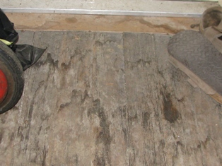

Water damaged landing at top of basement stairs

Picture 2

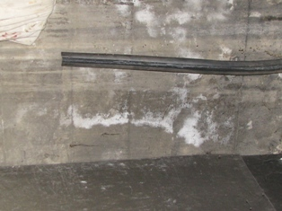

Efflorescence on basement wall

Picture 3

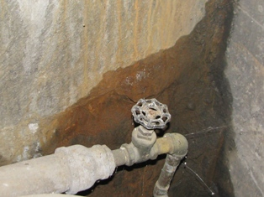

Moist stone wall in boiler room

Picture 4

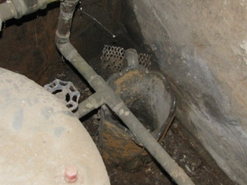

Glass pitcher positioned below water line

Picture 5

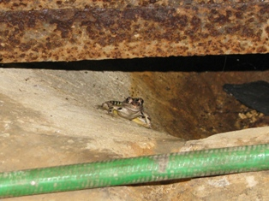

Frog in boiler room

Picture 6

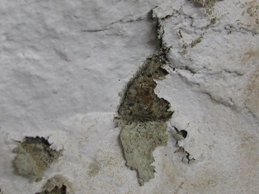

Peeling paint on stone in basement storage room

Picture 7

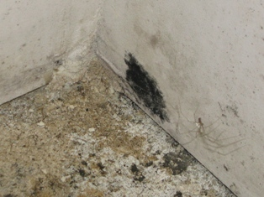

Mold colonization on storage room walls

Picture 8

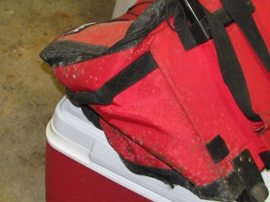

Mold colonization on items stored in basement

Picture 9

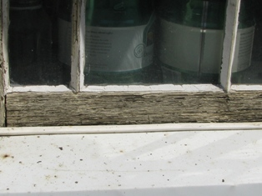

Moisture damaged window rail

Picture 10

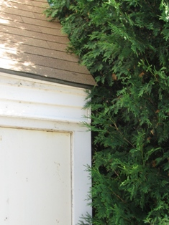

Shrubbery growing against building
Picture 11

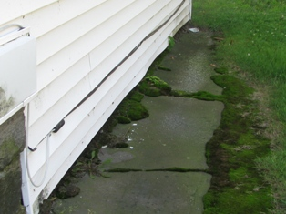

Moss growth on lawn, apron and stone foundation

Picture 12

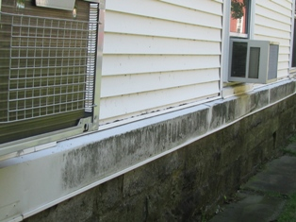

Accumulation of debris and probable mold growth on siding
Picture 13

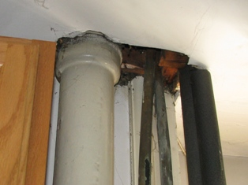

Open penetration into the ceiling of the kitchen

Picture 14

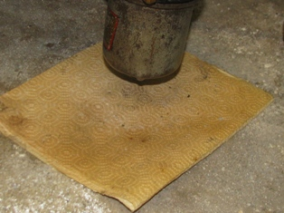

Absorbent pad beneath fuel oil filter
Picture 15

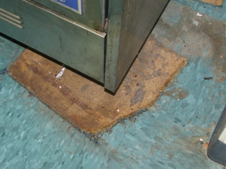

Organic accumulation on floor of kitchen

Picture 16

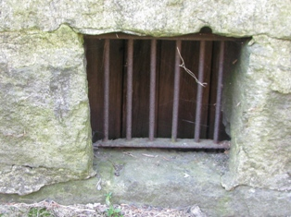

Metal bars on crawlspace window (note: no screening)
Picture 17

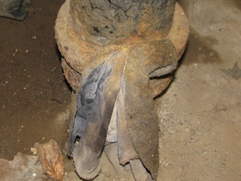

Sewer line in boiler room

Picture 18

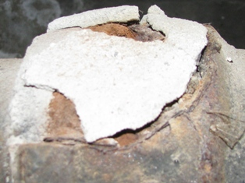

Old, crumbling repair to sewer line

Picture 19

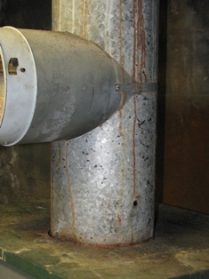

Hole in boiler duct

Picture 20

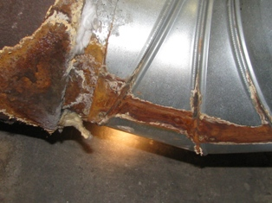

Heavy oxidation of exhaust duct
Note evidence of water leakage as well as protruding insulation

Picture 21

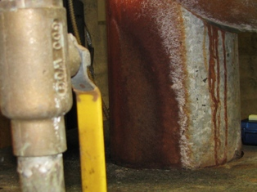

Heavy oxidation of boiler duct
Location | Occupants  in Room | Carbon  Dioxide  (ppm) | Temp  (°F) | Relative  Humidity  (%) | Carbon Monoxide  (ppm) | PM2.5  (µg/m3) | Windows  Openable | Ventilation |  | Remarks
 |  |  |  |  |  |  |  | Supply | Exhaust | Remarks
Outside  (Background) |  | 438 | 83 | 40 | ND | 13
Office 1  Director’s Office | 1 | 440 | 77 | 49 | ND | 11 | Y  1/1 open | N | N | DO, Plant, FC, 1 comp, 1 printer
Office 2 | 0 | 466 | 77 | 47 | ND | 12 | Y  2/2 open | N | N | DO, 3 computers, plants
Front Hall | 1 | 493 | 77 | 45 | ND | 12 | N | N | N | DO to outdoors, Copier
Computer Room | 0 | 487 | 78 | 45 | ND | 12 | Y  1/2 open | N | N | 1 DO, carpet stained from old leak
Cafeteria/TV Room | 17 | 560 | 77 | 43 | ND | 12 | Y | N | N | DO
Kitchen | 2 | 518 | 80 | 46 | ND | 14 | N | N | N | DO(3), 10 burner gas stove
Basement Storage Room | 0 | 766 | 78 | 40 | ND | 12 | N | N | N
Boiler room |  |  |  |  | ND

