INDOOR AIR QUALITY ASSESSMENT

Shepherd Hill Regional High School
Dudley-Charlton Regional School District
68 Dudley Oxford Road
Dudley, MA 01571
March 2026

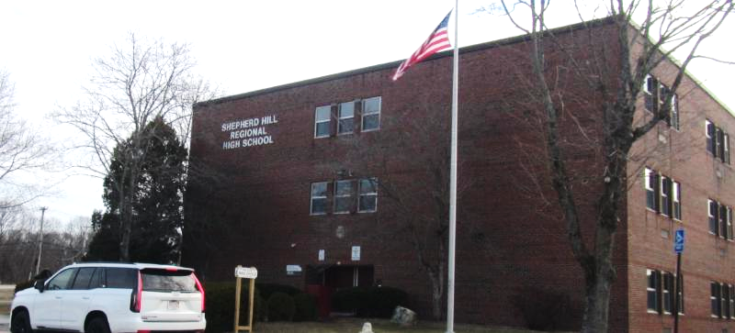

Prepared by:
Massachusetts Department of Public Health
Bureau of Climate and Environmental Health
Division of Environmental Health Regulations and Standards

Contents
EXECUTIVE SUMMARY 3
BACKGROUND 4
RESULTS AND DISCUSSION 5
Ventilation and HVAC System Maintenance 5
Water Damage and Moisture Concerns 8
Sources of Respiratory Irritants/Possible Asthma Triggers 11
Other IAQ Issues 14
CONCLUSIONS AND RECOMMENDATIONS 14
REFERENCES 21
FIGURES 23
PICTURES 24
Table 1 40
Table 2A 52
Table 2B 53
Table 2C 54
Table 3 55
Table 4 57

EXECUTIVE SUMMARY
The Massachusetts Department of Public Health’s Division of Environmental Health Regulations and Standards (MDPH/EHRS) conducted an indoor air quality (IAQ) assessment of the Shepherd Hill Regional High School (SHRHS). This assessment was prompted by concerns from a parent about asthma exacerbation at school and coordinated through the Dudley-Charlton Regional School District Superintendent, Facilities Department, and the Dudley Health Department.
Any building can have IAQ issues. These issues can worsen through conditions common to marginalized communities (Environmental Justice communities or EJ) such as inequitable exposure to outdoor air pollution and a greater likelihood of poor building conditions leading to deterioration of IAQ, resulting in higher asthma rates. SHRHS is not within an EJ community, however the town of Dudley contains a number of EJ communities (These data were obtained from https://www.mass.gov/info-details/massgis-data-2020-environmental-justice-populations). Pediatric asthma rates are not calculated for high schools, but the rates in the towns of Dudley and Charlton are 9.6% and 10.8% respectively based on 2024-2025 data. These rates are not statistically significantly different from the statewide pediatric asthma prevalence rate of 9.6% (MAEPHT, 2026).
The assessment was conducted by evaluating several key elements within the building; a visual inspection of the heating, cooling, and ventilating (HVAC) systems, water/microbial damage, cleanliness, point sources of respiratory irritants such as chemicals, and electronic measurement of carbon dioxide (CO₂), carbon monoxide (CO), temperature, relative humidity (RH), and small particulate matter (PM2.5) all taken with a Qtrak XP monitor. Data is collected in this manner to identify potential asthma triggers, allergens, and other environmental factors that can cause indoor air quality symptoms. Please refer to the Indoor Air Quality Manual on the MDPH website for methods, sampling procedures, and interpretation of results.
As a result of this assessment, there are several findings including: Levels of carbon dioxide in the school, a measure of the adequacy of ventilation, were higher than the EHRS guidance levels in almost half of the rooms assessed, indicating less than optimal fresh air in many rooms, which may be related to the age of the unit ventilators (univents) in the school. Water damage, mostly to ceiling tiles below the 30-year-old roof, was found in many areas. Art, science, and shop areas may lack sufficient exhaust ventilation for activities conducted. And occupants are using scented products such as plug-in air fresheners in shared spaces.
Based on the results of the assessment, the following primary recommendations are made:
- Ensure that univents are turned on, unblocked, and supplying fresh air during all occupied periods.
- Use openable windows to supplement fresh air during temperate weather. Ensure all windows are tightly closed at the end of the day or during periods of elevated relative humidity to avoid condensation/mold issues.
- Replace water-damaged ceiling tiles regularly.
- Ensure all task-based exhaust systems are kept in good repair and used whenever needed. Consider adding additional ventilation to the wood shop and wherever laminators and 3D printers are used.
- Avoid the use of scented products and other non-school-supplied cleaning and sanitizing products in the school.
(Conclusions and Recommendations)

BACKGROUND
Building: | Shepherd Hill Regional High School (SHRHS)
Address: | 68 Dudley Oxford Rd, Dudley, MA 01571
Assessment Requested by: | Requested by a parent of current students and coordinated through the Dudley Health Department and the Superintendent and Facilities Director of the Dudley-Charlton Regional School District
Reason for Request: | General indoor air quality (IAQ)
Date of Assessment: | March 19, 2026
Massachusetts Department of Public Health/Bureau of Climate and Environmental Health/Division of Environmental Health Regulations and Standards (MDPH/BCEH/EHRS) Staff Conducting Assessment: | Ruth Alfasso, Environmental Engineer, and Bharathi-Patimalla-Dipali, Environmental Analyst, Division of Environmental Health Regulations and Standards (EHRS)
Building Description: | The SHRHS is a three-story brick and block building originally constructed in the early 1970s. The roof is flat and may be over 30 years old. Some building mechanical systems, including univents, are original to the building.
Windows: | Windows in the building are openable and were replaced recently.

RESULTS AND DISCUSSION
The following is a summary of indoor air testing results (Table 1)
- Carbon dioxide (CO₂) | a measure of the adequacy of ventilation | Levels were above the MDPH guideline of 800 parts per million (ppm) in almost half of areas surveyed. Lower carbon dioxide levels were found in areas with lower occupancy and with windows open.
- Temperature | a measure of comfort | Was within the MDPH recommended range of 70°F to 78°F in almost all areas tested.
- Relative humidity | a measure of comfort and, when in excess for an extended period, a way to reflect the potential for mold and fungal growth | Was below the MDPH recommended range of 40 to 60% in all areas tested, which is common during the heating season.
- Carbon monoxide  (CO) | a product of combustion that can result in acute and long term cardiovascular, respiratory, and neurological symptoms | Levels were non-detectible in all areas assessed.
- Particulate matter (PM2.5) | a way to measure inhalable particle distribution in the air | Concentrations were below the National Ambient Air Quality Standard (NAAQS) of 35 micrograms per cubic meter (μg/m³) in all areas tested.

Ventilation and HVAC System Maintenance
Ventilation refers to both the supply of fresh air and the removal of stale air from a room. The introduction of fresh air into an occupied space will dilute normally occurring pollutants that are generated by occupancy and other activities. In addition, a heating, ventilation, and air conditioning (HVAC) system will remove pollutants from a building if operating appropriately.

The SHRHS uses unit ventilators (univents) in classrooms and some offices (Picture 1). Univents bring in fresh air from a vent on the outside of the building (Picture 2), filter it, heat it, and supply the air through a vent on the top. Some room air is recirculated along with the fresh air through a vent at the bottom (Figure 1). Classrooms with univents have an exhaust vent located high on the interior wall (Picture 3) which draws stale air out of classrooms via a fan and vent located on the roof. One of these exhaust vents was tested with a piece of paper and it was found to be drawing, however most of them could not be reached. Lack of sufficient exhaust air can reduce the effectiveness of the univent/exhaust vent system to provide fresh air and remove stale air from a room. Note that none of the univents supply cooling.
In common areas and the district offices, fresh air is supplied by air handling units (AHU) which heat and filters air, distributing it to ceiling-mounted supply vents (Picture 4). It is likely that the return vents in these areas will bring air back to the AHU to be filtered and mixed with fresh air. These AHU were not examined during this visit.
Both univents and AHU(s) are controlled using individual thermostats located in rooms. The school currently does not have any kind of building-wide control or automation system which limits the ability to modulate system operations due to weather conditions or occupancy.
A few rooms were equipped with window-mounted air conditioners (Picture 5; Table 1) which can provide cooling and a small amount of fresh air when in use. An IT office had what appeared to be a ceiling-mounted ductless air conditioner (Picture 6). Ductless units, also known as “mini-splits”, provide heating and/or cooling, but do not have a fresh air supply. It is likely this one was installed to provide cooling for IT equipment. When used in cooling mode, ductless air conditioners produce condensation that needs to be drained with a hose and sometimes a pump. These components should be checked for issues such as blockages periodically when in use and cleaned/repaired as needed.
Most rooms in the building are equipped with openable windows (Picture 8, Table 1). These windows appeared to be in good condition and had reportedly been replaced recently. Opening windows during temperate weather can supplement other HVAC components, and rooms with slightly open windows typically had lower carbon dioxide than other occupied rooms during this visit (Table 1). Windows should not be opened during heavy rain, very cold or hot weather, and when outdoor air quality is poor due to outside activities, pollen, or wildfire smoke. Windows should also remain closed when any air conditioning (e.g., window air conditioners) is in use to prevent condensation. Windows should be tightly closed at the end of the day to prevent water damage and pest access.
Various task- or equipment-based exhaust equipment were found in the school. A fume hood was noted in a science classroom (Picture 7). No certificate of calibration was on or next to the equipment. Fume hoods need to be calibrated annually to ensure they work properly. In addition, chemicals were stored in the hood. Other task-based exhaust included an exhaust vent for the kiln in the art room, and for plasma and laser cutting machines in the shop area. The shop area is also equipped with dust extractors for sanding equipment. All of these types of equipment need to be kept in good repair and used every time the accompanying machinery is activated.
Air purifiers were noted in some classrooms (Picture 8, Table 1). Many of these were the same model and had been supplied by the school when coming back after COVID lockdown. Air purifiers using High Efficiency Particulate Air (HEPA) filters and carbon filters are good choices to remove dust and other airborne particulates from the inside air. This specific brand/model of this air purifier lists that it has a UV light in it which is designed to reduce germs. This model was listed by the California Air Resources Board List of Certified Air Cleaning Devices which tests and certified air purifiers for ozone. Units that may produce ozone or other chemicals should not be used (EPA, 2003). Equipment should be maintained in accordance with manufacturers’ instructions including cleaning and filter changes.
The various types of ventilation components as well as devices that can move/redirect airflow are listed in Table 2A, Table 2B and Table 2C.

HVAC System Maintenance
- Univents are reportedly original to the building, and over 50 years old, which is beyond their service life. According to the American Society of Heating, Refrigeration, and Air-Conditioning Engineering (ASHRAE), the service life of this type of unit is 15-20 years, assuming routine maintenance of the equipment (ASHRAE, 1991). Maintaining equipment of this age becomes increasingly difficult and replacement parts are harder to find.
Balancing
To have proper ventilation with a mechanical supply and exhaust system, a system must be balanced to provide an adequate amount of fresh air to the interior of a room while also removing stale air from the room.
It is recommended that HVAC systems be re-balanced every five years to ensure adequate air systems function (SMACNA, 1994).

HVAC Types and Specific Conditions
(see Ventilation Pictures)

Classroom Unit ventilators:
- Some univents were blocked along the top or front with furniture or classroom items (Picture 9; Table 1).
- The MDPH IAQ Outreach and Education Unit recommends that filters of at least minimum efficiency reporting value (MERV) 8 or better be used, if the system can operate with them without adversely affecting function. MERV 8 filters are adequate to filter out pollen, mold, and similar particulates (ASHRAE, 2012).
  - Filters in univents are reportedly MERV 8 and changed twice a year. EHRS recommends that filters be changed two to four times a year.
  - A univent was opened and the filter examined (Picture 10). The filter in this unit was a type that needs to be cut to fit and installed in a metal bracket. The specific rating could not be determined, but the filter fit well with no gaps around the sides.
  - The filter examined was dusty despite being changed two or three months earlier. Clogged filters have a reduced effectiveness in filtering the air and can also stress the fans in the units. If filters are frequently very dusty when changed, the frequency of filter changes should be increased.
- Some supply vents in areas served by an AHU were dusty (Picture 11). Dust on vents can become airborne during very dry weather.
Classroom Exhaust vents:
- The location of exhaust vents makes them more difficult to test for air draw. Exhaust vents should be checked periodically to ensure they are operating.
- Exhaust vents in the auditorium were not working. It may be because the room was not in use, however, these exhaust vents should be checked periodically as well.

Water Damage and Moisture Concerns
Molds are found naturally in our environment both indoors and outdoors. Inside, mold growth may occur when items, particularly porous products such as paper or gypsum wallboard, are exposed to moisture. Typical water sources include leaks, floods, and condensation. To avoid mold growth, dry all water-damaged items and affected areas within 24-48 hours and reduce indoor humidity. Some people with chronic respiratory conditions, such as asthma, are more likely to experience health symptoms associated with molds, including allergic reactions and respiratory irritation. Controlling moisture is the key to preventing mold growth and potential health symptoms.

Hot humid summers are becoming more frequent due to climate change. Massachusetts has experienced hot, humid, and rainy summers in 2018, 2021, and 2023. July of 2021 was the wettest ever recorded in Massachusetts, and the three-month period from June through August, known as the meteorological summer, was the fourth wettest on record, according to the National Oceanic and Atmospheric Administration’s (NOAA) Centers for Environmental Information (NOAA, 2021). The summer of 2023 was also hot, and wet, being measured as the second rainiest on record (WBUR, 2023). The summers of 2024 and 2025 also had significant stretches of hot, humid weather.

During these hot and wet summers, extended periods of outdoor relative humidity above 70% occurred. Under these weather periods, public buildings experienced extended periods of water vapor exposure from high relative humidity. When exposed to these conditions, porous materials such as gypsum wallboard, cardboard, and other materials may become prone to developing mold colonization, particularly if located in areas that are prone to developing condensation on floors and walls (e.g., below grade space).
Please note that the IAQ Outreach and Education Unit does not recommend conducting mold testing in a typical water damage remediation. For details, please consult Guidance Regarding Testing for Mold in Water-Damaged Public Buildings | Mass.gov
The application of a mildewcide to moldy porous materials is not recommended.

Water Damage Issues
(see Water Damage and Moisture Concerns Pictures)

- Water damage from leaks and condensation was observed in the form of water-damaged ceiling tiles in various areas (Table 1; Pictures 12 through 14). Most of the water damage was on the 3rd floor, and the portion of the 1st floor without a floor above it. It was reported that the roof may be over 30 years old, which makes it more likely to leak. None of the stained tiles appeared to have the characteristic dark or fuzzy staining that indicates mold growth. Water-damaged ceiling tiles should be replaced.
- A musty odor was noted in a storage area (Room 108), a room which also had some stained ceiling tiles. A specific source of the odor was not found during the assessment. Items in this room should be examined to remove anything with a musty odor, which may include the stained ceiling tiles.
- Plants were noted in many classrooms (Table 1; Pictures 15 and 16). Plants, soil, and drip pans can serve as sources of mold/bacterial growth. Plants should be properly maintained, over-watering of plants should be avoided, and drip pans should be inspected periodically for mold growth and cleaned/replaced as needed. Plants should also not be placed on top of or next to univents or other HVAC components (e.g., Picture 16) as this distributes dust, odors, or pollen throughout the room.
- There were several full-sized and smaller refrigerators in the building. Food/liquid stains were observed in one (Picture 17). Spills in a refrigerator can be a source of odors and mold growth. Also note that while these refrigerators are not covered by the food code, it is good practice to have a thermometer in each refrigerator that is visible to ensure refrigerated food temperatures are kept at 5ºC (41ºF) or less (US FDA, 2022).
- Food and food preparation equipment was noted in many classrooms and offices (Table 1; Picture 18). Some of the equipment was dirty (Picture 19). To reduce the potential for pest activity, all food and food items should be stored in closed, pest-proof containers at all times other than active use. Food waste and crumbs should be cleaned up promptly.
- Some sinks were unable to be turned all the way off (Table 1). Dripping sinks not only use excess water but can be a source of excess moisture to the indoor environment. In addition, the cabinet under a sink is a moist environment and porous items should not be stored there. Some sinks were found with water stains underneath or packed full of items, making it difficult to stop leaks or condensation if they occur.
- Sinks and other drains that are not regularly used can have the traps dry out. This can allow sewer gases into occupied spaces, which can be a source of odors. In addition, during heavy rains, moist air from the sewer can be pushed back into occupied spaces and contribute to high humidity and condensation. Pouring water down drains every week or two will maintain the trap seal. If fixtures and drains are not going to be used again, they should be properly cut and capped. Temporary solutions also exist to close off piping and drains which can be reversed if the fixtures are needed later.
- Because this school does not have central air conditioning in classrooms, humidity on hot, humid days can build up. This is both a source of discomfort and provides the potential for condensation on surfaces that are cooler than ambient air. Such surfaces may include floors in contact with the ground, exterior walls in shade or overnight, and cold-water pipes. In general, any material that is porous and capable of supporting mold growth should not be stored on floors and against walls capable of becoming moistened by condensation. Such materials include cardboard boxes, cloth, paper, books, soft plastics (e.g., polyurethane), leather, upholstered furniture, and jute or latex-backed carpeting.
- A few dehumidifiers were noted on the first floor. Dehumidifiers are an excellent tool to remove humidity, increase comfort, and reduce the potential for water damage. When used, they should either drain directly into a floor or other drain or be emptied daily and cleaned regularly to remove stagnant water. Humidifiers should not be used when humidity is low, as they may increase feelings of dryness.
- Some ceiling tiles were noted to be bowed or sagging slightly in the ceiling tile grid (Table 1). In some buildings, this is a sign of chronic exposure to high humidity. However, building facility staff report that many of these ceiling tiles are original to the building, and may just be aging.

Several other conditions on the outside of the building were identified that can contribute to water infiltration issues, which are specified in Table 3 and are listed below.
Mold Growth
Porous materials (e.g., gypsum wallboard, ceiling tiles and carpeting) can be dried with fans and heating within 24 to 48 hours of becoming wet (US EPA, 2008).
If porous materials are not dried within this time frame, mold growth may occur.

An exterior evaluation was also conducted to identify potential pathways for water penetration and pest entry. The following issues were noted:
- Light was noted penetrating through the spaces around a few exterior doors (Picture 20), which can provide a pathway for odors, fumes, exhaust, uncontrolled drafts, moisture, water infiltration, and pests into the building.
- A few trees and shrubs were noted against exterior walls (Picture 21). The presence of trees prevents the exterior of the building from drying and may clog gutters/roof drains with leaves and other debris. In addition, trees and shrubs next to the building can be a source of pollen and odors to open windows and may provide pest harborage.

Sources of Respiratory Irritants/Possible Asthma Triggers
Asthma is a lung disease that can make breathing difficult. Without careful management of asthma, some individuals can have symptoms, like a tight feeling in the chest, shortness of breath, coughing, or wheezing. Although there is no cure for asthma, individuals with asthma can live healthy, active lives. A safe and healthy environment helps to reduce asthma symptoms.

Comparison of Local and State-wide Asthma Rates (2024-2025 school year/MAEPHT, 2026)
9.4% of children
have asthma
Town of Dudley
9.6% of children
have asthma
Massachusetts
10.8% of children
have asthma
Town of Charlton

- Sometimes, learning tools and personal items in a classroom can be a source of irritation. For example, a bird or insect nest is a great learning tool for students but may harbor microbes and allergens. Similarly, food-based projects can attract pests that carry disease or trigger allergies.
- Personal products, particularly those with volatile organic compounds (VOCs), including scents, can be a source of respiratory irritation. VOCs are carbon-containing substances that can evaporate at room temperature. Frequently, exposure to low levels of total VOCs (TVOCs) may produce eye, nose, throat and/or respiratory irritation in some sensitive individuals. Products noted were dry erase markers, plug-in air fresheners (Picture 22), scent diffusers (Picture 23) and other fragrance items, sanitizers (Picture 24), and cleaning products (Table 1). Consult “Clean Air Is Odor Free” for more information on fragrances in schools and other building.
- Dust, a common respiratory and eye irritant, can collect on surfaces and items. Although janitorial and maintenance staff perform routine cleaning in classrooms, they may not be able to clean as effectively if classroom items are not picked up or surfaces are cluttered. Some classrooms and storage areas had an excess of items such as books, craft materials, papers, boxes, and miscellaneous materials (Pictures 25 and 26).
Even with a properly functioning ventilation system, it is necessary to either eliminate or reduce the use of materials that can be a source of respiratory irritants to prevent symptoms in individuals who have sensitivity to such pollutants.

For guidance on maintaining an asthma-friendly healthy school environment, please consult the MDPH Asthma Prevention and Control Program’s Clearing the Air: An Asthma Toolkit for Healthy Schools.
Possible asthma triggers and/or airborne pollutants exist in the building. These are listed below as well as in (Table 4).

- A large laminator was found in a library workroom (Table 1). Laminators melt plastic and produce fumes and odors. They should be used with good ventilation. However, it did not appear there was any supply, return, or exhaust ventilation in the library workroom.
- Pottery wheels, other ceramics equipment, and a kiln are present in an art room (Picture 27).
  - Levels of particulate matter measured in this room were higher than other levels found in the school, while still being below the NAAQS levels used for comparison (Table 1), Ceramics activities produce fine dust which is difficult to clean. Wet wiping with microfiber cloths may help remove dust without aerosolizing it.
  - The kiln is an electric model and is equipped with an exhaust vent which is used whenever the kiln is in use. Items should not be left near the kiln when it is in operation. Students should not be in the room when the kiln is operating. It is not known if the second, smaller, kiln shown in Picture 27 is operational, but the same principles apply if it is used.
  - Only lead-free glazes and other materials should be used.
- 3D printers were found in several classrooms (Picture 28; Table 1). These appliances can produce fumes, particulates, and odors in use, with toxicity depending on temperature and the types of materials used in the printer (UL 2026). Most of the printers examined did not have dedicated exhaust ventilation, and some were in rooms without windows. This can allow the fumes from using them to build up.
- As noted above, there are science labs in the building and chemistry storage areas. Issues were noted with storage of chemicals:
  - Storage cabinets labeled “Flammable” were not fully closed (Picture 29). It was also not clear if all the items in the cabinet were in fact flammable.
  - Chemical bottles were not always organized on shelves, and some of the shelves and counters were dirty.
  - Chemical containers appeared to be of different manufacturers and ages, suggesting that chemical storage needs to be cleaned out more often to remove older products.
- The school contains a darkroom. A variety of hazards may occur with darkroom use, depending on chemicals and processes used. The darkroom should be equipped with effective exhaust ventilation that is used whenever chemicals are used in the darkroom. Sufficient make-up air to allow for effective exhaust ventilation should also be present.
- A wood shop is present in the building. While the sanders appear to have task-based dust removal, most of the machines present do not have any local exhaust. Piles of wood were stored in a disorganized manner (Pictures 30 and 31), and there were piles of wood dust or shavings on the floor (Picture 31). Wood dust can be irritating to the mucous membranes and skin, shavings on the floor are a slip hazard, and poor storage of wood and wood shavings is a fire hazard.
- A laser cutter and a plasma cutter are also present in shop areas, as well as painting spray booths. All of these had local exhaust, which should be used every time the equipment is used. Manufacturer’s safety instructions should also be followed.
- A key aspect of maintaining good IAQ is cleaning with the proper materials and equipment. The school maintains a catalog of all the cleaning supplies used in the school including the Material Safety Sheets for each product. This information is vital in an emergency and can be helpful in preventing overexposure or product interactions. Products that appeared to have been brought into the school from elsewhere were noted in classrooms and offices.
- Plush items (Picture 15) and upholstered furniture were found in some areas of the school. These items need to be cleaned regularly to remove accumulated dust.
- Some supply and exhaust vents, personal fans, and other equipment was found to be dusty. These should be cleaned periodically so that dust does not become aerosolized.
- A few areas of the building are carpeted and there are area rugs in some rooms (Table 1). Carpeting has a service life of approximately 10-11 years (IICRC, 2002). Carpeting that is beyond its service life becomes increasingly difficult to clean and may release fibers which can be irritating if airborne. Carpets should be vacuumed regularly with a HEPA-filter equipped vacuum cleaner and cleaned annually (or semi-annually in soiled/high traffic areas) in accordance with Institute of Inspection, Cleaning, and Restoration Certification (IICRC) recommendations (IICRC, 2012).
  - Only new area rugs should be brought into the school. They should be cleaned regularly and stored rolled-up in a climate-controlled space over the summer.
- Tennis balls were found cut open and placed on chair legs to muffle noise in at least one area (Table 1). Tennis balls are made of materials that may be a source of respiratory irritants. Constant wearing of tennis balls can produce fibers and off-gas VOCs. Tennis balls are made with a natural rubber latex bladder, which becomes abraded when used as a chair leg pad. Use of tennis balls in this manner may introduce latex dust into the school environment. Some individuals are highly allergic to latex (e.g., spina bifida patients) (SBAA, 2001). It is recommended that the use of materials containing latex be limited to reduce the potential for symptoms in sensitive individuals (NIOSH, 1997). Latex-free glides should be used for this purpose.
- A school bus was noted in the alley between the main school building and the district offices. This school bus is reportedly used for storage of sports equipment, and it needs to be within view of the school for security reasons. This bus should not be idling at any time when so close to the school building. Other vehicles should also not idle near the school and should follow the Massachusetts Anti-Idling Law.

Other IAQ Issues
Radon

Radon is a naturally occurring radioactive gas that seeps into buildings from the surrounding soil and at elevated levels can increase the risk of lung cancer.

The Environmental Protection Agency (EPA) conducted a National School Radon Survey “in which it discovered nearly one in five schools has at least one schoolroom with a short-term radon level above the action level of 4pCi/L (picocuries per liter) – the level at which the EPA recommends that schools take action to reduce the level” (US EPA, 1993).

The MDPH therefore recommends that every school be tested for radon, and that this testing be conducted during the heating season while school is in session in a manner consistent with US EPA radon testing guidelines. Radon measurement specialists and other information can be found at www.nrsb.org and http://aarst-nrpp.com/wp, with additional information at: https://www.mass.gov/radon.

Skating Rink

Lastly, based on the concerns related to asthma triggers and frequency of school-based recreational activities, the inspection included an assessment of potential combustible fuel-powered exhaust sources at the Horgan Ice Skating Rink on March 3, 2026. Nitrogen dioxide (NO2), a possible by-product of incomplete combustion associated with gas, propane and natural gas machine operation can cause airway inflammation, trigger asthma symptoms (coughing, wheezing) and reduce lung function. At the time of the assessment, MDPH EHRS confirmed that the facility was utilizing only electric power ice resurfacing equipment (resurfacer and edger), had no combustible fuel-powered ice resurfacing equipment on-site, had no natural gas powered space/area heaters in the playing or observing area(s)[bleachers] and had intact integrity based hard ducted exhaust systems directed outside the building for both of the documented natural gas water heaters.

CONCLUSIONS AND RECOMMENDATIONS
Short-term Recommendations
HVAC System
 |  | Helpful links
 | Use openable windows for additional fresh air during temperate weather. However, care should be taken to avoid opening windows when air conditioning is in use to prevent condensation and mold growth, and during extreme cold to prevent freezing of pipes. | https://www.airnow.gov/
 | Ensure all univents are operating during occupied periods and that they are not blocked by furniture or items. Check if dampers, if movable, are set appropriately to allow fresh air into classrooms
 | Check the function of all exhaust vents now, and periodically during the school year. Repair any vent fans that are not operating.
 | Change filters on univents and clean out the interior of cabinets at least twice a year. If filters are occluded with dust at filter changes, consider increasing the frequency of filter changes.
 | Consider upgrading to using cardboard-framed filters for univents rather than cut-to-fit if these will work with the univents. This style is faster to replace and is more likely to fit snugly and prevent air bypassing the filter.
 | Maintain air handling units as designed by the manufacturer, including cleaning and filter changes.
 | Without the use of a building-wide management system, individual thermostats need to be checked periodically for function and correct setpoints
 | Clean the filters of window air conditioners at the beginning and end of the cooling season, and whenever they look dusty.
 | Maintain and clean ductless air conditioning units per manufacturers’ instructions. Ensure condensation can drain properly to prevent leaks
 | If science lab fume hoods are used, they should be calibrated annually to ensure proper function. Chemicals should not be stored inside.
 | Task-based exhaust for art and shop equipment should be kept in good repair and used every time the associated equipment is used.
 | Air purifiers should be maintained in accordance with manufacturers’ instructions, including filter changes and cleaning. Units that may produce ozone should not be used. | https://www.epa.gov/indoor-air-quality-iaq/ozone-generators-are-sold-air-cleaners
Water Damage and Related Issues
 | Replace water-damaged ceiling tiles. During replacement, check above the ceiling tile grid for additional water-damaged materials or water sources. If any ceiling tiles appear moldy, use the EPA guidance “Mold Remediation in Schools and Commercial Buildings” to address mold. | http://www.epa.gov/mold/mold-remediation-schools-and-commercial-buildings-guide
 | Check items and ceiling tiles in Room 108 to determine the source of the musty odor.
 | Keep plants in good condition, avoid overwatering, and keep them away from the airstream of ventilation equipment.
 | Routinely clean food/liquid stains from refrigerators, and ensure they are cleaned out regularly. Consider adding a thermometer to every fridge to ensure correct temperatures. | https://www.fda.gov/media/164194/download
 | Clean food residues from microwaves, toasters, toaster ovens and any other appliances used to prepare or heat food.
 | Keep all food in pest-proof containers, and keep them closed when not in use.
 | Ensure plumbing is in good repair to prevent leaks.
 | Avoid storing porous items or large amounts of items under sinks. Clean the sink cabinets regularly to remove dirt and debris that can be moistened by condensation or leaks.
 | Ensure any drains that are not regularly used are moistened periodically to keep the drain traps functional. Temporary or permanent methods can be used to cap or seal fixtures and drains that are no longer needed
 | Use the guidance “Increasing Comfort in Non-Air-conditioned Schools” to assist in keeping the school comfortable during hot weather. | https://www.mass.gov/doc/methods-for-increasing-comfort-in-non-air-conditioned-schools/download
 | Use and maintain dehumidifiers during periods of humid weather. Ensure they drain properly or are emptied, and that they are kept clean.
 | Do not store porous items or other materials in the ground level of the building during summer months in direct contact with floors or exterior walls. Such materials include cardboard, paper, and other porous materials. These materials should be stored up off the floor and away from walls on shelving. | Preventing mold growth in Massachusetts schools during hot, humid weather | Mass.gov
 | Make sure all doors to the exterior are tight-fitting using weatherstripping to prevent water, moisture, odor, fumes, exhaust, drafts, and pest access.
 | Remove trees and plants away from exterior walls and windows to allow for better drying of building materials and prevent pollen and odors from being drawn into the building.
Respiratory Irritants/Possible Asthma Triggers
 | Reduce exposure to scented products such as diffusers and plug-in air fresheners. Scented items do not remove odors, they only cover them up with other odors. Address odors at the source through adequate ventilation and cleaning. | Clean Air Is Odor Free
 | Use only school-supplied cleaners to avoid potential product interactions and unknown exposures. Refer to Material Safety Data Sheets for information about specific products.
 | Ensure there is sufficient ventilation for pottery equipment, laminators, 3D printers, the darkroom, and shop equipment.
 | Use only lead-free glazes and other materials in the pottery classroom.
 | Evaluate storage and use of chemicals in school science labs. Laboratory chemicals should be stored properly, with flammable materials in closed, properly-designed, cabinets. Ensure old and expired products are regularly removed for proper disposal.
 | Take steps to keep the wood shop organized and clean to prevent excess wood dust in the air and physical hazards.
 | Given the number and different kinds of lab and workshop equipment in the school (cutters, darkroom, wood shop, 3D printers) it may be beneficial to engage the services of an Industrial Hygienist to ensure there is appropriate protection for indoor air and other potential hazards.
 | Clean plush and upholstered items regularly using damp wiping and HEPA-equipped vacuuming to remove dust and debris.
 | Clean dust/debris off personal fans, supply, and return vents periodically.
 | Replace cut-open tennis balls with latex free glides when needed on chair legs.
 | If necessary, replace worn, soiled, and damaged carpeting beyond its useful life. Clean carpeting in accordance with IICRC recommendations (IICRC, 2012); annually (or semi-annually in soiled/high traffic areas).
 | Clean area rugs on a consistent basis and discard when worn out. Store area rugs rolled up in a climate-controlled area during the summer.
 | Clean plush items and upholstered furniture regularly.
 | Enforce anti-idling regulations and post signs to give notice. | The Massachusetts Anti-Idling Law: FAQ
 | For buildings in New England, periods of low relative humidity during the winter are often unavoidable. Therefore, scrupulous cleaning practices should be adopted to minimize common indoor air contaminants whose irritant effects can be enhanced when the relative humidity is low. To control dust, HEPA filter equipped vacuum cleaner in conjunction with wet wiping of all surfaces is recommended. Avoid the use of feather dusters. Drinking water during the day can help ease some symptoms associated with a dry environment (throat and sinus irritations).

Radon and general IAQ issues
 | Test the school for radon by a certified radon measurement specialist during the heating season when school is in session. | Radon measurement specialists and other information can be found at: www.nrsb.org, and http://aarst-nrpp.com/wp
 | To learn more about radon, review the MDPH’s Radon in Schools and Childcare Programs factsheet. | https://www.mass.gov/radon.
 | Utilize the US EPA’s (2000), “Tools for Schools” as an instrument for maintaining a good IAQ environment in the building. | https://www.epa.gov/iaq-schools.
 | For guidance on maintaining an asthma-friendly healthy school environment, please consult the MDPH Asthma Prevention and Control Program’s Clearing the Air: An Asthma Toolkit for Healthy Schools. | https://www.maasthma.org/schooltoolkit
 | Include an IAQ component in the school’s Wellness Advisory Committee program. An IAQ plan should have an IAQ liaison/teacher representative, a member of maintenance/facilities and administration that conduct regular walk-throughs to identify on-going and/or potential environmental issues.
 | Refer to resource manual and other related IAQ documents located on the MDPH’s website for further building-wide evaluations and advice on maintaining public buildings. These documents are available at: Indoor Air Quality | Mass.gov
Long-term Recommendations
 | Given that the univents are well beyond their service life, consideration should be taken to replacing them with newer units.
 | The roof may be 30 years old or more, and consideration should be taken to fully replace or repair the roof.
 | Consider installing sensor technology in the SHTH to provide continuous monitoring of indoor air parameters (particularly temperature and relative humidity). Sensors should be re-calibrated quarterly or according to manufacturers’ specifications and building management software updated as per manufacturers’ instructions, industrial standards, and/or change in operating systems. As an example, the following link illustrates how this technology is serving Boston Public Schools to improve air quality (i.e., carbon dioxide, temperature, relative humidity, carbon monoxide, and particulate matter). COVID-19 Health & Safety Information / Indoor Air Quality Sensor Dashboard (bostonpublicschools.org)

REFERENCES
ASHRAE. 1991. ASHRAE Applications Handbook, Chapter 33 “Owning and Operating Costs”. American Society of Heating, Refrigeration and Air Conditioning Engineers, Atlanta, GA.
ASHRAE. 2012. American Society of Heating, Refrigeration and Air Conditioning Engineers (ASHRAE) Standard 52.2-2012 – Method of Testing General Ventilation Air-Cleaning Devices for Removal Efficiency by Particle Size (ANSI Approved).
IICRC. 2002. Institute of Inspection, Cleaning and Restoration Certification. A Life-Cycle Cost Analysis for Floor Coverings in School Facilities.
IICRC. 2012. Institute of Inspection, Cleaning and Restoration Certification. Carpet Cleaning: FAQ.
MAEPHT. 2024. Massachusetts Environmental Public Health Tracking. Massachusetts Department of Public Health – Bureau of Climate and Environmental Health. https://matracking.ehs.state.ma.us/
MDPH. 2015. Massachusetts Department of Public Health. Indoor Air Quality Manual: Chapters I-III. Available at: Indoor Air Quality Manual.
NIOSH. 1997. NIOSH Alert Preventing Allergic Reactions to Natural Rubber latex in the Workplace. National Institute for Occupational Safety and Health, Atlanta, GA.
NOAA. 2021. Summer 2021 neck and neck with Dust Bowl summer for hottest on record. National Oceanic and Atmospheric Administration, 1401 Constitution Avenue NW, Room 5128, Washington, DC 20230 https://www.noaa.gov/news/summer-2021-neck-and-neck-with-dust-bowl-summer-for-hottest-on-record.
SBAA. 2001. Latex In the Home And Community Updated Spring 2001. Spina Bifida Association of America, Washington, DC.
SMACNA. 1994. HVAC Systems Commissioning Manual. 1st ed. Sheet Metal and Air Conditioning Contractors’ National Association, Inc., Chantilly, VA.
UL. 2026. 3D Printing: Emissions Research and Your Health. Underwriter’s Limited Chemical Insights Program. Marietta, Georgia. https://chemicalinsights.ul.org/3d-printing/
US EPA. 2003. “Ozone Generators that are Sold as Air Cleaners: An Assessment of Effectiveness and Health Consequences”. United States Environmental Protection Agency, Office of Air and Radiation, Indoor Environments Division, Washington, DC. Last updated September, 2018. https://www.epa.gov/indoor-air-quality-iaq/ozone-generators-are-sold-air-cleaners.
US EPA. 2008. Mold Remediation in Schools and Commercial Buildings. US Environmental Protection Agency, Office of Air and Radiation, Indoor Environments Division, Washington, D.C. EPA 402-K-01-001. http://www.epa.gov/mold/mold-remediation-schools-and-commercial-buildings-guide.
US EPA. 1993. Radon Measurement in Schools, Revised Edition. Office of Air and Radiation, Office of Radiation and Indoor Air, Indoor Environments Division (6609J). EPA 402-R-92-014.
US FDA. 2022. 2022 Food Code. U.S. Department of Health and Human Services. U.S. Food and Drug Administration. College Park, MD January 18, 2023 Version. https://www.fda.gov/media/164194/download
WBUR. 2023. “It's been a summer of rain and flooding misery in Mass.” WBUR local news. September 12, 2023. https://www.wbur.org/news/2023/09/12/summer-flooding-rain-massachusetts.

Figure 1
Unit Ventilator (Univent)

Mixed Air

Air Diffuser

Outdoors Indoors

Fan

Heating/Cooling Coil

Air Mixing Plenum

Filter

Outdoor Return
Air Air

Air
Flow
Control
Louvers

Air Flow

= Fresh Air/Return Air

= Mixed Air

PICTURES
(Click to link back to report)
HVAC pictures
Picture 1
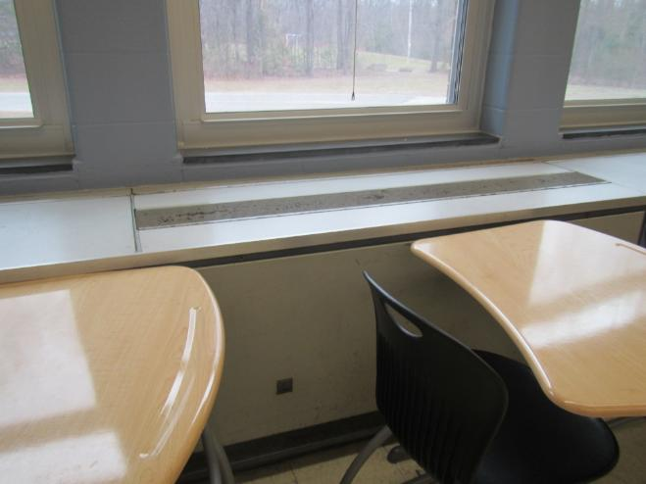
Unit ventilator, note chairs in front
Picture 2
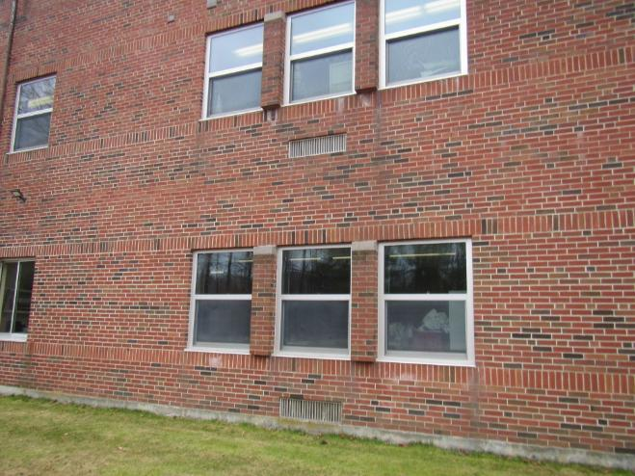
Unit ventilator supply vents on the building exterior (arrows)
Picture 3
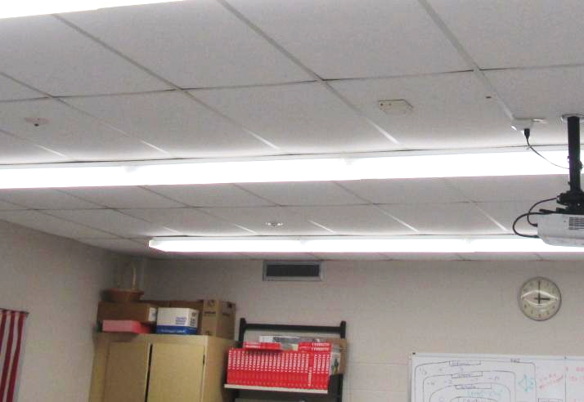
Exhaust vent high on interior wall of classroom
Picture 4
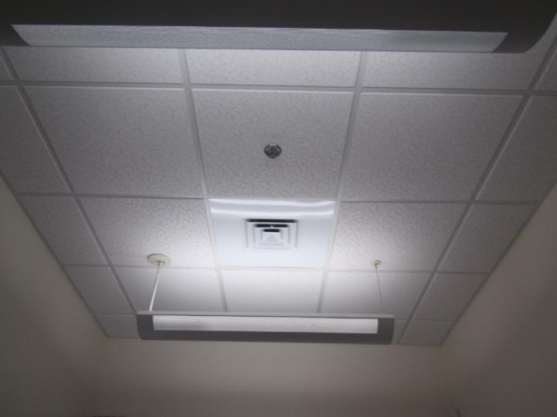
Supply vent in the district offices area
Picture 5
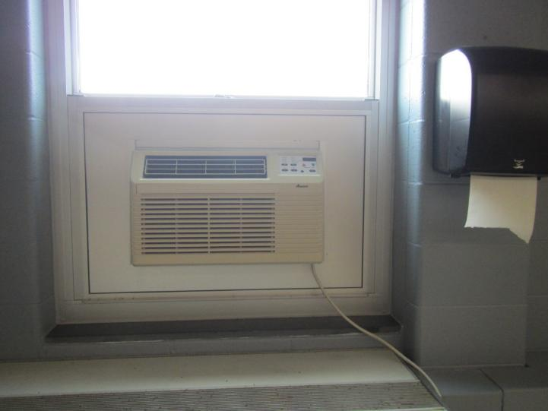
Window-mounted air conditioner in a classroom
Picture 6
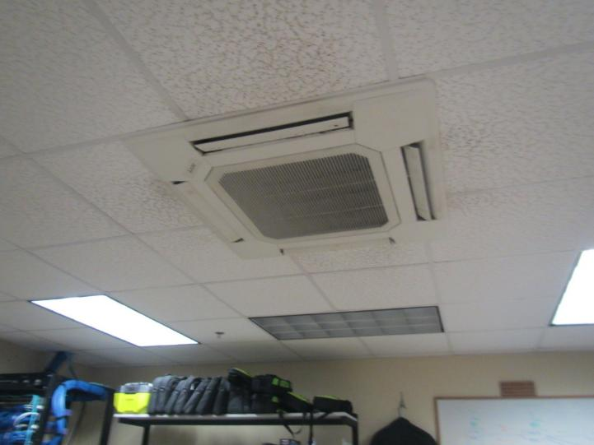
Ductless air conditioning unit on the ceiling of an IT office
Picture 7
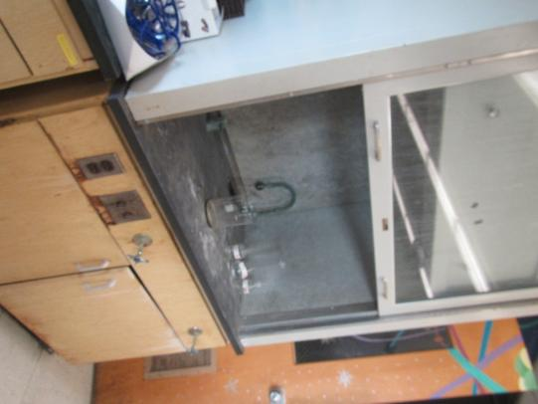
Chemical fume hood in a science classroom, note chemicals stored inside
Picture 8
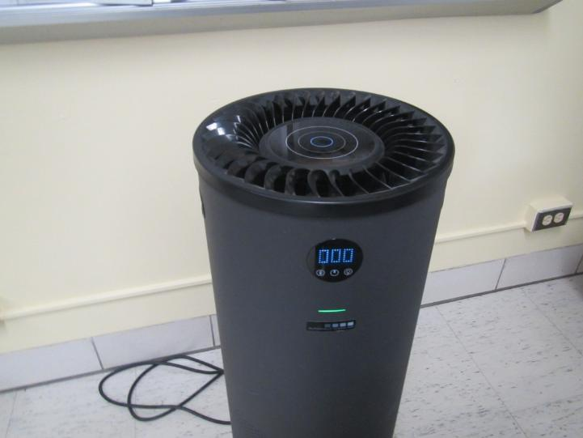
Air purifier in a classroom
Picture 9
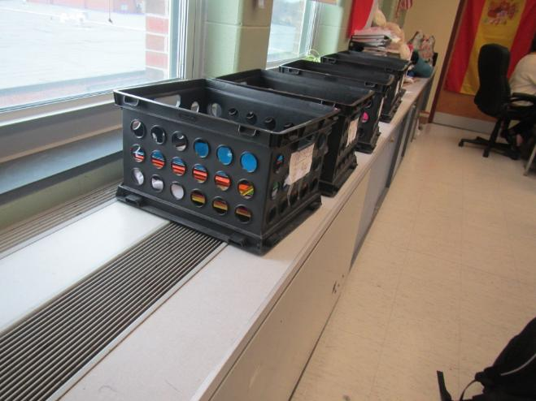
Items placed on top of a univent blocking airflow
Picture 10
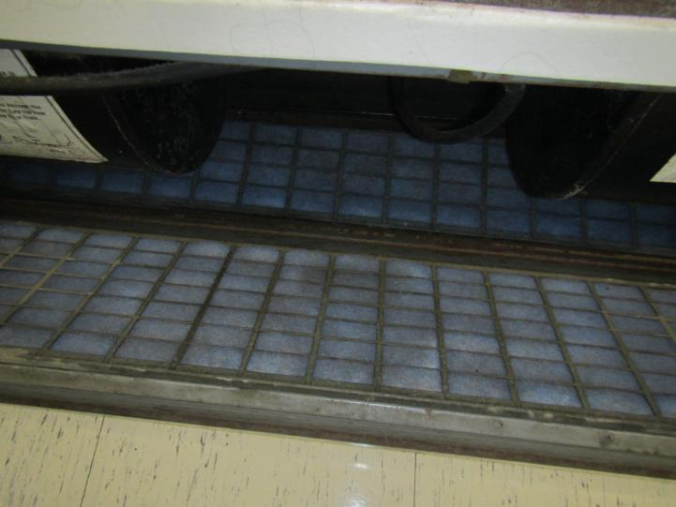
Filter material that needs to be cut to fit in a metal grid

Picture 11
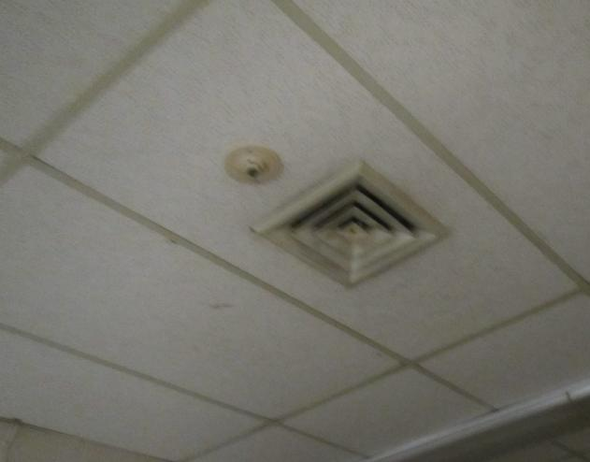
Dusty supply vent
Water Damage and Moisture Concern Pictures
(click to link back to report)
Picture 12
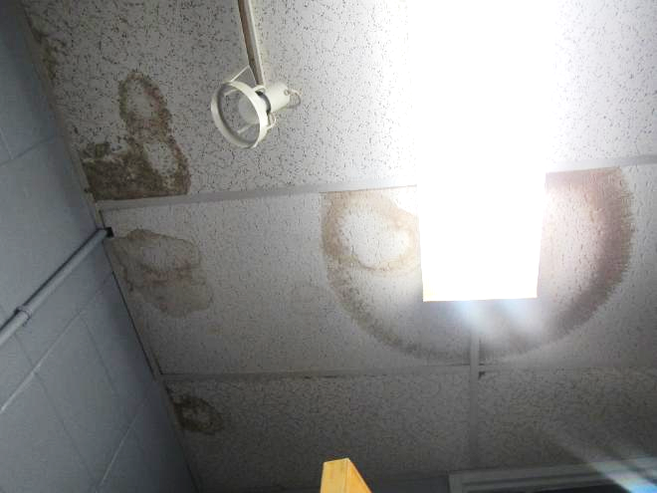
Water-damaged ceiling tiles
Picture 13
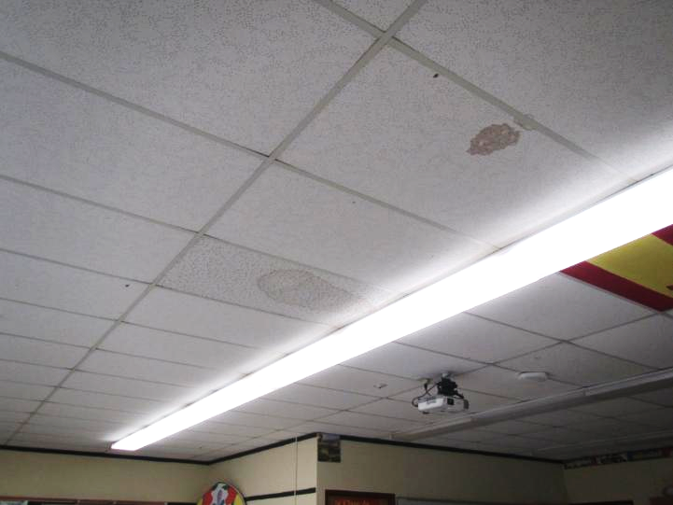
Water-damaged ceiling tiles
Picture 14
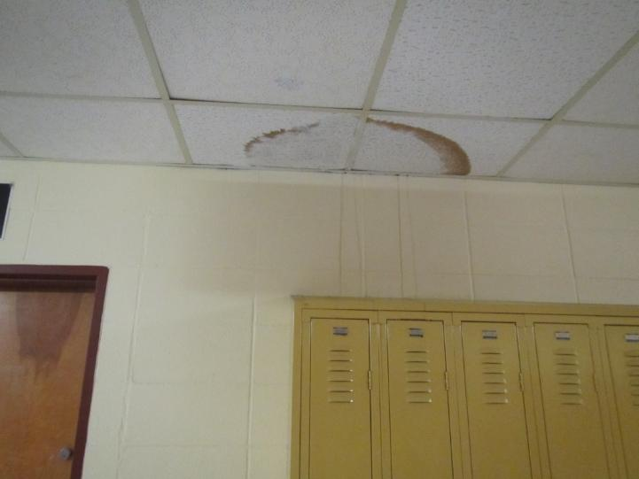
Water-damaged ceiling tiles and water stains on wall
Picture 15
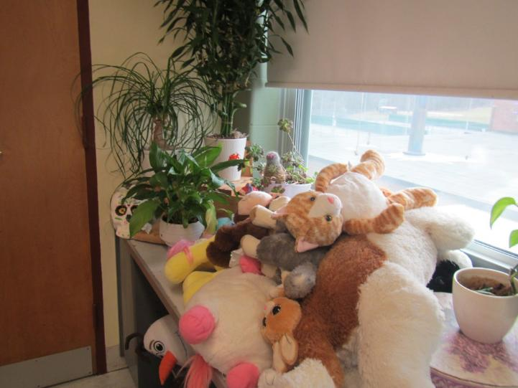
Plants and plush toys on a windowsill
Picture 16
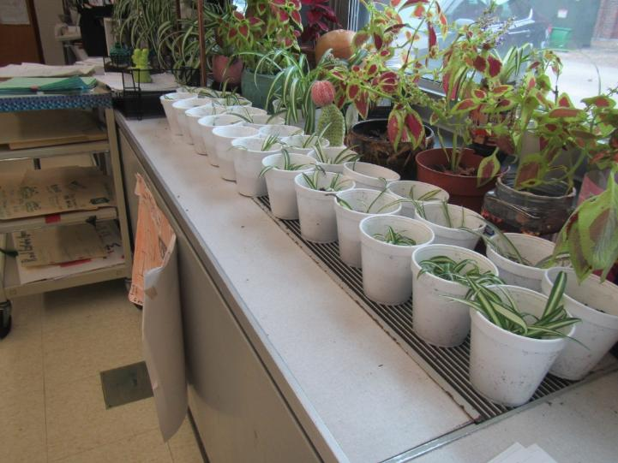
Plants on univent
Picture 17
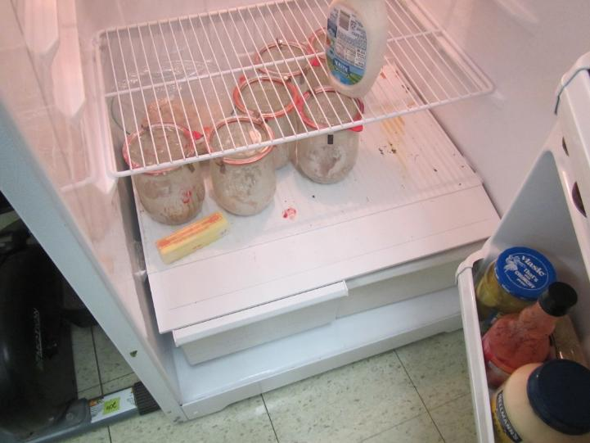
Dirty interior of refrigerator
Picture 18
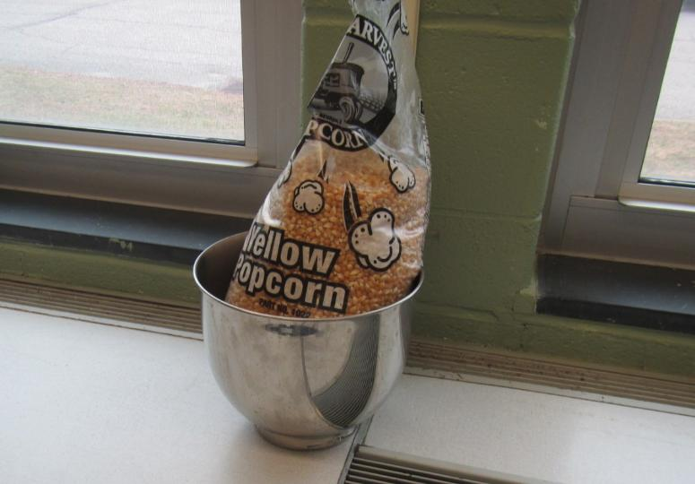
Food in a classroom
Picture 19
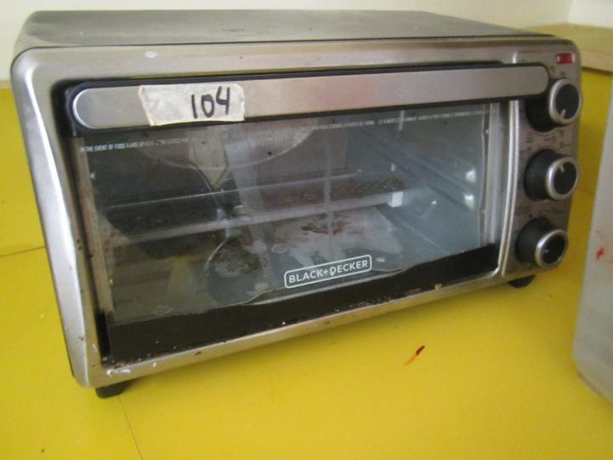
Dirty toaster oven
Picture 20

Light visible underneath an exterior door
Picture 21
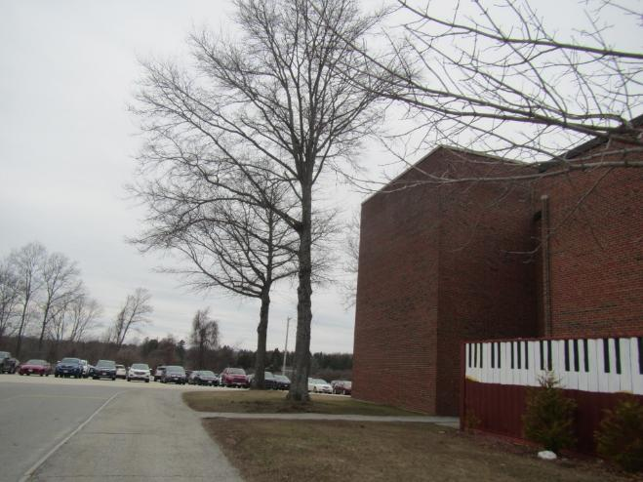
Trees next to the building
Sources of Respiratory Irritant Pictures
(Click to link back to report)
Picture 22
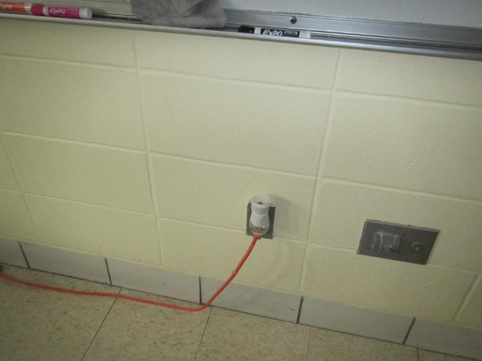
Plug-in air freshener in a classroom
Picture 23
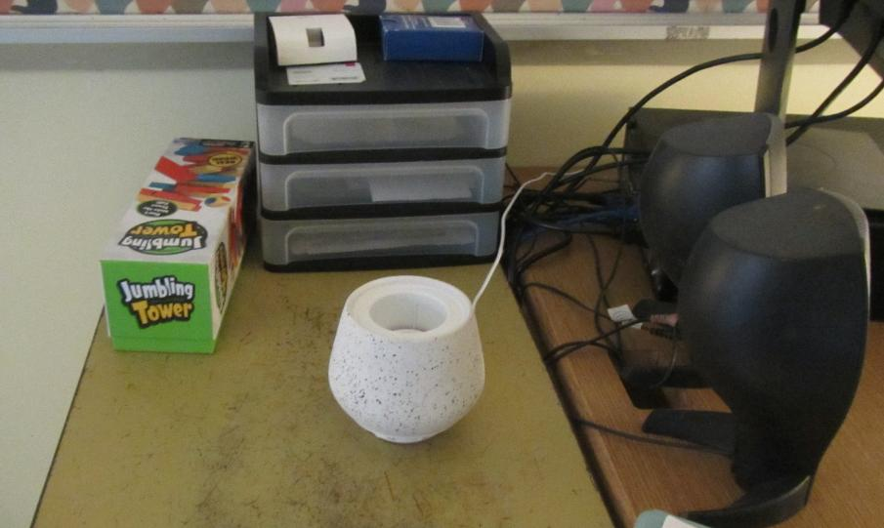
Scent diffuser
Picture 24
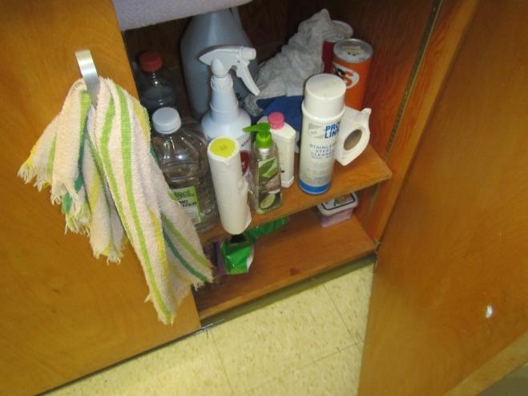
Cleaners, sanitizers, and other items under a sink

Picture 25
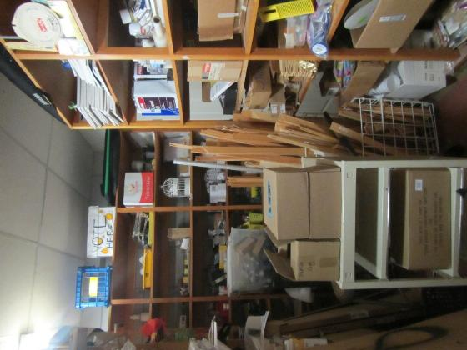
Cluttered storage area
Picture 26
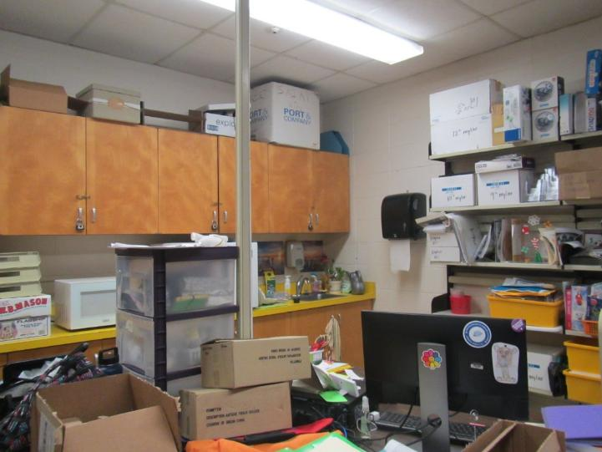
Cluttered science storage area
Picture 27
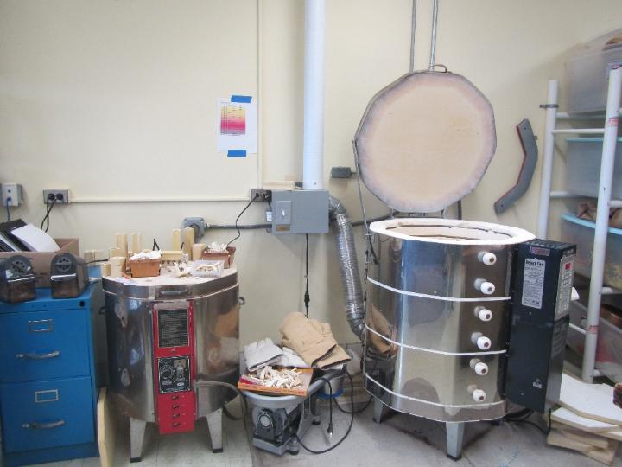
Kiln and other items in an art room
Picture 28
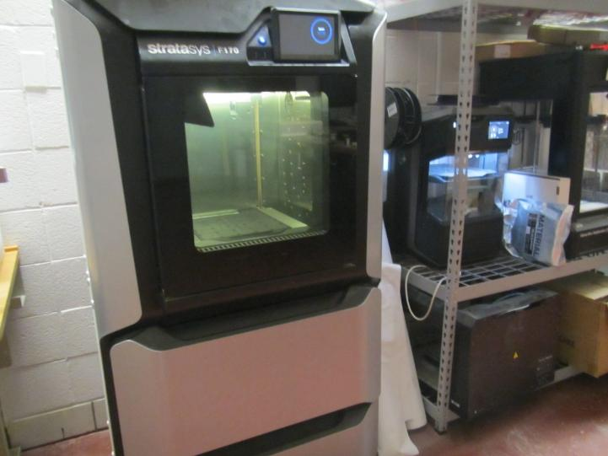
3D printers in an engineering lab
Picture 29
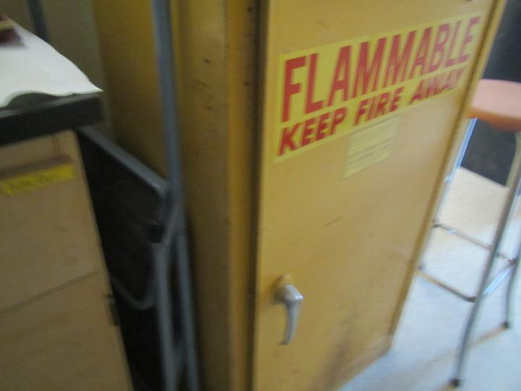
Flammables cabinet not fully closed
Picture 30
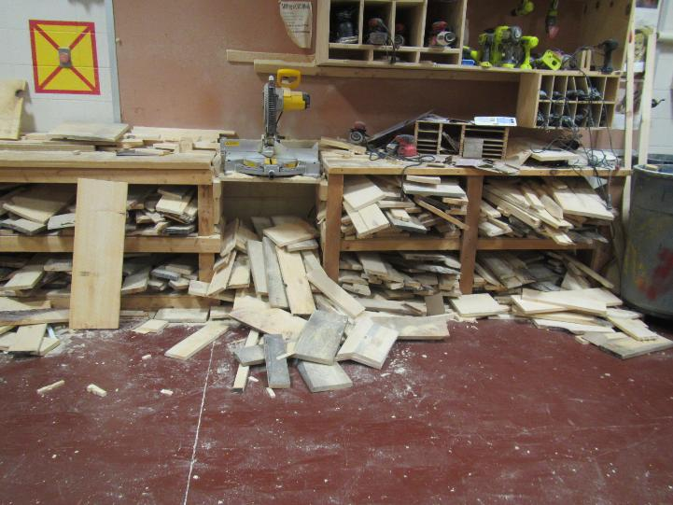
Piles of wood in the woodshop including on the floor

Picture 31
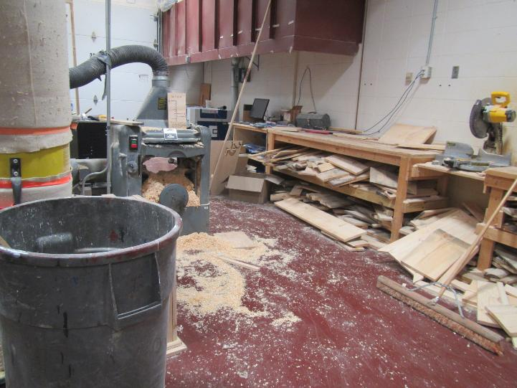
Piles of wood shavings/dust on the floor of the wood shop and stored wood

Table 1 Location | Carbon  Dioxide  (ppm) | Carbon Monoxide  (ppm) | Temp  (°F) | Relative  Humidity  (%) | PM2.5  (µg/m³) | Occupants  in Room | Windows  Openable | Ventilation |  | Remarks
 |  |  |  |  |  |  |  | Supply | Exhaust | Remarks
Background (outside) | 407 | ND | 35 | 46 | 2 |  |  |  |  | Brisk weather, quiet parking lot
Third Floor
300 | 1204 | ND | 69 | 24 | ND | 9 | Y | Y | Y | DEM, items hanging from ceiling
301 | 1037 | ND | 71 | 21 | 3 | 24 | Y | Y | Y | DEM
302 | 1304 | ND | 771 | 22 | 2 | 19 | Y | Y | Y | DEM, unlabeled spray bottle
303 | 713 | ND | 71 | 16 | 1 | 0 | Y | Y | Y | 2 WD CT, DEM
304 | 928 | ND | 71 | 20 | 2 | 13 | Y 1 open | Y | Y | DEM
305 |  |  |  |  |  |  |  |  |  | Science prep room, chemicals, some disorganized storage
306 | 1140 | ND | 73 | 20 | 2 | 14 | Y | Y | Y | Science lab, sinks, hood with no calibration tag and chemicals stored inside
307 | 1033 | ND | 74 | 20 | 1 | 20 | Y | Y | Y | Sinks, some dripping, DEM
307 prep room |  |  |  |  |  |  | Y | N | N | 3-D printer, refrigerator with items inside and evidence of spill
308 | 1108 | ND | 73 | 20 | 3 | 17 | Y 1 open | Y | Y | Science sinks, DEM
309 | 699 | ND | 76 | 13 | ND | 0 | Y | Y | Y | Food, WD CT
310 | 1318 | ND | 72 | 24 | ND | 16 | Y | Y | Y | Blocked UV, plush toys, plants, DEM, popcorn maker
311 | 1111 | ND | 73 | 20 | 2 | 9 | Y | Y | Y | Tea-making equipment, univent blocked, plush items
312 |  |  |  |  |  |  |  |  |  | Storage room, stains on ceiling tiles (smoke?)
313 | 923 | ND | 73 | 19 | 1 | 1 | Y | Y | Y | PF – one dusty, one on, bowed CT, AP, 5 WD CT, DEM
314 | 1577 | ND | 74 | 23 | ND | 18 | Y | Y | Y | DEM, heavily decorated
315 | 1257 | ND | 74 | 23 | 1 | 22 | Y | Y | Y | DEM, plants, scented products
316 | 839 | ND | 73 | 19 | 1 | 0 | Y | Y | Y | DEM
317 | 853 | ND | 70 | 18 | ND | 0 | Y | Y | Y | DEM, plants (real and fake),
318 | 882 | ND | 72 | 19 | 2 | 5 | Y | Y | Y | DEM, scented products
319 | 991 | ND | 73 | 19 | 1 | 20 | Y | Y | Y | Science room, cluttered counters and sink area, DEM
320 | 650 | ND | 75 | 14 | 0 | 4 | Y | Y | Y | Science storage room/Study area, unused biosafety cabinet,
321 |  |  |  |  |  |  |  |  |  | Storage room, printer, access to roof
Science Prep Rm | 1180 | ND | 73 | 24 | 3 | 0 | Y | Y | Y | Corrosive materials storage, WD CT 3
322 | 1196 | ND | 70 | 22 | 2 | 0 | Y | Y | Y | DEM, 3D printer printing,
323 | 1005 | ND | 74 | 21 | 15 | 0 | Y | Y | Y | DEM, lab materials
324 – student counseling in progress
325-inner teachers rm | 1380 | ND | 73 | 23 | 1 | 0 | Y | Y | Y | Dirty microwave, cluttered sink area
325 | 1270 | ND | 75 | 21 | 2 | 12 | Y | Y | Y | DEM
326 | 1851 | ND | 75 | 27 | 2 | 20 | Y | Y | Y | DEM
327 | 2170 | ND | 70 | 26 | 2 | 14 | Y | Y | Y | DEM
328 | 1556 | ND | 72 | 30 | 0 | 21 | Y | Y | Y | DEM, WD CT 2, CT cracked
Second Floor
228 | 1365 | 1 | 74 | 23 | 0 | 21 | Y | Y | Y | DEM, scented product, WD CT 3
227 | 1720 | ND | 74 | 23 | 0 | 21 | Y | Y | Y | DEM
226 | 1335 | ND | 75 | 21 | 0 | 25 | Y | Y | Y | DEM
225 | 1409 | ND | 72 | 23 | 4 | 14 | Y | Y | Y | DEM
224-Storage |  |  |  |  |  |  | Y |  |  | Upholstered chairs, textbook storage
223-Art rm | 831 | ND | 77 | 18.5 | 23 | 1 | Y | Y | Y | Pottery wheels, ceramics, humidifier, paint jugs
222-Art rm | 819 | ND | 74 | 17 | 13 | 0 | N | Y | Y | Kiln, painted CTs
Dark Rm | 860 | ND | 74 | 21 | 4 | 0 | N | Y | Y | Film developer fluids, missing CT, WD CT 4
220 | 1243 | ND | 74 | 22 | 1 | 0 | N | Y | Y | Art supplies
219 | 866 | ND | 73 | 18 | 3 | 4 | Y | Y | Y | DEM, cluttered sink area
218 | 700 | ND | 73 | 16.7 | 0 | 1 | Y | Y | Y | Computer lab
2nd fl Girls Bathroom |  |  |  |  |  |  |  |  |  | Dusty
217 | 890 | ND | 75 | 17 | 2 | 0 | Y | Y | Y | Textbook storage
216 | 620 | ND | 75 | 13 | 0 | 0 | Y | Y | Y | DEM
215 | 1060 | ND | 78 | 20 | 1 | 22 | Y | Y | Y | DEM, clutter, cardboard pile, stuffy
214 | 890 | ND | 77 | 17 | 1 | 25 | Y | Y | Y | DEM, stuffy, WD CT 1
213 | 1132 | ND | 75 | 20 | 1 | 14 | Y | Y | Y | DEM
212A | 671 | ND | 71 | 16 | 1 | 0 | Y | Y | Y | Area rug, dirty microwave
212B | 679 | ND | 73 | 16 | 1 | 1 | Y | N | Y | Area rug, DEM, passive vent in door from classroom
212 inner office | 664 | ND | 73 | 16 | ND | 0 | N | N | N
211 | 460 | ND | 71 | 14 | ND | 0 | Y 1 open | Y | Y | DEM, bowed CT
210 | 674 | ND | 73 | 16 | 1 | 16 | Y1 open | Y | Y | DEM
209 | 702 | ND | 73 | 15 | 1 | 1 | Y | Y | Y | DEM, PF – dusty
208 | 1063 | ND | 74 | 21 | 1 | 16 | Y | Y | Y | Sink, items under sink, DEM, perfume odor
207 old home ec room | 663 | ND | 74 | 15 | 2 | 0 | Y | Y | Y | Used as teacher lounge, full-sized appliances not in much use, sinks, WAC, dusty fan
206 | 640 | ND | 73 | 16 | ND | 1 | Y | Y | Y | Items under sink, WAC, fridge and microwave
205 | 766 | ND | 72 | 17 | 1 | 5 | Y | Y | Y | Area rug, bed, bowed CT, fridge, univent blocked
204 | 808 | ND | 773 | 16 | 2 | 8 | Y 1 open | Y | Y | DEM
203 | 905 | ND | 74 | 17 | 0 | 8 | Y | Y | Y | Fridge, sink, DEM
202 | 1246 | ND | 73 | 21 | 0 | 23 | Y | Y | Y | DEM, plush items
201 | 1077 | ND | 72 | 20 | 1 | 15 | Y | Y | Y | DEM, PF, AP
200 | 1243 | ND | 72 | 22 | 1 | 18 | Y | Y | Y | DEM, bowed CT
First Floor
100 | 831 | ND | 71 | 18 | 1 | 0 | Y | Y | Y | Conference room
101 | 590 | ND | 70 | 16 | 1 | 0 | Y | Y | Y | Food
102 | 1344 | ND | 71 | 24 | 2 | 23 | Y | Y | Y | Area rug, plants, TBs (a few legs)
103 | 895 | ND | 72 | 19 | 3 | 77 | Y | Y | Y | DEM
104 | 1469 | ND | 73 | 25 | 9 | 25 | Y | Y | Y | Food, plants, boxes, DEM, PF
105 | 1089 | ND | 73 | 21 | 5 | 12 | Y | Y | Y | Perfume (plug-in), DEM
106 | 974 | ND | 72 | 20 | 5 | 18 | Y | Y | Y | Plants, 2 WD CT
107 | 1502 | ND | 72 | 23 | 2 | 18 | Y | Y | Y | Plants, PF
Storage (108) | 705 | ND | 72 | 21 | 6 | 0 | N | N | N | Musty odor, WD CT, items
109 Staff lounge | 612 | ND | 72 | 17 | 1 | 0 | Y | Y | Y | Scented products, decorations
111 | 934 | ND | 72 | 21 | 4 | 12 | Y | Y | Y | Area rug, DEM
112 | 766 | ND | 72 | 18 | ND | 0 | Y | Y | Y | Plants, sweet odor (plug in), DEM
113 | 869 | ND | 71 | 21 | ND | 1 | Y | Y | Y | Many plants, DEM, PF
114 | 855 | ND | 73 | 19 | 1 | 12 | Y 1 open | Y | Y | Plants
115 | 808 | ND | 73 | 18 | ND | 1 | Y | Y | Y | DEM, AP, dehumidifier
116 | 848 | ND | 71 | 19 | 2 | 0 | Y | Y | Y | PF, DEM, AP, dehumidifier
117 | 1102 | ND | 72 | 22 | ND | 22 | Y 1 open | Y | Y | Plug-in, DEM, PF
118 | 753 | ND | 72 | 20 | 1 | 13 | Y | Y | Y | DEM
119 | 1247 | ND | 73 | 24 | 1 | 9 | Y | Y | Y | DEM, bowed CT outside the room
120 | 1230 | ND | 74 | 24 | 5 | 0 | Y | Y | Y | DEM, scented products
Storage Rm | 930 | ND | 74 | 33 | 4 | 0 | Y | Y | Y | Washer/dryer, outdoor equipment
121A | 1224 | ND | 73 | 25 | 7 | 0 | N | Y | Y | Space heater on, ceiling uninvent system
121-School Psychologist rm | 1182 | ND | 73 | 24 | 6 | 0 | N | Y | Y | Carpeted, pillows, plush seating
123 | 1471 | ND | 73 | 24 | 1 | 15 | Y | Y | Y | DEM, cluttered, articles on the floors
123A | 1171 | ND | 72 | 25 | 3 | 0 | N
124 | 1330 | ND | 73 | 24 | 3 | 22 | Y | Y | Y | DEM, uninvent blocked, cluttered
Nurses office | 1554 | ND | 77 | 23 | 2 | 0 | Y | Y | Y | Multiple rooms with cots
Main Office | 1224 | ND | 73 | 22 | 1 | 4 | N | Y | Y | Carpeted, decorations
Main – Rm A | 1570 | ND | 74 | 23 | 1 | 0 | Y | Y | Y | Carpeted,
Main-Rm B + C |  |  |  |  |  |  |  |  |  | locked
Storage
Main-Rm E | 1231 | ND | 75 | 23 | 1 | 1 | Y | Y | Y | Carpeted, printer area, storage lockers
Main-Rm F | 1437 | ND | 75 | 25 | 2 | 1 | N | Y | Y | Carpeted
Main-Rm G | 1520 | ND | 77 | 24 | 1 | 1 | Y | Y | Y | Carpeted
Main-Rm H |  |  |  |  |  |  |  |  |  | Locked - in a meeting
Main- Rm I | 1566 | ND | 77 | 23 | 2 | 1 | N | Y | Y | Carpeted
Main-Common space | 1454 | ND | 77 | 23 | 23 | 0 | N | Y | Y | Carpeted, ceiling fan
Library Conf | 642 | ND | 73 | 18 | 0 | 0 | Y | Y | Y | Carpeted, dusty
110 office in library | 612 | ND | 71 | 17 | 2 | 0 | Y | Y | Y | Carpet, old, cracked leather chairs
Library | 665 | ND | 71 | 18 | ND | ~30 | Y | Y | Y | WD CT (a few), carpet
Library workroom | 676 | ND | 71 | 19 | ND | 0 | N | Y | Y | Clutter, food, microwave
Library workroom office |  |  |  |  |  |  |  |  |  | Laminator, food
144A | 911 | ND | 71 | 22 | ND | 7 | N | Y loud | Y | DEM
Exercise/weight room | 875 | ND | 73 | 21 | ND | 200 | N | Y | Y | Fan-on, carpets and mats
Maintenance lunchroom | 525 | ND | 73 | 18 | 1 | 0 | N | Y | Y | Garage door
Locker-Girls | 609 | ND | 75 | 17 | 3 | FULL | N | Y | Y
Lockers-Girls Office | 578 | ND | 77 | 16 | 3 | 1 | N | Y | Y
Locker Rm-Boys | 527 | ND | 78 | 14 | 1 | 0 | N | Y | Y
Mechanical Rm | 625 | ND | 77 | 17 | 2 | 0 | N |  |  | Dirty microwave
Gym | 649 | ND | 73 | 19 | 0 | 0 | N |  |  | Gap under door to outside
Cafeteria | 763 | ND | 72 | 20 | ND | FULL | N | Y | Y
Rm198 | 786 | ND | 75 | 19 | 1 | 0 | N | Y | Y | Storage, CT missing, paper rolls
PT/OT room | 656 | ND | 72 | 17 | 1 | 0 | N | Y | Y | Training room
Auditorium, spectator side | 586 | ND | 70 | 20 | ND | 0 | N | Y | Y off | Carpeted, seats
Music Rm | 792 | ND | 74 | 17 | 1 | 10 | N | Y | Y | Cluttered, dusty
Music-Office | 780 | ND | 74 | 20 | 1 | 1 | N | Y | Y | Printer, WD CT 8 – persistent leak
Music Rm 2 | 647 | ND | 72 | 21 | 1 | 1 | N | Y | Y
Music-Store Rm | 776 | ND | 77 | 56 | 0 | 0 | N | Y | Y | WD CT 6
Music-Piano Rm | 783 | ND | 74 | 22 | 1 | 0 | N | Y | Y
181 | 677 | ND | 69 | 20 | ND | 0 | N | N | N | PF on
CAD lab | 495 | ND | 67 | 18 | ND | 1 | N | Y | Y | 3D printers, wood design equipment
Wood shop | 525 | ND | 68 | 19 | ND | 0 | N | Y | Y | Wood chips and shavings on floor and surfaces, some direct task exhaust but not for all equipment, laser and plasma cutters with direct vent exhaust
Engineering lab and associated rooms |  |  |  |  |  |  |  |  |  | Odor of plastic, WD CT and missing CT
IT office | 746 | ND | 69 | 21 | ND | 1 | Y | Y | Y | Ceiling-mounted minisplit unit
District offices
Student services office | 664 | ND | 71 | 19 | ND | 1 | Y | Y | Y | Perfume
office | 635 | ND | 71 | 18 | nd | 0 | Y | Y | Y | Carpet, 1 WD CT
Common Space | 860 | ND | 75 | 29 | 0 | 2 | N | Y | Y | Plants, personal items
Kitchen | 690 | ND | 75 | 18 | 0 | 0 | N | Y | Y
Conference Rm | 782 | ND | 75 | 16 | 0 | 0 | N | Y | Y
Office -Data Coordinator | 804 | ND | 76 | 23 | 0 | 2 | Y | Y | Y
Accounts Payable | 658 | ND | 71 | 18 | ND | 0 | Y | Y | Y | Carpeted
Payroll | 696 | ND | 71 | 18 | ND | 1 | Y | Y | Y | Carpeted, food
Director of Finance/  Operations | 694 | ND | 71 | 19 | ND | 0 | Y | Y | Y | Carpeted, boxes on floor
Facility office | 702 | ND | 71 | 19 | ND | 0 | Y | Y | Y | Carpeted
Assistant superintendent | 708 | ND | 71 | 19 | ND | 1 | Y | Y | Y | Sweet

(Click to link back to report)

Table 2A
Equipment Present in Building  (X = Yes) | Type of Heating/Cooling Ventilation  Equipment | Fresh  Air  Supply  (X = Yes) | Type of Location(s) | Air Filters Installed  MERV Rating  (1-15, U*)  (X = Yes) | Comments
X | Univents | X | Classrooms | 8
 | Rooftop Air Handling Units
 | Outdoor, Ground-Installed Air Handling Units
 | Attic/Crawlspace Air Handling Units
 | Ceiling-Mounted Air Handling Units (including inside plenum)
 | Basement/Crawlspace-Installed Air Handling Units
 | Mechanical Room-installed Air Handling Units
 | Fan Coil Units
X | Window-Mounted Air Conditioners | X | A few classrooms
 | Wall Louver-Controlled Gravity Air Supply
X | Windows | X | Most rooms |  | In good conditoin
 | Fan in window (blowing in)
 | Built in wall fan (switched)
 | Heat recovery ventilator unit
 | Energy recovery ventilator unit
 | Chilled Beam
 | Passive combustion supply vent in basement/boiler room

*U = Filter Rating underdetermined due to inaccessibility during building visit

(Click to link back to report)

Table 2B
Equipment Present in Building  (X = Yes) | Type of Exhaust Ventilation  Equipment | Ducted  To Outdoors  (X = Yes) | Type of Location(s) | Comments
X | Rooftop Motors/Fans | X | For classrooms/offices with univents
 | Unit Exhaust
X | Ceiling Return Vent
 | Ceiling Return Vent, Plenum
X | Wall Return Vent
 | Kitchen Stove Hood
X | Restroom Exhaust Vent
 | Photocopier Exhaust Vent
 | Garage
X | Chemical Hood(s) | X | Science rooms | No calibration sticker
X | Locker Rooms
X | Showers
 | Lock up Cells
 | Clothes Dryers
 | Gas Water Heaters
 | Furnace-Flue to Chimney
 | Furnace/Boiler direct vent or power vent (no combustion air supply)
X | Kiln, Pottery
X | Dark Room |  | Art room | Electric kilns with vents to outside
 | Generator Room
X | Wood Shop Dust Collector |  |  | For sanders only
x | Spray Paint Booths
 | Fan in window (blowing out)

Table 2C
Equipment Present in Building  (X = Yes) | Type of Equipment | Type of Location(s) | Comments
 | Floor Fans, pedestal
X | Portable fans | Various areas | Some dirty and dusty
X | Air Purifier (HEPA, other) | Some classrooms | Clean/replace filters on regular basis
 | Floor heaters, portable
X | Refrigerators, Cold Beverage Vending Machines | Break rooms and some offices | Clean food/liquid spills
 | Radiator, wall-mounted
 | Radiator, floor-mounted
 | Passive vents (Wall/Door)

(Click to link back to report)

Table 3
Found in Building  X = Yes | Water-Damaged Materials, Building Components or Stored Materials | Location | Visible Microbial Growth?  X = Yes | Musty odor detected?  X = Yes | Comments
 | Books-other bound materials
 | Brick walls – broken, missing mortar
 | Brick walls – blocked weep holes
 | Cardboard boxes
 | Carpet tiles
 | Carpet - Area rugs
 | Carpet wall-to-wall
 | Ceiling tiles - affixed directly to ceiling surface
 | Ceiling tiles - bowing-in suspended ceiling
 | Ceiling tiles - water-stained in splined ceiling
X | Ceiling tiles - water-stained in suspended ceiling | Various | X
 | Chairs - laminated
 | Cloth
 | Countertops (around sinks)
 | Curtains
 | Dust/debris within AHU, uninvent, HVAC, chilled beam units, etc. (WD through condensation, humidity, or leaks)
 | Efflorescence (i.e., mineral deposits)
 | Engineered woods - particleboard, plywood, Masonite
 | Flooring – loosened tiles
 | Flooring - wooden
 | Furniture - laminated
 | Furniture - upholstered
 | Gypsum wallboard - ceiling
 | Gypsum wallboard - restroom wall
 | Gypsum wallboard - interior wall
 | Gypsum wallboard – located on exterior wall
 | HVAC drain pan – lack of draining
 | HVAC filters
 | Insulation- attic (paper-backed)
 | Insulation - inside air handling unit
 | Insulation - on pipe(s) fiberglass
 | Insulation - on pipe(s) other/plaster-like material
 | Insulation - wall cavity
 | Insulation – ceiling plenum
 | Modular furniture – walls/cloth partitions
 | Musical instrument cases
 | Plaster ceilings
 | Plaster walls
 | Records/files
 | Refrigerator - door gasket
 | Refrigerator - drip pan
 | Refrigerator - Interior surfaces
 | Room divider - ceiling-mounted, sliding
 | Sink backsplash
 | Tables – laminated
 | Wallpaper
 | Wood - attic/roof materials
 | Wood - floor joists in basement ceiling
 | Wood - wall framing
 | Wood - window sills
 | Wood - window-mounted air conditioner framing
X | OTHER: material under sinks | Some classrooms with sinks | no

WHAT ARE ENVIRONMENTAL ASTHMA TRIGGERS?
Asthma triggers are any chemical, pollutant, or allergen that can make your asthma worse. Asthma triggers can also be strong chemical smells, dust, or pets. Your asthma triggers may be different from those of other people. Not all asthma triggers affect people the same way. Environmental asthma triggers are found both indoors and outdoors. DPH link: Asthma and Your Environment (mass.gov)

(click to link back to report)

Table 4
Condition Present  X = Yes | Possible asthma symptom-inducing environmental pollutant | Recommendation to reduce or eliminate the pollutant
X | Water Damage and/or Mold  (allergen) | Identify water source and repair to eliminate.  Clean non-porous materials.  Remove and replace porous materials susceptible to mold growth.  Perform regular water damage assessments as a tool to ensure timely mitigation as needed.  Use NIOSH water damage assessment protocol as a guide: NIOSH water damage assessment guideline.
 | Moistening of building components during hot, humid weather (>2 days in length) (mold, allergen) | Remove materials not dried in <2 days in a manner consistent with US EPA Mold Removal in Commercial Buildings guideline.  Use dehumidification in occupied basement areas and other areas with chronic dampness.
X | Vegetation against exterior of building (water damage-mold) | Remove all vegetation preventing building exterior drying.  Remove all vegetation capable of falling onto a building or depositing debris onto the roof.
 | Personal humidifiers (lack of proper maintenance)  (pollutant and allergen) | Clean and maintain properly.  Use distilled water to eliminate metal and water treatment odors.  Maintain hydration by increasing water consumption.
X | Drains: Floor drains, Sink drains (abandoned use)  Water bubblers (abandoned use) | If in use, pour water into drain at least twice a week.  If not in use, seal the drain with an appropriate material in accordance with Massachusetts Plumbing Code (248 CMR 10.00).
 | Live Animals (turtles, gerbils, birds, rabbits, etc.) | Ensure cleanliness or remove animals from the location.
 | Improperly maintained aquariums and terrariums (allergen) | Maintain such equipment properly to eliminate odor.  Discontinue use.
X | Plants and flowers  (allergen and mold) | Keep indoor plants well maintained and not overwatered. Monitor for signs of mold and pests.  Ensure water for cut flowers does not become stagnant.  Ensure dried plant material is free of odors, mold, and pests and handled carefully  If asthma risks are high, eliminate plants and flowers.
 | HVAC system moisture issues  (mold, allergen) | Consult ASHRAE’s minimum standards for HVAC maintenance and inspection of commercial HVAC systems (https://www.ashrae.org/technical-resources/bookstore/standards-180-and-211).
 | HVAC system contaminant issues (allergen) | Consult ASHRAE’s minimum standards for HVAC maintenance and inspection of commercial HVAC systems (https://www.ashrae.org/technical-resources/bookstore/standards-180-and-211).
 | Indoor swimming pool odors outside of swimming pool (mold, chemical) | Maintain and operate pool HVAC systems to vent odors from building.  Ensure locker room exhaust vents are operating during building hours.  All doors leading to pool should be rendered airtight and be closed.
X | Pollen (allergen) | Recommend installation of MERV 8 or better filters if HVAC engineer confirms HVAC system can be so equipped without adversely affecting function.  Cut grass after hours.  Cut grass in a pattern to direct clippings away from exterior wall.  Remove trees and shrubs from in front of windows and air intakes.
X | Dry air | Maintain hydration.  Avoid overheating of air.
 | Dust mites  (allergen) | Recommendation to remove non-official upholstered furniture, area rugs, pillows, cushions, etc.  Cleaning with use of HEPA-filtered vacuum cleaner.  Eliminating clutter, storing items in dust and moisture-proof containers, and regularly removing dust through wet wiping.
 | Pests, including rodents and cockroaches  (allergen) | Use of integrated pest management guidelines, including:  - Proper disposal of food containers  - Proper storage of food products in airtight containers  - Elimination of use of food as art projects  - Remove pest harborages/clutter  - Regular monitoring for pests  EPA IPM guideline link
X | Latex-containing materials | Remove tennis balls from furniture legs.
X | Fragrances  (chemical) | Eliminate point sources, such as:  - Plug-in air fresheners  - Aroma/oil reed diffusers  - Scented sprays  - Discontinue use of other scented materials  - Consult DPH fragrance guideline: Clean air is odor-free
X | Strong smells from /use of Chemicals (such as cleaning products)  (chemical) | Use building-issued cleaning products.  Use products in accordance with manufacturer’s instructions including dilution, application, and ventilation.  Avoid using products that are stronger than needed for the situation.
 | Strong odors from new building materials (carpeting/furniture)  (chemical) | Use low VOC-emitting materials.  Air out materials (outside or in unoccupied area) prior to installation.
 | Tobacco smoke  Secondhand Smoke  (pollutant) | Eliminate tobacco smoking.  Seal all shared wall penetrations.
X | Products with a strong odor such as paint, perfume, hairspray, air fresheners, bug-spray, laminators, candles, wax melters, dry erase markers and other VOC-containing products  (chemical) | If essential:  - Provide proper exhaust ventilation to eject aerosolized product directly outdoors.  - Avoid/reduce use during occupied hours.  If not necessary, remove and eliminate.
X | Vehicle exhaust  (pollutant) | Enforce anti-idling regulations and post signs to give notice.  Relocate vehicles away from fresh air intakes.  Require vehicles to park face-in at building walls.  Close doors to prevent vehicle exhaust from entering occupied spaces. idling-faq
 | Vapors and or fumes from gas, oil, or kerosene stoves  (pollutant) | Operate stove hood when stove in use.  Install stove hood if not present.  Ensure equipment is in good working order.
 | Ozone (pollutant) | Eliminate use of ozone generating equipment.
X | Window Air Conditioners (if not properly maintained) (allergen) | Equip with proper filter and clean periodically.  Clean drip pans.  Install in window with weathertight, non-mold-growth sustaining material.
X | Pottery (pollutant) | Do not operate kiln during occupied hours.  Operate kiln with exhaust system activated.  Seal all seams and holes in kiln vent.  Ensure kiln exhaust discharge terminates outdoors.
X | Carpeting (allergen) | Clean carpeting in a manner consistent with IICRC standards, including regular vacuuming with a high efficiency particulate air (HEPA) filtered vacuum in combination with annual cleaning or semi-annual cleaning in soiled high traffic areas.
X | Sweeping/dusting vs HEPA vacuuming/wet wiping  (allergen or pollutant) | Refrain from using feather dusters or brooms.  Utilize HEPA vacuums and wet wiping to minimize aerosolizing particulate matter.
X | Lack of adequate air exchange/mechanical ventilation | Make repairs as necessary and ensure all HVAC system components are operating continuously when building is occupied.
X | Lack of local exhaust at source of pollution (vocational shop activities, kitchen exhaust hood) (all) | Recommend installation of exhaust ventilation to direct pollutants directly outdoors.
 | Renovating buildings while occupied  (chemical) | Use all SMACNA guidelines for Renovation While Buildings Are Occupied. For information, visit https://www.mass.gov/service-details/construction-and-renovation-generated-pollutants-in-occupied-buildings.
X | Chemistry program chemical storage  (chemical) | Repair (if needed) and operate chemical storeroom vents appropriately.  Reduce or eliminate unneeded or overstocked chemicals.  Store all chemicals in a manner to separate incompatible chemicals.  Keep chemical storerooms clean.
X | Photocopiers/duplicating machines | All machines should have dedicated exhaust vents or be used in a well-ventilated area.

