Examination of Health Care Cost Trends and Cost Drivers Pursuant to G.L. c. 12C, § 17

Report for Annual Public Hearing Under G.L. c. 6D, § 8

Office of the Attorney General Commonwealth of Massachusetts

November 17, 2021

The ambulatory care expansion of high-cost hospital systems is poised to transform the Massachusetts health care market. Whether this transformation harms consumers by driving up statewide costs and health insurance premiums or helps consumers by providing more convenient access to care in the suburbs (or both), these proposed projects are significant market changes and merit complete, transparent, and data-driven analysis. Unlike mergers or acquisitions, proposed system expansions do not trigger notification to antitrust regulators, nor the option of a full Cost and Market Impact Review at the Health Policy Commission (HPC). In its 2021 Cost Trends Report, the HPC recently highlighted the need for enhanced scrutiny and monitoring of provider expansions and ambulatory care. Assumptions and conclusions by the proponents of these projects must be thoroughly tested against the state’s health care cost containment goals. Whether a proposed expansion project ultimately raises or lowers costs depends in large part on whether it shifts commercial market share to or away from higher-priced options.1 Low-cost community hospitals rely on narrow commercial margins to stay in business, and a shift of commercial patients away from them threatens their continued viability as affordable and high-quality options in the market.

The Attorney General’s Office (AGO) has a special role in promoting access to affordable health care in Massachusetts. The AGO is charged by law with monitoring trends in the health care market, especially in the size of provider organizations2, and is authorized to obtain information through civil investigative demands related to health care cost trends and cost drivers from market participants.3

Mass General Brigham (MGB) is one of the most preeminent health care institutions in the world, and Massachusetts residents benefit immensely from the high quality and cutting-edge research, training, and care it provides here in the Commonwealth. It is also the biggest and highest

1 The Attorney General’s Office has issued previous reports citing commercial market share shifting toward high-priced providers as a key driver of overall health care costs. See OFF. OF ATT’Y GEN., EXAMINATION OF HEALTH CARE COST TRENDS AND COST DRIVERS at 3-5, (Oct. 17, 2019); OFF. OF ATT’Y GEN., EXAMINATION OF HEALTH CARE COST TRENDS AND COST DRIVERS at 23-24, (Sept. 18, 2015).
2 Mass. Gen. Laws ch. 12, § 11N (“The attorney general shall monitor trends in the health care market including, but not limited to, trends in provider organization size and composition, consolidation in the provider market, payer contracting trends and patient access and quality issues in the health care market.”) (emphasis added).
3 Mass. Gen. Laws ch. 12C, § 17 (“The attorney general may require that any provider, provider organization, or payer produce documents, answer interrogatories and provide testimony under oath related to health care costs and cost trends, factors that contribute to cost growth within the commonwealth's health care system and the relationship between provider costs and payer premium rates.”).
1

priced health care system in Massachusetts. In early 2021,4 MGB released plans to build three ambulatory care centers with ambulatory surgery, physician services, and high-tech imaging in Massachusetts: new sites in Westborough and Woburn and a significant expansion of MGB’s existing physician site in Westwood.5 At the same time, MGB also released plans to renovate and expand Massachusetts General Hospital and Brigham and Women’s Faulkner Hospital. Consistent with its statutory responsibility to monitor and investigate health care cost trends and drivers, the AGO initiated an independent examination of the cost impacts of MGB’s ambulatory care expansion proposal, including a review of documents MGB has produced in response to our civil investigative demand. The AGO thanks MGB for its cooperation with this examination.

The HPC and the Department of Public Health (DPH) are undertaking reviews of these proposals. Market participants, community organizations, members of the public and other stakeholders have an opportunity to comment on the proposals, informed by materials MGB has released through its Determination of Need (DoN) application. Based on our understanding of the parameters of the HPC and DPH analyses, and after review of documents MGB produced as part of our examination, the AGO determined that disclosure of certain information from our examination is necessary to ensure that the HPC and DPH analyses proceed with the appropriate analytical scope and frame.

After balancing the public interest in this disclosure with the privacy, trade secret, and anti- competitive interests, and determining that the disclosure will promote the health care cost containment goals of the Commonwealth, the AGO concludes that the following limited disclosure from MGB’s documents is warranted.6

- The three ambulatory sites MGB proposes in Westborough, Woburn, and Westwood are part of a larger multi-year ambulatory expansion plan across Eastern Massachusetts. In its 2018 planning process, MGB projected that this expansion plan would ultimately contribute direct margins to the MGB system of approximately $385 million per year, including new ambulatory volume as well as net revenue from incremental hospital volume resulting from new ambulatory sites. New hospital margin from patient referrals from the ambulatory sites to MGB hospitals was projected to outweigh losses resulting from the shift of visits from MGB hospitals to the ambulatory sites.7, 8

4 MGB initially announced these proposals in December 2019 but delayed its expansion plan due to the COVID-19 pandemic. See Priyanka Dayal McCluskey, Partners plans $400M expansion in Boston suburbs, BOSTON GLOBE (Dec. 19, 2019).
5 The AGO has not examined MGB’s proposed ambulatory care expansion in Salem, New Hampshire.
6 Mass. Gen. Laws ch. 12C, § 17 (disclosure permitted “in a public hearing under section 8 of chapter 6D, a rate hearing before the division of insurance or in a case brought by the attorney general, if the attorney general believes that such disclosure will promote the health care cost containment goals of the commonwealth and that the disclosure should be made in the public interest after taking into account any privacy, trade secret or anti-competitive considerations”).
7 MGB internal analysis (June 2018).
8 MGB produced a 79-page report to the AGO dated November 10, 2021 projecting that the three pending DoN proposals (the three ambulatory sites, the Massachusetts General Hospital project, and the Brigham and Women’s Faulkner Hospital project) would decrease annual total medical expenditures for Massachusetts residents. The AGO has not vetted the models, data, or assumptions underlying this report, but notes that the report does not account for any increase in medical expenditures generated by MGB backfilling its hospitals as MGB hospital patients move to the new
2

- In its 2018 planning process, MGB projected that the multi-year MGB ambulatory expansion plan would ultimately increase MGB’s share of the market for inpatient hospital services and covered lives. MGB projected it would gain an additional 1-2% of all secondary inpatient admissions in Eastern Massachusetts and an additional 3- 4% of all tertiary inpatient admissions in Eastern Massachusetts.9 MGB projected it would gain an additional 1-2% of all covered lives in Eastern Massachusetts.10, 11
- Volume projections are a key element to any assessment of cost impacts. The volume of ambulatory surgery procedures performed at a health care facility depends on the utilization plan for its operating rooms (ORs). MGB’s projections from 2018 relied on the assumption that the ORs created in its ambulatory care expansion would have a throughput of 1200-1600 cases per year, depending on acuity, and approximately 2000 cases per OR per year for otolaryngology and ophthalmology procedures. MGB projected that OR capacity utilization would be 85%.12 In MGB’s 2021 DoN application for its Westborough, Woburn, and Westwood sites, it relied on significantly lower OR productivity assumptions: 1000 cases per year and 70% capacity utilization.13 The cost implications of this differential and analysis of any reasons for the decline in volume projections should be part of the cost containment analysis of these proposals.
- Staffing plans are critical to a complete analysis of the likely cost and market impacts of a new health care facility. Primary care staffing is especially important given the current environment of workforce shortages and the fact that primary care providers often bring their patient panels with them if they move to a new system. Based on MGB projections dated 2018, MGB planned to staff the three currently proposed sites at Westborough, Westwood, and Woburn by adding 22 new primary care physicians to the MGB system in total across the three sites. MGB planned to staff the specialty physician practices at the three proposed sites as follows:14

ambulatory sites. To the extent patients receiving care in the newly available MGB hospital capacity would have otherwise received care at lower-priced competitors, total health care expenditures would increase.
9 MGB internal analysis (June 2018).
10 MGB internal analysis (June 2018).
11 MGB’s documents do not quantify projected changes in market share for outpatient hospital services or freestanding ambulatory services.
12 MGB internal analysis (June 2018).
13 MGB Determination of Need Application 21012113-AS (2021), p. 9-10 (“Assuming that each OR at a Project Site has a capacity of 1,000 procedures per year, the Applicant projects that each Project Site will need a minimum of four (4) ORs to accommodate this projected volume of Ambulatory Surgery Services.”); n. 20 (“The 1,000 procedures per OR per year amount is based on the assumptions that (i) the ambulatory surgery centers at the Project Sites will operate 9 hours per day, 5 days per week for 48 weeks annually; (ii) each surgical procedure will take an average of 95 minutes to complete (including both surgical case time and OR turnover time); and (iii) the ambulatory surgery centers will operate at 70% efficiency (i.e., an average 70% of the available procedure times will be utilized).”).
14 MGB internal analysis (June 2018). The primary care physician staffing projections are net-new to the MGB system, while the specialist staffing projections reflect the total number of specialists (including specialists new to the MGB system as well as specialists relocated from other MGB practices).
3

Total Number of Specialists at Westborough,
Westwood, and Woburn Sites (Projected)
General Surgery | 5
Orthopedics | 10
Cardiovascular | 5
GI | 2
Neurosciences | 7
OB/GYN | 8
Hematology/Oncology | 2
ENT | 17
Ophthalmology | 8
Pediatrics | 4

This information is relevant to the analysis of MGB’s proposed ambulatory care center expansion, including how its plan could impact the Commonwealth’s cost containment goals. The public discussion has focused on the anticipated flow of patients from MGB’s hospitals to MGB’s proposed ambulatory sites (which MGB has stated will have rates approximately 25% lower than MGB’s community hospitals).15 Our examination and the projections described above speak to the importance of a broad analysis of the cost impacts of these proposals, including the likely shifts in hospital commercial volume and migration of primary care physicians and specialists from lower- cost systems to MGB.

Based on our review, we recommend that HPC and DPH consider this information as part of robust and transparent analyses of MGB’s proposed expansion, including the extent to which these projects contribute to or threaten the state’s goals for cost containment, and their impact on the state’s goals of health care access for all and health equity.

15 See John Fernandez, Better access to health care lowers costs, BOSTON GLOBE (Oct. 25, 2021) (“The ambulatory care sites we at Mass General Brigham are proposing to build will offer quality care closer to our patient’s homes for approximately 25 percent lower cost than current Mass General Brigham community hospital rates.”)
4

Mass General Brigham

Anne Klibanski, M.D.
President & Chief Executive Officer
Peter Markell
EVP Administration & Finance, CFO & Treasurer

J.P. Morgan Healthcare Conference January 13, 2020

Disclaimer
The presentation you are about to view is provided as of January 13, 2020. If you are viewing this presentation after that date, there may have been events that occurred subsequent to such date that would have a material adverse effect on the information that was presented.
This presentation contains certain “forward-looking statements” concerning financial and operating plans and results which involve known and unknown risks and uncertainties. In particular, statements preceded or followed by, or that include the words, “believes,” “expects,” “estimates,” “anticipates,” “plans,” “intends,” “scheduled,” or similar expressions are forward-looking statements. Various factors could cause Mass General Brigham’s actual results to differ materially including, but not limited to, federal and state regulation of healthcare providers, changes in reimbursement policies of state and federal government and managed care organizations, competition in the healthcare industry in our market, general economic and capital market conditions, and changes in our labor and supply costs and in our ability to retain personnel. For more information on these and other risk factors, please refer to our most recent bond official statement or offering memorandum or our annual disclosure statement filed on the Electronic Municipal Market Access (EMMA) website maintained by the Municipal Securities Rulemaking Board.
This presentation does not constitute an offer or solicitation for the purchase or sale of any security.
Mass General Brigham does not undertake any responsibility to update any information in this presentation except as expressly required by law.

2

Mass General Brigham Locations are Concentrated in Eastern MA
12
Mass General Brigham

Hospitals
Ambulatory Surgery Centers
Rehabilitation Locations
Urgent Care Centers
Mass General Brigham

ass General Brigham
S News AMC and
M U S
pecialty Hospital Rankings

Acute and Specialty
Hospitals

28
Spaulding Rehabilitation Locations
4
Ambulatory Surgery Centers
21
Urgent Care Centers
#2 in Best Hospital #13 in Best Hospital #2 in Psychiatry
#3 in Rehabilitation

#2 in Ear, Nose & Throat
#4 in Ophthalmology

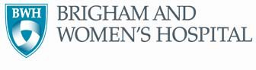
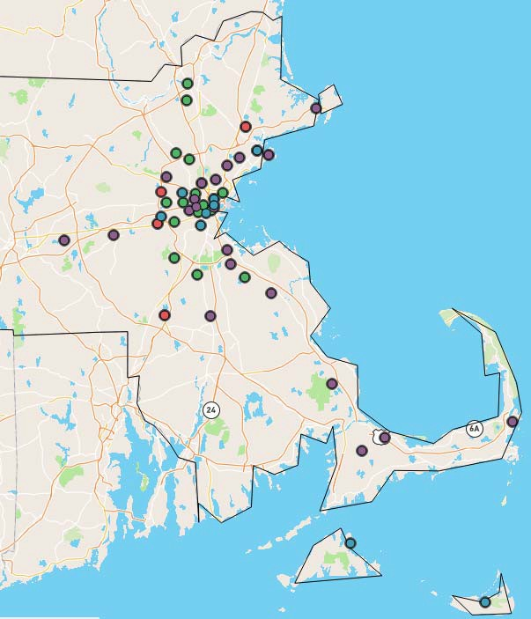

3

External Environment Massachusetts

- Health care continues to be an area of focus for Massachusetts
- Fall 2019 cost trend hearings led by the Health Policy Commission focused on provider market trends and cost drivers
- Favorable performance relative to MA cost growth benchmark (3.6% in 2016 & 2017)
- Governor Baker’s proposed legislation calls for expanding telemedicine, behavioral health and primary care as well as provisions to address surprise billing

4

Unified System Goals

Rebranding as Mass General Brigham to better demonstrate what we offer patients and build upon our national and international impact

Substantially broaden the number of patients we reach and improve patient outcomes through existing and new delivery methods (e.g., digital health, ambulatory, multi-specialty centers of excellence)
  - Expand our impact by getting more breakthrough ideas and innovations out into the world
  - Improve patient access and patient experience
  - Reduce the total cost of care, while improving outcomes
  - Optimize the use of, and innovate across, the full continuum of care we provide
  - Grow existing, and develop new, revenue streams

5

Five Synergistic Strategic Priorities Focused On Broader Impact, Improved Outcomes, and New Revenue Streams

Recognition as the “Go To Place”
Enhance regional and national recognition of MGH & BWH as “go to” destinations for key clinical services by developing cross- academic, multi- disciplinary, next- generation centers of excellence
National & International Business Development
Develop new opportunities for national and international business development by expanding system-wide efforts to attract patients to MGH & BWH and providing remote diagnostics, remote care delivery and advisory services
Innovation
Substantially increase innovations in diagnostics, therapies, devices, and data analytics brought to market by expanding commercialization investments and infrastructure
Value-Based Model
Build and implement new value-based operating model for primary, secondary and behavioral health care that delivers “value for price,” improves patient access and outcomes and grows clinical volume and attributed lives
Community Health Impact
Expand impact on leading community health issues by taking a multi-pronged approach to advance health equity and address social determinants of health in targeted communities

6

Mass General Brigham Research Revenue Exceeds $1.8 Billion

FY19 Research Revenue by Sponsor

#1 recipient of research funding globally

Committed future research funding: $3.8 billion
All Other Sponsors 17%

Foundations 8%

Non-Profit 7%

DHHS 46%

Industry/Corp.
9%
Federal Subcontracts 10%

Other Federal 3%
7

Innovation: Commercializing Capabilities and Discoveries of Mass General Brigham Faculty

400
350
300
250
200
150
100
50
0

$103
$146
Total Innovation Revenue

$126
$133
$138

$349
INNOVATION FUND KEY STATISTICS
- $171M Fund
- 38 Portfolio Companies
- 12 Exits
- $62.5M returned
- Enterprise value >$8.4B

NEW INVESTMENT FUNDS LAUNCHED (OCTOBER 2019)

FY14 FY15 FY16 FY17 FY18 FY19
Revenue (Millions)
  - $50M Translational Innovation Fund
  - $30M AI and Digital Investment Fund

8

Mass General Brigham
Center for Clinical Data Science

Using Healthcare IT & AI to improve patient experience, accelerate digital innovation and transform clinical care

Initial Clinical
Impact Emergency Care

Women’s Health

Orthopedics Cardio- Vascular Medicine

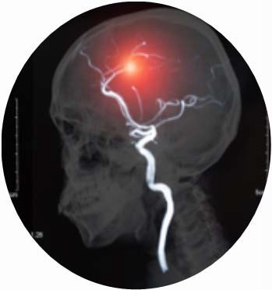
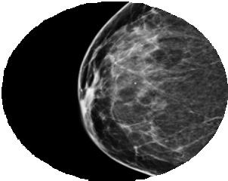
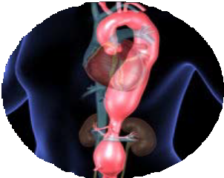

Emerging Areas: Oncology, Critical Care, Anesthesia, Obstetrics

9

Massachusetts Market: Competitive Landscape

• Since affiliating in March 2019, BI Lahey has been working to advance its visibility and standing in the marketplace
• Harvard Pilgrim and Tufts have announced their intention to merge, consolidating the #2 and #3 commercial payers in MA
• Care New England acquisition plans were terminated, but clinical collaboration continues with strong relationships at BWH, McLean and Spaulding
• Definitive agreement signed with Exeter (NH community hospital) in spring 2019; public education campaign launched in fall 2019 in response to regulatory headwinds

10

Mass General Brigham Market Share

Eastern MA Tertiary Market Share: FY18

Tertiary discharges are forecast to grow at a faster pace than secondary discharges in E. MA
Steward
5% Other
24%

Wellforce 9%

Mass General Brigham 38%

Lahey Health
7%
CareGroup 17%

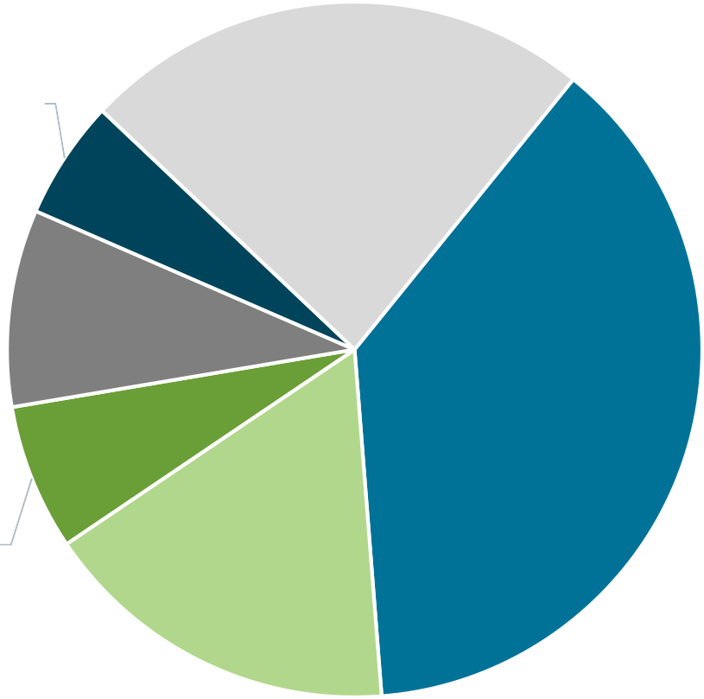

Sources: Sg2 Inpatient Forecast, FY17-27; Mass Center for Health Information and Analysis.
11

Expansion of Outpatient Services in

Salem

Pease/Portsmouth

GOALS
• Offer wide array of multi-specialty lower cost ambulatory services
• Enable better access for patients closer to where they live

Regional
Network

Waltham Wellesley
Westborough
Danvers
Woburn

Brookline
- Enhance ambulatory experience with efficient patient flow and space design
- Increase network lives and

Westwood

Foxboro
secondary & tertiary commercial referral volume
ACTIVITY
  - Plans underway for 3 new sites and expansion of 2 sites

Ambulatory Surgical Center w. imaging Medical Office Building w. imaging
Ambulatory sites under development or expansion

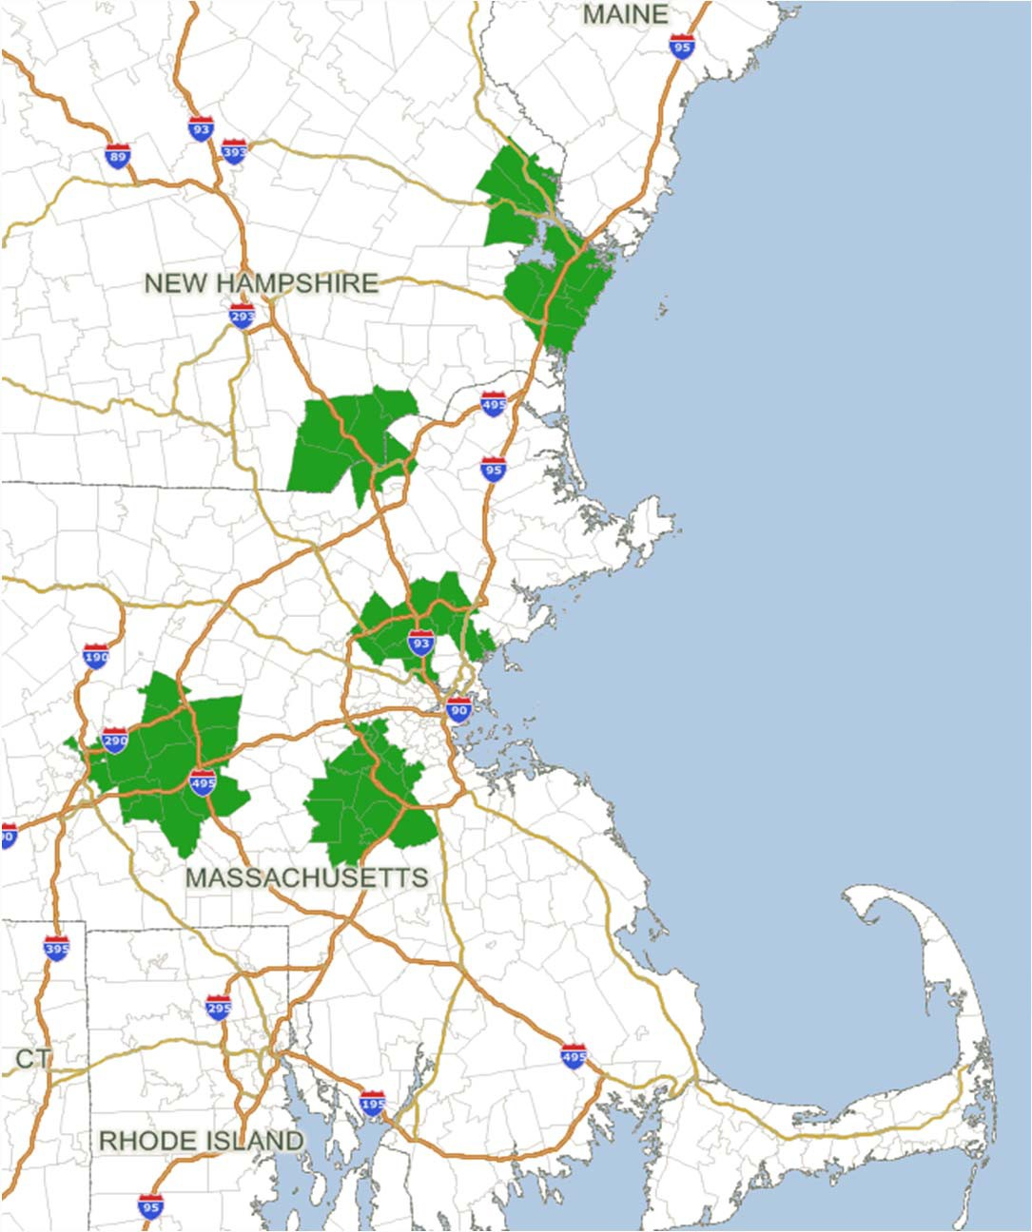
12

Mass General Brigham Currently Manages ~650,000 (~12%) of E. MA Lives in Various Accountable Care Relationships

COMMERCIAL
Alternative Quality Contract
~350k
Covered Lives
Younger population, specialists critical to management

MEDICAID
MassHealth ACO

~105k
Covered Lives
Population with significant disability, mental health, and substance use challenges

SELF INSURED
Employees

~100k
Covered Lives
Commercial population, but Mass General Brigham at full-risk for cost and quality

P dvv#Jhqhudo# Euljkdp

MEDICARE
Next Generation

~105k
Covered Lives
Elderly population, care management central to trend management

*ACO = Accountable Care Organization.
13

System-wide Expense Management and Revenue Optimization Initiatives Fueling Favorable Financial Performance

$424M

$182M

$76M

$500M

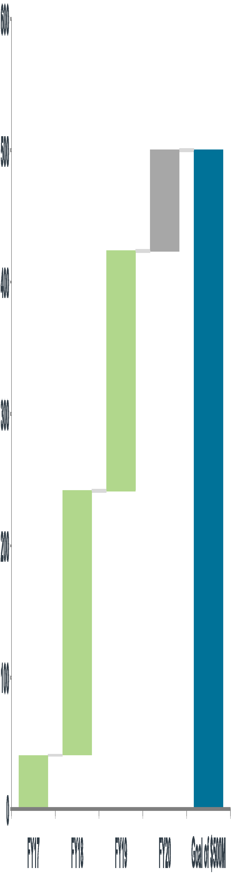

$201M
Successful efforts to better align clinical and administrative expenses with payment rates for patient care that have been growing more slowly than medical inflation
$ in millions

$41M

14

Favorable Cost Curve Trend at Acute Care Hospitals

$13,500
AVERAGE ANNUAL TREND
- Mass General Brigham: -0.7%
- Regional medical inflation: 3.1%

$13,000

$12,500

$12,000

$11,500

$11,417

2.6%

1.6%
4.2%

2.1%
$13,269
4.9%

$11,000

$10,500

-1.7%
1.2% 0.5% -1.3%
$11,044
-2.0%

CPI source: Bureau of Labor Statistics, 12 month change as of September in each year.
O/P Adj. CMAD = Mass General Brigham acute hospitals.
$10,000

FY14 FY15 FY16 FY17 FY18 FY19
O/P Adj CMAD Medical Care Inflation Northeast Urban

15

Three-Year Trend of Improved Consolidated Operating Performance

Consolidated Operating Income/(Loss) Consolidated Operating Cash Flow and Margin

$600
$1,600
11%

$500

$400

$300
$1,400
9%

$1,352

$485
$1,200

$1,165
7%
$1,000

$200

$100

$0 ($100)
($200)

$106

($108)

$310

$53
$583
$800

$600

$400

$200

$0
5%

3%

1%

-1%

FY15 FY16 FY17 FY18 FY19

$717

$861
FY15 FY16 FY17 FY18 FY19

$ in millions.
16

Key Balance Sheet Metrics also Reflect Improving Trends

Unrestricted Cash, Debt and Cash-to-Debt Unrestricted Net Assets

$10
$9
$8
$7
$6
$5
$4
$3
$2
$1
$0

$ in billions.
Unrestricted Cash
Debt
Cash-to-Debt

$9.3
$8.2
$7.4
$6.8
$6.7
$4.4 $5.0 $5.1 $5.4 $5.7

FY15 FY16 FY17 FY18 FY19
- Unrestricted Cash increased $2.6B from FY15 to FY19 (8.5% CAGR)
- Debt increased $1.3B from FY15 to FY19 (6.8% CAGR)

170% $8

160% $7
150% $6
$5
140%
$4
130%
$3
120% $2
110% $1

100% $0

$7.1
$7.4
$4.7

$4.1
$5.9

FY15 FY16 FY17 FY18 FY19
- Unrestricted Net Assets increased $2.7B from FY15 to FY19 (11.8% CAGR)

17

FY20-FY24 Capital Spending Capacity: $6.8 Billion

$ in millions
$1,600

$1,400

$1,200

$1,000

New Initiatives Spending Committed Capital

$800
FY20-24 capital capacity exceeds capital requests by
~$675 million, providing flexibility to accelerate future capex plans

$600

$400

$200

$0
FY15 FY16 FY17 FY18 FY19 FY20 FY21 FY22 FY23 FY24

PROJECTED SPENDING

*Committed Capital has been approved by Mass General Brigham Finance Committee. 18

Mass General Brigham Strategic Focus and Key Enablers

Rebrand system
  - Create centers of excellence
  - Develop new opportunities for national and international business
  - Increase innovation to support commercialization efforts
  - Build value-based operating model for primary and secondary care
  - Grow commercial insurance business
  - Manage total medical expense and risk
  - Expand community impact
  - Continue to invest in data analytics and digital health
  - Physician alignment and retention initiatives addressing compensation and burnout
  - Develop and retain high performing talent pool

