

Evaluation of Brain & CNS Cancer Incidence
in Attleboro, MA
1999-Present

May 2007

Center for
Environmental Health,
Community Assessment
Program

Massachusetts
Department Of
Public Health
Table of Contents

I. Introduction 3
II. Methods 3
III. Findings 5
IV. Risk Factor Review 7
V. Brain & CNS Cancer Subtypes 7
VI. Discussion 8
VII. Summary 9
VIII. References 10

Figure 1. Census Tracts in Attleboro, MA

Table 1. Brain and CNS Cancer Incidence, Attleboro, MA 1999-2003

Attachment A

Introduction

In a letter to the Massachusetts Department of Public Health (MDPH) dated March 13, 2007, the City of Attleboro Health Department requested an update on the incidence of brain and central nervous system (CNS) cancers in the city of Attleboro. In February 2004, MDPH had issued a report to the Attleboro Health Department that evaluated the incidence of brain and CNS cancer for the years 1995-2002. The 2004 report concluded that while the incidence of brain and CNS cancer in Attleboro was lower than expected during 1995-1999, the incidence appeared to be increasing in the years 2000-2002 (MDPH 2004).

At the time of the 2004 report, incidence data for the years 2000-2002 were not considered complete by the Massachusetts Cancer Registry (MCR), either for Attleboro or for the state as a whole. Although the analysis of preliminary data for the years 2000-2002 showed a possible elevation in the incidence of brain and CNS cancer in Attleboro during this time period, a review of case-specific information available at the time did not indicate an atypical geographic pattern, age distribution, or cell type pattern for the individuals diagnosed with brain and CNS cancer during these three years.

To respond to the current request for an update on the status of MDPH’s efforts to further evaluate brain cancer in Attleboro, the Community Assessment Program (CAP) within the Center for Environmental Health (CEH) reviewed cancer incidence data for the last five years (1999-2003) as well as for the years 2004 to the present.

Methods

Cancer incidence in communities across the state is evaluated by comparing the number of diagnoses of a particular type of cancer reported to the MCR to the number of diagnoses that would be expected if the community experienced that type of cancer at the statewide rate. The statewide rate for a particular type of cancer is applied to the age and gender distribution of the community’s population; this allows for age and gender differences to be accounted for between the two populations (the state’s and the municipality’s). This is necessary because age and gender are important risk factors for cancer. Standardized incidence ratios are presented for brain & CNS cancer in Attleboro. An SIR is the ratio of the observed or reported number of cancer diagnoses in an area to the expected number of diagnoses multiplied by 100. For a more thorough description of the statistics reported here, the Standardized Incidence Ratio (SIR) and 95% confidence interval (95% CI), please refer to Attachment A.

When reviewing the incidence of brain and CNS cancers, it is also important to note that the brain is a site where both primary and secondary malignant tumors can arise; secondary brain tumors generally originate elsewhere in the body and then metastasize, or spread, to the brain (ACS 2006). Secondary brain or CNS cancers that occur as the result of the metastasis of another primary site cancer to the brain or CNS are not included in this analysis. In addition, the MCR collects data on some individuals diagnosed with benign (non-cancerous) tumors of the brain and CNS. Given that these tumors are not actually cancer diagnoses, data for these individuals are also not included in this report. The exclusion of secondary cancers and benign tumors is consistent with how statewide brain and CNS cancer incidence rates are calculated and therefore allows for the most meaningful comparisons.
To update the incidence of brain and CNS cancers in Attleboro, cancer incidence data from 1999-2003 for the city as a whole and for each individual census tract (CT) in Attleboro were reviewed. The city of Attleboro is comprised of eight census tracts (Figure 1). Census tracts are the smallest geographic area for which we can reliably calculate cancer rates, because of the necessity of age group and gender-specific population information. In addition, a review of more recent diagnoses (i.e., from 2004 to present) was conducted. Because statewide MCR data are complete through the year 2003, SIRs were calculated that include incidence data through 2003; for 2004 forward, it was possible to identify and report on additional new diagnoses but SIRs could not be calculated for these years because of the lack of complete statewide data necessary to calculate an actual rate.

In addition to determining census tract-specific incidence rates for brain & CNS cancer, a qualitative evaluation of the point pattern of cancer diagnoses was conducted. Place of residence at the time of diagnosis was mapped for each individual diagnosed with brain & CNS cancer to assess any possible geographic concentrations of cases in relation to one another.

Findings

For the five-year period 1999-2003, 22 individuals were diagnosed with cancer of the brain or CNS compared to approximately 16 diagnoses expected based on statewide rates (Table 1). This difference was due primarily to an elevation among males (13 diagnoses observed versus approximately 8 expected). However, neither elevation, among males and females combined or among males alone, was statistically significant (i.e., the elevation could be due to chance or random variation).

In the MDPH 2004 report, for the five-year period 1995-1999, nine individuals were reported to be diagnosed with brain or CNS cancer compared to approximately 13 diagnoses expected based on statewide rates (MDPH 2004).

When evaluated by CT for the years 1999-2003, the incidence of brain and CNS cancers was about as expected for both genders in seven of the eight CTs. The one exception occurred in CT 6312 where five males were diagnosed while approximately one diagnosis would be expected. This elevation is statistically significant (SIR = 394; 95% CI: 127-919). It is important to note that the confidence interval is wide and reflects the instability of the SIR; see Attachment A for more discussion on the 95% CI.

To evaluate whether the elevation noted in Attleboro CT 6312 during 1999-2003 was present in earlier years, cancer incidence data for the previous five years were also reviewed. Between 1994 and 1998, one individual was diagnosed with brain and CNS cancer in this CT. Therefore, there does not appear to be a long-term elevation in CT 6312.

Review of address data collected by the MCR, specifically residence at diagnosis, showed that the distribution of residences closely followed the population density of Attleboro. For the five males residing in CT 6312, the one CT with a statistically significant elevation, mapping of their residences at diagnosis did not reveal an unusual pattern; the distribution of the residences at diagnosis closely followed the population density of the CT.

As previously stated, it is possible to search the MCR for more recent diagnoses of brain and CNS cancers even though an SIR cannot be calculated. From January 1, 2004 to the present, five individuals have been reported to the MCR with a diagnosis of brain cancer within the town of Attleboro. In addition, as requested, the MCR contacted the Rhode Island Cancer Registry (RICR) to determine if any Attleboro residents have been diagnosed with brain or CNS cancer in Rhode Island in recent years, such that the MCR may not yet have been notified of these diagnoses under the reciprocal reporting agreement between the MCR and the RICR. For diagnoses made through the year 2004, all Attleboro residents diagnosed in RI with brain or CNS cancers have been reported to the MCR. For the years 2005 and 2006, four additional diagnoses (two in each year) have been made in RI and not yet reported to the MCR.

While an incidence rate for the years 2004 forward cannot be calculated, based on the 5-year period of 1999-2003 when 22 individuals in Attleboro were diagnosed with brain or CNS cancers, a crude expected number of diagnoses would be approximately 3.2 diagnoses each year in Attleboro with brain or CNS cancer. (It is important to note that the crude expected number of diagnoses does not take into account the actual state rate or the population of Attleboro during these years and therefore the age- and gender-adjusted expected number of diagnoses, based on the actual state rate, may differ from the crude estimate.) At this time, it is known that nine Attleboro residents have been diagnosed between 2004 and the present (approximately a three-year period). This represents, on average, three additional diagnoses per year.

Address information for each of these individuals, diagnosed since 2004, was mapped and evaluated to determine if an unusual geographic pattern existed. The residences of these nine individuals were evenly distributed throughout the area and closely followed population density. Although it is still too early to know the final number of diagnoses for these recent years, at this time, the number of reported residents with brain or CNS cancer in Attleboro does not appear to be unusual.

Risk Factor Review

According to the medical literature, although brain cancer can occur at any age, a peak generally occurs in childhood (generally under 10 years of age) and then the risk of brain or CNS cancer increases with age from 25 to 75 years old (Preston-Martin et. al. 2006; ACS 2001). In the city of Attleboro, the ages of the individuals diagnosed with brain and CNS cancers from 1999 to present are consistent with the established age patterns for this type of cancer. Three individuals diagnosed with brain or CNS cancer were less than 10 years of age, three individuals were between 11 and 24 years of age, and the remaining 25 individuals were 25 years of age or older at the time of diagnosis. For CT 6312, the one CT with a statistically significant elevation, the age distribution was also as would be expected, based on the medical literature.

Brain & CNS Cancer Subtypes

In the March 2007 letter from the Attleboro Health Department, specific concerns are raised regarding the incidence of glioblastoma multiforme, a subtype of brain cancer which is also called a stage IV astrocytoma. Primary brain tumors (i.e., brain cancer) comprise two main types: gliomas and malignant meningiomas. Gliomas are a general classification of malignant tumors that include a variety of types, named for the cells from which they arise: astrocytomas, oligodendrogliomas, and ependymomas. Meningiomas arise from the meninges, tissues that surround the outer part of the spinal cord and brain. In addition to these more common cell types, there are a number of rare brain tumors, including medulloblastomas which develop from the neurons of the cerebellum and are most often seen in children. In adults, the most frequent types of brain tumors are astrocytic tumors (mainly astrocytomas and glioblastoma multiforme) (Preston-Martin et al. 2006). In Massachusetts, almost half (47%) of all individuals diagnosed with a tumor of the brain or CNS from 1999-2003 were diagnosed with a glioblastoma multiforme. In the city of Attleboro during the same time period, 9 of the 22 (41%) individuals diagnosed with a brain or CNS tumor were diagnosed with a glioblastoma multiforme. Since 2004, six of the nine Attleboro individuals diagnosed with a brain or CNS tumor were diagnosed with a glioblastoma multiforme. Therefore, of the 31 individuals diagnosed with a brain or CNS cancer between 1999 and the present, 15 (or 48%) were diagnosed with a glioblastoma mulitforme; this is consistent with the statewide percentage of 47% for this time period.

Discussion

As discussed in the March 2007 letter of the Attleboro Health Department, MDPH reported recently in a health consultation on cancer incidence in Norton and Attleboro (MDPH 2006) that the incidence of brain and CNS cancer was statistically significantly elevated in Norton CT 6112 for one of the four time periods evaluated (2000-2002), primarily due to an elevation in males (5 diagnoses observed versus 1.0 expected). During the earlier three time periods evaluated, brain and CNS cancer occurred about as expected in males in CT 6112. This health consultation was conducted in response to residents’ concerns about health impacts from contamination at the Shpack Landfill, a National Priorities List (NPL) Superfund site located on the border between Norton and Attleboro. The Shpack Landfill is located in Attleboro CT 6317 and Norton CT 6112.

To further assess these 2 CTs, we evaluated the incidence of brain and CNS cancer in these two CTs combined for the 1999-2003 time period. During this five year period, 11 diagnoses of brain and CNS cancer were reported to the MCR when approximately 6 diagnoses would have been expected (SIR = 195; 95% CI: 97-349). This difference between the number of observed and expected diagnoses is of borderline statistical significance. When we examined the geographic distribution of where these 11 individuals lived at the time of their diagnosis, no unusual geographic pattern emerged. Also, no clustering occurred near the landfill; the closest residence to the landfill was approximately one mile away. Since the beginning of 2004, within Attleboro CT 6317 and Norton CT 6112, one new diagnosis of brain and CNS cancer has been reported in each CT since the beginning of 2004; the approximate distance between their two residences is 2.5 miles. For the previous five years, 1994-1998, three diagnoses of brain and CNS cancers were reported for the two CTs combined whereas five diagnoses would have been expected. Because the elevation noted in the latest time period did not exist in the previous five years, there does not appear to be a consistent trend with respect to time in these two CTs. For CTs 6317 and 6112, the age distribution of the 13 individuals was also consistent with what would be expected.

Summary

In conclusion, although the number of individuals citywide diagnosed with brain and CNS cancers in Attleboro between 1999 and 2003 is more than expected based on the statewide experience, the elevation is not statistically significant and could represent natural random variation. For the one CT within the city with a statistically significant elevation in males during 1999-2003 (CT 6312), a more in-depth examination of cancer incidence data for this CT showed that the elevation has not persisted over time. Fewer diagnoses of brain and CNS cancers occurred in CT 6312 than expected in the preceding five-year period. Regarding the incidence of the particular subtype of brain and CNS cancer called glioblastoma multiforme, the percentage of individuals in Attleboro diagnosed with this subtype closely matches the percentage of individuals statewide with this same subtype. Finally, based on the number of individuals diagnosed from 2004 to the present, including those identified by the RICR not yet reported to the MCR, the number of Attleboro residents with brain or CNS cancer in Attleboro does not appear unusual. As previously stated, the years 2004 to the present are not considered closed data files at this time. The CAP will continue to monitor the incidence data for brain and CNS cancers in Attleboro as more data become available.

References

American Cancer Society. 2001. Clinical Oncology. Atlanta, Georgia.

American Cancer Society. 2006. Detailed Guide: Brain/CNS Tumors in Adults. Available at: http://www.cancer.org. Cited March 31, 2006.

MDPH. 2004. Letter report from Suzanne K. Condon, Assistant Commissioner, MDPH to James P. Mooney (Attleboro Health Agent) and Christopher Quinn, M.D. of Attleboro Health Department. February 11, 2004.

MDPH.2006. Health Consultation, Public Comment Release, Evaluation of Cancer Incidence in Census Tracts of Attleboro and Norton, Bristol County, Massachusetts: 1982-2002. November 16, 2006.

Preston-Martin S, Munir R, and Chakrabarti, I. 2006. Nervous system. In: Cancer Epidemiology and Prevention. 3rd Ed, edited by Schottenfeld D, Fraumeni. JF. New York: Oxford University Press.

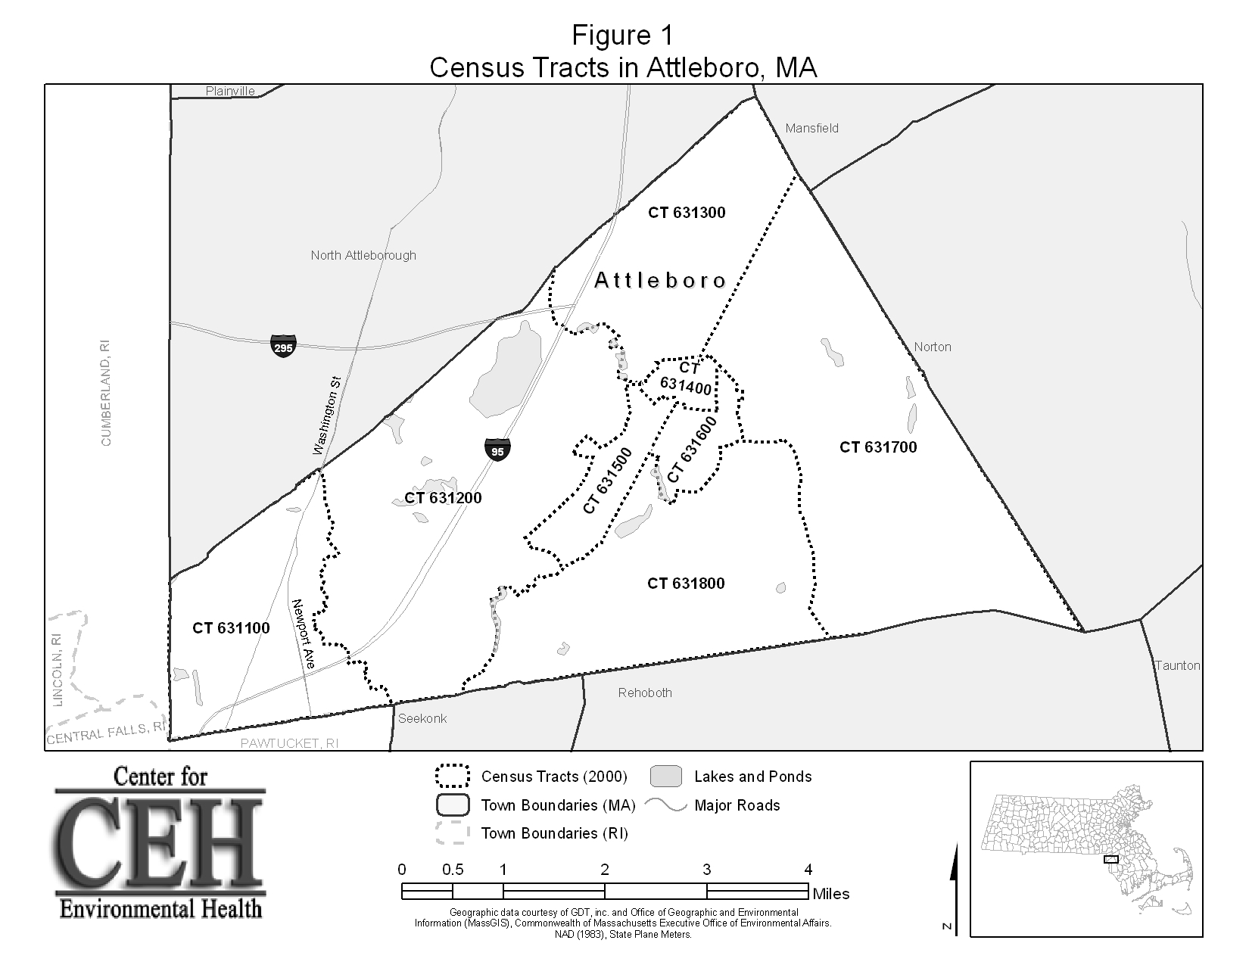

Attachment A
Explanation of a Standardized Incidence Ratio (SIR)
And 95% Confidence Interval

In order to evaluate cancer incidence a statistic known as a standardized incidence ratio (SIR) was calculated for each cancer type. An SIR is an estimate of the occurrence of cancer in a population relative to what might be expected if the population had the same cancer experience as some larger comparison population designated as “normal” or average. Usually, the state as a whole is selected to be the comparison population. Using the state of Massachusetts as a comparison population provides a stable population base for the calculation of incidence rates. As a result of the instability of incidence rates based on small numbers of cases, SIRs were not calculated when fewer than five cases were observed.

Specifically, an SIR is the ratio of the observed number of cancer cases to the expected number of cases multiplied by 100. An SIR of 100 indicates that the number of cancer cases observed in the population evaluated is equal to the number of cancer cases expected in the comparison or “normal” population. An SIR greater than 100 indicates that more cancer cases occurred than expected and an SIR less than 100 indicates that fewer cancer cases occurred than expected. Accordingly, an SIR of 150 is interpreted as 50% more cases than the expected number; an SIR of 90 indicates 10% fewer cases than expected.

Caution should be exercised, however, when interpreting an SIR. The interpretation of an SIR depends on both the size and the stability of the SIR. Two SIRs can have the same size but not the same stability. For example, an SIR of 150 based on 4 expected cases and 6 observed cases indicates a 50% excess in cancer, but the excess is actually only two cases. Conversely, an SIR of 150 based on 400 expected cases and 600 observed cases represents the same 50% excess in cancer, but because the SIR is based upon a greater number of cases, the estimate is more stable. It is very unlikely that 200 excess cases of cancer would occur by chance alone.

To determine if the observed number of cases is significantly different from the expected number or if the difference may be due solely to chance, a 95% confidence interval (CI) was calculated for each SIR. A 95% CI assesses the magnitude and stability of an SIR. Specifically, a 95% CI is the range of estimated SIR values that has a 95% probability of including the true SIR for the population. If the 95% CI range does not include the value 100, then the study population is significantly different from the comparison or “normal” population. “Significantly different” means there is less than 5% percent chance that the observed difference is the result of random fluctuation in the number of observed cancer cases.

For example, if a confidence interval does not include 100 and the interval is above 100 (e.g., 105-130), then there is statistically significant excess in the number of cancer cases. Similarly, if the confidence interval does not include 100 and the interval is below 100 (e.g., 45-96), then the number of cancer cases is statistically significantly lower than expected. If the confidence interval range includes 100, then the true SIR may be 100, and it cannot be concluded with sufficient confidence that the observed number of cases is not the result of chance and reflects a real cancer increase or decrease. Statistical significance is not assessed when fewer than five cases are observed.

In addition to the range of the estimates contained in the confidence interval, the width of the confidence interval also reflects the stability of the SIR estimate. For example, a narrow confidence interval (e.g., 103--115) allows a fair level of certainty that the calculated SIR is close to the true SIR for the population. A wide interval (e.g., 85--450) leaves considerable doubt about the true SIR, which could be much lower than or much higher than the calculated SIR. This would indicate an unstable statistic.

The RICR provides its report to the MCR on Massachusetts residents newly diagnosed with cancer in RI on an annual basis.

