# BACKGROUND

**INDOOR AIR QUALITY**

**ASSESSMENT**

**Shutesbury Elementary School**

**23 West Pelham Road**

**Shutesbury, Massachusetts**



Prepared by:

Massachusetts Department of Public Health

Bureau of Environmental Health

Indoor Air Quality Program

October 2022

|  |  |
| --- | --- |
| Building: | Shutesbury Elementary School (SES) |
| Address: | 23 West Pelham Road, Shutesbury, MA |
| Assessment Requested by: | Rebecca Torres, Town Administrator, Town of Shutesbury |
| Reason for Assessment: | General Indoor Air Quality (IAQ) concerns |
| Date of Assessment: | August 26, 2022 |
| Massachusetts Department of Public Health/Bureau of Environmental Health (MDPH/BEH) Staff Conducting Assessment: | Michael Feeney, Director, IAQ Program,  and Stefanie Santora, Environmental  Analyst, IAQ Program |
| Building Description: | The SES was constructed in 1972 as a one-story building with a flat roof. In the early 2000’s, a wing was added with a wooden peaked roof installed over the original flat roof. |
| Windows: | openable |

**METHODS**

MDPH IAQ staff conducted a series of visual assessments, and temperature, and relative humidity measurements to identify likely areas that could be prone to condensation in hot, humid weather. A complete Indoor Air Quality assessment during the occupied heating season can be scheduled upon request. Please refer to the IAQ Manual for methods, sampling procedures, and interpretation of results (MDPH, 2015).

**RESULTS AND DISCUSSION**

The following is a summary of testing results (Table 1):

* ***Temperature*** was within the MDPH recommended range of 70°F to 78°F in all areas tested.
* ***Relative Humidity*** was above the MDPH recommended range of 40 to 60% in the majority of areas the day of assessment due to outside weather conditions.

## Ventilation

A heating, ventilating, and air conditioning (HVAC) system has several functions. First it provides heating and, if equipped, cooling. Second, it is a source of fresh air. Finally, an HVAC system will dilute and remove normally occurring indoor environmental pollutants by not only introducing fresh air, but by filtering the airstream and ejecting stale air to the outdoors via exhaust ventilation. Even if an HVAC system is operating as designed, point sources of respiratory irritation may exist and cause symptoms in sensitive individuals.

Fresh air in classrooms is supplied by ceiling-mounted fresh air diffusers connected to an air handling unit (AHU) located in the attic crawlspace. To maximize air exchange, the MDPH recommends that both supply and exhaust ventilation operate continuously during periods of occupancy. To have proper ventilation with a mechanical supply and exhaust system, the systems must be balanced to provide an adequate amount of fresh air to the interior of a room while removing stale air from the room. It is recommended that HVAC systems be re-balanced every five years to ensure adequate air systems function (SMACNA, 1994).

## Microbial/Moisture Concerns

All classrooms were assessed for the presence of either mold or visible water damage. IAQ staff did not observe any materials that were either water-damaged, had visible mold growth, or had musty odors during this assessment. Due to weather conditions of the past decade, IAQ staff assessed whether the SES may be prone to developing condensation on building materials.

### Building Materials That May Be Prone to Condensation.

It is important to note that Massachusetts has experienced extended periods of relative humidity during the summer of 2021. July of 2021 was the wettest ever recorded in Massachusetts, and the three-month period from June through August 2021 (meteorological summer), was the fourth wettest on record, according to the National Oceanic and Atmospheric Administration’s Centers for Environmental Information. The three-month period also was the third warmest ever in the state and was tied for the warmest on record across the United States. (HG, 2021, NOAA, 2021). These conditions are challenging for buildings, particularly those without air conditioning.

Based on the type of floor construction (cement on soil), the SES was assessed to determine if floors were subject to developing condensation during extended (>24 hours) hot, humid weather. The key to managing condensation in hot, humid weather indoors is understanding dew point. When warm, moist air passes over a cooler surface, condensation can form. Condensation is the collection of moisture on a surface at or below the dew point. The dew point is the temperature that air must reach for saturation to occur. If a building material/component has a temperature below the dew point, condensation will accumulate on that material. Over time, condensation can collect and form water droplets.

A method to locate areas in a building prone to condensation is to measure air and building material temperatures using a laser thermometer (Table 1). If a wide temperature range exists between measurements (>5°F), the building materials at the colder end of the range may be prone to becoming moistened with condensation if exposed to hot, humid weather (70% relative humidity) for extended periods of time. According to the test results in Table 1, most floors in the SES appear to be prone to condensation if exposed to hot, humid weather for extended periods of time. Note that the SES has significant carpeting, which, if chronically exposed to moisture, can support mold growth.

Relative humidity measured in the building **was near 70%** in all locations during this assessment (Table 1). According to American Society of Heating, Refrigerating and Air-Conditioning Engineers (ASHRAE), if relative humidity exceeds 70%, mold growth may occur due to wetting of building materials (ASHRAE, 2019). Porous materials such as gypsum wallboard, cardboard and other materials may become prone to mold colonization. It is recommended that porous material be dried with fans and heating within 24 to 48 hours of becoming wet (US EPA, 2008, ACGIH, 1989). If porous materials are not dried within this time frame, mold growth may occur. Water-damaged porous materials cannot be adequately cleaned to remove mold growth.

### Building Envelope Issues

IAQ staff examined the building envelop to identify possible sources of water outside, possible breaches in the building envelope, and/or other conditions that could provide a source of moisture that can adversely affect indoor air quality. The following outdoor conditions related to moisture were identified:

* Plants were observed in direct contact with or near the foundation, building exterior, and the AHU exterior doors. Plants near the building can cause water damage to brickwork and mortar. In addition, plants shading exterior walls can slow the drying of exterior walls, which is important to prevent damage to brick and mortar as well as wood rot. Water can eventually penetrate the brick, subsequently freezing and thawing during the winter. This freezing/thawing action can weaken and damage bricks and mortar.
* The exterior walls are covered in places with moss (Picture 1), which can indicate chronic water exposure from rainwater. Moss tends to form on wood that retains moisture due to lack of drainage, poor design, and shade. Many of the wall surfaces of the SES do not see extended exposure to sunlight due to the topography and trees along the east side of the building.
* With exception of the exterior wall around doors, the roof does not have a gutter/downspout system to capture rainwater. Rainwater flows off the roof edge to impact on the base of the exterior wall soil (Picture 2), as shown by extensive furrows. As rainwater impacts the ground with force, soil becomes compressed, which creates furrows. This allows for water to puddle at the base of the exterior walls, which in turn, likely splashes exterior walls. The repeated wetting, and lack of drying, of exterior walls likely provides the condition that results in moss growth on sills, which then can accelerate the weathering/damage to the wood.
* Without gutters equipped with proper flashing to transition rainwater from roof to a gutter, roof eaves have been routinely exposed to rainwater, which has caused significant damage (Picture 3).
* In one instance, water was found leaking from a gutter, which can indicate accumulated debris in the gutter and/or gaps in seams.
* Around the original gymnasium roof, scuppers were found without exterior downspout drainage which wets exterior walls (Picture 4).
* Shutesbury Town and School officials, reported that the SES experienced significant ice dams in recent winters. To prevent ice dams, roofs are equipped with both soffit vents (Picture 5) and ridge vents. Roof vents prevent ice dams by reducing the temperature of the roof surface so accumulated snow doesn’t melt and refreeze. IAQ staff could not determine if ridge vents are open to outdoors. If ridge vents are open, an individual can see outdoor light at the peak of the roof. If the ridge vent is not open, waste heat from the building may accumulate in the roof to cause melting and refreezing, leading to ice dams.
* Significant portions of the SES roof are in continuous shade due to a stand of high trees east of the building. Due to this shading, the roof is discolored from moss/organic debris, which indicates chronic moistening (Picture 6). Without direct sunlight, roof materials can remain wet which can then damage shingles and the underlayment of the roof, which can result in water damage to the building interior.

These conditions can undermine the integrity of the building envelope and provide a means for water entry into the building through exterior walls, foundation concrete, and masonry (Lstiburek & Brennan, 2001). In addition, these breaches in exterior areas can provide a means for drafts and pest entry into the building.

# CONCLUSIONS AND RECOMMENDATIONS

The SES has a number of issues related to moisture in the building. One issue that is a significant problem given the extreme relative humidity and rain during recent summers, is that management of buildings in such weather without air conditioning can be challenging. The following documents can provide guidance that can be used to reduce the impact of hot, humid weather in buildings.

* Mold Growth Prevention during Hot, Humid Weather <https://www.mass.gov/service-details/preventing-mold-growth-in-massachusetts-schools-during-hot-humid-weather>
* Remediation and Prevention of Mold Growth and Water Damage in Public Schools <https://www.mass.gov/service-details/remediation-and-prevention-of-mold-growth-and-water-damage-in-public-schools-and>
* Methods for Increasing Comfort in Non-air-conditioned Schools <https://www.mass.gov/doc/methods-for-increasing-comfort-in-non-air-conditioned-schools/download>

To remedy building problems, two sets of recommendations are made: **short-term** measures that may be implemented as soon as practicable and **long-term** measures that will require planning and resources to address overall IAQ concerns. In view of the findings at the time of the visit, the following recommendations are provided:

## Short Term Recommendations

1. Examine whether roof ridge vents are open. Consider opening vents if closed.
2. Repair leaking gutters. Ensure that all roof drains, gutters, and downspouts are regularly cleaned of debris.
3. Examine the feasibility of preventing rainwater pooling along the exterior walls by regrading soil. In general, a water-resistant material in a configuration of 1’ in height and 5’ in length is recommended to increase drainage of rainwater.
4. Consider replacing carpeting with a floor covering that would not be susceptible to becoming water-damaged.
5. Replace missing ceiling tiles to ensure the ceiling plenum is intact and prevent dust and debris from above the grid from infiltrating into occupied spaces.
6. Consider removing all plants in the interior courtyard to reduce water accumulation.
7. Consider installing a downspout on all scuppers to reduce exterior wall damage.
8. Consider adopting the US EPA document, “Tools for Schools” as a method for maintaining a good indoor air quality environment. This document can be downloaded from the Internet at <http://www.epa.gov/iaq/schools/index.html>
9. Contact the MDPH IAQ Program during the heating season when the school is in session for a follow-up visit.
10. Refer to the resource manual and other related indoor air quality documents located on the MDPH’s website for further building-wide evaluations and advice on maintaining public buildings. These documents are available at <http://mass.gov/dph/iaq>.

## Long Term Recommendations

1. Contact a building engineering firm for advice regarding the following conditions noted at the SES.
   1. Examine whether exterior wall/slab junction can be repaired to render watertight.
   2. Repair or replace the exterior wall cladding.
   3. Improve drainage through installation of a drain system or further regrading of ground around the SES as detailed in short-term recommendation #5.
   4. Repair or replace the exterior fenestration system.
2. Conduct a building-wide ventilation system assessment. Based on historical issues with air exchange/indoor air quality complaints, age, physical deterioration, and availability of parts for ventilation components, such an evaluation is necessary to determine the operability and feasibility of replacing the equipment.
3. Consider installing a gutter/downspout system along all roof edges. Once completed, conduct repairs to roof eave wood.

# REFERENCES

ACGIH. 1989. Guidelines for the Assessment of Bioaerosols in the Indoor Environment. American Conference of Governmental Industrial Hygienists, Cincinnati, OH.

ASHRAE, 2019. American Society of Heating, Refrigeration and Air Conditioning Engineers (ASHRAE) Ventilation for Acceptable Indoor Air Quality. ANSI/ASHRAE Standard 62.1-2019. Atlanta, GA. (<https://ashrae.iwrapper.com/ASHRAE_PREVIEW_ONLY_STANDARDS/STD_62.1_2019>)

HG. 2021. Mold keeps South Hadley High School shuttered. Hampshire Gazette. https://www.gazettenet.com/South-Hadley-High-School-still-closed-amid-mold-remediation-42413519.

MDPH. 2015. Massachusetts Department of Public Health. “Indoor Air Quality Manual: Chapters I-III”. Available at: <https://www.mass.gov/lists/indoor-air-quality-manual-and-appendices> .

Lstiburek, J. & Brennan, T. 2001. Read This Before You Design, Build or Renovate. Building Science Corporation, Westford, MA. U.S. Department of Housing and Urban Development, Region I, Boston, MA.

MDPH. 2015. Massachusetts Department of Public Health. Indoor Air Quality Manual: Chapters I-III. Available at: <http://www.mass.gov/eohhs/gov/departments/dph/programs/environmental-health/exposure-topics/iaq/iaq-manual/>.

NOAA. 2021. Summer 2021 neck and neck with Dust Bowl summer for hottest on record. National Oceanic and Atmospheric Administration, 1401 Constitution Avenue NW, Room 5128, Washington, DC 20230 <https://www.noaa.gov/news/summer-2021-neck-and-neck-with-dust-bowl-summer-for-hottest-on-record>

SMACNA. 1994. HVAC Systems Commissioning Manual. 1st ed. Sheet Metal and Air Conditioning Contractors’ National Association, Inc., Chantilly, VA.

US EPA. 2000. Tools for Schools. Office of Air and Radiation, Office of Radiation and Indoor Air, Indoor Environments Division (6609J). EPA 402-K-95-001, Second Edition. <http://www.epa.gov/iaq/schools/index.html>.

US EPA. 2008. “Mold Remediation in Schools and Commercial Buildings”. Office of Air and Radiation, Indoor Environments Division, Washington, DC. EPA 402-K-01-001. September 2008. Available at: <http://www.epa.gov/mold/mold-remediation-schools-and-commercial-buildings-guide>

**Picture 1**

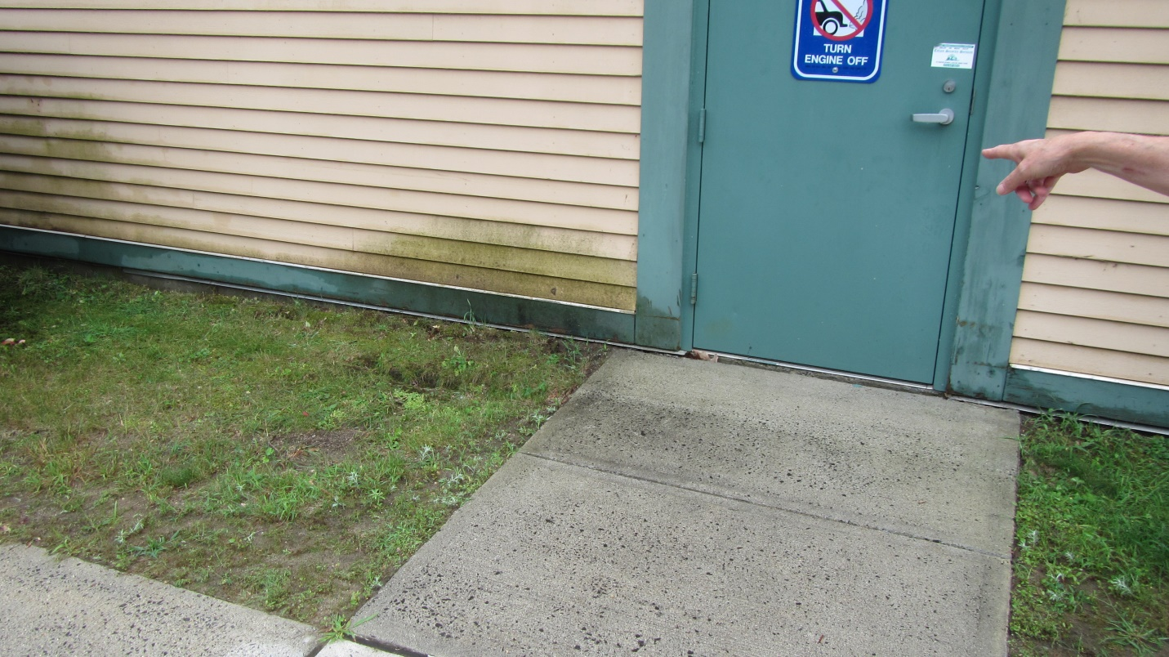

**Moss on exterior walls**

**Picture 2**

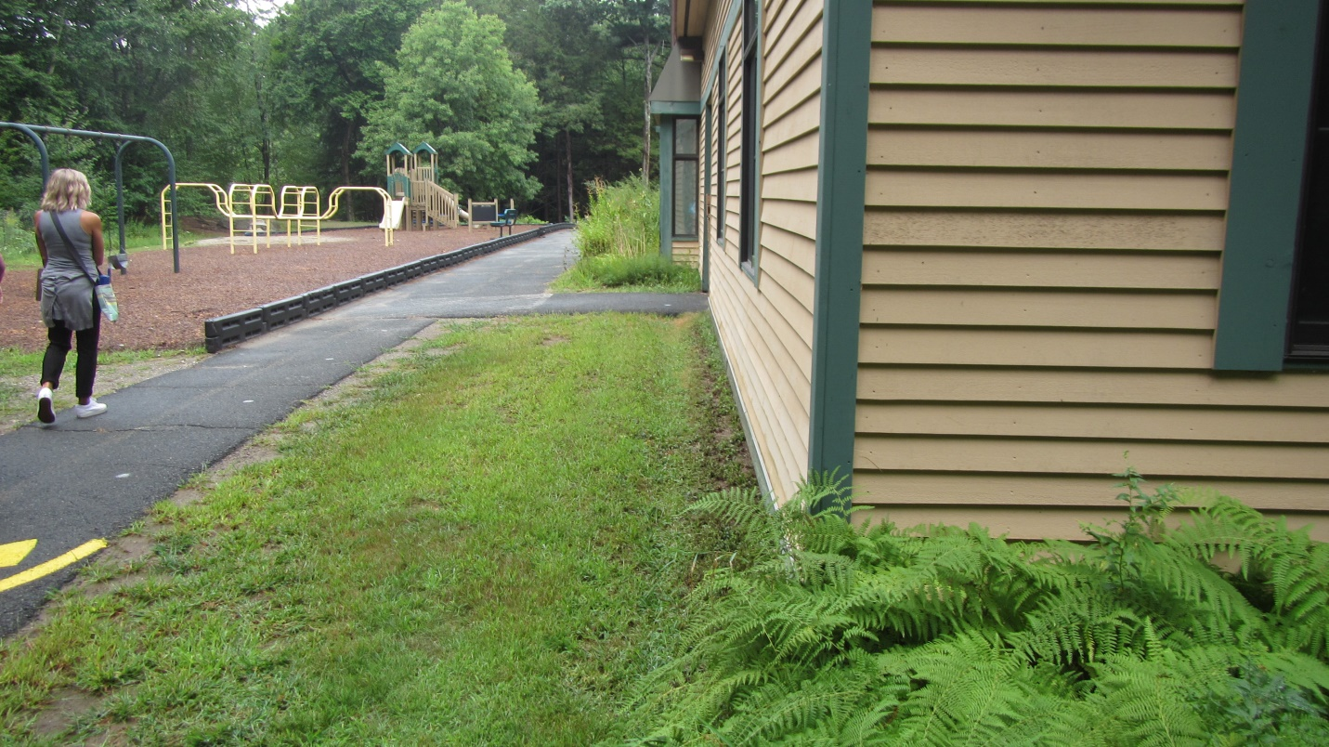

**Furrows in lawn/soil from rainwater impact**

**Picture 3**

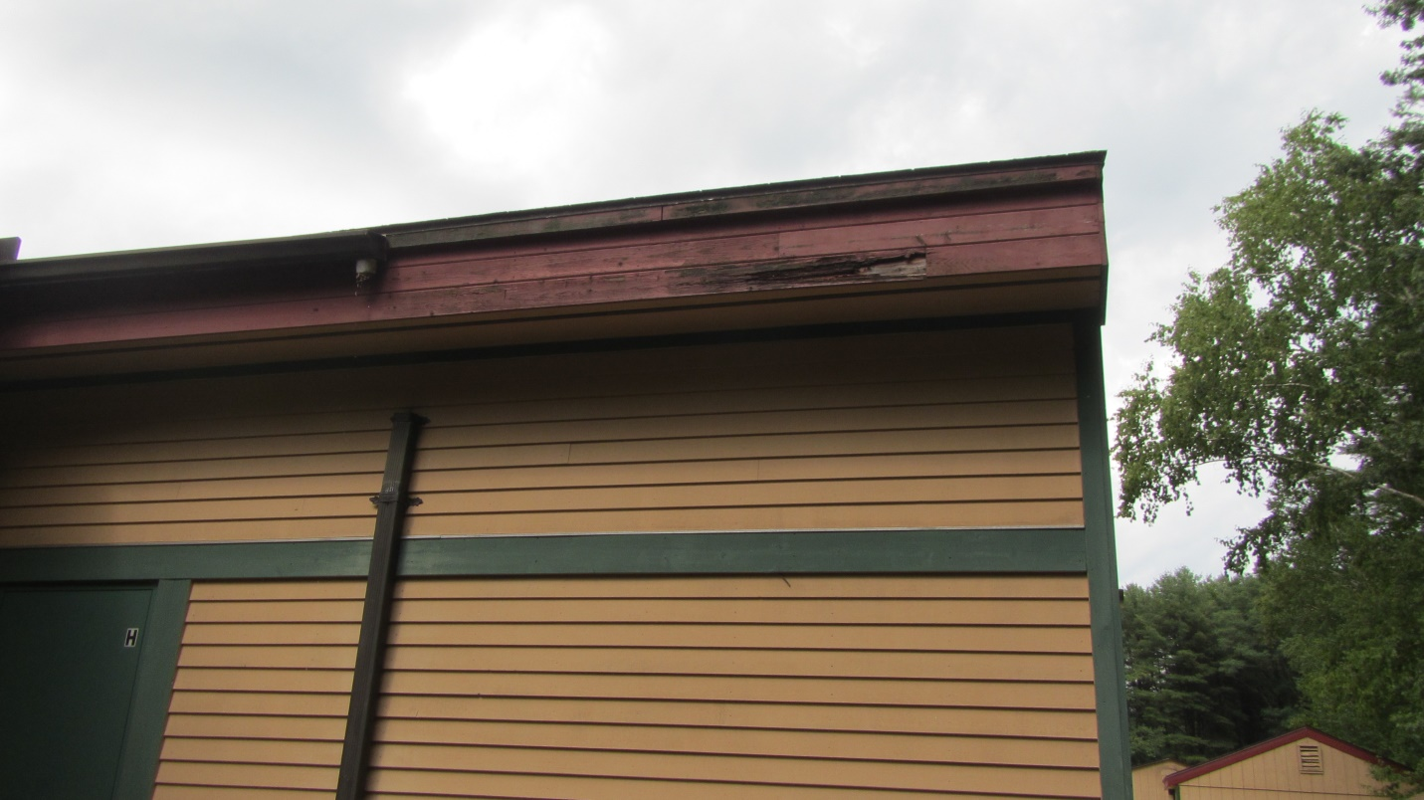

**Water-damaged roof eaves**

**Picture 4**

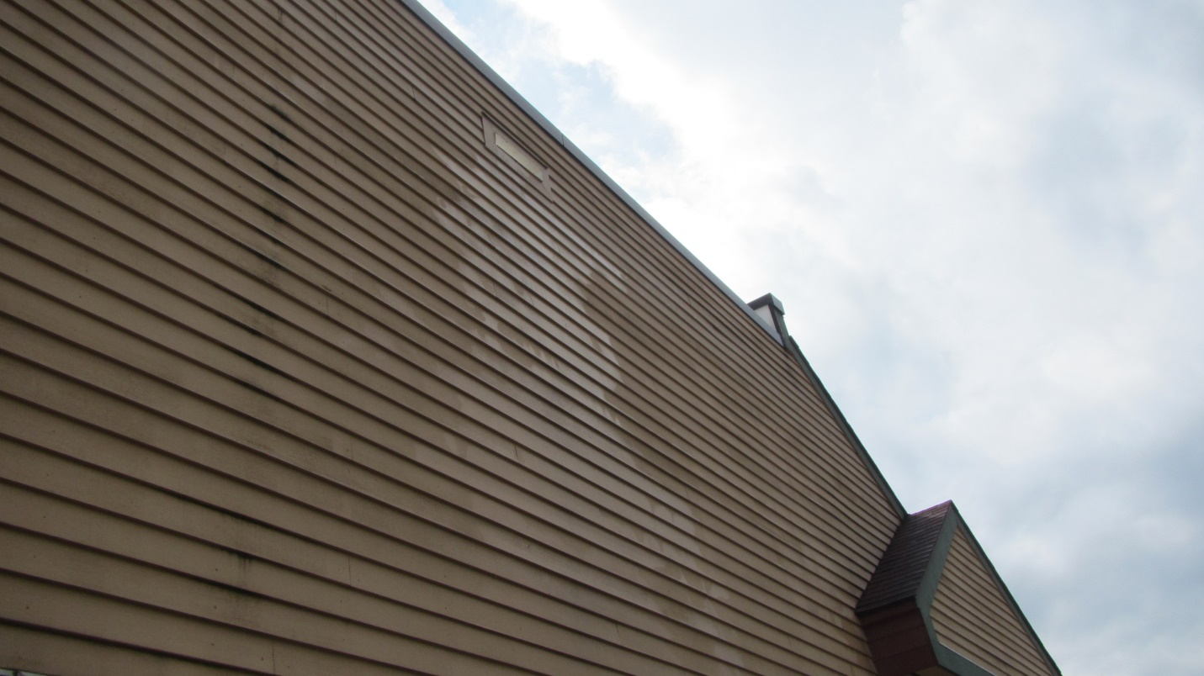

**Wall wet from rain draining from scupper**

**Picture 5**

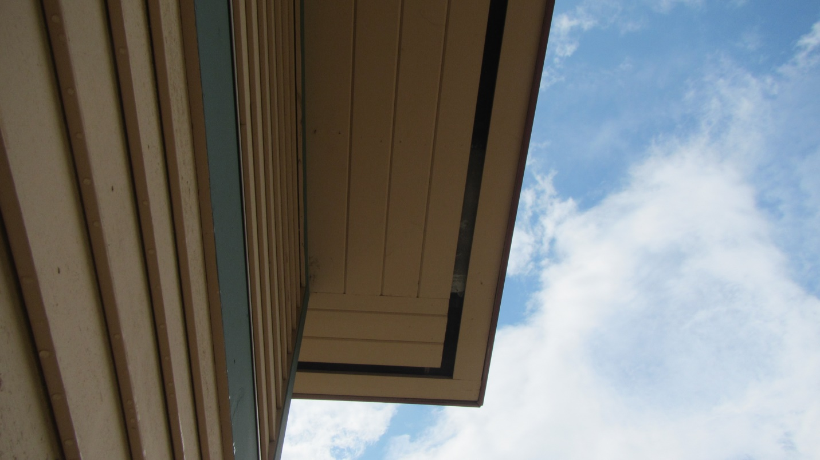

**Soffit vents**

**Picture 6**

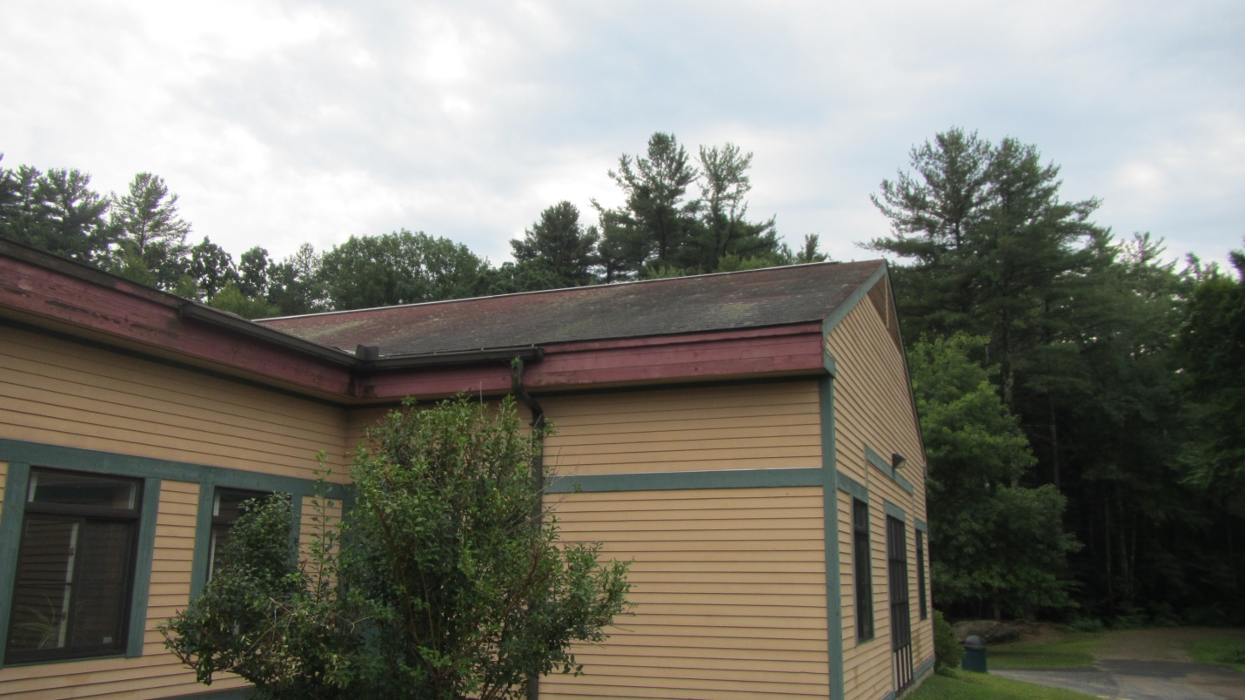

**Discolored roof**

| **Location** | **Air Temp**  **(oF)** | **Relative Humidity**  **(%)** | **Dew Point**  **(oF)** | **Floor Temp**  **(oF)** | **Floor/Wall Junction Temp**  **(oF)** | **Water-Damaged/ Ceiling Tiles-stained**  **(#)** | **Water-Damaged/Bowed Ceiling Tiles**  **(#)** | **Ventilation** | | | **Floor to Air Temp**  **Difference**  **(oF)** | **Comments** |
| --- | --- | --- | --- | --- | --- | --- | --- | --- | --- | --- | --- | --- |
| **Windows openable** | **Supply** | **Exhaust** |
| Background | 84 | 51 | 64 |  |  |  |  |  |  |  |  | Rain downpour during assessment |
| Bathroom – 5th gr |  |  |  |  |  | 0 | All | N/A | Y on | Y on |  |  |
| Bathroom – 6th gr |  |  |  |  |  | 0 | All | N/A | Y on | Y on |  |  |
| Bathroom 1st gr |  |  |  |  |  | 0 | All | N/A | Y on | Y on |  |  |
| Bathroom 3-4 gr |  |  |  |  |  | 0 | All | N/A | Y on | Y on |  |  |
| Cafe/Gym | 79 | 62 | 65 | 71 | 71 | 0 | All | N | Y | Y | 8 | MCT |
| Computer Lab | 77 | 59 | 61 | 66 | 66 | 0 | All | N/A | Y | Y | 11 | MCT, carpet, minisplit |
| Kitchen | 78 | 64 | 65 | 71 | 71 | 0 | All | N/A | Y | Y | 7 | MCT |
| Library 125 | 74 | 61 | 65 | 69 | 69 | 0 | All | Y | Y | Y | 5 | MCT, minisplit |
| Nurse | 78 | 67 | 66 | 73 | 73 | 0 | All | Y | Y | Y | 5 | MCT |
| Office | 78 | 68 | 67 | 73 | 73 | 0 | All | Y  1 open | Y | Y | 5 |  |
| Principal | 78 | 70 | 68 | 75 | 75 | 0 | All | Y  1 open | Y | Y | 5 |  |
| Room 112 | 74 | 74 | 65 | 71 | 72 | 0 | All | Y  2 open | Y | Y | 3 | Carpet |
| Room 113 | 74 | 68 | 63 | 73 | 73 | 0 | All | Y | Y | Y | 1 | MCT, area rug |
| Room 115 | 74 | 68 | 63 | 72 | 72 | 0 | All | Y | Y | Y | 2 | MCT, area rugs (3) |
| Room 116 | 75 | 76 | 63 | 71 | 71 | 0 | All | Y | Y | Y | 4 | Carpet, air purifier |
| Room 117 | 75 | 70 | 64 | 71 | 72 | 0 | All | Y | Y | Y | 4 | Area rugs (3) |
| Room 119 | 77 | 64 | 64 | 70 | 72 | 0 | All | Y | Y | Y | 7 | MCT, bookcases covering radiators, area rugs (4) |
| Room 121 | 77 | 63 | 63 | 71 | 72 | 0 | All | Y | Y | Y | 6 | MCT, partially carpeted |
| Room 122 | 77 | 62 | 63 | 70 | 71 | 0 | All | Y | Y | Y | 7 | MCT, partially carpeted |
| Room 126 | 74 | 62 | 61 | 68 | 68 | 0 | All | N/A | Y | Y | 6 | Carpet |
| Room 126 adjacent office | 73 | 63 | 60 | 69 | 69 | 0 | All | N/A | Y | Y | 4 | MCT, carpet |
| Room 130 | 76 | 62 | 62 | 69 | 69 | 0 | All | Y | Y | Y | 7 | Carpet |
| Room 135 | 76 | 65 | 63 | 71 | 71 | 0 | All | Y | Y | Y | 5 | Area rug |
| Room 136 Conference Rm | 77 | 61 | 63 | 74 | 78 | 0 | All | Y | Y | Y | 3 | carpet |
| Room 137 | 78 | 61 | 63 | 71 | 70 | 0 | All | N/A | Y | Y | 7 | Photocopier, laser printer |
| Room 144 | 81 | 59 | 64 | 73 | 73 | 0 | All | N/A | Y | Y | 8 | MCT |
| Room 155 School Psych | 76 | 65 | 63 | 70 | 70 | 0 | All | Y | Y | Y | 6 | MCT |
| Room 155 Tech Coordinator | 76 | 66 | 63 | 72 | 72 | 0 | All | N/A | Y | Y | 4 | MCT |
| Room 160 | 80 | 57 | 64 | 69 | 69 | 0 | All | Y | Y | Y | 11 | MCT, area rugs (4) |
| Room 160 adjoining supply rm | 76 | 61 | 62 | 69 | 69 | 0 | All | N/A | Y | Y | 7 | MCT |
| Room 161 | 74 | 66 | 66 | 68 | 68 | 0 | All | Y | Y | Y | 6 | MCT |
| Room 163 | 75 | 62 | 62 | 69 | 69 | 0 | All | Y | Y | Y | 6 | Area rug |
| Staff Lounge | 77 | 62 | 63 | 71 | 71 | 0 | All | N/A | Y | Y | 6 | MCT |