Sign-in to Outlook Client

Steps | Process | Image
 | Log in to your PC using the same network username and password you use today. | 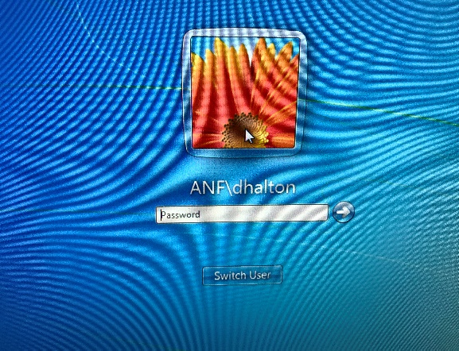
 | Open Outlook | Outlook 2010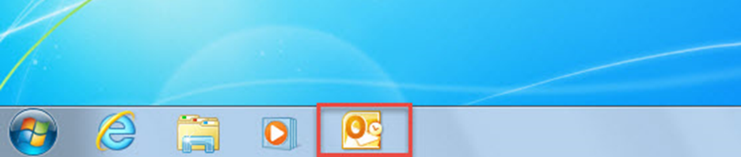  Outlook 2013 and 2016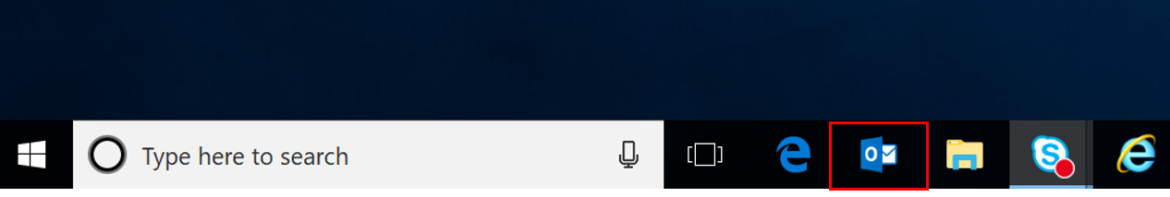
 | If you are prompted to provide credentials after opening Outlook:  User ID - enter your email address with the @mass.gov extension  Password - enter your existing network password  Click ‘Remember my credentials’ and click ‘OK’ | 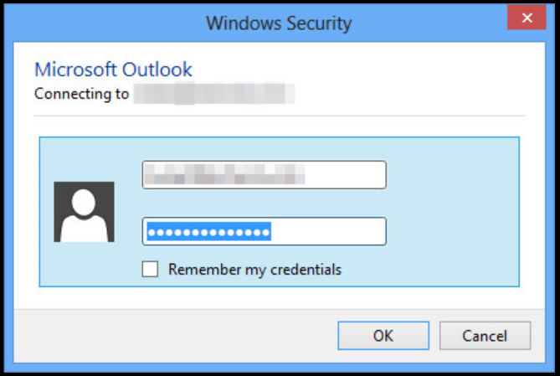
 | If you have any shared mailboxes and/or shared calendars, please validate they appear in the left-side panels under your mailbox and in your calendar  (NOTE: depending on the size of the mailbox, it may take some time to display messages. If shared calendars still do not appear, you may to re-add them). | Shared Mailboxes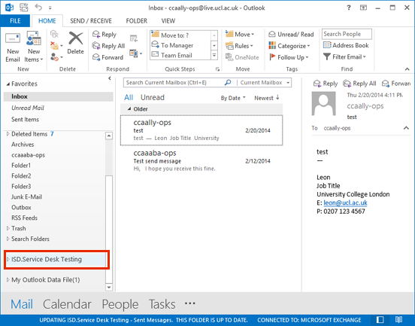  Shared Calendars