## Massachusetts Department of Public Health

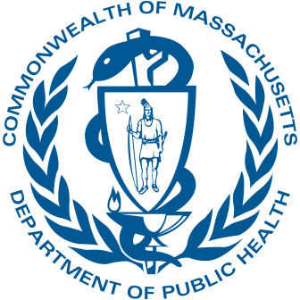

Signs of Health Equity: Developing public-health survey instruments in American Sign Language

October 29, 2024

**Nick Griffiths**, Nassira Nicola, Caroline Stack, McKane Sharff, Kimberley Warsett, Bianey Ramirez, Kerra Washington, Ana Kantorowski, Nicole Kitos, Anna Makaretz, Lauren Kipling, Ta-wei Lin

**MA Dept. of Public Health**

**Conflicts of interest**

* No conflicts of interest

**Background: How is deafness defined?**

* Most data sources define deafness in **audiological** terms
  + American Community Survey: "Are you deaf or do you have serious difficulty hearing?"
* Deaf/hard-of-hearing people do not all use ASL

**Background: ASL & Literacy**

# ASL users are not all fluent in English

* + American Sign Language (ASL) is *unrelated* to English
  + Data on ASL use and general English fluency are limited, but we know ASL users communicate best in their first language
  + Health surveys are nearly always written only

**Background: Health Inequities**

# Limited data on health inequities impacting Deaf people

* + Health literacy
    - Knowledge of nutrition, cardiovascular disease, preventive health, etc.
  + Healthcare access
    - Communication difficulties, lack of access to interpreters & native signers
  + Little data on outcomes

(Kuenburg et al., 2016;

McKee et al., 2011, 2015)

# The Community Health Equity Initiative (CHEI)

CHEI promotes the health of MA residents through a **health equity data & response system**

Capture root causes of health outcomes

Health Equity Data System

**CHEI**

Community Engagement Practice

Data & Action

Reach communities that are frequently left out of health data

**Background: The Programs (1)**

Actionable & timely analysis

**Background: The Programs (2)**

# The Health & Disability Program (HDP)

* + HDP helps people across Massachusetts understand and act on health inequities affecting the disability community
  + Conducting a large health needs assessment of adults with disabilities in Massachusetts

**Methods: The Surveys**

## Health & Disability Needs Assessment

(August – December 2023)

## Community Health Equity Survey

(February – March 2024)

* Similar length: ~60 questions, typical response time 10- 30 min
* REDCap

**Methods: Animated GIFs (HDP survey)**

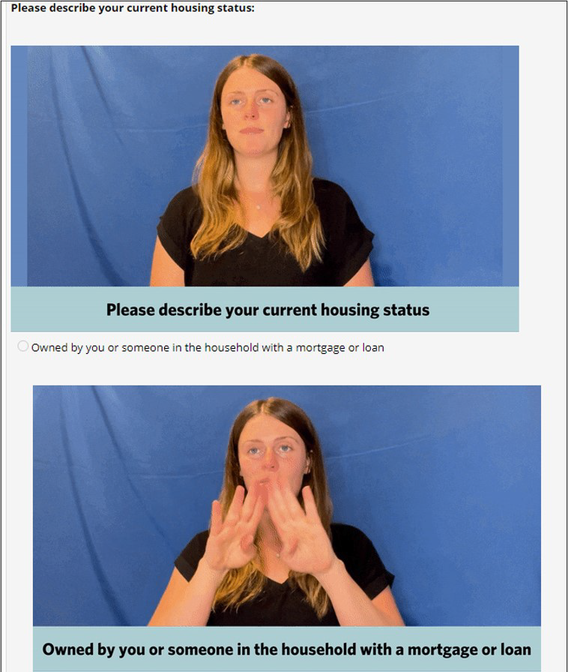GIF showing question

GIF showing first response, displayed below the corresponding radio button

**Methods: ASL Module (CHES)**

Dedicated video player (Auto-plays question & responses)

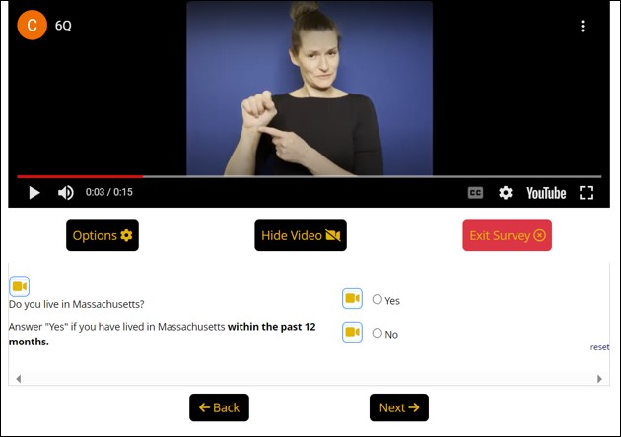

Response radio buttons

Buttons to select a video to play

**Methods: Taking the two surveys (1)**

# What does the user need?

* Seamless video playing

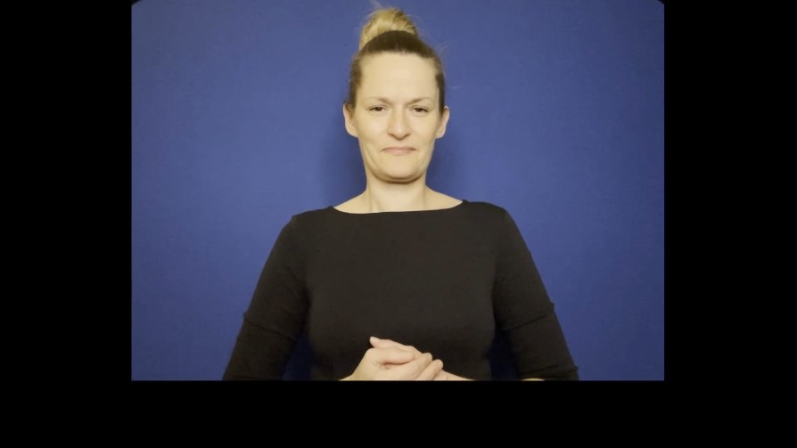

Feedback: ensure signing begins in the first seconds of each clip

**Methods: Taking the two surveys (2)**

# What does the user need?

* Matching response options to radio buttons
  + Captioning with English helps

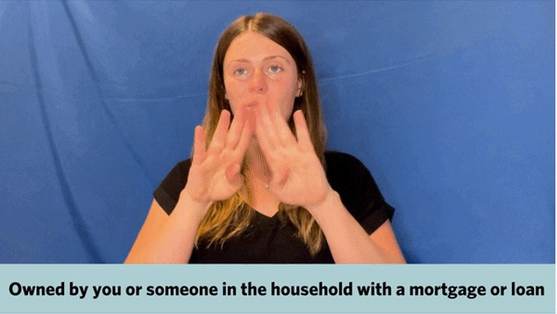

Feedback: ensure caption timing matches exactly



**Methods: Taking the two surveys (3)**

# What does the user need?

* High-quality translations
  + Health surveys are likely to include some precise and nuanced concepts that are critical to convey accurately

**Results**

# The ASL User Survey Samples

* Surveys were disseminated in partnership with Advocates, Center for Living and Working, Deaf Inc, Viability
* Total: 108 respondents to the two surveys
  + Includes 87 deaf or hard of hearing respondents

**Best Practices for ASL surveys**

# Effective outreach & understanding tools

* **Involve ASL users** throughout development
* **Research existing tools** and their pros & cons
* **Disseminate surveys** using tailored promotional materials, and create tutorial videos and user resources

**Conclusion**

* ASL surveys are feasible
* Community engagement is critical
* ASL surveys address a major language access problem
* The Massachusetts Health and Disability Program is funded by the CDC Disability and State Health Program

(Grant Number: NU27DD000030; CDC-RFA-DD21-2103).

* The Community Health Equity Initiative is supported by funding from the CDC Immunization and Vaccines for Children Program COVID Cycle 3 and Cycle 4 Supplemental Funding.
* The CHES survey used the Rochester Survey Accessibility module ([https://github.com/vanderbilt-](https://github.com/vanderbilt-redcap/rochester-survey)

[redcap/rochester-survey](https://github.com/vanderbilt-redcap/rochester-survey)).

[**nicholas.g.griffiths@mass.gov**](mailto:nicholas.g.griffiths@mass.gov)

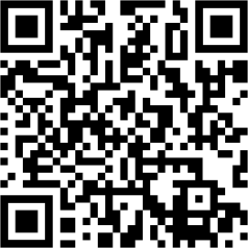**Community Health Equity**

**Thank you!**

**Initiative**

mass.gov/chei

**Health & Disability Program**

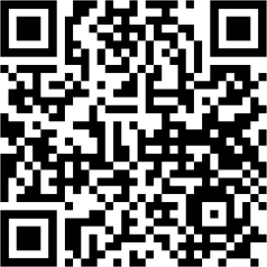mass.gov/health-and-disability-

program-hdp

**References**

Kuenburg, A., Fellinger, P., & Fellinger, J. (2016). Health Care Access Among Deaf People.

*Journal of Deaf Studies and Deaf Education*, *21*(1), 1–10. <https://doi.org/10.1093/deafed/env042>

McKee, M. M., Barnett, S. L., Block, R. C., & Pearson, T. A. (2011). Impact of communication on preventive services among deaf American Sign Language users. *American Journal of Preventive Medicine*, *41*(1), 75–79. <https://doi.org/10.1016/j.amepre.2011.03.004>

McKee, M. M., Paasche-Orlow, M. K., Winters, P. C., Fiscella, K., Zazove, P., Sen, A., & Pearson, T. (2015). Assessing Health Literacy in Deaf American Sign Language Users. *Journal of Health Communication*, *20*(sup2), 92–100. <https://doi.org/10.1080/10810730.2015.1066468>

Zazove, P., Meador, H. E., Reed, B. D., & Gorenflo, D. W. (2013). Deaf persons’ english reading levels and associations with epidemiological, educational, and cultural factors. *Journal of Health Communication*, *18*(7), 760–772. <https://doi.org/10.1080/10810730.2012.743633>