INDOOR AIR QUALITY ASSESSMENT

Silvio O. Conte Community School
200 West Union Street
Pittsfield, MA

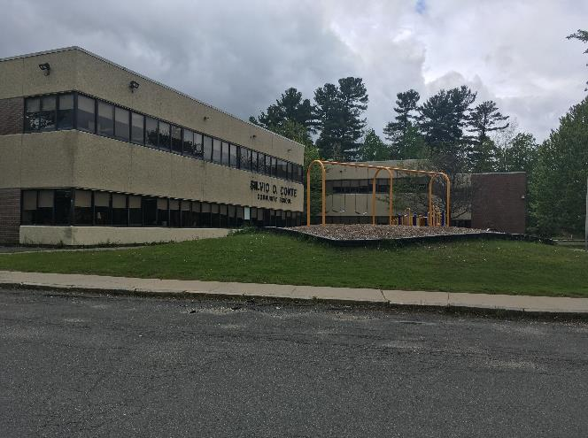

Prepared by:
Massachusetts Department of Public Health
Bureau of Environmental Health
Indoor Air Quality Program
June 2019

Background

Building: | Silvio O. Conte Community School (SOC)
Address: | 200 West Union Street, Pittsfield
Reason for Request: | General indoor air quality (IAQ) and water damage/mold concerns
Date(s) of Assessment: | May 24, 2019
Assessment Requested by: | James Esoldi, Project Supervisor, Building Maintenance, City of Pittsfield
Massachusetts Department of Public Health/Bureau of Environmental Health (MDPH/BEH) Staff Conducting Assessment: | Michael Feeney, Director, IAQ Program
Date of Building Construction: | 1974
Building Description: | The school is a two-story brick building. The building has large, open areas separated into “pods” and classrooms by flexible barriers. The building also has rooms for specialized instruction, common areas and office space.
Building Population: | Approximately 400 students in grades pre-K through 5 with a staff of approximately 70
Windows: | Windows throughout the building are openable; the window system is original to the building.

Background

IAQ Testing Results
Please refer to the IAQ Manual for methods, sampling procedures, and interpretation of results (MDPH, 2015). The following is a summary of indoor air testing results (Table 1).
- Carbon dioxide levels were above the MDPH guideline of 800 parts per million (ppm) in about half of the locations assessed, indicating a lack of air exchange, mainly due to deactivated/outdated ventilation components.
- Temperature was above the recommended range of 70°F to 78°F in a number of areas.
- Relative humidity was within the recommended range of 40 to 60% the day of assessment.
- Carbon monoxide levels were non-detectable (ND) in all indoor areas tested.
- Fine particulate matter (PM2.5) concentrations measured were below the National Ambient Air Quality Standard (NAAQS) limit of 35 μg/m³ in all areas tested.

Ventilation
A heating, ventilating and air conditioning (HVAC) system has several functions. First it provides heating and, if equipped, cooling. Second, it is a source of fresh air. Finally, an HVAC system will dilute and remove normally occurring indoor environmental pollutants by not only introducing fresh air, but by filtering the airstream and ejecting stale air to the outdoors via exhaust ventilation. Even if an HVAC system is operating as designed, point sources of respiratory irritation may exist and cause symptoms in sensitive individuals.
Mechanical ventilation is provided by roof-top air-handling units (AHUs). The AHUs draw in fresh air through air intakes and distribute it via ceiling-mounted air diffusers (Picture 1). Return air is ducted back to AHUs via ceiling-mounted return vents.
Mechanical ventilation equipment was deactivated in a number of areas throughout the building in both classrooms and common areas (e.g., cafeteria, gym, library) (Table 1). It is also important to note that several classrooms with carbon dioxide levels below 800 ppm were unoccupied or sparsely populated, which can greatly reduce carbon dioxide levels. Therefore during full occupancy the carbon dioxide levels would be expected to be higher.
In order to have proper ventilation with a mechanical supply and exhaust system, these systems must be balanced to provide an adequate amount of fresh air to the interior of a room while removing stale air from the room. It is recommended that existing ventilation systems be re-balanced every five years to ensure adequate air systems function (SMACNA, 1994).
According to the American Society of Heating, Refrigeration and Air-Conditioning Engineers (ASHRAE), the service life for a unit heater, hot water or steam is 20 years, assuming routine maintenance of the equipment (ASHRAE, 1991). Despite attempts to maintain the univents (e.g., oiling bearings, changing filters regularly), the operational lifespan of this equipment has been exceeded. Maintaining the balance of fresh to exhaust air will become more difficult as the equipment ages and as replacement parts become increasingly difficult to obtain.

Microbial/Moisture Concerns
The New England area experienced an unprecedented period of extended hot, humid weather. According to the Washington Post, “[d]ata…show[s]…cities in the Northeast have witnessed such humidity levels for record-challenging duration...[i]ncluding Albany, Boston, Burlington Portland and Providence” during the summer of 2018 (WP, 2018). “Boston and nearby locations… [saw]…historic numbers of those warm nights with low temperatures at or above 70 degrees…Providence and Blue Hill Observatory have already broken their annual records” (WP, 2018). If a building does not have adequate exhaust ventilation and air chilling capacity to remove/reduce relative humidity from outside air, then hot, moist air can be introduced into a building and linger to increase occupant discomfort as well as possibly moisten materials that may lead to mold growth.
Water-damaged ceiling tiles from roof leaks were seen in several areas (Table 1). Of note were bowed ceiling tiles adjacent to windows (Picture 2). Bowed ceiling tiles may occur during extended periods of hot, humid weather. Bowed ceiling tiles in Picture 2 may indicate a space exists in window frames or exterior walls to allow water vapor into the ceiling plenum above the tiles.
Water-damaged window sills were note in a number of areas, as well as windows that have damaged gaskets to allow water vapor into the space between panes. Failing windows can be a source of water intrusion.
Indoor plants were observed in a few areas. Plants can be a source of pollen and mold, which can be respiratory irritants to some individuals. Plants should be properly maintained, equipped with non-porous drip pans, and should be located away from air diffusers to prevent the aerosolization of dirt, pollen and mold.

Other IAQ Evaluations
Ceiling tiles around vents show staining (Picture 1) that can indicate the use of filters that are not adequate to filter out dust and debris at some point prior to this assessment. The BEH/IAQ Program recommends pleated filters with a Minimum Efficiency Reporting Value (MERV) of 8 which are adequate in filtering out pollen and mold spores (ASHRAE, 2012). Note, that an increase in filtration can cause stress on equipment, which needs to be evaluated to determine if the higher-rated filters will allow adequate function.
Of note were a number of trees located in close proximity to school walls (Picture 3). Large trees shade exterior walls, which can remain moistened for extended periods. Conditions such a moss growing from/along window frames (Picture 4), likely indicates exterior walls remain wet for significant times.
Most classrooms had carpeting that appeared to be several decades old as indicated by the variety of different colors located throughout the building. In many areas, this carpeting was visibly worn, frayed, wrinkled and stained. The service life of carpeting in schools is approximately 10-11 years (IICRC, 2002). Aging carpet can produce fibers that can be irritating to the respiratory system. In addition, tears or lifting carpet can create tripping hazards. Carpeting should be cleaned annually or semi-annually in soiled high traffic areas as per the recommendations of the Institute of Inspection, Cleaning and Restoration Certification (IICRC, 2012). Non-carpeted surfaces are recommended for most areas of schools.

Other IAQ Evaluations
Exposure to low levels of total volatile organic compounds (TVOCs) may produce eye, nose, throat, and/or respiratory irritation in some sensitive individuals. To determine if VOCs were present, BEH/IAQ staff examined rooms for products containing VOCs. BEH/IAQ staff noted hand sanitizers, scented cleaners, air fresheners, and dry erase materials in use within the building. All of these products have the potential to be irritants to the eyes, nose, throat, and respiratory system of sensitive individuals (e.g., asthmatics). Due to the pervasive use of these products in schools throughout Massachusetts, the MDPH has produced a guideline called “Clean Air Is Odor-Free” which is included as Appendix A.
In many areas, accumulated items including books, papers, and decorative items were observed on floors, windowsills, tabletops, counters, bookcases, and desks. Excess items on surfaces can make it more difficult for custodial staff to clean.
Note that the Environmental Protection Agency (EPA) conducted a National School Radon Survey in which it discovered nearly one in five schools had “…at least one frequently occupied ground contact room with short-term radon levels above 4 [picocuries per liter] pCi/L” (US EPA 1993). The BEH/IAQ Program therefore recommends that every school be tested for radon, and that this testing be conducted during the heating season while school is in session in a manner consistent with USEPA radon testing guidelines. Radon measurement specialists and other information can be found at www.nrsb.org and http://aarst-nrpp.com/wp, with additional information at: http://www.mass.gov/eohhs/gov/departments/dph/programs/environmental-health/exposure-topics/iaq/radon.

Conclusions/Recommendations
- Operate all ventilation systems throughout the building (e.g., gym, cafeteria, classrooms) continuously during periods of school occupancy and independent of thermostat control.
- Exam the area above bowed ceiling tiles for spaces in window frames of the exterior wall.
- Monitor windows for leaks/failed gaskets and make repairs as needed.
- Survey classrooms for HVAC system function to ascertain if an adequate air supply exists for each room. Consider consulting an HVAC engineer concerning the calibration of univent fresh air control dampers throughout the school.
- Check exhaust vents for air draw periodically. Inspect unit exhaust motors and belts for proper function. Repair and replace as necessary.
- Use openable windows in conjunction with classroom univents and exhaust vents to increase air exchange. Care should be taken to ensure windows are properly closed at night and weekends.
- Consider adopting a balancing schedule of every 5 years for all mechanical ventilation systems, as recommended by ventilation industrial standards (SMACNA, 1994).
- Once leaks are repaired replace water-damaged ceiling tiles and paint/refinish areas with water stains, etc.
- Avoid storage of any porous materials in areas of known leaks or in unconditioned spaces.
- Properly maintain plants, including drip pans, to prevent water damage to porous materials. Plants should also be located away from air diffusers to prevent the aerosolization of dirt, pollen, and mold.
- Remove or significantly trim back trees from overhanging the roof and ensure all plants/shrubs are located at least five feet away from air intakes (e.g., courtyard).
- Consider upgrading to a pleated filter of MERV 8 in the HVAC system, if not already done and only if this type of filter can be used with the current equipment. Change filters 2-4 times a year or as per the manufacture’s recommendations.
- For buildings in New England, periods of low relative humidity during the winter are often unavoidable. Therefore, scrupulous cleaning practices should be adopted to minimize common indoor air contaminants whose irritant effects can be enhanced when the relative humidity is low. To control for dusts, a high efficiency particulate arrestance (HEPA) filter-equipped vacuum cleaner in conjunction with wet wiping of all surfaces is recommended. Avoid the use of feather dusters. Drinking water during the day can help ease some symptoms associated with a dry environment (throat and sinus irritation).
- Replace outdated carpeting past its useful life. Consider using non-carpet flooring in classroom areas.
- Note due to the age of the building, it may include asbestos-containing materials (ACM). Follow AHERA regulations including 3-year inspections and updates/availability of the school’s asbestos management plan.
- Clean carpeting and area rugs annually or more often in high-traffic locations in accordance with IICRC recommendations (IICRC, 2012) and discard those that are worn out or too soiled to be cleaned.
- Clean upholstered and plush items regularly to remove oils, dust and debris.
- Remove/replace worn/soiled/stained chairs/furniture (e.g., chairs in Faculty Lounge).
- Consider reducing the amount of items stored in classrooms/offices to make cleaning easier. Periodically move items to clean flat surfaces.
- Encourage faculty to report classroom/building related issues via a tracking program.
- The school should be tested for radon by a certified radon measurement specialist during the heating season when school is in session. Radon measurement specialists and other information can be found at: www.nrsb.org, and http://aarst-nrpp.com/wp.
- Consider adopting the US EPA (2000) document, “Tools for Schools”, as an instrument for maintaining a good IAQ environment in the building available at: http://www.epa.gov/iaq/schools/index.html.
- For more information on mold refer to “Mold Remediation in Schools and Commercial Buildings” published by the US Environmental Protection Agency (US EPA, 2008). http://www.epa.gov/mold/mold-remediation-schools-and-commercial-buildings-guide.
- Refer to resource manual and other related IAQ documents located on the MDPH’s website for further building-wide evaluations and advice on maintaining public buildings. These documents are available at: http://mass.gov/dph/iaq.

Long-term Recommendations:
- Contact an HVAC engineering firm for an assessment of the ventilation system’s components and control systems (e.g., controls, air intake louvers, thermostats). Based on the age, physical deterioration, and availability of parts for ventilation components, such an evaluation is necessary to determine the operability and feasibility of repairing/replacing the equipment.
- Examine the feasibility of initiating capital improvement plans for major roof repairs/replacement.

References
ASHRAE. 1991. ASHRAE Applications Handbook, Chapter 33 “Owning and Operating Costs”. American Society of Heating, Refrigeration and Air Conditioning Engineers, Atlanta, GA.
ASHRAE. 2012. American Society of Heating, Refrigeration and Air Conditioning Engineers (ASHRAE) Standard 52.2-2012 -- Method of Testing General Ventilation Air-Cleaning Devices for Removal Efficiency by Particle Size (ANSI Approved). 2012.
IICRC. 2002. Institute of Inspection, Cleaning and Restoration Certification. A Life-Cycle Cost Analysis for Floor Coverings in School Facilities.
IICRC. 2012. Institute of Inspection, Cleaning and Restoration Certification. Carpet Cleaning: FAQ.
MDPH. 2015. Massachusetts Department of Public Health. “Indoor Air Quality Manual: Chapters I-III”. Available at: http://www.mass.gov/eohhs/gov/departments/dph/programs/environmental-health/exposure-topics/iaq/iaq-manual/.
SMACNA. 1994. HVAC Systems Commissioning Manual. 1st ed. Sheet Metal and Air Conditioning Contractors’ National Association, Inc., Chantilly, VA.
US EPA. 2000. Tools for Schools. Office of Air and Radiation, Office of Radiation and Indoor Air, Indoor Environments Division (6609J). EPA 402-K-95-001, Second Edition. http://www.epa.gov/iaq/schools/index.html.
US EPA. 1993. Radon Measurement in Schools, Revised Edition. Office of Air and Radiation, Office of Radiation and Indoor Air, Indoor Environments Division (6609J). EPA 402-R-92-014. https://www.epa.gov/sites/production/files/2014-08/documents/radon_measurement_in_schools.pdf.
US EPA. 2008. Mold Remediation in Schools and Commercial Buildings. US Environmental Protection Agency, Office of Air and Radiation, Indoor Environments Division, Washington, D.C. EPA 402-K-01-001. http://www.epa.gov/mold/mold-remediation-schools-and-commercial-buildings-guide.
WP. 2018. ‘It’s been relentless’: Smothering summer humidity in the Northeast has crushed records. Washington Post, Washington, DC. https://www.washingtonpost.com/news/capital-weather-gang/wp/2018/08/30/its-been-relentless-smothering-summer-humidity-in-the-northeast-has-crushed-records/.
Picture 1
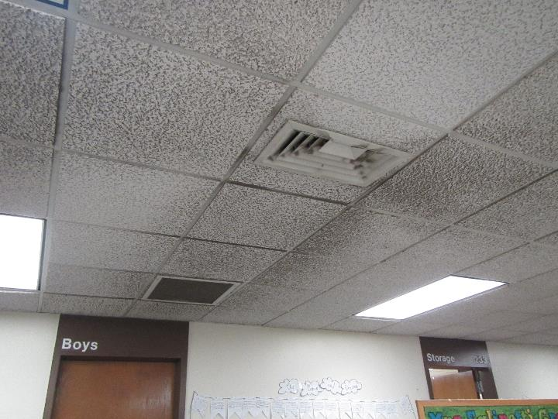
Fresh air diffuser, note stains on ceiling tiles
Picture 2
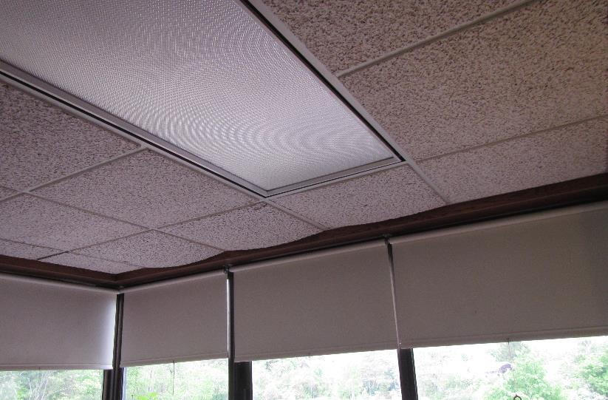
Bowed ceiling tiles against windows
Picture 3
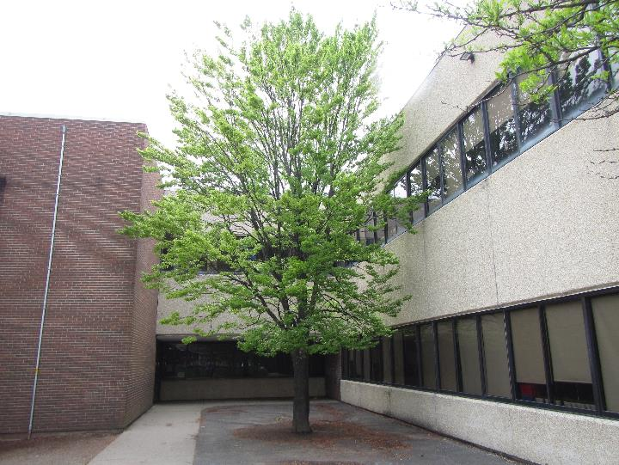
Trees in courtyard shading walls
Picture 4
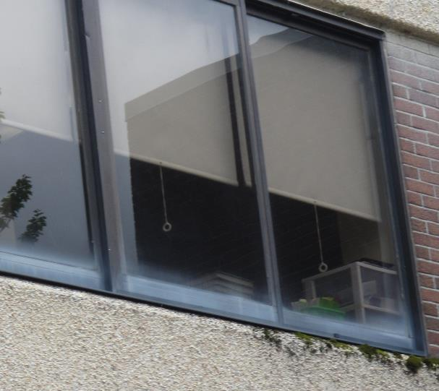
Moss growing on exterior walls (arrow)
Location | Carbon  Dioxide  (ppm) | Carbon Monoxide  (ppm) | Temp  (°F) | Relative  Humidity  (%) | PM2.5  (µg/m³) | Occupants  in Room | Windows  Openable | Ventilation |  | Remarks
 |  |  |  |  |  |  |  | Supply | Exhaust
Quad A - A | 495 | ND | 84 | 47 | 3 | 2 | Y | Y | Y
Quad A - B | 505 | ND | 83 | 47 | 4 | 1 | Y open | Y | Y
Quad A - C | 476 | ND | 83 | 47 | 3 | 1 | Y open | Y | Y | Stained carpet
247 | 436 | ND | 82 | 47 | 3 | 0 | N | Y | Y | 6 WD CT
Quad A - D | 408 | ND | 82 | 46 | 3 | 1 | Y | Y | Y
Quad D - D | 365 | ND | 82 | 50 | 3 | 0 | Y | Y | Y
Quad D - C | 355 | ND | 70 | 51 | 3 | 0 | Y | Y | Y | Stained carpet
Quad D - B | 382 | ND | 70 | 52 | 3 | 0 | Y | Y | Y
Quad D - A | 389 | ND | 70 | 52 | 3 | 0 | Y | Y | Y
239 | 531 | ND | 72 | 52 | 4 | 1 | N | Y | Y
213 | 532 | ND | 73 | 51 | 4 | 10 | N | Y | Y
A kindergarten | 1018 | ND | 72 | 55 | 6 | 16 | Y | Y | Y
B kindergarten | 1039 | ND | 72 | 55 | 5 | 1 | Y | Y | Y
C kindergarten | 967 | ND | 72 | 55 | 5 | 2 | Y | Y | Y
D kindergarten | 972 | ND | 71 | 55 | 5 | 2 | Y | Y | Y | Plants
C Art | 816 | ND | 71 | 54 | 4 | 15 | Y | Y | Y
B Art | 973 | ND | 72 | 54 | 4 | 15 | Y | Y | Y | Algae in aquarium
A Art | 929 | ND | 72 | 53 | 4 | 10 | Y | Y | Y | plants
Nurse | 647 | ND | 74 | 50 | 2 | 1 | Y | Y | Y
172 | 647 | ND | 75 | 47 | 3 | 1 | Y | Y | Y
168 | 605 | ND | 75 | 47 | 2 | 1 | N | Y | Y
123 | 697 | ND | 75 | 48 | 3 | 1 | N | Y | Y
Gym | 617 | ND | 74 | 48 | 6 | 16 | N | Y | Y
Cafeteria | 647 | ND | 73 | 49 | 3 | 100+ | Y | Y | Y
Conference room | 508 | ND | 72 | 49 | 3 | 0 | Y | Y | Y
209 | 455 | ND | 72 | 49 | 3 | 0 | N | Y | Y
Copy Room | 531 | ND | 73 | 48 | 3 | 1 | N | Y | Y | Fans
Computer Room 1 | 527 | ND | 75 | 46 | 3 | 0 | N | Y | Y
208 | 548 | ND | 75 | 46 | 3 | 0 | N | Y | Y
Library | 518 | ND | 75 | 45 | 3 | 0 | N | Y | Y | Upholstered furniture
Computer Room | 536 | ND | 75 | 44 | 3 | 0 | N | Y | Y
205 | 809 | ND | 76 | 46 | 4 | 3 | N | Y | Y
204 | 669 | ND | 76 | 45 | 3 | 5 | Y | Y | Y | WD windowsill
200 | 602 | ND | 76 | 45 | 3 | 0 | Y | Y | Y | Unused sink
Quad E – A | 1788 | ND | 75 | 47 | 8 | 12 | Y | Y | Y | Plants
Quad E – B | 1157 | ND | 76 | 49 | 5 | 0 | Y | Y | Y
233 | 1137 | ND | 75 | 49 | 4 | 0 | N | N | Y | 10 WD CT
Quad E – C | 1328 | ND | 75 | 50 | 4 | 26 | Y | Y | Y | Bowed CT
Quad E – D | 1338 | ND | 76 | 49 | 5 | 10 | Y | Y | Y | Bowed CT
Quad E – E | 1275 | ND | 76 | 50 | 4 | 1 | Y | Y | Y
Quad E – F | 1162 | ND | 75 | 51 | 5 | 2 | Y | Y | Y
Quad E – G | 995 | ND | 75 | 49 | 5 | 2 | Y open | Y | Y
Quad E – H | 952 | ND | 75 | 48 | 4 | 1 | Y | Y | Y | Stained carpet
FRONT DESK | 531 | ND | 74 | 46 | 3 | 1 | Y | Y | Y
Quad B – A | 1117 | ND | 73 | 53 | 5 | 1 | Y | Y | Y
Quad B – B | 1120 | ND | 72 | 54 | 5 | 0 | Y | Y | Y
Quad B – C | 1105 | ND | 72 | 55 | 4 | 1 | Y | Y | Y
Quad B – D | 1134 | ND | 72 | 54 | 5 | 1 | Y | Y | Y
D | 889 | ND | 71 | 56 | 4 | 0 | Y | Y | Y
C | 949 | ND | 71 | 53 | 4 | 0 | Y | Y | Y
B | 982 | ND | 71 | 55 | 4 | 11 | Y | Y | Y
A | 1058 | ND | 72 | 55 | 4 | 0 | Y | Y | Y
133 | 642 | ND | 73 | 52 | 4 | 0 | Y | Y | Y
Faculty Room | 704 | ND | 74 | 51 | 3 | 6 | N | Y | Y
Music | 636 | ND | 74 | 49 | 4 | 16 | N | Y | Y

