INDOOR AIR QUALITY ASSESSMENT

Sippican School
16 Spring Street
Marion, MA

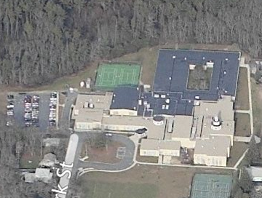

Prepared by:
Massachusetts Department of Public Health
Bureau of Environmental Health
Indoor Air Quality Program
April 2016

Background

Building: | Sippican School
Address: | 16 Spring Street, Marion, MA
Assessment Requested by: | Eugene Jones, Facilities Director, Old Rochester Regional School District
Reason for Request: | Mold and general indoor air quality (IAQ) concerns
Date of Assessment: | March 11, 2016
Massachusetts Department of Public Health/Bureau of Environmental Health (MDPH/BEH) Staff Conducting Assessment: | Mike Feeney, Director; Ruth Alfasso, Environmental Engineer/Inspector; and Cory Holmes, Environmental Analyst/Inspector, IAQ Program
Date of Building Construction: | Original section 1937, additions in 1958, 1974, 1992, and 2001
Building Description: | Elementary School, two-story brick construction with flat roofs and skylights
Building Population: | 450 students in grades K through 6 with a staff of approximately 74
Windows: | Mostly openable

METHODS
Please refer to the IAQ Manual for methods, sampling procedures, and interpretation of results (MDPH, 2015).

IAQ Testing Results
The following is a summary of indoor air testing results (Table 1).
- Carbon dioxide levels were above 800 parts per million (ppm) in thirty-five of eighty-nine areas surveyed, indicating a lack of air exchange in 39 % of the areas tested.
- Temperature was within the recommended range of 70°F to 78°F in almost all areas tested.
- Relative humidity was within or close to the recommended range of 40 to 60% in most areas tested.
- Carbon monoxide levels were non-detectable in all indoor areas tested.
- Fine particulate matter (PM2.5) concentrations measured were below the National Ambient Air Quality Standard (NAAQS) level of 35 μg/m³ in all areas tested.

This sampling indicates that the ventilation system in the building could provide more fresh air. However, please note that the system was deactivated in a number of areas throughout the school, reportedly at the request of occupants’ thermal comfort. To maximize air exchange, the BEH recommends that mechanical ventilation systems operate continuously during periods of school occupancy. Without the system operating as designed, normally occurring pollutants cannot be diluted or removed, allowing them to build up and lead to IAQ/comfort complaints.

Ventilation
A heating, ventilating and air conditioning (HVAC) system has several functions. First it provides heating and, if equipped, cooling. Second, it is a source of fresh air. Finally, an HVAC system will dilute and remove normally occurring indoor environmental pollutants by not only introducing fresh air, but by filtering the airstream and ejecting stale air to the outdoors via exhaust ventilation. Even if an HVAC system is operating as designed, point sources of respiratory irritation may exist and cause symptoms in sensitive individuals. The following analysis examines and identifies components of the HVAC system and likely sources of respiratory irritant/allergen exposure due to water damage, aerosolized dust and/or chemicals found in the indoor environment.
Fresh air is provided by a combination of unit ventilators (univents) located in individual classrooms along the outside wall (Picture 1) and air handling units (AHUs) which serve central areas such as the gym and cafeteria. Unit ventilators draw fresh air through a vent on the exterior wall (Picture 2). Air is mixed with return air from the room, filtered, heated/cooled (if needed) and delivered back to the room. Air from the AHUs is filtered, heated/cooled and delivered to rooms via ducted supply vents (Picture 3).
Exhaust vents are located on the ceilings of classrooms and offices (Picture 4) and are ducted to fans on the roof. Additional exhaust vents are located in toilet rooms and other areas. Some of the univents, supply vents, and exhaust vents were found to be weakly functioning or off at the time of the assessment which can limit air exchange. School staff reported that some of these were turned off deliberately due to noise and drafts.
A switch-operated dedicated exhaust vent was found in the kiln room, to remove heat and pollutants from operation. This vent should be used every time the kiln is in use and for a period of time after it cools down.

Microbial/Moisture Concerns
Stained ceiling tiles were observed in a number of areas (Picture 5; Table 1). Some of the observed stained tiles were from plumbing and roof leaks that have reportedly been repaired. School officials report that additional areas of leaks existed and that ceiling tiles in several areas were already replaced prior to the MDPH visit.
A leaking pipe elbow was found in the ceiling above the “ramp room” (Picture 6); this was reported to school staff during the visit. Other pipes (in Classroom 129) were found to have wet insulation that appeared to be from a leaking valve (Picture 7). A ceiling tile in room 207 had been replaced with one that catches water and directs it to a bucket (Picture 8). The roof reportedly leaks in this area, despite several attempts at repair. A small amount of water was collected in the bucket at the time of the visit.
Of note were reports of water-damaged classroom materials and floor tiles that were found by faculty and staff after the summer vacation in rooms located in the 1954 wing. As reported by school officials, significant cleaning of water-damaged materials was done in the SMEC, SLP1, SLP2 and the hallway outside these rooms. The 1954 section of the building is said to be prone to having water accumulate on floors. This section was constructed with an uninsulated crawlspace. The crawlspace is designed with passive air vents which allow odors, cold air and water vapor to escape from the crawlspace. This airflow prevents condensation in the interior of the crawlspace and allows for outdoor air to warm the crawlspace walls and ceiling during warmer months. The passive vents around the 1954 section were sealed, which traps cold air in the crawlspace. Without insulation the foundation walls and ceiling of the crawlspace will have the same temperature as the soil. The soil temperature then cools the cement foundation walls and ceiling making this temperature transfer cause floor condensation in the 1954 wing.
Compounding this condition is the use of an AC system in the summer in which a chiller creates cold water that is fed to univents and AHUs for cooling. When the HVAC system was designed, a thermal load (heat produced by occupants and activities) corresponding to the full capacity of the school, approximately 500 people, was used in design calculations. This thermal load determines the temperature at which the coolant is chilled to provide comfortable air. As reported by school officials, the building has a population of roughly 10 individuals on a regular basis during summer vacation. This discrepancy is likely leading to overcooling when the chiller is in use, which may lead to condensation on surfaces that are chilled below the dew point. Since the temperature cannot be adjusted, the operation of the HVAC system in the chilling mode, combined with the structure of the 1954 wing, results in the floor becoming wet by condensation during summer months. This condition can be further exacerbated by exterior doors being left open to the outside or between sections for maintenance/moving activities, and activities that may take place inside the building such as floor cleaning. Finally, the hallway outside the SMEC, SLP1 and SLP2 rooms does not have exhaust ventilation that is interconnected to the HVAC system providing chilled air. In hot, humid weather, no means to remove moistened air exists in this area, which then results in increased relative humidity and moistening of the floor and materials in direct contact with the floor.
Since only a few limited areas need cooling during the summer (e.g., administrative offices), it is recommended that use of this general HVAC system chiller be discontinued during times of low building occupancy.
The roof of the building was also examined. This building has a large roof surface (more than 115,000 square feet) that comprises several renovations and additions. There are also penetrations such as skylights. This means that there are a lot of locations where joints/breaches in the materials are prone to leaks, particularly during heavy and wind-driven rain events (Picture 10). Roof repairs have reportedly been ongoing; further examination of roof membranes, joints, and flashing should be conducted with repairs as needed. Water was observed pooling on the roof in a few areas (Picture 10), which makes leaking more likely. Debris is also present, which holds moisture on the roof and can be a source of mold odors and pests. Note that due to the size and complexity of the roof, leaks may reoccur. Procedures should be in place to report suspected leaks (e.g., wet ceiling tiles) as well as to periodically examine and clean the roof.
Several sinks in classrooms had backsplashes with a gap (Picture 11; Table 1), which can allow for moistening of the wood material and potential microbial growth. Most sinks had an open area underneath, however in a few classrooms curtains had been made to cover the under-sink area (Picture 12; Table 1). Porous items, including the curtains themselves, should not be stored under sinks where they may be moistened by leaks or condensation.
Plants were observed in a few areas (Pictures 13 and 14; Table 1). Plants can be a source of pollen and mold, which can be respiratory irritants to some individuals. Plants should be properly maintained and equipped with drip pans and should be located away from air diffusers to prevent the aerosolization of dirt, pollen and mold.
Aquariums and terrariums were found in a few areas (Picture 14; Table 1). These need to be kept clean so that stagnant water and organic matter (e.g., soil, vegetation) do not become a source of odors.
There were several refrigerators in the building, and one was found to have an odor and evidence of a spill (Picture 15). Refrigerators should be cleaned regularly to prevent microbial growth and odors.
The outside of the building was examined for conditions that may impact IAQ. Plants were noted along the outside of the building, including near univent air intakes (Picture 2). This was especially prominent in the courtyard (Picture 16). Plants along the edges of the foundation can prevent walls from drying and lead to drainage problems/deterioration of the building envelope. When near air intakes, they can also be a source of odors, pollen and debris to the inside of the building.

Other IAQ Evaluations
Exposure to low levels of total volatile organic compounds (TVOCs) may produce eye, nose, throat, and/or respiratory irritation in some sensitive individuals. To determine if VOCs were present, BEH/IAQ staff examined rooms for products containing VOCs. BEH/IAQ staff noted air fresheners, hand sanitizers, cleaners, and dry erase materials in use within the building (Table 1). All of these products have the potential to be irritants to the eyes, nose, throat, and respiratory system of sensitive individuals.
Tennis balls were found sliced open and placed on chair legs to reduce noise (Picture 17; Table 1). Tennis balls are made of a number of materials that are a source of respiratory irritants. Constant wearing of tennis balls can produce fibers and off-gas VOCs. Tennis balls are made with a natural rubber latex bladder, which becomes abraded when used as a chair leg pad. Use of tennis balls in this manner may introduce latex dust into the school environment. Some individuals are highly allergic to latex (e.g. spina bifida patients) (SBAA, 2001). It is recommended that the use of materials containing latex be limited to reduce the potential for symptoms in sensitive individuals (NIOSH, 1997). Latex-free glides should be used for this purpose.
An air purifier called a Puradigm 3000TM was in use in Room 119. Product literature for this unit suggests it creates ozone as part of its operation. Ozone is a respiratory irritant and should not be used in occupied areas (US EPA, 2003).
Accumulations of pencil shavings, chalk dust and dry erase marker debris (Picture 18; Table 1) were found in classrooms. This material can be aerosolized and cause irritation. Pencil sharpeners and chalkboard/whiteboard trays should be cleaned frequently and pencil sharpeners should be kept away from sources of airflow.
Some classrooms had area rugs, and some other areas of the school were carpeted (Table 1). Carpeting should be cleaned annually or semi-annually in soiled high traffic areas as per the recommendations of the Institute of Inspection, Cleaning and Restoration Certification (IICRC, 2012). Plush and upholstered items such as pillows were also found (Picture 19) and should also be cleaned regularly. Area rugs and plush/upholstered items that are worn and/or have become hard to clean should be discarded.
Some personal fans, supply and exhaust vents were observed to be dusty (Table 1). Univent cabinets had dust and debris in them as well (Table 1). In some areas, items were observed on the floor, windowsills, tabletops, counters, bookcases, and desks (Table 1/ Pictures 12, 14 and 19). The numerous items/irregular surfaces make it difficult for custodial staff to clean.
Note that a portion of the room adjacent to Room 203 is currently being used to store files from the Marion Town Hall. Files from other areas should be carefully examined before they are brought into the school to ensure they are not contaminated with mold, odors, pests or excessive dusts.

Conclusions/Recommendations
Based on observations made at the time of the assessment, the following recommendations are made:
- Open/reopen passive crawlspace vents for the 1954 section during summer months. Install screens to prevent pests entering the crawlspace.
- Deactivate the general AC system in the building during summer vacation. Install window-mounted AC units in areas occupied during the summer months. Only operate the HVAC system chiller when the building is at its design capacity for thermal load.
- If the building’s general HVAC system chiller is not deactivated, discontinue having exterior doors propped open.
- Operate supply and exhaust ventilation in all areas during occupied periods. During temperate weather, use windows to supplement fresh air. Work with building occupants to resolve comfort/noise concerns without reducing fresh air supply (e.g., repairing noisy univents, relocating desks away from vents).
- Examine the feasibility of providing mechanical exhaust ventilation for the hallway outside the SMEC, SLP1, and SLP2 rooms.
- Remove blockages from the top and front of univents and from next to exhaust vents.
- Ensure the kiln exhaust vent is used whenever the kiln is on and until the cycle has finished/kiln cooled down. Consider running the kiln only when the adjacent classroom is not occupied.
- Repair roof/plumbing leaks (i.e., Room 129/Picture 7) and replace stained ceiling tiles. Ensure that temporary measures such as the water-catching ceiling tile are well-maintained with collected water emptied daily and the receptacles kept clean to prevent odors.
- Ensure that the roof gets examined regularly for deterioration and leaks, and that debris is removed regularly.
- Ensure that procedures are in place for occupants to report leaks, wet tiles, and other maintenance conditions so that they can be logged and repaired promptly.
- Clean mastic from around floor tiles. If issues reoccur with damaged tiles, consider replacing or contacting a flooring specialist for repair/replacement options/strategies.
- Repair sink backsplashes to render them watertight. Refrain from storing porous or significant amounts of materials under sinks.
- Keep plants in good condition, avoid overwatering, and remove from the airstream of univents and other air sources.
- Ensure refrigerators are cleaned out regularly and that spills are cleaned promptly to prevent odors.
- Keep aquariums and terrariums clean to prevent mold growth and odors.
- Remove plants to about five feet away from the building foundation, including in the courtyard.
- Reduce the use of cleaning products, sanitizers and other products containing VOCs. Use only school-issued products, ensure they are properly labeled, and keep material safety sheets on file for each product at the school.
- Replace tennis balls in classrooms with latex-free glides.
- Avoid the use of air purifiers that may produce ozone. Ensure any other air purifiers/filters used are maintained in accordance with manufacturer’s instructions.
- Keep pencil sharpeners away from air movement sources such as univents, and keep them clean.
- Clean trays of whiteboard marker and chalk debris regularly.
- Change filters regularly in univents (2 to 4 times a year), and vacuum the cabinets of debris each time the filters are changed.
- Clean supply and exhaust vents and personal fans regularly to prevent aerosolization of debris.
- Clean carpeting, area rugs and plush/upholstered items regularly and discard those that are worn out or too soiled to be cleaned.
- Consider reducing the amount of items stored in classrooms to make cleaning easier. Periodically move items to clean flat surfaces.
- Ensure that files brought in from elsewhere to be stored in the school are free from odors, mold, pests and excessive dust.
- Consider adopting the US EPA (2000) document, “Tools for Schools”, as an instrument for maintaining a good IAQ environment in the building. This document is available at: http://www.epa.gov/iaq/schools/index.html .
- Refer to resource manual and other related IAQ documents located on the MDPH’s website for further building-wide evaluations and advice on maintaining public buildings. These documents are available at: http://mass.gov/dph/iaq.

References
IICRC. 2012. Institute of Inspection, Cleaning and Restoration Certification. Carpet Cleaning: FAQ. Retrieved from http://www.iicrc.org/consumers/care/carpet-cleaning/#faq.
MDPH. 2015. Massachusetts Department of Public Health. Indoor Air Quality Manual: Chapters I-III. Available at: http://www.mass.gov/eohhs/gov/departments/dph/programs/environmental-health/exposure-topics/iaq/iaq-manual/.
NIOSH. 1997. NIOSH Alert Preventing Allergic Reactions to Natural Rubber latex in the Workplace. National Institute for Occupational Safety and Health, Atlanta, GA.
SBAA. 2001. Latex In the Home And Community Updated Spring 2001. Spina Bifida Association of America, Washington, DC.
US EPA. 2000. Tools for Schools. Office of Air and Radiation, Office of Radiation and Indoor Air, Indoor Environments Division (6609J). EPA 402-K-95-001, Second Edition. http://www.epa.gov/iaq/schools/tools4s2.html.
US EPA. 2003. “Ozone Generators that are Sold as Air Cleaners: An Assessment of Effectiveness and Health Consequences”. US Environmental Protection Agency, Office of Air and Radiation, Indoor Environments Division, Washington, D.C. https://www.epa.gov/indoor-air-quality-iaq/ozone-generators-are-sold-air-cleaners last updated on March 17, 2016.
Picture 1
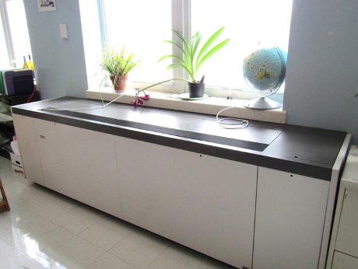
Typical classroom univent
Picture 2
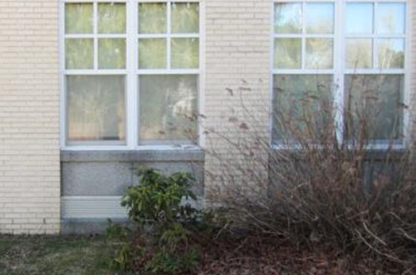
Univent fresh air intake (arrow), note plants next to vent
Picture 3
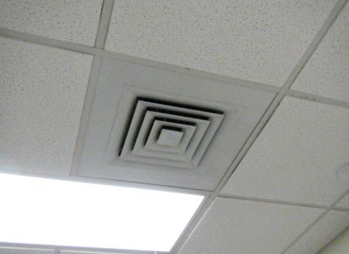
Typical supply vent
Picture 4
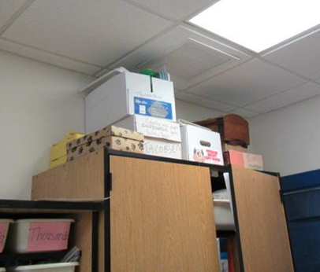
Typical exhaust vent (arrow)
Picture 5
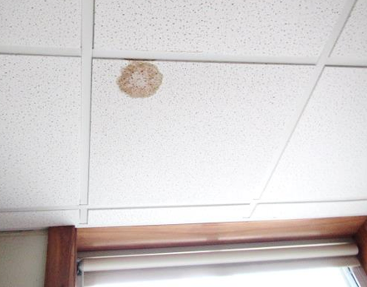
Water-damaged ceiling tile
Picture 6
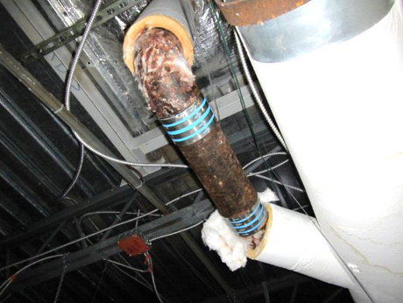
Leaks/condensation from elbow and unwrapped insulation
Picture 7
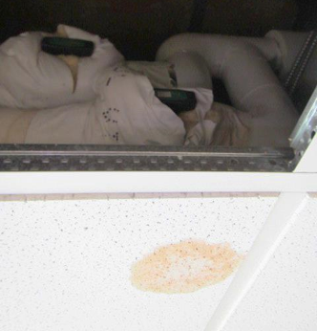
Water-damaged tile and wet insulation around valves above tile system in Room 129
Picture 8
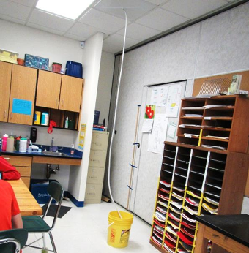
Water-collection ceiling tile and bucket
Picture 9
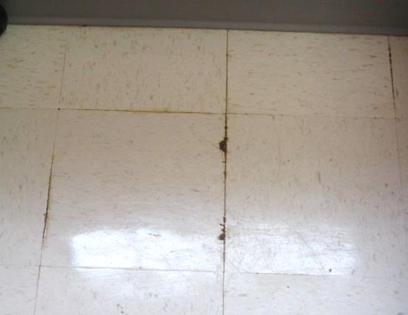
Floor tiles with evidence of chronic moistening
Picture 10
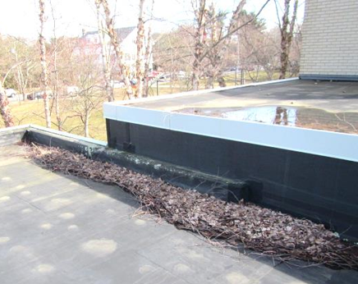
Water pooling on roof (upper right), roof joint and debris on roof
Picture 11
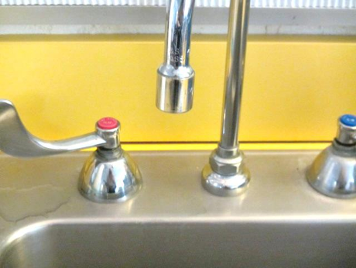
Gap between sink and backsplash
Picture 12
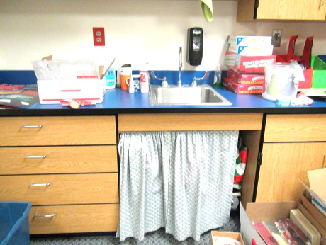
Sink with curtain creating a storage space (note accumulated items)
Picture 13
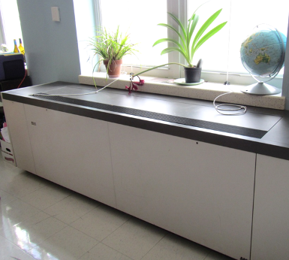
Plants next to univent
Picture 14
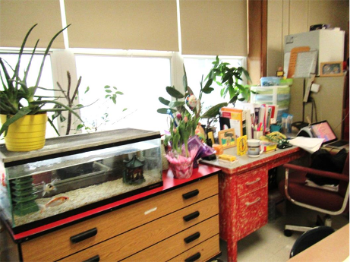
Plants, aquarium and accumulated items
Picture 15
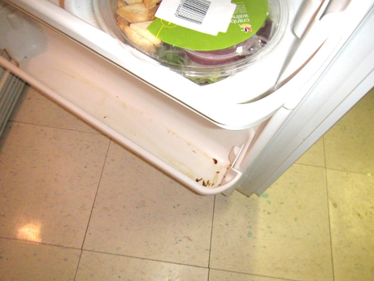
Stain/spill in refrigerator
Picture 16
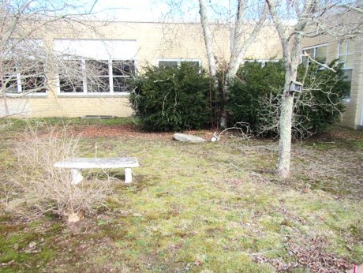
Trees and bushes in the courtyard
Picture 17
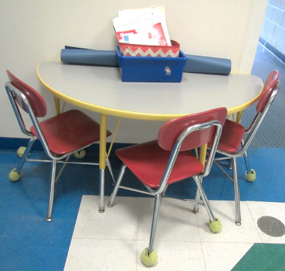
Tennis balls used as chair glides
Picture 18
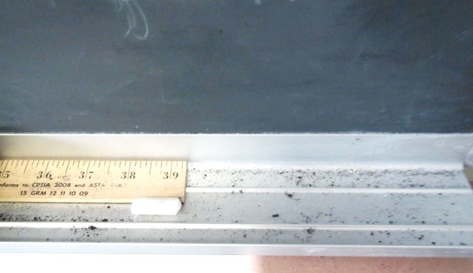
Chalk dust and whiteboard marker debris
Picture 19
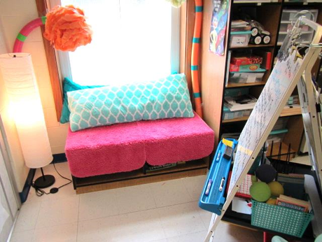
Plush items, pillows and other accumulated items

Location | Carbon  Dioxide  (ppm) | Carbon Monoxide  (ppm) | Temp  (°F) | Relative  Humidity  (%) | PM2.5  (µg/m³) | Occupants  in Room | Windows  Openable | Ventilation |  | Remarks
 |  |  |  |  |  |  |  | Supply | Exhaust
Background | 353 | 0.7 | 65 | 52 | 4 |  |  |  |  | Warm, cloudy, humid
Second Floor
201 | 903 | ND | 75 | 41 | 15 | 16 | Y | U UV on | Y | Area rug, PF
202 | 1157 | ND | 74 | 44 | 7 | 19 | Y | Y | Y | TB, plant, coffee, PF
203 | 1034 | ND | 76 | 42 | 33 | 19 | Y 1 open | Y UV on | Y | Area rug, MT, PS on UV, DEM, CP
203 - Town Hall Files |  |  |  |  |  |  | N | Y | Y | Opens into room 203, used to store town hall files
204 | 1453 | ND | 75 | 48 | 8 | 18 | Y | Y | Y | DO, feels stuffy/little air flow
206 | 795 | ND | 74 | 40 | 4 | 0 | Y | Y | Y
207 | 1108 | ND | 73 | 45 | 20 | 17 | Y | Y UV off | Y | Area rug, DO, TB, plant, DEM, CP, water-collecting ceiling tile
208 Computer | 463 | ND | 75 | 39 | 4 | 0 | Y | Y | Y | DEM, WD CT
209 | 513 | ND | 72 | 39 | 5 | 0 | Y | Y UV obst. | Y | TB, DEM, sink, movable wall to 207
210 | 685 | ND | 74 | 45 | 4 | 22 | Y open | Y | Y | TB, HS
211 | 630 | ND | 74 | 40 | 3 | 2 | Y | Y UV on | Y | TB, plants, DEM
212 | 810 | ND | 74 | 44 | 3 | 22 | Y | Y | Y | DO, TB, 1 WD CT-near exhaust vent
Conference Room C | 592 | ND | 75 | 41 | 8 | 2 | Y | Y | Y | Carpet, DO, DEM, HS, CP
Conference Room D | 533 | ND | 75 | 41 | 5 | 0 | N | Y | Y | 1 WD CT
Guidance | 1044 | ND | 74 | 44 | 3 | 1 | N | Y | Y | WD CT, carpet, DEM
Mezzanine | 747 | ND | 64 | 41 | 4 | 0 | N | Y | Y
OT | 848 | ND | 74 | 42 | 15 | 6 | N | Y | Y | DEM, rubber balls, DO, TB
Planning | 512 | ND | 75 | 38 | 6 | 0 | Y | Y | Y | DEM, carpet, PC, microwave, small fridge
Staff Restroom |  |  |  |  |  |  |  | Y | Y off or weak | CP, AF
Storage/MTS Room | 695 | ND | 73 | 45 | 3 | 0 | N | Y | Y | DEM, carpet
300 Block
Conference Room A | 1344 | ND | 67 | 63 | 4 | 3 | N | Y | Y
326 | 547 | ND | 74 | 42 | 4 | 0 | Y | Y | Y
327 | 550 | ND | 73 | 42 | 2 | 6 | Y | Y | Y
331 | 547 | ND | 73 | 41 | 2 | 0 | Y | Y | Y | WD CT
332 | 557 | ND | 73 | 42 | 2 | 0 | N | Y | Y | WD CT, DEM
333 | 526 | ND | 73 | 42 | 2 | 0 | N | Y | Y | DEM
334 | 539 | ND | 74 | 39 | 2 | 1 | N | Y | Y
335 | 516 | ND | 72 | 44 | 1 | 0 | Y | Y | Y | TB
First Floor
Art Storage |  |  |  |  |  |  |  | N | N | Art supplies
Assistant Principal Office | 752 | ND | 72 | 44 | 4 | 0 | Y | Y | Y | Plants
Assistant Principal/Bus Loop | 612 | ND | 72 | 41 | 9 | 0 | Y | Y | Y | Carpeted
Band | 716 | ND | 72 | 46 | 21 | 7 | Y and door | Y | Y | Area rug, instrument storage
Boiler room |  | ND |  |  |  |  | N
Cafeteria | 923 | ND | 71 | 46 | 34 | ~50 – 100 | Y and door | Y | Y | NC
Conference Room B | 659 | ND | 72 | 43 | 4 | 0 | N | Y | Y
Custodian’s Office | 748 | ND | 72 | 48 | 24 | 0 | N - door | Y | Y | Items and maintenance supplies
Early Childhood Office | 589 | ND | 72 | 39 | 5 | 0 | Y | Y | N | Carpet, HS, items on floor
ESC | 632 | ND | 73 | 40 | 22 | 0 | N | Y | Y | PC, carpet, DO
Faculty RR |  |  |  |  |  | 0 | N | Y | Y off or weak
Faculty Study | 781 | ND | 73 | 41 | 10 | 0 | N | Y | Y | Hospital bed, carpet, microwave, DEM, plush beanbags, DO
Gym | 711 | ND | 70 | 44 | 5 | 0 | N | Y | Y | 20 occupants just left
Gym Office/Storage |  |  |  |  |  |  |  | Y | Y
Head End Room (MDF) |  |  |  |  |  |  | N | N | N
Health Office | 841 | ND | 75 | 40 | 3 | 5 | N | Y | Y | PF
Kiln Room |  |  |  |  |  |  |  | Y | Y | Regular supply vent, switch-activated exhaust vent for kiln, used 10x a year
Library | 777 | ND | 72 | 38 | 10 | 1 | N | Y | Y | Skylight, carpet, books
Library Classroom | 823 | ND | 72 | 37 | 9 | 0 | N | Y | Y | Carpet
Library Office | 833 | ND | 72 | 37 | 16 | 0 | N | Y | Y | Carpet, AI, items under sink with curtain
Main Office | 789 | ND | 73 | 41 | 16 | 3 | Y | Y | Y | PC, NC, HS
More Gym Storage |  |  |  |  |  |  |  | N | N
Multipurpose Room | 718 | ND | 72 | 41 | 6 | 0 | N | Y | Y | NC – wood floor
Multipurpose Room Book Sale | 686 | ND | 71 | 40 | 6 | 15 | N | Y | Y | Books for sale, AT in ramp area
Music | 866 | ND | 71 | 47 | 12 | 20 | Y | Y | Y | Plant
Office (Gym) | 779 | ND | 69 | 47 | 7 | 0 | N | Y | Y
Office Files/Lunch | 854 | ND | 72 | 41 | 7 | 0 | N | Y | Y | Fridge, some spills, microwave
Physical Therapy | 478 | ND | 74 | 46 |  |  | Y | Y UV on | Y | DE, DEM, mats and balls
Planning | 587 | ND | 74 | 40 | 3 | 0 | Y | Y | Y | PC
Principal’s Office | 863 | ND | 72 | 40 | 4 | 1 | Y | Y | Y | Plant and dried/dead plant. HS
Ramp Room | 954 | ND | 73 | 43 | 13 | 0 some just left | N | Y | Y | Carpet, report of chronic leak – above ceiling tiles elbow or coupling may be leaking, bucket in ceiling
Staff Study | 611 | ND | 74 | 43 | 4 | 5 | N | Y | Y | PC, 2 laminators, DO, TB, carpet
Teacher’s Lounge | 502 | ND | 74 | 39 |  | 0 | N |  |  | Fridge
Teachers Dining | 808 | ND | 71 | 41 | 9 | 1 | Y | Y | Y | Microwave, thermostat – off, sink and small fridge
VASE | 519 | ND | 73 | 40 | 4 | 0 | Y | Y | Y
101 | 883 | ND | 74 | 42 | 8 | 15 just in | Y | Y UV off | Y | TB, HS, AI, DEM, toilet room
102 | 662 | ND | 74 | 41 | 2 | 0 | Y | Y | Y | Seal – window condensation, area rug and pillows
103 | 807 | ND | 73 | 42 | 9 | 16 | Y | Y UV on | Y | TB, area rugs, DEM, HS, toilet room - odor
104 | 662 | ND | 73 | 43 | 2 | 0 | Y | Y off | Y | UV deactivated
105 | 839 | ND | 73 | 43 | 16 | 17 | Y | Y UV | Y | DO, HS, toilet room
106 | 754 | ND | 72 | 43 | 3 | 0 | N | Y | Y | Carpet
107 | 740 | ND | 72 | 45 | 13 | 14 | Y | Y UV on | Y | Area rugs, TB, DEM, toilet room
108 | 487 | ND | 72 | 38 | 5 | 0 | N | Y | Y
109 | 1366 | ND | 73 | 46 | 33 | 14 | Y | Y UV off | Y | Area rug, HS, toys, plants, toilet room
111 | 704 | ND | 72 | 44 | 7 | 0 | Y | Y | Y on | Shrub outside univent, TB
112 | 578 | ND | 71 | 48 | 2 | 0 | Y | Y | Y on
114 | 997 | ND | 71 | 50 | 13 | 9 | Y | Y off | Y off
115 | 763 | ND | 72 | 47 | 2 | 4 | Y | Y | Y off
116 | 910 | ND | 72 | 40 | 3 | 5 | Y | Y | Y
117 | 958 | ND | 71 | 44 | 5 | 7 | Y | Y off | Y
118 | 1174 | ND | 71 | 46 | 7 | 20 | Y | Y off | Y | DO, area rug
118 Storage Closet | 1074 | ND | 71 | 44 | 5 | 0 | N | N | N
119 | 860 | ND | 73 | 42 | 2 | 4 | Y | Y UV |  | Aqua and plants, DEM, area rug, AP, black particles reported on items overnight
120 | 1267 | ND | 72 | 44 | 29 | 15 | Y | Y UV off | Y | Area rug, TB, space between sink/countertop
121 | 1412 | ND | 72 | 46 | 9 | 20 | Y | Y off | Y | TB, exhaust near classroom door, area rug, DO
122 | 1041 | ND | 73 | 43 | 4 | 0 | Y | Y | Y | TB, space between sink/countertop
123 | 745 | ND | 72 | 42 | 3 | 1 | Y | Y off | Y | Pillows/cushions
124 | 983 | ND | 72 | 42 | 3 | 0 | Y | Y UV | Y | CP or AF odor, area rug, AI
125 | 770 | ND | 73 | 43 | 3 | 0 | Y | Y | Y | Pillows/cushions
126 | 578 | ND | 71 | 41 | 1 | 0 | Y | Y UV on | Y | Area rug, fridge, movable wall to 128
127 | 1017 | ND | 72 | 44 | 7 | 0 | Y | Y UV off | Y | Plush items, area rugs, aqua, TB, minty scent/AF, plants, DEM
128 | 530 | ND | 71 | 41 | 3 | 0 | Y | Y UV | Y | Area rug, plush items, DEM
129 | 862 | ND | 73 | 43 | 3 | 9 | Y | Y | Y | TB, WD CT, DEM, area rug, leaking valve above ceiling
130 | 661 | ND | 71 | 41 | 5 | 0 | Y | Y UV on | Y | Area rug, HS
131 | 796 | ND | 72 | 42 | 3 | 0 | Y | Y UV on | Y | DEM, AI, TB, area rug
135 | 685 | ND | 72 | 44 | 4 | 1 | Y | Y | Y | UV off, area rugs
137 | 557 | ND | 72 | 43 | 7 | 0 | Y | Y | Y | Fridge, sink, DEM
138 | 591 | ND | 72 | 43 | 5 | 0 | Y | Y | Y | UV off
139 Art | 1064 | ND | 73 | 46 | 18 | 21 | 4 | Y UV on | Y | DEM, area rug, 3 sinks, art supplies
140 | 671 | ND | 71 | 40 | 4 | 0 | Y | Y | Y

