Helping Youth Become

the Drivers of Their Own

College and Career Readiness Success:

Nature, Promise, and Implementation Recommendations for Supporting Districts

to Adopt Individual Learning Plans

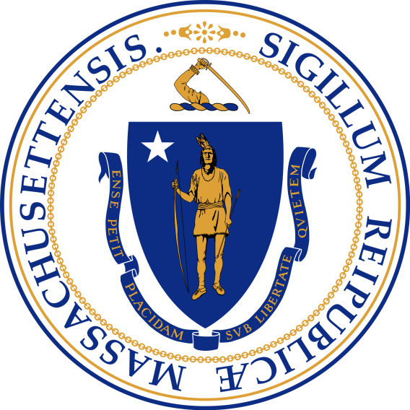

Report and Recommendations of the
Advisory Committee Studying
The Development and Implementation
Of Six-Year Career Plans

December 2016

TABLE OF CONTENTS
LETTER FROM SECRETARY OF EDUCATION | 3
ADVISORY COMMITTEE | 4
EXECUTIVE SUMMARY | 5
BACKGROUND | 9
THE VALUE OF INDIVIDUAL LEARNING PLANS | 14
NATIONAL EXAMPLES OF INDIVIDUAL LEARNING PLAN IMPLEMENTATION  CURRENT POLICIES AND ADOPTION OF ILPs IN MASSACHUSETTS | 17  18
RECOMMENDATIONS | 21
CONCLUSION | 24
ACKNOWLEDGEMENTS | 25
REFERENCES | 26

LETTER FROM SECRETARY OF THE
EXECUTIVE OFFICE OF EDUCATION

Members of the General Court:

I am pleased to present Helping Youth Become the Drivers of Their Own College and Career Readiness Success: Nature, Promise, and Implementation Recommendations for Supporting Districts to Adopt Individual Learning Plans.

The report, pursuant to Chapter 449 of the Acts of 2014, emanates from the extensive work of a state-wide Advisory Committee of experts convened in December 2015 to study the efficacy of six-year career plans for all students across the Commonwealth.

I want to thank the Advisory Committee for their thorough investigation and, moreover, their diligence in providing a set of recommendations that advances the Executive Office of Education’s goal of post-secondary success for every child in the Commonwealth.

If you have questions about this report, please contact Blair Brown, Legislative Director, Executive Office of Education, at (617) 979-8351 or via email at Blair.Brown@massmail.state.ma.us.

Sincerely,

James Peyser
Secretary
Executive Office of Education

ADVISORY COMMITTEE
Thomas M. Graf, Chair
(Secretary of Education’s Designee)
Executive Director, Massachusetts Educational Financing Authority

Anne Berrigan
(Representing Secretary of Labor and Workforce Development)
Senior Program Manager, Youth Employment Initiatives

Jennifer Caccavale
(Representing New England Regional Office of the College Board)
Director of K-12 Services, The College Board

Katie Gray
(Representing Massachusetts School Counselors Association, Inc.)
Past President, MSCA

Lytania Mackey
(Representing Massachusetts Secondary School Administrators’ Association)
Assistant Principal, Swampscott High School

Jennifer J. McGuire
(Representing Massachusetts Association of Vocational Administrators, Inc.)

Teacher Leader for Guidance
School Counselor, Upper Cape Cod Regional Technical School

Erin M. Nosek, Ed.D
(Representing Massachusetts Association of School Superintendents, Inc.)
Superintendent, Tantasqua Regional & Union 61 School Districts

Erin Regan
(Representing New England Association for College Admission Counseling, Inc.)
School Counselor, Sharon High School

Paul Toner
(Representing Commissioner of Higher Education)
Member, Board of Higher Education

Paulette Van der Kloot
(Representing Massachusetts Association of School Committees, Inc.)
Medford School Committee, M.A.S.C. Division IX, Chair

Keith Westrich
(Representing Commissioner of Elementary and Secondary Education)
College & Career Readiness, Massachusetts Department of Elementary & Secondary Education

EXECUTIVE SUMMARY

Pursuant to Chapter 449 of the Acts of 2014, an Advisory Committee was convened in December 2015 by the Executive Office of Education. The Advisory Committee was tasked with “investigating and studying a development and implementation process for a 6-year career plan to be coordinated by licensed school counselors for all students in grades 6 to12…and, accordingly, make recommendations.” Section 3 of the Chapter named the 11 Advisory Committee members, as represented on the previous page.

This report describes the findings of the Advisory Committee regarding the nature and promise of engaging in 6-year career plans and identifies a set of recommendations to further the Commonwealth’s capacity to support school districts and schools in the development and implementation of 6-year career plans.

BACKGROUND AND CONTEXT: IMPLEMENTING THE INTEGRATION OF COLLEGE AND CAREER READINESS (ICCR) TASK FORCE RECOMMENDATIONS
In November 2011, the Board of Elementary and Secondary Education asked then-Board member Gerald Chertavian to chair a task force to develop recommendations on integrating college and career readiness to help all students become better prepared for post-secondary education and economically viable career pathways. The resulting Integration of College and Career Readiness (ICCR) Task Force Report was accepted by the Board on June 26, 2012, and the Department was charged with developing a plan for moving the report recommendations forward.

One of the recommendations in the ICCR Task Force Report was to “Improve the Utilization of School Counselors in Deployment of Career Readiness” through the implementation of Individual Learning Plans (ILPs) for grades 6-12 (nationally, 6-year career plans are referred to as ILPs). In addition, the report recommended that this task force be convened - Chapter 449 of the Acts of 2014 - in order to evaluate the nature and promise of implementing ILPs in Massachusetts. Though Massachusetts is recognized as one of 42 states invested in using ILPs, ILPs are not widely adopted throughout Massachusetts.

THE VALUE OF INDIVIDUAL LEARNING PLANS
Nationally, ILPs are being used as a key strategy for increasing engagement in career pathways, selecting rigorous high school courses, and engaging in post-secondary planning. Consistent with the goals described in a report by the Council of Chief State School Officers (CCSSO), ILPs provide a promising strategy for increasing the number of students who possess the college and career readiness skills needed to enter and successfully complete a two or four-year post-secondary credential, program, or degree.
As an instrument, ILPs store the results of student’s career interests, course-taking and post-secondary plans, and achievements in an ePortolio that is found in online career information systems.
As a process, ILPs enable students to define their career and life goals based on their unique pattern of interests, skills, and values. Once defined, ILPs facilitate students’ ability to align their high school courses and identify post-secondary pathways that enable them to pursue those goals.
Consistent with college and career readiness efforts underway in Massachusetts, quality ILP implementation provides students with access to intensive work-based learning opportunities (e.g., through paid internships, apprenticeships, summer jobs, etc.) and early college access in order to help youth pursue their career goals while gathering the experiences that will help them successfully enter and complete a post-secondary degree. With support from the Department of Elementary & Secondary Education (ESE), ILPs are gaining interest from Massachusetts school leaders and counselors.

ILPs raise the status and strengthen the role of school counselors (i.e., guidance counselors) by enabling them to become leaders in collaboration with special education and career and vocational education administrators to design whole-school implementation strategies and provide the professional development necessary to help educators and mentors inspire their students to pursue post-secondary pathways. As such, ILPs enable schools to demonstrate whether and how they are enabling all students to graduate with the career readiness skills needed to enable them to achieve their career and life goals.

ADVISORY COMMITTEE RECOMMENDATIONS
The four overarching recommendations from the Advisory Committee established under Chapter 449 of the Acts of 2014 include that the state’s educational system, in collaboration with related non-profits, institutes of higher education, and professional associations, should:
- Build Capacity For Implementing Six-Year Career Plans (ILPs) For Students In Grades 6-12 Across The Commonwealth
Private and/or philanthropic resources are needed to enable the Massachusetts School Counselors Association (MASCA), with support from the Massachusetts Department of Elementary and Secondary Education (ESE), to coordinate and lead a broad range of stakeholders to effectively implement ILPs. Specifically, efforts are needed to:
  - Create opportunities for cross-sector and cross-departmental collaboration to develop grade level goals and support the continuous improvement of ILP content and activities
- Create opportunities for cross-sector and cross-departmental collaboration to create an ILP implementation framework
- Create opportunities for cross-sector and cross-departmental collaboration to identify key inputs and measurable outcomes that demonstrate students’ readiness for college and career
- Identify key data points and a process to measure the impact of ILPs on student outcomes
- Create opportunities for cross-sector and cross-departmental collaboration to develop communication and marketing strategies and materials including a “toolkit” that provides local education agencies (LEAs) and other relevant organizations with the information and processes needed to effectively inform students, parents, teachers, business leaders, and community-based organizations about the value and nature of ILPs and ways they can be engaged in the ILP process
- Prioritize building understanding, outreach and adoption first in the districts that serve a significant number of economically disadvantaged students (i.e., Gateway Cities, Boston)

- Establish A No-Cost Single College And Career Planning Portal

The Advisory Committee recommends that the Commonwealth continue to provide free access to an online college and career planning portal and that existing systems are aligned into one integrated web-based portal for the 6-12 grade level population

The state’s college and career planning portal should include a comprehensive approach to planning for college and career, including:

- The capacity to capture student attainment of knowledge, skills, and experiences in all three college and career readiness domains - academic, personal/social, and workplace readiness
- The ability to seamlessly transfer information (e.g., student accounts) so that the account and/or data follows the student from school to school and grade to grade
- The enabling of key staff to monitor student accounts so that teachers and mentors are able to determine student engagement in the process and track student progress aligned to career and college goals

- Create And Expand Professional Development Opportunities for Quality ILP Implementation

- At the state level, a cross section of stakeholders including ESE, MASCA, Reach Higher, Massachusetts Business Alliance for Education (MBAE), and other related organizations should develop and expand in-service training for use by districts, schools. and professional associations focused on [but not limited to]:
  - Why ILPs are recommended
  - Strategies for leading a school-wide ILP implementation efforts, particularly efforts that include phases of implementation over multiple years
  - How to foster whole-school ILP implementation by incorporating career development activities into structured settings such as Advisory Periods
  - Strategies to be a successful advisor/advocate across multiple years
  - Strategies to engage family members in ILPs
  - Strategies to incorporate the ILP process into academic course work
  - Models for implementing ILPs with fidelity in school and community settings
- At the state level, a cross section of stakeholders including DESE, MASCA, Reach Higher, MBAE, and others should work with professional associations to ensure that schools can access ILP materials and in-service training opportunities through cost-effective dissemination strategies such as webinars, teleconferences, and online resource directories
- At the district or school level, properly trained building administrators and school counselors should form and co-lead an advisory committee comprised of representatives from higher education, workforce development, community organizations, and other appropriate stakeholders to guide the local ILP implementation initiative by:
  - Determining the implementation model best suited to each district or school
  - Coordinating/leading professional development for identified ILP educators (based on the bullets above) following a “train the trainer” model
  - Identifying and establishing opportunities for significant work-based learning opportunities for students with local employers with support from state funded support systems (e.g., Connecting Activities and Youth Works)
  - Providing ongoing support to ILP educators and a forum for feedback to facilitate continuous improvement
- In order to foster success of future educators and to benefit students, post-secondary institutions should be encouraged to consider establishing specific training requirements for administrators, teachers, and school counselors both before service and during service on how to implement ILPs with quality and fidelity
- Develop A New Naming Convention To Replace ILP
In order to avoid confusion with existing educational names, such as Individualized Education Programs, the Advisory Committee recommends that the ILPs naming convention is changed (e.g., Student Career and Academic Plans)

Helping Youth Become

the Drivers of Their Own

College and Career Readiness Success:

Nature, Promise, and Implementation

Recommendations for Supporting Districts

to Adopt Individual Learning Plans

BACKGROUND

In November 2011, the Board of Elementary and Secondary Education asked then-Board member Gerald Chertavian to chair a task force to develop recommendations on integrating college and career readiness to help all students become better prepared for post-secondary education and economically viable career pathways. The resulting Integration of College and Career Readiness (ICCR) Task Force Report was accepted by the Board on June 26, 2012, and the Department was charged with developing a plan for moving the report recommendations forward.

The ICCR Task Force felt strongly that:

Massachusetts must create a comprehensive state-wide system with structured, aligned, and strategic partnerships that support students’ fluid movement through elementary, secondary, and higher education into successful careers.

The ICCR Task Force recommended that efforts be made to “improve the utilization of school counselors in deployment of career readiness education” and specifically that these efforts ensure that “all students in Massachusetts produce career plans with school counselors to help identify their own pathways for a successful career.”

To further study this recommendation, Chapter 449 of the Acts of 2014 established an Advisory Committee that was convened in December 2015 by the Executive Office of Education. The Advisory Committee was tasked with “investigating and studying a development and implementation process for a 6-year career plan to be coordinated by licensed school counselors for all students in grades 6 to12…and, accordingly, make recommendations.” Section 3 of the Chapter named 11 Advisory Committee members (described above) to serve on the Advisory Committee.

The Advisory Committee studied the nature and promise of 6-year career plans, which are referred to nationally as Individual Learning Plans (ILPs). The nature of this study included the Advisory Committee learning about ILPs from the perspectives of school counselors, national researchers, and state leaders tasked with supporting district and school ILP implementation. What follows are the results of this study and recommendations for moving the Commonwealth forward in supporting our districts and schools in the implementation of ILPs. It was clear from the research that ILPs are contributing to the success of college and career readiness in several states.

COLLEGE AND CAREER READINESS INDICATORS IN MASSACHUSETTS
Among the concerns for the ICCR Task Force was that many students are unprepared to enter the world of work in large part due to not being prepared to enter and successfully complete a post-secondary degree, program, or credential.
The Commonwealth gathers data from each district and school and makes this data publically accessible through the District Analysis and Review Tool (DART). DART provides districts and schools with valuable information about school performance and student outcomes and enables them to annually evaluate whether their students are becoming prepared to enter and complete a post-secondary pathway.
The data indicates that within Massachusetts, high school graduation rates are strong but that the six-year college completion rate is low. The Commonwealth averages 87.3 percent for high school completion but has reached a six-year college completion rate of only 36 percent for 2008 high school graduates. The disaggregated picture also shows serious inequities in college completion rates for students from low-income families, specific racial/ethnic backgrounds, and students with disabilities.

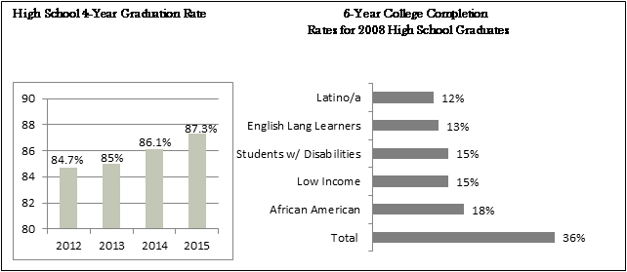

A number of data points may be used to determine whether and if high school students are becoming college and career ready such as MassCore completion rates (the Commonwealth’s recommended rigorous course of high school studies), participation in Advanced Placement (AP) courses, and Massachusetts Comprehensive Assessment System (MCAS) scores. It is interesting to note in the charts below the correlation of inequities in these data points with the results for six-year college completion noted above.

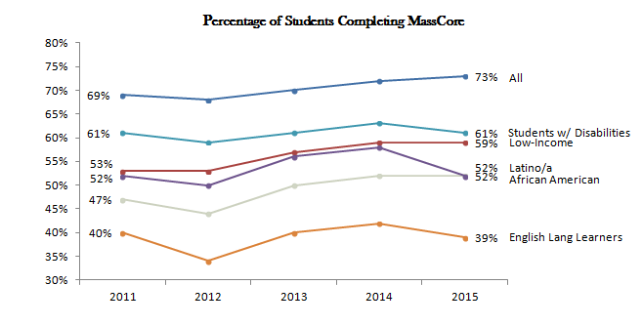

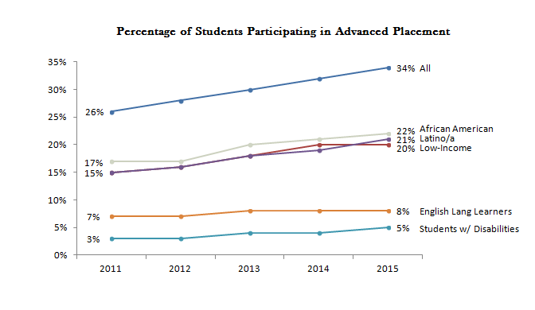

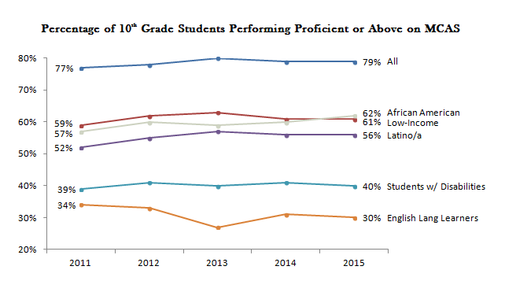

LOCAL AND NATIONAL EFFORTS IN COLLEGE AND CAREER READINESS

The Commonwealth of Massachusetts is making great strides in graduating youth from high school. Among the positive indicators include high school graduation rates, increases in the percentage of students participating in advanced placement, and some improvements in the number of student completions of MassCore.

Significant challenges remain nationally with respect to the percentage of entering 9th grade students who successfully matriculate into and complete a two or four-year post-secondary degree. Within Massachusetts, a little more than 1/3 of entering 9th grade students go on to complete a post-secondary degree or program; however, the percentages are far less for students who are African American, Latino/a, low-income, English language learners, and students with disabilities.

In Massachusetts, efforts to increase participation in advanced placement courses and the MassCore are important outgrowths of efforts to increase college readiness. College readiness is often indicated by standardized test scores that serve as an indicator of whether students possess the cognitive skills needed to enter and succeed in post-secondary education.

More recently, efforts have moved to focus on career readiness as a separate, complementary strategy for helping students become motivated to pursue post-secondary education. ILPs have emerged as a career readiness strategy that facilitates college readiness efforts by helping students and their families become invested and engaged in these efforts because they become aware of the meaningfulness and relevance of post-secondary education as the pathway to helping students pursue their career and life goals.

An important component of student career readiness education is the opportunity to explore potential careers through internship or apprenticeships opportunities. The Commonwealth supports two programs – Connecting Activities and YouthWorks - that aim to help high school students, particularly those students who are in traditional high schools and/or at-risk, participate and succeed in work-based learning opportunities.

While the Commonwealth has been making strides in advancing college and career readiness, the Council of Chief State School Officers (CCSSO) has also recommended that states invest in strategies that increase career readiness for all students. This affirmation was detailed in a major report from the CCSSO Career Readiness Task Force titled Opportunities and Options: Making Career Preparation Work for Students. The task force analyzed leading career preparation practices in the U.S. and abroad and identified specific policies states must adopt to dramatically improve the preparation of their high school graduates. ILPs were recognized as one strategy many states are using to support their career readiness efforts.

Ultimately, the CCSSO task force made policy and related implementation recommendations to states that will elevate and advance the career readiness of high school graduates. The three high-level recommendations in the report include:
Tony Evers, Wisconsin State Superintendent and Board President of the Council of Chief State School Officers, opened his 2016 State of the State address with the following story that captures the essence and impact of ILPs:

In Wisconsin, we are growing our approach to individual learning plans statewide. We’re calling them Academic and Career Plans. What always strikes me about the power of a student portfolio is the way these kids can’t help but completely take over the conversation about their own learning when looking at their portfolio. Lessly was no different, and it’s no secret why she was so proud. As we finished looking through her portfolio, she told me that she had secured over 95 thousand dollars in scholarships to attend a four-year college in Wisconsin due in large part to that portfolio. I wasn’t surprised because her art was fantastic, but there was a nagging question in my head, and I couldn’t help but ask it. “So what are you planning to do with that art degree after you graduate from college?” She looked at me with a straight face and said, “I’m not going to school for art! I’m going to be a biologist!” She went on to explain that the skills that made her a great artist would also make her a great biologist; the patience it took to get something right, the meticulous attention to detail, the creativity and tenacity and sensitivity she applied to these paintings and drawings were skills she could use in her journey toward this career, or frankly, any career.
As a state superintendent, what could be better than leaving a school visit knowing that? And it’s because of stories like these that I believe what we do at the state level can have a positive impact on a child’s life.

- Enlist the employer community as a lead partner in defining the pathways and skills most essential in today’s economy
- Set a higher bar for the quality of career preparation programs, enabling all students to earn a meaningful post-secondary degree or credential
- Make career readiness matter to schools and students by prioritizing it in accountability systems

As a result of the CCSSO task force’s work, JP Morgan Chase established a New Skills for Youth (NSFY) grant opportunity and through this opportunity Massachusetts was awarded a $100,000 planning grant in March 2016 to develop a career readiness action plan for the state. The grants are one piece of a $75 million, five-year initiative that JP Morgan Chase developed in partnership with the CCSSO and Advance CTE. The initiative is aimed at increasing economic opportunity for young people by strengthening career-focused education starting in high school and ending with post-secondary degrees or industry recognized credentials. The initiative is aimed at increasing economic opportunity for young people by strengthening career-focused education starting in high school and ending with post-secondary degrees or industry recognized credentials.

A major goal of the NSFY initiative is to improve career readiness efforts by dramatically increasing the number of students in the U.S. who participate in career pathways that culminate in post-secondary degrees or industry-recognized credentials aligned with labor market need. NSFY defines a high-quality career pathway as a structured learning experience that has all of the following elements:

- Blends rigorous core academics and career-technical instruction
- Offers focused career guidance and advisement systems
- Includes high-quality work-based learning experiences
- Spans secondary and post-secondary levels
- Culminates in post-secondary or industry credentials with labor market value

THE VALUE OF INDIVIDUAL LEARNING PLANS
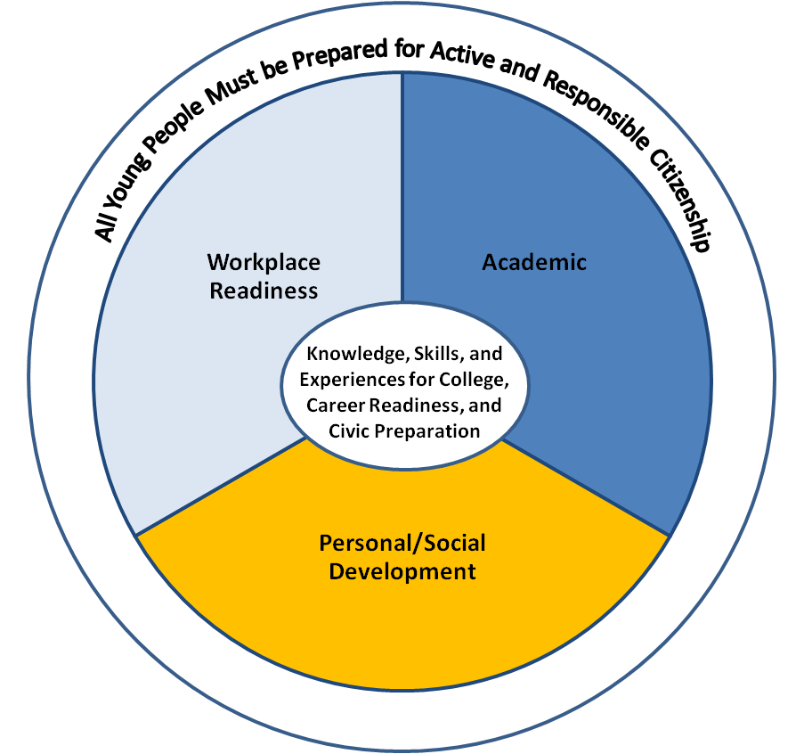
Though Massachusetts is recognized as one of 42 states invested in using Individual Learning Plans ILPs, ILPs are not widely used throughout the Commonwealth. Massachusetts defines ILPs as a multi-year, dynamic tool that enables students to become self-directed learners that seek the academic planning, social-emotional growth, and workforce development experiences necessary to enter and complete a post-secondary credential or degree in order to successfully pursue their career and life goals.
The ILP is intended for ALL students beginning in sixth grade and can be thought of as both an instrument and a process to engage students in planning while simultaneously deepening their understanding of the relevance of course selections and learning opportunities (in and out of school) aligned with their career interests, post-secondary education/training, and attainment of career and life goals.

As an instrument, ILP activities provide a place to organize and record progress related to academic, personal/social, and workplace readiness experiences. As a process, ILP activities encourage students to identify career goals that are based on individual interests and strengths while identifying the learning experiences necessary to achieve those goals. The ILP process promotes relevant communication among students, school staff, parents, and other influential adults. The ILP process also supports school and district improvement efforts to be responsive to students’ interests and needs.
- The ILP is student-driven: the student’s self-defined goals and unique interests guide the plan for academic, personal/social, and workplace readiness skill attainment.
- Every student has at least one key adult (i.e. mentor) on the school staff, typically referred to as his or her school mentor to encourage, support, and guide ILP progression.
- Short- and long-term goal setting is included and is based on the student’s self-identified interests and strengths.
- The school or district selects at least one system (online and/or paper) as the instrument(s) to track the student’s ILP development over time.
- Professional development provides staff with clear objectives, role definitions, and strategies to ensure appropriate and successful supports to students and to promote quality school-wide implementation.
The ILP process is designed to empower students to take responsibility for their future. It engages students in career development activities that enable them to identify personal strengths and weaknesses and set short- and long-term goals to achieve academic, social-emotional, and workplace readiness knowledge and skills necessary for future success.
RESEARCH INVESTIGATING THE NATURE AND PROMISE OF INDIVIDUAL LEARNING PLANS
In order to determine that ILPs serve as a promising strategy for improving college and career readiness outcomes and to identify recommendations for building capacity among Massachusetts districts and schools to implement ILPs effectively, the Advisory Committee examined results from a national multi-method, multi-study of 14 schools in four states as well as a comparative case study of ILP implementation experiences in 13 states. Throughout the four years of research, the multi-method, multi-study included surveys, interviews, and focus groups with students, teachers, and parents. The research findings were further supported through interviews from state and district leaders in 13 states that were found to be highly invested in statewide implementation. The resulting comparative case study offered a number of recommendations that states are using to guide their state-wide implementation efforts. One feature of the research was a focus on understanding the experiences of all students, including those with disabilities. The results and most of the quotes were drawn from the results of this research.

With regard to the nature of ILPs, the research found that quality ILP implementation:

- Begins in middle school and continues through and beyond high school graduation
- Includes using web-based career information systems that incorporate ILPs as an ePortfolio. An ePortfolio is a feature often found in online career information systems that allows the student to catalogue, store, and share various ILP and career development activities
- Includes family engagement activities
- Incorporates quality career development opportunities that include: (a) self-exploration of interests, values, and skills; (b) career exploration of various career options and the post-secondary pathways needed to reach those careers; (c) developing career planning and management skills; and, (d) engaging in work-based learning and developing career readiness skills (e.g., social-emotional learning, soft skills, leadership skills, etc.).
- Promotes personalized learning by: (a) using a whole-school strategy by using advisory periods in the weekly class schedule to allow time for ILP activities; and (b) ensuring that students have at least one adult advisor they stay with throughout middle school and high school, respectively.

STUDENTS WITH DISABILITIES
Upon initial reflection, for youth with disabilities, ILPs appear very similar to the Transition Planning Form section of students’ Individualized Education Programs (IEPs). Whereas the IEP occurs annually following federal standards, ILPs occur throughout the academic year and focus on helping youth and their families become more engaged in the design and implementation of their career and life goals.

Students with Disabilities Should Participate in ILPs
[ILPs] gives student with disabilities direction for completing high school and creates awareness that college is an option. It gives teachers a reference point for students’ progress toward career goals.

District Official, Kentucky

- In most states, ILPs apply to all students. Some states, however, excuse students with significant disabilities from engaging in ILP activities because assessment tools and ILP activities are perceived as inaccessible to these students. However, students with significant disabilities may benefit from career development education as it can help students think about and understand the workplace setting in which they prefer to work.
- Most states develop clear policy guidelines that describe the connection between ILPs and IEPs:
  - Kentucky offers the strongest language whereby they indicate that information in the Transition Planning Form must first be evident in the ILP. In this way, the Transition Planning Form meeting focuses on the accommodations necessary to support the goals and career development activities the youth and their family have selected as a result of the ILP process.
  - South Carolina describes how the ILP informs the development of the Transition Planning Form.
ILPs are a Promising Strategy for Students with Disabilities When:
- General and special education officials and educators work together to ensure accessibility of ILP resources and activities;
- ILP implementation begins in middle school and engages families in the process so that students and families can be stronger advocates in designing the transition plan section of their IEP and in having the accommodations they view as necessary to achieving future career goals put in place; and
- Staff responsible for ILPs and IEPs collaborate and are equipped with knowledge and skills to assist students in developing goals and identifying skills, interests, and accommodation-related needs in both plans.

IMPACT OF CAREER READINESS ON COLLEGE READINESS

ILPs facilitate the development of the career readiness component of the Commonwealth’s goal of college and career readiness for every student.
- The research found that “career readiness drives college readiness” by empowering youth to direct their own lives by seeking learning opportunities in school and in their community that match their identified career interests and enable them to pursue their career and life goals.
- Correlational data demonstrates a pathway between youth having access to quality ILP experiences and key academic, social, emotional, and college- and career-ready outcomes. This figure was created based on the results to provide a visual path for how engaging in ILPs is associated with the development of three key social-emotional learning skills – goal setting, motivation to attend school because it is deemed meaningful, and academic self-efficacy. The combination of these social-emotional learning skills drive students to select appropriate coursework and improve grades, successfully manage stress and health concerns, and be prepared to engage in career decision-making.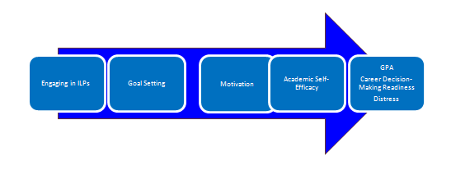
- ILPs support students becoming career ready by helping them identify clear career goals, describe key characteristics about the career tasks and activities, identify post-secondary pathways to achieve these goals, and describe in- and out-of-school experiences related to further explore the nature of these careers.
- The results also found that access to caring and encouraging adults (both in school and family) are important factors in supporting students to become career ready.

NATIONAL EXAMPLES OF INDIVIDUAL LEARNING PLAN IMPLEMENTATION

Several states have developed best practices for ILP implementation, and efforts continue to develop and expand the range of resources and materials to support quality implementation. A snapshot of ILP utilization across the country follows.

- South Carolina refers to ILPs as individual graduation plans (IGPs) and as a state has invested significantly by placing a career specialist in each high school and engaged the employer community to offer work-based learning opportunities. In Massachusetts, the one system for supporting work-based learning for high school students is referred to as Connecting Activities, which is a program operated by the Department of Elementary and Secondary Education.
First [ILP activities] show them certain job opportunities that fall within what some of their results are right now for projected career paths… [the teacher] works hand in hand with the students and the parents as they help map out their curriculum, making sure that for those projected paths their courses that they need to take for those are covered. It is not just where they look at them as 8th grade freshmen… it’s an ongoing process you know that just keeps evolving and pushing them towards what their goals are. I think it works really well. It gives them something to follow. It gives them something that they can change also, you know if there is a progression in their academics. So it’s not a concrete plan either; it is very flexible.
Wisconsin Parent
- Kentucky uses the term ILP and has worked with their state career system vendor to develop a wide range of professional development and communication materials.

- Wisconsin refers to ILPs as Academic and Career Plans and has invested significantly in creating a website with extensive resources to support ILP implementation. Wisconsin generated these resources by convening a cross-sector team of personnel and leaders representing state and local education representing school counseling, special education, career and technical education, workforce development, parent advocacy groups, and higher education. Prior to launching ILPs, the state spent two years developing communication materials that describe the nature and value of ILPs for a wide range of audiences and generated a wide range of implementation tools for districts and schools and convened a two-day professional development event where teams from schools met to learn about evidence-based practices and to develop their implementation plans.
- Colorado refers to ILPs as Individual Career and Academic Plans and has developed a website of materials to support districts that complements many of the areas articulated in the Wisconsin site.
- Arizona refers to ILPs as Education and Career Action Plans. In addition to developing a website of resources, Arizona has created a step-by-step administrative guide for districts and schools to use in designing their ILP implementation strategy. Their website also provides links to district efforts including outcome data on school performance since implementing ILPs, scope and sequence materials that districts are using to articulate grade level ILP activities, and communication materials that are in both English and Spanish.

CURRENT POLICIES AND ADOPTION OF ILPS IN MASSACHUSETTS

In Massachusetts, the ILP process is shaped by the Career Development Education (CDE) Guide and Glossary as including three stages of development: career awareness, career exploration, and career immersion. Each stage identifies CDE activities supporting students’ movement from the cognitive to experiential as they explore career pathways:

- Career Awareness: students learn about the multiple career options available and the educational steps needed to prepare for the desired career and the ways that people shape their career paths. This stage may happen in the classroom, on field trips, after school, or in summer enrichment experiences.
- Career Exploration: once students identify their areas of interest, they can learn more about specific career options through career development courses, job shadowing opportunities, workshops on resume writing or interviewing skills, informational interviews with someone in the field of interest, or a career-related research project.
- Career Immersion: the activities in this stage allow students to participate directly in career-related activities. Some of these activities could be a capstone project incorporating research along with reflections and other writing, career related clubs and after-school activities, community-based volunteer work, internships, summer jobs, or other intensive work-based learning placements.

Each stage of career development challenges the student to engage in activities designed to support his or her learning while making a more informed decision in choosing a career pathway. In doing so, the student is able to align academic learning with workplace readiness activities while attending to social-emotional development in order to graduate college and career ready.

With support from the Department of Elementary & Secondary Education (ESE), ILPs are gaining interest from Massachusetts school leaders and counselors.

In May 2016, ESE held an ILP Workshop to expand the exposure and provide assistance to any school or district seeking information about ILPs. Forty-three districts were represented at that event. Also, ESE in collaboration with the Massachusetts Institute for College and Career Readiness (MICCR) is supporting ILP implementation in nine districts located in Gateway Communities. ESE has delivered presentations to 15 districts as well as provided individual workshops embedded in several statewide convening(s) such as Connecting Activities, Special Education, and Career Vocational Technical Education Leadership meetings. Finally, the Boston Public Schools is preparing to implement ILPs in their middle and high schools.

EXAMPLE: BARNSTABLE PUBLIC SCHOOLS (BARNSTABLE)

Barnstable is receiving support from MICCR to implement ILPs as part of their college and career efforts. Using a project management system, Barnstable is undergoing a multi-year implementation process. Year one was identified as the pilot year with implementation beginning in the Alternative Learning Program. There were challenges to the start-up including access to technology, staff buy-in, budget issues, and time in the student schedule. The implementation team had to identify why they wanted to do ILP(s), who they needed to have on board to support the effort, take inventory of what they had and what they needed, and choose an online platform for ILP development. Mitigating the challenges required using local and state data, building partnerships in-school and community-wide, and connecting with institutions of higher learning. Year two will see expansion of this work into the 8th grade which is part of the high school.

ILP ALIGNMENT WITH OTHER PERSONALIZED STUDENT PLANS IN MASSACHUSETTS

Schools in the Commonwealth utilize a number of tools to track students’ progress on college and career indicators. ILPs work well with them, including:

- Education Proficiency Plans (EPPs): For students scoring below 240 but above 220 on their 10th grade MCAS standardized test, an EPP is developed to document the course to be taken and the assessment to be used to ensure the student meets the requirements for graduation. Because districts may select their own format for this documentation, the ILP can be the vehicle to record the steps towards successful completion of the Competency Determination (CD). ILPs align well and should engage students in designing and successfully completing their EPP.
- Career Plans: For students participating in career vocational technical education, ILPs are considered essentially comparable to the career plan specified in Chapter 74 of the Vocational Technical Education Regulations (603 CMR 4.03 (4) (d).
- Individualized Education Programs (IEPs) and Transitional Planning Form (TPF): For students with disabilities and who participate in an IEP, the ILP process supports the development of the state-mandated Transition Planning Form (TPF) that serves as the brainstorming phase in developing and annually updating the federally mandated transition plan for youth once they reach 14.
- Individual Student Success Plans (ISSPs): Chapter 69, Section 1I of the Massachusetts General Law directs districts to create ISSPs for any student scoring below Level II on the MCAS exam when 20% or more of their students score below Level II on MCAS exams. ILPs have the potential to fulfill and expand upon the requirements of the ISSP. Therefore, schools may consider using the ILP as the process and instrument to capture a student’s ISSP.
Additionally, there are a number of current initiatives and policies in place in the state that support quality implementation of ILPs. Examples of those policies and programs include:

- The newly revised MA Model for Comprehensive School Counseling Programs: This model proposes in its mission statement that the ultimate goal for school counselors is to have all students graduate college and career ready. To accomplish this, school counselors are to provide tiered interventions that: “a) Assist students in creating meaningful post-secondary plans and making informed decisions to reach their goal; b) Focus on integrating academic/ technical, personal/social, and employability competency development across all grade levels; c) Encourage participation in multiple career development activities with opportunities for feedback and reflection and d) Support the documentation of career development via an Individual Learning Plan [ILP] and/or a Portfolio.”
- Early Warning Indicator System: Schools that engage in quality ILP implementation are likely to have students who are more engaged and motivated to successfully complete their courses, which will decrease the number of students identified by the Massachusetts Early Warning System as being at risk for not meeting academic milestones throughout K-12 education and ultimately for not graduating from high school.

- MassCore: The Massachusetts High School Program of Studies (MassCore) is intended to help our state's high school graduates arrive at college or the workplace well prepared and reduce the number of students taking remedial courses in college. MassCore recommends a comprehensive set of subject area courses and units as well as other learning opportunities to complete before graduating from high school. By aligning course-taking to self-defined career goals, ILPs hold promise to increase the number of students, especially those from lower income backgrounds to embrace and complete the MassCore academic requirements needed to be eligible for competitive four-year colleges and universities.

- Social Emotional Learning (SEL): By facilitating students’ exploration and engagement in developing the personal and social skills needed to pursue their career and life goals, ILPs effectively engage students in positive youth development outcomes such as the SEL skills that have been promoted by CASEL.
There are also a number of initiatives, organizations, and collaborative efforts that align with ILP efforts. A sample of these is listed below:
- Executive Office of Education & STEM Advisory Council: Early College Career Pathway Working Group
- Executive Office of Labor and Workforce Development (EOLWD): Career Pathways initiative
- Department of Higher Education (DHE): Vision Project, College Participation Advisory Group, College Access Challenge Grants
- Department of Elementary and Secondary Education: School-to-Career Connecting Activities
- Department of Public Health (DPH): Youth Employment Safety Initiative
- Department of Transportation (DOT): Construction Career Days
- Division of Career Services (DCS): Mass CIS, WIA Youth Initiatives
- Massachusetts Business Alliance for Education (MBAE): Future Ready
- Massachusetts Educational Financing Authority (MEFA): YourPlanForTheFuture
- Rennie Center, MassINC and Boston University: Massachusetts Institute for College and Career Readiness (MICCR)
- Jobs for the Future (JFF): Pathways to Prosperity, Youth CareerConnect
- Commonwealth Corporation (CommCorp): YouthWorks, Signaling Success
- Contextualized Learning in Classroom and Community Settings: Contextual Learning Portal
- Massachusetts Reach Higher Campaign
RECOMMENDATIONS

In addition to examining the nature and promise of using 6-year career plans or ILPs, the Advisory Committee was tasked with recommending actions that will support quality ILP implementation by districts and schools throughout the Commonwealth. These recommendations were drawn from the comparative case study of 13 states engaged in ILPs and discussions the Advisory Committee held with state leaders about their implementation experience as well as the knowledge and experience of Advisory Committee members.

In order to ensure that all students graduate from high school with the skills needed to enter and complete a post-secondary program, degree, or credential or directly enter the world of work, the Advisory Committee recommends that the state’s educational system, as well as related non-profits, institutes of higher education, and professional associations, consider how they collectively can:

- Build Capacity For Implementing Six-Year Career Plans (ILPs) For Students In Grades 6-12 Across The Commonwealth
Private and or philanthropic resources are needed to enable the Massachusetts School Counselors Association (MASCA), with support from the Massachusetts Department of Elementary and Secondary Education (ESE), to coordinate and lead a broad range of stakeholders to effectively implement ILPs. Specifically, efforts are needed to:
- Create opportunities for cross-sector and cross-departmental collaboration to develop grade level goals and support the continuous improvement of ILP content and activities
- Create opportunities for cross-sector and cross-departmental collaboration to create an ILP implementation framework
- Create opportunities for cross-sector and cross-departmental collaboration to identify key inputs and measurable outcomes that demonstrate students’ readiness for college and career
- Identify key data points and a process to measure the impact of ILPs on student outcomes
- Create opportunities for cross-sector and cross-departmental collaboration to develop communication and marketing strategies and materials including a “toolkit” that provides local education agencies (LEAs) and other relevant organizations with the information and processes needed to effectively inform students, parents, teachers, business leaders, and community-based organizations about the value and nature of ILPs and ways they can be engaged in the ILP process
- Prioritize building understanding, outreach and adoption first in the districts that serve a significant number of economically disadvantaged students (i.e., Gateway Cities, Boston)

- Establish A No-Cost Single College And Career Planning Portal

The Advisory Committee recommends that the Commonwealth continue to provide free access to an online college and career planning portal and that existing systems are aligned into one integrated web-based portal for the 6-12 grade level population.

The state’s college and career planning portal should include a comprehensive approach to planning for college and career, including:

- The capacity to capture student attainment of knowledge, skills, and experiences in all three college and career readiness domains - academic, personal/social, and workplace readiness
- The ability to seamlessly transfer information (e.g., student accounts) so that the account and/or data follows the student from school to school and grade to grade
- The enabling of key staff to monitor student accounts so that teachers and mentors are able to determine student engagement in the process and track student progress aligned to career and college goals

- Create And Expand Professional Development Opportunities for Quality ILP Implementation

- At the state level, a cross section of stakeholders including ESE, MASCA, Reach Higher, Massachusetts Business Alliance for Education (MBAE), and other related organizations should develop and expand in-service training for use by districts, schools. and professional associations focused on [but not limited to]:
  - Why ILPs are recommended
  - Strategies for leading school-wide ILP implementation efforts, particularly efforts that include phases of implementation over multiple years
  - How to foster whole-school ILP implementation by incorporating career development activities into structured settings such as Advisory Periods
  - Strategies to be a successful advisor/advocate across multiple years
  - Strategies to engage family members in ILPs
  - Strategies to incorporate the ILP process into academic course work
  - Models for implementing ILPs with fidelity in school and community settings
- At the state level, a cross section of stakeholders including ESE, MASCA, Reach Higher, MBAE, and others should work with professional associations to ensure that schools can access ILP materials and in-service training opportunities through cost-effective dissemination strategies such as webinars, teleconferences, and online resource directories
- At the district or school level, properly trained building administrators and school counselors will form and co-lead an advisory committee comprised of representatives from higher education, workforce development, community organizations, and other appropriate stakeholders to guide the local ILP implementation initiative by:
  - Determining the implementation model best suited to each district or school
  - Coordinating/leading professional development for identified ILP educators (based on the bullets above) following a “train the trainer” model
  - Identifying and establishing significant work-based learning opportunities for students with local employers with support from state funded support systems (e.g., Connecting Activities and Youth Works)
  - Providing ongoing support to ILP educators and a forum for feedback to facilitate continuous improvement
- In order to foster success of future educators and to benefit students, post-secondary institutions should be encouraged to consider establishing specific training requirements for administrators, teachers, and school counselors both before service and during service on how to implement ILPs with quality and fidelity
- Develop A New Naming Convention To Replace ILP
- In order to avoid confusion with existing educational names, such as Individualized Education Programs, the Advisory Committee recommends that the ILPs naming convention is changed (e.g., Student Career and Academic Plans)

CONCLUSION

Success after high school – whether in post-secondary education or in the workplace – is dependent on students having a clear understanding of pathways for the careers in their area of interest. Students entering a credential program, including 2 or 4-year colleges, are at risk of spending unnecessary time and money on coursework that is not relevant or on coursework they did not take in high school, though it was available.

Therefore, the Advisory Committee finds that ILPs show tremendous promise to enable youth to become more active in seeking the learning opportunities needed to be college and career ready and that all students in the Commonwealth should have access and support to develop and maintain 6-year career plans. The Advisory Committee is confident that recommendations included in this report will help facilitate the achievement of that goal.

The value of ILPs is helping youth align their self-defined career and life goals to the academic courses and post-secondary pathways that will enable them to successfully pursue those goals. With that focus, the Advisory Committee also concludes that school counselors are best positioned within a school to serve as co-leaders to move a whole-school effort to implement ILPs and that this leadership role should be shared by special education and career and technical education administrators.

Successful implementation demands access to high quality online career information system technology. The Commonwealth is fortunate to have two systems accessible to schools at no charge, however, it is recommended that a blending of features between these systems is needed in order to ensure they are responsive to the varied needs of school counselors, educators, employers, and most importantly students and their families.

ILPs are also well aligned with supporting a range of college readiness efforts and personalized planning underway in various agencies. However, broad implementation of ILPs in schools across the state demands a number of collaborative efforts from a wide range of stakeholders both in and outside the education system. In order to achieve the capacity within the Commonwealth that is necessary to offer quality ILP implementation to all students, it is necessary for stakeholder organizations to work with the state’s institutes of higher education in order to design and offer career development before service and professional development opportunities for school counselors, educators, and youth service professionals working in and out of school settings.

Additionally, school leaders need access to regional labor market information as well as a connection to employers in order to define the career pathways needed to pursue in-demand careers. Students will also benefit from intensive work-based learning opportunities (e.g., summer jobs, internships) connected to their interests in order to help them learn about potential careers and develop the necessary skills and competencies.

The recommendations included in this report complement and build upon the tremendous college and career readiness efforts currently underway in the state, such as MassCore. With the implementation of the recommendations of this report, the Advisory Committee believes that the state’s system of preparing students for post-secondary opportunities will be even more robust.

ACKNOWLEDGEMENTS
The Advisory Committee would like to thank the following people and organizations for their time and insights into 6-Year Career Plans and ILPs:
- Massachusetts School Counselors Association
- Massachusetts Department of Elementary and Secondary Education
- National Collaborative on Workforce and Disability for Youth
- State Leaders Career Development Network
- Colleagues in state education agencies across the country, including:
  - Arizona Department of Education
  - Colorado Department of Education
  - Wisconsin Department of Education
Finally, the Advisory Committee wants to thank and acknowledge Drs. V. Scott Solberg and Judith Martin from Boston University for their work in authoring the report.

REFERENCES

Massachusetts Department of Elementary and Secondary Education. (2012). From cradle to career: Educating our students for lifelong success. Recommendation from the Massachusetts Board of Elementary and Secondary Education Task Force on Integrating College and Career Readiness. Retrieved from http://www.doe.mass.edu/ccr/ccrta/2012-06BESEReport.pdf
While Massachusetts continues to use the term “guidance counselors,” nationally states have adopted “school counselors” following National School Counseling Association standards.
Massachusetts Department of Elementary and Secondary Education. (2012). From cradle to career: Educating our students for lifelong success. Recommendation from the Massachusetts Board of Elementary and Secondary Education Task Force on Integrating College and Career Readiness. Retrieved from http://www.doe.mass.edu/ccr/ccrta/2012-06BESEReport.pdf
Massachusetts Department of Elementary and Secondary Education. (n.d.). District Analysis and Review Tools (DARTs). Retrieved from http://www.mass.gov/edu/government/departments-and-boards/ese/programs/accountability/tools-and-resources/district-analysis-review-and-assistance/dart-for-districts-and-dart-for-schools.html
Council of Chief State School Officers. (2014). Opportunities and Options: Making Career Preparation work for Students. A report of the CCSSO Task Force on Improving Career Readiness. Washington DC: CCSSO. Retrieved from https://careertech.org/sites/default/files/CCSSOTaskForceCareerReadiness120114.pdf
Council of Chief State School Officers (CCSSO). (2016). New Skills for Youth. Retrieved from http://www.ccsso.org/Resources/Programs/New_Skills_for_Youth.html
United States Department of Labor, Office of Disability Employment Policy. (n.d.). Individualized Learning Plans Across the U.S. Retrieved from https://www.dol.gov/odep/ilp/map/
Rennie Center for Education Research & Policy. (2011). Student Learning Plans: Supporting Every Student’s Transition to College and Career. Cambridge, MA: Rennie Center for Education Research & Policy. Retrieved from http://www.renniecenter.org/research/StudentLearningPlans.pdf
Solberg, V. S., Wills, J., Redmond, K., & Skaff, L. (2014). Use of Individualized Learning Plans: A Promising Practice for Driving College and Career Readiness Efforts: Findings and Recommendations from a Multi-Method, Multi-Study Effort. Washington, DC: National Collaborative on Workforce and Disability for Youth, Institute for Educational Leadership. Retrieved from http://www.ncwd-youth.info/use-of-individualized-learning-plans
Solberg, V. S., Wills, J., & Larson, M. (2013). Using Individualized Learning Plans to Produce College and Career Ready High School Graduates. Washington, DC: National Collaborative on Workforce and Disability for Youth, Institute for Educational Leadership. Retrieved from http://www.ncwd-youth.info/ilp/produce-college-and-career-ready-high-school-graduates
Kentucky Department of Education. (2015). IEP Guidance and Documents. Retrieved from http://education.ky.gov/specialed/excep/forms/Pages/IEP-Guidance-and-Documents.aspx
South Carolina Department of Education. (2013). IGP-IEP Conferences: Individual Graduation Plans for Students with Disabilities. Retrieved from https://ed.sc.gov/scdoe/includes/eeda/Pathways/documents/IGP-IEP-Guidelines.pdf
Solberg, V. S., Wills, J., Redmond, K., & Skaff, L.
Fraser, B., Solberg, V. S., Ali, Z., & Wheeler, K. (2013). Battling Poverty By Increasing Workforce Readiness: Understanding Career Development Processes Among Youth with Disabilities. Presented at the 2013 Annual Meeting of the American Educational Research Association, San Francisco.
South Carolina Department of Education Personal Pathways to Success. (n.d.). How EEDA Works for South Carolina. Retrieved from http://s3.amazonaws.com/PCRN/docs/DQI/SOUTH CAROLINA 2 How EEDA Works.pdf.
Kentucky Department of Education (2016). Individual Learning Plan. Retrieved from http://education.ky.gov/educational/ccadv/ilp/Pages/default.aspx
Wisconsin Department of Public Instruction (n.d.). Academic & Career Planning (ACP). Retrieved from http://dpi.wi.gov/acp.
Colorado Department of Education (2014). Individual Career and Academic Plan (ICAP). Retrieved from https://www.cde.state.co.us/postsecondary/icap
Arizona Department of Education (n.d.). ECAP – Education and Career Action Plan. Retrieved from http://www.azed.gov/ecap/
Arizona Department of Education (2015). ECAP Implementation Toolkit. Retrieved from http://www.azed.gov/ecap/ecap-implementation-toolkit/
Massachusetts Institute for College and Career Readiness (MICCR) is a collaboration between Boston University, MassINC Gateway Cities Innovation Institute, and the Rennie Center for Education Research & Policy and operates in close partnership with the Massachusetts Department of Elementary and Secondary Education. Created using a three-year grant from the U.S. Department of Education’s Institute for Education Sciences, MICCR works with 15 districts located in Gateway Communities. Retrieved from http://sites.bu.edu/miccr/
The 189th General Court of the Commonwealth of Massachusetts. (n.d.). Section 1l. Retrieved from http://www.mass.gov/legis/laws/mgl/69-1i.htm
Solberg, V. S., Wills, J., & Larson, M.

