Building Community Connections with Opioid Treatment Programs (OTPs) and Office-Based Addiction Treatment (OBAT) Programs
to Support your Residents
May 18, 2023

Webinar Overview

- Logistics and Invitation
- Why are we here?
- Panelist Remarks
- Open Discussion

Logistics for today’s webinar

  - All participants will be muted for today’s presentation.
  - Enter into the chat, your name, organization, and the number of people joining you today.
  - Utilize the chat feature for any questions you have; we’ll address questions at the end of the presentation.
  - Slides and the audio recording will be posted on the MA Department of Public Health (DPH) website.

Invitation

  - To be open, impacted, and changed by what you hear
  - Speak from your own personal experience, from the “I” perspective, rather than speaking generally for others
  - To demonstrate self-awareness regarding the amount of airtime we use and stay in balance with contributions made by other participants
  - If sharing a story, provide the headline version and only relevant details that support learning for the whole

Why are we here?

The mission of the MA DPH is to prevent illness, injury, and premature death; to ensure access to high quality public health and health care services; and to promote wellness and health equity for all people in the Commonwealth.

Problem statement: Observed variability in discharge options, facility capacity or comfort to care for residents with opioid use disorder (OUD) paired with
  - Negative outcomes for non-compliance: DPH and Centers for Medicare & Medicaid Services (CMS) citations, and Office of Inspector General (OIG) fines
Solution: MOUD in long-term care (LTC) initiative
  - Goal is to improve care coordination and services for residents with OUD on MOUD within long-term care facilities
  - Shared a commitment to equity in healthcare

MOUD in LTC Toolkit can be found at: https://www.mass.gov/info-details/the-care-of-residents-with-opioid-stimulant-use-disorders-in-long-term-care-settings-toolkit

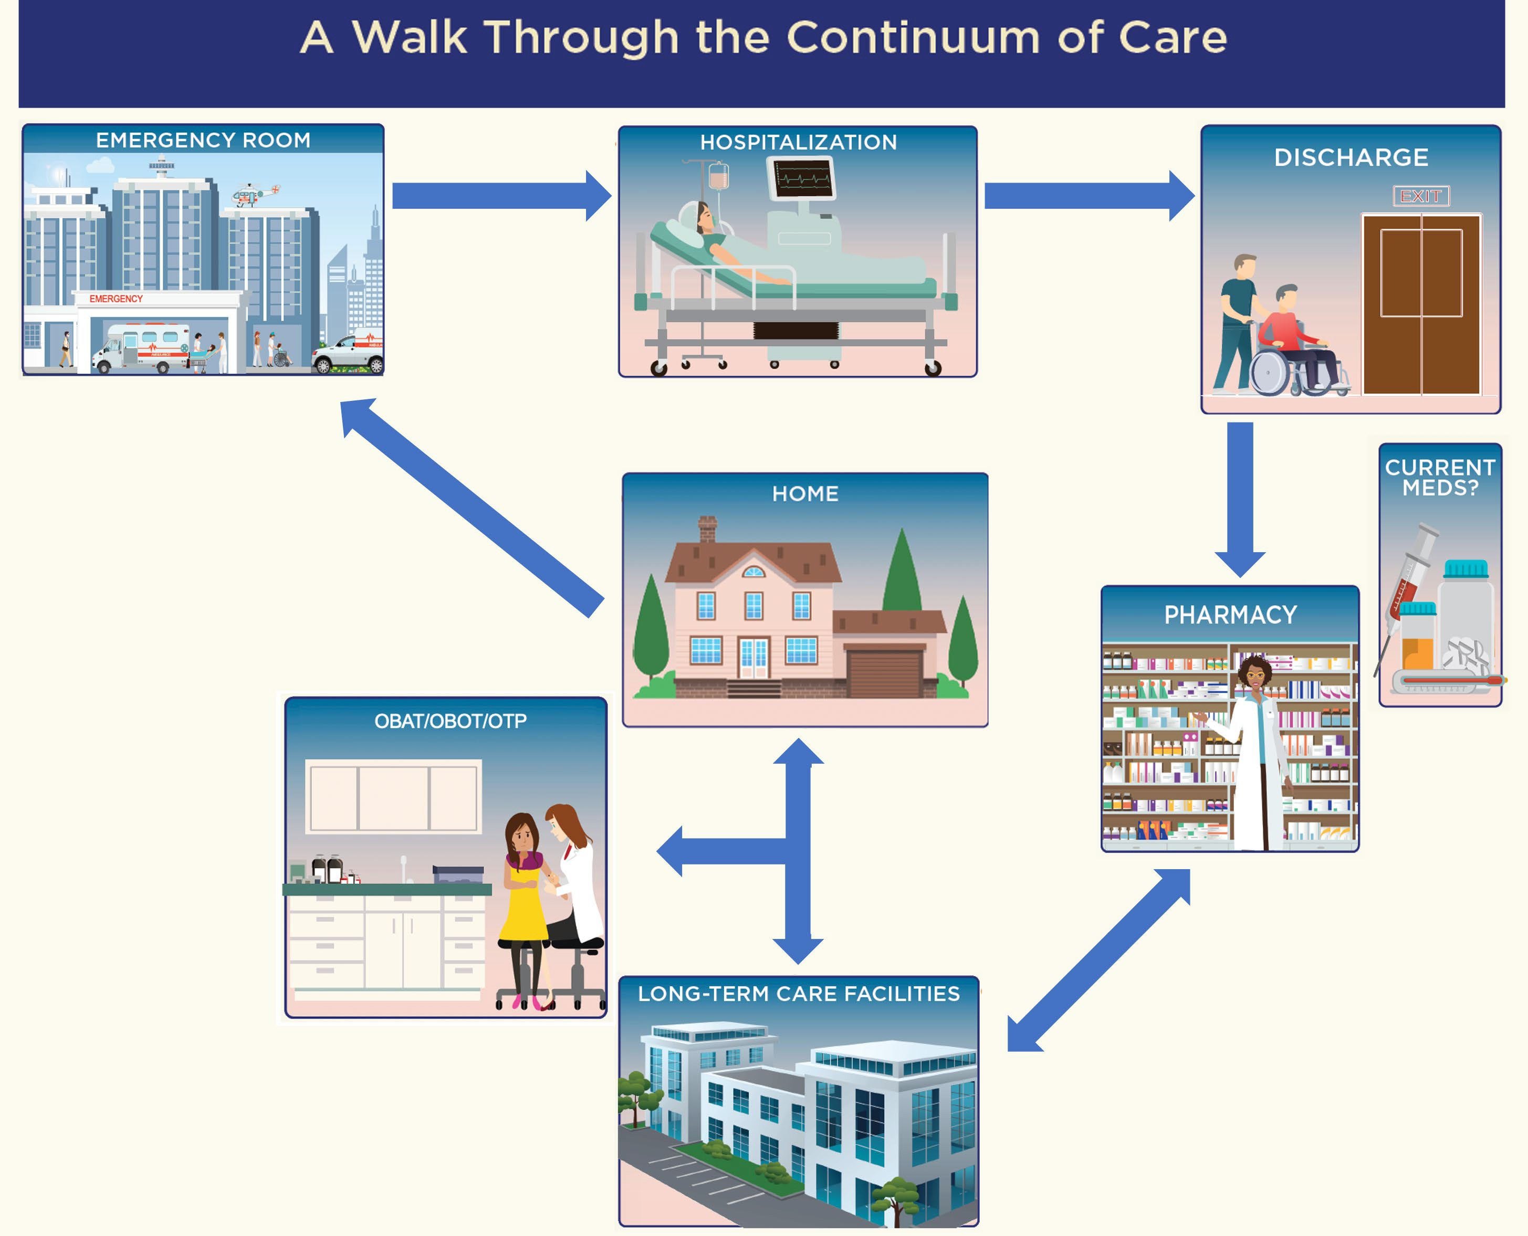

A Walk through the Continuum

Outpatient program that provides services to treat and manage OUD in a clinical setting.
Only entity federally certified and licensed to dispense methadone for the treatment of OUD.

OTP

May dispense or administer other medications, including buprenorphine, buprenorphine/naloxone, or naltrexone onsite.
Opioid Treatment Program
Generally administers medication on- site but can provide take-home medication (pre-poured doses) on a case-by-case basis.

Outpatient treatment program in which specific primary care or general health care practitioners are permitted to administer or prescribe certain medications for OUD.
Prescribe buprenorphine, or naloxone as take-home prescriptions and administer naltrexone on-site.

OBAT

Required to provide integrated emotional, social, and behavioral health services, if they are licensed by BSAS.
Office-Based Addiction Treatment Programs in MA
If not licensed by BSAS, they are strongly encouraged to refer patients to relevant resources or medical sub-specialties, as needed.

OTPs and OBATs

It is important to establish a clear understanding of the LTC facility’s relationship with the OTP or OBAT upon admission of a resident with OUD

Welcome to our Panelist Discussion
Massachusetts Department of Public Health | mass.gov/dph

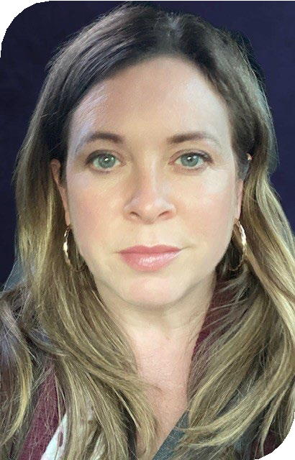
Nancy Regan, MSN, FNP, CNM, CARN-AP
Clinical Nurse Educator
Grayken Center for Addiction Boston Medical Center

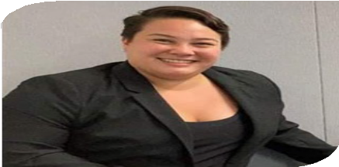
Matthew N Davis, MA MLADC LMHC Regional Vice President, Northeast Region Acadia Healthcare

Jennifer Miller
State Opioid Response, Program Manager MDPH BSAS

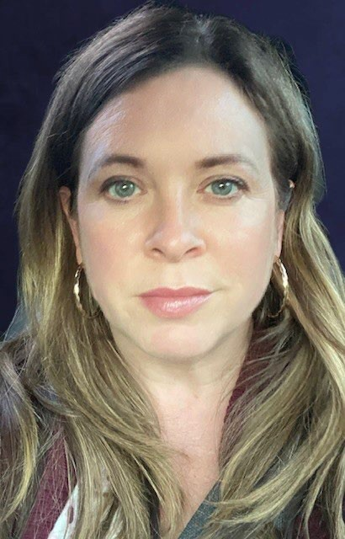

Office-Based Addiction Treatment Program
Nancy Regan, MSN, FNP, CNM, CARN-AP
Clinical Nurse Educator
Grayken Center for Addiction Boston Medical Center

Opioid Treatment Programs Matthew N. Davis, MA, MLADC, LMHC Regional Vice President
Northeast Region, Acadia Healthcare

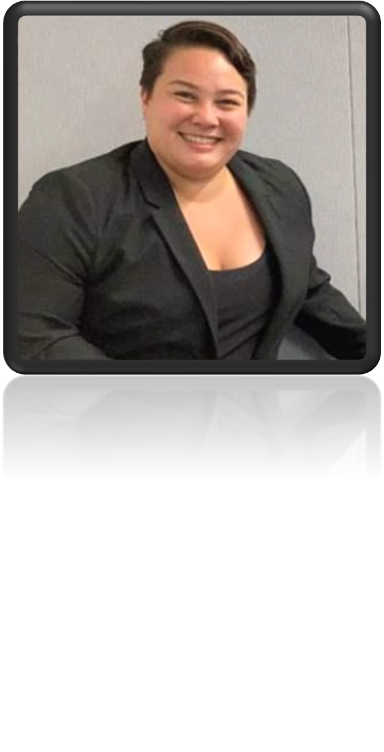
Bureau of Substance Addiction Services Jennifer Miller
State Opioid Response, Program Manager

Discussion

Upcoming Events

Collaborating on the Care of Residents with Substance Use Disorders
- June 27th (9am-3pm) – In-person Conference at the DCU Center
- Registration is at 8:30 am
- Discounted parking at Major Taylor Parking Garage (with validation at registration desk)
- Complimentary continental breakfast and lunch
- Register at: https://lp.constantcontactpages.com/sv/Gu1Ig2A

Individualized coaching is available, please reach out to MOUD2@abtassoc.com

