Slot Management:

Flex Pool, Age up, Contract Activity Reports

- Slot Management Overview

- Flex Pool

- Age Up

- Contract Activity Reports

- Common Issues & Questions

- Q&A

2

- Applies to contract placements only which were awarded to
providers through a competitive process

- The number of hours are based on the authorization (full/part time)
  - Full time placement= one slot, includes SA intermittent
    - Up to 50 hours = full time
  - Part time placement= half a slot
    - Up to 30 hours = half time
  - See chart on slide 6 for additional guidance

- Types of Contract slots:
  - Regular: Supportive, Income Eligible, Teen and Homeless
  - QRIS: If awarded, available for providers with a QRIS level of 2 or above
  - IE Flex: For age up and DCF continuity within the same umbrella
    - Teen parent and Homeless contracts do not have flex pool
  - Expansion: Supportive (DCF) placements only 3

CCFA analyzes slot utilization daily and will balance the
slots by automatically aging up any children
  - If there are no slots available, CCFA will place that child in flex pool up to 5% above the contract award
  - If the contract is over utilized, the provider will receive a notification on the CCFA dashboard

Slots utilized by SA children should not be split for both CBC and FCC over 2

- There are validations that occur when the subsidy administrator enters the placement
  - CCFA looks at the entire placement time period and checks to see if there is an available slot and if you are under 5% FLEX. If no slots are available:
    - For reassessment the child is placed in Flex
    - If the placement is for a new authorization, or you are at 5% Flex, you are prevented from completing the placement except for a DCF child transitioning to IE

Unlike the legacy system, CCFA manages slot allocation and flex/expansion

At the time of placement, the slot check determines if there is a slot opening (QRIS, Regular or Flex) for the length of the authorization. If the slot is blocked on even 1 day within the authorization period, then the placement is blocked.

Flex/Expansi on in use?
• Nightly check at 9:00 PM to identify all Flex/Expansion placements in
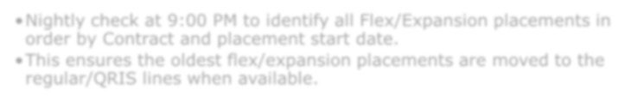
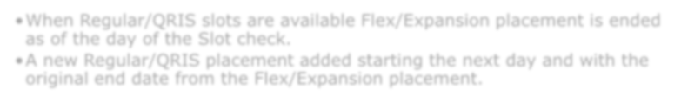
order by Contract and placement start date.
• This ensures the oldest flex/expansion placements are moved to the regular/QRIS lines when available.

Regular or QRIS Slots Available?
• CCFA checks for any vacant regular/QRIS slots on the contract.

Move to Regular/QRI S Slot
• When Regular/QRIS slots are available Flex/Expansion placement is ended as of the day of the Slot check.
• A new Regular/QRIS placement added starting the next day and with the original end date from the Flex/Expansion placement.

 | Regular |  | Intermittent |  | Flexible |  | Intermittent Flexible |  | School Closure Only
 | Max 30 | >30 | Max 30 | >30 | PT  Auth | FT Auth | PT Auth | FT Auth | PT Auth | FT Auth
Infant | H | F | NA | NA | H | F | NA | NA | NA | NA
Toddler | H | F | NA | NA | H | F | NA | NA | NA | NA
Pre School | H | F | H | F | H | F | H | F | NA | NA
School Age | H | F | NA | NA | H | F | NA | NA | H | F
Under 2 | H | F | NA | NA | H | F | NA | NA | NA | NA
2 and Over | H | F | F | F | H | F | H | F | H | F
Kindergarten | H | F | NA | NA | H | F | NA | NA | H | F
Full Day Headstart | H | F | NA | NA | H | F | NA | NA | H | F
Before School | H |  | H |  | H |  | H |  | NA
After School | F |  | F |  | F |  | F |  | NA
Before&After School | F |  | F |  | F |  | F |  | NA
Before Headstart | H |  | H |  | H |  | H |  | NA
After Headstart | F |  | F |  | F |  | F |  | NA
Before&After Headstart | F |  | F |  | F |  | F |  | NA
Before Kindergarten | H |  | H |  | H |  | H |  | NA
After Kindergarten | F |  | F |  | F |  | F |  | NA
Before&After Kindergarten | F |  | F |  | F |  | F |  | NA
NA = Not applicable H = Half Slot F = Full Slot

- A child’s age determines their program placement

- When a child’s age surpasses that of their current program, CCFA will attempt to automatically age the child up starting the day after the Start of Eligibility for the program
  - Exception is preschool to school age (SA)
  - CCFA will allow you to age a child up early

 | Start of Eligibility
Infant | 0 months
Toddler | 15 months  (1 year, 3 months)
Preschool | 33 months  (2 years, 9 months)
School Age | 60 months  (5+ years)

If the system is able to successfully age the child up,
the following notification appears

- No further action is required

- If the system is unable to age up the child, a notification will appear on the Home page.

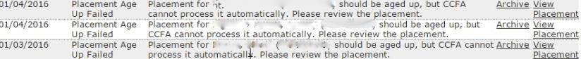

  - Age Out Notifications also appear during attendance validation, after attendance has been submitted.

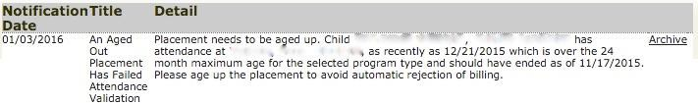

  - A placement that has aged out must be resolved, or
billing will be rejected when submitted

- CCFA WILL NOT automatically age up a special needs child.

- CCFA WILL NOT automatically age up a preschool child who turns 5 years old
  - This is to accommodate the different school year start dates and
school ages between districts

If a child turns 5 during the authorization period, CCFA will allow the subsidy administrator to select the “exempt” flag when initially entering the placement in CCFA.

- Meet Thomas
- Age: 4

- Authorization: full time,
8/14/15--8/13/2016

- Program: Center Based Preschool

• Birthday: 7/7/2011

- When placed, the “exempt…” flag must be checked because Thomas will turn 5 during the summer and enter school in the fall.
  - This allows Thomas to remain in his current program until the
start of the school year.

- If the child’s turns 5 in the calendar year they are
eligible for kindergarten:
  - If they turn 5 after the start of the school calendar year, the subsidy administrator can use the “exempt…” flag. This will allow the child to remain in the preschool program until the next school calendar year.
  - The family may choose not to send the child to kindergarten if they are 5 before the start of the school calendar year, the subsidy administrator can use the “exempt…” flag. This will allow the child to remain in the preschool program until the next school calendar year.

- Contract Line Activity – Summary
  - Provides a summary of how slots are utilized on a monthly level within a given timeframe
  - Shows programs and placements within them

Contract Line Activity – Monthly
  - Provides a summary of how slots are utilized on a daily basis within a given month
  - Shows programs and placements within them

- Must complete reassessments prior to the expiration of the existing authorization
  - Failure to complete timely reassessments may result in the child’s authorization expiring and being replaced by a child in the FLEX pool
  - CCFA sends reassessment notifications at 90, 60, and 30 days
  - Must be completed any time in that timeframe

- What if a child ages up, but flex pool is full?
  - The Admin should reach out the CCR&R to get that child a voucher.

What if the provider doesn’t offer voucher care?
  - The child must be moved to a another program.

What if a child ages up and their provider doesn’t offer care in the next age group?
  - The child must be moved to another program.

What if there are no vouchers available?
  - EEC regulations and policies ensure continuity of care.

What if CCFA ages a child up and places him/her in a slot that was meant for a new authorization beginning later in the same week?
  - Be sure you are tracking the age up notifications. CCFA sends notices starting 45 days before a child ages up.

What if a child ages up from toddler to preschool and the provider doesn’t have any available slots at their site, but there are slots available at another provider under the same contract?
  - CCFA will utilize slots on the contract. The child can remain at the current provider so long as the provider isn’t over their licensing capacity AND has a contract for the program type the child has aged up to.

- Questions?

