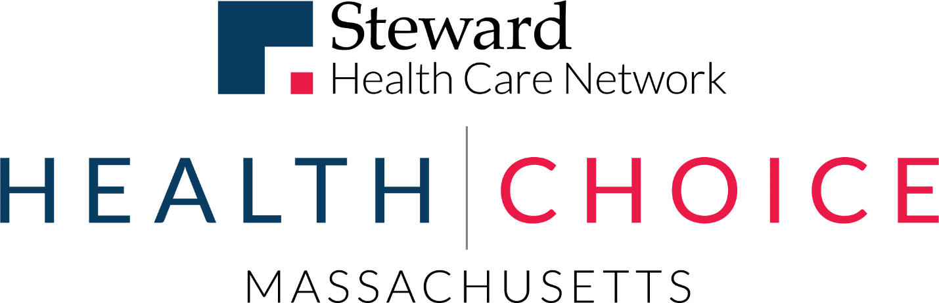

Delivery System Reform Incentive Payment (DSRIP) Program

Accountable Care Organization (ACO)

PY2 Annual Progress Report

General Information
Full ACO Name: | Steward Medicaid Care Network, Inc.
ACO Address: | 89 A Street, Needham, MA 02494

Part 1. PY2 Progress Report Executive Summary

ACO Goals from its Full Participation Plan
Our vision for our Medicaid ACO program aligns closely with MassHealth’s stated goals and reflects Steward’s overall mission. Through this program, we aim to:
- Deliver world-class health care where members live
- Advance the Quadruple Aim: improve members’ health while improving members’ experience and quality of care, reducing total costs and improving providers’ administrative burden
- Actively engage a continuum of providers to address the needs of the communities we serve, including physical health, preventive care, behavioral health, and long-term services and supports
- Create and operate a scalable, sustainable, and replicable model that uses sophisticated incentives to engage and align priorities among both ACO providers and members
- Use data and technology to effectively identify needs of both members and practices and efficiently target resources to meet these needs
Our plan below lays out 12 specific goals that extend this vision and that will support our efforts to improve quality and reduce total cost of care.

Table 1. Steward Health Choice five-year objectives
Cost and utilization management | - Reduce avoidable ED utilization, hospital admissions and readmissions  - Reduce impact and prevalence of chronic conditions, such as heart disease, heart failure, diabetes, COPD and depression  - Reduce impact of homelessness and housing instability
Integration of physical health, behavioral health, LTSS, and health-related social services | - Integrate resources into every primary care practice to increase access to behavioral health resources and services to address health-related social needs  - Integrate and manage long-term services and supports so members remain in the community  - Decrease prevalence of substance use disorder, including opioid use and incidence of overdose
Member engagement | - Keep care local and community-based  - Increase member engagement in primary care, preventive services and self-management
Quality | - Optimize maternity care to improve birth outcomes  - Improve member and family experience in understanding, accessing and receiving services
Other | - Develop the workforce necessary to successfully meet needs of the Medicaid ACO population  - Establish a scalable, sustainable, and replicable ACO model

We developed goals informed by data on our Medicaid ACO population and have evolved them to reflect insight gained from our experience during PY1. We have established specific, measurable targets for each goal as based on the costs and utilization patterns of our ACO members. We will continually use data to focus and drive the programs we implement and the populations we target. We will submit requests to modify these goals and our investment strategy if, during the course of the program, our data suggests we need to adjust our focus to achieve success in managing total cost of care and quality.

PY2 Investments Overview and Progress Towards Goals
Our PY2 was focused on investments required for Steward and our providers to succeed in the ACO program. We have adapted our investment approach as the program evolves, and as we refine our understanding of the operational requirements and challenges.
Our PY2 investments included the following specific investments from our PY2 full participation plan:
ID | INVESTMENT CATEGORY | SPECIFIC INVESTMENT OR PROGRAM
S/O PC: 1002 | Organizational Integration | Invest in primary care practices to support risk adjustment and quality, and to improve patient experience of care
S/O PC: 1003 | Health-Related Social Needs | Increase access to non-emergency medical transportation (including same day, evenings, and weekends) to support patient activation and connection to primary care
S/O PC: 1004 | Community-Based Care Initiatives | Develop resources to support primary care providers care for patients with SMI, SUD, or social/safety needs
S/O PC: 1007 | Health Information Technology | Enhance health information technology resources (including EMRs) to support care coordination, care planning, and data exchange among primary care, behavioral health, and other service providers
S/O PC: 1009 | Health Information Technology | Implement enhancements to routine patient screenings to include housing/social needs, behavioral health conditions (including opiate addiction), pregnancy, and other key conditions
S/O PC: 1016 | Clinical Integration | Develop and implement clinical protocols and supports for pharmacy to encourage medication adherence and support PCP management of medications (including opiates)
S/O PC: 1017 | Culturally and Linguistically Appropriate Services | Expand resources to support PCPs with accessible and culturally/linguistically appropriate care
S/O PC: 1024 | Care Coordination & Care Management | Integrate population health staff (community health workers, social workers, and other clinicians and resources) into primary care practices support care coordination
S/O PC: 1027 | Organizational Integration | Additional investments proposed by network PCCs and community based organizations partnering with PCPs
S/O D: 2001 | Health Information Technology | Invest in population health analytics and information technology, including predictive analytics and risk stratification, event notification, and secure data exchange
S/O D: 2004 | Care Coordination & Care Management | Expand current Steward population health management programs to support Medicaid
S/O D: 2005 | Care Coordination & Care Management | Develop care management programs for conditions prevalent among Medicaid enrollees, including behavioral, long-term, and social needs
S/O D: 2009 | Other | Invest in new capacity to support Medicaid ACO members' social needs, including transportation, housing, nutrition, etc.
S/O D: 2015 | Care Coordination & Care Management | Implement referral management and utilization management processes and technology
S/O D: 2016 | Organizational Integration | Develop robust member engagement and communications program incorporating culturally and linguistically appropriate communication channels
S/O D: 2018 | Other | Support ACO members in maintaining eligibility and accurate demographic data
S/O D: 2020 | Care Coordination & Care Management | Develop supports for children and parents, including childbirth and parenting classes, care coordination, and other targeted programs
S/O D: 2021 | Organizational Integration | Build infrastructure to support member and provider services, including call center, CRM, and collateral
S/O D: 2022 | Workforce Development | Enhance network's ability to address Medicaid member needs through training, contracting, and other development activities
S/O D: 2028 | Other | Develop financial models, controls, and evaluation program for all ACO-related funding
S/O D: 2029 | Organizational Integration | Clinical leadership for medical and behavioral health programs
S/O D: 2030 | Organizational Integration | Invest in primary care practices, hospitals, and community based organizations, including technical assistance, to support transformation to value-based care and improve program performance
S/O D: 2031 | Care Coordination & Care Management | Develop protocols and infrastructure for flexible services program
S/O D: 2033 | Organizational Integration | Build administrative infrastructure to support implementation, operation, and monitoring of ACO

Examples of progress on initiatives to date:

S/O PC 1003. Increase access to non-emergency medical transportation (including same day, evenings, and weekends) to support patient activation and connection to primary care
In PY2, we successfully launched our wraparound non-emergency medical transportation initiative. In certain cases when a PT-1 was not available, our care management team scheduled rides for nearly 600 members. Transportation was arranged for members to visit the following sites: PCP and specialist offices, urgent care, SUD treatment, behavioral health counseling, cancer treatment, and family planning.

S/O PC 1027. Additional investments proposed by network PCCs and community-based organizations partnering with PCPs
In PY2, Steward provided grant funds to one of its practices, Hawthorn Medical Associates, to establish a behavioral health department that will offer substance use treatment services. With this project, Hawthorn recruited and onboarded a full-time recovery coach and administrative staff. As a result, the initiative supported the ACO’s and practice’s shared goal to integrate behavioral health services into the primary care setting.

S/O D 2018. Support ACO members in maintaining eligibility and accurate demographic data
In PY2, Steward successfully implemented an eligibility renewal program with our Member Services team. Specifically, a team of disenrollment navigators was hired to outreach members at risk of losing their MassHealth coverage. These team members contact members to remind them to renew their eligibility, walk them through the process of completing redetermination paperwork, and connect them with appropriate resources at MassHealth to submit their applications. In addition, Steward mails renewal reminder letters to members we are unable to reach by phone. As a result of these efforts, Steward observed a reduction in membership churn during PY2.

Successes and Challenges of PY2
Our focus in PY2 was optimization of the infrastructure, processes, and program required to advance the ACO. Some of our key successes and challenges in 2018 were:
Successes:
- Steward enrolled significantly more members in our care management programs in PY2. For example, our Behavioral Health Complex Chronic Patient Management (BH CCPM) program managed over 1,000 members in PY1 and nearly tripled the number of members managed in PY2 to almost 3,000 enrollments. We also expanded our social services and maternal health programs during PY2.
- We partnered with an actuarial firm to establish a reliable cost and utilization portal that is updated on a recurring basis. This tool has significantly improved our ability to track our cost and utilization data across a plethora of service categories. We are able to filter the data by year, region, rating category, and PCC, or any combination of these variables. This tool has allowed us to identify areas of high performance and isolate opportunities for improvement across populations, regions and services.
Challenges:
- In PY2, ACOs experienced a market-wide shift in the acuity of the MassHealth population as the total number of enrolled members decreased. Despite the change in risk profile, we successfully managed utilization within our control and influence. For example, Steward beat targets on avoidable Emergency Department (ED) and Inpatient Hospital utilization and costs, and significantly reduced TCOC for homeless members, reflecting the expected impact of our Care Management programs.
- Compounding the shift in population acuity, Steward experienced significant growth in utilization and costs associated with members who have substance use disorders in PY2. This unforeseen utilization increase was and continues to be outside the control of Model B ACOs due to program design constraints, including the lack of patient-level data necessary to proactively manage this complex population. We are encouraged by incremental steps that MassHealth and MBHP are taking in PY3 to make some of this information available for limited use cases. We will continue to work with MassHealth and MBHP to identify appropriate workarounds such to ensure our members’ needs are identified and met.

