Social Media Package for Provincetown Health Department
Week of May 4-8th

POTENTIAL BROAD TOPICS TO COVER
- Maintaining hope/conquering fear
- Handwashing, social distancing, other science-based recommendations
- Mental health
- Local resources
- Funny and meme-y
- Looking forward to the future
- Be kind to yourself and others
- Timely content (i.e., Tied to global/national health related days/weeks such as World immunization week)
- COVID19 info from reputable sources
- Critical COVID19 information (safety issues)
- Opportunities to dig deep on COVID19 (webinars with scientists, etc.)
- Gratitude (for essential workers, our community, etc.)
- Healthy distractions (open access films, online poetry slams, online tours of art galleries, interesting podcasts, etc.)
- Activities to enhance health at home (links to meditation, yoga, fitness, how-to tutorials on growing produce at home, etc.)
- Ideas for staying connected/building community in Provincetown
- Good news stories in the time of COVID19
- Quirky COVID19 news

SOURCES TO CHECK REGULARLY
- Local non-profits
- Provincetown Health Department
- Mass Department of Health
- Various city departments of health
- World Health Organization campaigns page
- CDC
- American Public Health Association
- Boston University School of Public Health
- Harvard Chan School of Public Health
- Boston Globe Ideas section, op-ed section, health and science sections
- New York Times health, science, and op-ed sections
- WCAI
- WBUR CommonHealth, Cognoscenti
- NPR
- CDC’s Social Media Toolkit
- https://www.who.int/emergencies/diseases/novel-coronavirus-2019/advice-for-public
- https://www.capecodtimes.com/
- Vox

SOCIAL MEDIA CONTENT FOR MAY 4-8, 2020

Post 1:
The Massachusetts Department of Public Health shares tips for coping with stress and fear relating to COVID19.
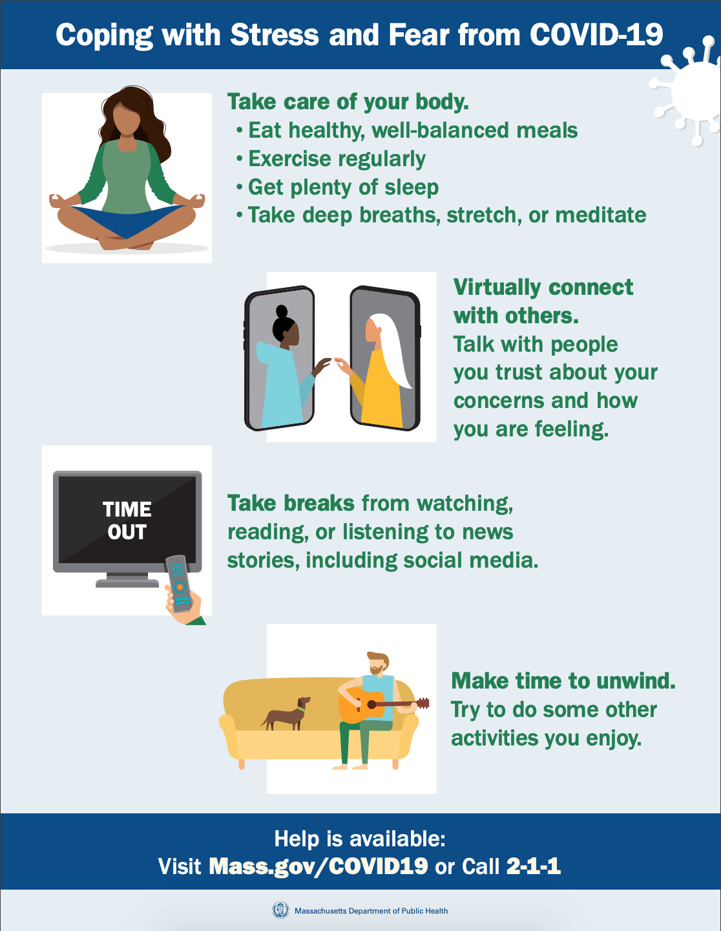

Post 2:
Anyone else feeling the Zoom fatigue? If you are working from home on your computer, make sure to take breaks away from the screen!

Post 3:
Here is one way to think about mask use. Stay safe: wear your masks and don’t forget your pants!
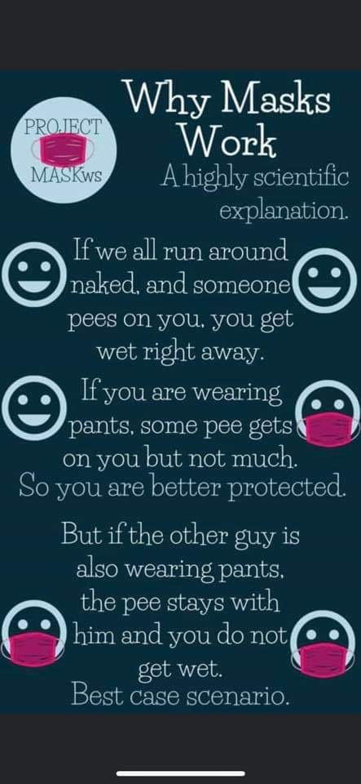

Post 4:
You know that COVID19 graph you are seeing everywhere? There is a lot more to it than meets the eye. Watch this short video to understand how the process of data visualization can shape our perception of this crisis.
https://www.vox.com/videos/2020/4/28/21238769/coronavirus-covid19-chart-data-misleading

Post 5:
The COVID19 pandemic has forced many couples into full-time togetherness. This article shares ideas to “rekindle romantic love and grow together rather than apart.”
https://www.nytimes.com/2020/04/13/well/mind/coronavirus-relationships-love-couples-quarantine-shelter.html?action=click&module=moreIn&pgtype=Article&region=Footer&action=click&module=MoreInSection&pgtype=Article&region=Footer&contentCollection=Voices

Post 6:
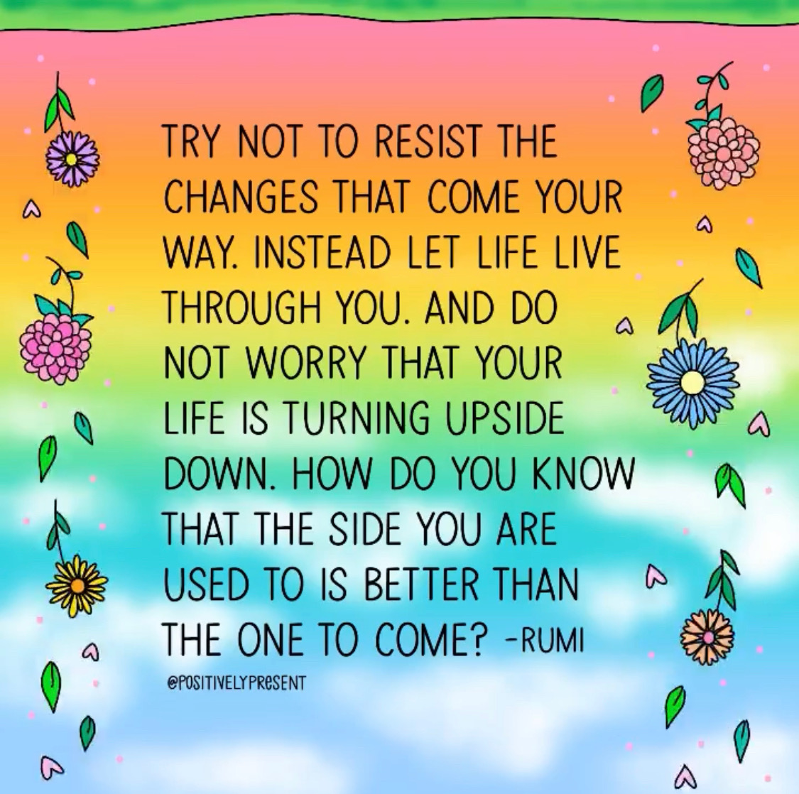

Post 7:
Have you witnessed profound acts of kindness in Provincetown during the COVID19 emergency? Share your stories using hashtag #coronakindness. When you can be anything, be KIND. 🤗 #BeKind
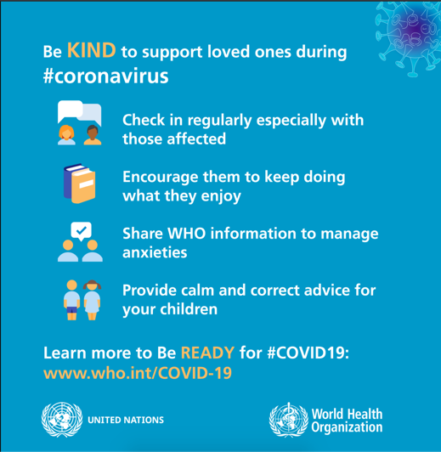
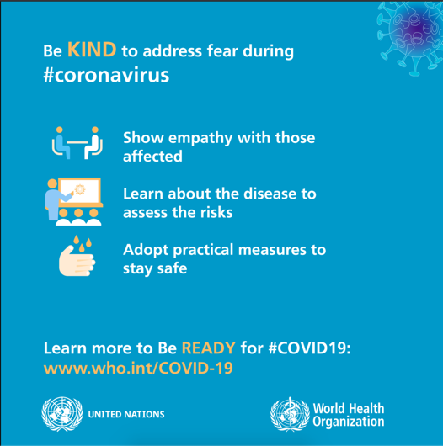
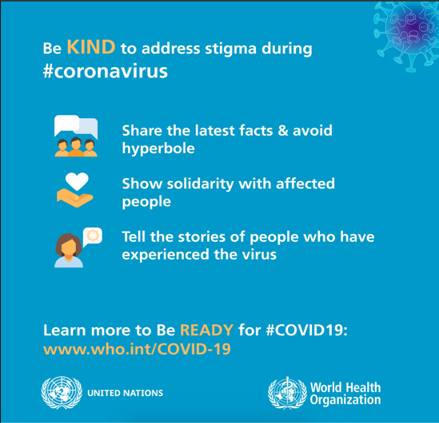

Post 8:
Plain old soap and water absolutely annihilate coronavirus...but why? And how? Check out this short video for a clear and scientific explanation!
https://www.vox.com/2020/3/18/21185262/how-soap-kills-the-coronavirus

Post 9:
The Centers for Disease Control and Prevention has renewed calls for social distancing between pets and humans after a pug in North Carolina tested positive for COVID19.

“Winston the pug is believed to be the first case of the virus in a dog in the U.S. He showed minor symptoms including a small cough and refusing to eat his breakfast, but now his owners say he’s doing well…”
https://www.wbur.org/hereandnow/2020/04/30/pets-coronavirus

Post 10:
The science of helping out: During a crisis, helping others will help you to cope.
https://www.nytimes.com/2020/04/09/well/mind/coronavirus-resilience-psychology-anxiety-stress-volunteering.html?action=click&module=moreIn&pgtype=Article&region=Footer&action=click&module=MoreInSection&pgtype=Article&region=Footer&contentCollection=Voices

Post 11:
Looking for some extra activities to do with the kids while at home? National Geographic has tons of fun ideas. Learn about black rhinos, the history of space travel, how to make homemade yogurt and so much more!
https://www.nationalgeographic.com/family/at-home-education-resources/?cmpid=org=ngp::mc=display::src=natgeo::cmp=natgeoathome::add=homepagead

Post 12:
How will theaters resume public performances when the pandemic subsides?

The American Repertory Theater and the Harvard T.H. Chan School of Public Health are working together to make sure performance spaces are prepared to mitigate the risk of spreading COVID19.
https://www.wbur.org/artery/2020/04/29/roadmap-coronavirus-reopening-american-repertory-theater-th-chan?fbclid=IwAR2fqBkT5bXUX-7KdEOvNI_trozjddlkHu89YesHTW3TkhljGhmLE3cqBsA

Post 13:
With many people stuck at home, virtual open poetry mics are offering a way for artists to connect, make art, share emotions, and offer a healing respite during these times of uncertainty.
https://www.wbur.org/artery/2020/04/27/virtual-poetry-open-mics-offer-a-healing-respite-from-daily-worries

Post 14:
“When workers have to choose between earning a living and staying home sick, it incentivizes them to come to work when they’re ill and potentially infect their colleagues and anyone else they come into contact with. That’s why public health officials are concerned that millions of American workers don’t have access to paid sick days.”

Learn more about paid sick leave–a critical policy that could dramatically change the coronavirus math–in the United States:
https://www.vox.com/2020/3/27/21196932/paid-sick-leave-coronavirus

Post 15:
Are you feeling stressed? The World Health Organization has published a new guide with techniques to help all of us cope with stress relating to COVID19.
Download it here: http://bit.ly/WHOStressManagement

