INDOOR AIR QUALITY ASSESSMENT

Somerset Middle School
1141 Brayton Avenue
Somerset, MA

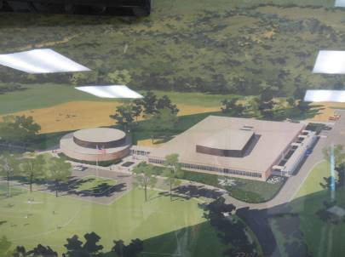

Prepared by:
Massachusetts Department of Public Health
Bureau of Environmental Health
Indoor Air Quality Program
February 2023

BACKGROUND

Building: | Somerset Middle School (SMS)
Address: | 1141 Brayton Avenue, Somerset, MA
Assessment Requested by: | Massachusetts Department of Labor Standards referral in coordination with Somerset School Department and Board of Health
Reason for Request: | General indoor air quality (IAQ) and mold concerns
Date of Assessment: | January 9, 2023
Massachusetts Department of Public Health/Bureau of Environmental Health (MDPH/BEH) Staff Conducting Assessment: | Cory Holmes, Assistant Director, and Stefanie Santora, Environmental Analyst, IAQ Program
Building Description: | The SMS is a single-story, flat-roofed, brick and concrete block building originally built in 1964 with an addition built in 1969. Parts were replaced on the Auditorium’s mechanical ventilation system, the gymnasium floor was replaced within the last year, and the Media Center carpet has been replaced within the last 14 years. However, most building components (e.g., flooring, ceilings, windows, mechanical ventilation) date back to building construction. The roof is reported to be approximately 20 years old.
Windows: | Windows are openable

It is important to note that construction of a new SMS building is underway. The project was started in December of 2022 and is slated for completion in September of 2024. More information can be found at this link: Somerset Middle School - New Building Construction Updates (somersetschools.org).

METHODS
Please refer to the IAQ Manual for methods, sampling procedures, and interpretation of results (MDPH, 2015). The following is a summary of indoor air testing results (Table 1).

RESULTS AND DISCUSSIONS
The following is a summary of indoor air testing results (Table 1).
- Carbon dioxide levels were above the MDPH guideline of 800 parts per million (ppm) in 31 of 55 areas tested, indicating a need for increased air exchange in those areas.
- Temperature was within or close to the MDPH recommended range of 70°F to 78°F in most areas the day of the assessment. Occupants in a few areas expressed temperature complaints, which is to be expected in a building of this age/condition.
- Relative humidity was below the MDPH recommended range of 40 to 60% in all but one area the day of assessment, which is typical in New England during winter months.
- Carbon monoxide levels were non-detectable (ND) in all areas tested.
- Fine particulate matter (PM2.5) concentrations measured were below the National Ambient Air Quality (NAAQS) limit of 35 μg/m³ in all areas tested.

Ventilation
A heating, ventilating, and air conditioning (HVAC) system has several functions. First it provides heating and, if equipped, cooling. Second, it is a source of fresh air. Finally, an HVAC system will dilute and remove normally occurring indoor environmental pollutants by not only introducing fresh air, but by filtering the airstream and ejecting stale air to the outdoors via exhaust ventilation. Even if an HVAC system is operating as designed, point sources of respiratory irritation may exist and cause symptoms in sensitive individuals.
Fresh air in the majority of classrooms is supplied by 1950’s/1960’s vintage unit ventilators (univents, Picture 1), which are now over 50 years old. According to the American Society of Heating, Refrigeration, and Air-Conditioning Engineers (ASHRAE), the service life of this type of unit is 15-20 years, assuming routine maintenance of the equipment (ASHRAE, 1991).
Univents draw air from the outdoors through a fresh air intake located on the exterior wall of the building (Picture 2) and return air through an air intake located at the base of the unit. Fresh and return air are mixed, filtered, heated or cooled, and provided to rooms through an air diffuser located in the top of the unit (Figure 1). In order for univents to provide fresh air as designed, intakes/returns must remain free of obstructions. Importantly, these units must remain on and be allowed to operate while rooms are occupied. Most of the units throughout the school were operating and free from obstructions.
Classroom exhaust vents are located in the ceilings of classrooms (Picture 3), walls (Picture 4), or classroom coat closets connected with ducts to exhaust fans on the roof. It was reported that coat closet doors were removed to facilitate airflow (Picture 5). Exhaust vents in a few areas of the school were weak or not drawing air during the assessment (Table 1). Some exhaust vents were obstructed, which inhibits airflow (Picture 4).
Mechanical ventilation for common areas like the gym, cafeteria and interior rooms is provided by rooftop or ceiling-mounted air handling units (AHUs). Fresh air is distributed via ductwork connected to ceiling-mounted air diffusers (Picture 6). Return vents draw air back to the AHUs through wall or ceiling-mounted grilles (Picture 3).
To maximize air exchange, the MDPH recommends that both supply and exhaust ventilation operate continuously during periods of occupancy. To have proper ventilation with a mechanical supply and exhaust system, these systems must be balanced to provide an adequate amount of fresh air while removing stale air from a room. It is recommended that existing ventilation systems be re-balanced every five years to ensure adequate air systems function (SMACNA, 1994).
It is also important to note that despite ongoing maintenance and replacement of parts/components by facilities/maintenance staff, many of the HVAC units are at the end of their life cycle. Efficient function of equipment of this age is difficult to maintain since compatible replacement parts are often unavailable.

Microbial/Moisture Concerns
Water-damaged ceiling tiles were observed in a number of areas throughout the building (Table 1, Pictures 7 and 8), which indicate leaks from the building envelope or plumbing system. Many of these areas were reported to be from historic water leaks that have since been repaired. Ceiling tiles are considered a porous material which, if exposed to chronic moisture, may become a source for microbial colonization. These tiles should be discarded and replaced. Chronic exposure to humidity and moisture over the years has resulted in rust/corrosion on the underside of metal decking above ceiling tiles (Picture 9) and the suspended ceiling tile grid.
It is important to note that Massachusetts has experienced extended periods of relative humidity during the summers of 2021 and 2022, with July 2021 being the wettest ever recorded in Massachusetts, and the three-month period from June through August 2021, known as the meteorological summer, was the fourth wettest on record, according to the National Oceanic and Atmospheric Administration’s Centers for Environmental Information. The three-month period also was the third warmest ever in the state and was tied for the warmest on record across the United States (HG, 2021, NOAA, 2021). These conditions resulted in water damage and mold growth in a number of buildings across the state (HG, 2021).
To mitigate potential mold conditions in the building during periods of elevated relative humidity/summer months, the school stationed large industrial dehumidification units and fans in main corridors, with smaller units deployed in classrooms and common areas (Pictures 10 and 11). In addition, the Somerset School Department works with their in-house HVAC technician and a private company over summer months to monitor air quality and relative humidity conditions to prevent mold growth.
Signs of water penetration in the form of peeling paint and efflorescence were observed on the lower wall of classroom 4 (Picture 12) and the ceiling of the restroom area of classroom 36. Efflorescence is a characteristic sign of water damage to building materials such as brick, mortar, or plaster. As moisture penetrates and works its way through mortar around brick, water-soluble compounds dissolve, creating a solution. As the solution moves to the surface of the brick or mortar, water evaporates, leaving behind white, powdery mineral deposits. This condition indicates that water from the exterior has penetrated into the building. When present, efflorescence can be readily cleaned. Although plaster itself is not a mold growth medium, the accumulated dirt, dust, and debris on the surface of walls/ceilings can be.
Dark staining at the bottom of wall plaster was observed in classroom 5, below the dry erase board (Picture 13). The occupant of classroom 7 reported mold growth along the top of dry erase boards at the front of the room. These materials are hard, non-porous materials that can be cleaned with an antimicrobial as needed.

Other IAQ Evaluations
Other conditions that can affect IAQ were observed during the assessment. The MDPH recommends filters for HVAC equipment with a Minimum Efficiency Reporting Value (MERV) of 8, which are adequate in filtering out pollen and mold spores (ASHRAE, 2012) or the highest MERV rating the ventilation system can accommodate. Filters should also be changed two to four times a year, or per the manufacturer’s recommendations. Univent filters observed in use at SMS were MERV 8 (Picture 14), and MERV 13 for rooftop AHUs. Filters are reportedly changed three times annually. The interior of the univent in music room 44 was examined and found to have improperly sized filters (Picture 14), which can cause filter bypass. It should be noted however, that proper sized filters may be difficult to find, due to the age of equipment. To prevent filter bypass, IAQ staff recommended that in lieu of a “spacer” that is typically used between two small filters, that two proper width filters be cut and taped together to make one large, properly fitting filter that slides into the filter rack.
Some classrooms had personal fans. Some of these had dusty blades/housings. Some supply diffusers and exhaust/return vents were also observed to have accumulated dust/debris (Table 1, Pictures 15 through 18). This dust can be reaerosolized when the equipment is activated and provide a source of eye and respiratory irritation.
In some areas, accumulated items including books, papers, and other materials were observed on floors, windowsills, tabletops, counters, bookcases, and desks. Excess items on surfaces can make it more difficult for custodial staff to clean.
Missing/dislodged ceiling tiles were observed in some areas (Table 1). It appeared that the tiles were moved for the installation of network wiring. These breaches can provide a pathway for dust, debris, and particulates from the ceiling plenum into occupied areas, which can be a source of eye, skin, or respiratory irritation.
Many classrooms contained high efficiency particulate arrestance (HEPA)-filtered air purifiers (Table 1, Picture 19). It is important to note that filters should be changed, and these units be maintained in accordance with the manufacturers’ recommendations.
The library and some office areas contained wall to wall carpeting. Aging carpet can produce fibers that can be irritating to the respiratory system. Carpets should be cleaned annually (or semi-annually in soiled/high traffic areas) in accordance with Institute of Inspection, Cleaning and Restoration Certification (IICRC) recommendations, (IICRC, 2012). Regular cleaning with a high efficiency particulate air (HEPA) filtered vacuum in combination with an annual cleaning will help to reduce accumulation and potential aerosolization of materials from carpeting.
Exposure to low levels of total volatile organic compounds (TVOCs) may produce eye, nose, throat, and/or respiratory irritation in some sensitive individuals. To determine if VOCs were present, BEH/IAQ staff examined rooms for products containing VOCs. MDPH/IAQ staff noted hand sanitizers, dry erase materials, wax melters, clip-on, and plug-in air fresheners (Table 1, Pictures 6 and 20) in use within the building. These products have the potential to be irritants to the eyes, nose, throat, and respiratory system of sensitive individuals (e.g., asthmatics).

CONCLUSIONS AND RECOMMENDATIONS
As mentioned previously, the SMS has broken ground to replace the existing building through new construction to be completed in September of 2024. In view of the findings at the time of assessment, the following recommendations are made to help improve IAQ conditions until the new SMS is completed:

Ventilation Recommendations
- Make necessary adjustments to HVAC controls/air intakes to allow an increase in fresh air to rooms with elevated carbon dioxide levels (Table 1).
- Operate all supply and exhaust ventilation equipment continuously during occupied hours.
- Ensure all univents, and exhaust/return vents are free of obstructions to facilitate airflow.
- Close hallway doors during occupancy to allow for more effective air exchange within classrooms.
- Temperature/comfort complaints should be made through proper channels and followed up by facilities staff using existing electronic reporting procedures.
- Use openable windows to supplement fresh air during temperate weather. Ensure all windows are tightly closed at the end of the day or during periods of elevated relative humidity or extreme cold to avoid condensation/mold issues and freezing of pipes.
- Periodically check exhaust vents in classrooms and restrooms for draw and repair any non-operating motors/vents.
- Continue to change filters for HVAC equipment 2-4 times a year using the highest MERV rating the ventilation system can accommodate to improve air filtration as much as possible without significantly reducing airflow.
- Clean the interior of univents and AHUs during regular filter changes using a HEPA-filtered vacuum cleaner with brush attachment or compressed air.
- Contact the manufacturer or other provider(s) to obtain properly fitting filters for univents. If properly sized filters are unavailable, make modifications to existing filters or use spacers to prevent filter bypass (e.g., music room 44).

Water Damage Recommendations
- Continue to ensure any roof and plumbing leaks are repaired promptly and replace any remaining water-damaged suspended ceiling tiles or other porous building materials.
- Install tight-fitting door gaskets/door sweeps on exterior doors to prevent the infiltration of moisture, pests, and particulates.
- Clean and maintain portable dehumidifying units in accordance with manufacturers’ recommendations.
- Continue to closely monitor parameters such as temperature, relative humidity, and dew point over summer months to prevent condensation on floors/surfaces. Refrain from storing porous items, such as cardboard and paper on floors in these areas. If carpeting is present, consider removing from areas that are prone to condensation.
- Repair water-damaged plaster; scrape off/vacuum efflorescence/peeling paint on wall of classroom 4, restroom ceiling in classroom 36, and any other areas. Examine exterior of the building in these areas to determine if breaches are present and repair/seal to prevent further water infiltration.
- Examine dark staining at the bottom of wall plaster in classroom 5 below the dry erase board. Clean and refinish as necessary.
- Examine dry erase boards in classroom 7 for presence or mold growth (and any other areas of concern). Clean non-porous materials with an antimicrobial as needed.
- Consider using the methods described in the document “Preventing Mold Growth in Massachusetts Schools During Hot, Humid Weather” to help reduce impact of conditions during hot, humid weather. This guideline can be found online at: https://www.mass.gov/service-details/preventing-mold-growth-in-massachusetts-schools-during-hot-humid-weather
- Ensure water-damaged materials are cleaned, replaced, and/or repaired in a manner consistent with the U.S. Environmental Protection Agency’s guidelines (US EPA, 2008) available at: http://www.epa.gov/mold/mold-remediation-schools-and-commercial-buildings-guide

Other Recommendations
- Reduce use of products and equipment that create irritating volatile organic compounds (VOCs) and only use in well-ventilated areas. Minimize the use of air fresheners (e.g., plug-ins), deodorizers and scented products.
- Encourage staff to use current system (i.e., School Dude) to report and track maintenance issues so that concerns can be reported by staff and maintenance staff can report when issues have been resolved.
- Change filters and maintain portable air purifiers/HEPA units in accordance with manufacturers’ recommendations.
- Regularly clean supply/return/exhaust vents and fans to avoid aerosolizing accumulated particulate matter. To clean ceiling vents/grills, remove and wash, and replace if necessary.
- Clean AC filters prior to the start of the cooling season and on a regular basis while in use.
- Replace missing and/or broken ceiling tiles.
- Consider reducing the number of items stored in rooms to make cleaning easier. Periodically move items to clean flat surfaces. Store porous items on shelving and away from walls.
- For buildings in New England, periods of low relative humidity during the winter are often unavoidable. Therefore, scrupulous cleaning practices should be adopted to minimize common indoor air contaminants whose irritant effects can be enhanced when the relative humidity is low. To control dusts, a high efficiency particulate arrestance (HEPA) filter equipped vacuum cleaner in conjunction with wet wiping of all surfaces is recommended. Avoid the use of feather dusters. Drinking water during the day can help ease some symptoms associated with a dry environment (throat and sinus irritations).
- Clean carpeting annually or semi-annually in soiled high traffic areas as per the recommendations of the Institute of Inspection, Cleaning and Restoration Certification (IICRC, 2012).
- Consider including an IAQ component in the school’s Wellness Advisory Committee program. An IAQ plan should have an IAQ liaison/teacher representative, a member of maintenance/facilities and administration that conduct regular walk-throughs to identify on-going and/or potential environmental issues.
- Consider adopting the US EPA (2000) document, “Tools for Schools,” as an instrument for maintaining a good IAQ environment in the building available at: http://www.epa.gov/iaq/schools/index.html.
- For guidance on maintaining an asthma-friendly healthy school environment, please consult the MDPH Asthma Prevention and Control Program’s Clearing the Air: An Asthma Toolkit for Healthy Schools.
- Refer to resource manual and other related IAQ documents located on the MDPH’s website for further building-wide evaluations and advice on maintaining public buildings. These documents are available at: http://mass.gov/dph/iaq.

REFERENCES
ASHRAE. 1991. ASHRAE Applications Handbook, Chapter 33 “Owning and Operating Costs”. American Society of Heating, Refrigeration and Air Conditioning Engineers, Atlanta, GA.
ASHRAE. 2012. American Society of Heating, Refrigeration and Air Conditioning Engineers (ASHRAE) Standard 52.2-2012 – Method of Testing General Ventilation Air-Cleaning Devices for Removal Efficiency by Particle Size (ANSI Approved).
HG. 2021. Mold Keeps South Hadley High School Shuttered. Hampshire Gazette. https://www.gazettenet.com/South-Hadley-High-School-still-closed-amid-mold-remediation-42413519
IICRC. 2012. Carpet Cleaning FAQ 4 Institute of Inspection, Cleaning and Restoration Certification. Institute of Inspection Cleaning and Restoration, Vancouver, WA.
MDPH. 2015. Massachusetts Department of Public Health. “Indoor Air Quality Manual: Chapters I-III”. Available at: Indoor air quality – manual and appendices | Mass.gov
NOAA. 2021. Summer 2021 neck and neck with Dust Bowl summer for hottest on record. National Oceanic and Atmospheric Administration, 1401 Constitution Avenue NW, Room 5128, Washington, DC 20230 https://www.noaa.gov/news/summer-2021-neck-and-neck-with-dust-bowl-summer-for-hottest-on-record
SMACNA. 1994. HVAC Systems Commissioning Manual. 1st ed. Sheet Metal and Air Conditioning Contractors’ National Association, Inc., Chantilly, VA.
US EPA. 2000. Tools for Schools. Office of Air and Radiation, Office of Radiation and Indoor Air, Indoor Environments Division (6609J). EPA 402-K-95-001, Second Edition. https://www.epa.gov/iaq-schools.
US EPA. 2008. “Mold Remediation in Schools and Commercial Buildings”. Office of Air and Radiation, Indoor Environments Division, Washington, DC. EPA 402-K-01-001. September 2008. Available at: http://www.epa.gov/mold/mold-remediation-schools-and-commercial-buildings-guide.

Figure 1

Unit Ventilator (Univent)

Mixed Air

Air Diffuser

Outdoors Indoors

Fan

Heating/Cooling Coil

Air Mixing Plenum

Filter

Outdoor Return
Air Air

Air
Flow
Control
Louvers

Air Flow

= Fresh Air/Return Air

= Mixed Air

Picture 1
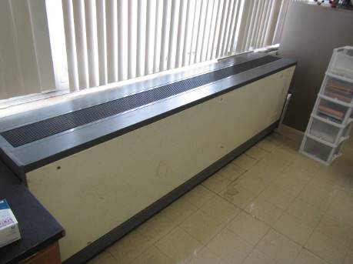
Classroom univent

Picture 2
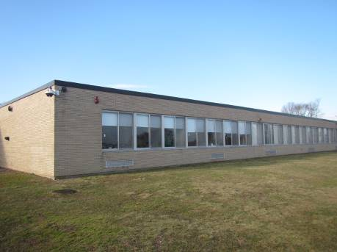
Univent fresh air intakes (arrows)
Picture 3
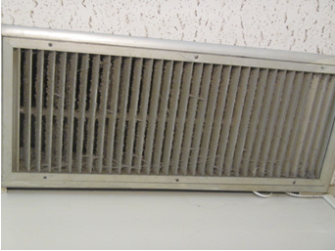
Ceiling-mounted return/exhaust vent

Picture 4
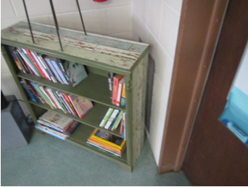
Wall exhaust in classroom obstructed by bookcase (arrow)
Picture 5
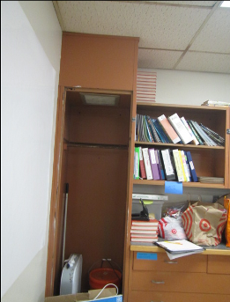
Coat closet exhaust vent (arrow), note door removed to facilitate airflow

Picture 6
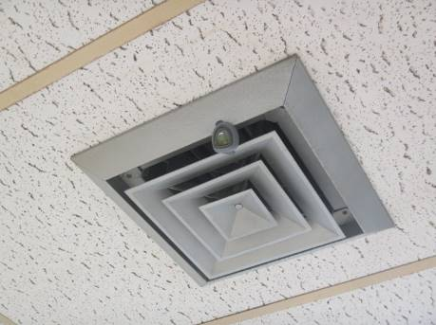
Ceiling-mounted supply vent, note air deodorizer clipped to louvers (arrow)
Picture 7
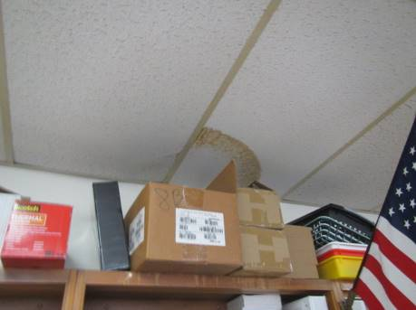
Water-damaged ceiling tiles

Picture 8
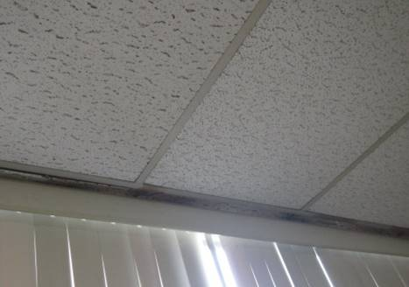
Water-damaged ceiling tiles along window frames
Picture 9
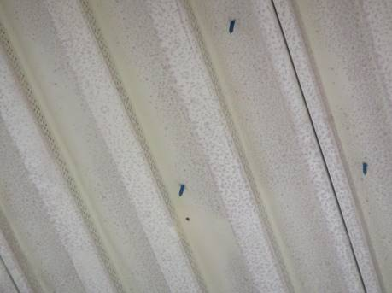
Rusted underside of metal roof decking indicating chronic moisture exposure

Picture 10
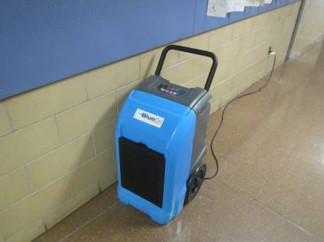
Industrial dehumidifier in main hallway
Picture 11
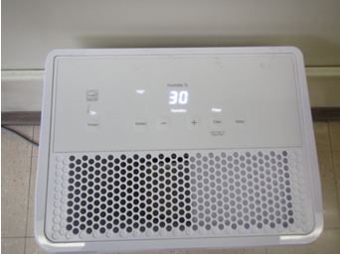
Classroom dehumidifier, note filter indicator light is “on”
Picture 12
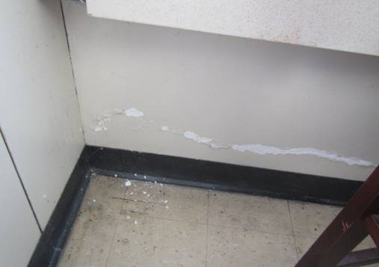
Efflorescence (mineral deposits) and peeling paint on interior plaster wall indicating water penetration through exterior brick in Classroom 4
Picture 13
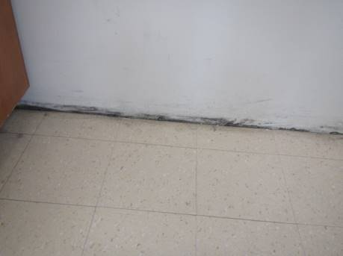
Dark staining on wall plaster in room 5 below dry erase board

Picture 14
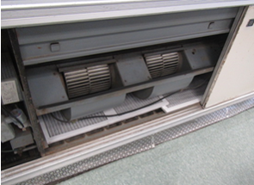
Interior of univent in music room 44, note overlapping improperly sized filters
Picture 15
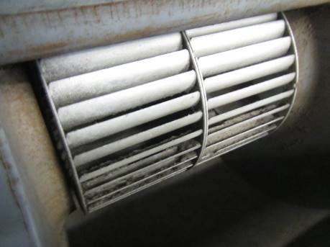
Dust/debris accumulation in squirrel cage/fan in music room 44 univent

Picture 16
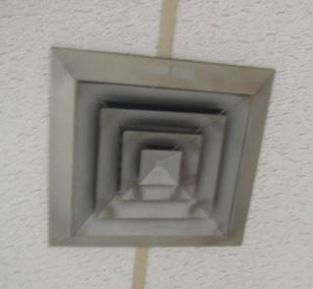
Dust/debris accumulation on supply vent louvers
Picture 17
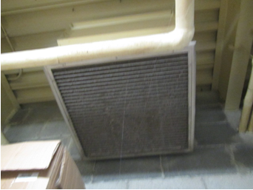
Dust/debris and cobwebs on return/exhaust vent

Picture 18
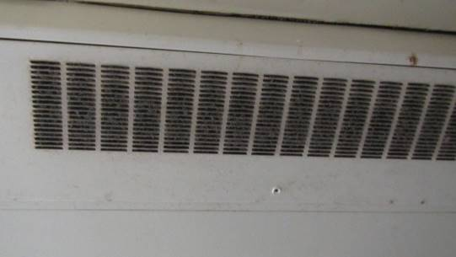
Dust/debris and cobwebs on ceiling-mounted univent
Picture 19
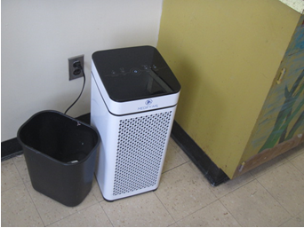
Air purifier in classroom

Picture 20
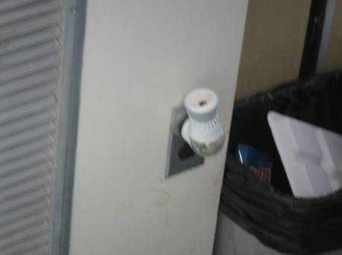
Plug in air freshener in classroom

Location | Carbon  Dioxide  (ppm) | Carbon Monoxide  (ppm) | Temp  (°F) | Relative  Humidity  (%) | PM2.5  (µg/m³) | Occupants  in Room | Windows  Openable | Ventilation |  | Remarks
 |  |  |  |  |  |  |  | Supply | Exhaust
Background | 421 | ND | 45 | 75
Conference Room | 692 | ND | 69 | 37 | 2 | 0 | N/A | Y | Y | 3 WD CT
4 | 818 | ND | 71 | 37 | 4 | 19 | Y | Y DD | Y DD | Window AC, PF, efflorescence on wall plaster
5 | 1101 | ND | 73 | 37 | 3 | 19 | Y | Y | Y | WD CT along ceiling/wall, hallway DH draining in classroom sink, dark staining at base of wall plaster below dry erase board
6 | 1272 | ND | 69 | 42 | 3 | 23 | Y | Y | Y | WD CT along ceiling/wall joint, DD windowsills, student/objects on UV
7 | 998 | ND | 72 | 37 | 3 | 22 | Y | Y | Y weak | 2 WD CT, emergency sink/shower, occupant reported mold on dry erase board (staining), PF, DO
Teachers’ Dining | 594 | ND | 78 | 29 | 4 | 0 | Y | Y | N | PF DD off
Cafeteria | 735 | ND | 74 | 34 |  | 160 | Y |  |  | Standing old utility fan-off
Special Ed | 799 | ND | 74 | 34 | 1 | 1 | N/A | N | Y DD | Water-stained light, PF off, DH
10 | 761 | ND | 71 | 31 | 8 | 19 | Y | Y | Y | Dust/debris on vents, AP, DO
11 | 634 | ND | 72 | 30 | 1 | 8 | Y | Y | Y | Plants
12 | 1029 | ND | 77 | 30 | 1 | 8 | Y | Y | Y  OFF | AP
Assistant Principal | 787 | ND | 74 | 30 | 2 | 0 | Y | N | N
13 | 857 | ND | 74 | 34 | 3 | 18 | Y | Y | Y OFF
13A | 619 | ND | 75 | 29 | 3 | 0 | Y | Y OFF | Y OFF
14 | 819 | ND | 72 | 34 | 3 | 26 | Y | Y | Y
15 | 954 | ND | 77 | 33 | 2 | 8 | Y | Y | Y
Guidance | 666 | ND | 75 | 30 | 1 | 2 | N/A | Y | Y | Photocopier
Guidance Vasconcelos | 604 | ND | 73 | 31 | 1 | <1 | N/A | Y | N
Guidance Dutra | 821 | ND | 73 | 30 | 1 | 1 | N/A | Y | Y | AP-filter light “on”
Guidance Longo | 771 | ND | 73 | 30 | 3 | 0 | N | Y | Y
16 | 1042 | ND | 74 | 35 | 4 | 26 | Y | Y | Y | DO
17 | 1150 | ND | 75 | 36 | 3 | 25 | Y | Y | Y
30 | 848 | ND | 74 | 33 | 2 | 0 | Y | Y | Y | 2 WD CT, PF off, DH on-filter indicator light on
Media Center | 682 | ND | 72 | 33 | 3 | 30 | Y | Y | Y | 2 wall-mounted minisplits on, DH on, carpet, photocopier, ionizer air purifier
31 | 783 | ND | 73 | 34 | 2 | 1 | Y | Y | Y
32 | 606 | ND | 72 | 32 | 3 | 1 | Y | Y | Y | DH, terrarium, aquarium, window open, 20 occupants gone 20 min
33 | 783 | ND | 73 | 34 | 3 | 15 | Y | Y | Y | PF, 2 WD CT, vaporizer
34 | 867 | ND | 73 | 33 | 4 | 7 | Y | Y | Y
35 | 977 | ND | 73 | 35 | 4 | 30 | Y | Y | Y | Wax melter
36 | 776 | ND | 74 | 33 | 4 | 8 | Y | Y | Y covered | Efflorescence on plaster-bathroom ceiling
37 | 856 | ND | 73 | 34 | 5 | 6 | Y | Y OFF | Y OFF | PF off, 1 WD CT
40 | 599 | ND | 72 | 34 | 3 | 2 | Y | Y | Y | 2 of 3 exhaust vents off, 1 of 2 UV off, interior office (intake off, exhaust on)
43 | 735 | ND | 72 | 35 | 6 | 28 | Y | Y | Y | Dust/debris on ceiling-mounted UV and closet exhaust vent, rust on metal ceiling (chronic moisture exposure)
44 | 1040 | ND | 72 | 36 | 1 | 21 | Y | Y  OFF | Y | UV filters overlap (bypass), dust/debris in squirrel cage (fan)
45 | 1042 | ND | 71 | 36 | 3 | 21 | Y | Y | Y | Dust and debris on CTs around vents
46 | 851 | ND | 71 | 36 | 3 | 3 | Y | Y | Y | AP
47 | 850 | ND | 71 | 33 | 2 | 3 | Y | Y | Y | Dust/debris on vents and surrounding CTs, AP
48 | 849 | ND | 71 | 33 | 2 | 0 | Y | Y | Y | Dust/debris on vents and surrounding CTs, AP, PF
49 | 797 | ND | 71 | 33 | 2 | 0 | Y | Y | Y | AP
Faculty Breakroom | 823 | ND | 72 | 32 | 2 | 0 | N | Y | Y | Dust/debris on vents
50 | 795 | ND | 72 | 32 | 4 | 2 | Y | Y | Y | MT
51 | 809 | ND | 72 | 31 | 3 | 3 | Y | Y | Y | AP, MTs
52 | 693 | ND | 72 | 33 | 2 | 2 | Y | Y | N
53 | 689 | ND | 72 | 33 | 1 | 1 | Y | Y | N
54 | 713 | ND | 72 | 33 | 3 | 6 | Y | Y | Y
55 | 825 | ND | 75 | 33 | 2 | 0 | Y | Y | Y OFF
56 | 860 | ND | 74 | 33 | 1 | 0 | Y | Y | Y OFF
57 | 850 | ND | 74 | 34 | 3 | 0 | Y | Y | Y OFF
58 | 916 | ND | 75 | 32 | 3 | 0 | Y | Y | N
59 | 870 | ND | 76 | 32 | 2 | 1 | Y | Y | Y OFF
60 | 1127 | ND | 76 | 35 | <1 | 27 | Y | Y
61 | 1175 | ND | 75 | 35 | <1 | 18 | Y | Y | Y
62 | 1088 | ND | 73 | 36 | <1 | 0 | Y | Y | Y blocked
Art Room 1 | 831 | ND | 74 | 33 | 1 | 1 | N/A | Y |  | PF on, kiln w/exhaust hood
Art Room 2 | 795 | ND | 74 | 33 | 2 | 1 | N/A | Y | Y blocked

The service life is the median time during which a particular system or component of … [an HVAC]… system remains in its original service application and then is replaced. Replacement may occur for any reason, including, but not limited to, failure, general obsolescence, reduced reliability, excessive maintenance cost, and changed system requirements due to such influences as building characteristics or energy prices (ASHRAE, 1991).

