INDOOR AIR QUALITY ASSESSMENT

South Egremont School
42 Main Street
South Egremont, MA

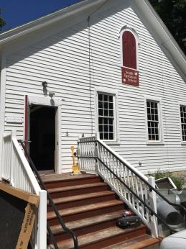

Prepared by:
Massachusetts Department of Public Health
Bureau of Environmental Health
Indoor Air Quality Program
September 2018

BACKGROUND
Building: | South Egremont School (SES)
Address: | 42 Main Street  South Egremont, MA
Assessment coordinated via: | Juliette Haas, Health Director, Egremont
Reason for Request: | Assessment for general indoor air quality (IAQ) concerns and lead paint
Date of Assessment: | August 23, 2018
Massachusetts Department of Public Health/Bureau of Environmental Health (MDPH/BEH) Staff Conducting Assessment: | Michael Feeney, Director, IAQ Program
Date of Building Construction: | This building was originally constructed in 1881
Building/Site Description: | This building is a two-room schoolhouse with a peaked roof
Building Population: | This building is used by approximately 20 people, including students in pre-k/kindergarten and staff
Windows: | Openable

METHODS
Please refer to the IAQ Manual for methods, sampling procedures, and interpretation of results (MDPH, 2015). No air testing was conducted as the building was not occupied during the visit.

RESULTS and DISCUSSION

Ventilation
The SES has no installed mechanical ventilation. Both rooms have grills that appear to be connected to a forced hot air heating system. Ductwork and mechanical systems were not installed at the time of this assessment. Windows in the building open to provide fresh air.

Microbial/Moisture Concerns
A water-damaged ceiling tile was observed in one room. This water damage is likely from a leak in the chimney/roof junction and does not appear to be recent. Wall-to-wall carpeting was found to be water-stained around the entrance of the front room.
Carpets should be cleaned annually (or semi-annually in soiled/high traffic areas) in accordance with Institute of Inspection, Cleaning and Restoration Certification (IICRC) recommendations, (IICRC, 2012). The service life of carpeting is approximately 10-11 years (IICRC, 2002). As noted, carpeting was observed to be worn and stained. Carpeting of this age and condition becomes increasingly difficult to clean and maintain and may be a source of particulate matter to the indoor environment. Regular cleaning with a high efficiency particulate air (HEPA) filtered vacuum in combination with an annual cleaning will help to reduce accumulation and potential aerosolization of materials from carpeting.
Of note is the condition of the crawlspace. Cement on the western side of the crawlspace appears to be wet (Picture 1), which can be attributed to water penetration through the foundation. On the west wall of the building is a newly constructed staircase, which appears to have seams that may allow water to penetrate through the foundation. In addition, downspouts from the roof appear to empty into cement splash blocks (Picture 2). In Picture 2, the splash block appears to be tilted towards instead of away from the foundation, which would allow for water to gather along the foundation.
It is recommended that downspouts direct water at least five feet away from the base of the foundation. The ground area at the foundation should be covered with a water impermeable material (e.g., clay) that is sloped away from the foundation at a rate of 1 foot height by 5 feet in length so that rainwater shed off walls will drain away from the foundation.

Other IAQ Evaluations
As part of the assessment, concerns were raised with regard to the condition of paint that may contain lead in the building. According to test results, lead paint was found on window sills, window frames and chair rails. IAQ staff noted that window sills, window frames and chair rails were covered with a heavy coat of material and no paint chips or flaking was noted on any of these materials. The building has undergone a number of renovations since it was originally constructed. Several layers of paneling exist over walls, which would render the original walls inaccessible. A building like the SES would be classified as a child occupied building under the current Massachusetts lead paint laws [M.G.L. c. 189A a.k.a. Lead Law). The Lead Law requires the removal or covering of lead paint hazards in residences (defined as premises) built before 1978 where any children under 6 live (MDPH, 2018). The Lead Law requires proper remediation efforts for child occupied buildings.
The department shall also, in consultation with the director, adopt regulations specifying licensing requirements and safety procedures to be used by all persons employed in performing renovations or rehabilitation in a residential premises or child-occupied facilities in a manner that disturbs paint, plaster or other materials containing dangerous levels of lead. [M.G.L. c 197B(c)].
Pursuant to this requirement, the MA Department of Labor Standards (MDLS) promulgated the document “Operation & Maintenance Guidelines for Public Buildings with Lead-based Paint” (MDLS, 1996), which is included with this assessment as Appendix A. In this document, it is recommended that a building operator adopt the following housekeeping practices if lead-paint is present:
- Lead-contaminated dust can be generated by the friction of painted surfaces. Windows, sills, stools and troughs are likely areas for this type of lead-contaminated dust accumulation.
- The recommended housekeeping procedure is periodic damp wiping or wet cleaning of areas such as those mentioned above. Horizontal surfaces (e.g., floors, stairs) where children play frequently should receive special attention.
- Increased efficiency vacuum cleaner bags are advertised by many manufacturers for use with normal vacuum cleaners. Their use is recommended as a reasonably inexpensive precaution for routine cleaning where no lead based paint (LBP) chips or dust are present, though no scientific data currently exist to verify the manufacturer's advertising claims. If HEPA vacuum equipment is available, its periodic use for normal cleaning is strongly recommended. (MDLS, 1996).

During this assessment, a cleaning contractor was observed cleaning the building interior, including wet wiping of flat surfaces, which would be consistent with recommended MDLS housekeeping practices.

CONCLUSION AND RECOMMENDATIONS
In view of the findings at the time of the visit, the following recommendations are made:
- Continue to following the recommended MDLS practices detailed in the guideline “Operation & Maintenance Guidelines for Public Buildings with Lead-based Paint” (Appendix A).
- Replace water-damaged wall-to-wall carpeting.
- Repair holes/seams in the building envelope, such as in the side steps, to prevent water accumulation in the crawlspace.
- Consider extending downspouts at least five feet from the foundation.
- During occupied periods use openable windows for fresh air. Ensure they are tightly closed when the building is not occupied to prevent moisture and pest infiltration. Ensure openable windows have intact screens to prevent pest entry.
- Refer to resource manual and other related indoor air quality documents located on the MDPH’s website for further building-wide evaluations and advice on maintaining public buildings. These documents are available at http://mass.gov/dph/iaq.

REFERENCES
MDLS. 1996. MA Department of Labor Standards (MDLS) promulgated the document “Operation & Maintenance Guidelines for Public Buildings with Lead-based Paint”.
MDPH. 2015. Massachusetts Department of Public Health. Indoor Air Quality Manual: Chapters I-III. Available at: http://www.mass.gov/eohhs/gov/departments/dph/programs/environmental-health/exposure-topics/iaq/iaq-manual/.
MDPH. 2018. Massachusetts Department of Public Health Lead Paint Laws [M.G.L. c. 189A].
Picture 1
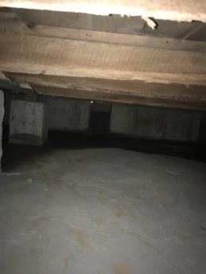
Moisture in the west side of the crawlspace
Picture 2
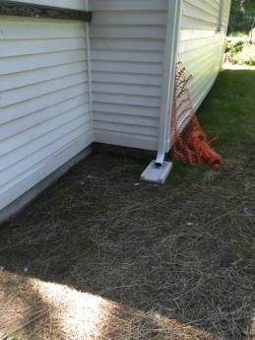
Downspout emptying at base of foundation onto splash block

