INDOOR AIR QUALITY ASSESSMENT

South Elementary School
831 Main Street
Hingham, Massachusetts 02043

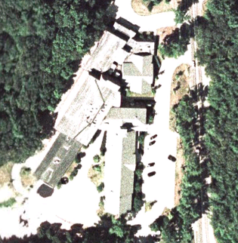
Prepared by:
Massachusetts Department of Public Health
Bureau of Environmental Health
Indoor Air Quality Program
January 2009

Background/Introduction
At the request of David Killory, Director of Business and Support Services for the Hingham Public Schools (HPS), the Massachusetts Department of Public Health (MDPH), Bureau of Environmental Health (BEH) provided assistance and consultation regarding indoor air quality concerns at the South Elementary School (SES), 851 Main Street, Hingham Massachusetts. On November 11, 2008, a visit to conduct an assessment was made to the SES by Cory Holmes and James Tobin, Environmental Analysts/Inspectors in BEH’s Indoor Air Quality (IAQ) Program.
The SES is a two-story, red-brick building originally constructed in 1948. In 1997-1998, the building underwent extensive renovations, which included new windows, mechanical ventilation, roof and interior renovation of building materials (e.g., floors, ceilings, paint). The school consists of general classrooms, a gymnasium, kitchen/cafeteria, media center, computer room, art room/music rooms, teacher work rooms and office space. Windows are openable throughout the building. Some classrooms have ceiling fans to facilitate air circulation.

Methods
Air tests for carbon dioxide, carbon monoxide, temperature and relative humidity were conducted with the TSI, Q-TRAK™ IAQ Monitor, Model 7565/8554. Air tests for airborne particulate matter with a diameter less than 2.5 micrometers were taken with the TSI, DUSTTRAK™ Aerosol Monitor Model 8520. BEH staff also performed a visual inspection of building materials for water damage and/or microbial growth.

Results
The SES currently houses grades pre-K through 5 with a student population of 610 and a staff of approximately 85. Tests were taken under normal operating conditions and results appear in Table 1.

Discussion

Ventilation
It can be seen from Table 1 that carbon dioxide levels were above 800 parts per million (ppm) in thirteen of fifty-two areas, indicating adequate air exchange in approximately 75 percent of the areas surveyed on the day of the assessment. Several areas with carbon dioxide levels below 800 ppm however, were sparsely populated, unoccupied and/or had windows open, which can greatly reduce carbon dioxide levels. Carbon dioxide levels would be expected to be higher with full occupancy and with windows shut. It is also important to note that outside temperatures were below and/or close to freezing on the day of the assessment. During such extreme temperatures, outdoor air intake is typically limited to prevent freezing of pipes. Limiting outside air intake can also contribute to an increase in carbon dioxide levels.
Fresh air in exterior classrooms is supplied by unit ventilator (univent) systems (Picture 1). A univent is designed to draw air from outdoors through a fresh air intake located on the exterior wall of the building (Picture 2). Return air is drawn through an air intake located at the base of the unit (Figure 1). Fresh and return air are mixed, filtered, heated and provided to classrooms through an air diffuser located in the top of the unit. Univents in a several areas were found blocked by various items (Picture 3), limiting airflow in these rooms. In order for univents to provide fresh air as designed, air intakes and returns must remain free of obstructions. Noises were detected emanating from univents in rooms 112 and 134. In these rooms, it appeared that paper or other items had fallen into the air diffuser and were being agitated by the univent fan. BEH staff attempted to remove the objects; however, the attempt was unsuccessful.
Exhaust ventilation in classrooms is provided by wall or ceiling-mounted vents (Pictures 4 through 6) powered by rooftop motors. At the time of the assessment, exhaust vents were operating in all areas surveyed in the building. It is important to note that classroom exhaust vents are located above or near hallway doors, which can limit exhaust efficiency. When classroom doors are open, exhaust vents tend to draw air from the hallway, thereby reducing the effectiveness of the vents to remove common environmental pollutants from classrooms.
Fresh air for common/centrally located areas is provided by air handling units (AHUs) located on the roof or in mechanical rooms. AHUs draw in air through outdoor air intakes; filter, heat and/or cool the air, and then distribute it to occupied areas via ceiling-mounted air diffusers (Picture 7). Exhaust air is returned back to the AHUs via ceiling-mounted return vents (Picture 8). These systems appeared to be operating at the time of the assessment. It was reported by school officials that the mechanical ventilation systems at SES are computer-controlled and maintained under a preventive maintenance contract by a private HVAC engineering firm.
To maximize air exchange, the MDPH recommends that both supply and exhaust ventilation operate continuously during periods of school occupancy. In order to have proper ventilation with a mechanical supply and exhaust system, the systems must be balanced to provide an adequate amount of fresh air to the interior of a room while removing stale air from the room. It is recommended that existing ventilation systems be re-balanced every five years to ensure adequate air systems function (SMACNA, 1994). The date of the last balancing of these systems reportedly occurred in 2007.
The Massachusetts Building Code requires a minimum ventilation rate of 15 cubic feet per minute (cfm) per occupant of fresh outside air or have openable windows in each room (SBBRS, 1997; BOCA, 1993). The ventilation must be on at all times that the room is occupied. Providing adequate fresh air ventilation with open windows and maintaining the temperature in the comfort range during the cold weather season is impractical. Mechanical ventilation is usually required to provide adequate fresh air ventilation.
Carbon dioxide is not a problem in and of itself. It is used as an indicator of the adequacy of the fresh air ventilation. As carbon dioxide levels rise, it indicates that the ventilating system is malfunctioning or the design occupancy of the room is being exceeded. When this happens a buildup of common indoor air pollutants can occur, leading to discomfort or health complaints. The Occupational Safety and Health Administration (OSHA) standard for carbon dioxide is 5,000 parts per million parts of air (ppm). Workers may be exposed to this level for 40 hours/week based on a time weighted average (OSHA, 1997).
The MDPH uses a guideline of 800 ppm for publicly occupied buildings. A guideline of 600 ppm or less is preferred in schools due to the fact that the majority of occupants are young and considered to be a more sensitive population in the evaluation of environmental health status. Inadequate ventilation and/or elevated temperatures are major causes of complaints such as respiratory, eye, nose and throat irritation, lethargy and headaches. For more information concerning carbon dioxide, please see Appendix A.
Indoor temperature readings on the day of the assessment ranged from 65º F to 71º F, which were below or close to the low end of the MDPH comfort guidelines. The MDPH recommends that indoor air temperatures be maintained in a range of 70 º F to 78 º F in order to provide for the comfort of building occupants. In many cases concerning indoor air quality, fluctuations of temperature in occupied spaces are typically experienced, even in a building with an adequate fresh air supply. In guidance room 106-C, an occupant had comfort complaints related to the proximity of the supply diffuser, which was positioned directly over the individual’s desk. To improve comfort, the diffuser can easily be relocated several feet away from the occupant’s work station.
The relative humidity measurements in the building ranged from 12 to 25 percent, which were below the MDPH recommended comfort range. The MDPH recommends a comfort range of 40 to 60 percent for indoor air relative humidity. Relative humidity levels in the building would be expected to drop during the winter months due to heating. The sensation of dryness and irritation is common in a low relative humidity environment. Low relative humidity is a very common problem during the heating season in the northeast part of the United States.

Microbial/Moisture Concerns
BEH staff performed a visual inspection of building materials for water damage and/or microbial growth. Plants were noted in several classrooms. Plants can be a source of pollen and mold, which can be respiratory irritants for some individuals. Plants should be properly maintained and equipped with drip pans to prevent water damage to porous building materials, which can lead to mold growth. Plants should also be located away from ventilation sources (e.g., air intakes, univent diffusers) to prevent the entrainment and/or aerosolization of dirt, pollen or mold.
A few areas had water-damaged ceiling tiles which can indicate leaks from either the roof or plumbing system (Picture 9/Table 1). Water-damaged ceiling tiles can provide a source of mold and should be replaced after a water leak is discovered and repaired.
Water-damaged plaster, peeling paint and efflorescence was noted on the library ceiling (Pictures 10 and 11). Efflorescence is a characteristic sign of water damage, but it is not mold growth. As moisture penetrates and works its way through porous building materials (e.g., brick, plaster, cement), water-soluble compounds in the material dissolves, creating a solution. As this solution moves to the surface of the material, the water evaporates, leaving behind white, powdery mineral deposits. This condition indicates that moisture is penetrating through the building envelope in this area. This area should be cleaned, sealed, re-painted and monitored for further damage. If evidence of water penetration recurs, an evaluation of the building envelope/exterior in this area should be conducted for possible sources of water penetration.
Open seams between sink countertops and walls were observed in several rooms (Table 1). If not watertight, water can penetrate through the seam, causing water damage. Improper drainage or sink overflow can lead to water penetration into the countertop, cabinet interior and areas behind cabinets. Water penetration and chronic exposure of porous and wood-based materials can cause these materials to swell and show signs of water damage.

Other IAQ Evaluations
Indoor air quality can be negatively influenced by the presence of respiratory irritants, such as products of combustion. The process of combustion produces a number of pollutants. Common combustion emissions include carbon monoxide, carbon dioxide, water vapor and smoke (fine airborne particle material). Of these materials, exposure to carbon monoxide and particulate matter with a diameter of 2.5 micrometers (μm) or less (PM2.5) can produce immediate, acute health effects upon exposure. To determine whether combustion products or airborne particulate matter related to respiratory irritation were present, BEH staff obtained measurements for carbon monoxide and PM2.5.

Carbon Monoxide
Carbon monoxide is a by-product of incomplete combustion of organic matter (e.g., gasoline, wood and tobacco). Exposure to carbon monoxide can produce immediate and acute health affects. Several air quality standards have been established to address carbon monoxide and prevent symptoms from exposure to these substances. The MDPH established a corrective action level concerning carbon monoxide in ice skating rinks that use fossil-fueled ice resurfacing equipment. If an operator of an indoor ice rink measures a carbon monoxide level over 30 ppm, taken 20 minutes after resurfacing within a rink, that operator must take actions to reduce carbon monoxide levels (MDPH, 1997).
The American Society of Heating Refrigeration and Air-Conditioning Engineers (ASHRAE) has adopted the National Ambient Air Quality Standards (NAAQS) as one set of criteria for assessing indoor air quality and monitoring of fresh air introduced by HVAC systems (ASHRAE, 1989). The NAAQS are standards established by the US EPA to protect the public health from six criteria pollutants, including carbon monoxide and particulate matter (US EPA, 2006). As recommended by ASHRAE, pollutant levels of fresh air introduced to a building should not exceed the NAAQS levels (ASHRAE, 1989). The NAAQS were adopted by reference in the Building Officials & Code Administrators (BOCA) National Mechanical Code of 1993 (BOCA, 1993), which is now an HVAC standard included in the Massachusetts State Building Code (SBBRS, 1997). According to the NAAQS, carbon monoxide levels in outdoor air should not exceed 9 ppm in an eight-hour average (US EPA, 2006).
Carbon monoxide should not be present in a typical, indoor environment. If it is present, indoor carbon monoxide levels should be less than or equal to outdoor levels. On the day of assessment, outdoor carbon monoxide concentrations were non-detect (ND). No measurable levels of carbon monoxide were detected in the building (Table 1).

Particulate Matter (PM2.5)
The US EPA has established NAAQS limits for exposure to particulate matter. Particulate matter is airborne solids that can be irritating to the eyes, nose and throat. The NAAQS originally established exposure limits to particulate matter with a diameter of 10 μm or less (PM10). According to the NAAQS, PM10 levels should not exceed 150 microgram per cubic meter (μg/m³) in a 24-hour average (US EPA, 2006). These standards were adopted by both ASHRAE and BOCA. Since the issuance of the ASHRAE standard and BOCA Code, US EPA established a more protective standard for fine airborne particles. This more stringent PM2.5 standard requires outdoor air particle levels be maintained below 35 μg/m³ over a 24-hour average (US EPA, 2006). Although both the ASHRAE standard and BOCA Code adopted the PM10 standard for evaluating air quality, MDPH uses the more protective PM2.5 standard for evaluating airborne particulate matter concentrations in the indoor environment.
Outdoor PM2.5 concentrations were measured at 7 μg/m³ (Table 1). PM2.5 levels measured indoors ranged from 1 to 8 μg/m³ (Table 1), which were well below the NAAQS PM2.5 level of 35 μg/m³. Frequently, indoor air levels of particulates (including PM2.5) can be at higher levels than those measured outdoors. A number of mechanical devices and/or activities that occur in schools can generate particulate during normal operations. Sources of indoor airborne particulates may include but are not limited to particles generated during the operation of fan belts in the HVAC system, cooking in the cafeteria stoves and microwave ovens; use of photocopiers, fax machines and computer printing devices; operation of an ordinary vacuum cleaner and heavy foot traffic indoors.

Volatile Organic Compounds
Indoor air quality can also be impacted by the presence of materials containing volatile organic compounds (VOCs). VOCs are substances that have the ability to evaporate at room temperature. Frequently, exposure to low levels of total VOCs (TVOCs) may produce eye, nose, throat and/or respiratory irritation in some sensitive individuals. For example, chemicals evaporating from a paint can stored at room temperature would most likely contain VOCs. In an effort to identify materials that can potentially increase indoor VOC concentrations, BEH staff examined classrooms for products containing these respiratory irritants.
Several classrooms contained dry erase boards and dry erase board markers. Materials such as dry erase markers and dry erase board cleaners may contain VOCs, such as methyl isobutyl ketone, n-butyl acetate and butyl-cellusolve (Sanford, 1999), which can be irritating to the eyes, nose and throat. Cleaning products were also found on countertops and in unlocked cabinets beneath sinks in some classrooms (Pictures 12 and 13). Like dry erase materials, cleaning products contain VOCs and other chemicals that can be irritating to the eyes, nose and throat of sensitive individuals.
Plug-in air fresheners and deodorizing materials were observed in several areas (Picture 14). Air deodorizers contain chemicals that can be irritating to the eyes, nose and throat of sensitive individuals. Many air fresheners contain 1,4-dichlorobenzene, a VOC which may cause reductions in lung function (NIH, 2006). Furthermore, deodorizing agents do not remove materials causing odors, but rather mask odors that may be present in the area.

Other Conditions
Other conditions that can affect indoor air quality were observed during the assessment. In several classrooms, items were observed on windowsills, tabletops, counters, bookcases and desks (Picture 3). The large number of items stored in classrooms provides a source for dusts to accumulate. These items (e.g., papers, folders, boxes) make it difficult for custodial staff to clean. Items should be relocated and/or be cleaned periodically to avoid excessive dust build up. In addition, these materials can accumulate on flat surfaces (e.g., desktops, shelving and carpets) in occupied areas and subsequently be re-aerosolized causing further irritation.
A number of supply and exhaust/return vents as well as personal fans were observed to have accumulated dust/debris (Pictures 6 through 8). If exhaust vents are not functioning, backdrafting can occur, which can re-aerosolize accumulated dust particles. Re-activated supply vents and fans can also aerosolize dust accumulated on vents/fan blades.
Accumulated dry erase particulate was observed in dry erase board trays (Picture 15). When windows are opened and/or mechanical ventilation components are operating, these materials can become airborne. Once aerosolized, they can act as irritants to the eyes and respiratory system.
Bird and insect nests were observed in a classroom (Picture 16). Nests can contain bacteria and may also be a source of allergenic material. Nests should be placed in resealable bags to prevent aerosolization of allergenic material.
Finally, airflow in many classrooms is supplemented by ceiling fans. Ceiling fans are used to aid in air circulation within the room, especially during warmer months when windows are open. It is important to note that before operating, ceiling fans must be cleaned of dust buildup. Accumulated dust on the fan blades can aerosolize causing irritation to eyes and respiratory system.

Conclusions/Recommendations
In view of the findings at the time of the visit, the following recommendations are made to improve indoor air quality:
- Continue to operate all ventilation systems throughout the building (e.g., gym, auditorium, classrooms) continuously during periods of school occupancy independent of thermostat control to maximize air exchange.
- Remove all blockages from univents and exhaust vents to facilitate airflow. Consider removing sections of sink countertop or drill holes in wood (Picture 3) to facilitate airflow into exhaust vents.
- Investigate univent noise issues in rooms 112 and 134. Ensure item in room 134 univent has been removed.
- Close classroom doors to maximize air exchange.
- Use openable windows and ceiling/personal fans in conjunction with mechanical ventilation to supplement air exchange. Care should be taken to ensure windows are properly closed at night and weekends to avoid the freezing of pipes and potential flooding.
- To improve comfort in guidance in room 106-C, relocate air diffuser several feet away from the occupant’s work station.
- Consider adopting a balancing schedule of every 5 years for all mechanical ventilation systems, as recommended by ventilation industrial standards (SMACNA, 1994).
- For buildings in New England, periods of low relative humidity during the winter are often unavoidable. Therefore, scrupulous cleaning practices should be adopted to minimize common indoor air contaminants whose irritant effects can be enhanced when the relative humidity is low. To control for dusts, a high efficiency particulate arrestance (HEPA) filter equipped vacuum cleaner in conjunction with wet wiping of all surfaces is recommended. Avoid the use of feather dusters. Drinking water during the day can help ease some symptoms associated with a dry environment (throat and sinus irritations).
- Ensure leaks are repaired. Remove/replace water damaged ceiling tiles. Examine the areas above and around for mold growth. Disinfect areas of water leaks with an appropriate antimicrobial.
- Ensure plants have drip pans. Examine drip pans periodically for mold growth and disinfect with an appropriate antimicrobial where necessary. Remove plants from the air stream of mechanical ventilation.
- Scrape, clean, seal and re-paint water-damaged library ceiling; if evidence of water penetration recurs, then an evaluation of the building envelope/exterior in this area should be conducted for possible sources of water penetration.
- Seal areas around sinks to prevent water-damage to the interior of cabinets and adjacent wallboard.
- Clean accumulated dust and debris periodically from the surface of air diffusers, exhaust vents and blades of personal and ceiling fans. Exhaust grills may have to be removed in order for proper access for cleaning.
- Store cleaning products properly and out of reach of students.
- Refrain from using air fresheners and deodorizers to prevent exposure to VOCs.
- Relocate or consider reducing the amount of materials stored in classrooms to allow for more thorough cleaning of classrooms. Clean items regularly with a wet cloth or sponge to prevent excessive dust build-up.
- Clean dry erase board trey and/or chalk treys periodically to prevent accumulation of particulate.
- Bird and Insect nests should be placed in resealable bags to prevent aerosolization of allergenic material.
- Consider adopting the US EPA (2000) document, “Tools for Schools”, to maintain a good indoor air quality environment on the building. This document can be downloaded from the Internet at: http://www.epa.gov/iaq/schools/index.html.
- Refer to resource manuals and other related indoor air quality documents for further building-wide evaluations and advice on maintaining public buildings. Copies of these materials are located on the MDPH’s website: http://mass.gov/dph/indoor_air

References
ASHRAE. 1989. Ventilation for Acceptable Indoor Air Quality. American Society of Heating, Refrigeration and Air Conditioning Engineers. ANSI/ASHRAE 62-1989
BOCA. 1993. The BOCA National Mechanical Code/1993. 8th ed. Building Officials & Code Administrators International, Inc., Country Club Hills, IL.
MDPH. 1997. Requirements to Maintain Air Quality in Indoor Skating Rinks (State Sanitary Code, Chapter XI). 105 CMR 675.000. Massachusetts Department of Public Health, Boston, MA.
NIH. 2006. Chemical in Many Air Fresheners May Reduce Lung Function. NIH News. National Institute of Health. July 27, 2006. http://www.nih.gov/news/pr/jul2006/niehs-27.htm
OSHA. 1997. Limits for Air Contaminants. Occupational Safety and Health Administration. Code of Federal Regulations. 29 C.F.R 1910.1000 Table Z-1-A.
Sanford. 1999. Material Safety Data Sheet (MSDS No: 198-17). Expo® Dry Erase Markers Bullet, Chisel, and Ultra Fine Tip. Sanford Corporation, Bellwood, IL.
SBBRS. 1997. Mechanical Ventilation. State Board of Building Regulations and Standards. Code of Massachusetts Regulations. 780 CMR 1209.0.
SMACNA. 1994. HVAC Systems Commissioning Manual. 1st ed. Sheet Metal and Air Conditioning Contractors’ National Association, Inc., Chantilly, VA.
US EPA. 2000. Tools for Schools. Office of Air and Radiation, Office of Radiation and Indoor Air, Indoor Environments Division (6609J). EPA 402-K-95-001, Second Edition. http://www.epa.gov/iaq/schools/tools4s2.html
US EPA. 2006. National Ambient Air Quality Standards (NAAQS). . US Environmental Protection Agency, Office of Air Quality Planning and Standards, Washington, DC. http://www.epa.gov/air/criteria.html.
Picture 1

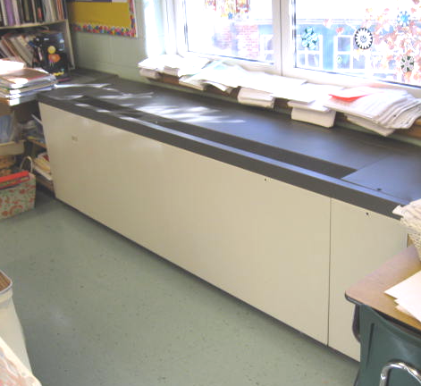

Classroom Univent

Picture 2

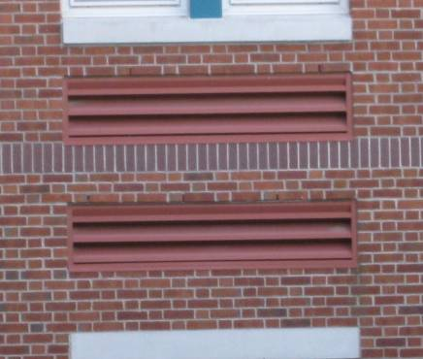

Univent Fresh Air Intakes
Picture 3

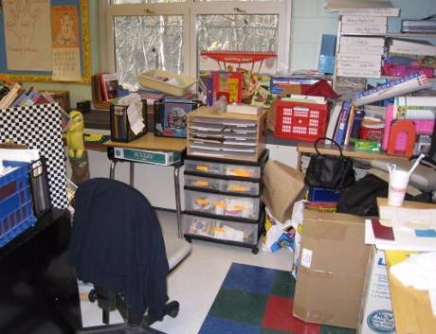

Accumulated Items in Classroom Obstructing Univent Airflow

Picture 4

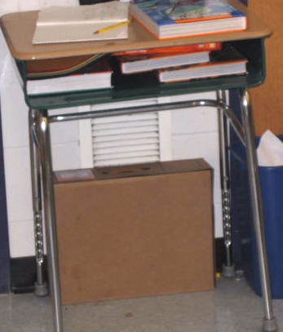

Partially Obstructed Exhaust Vent
Picture 5

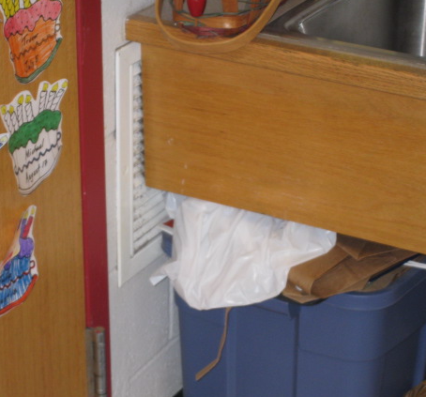

Wall-Mounted Exhaust Vent Partially Obstructed by Sink Countertop

Picture 6

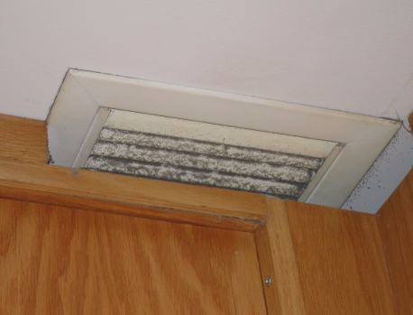

Ceiling-Mounted Exhaust Vent at Corner of Coat Closet, Note Accumulation of Dust/Debris
Picture 7

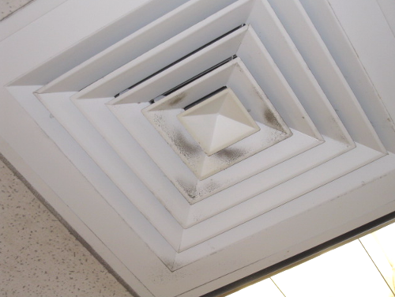

Ceiling-Mounted Supply Diffuser, Note Accumulation of Dust/Debris

Picture 8

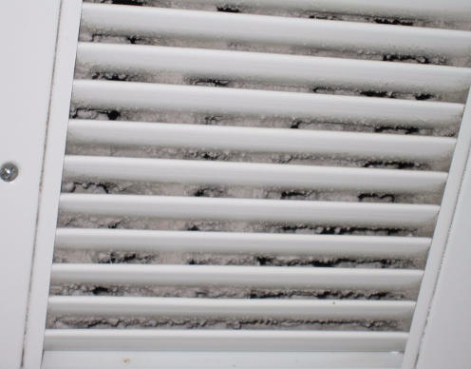

Ceiling-Mounted Exhaust/Return Vent, Note Accumulation of Dust/Debris
Picture 9

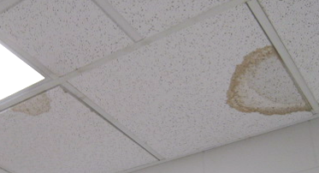

Water Damaged Ceiling Tiles in Hallway near Room 128

Picture 10

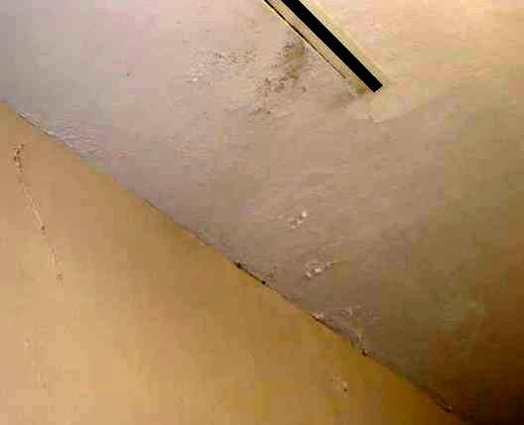

Water Damaged Plaster, Peeling Paint and Efflorescence on Library Ceiling
Picture 11

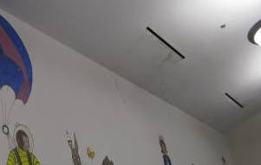

Water Damaged Plaster, Peeling Paint and Efflorescence on Library Ceiling

Picture 12

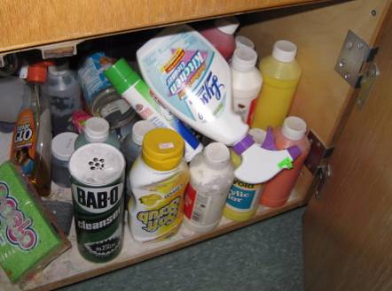

Various Cleaning Products beneath Sink
Picture 13

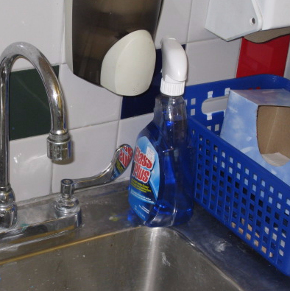

Spray Cleaning Product on Sink Countertop

Picture 14

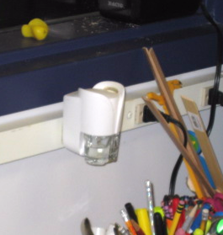

Plug-In Air Freshener
Picture 15

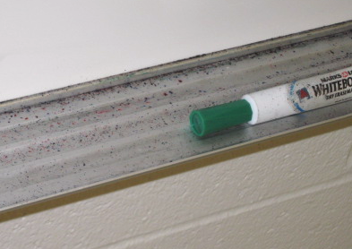

Dry Erase Particulate

Picture 16

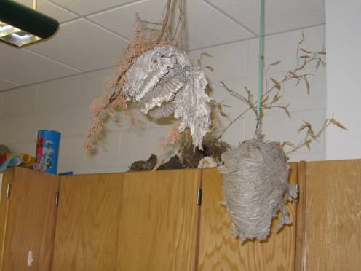\

Bird and Insect Nests
Location/ Room | Occupants  in Room | Temp  (°F) | Relative  Humidity  (%) | Carbon  Dioxide  (ppm) | Carbon Monoxide  (ppm) | PM2.5  (µg/m³) | Windows  Openable | Ventilation |  | Remarks
 |  |  |  |  |  |  |  | Supply | Exhaust | Remarks
Background |  | <32 | 30 | 350 | ND | 7 |  |  |  | Cold, partly cloudy, winds: NNW 11-20 mph
Main Office | 3 | 68 | 21 | 679 | ND | 1 | Y | Y | Y | PC
Planning Office | 0 | 65 | 15 | 660 | ND | 5 | Y | Y | N | DO
Nurse | 1 | 71 | 16 | 610 | ND | 2 | Y | Y | Y | DO
Library | 0 | 69 | 15 | 555 | ND | 4 | Y | Y | Y  dust, debris | Efflorescence on wall
Computer lab | 1 | 70 | 14 | 511 | ND | 4 | N | Y | Y | 26 computers
Gym | 15 | 70 | 14 | 490 | ND | 6 |  | Y | Y
Gym Office | 1 | 68 | 14 | 505 | ND | 4 | Y | Y | Y
Cafeteria | ~100 | 70 | 12 | 488 | ND | 5 | Y | Y | Y | DO
001 Book Storage | 0 | 69 | 13 | 516 | ND | 5 | N | Y | Y | PC, DO
002 | 19 | 69 | 16 | 810 | ND | 5 | Y | Y | Y
003 | 26 | 69 | 19 | 980 | ND | 5 | Y | Y | Y | DEM particulate, exhaust obstructed
004 | 23 | 69 | 18 | 910 | ND | 5 | Y | Y | Y | DO
005 | 1 | 69 | 15 | 633 | ND | 5 | N | Y | Y | DO, PF, CP
6 | 0 | 68 | 17 | 712 | ND | 6 | Y | Y | Y | Accumulated Items around UV; PF
7 | 0 | 69 | 17 | 813 | ND | 7 | Y | Y | Y | PF
8 | 0 | 69 | 17 | 777 | ND | 8 | Y | Y | Y | 20 occupants gone 5 minutes; space between sink backsplash and wall; PF
9 | 2 | 70 | 18 | 897 | ND | 8 | Y | UV off | Y | UV blocked in front by desk; 20 occupants gone 5 minutes
10 | 0 | 70 | 16 | 750 | ND | 7 | Y | Y | Y | UV blocked in front by desk; 22 occupants leaving upon BEH staff entering
015 | 19 | 68 | 16 | 558 | ND | 3 | Y | Y | Y | 1 WD CT near window
016 | 1 | 68 | 16 | 543 | ND | 4 | N | Y | Y | Plug-in AD
104 | 0 | 69 | 15 | 580 | ND | 3 | Y | Y | Y | PC, lamination machine, DO
106 C Guidance | 1 | 68 | 16 | 576 | ND | 3 | Y | Y | Y | Occupant airflow complaints, consider relocating supply vent away from occupant
106 | 2 | 68 | 16 | 582 | ND | 3 | N | Y | Y | DO
107 | 0 | 68 | 16 | 633 | ND | 2 | Y | Y | Y
108 | 10 | 69 | 16 | 620 | ND | 2 | Y | Y | Y | Plant, DO, dust/debris on vent
109 OT/PT | 0 | 69 | 16 | 631 | ND | 3 | Y | Y | Y | DO
110 | 7 | 68 | 16 | 630 | ND | 3 | Y | Y | Y | DO
111 | 12 | 70 | 19 | 706 | ND | 4 | Y | Y | Y
112 | 15 | 70 | 17 | 618 | ND | 5 | Y | Y | Y | noise from UV
120 | 1 | 67 | 20 | 801 | ND | 4 | Y | Y | Y | PF
121 | 3 | 69 | 17 | 634 | ND | 6 | Y | Y | Y | DO
123 | 8 | 68 | 14 | 582 | ND | 4 | Y | Y | Y | Window open, DO, PF
124 | 22 | 69 | 17 | 638 | ND | 5 | Y | Y | Y | DO
125 | 0 | 69 | 16 | 574 | ND | 4 | Y | Y | Y | CP, accumulated items
126 | 0 | 69 | 16 | 544 | ND | 6 | Y | UV off | Y | Nests (bird, wasp, bee); CFs
Hallway Outside 128 |  |  |  |  |  |  |  |  |  | 2 WD CTs
129 | 1 | 71 | 16 | 611 | ND | 5 | N | off | Y  dirt, debris
130 | 24 | 69 | 20 | 1034 | ND | 5 | Y | Y | Y | Clutter around teacher’s desk; microwave; oven; refrigerator; stove; space between sink backsplash and wall
131 | 24 | 69 | 18 | 855 | ND | 4 | Y | Y | Y
132 | 24 | 69 | 20 | 939 | ND | 4 | Y | Y | Y
133 | 26 | 67 | 19 | 876 | ND | 3 | Y | Y | Y | PF
134 | 21 | 67 | 20 | 732 | ND | 3 | Y | Y | Y | Noise from univent, exhaust obstructed
135 | 21 | 68 | 15 | 632 | ND | 6 | Y | Y | Y | Kiln in separate room with local exhaust
136 TV Studio | 0 | 68 | 15 | 673 | ND | 4 | N | Y | Y
201 | 2 | 69 | 18 | 809 | ND | 5 | Y | Y | Y | Window AC; 4 CFs; CP, space between sink backsplash and wall
202 | 2 | 65 | 15 | 734 | ND | 3 | Y | Y | Y | ~20 occupants gone 8 mins, DO, CP
203 | 0 | 67 | 17 | 783 | ND | 3 | Y | Y | Y | ~23 occupants gone 5 mins, AC, CP
204 | 0 | 67 | 20 | 903 | ND | 4 | Y | Y | Y | ~22 occupants gone 5 mins, AC, DO
205 | 22 | 68 | 25 | 1107 | ND | 3 | Y | Y | Y | AC, PF
206 | 27 | 67 | 21 | 790 | ND | 3 | Y | Y | Y | AC
207 | 21 | 67 | 17 | 654 | ND | 2 | Y | Y  dirt, debris | Y | Window AC; DEM; 4 CFs; PF; space between sink backsplash and wall
208 | 20 | 68 | 17 | 713 | ND | 3 | Y | Y | Y | Window AC; 4 CFs; DEM
209 Front | 0 | 69 | 16 | 653 | ND | 6 | N | Y | N | Microwave; water cooler

