INDOOR AIR QUALITY ASSESSMENT

South Hadley Council on Aging
45 Dayton Street
South Hadley, Massachusetts 01075



Prepared by:
Massachusetts Department of Public Health
Bureau of Environmental Health
Indoor Air Quality Program
February 2009

Background/Introduction
At the request of Sharon Hart, Director of Public Health for the South Hadley Board of Health, the Massachusetts Department of Public Health (MDPH), Bureau of Environmental Health (BEH) provided assistance and consultation regarding indoor air quality concerns at the South Hadley Council on Aging (SHCA), 45 Dayton Street, South Hadley, Massachusetts. The request was prompted by concerns of water damage and potential mold formation in the building. On September 17 and 22, 2008, visits to conduct an assessment were made to the SHCA by Lisa Hébert, Environmental Analyst in BEH’s Indoor Air Quality (IAQ) Program. Due to a water main break in the street on September 17, 2008 the building was closed to the public; therefore, Ms. Hébert returned on September 22, 2008 to conduct air sampling in the building while the building was occupied.
The SHCA is a building complex that consists of three separate wings that were constructed at various times (Figure 1). BEH was informed that the original structure in the SHCA was constructed as a school building (Woodlawn School) in 1924 (the west wing). This section of the building currently contains the kitchen, dining room and office space. An addition to the existing building was made in the 1950s, which now houses the exercise room (the center wing). In the late 1960s, the newest portion of the building was constructed, which now houses the billiards, ceramics, card and conference rooms as well as several smaller rooms utilized for nursing services (east wing).

Methods
Air tests for carbon monoxide, carbon dioxide, temperature and relative humidity were conducted with the TSI, Q-Trak, IAQ Monitor, Model 8551. Air tests for airborne particle matter with a diameter less than 2.5 micrometers were taken with the TSI, DUSTTRAK™ Aerosol Monitor Model 8520. BEH staff also performed visual inspection of building materials for water damage and/or microbial growth. Moisture content of porous building materials was measured with a Delmhorst, BD-2000 Model, Moisture Detector equipped with a Delmhorst Standard Probe.

Results
The SHCA has an employee population of approximately 15 and is used by over 300 individuals on a daily basis. Tests were taken under normal operating conditions and results appear in Table 1. Air sampling results are listed in the tables by location that the air sample was taken. Moisture testing results appear in Table 2.

Discussion
Ventilation
It can be seen from Table 1 that carbon dioxide levels were above 800 parts per million (ppm) in 7 of 25 areas at the time of the assessment, indicating adequate air exchange in many areas surveyed on September 22, 2008. However, all elevated readings were in rooms located in the east wing, indicating less than adequate air exchange in that portion of the building complex.
It is also important to note that several rooms throughout the SHCA were empty/sparsely populated, which can greatly reduce carbon dioxide levels. Carbon dioxide levels would be expected to increase with full occupancy and windows closed.
Ventilation is provided to the west (original building) and center wings by means of five air-handling units (AHUs). One AHU services the exercise room, two AHUs serve the large dining room, and the remaining two AHUs serve the offices, library and conference room of the west wing. Fresh air is provided by rooftop fresh air intakes and is distributed to areas of the building by fresh air diffusers connected to ductwork. Air is returned to AHUs through ceiling-mounted grilles connected by ductwork (Pictures 1 to 3).
Ventilation is provided to the east wing by means of univents (Picture 4). Air conditioning is provided to this wing by wall-mounted air conditioners with rooftop condensers. No means of exhaust is provided for these rooms. It appears that a portion of the conference room was subdivided into three small offices utilized by the public health nurse, the foot clinic and the nurse’s file room. These rooms lack a fresh air supply, exhaust ventilation, as well as windows.
To maximize air exchange, the MDPH recommends that both supply and exhaust ventilation operate continuously during periods of building occupancy. In order to have proper ventilation with a mechanical supply and exhaust system, the systems must be balanced to provide an adequate amount of fresh air to the interior of a room while removing stale air from the room. It is recommended that HVAC systems be re-balanced every five years to ensure adequate air systems function (SMACNA, 1994). The date of the last balancing of these systems was not available at the time of the assessment.
The Massachusetts Building Code requires a minimum ventilation rate of 20 cubic feet per minute (cfm) per occupant of fresh outside air or have openable windows in each room (SBBRS, 1997; BOCA, 1993). The ventilation must be on at all times that the building is occupied. Providing adequate fresh air ventilation with open windows and maintaining the temperature in the comfort range during the cold weather season is impractical. Mechanical ventilation is usually required to provide adequate fresh air ventilation.
Carbon dioxide is not a problem in and of itself. It is used as an indicator of the adequacy of the fresh air ventilation. As carbon dioxide levels rise, it indicates that the ventilating system is malfunctioning or the design occupancy of the room is being exceeded. When this happens, a buildup of common indoor air pollutants can occur, leading to discomfort or health complaints. The Occupational Safety and Health Administration (OSHA) standard for carbon dioxide is 5,000 parts per million parts of air (ppm). Workers may be exposed to this level for 40 hours/week, based on a time-weighted average (OSHA, 1997).
The MDPH uses a guideline of 800 ppm for publicly occupied buildings. A guideline of 600 ppm or less is preferred in schools due to the fact that the majority of occupants are young and considered to be a more sensitive population in the evaluation of environmental health status. Inadequate ventilation and/or elevated temperatures are major causes of complaints such as respiratory, eye, nose and throat irritation, lethargy and headaches. For more information concerning carbon dioxide, consult Appendix A.
Temperature measurements in the building ranged from 60° F to 72° F, which were within the MDPH recommended range in approximately one half of the areas surveyed (Table 1). The MDPH recommends that indoor air temperatures be maintained in a range of 70º F to 78º F in order to provide for the comfort of building occupants. In many cases concerning indoor air quality, fluctuations of temperature in occupied spaces are typically experienced, even in a building with an adequate fresh air supply.
The relative humidity measured in the building ranged from 52 to 62 percent at the time of the assessment, which was within the MDPH recommended comfort range in the majority of areas surveyed (Table 1). The MDPH recommends a comfort range of 40 to 60 percent for indoor air relative humidity. It is important to note however, that relative humidity measured indoors exceeded outdoor measurements (range +11-21 percent). This increase in relative humidity can indicate that the exhaust system alone is not operating sufficiently to remove normal indoor air pollutants (e.g., water vapor from respiration). Moisture removal is important since the sensation of heat conditions increase as relative humidity increases (the relationship between temperature and relative humidity is called the heat index). As indoor temperature rises, the addition of more relative humidity will make occupants feel hotter. If moisture is removed, the comfort of the individuals is increased. Removal of moisture from the air, however, can have some negative effects. The sensation of dryness and irritation is common in a low relative humidity environment. Low relative humidity is a very common problem during the heating season in the northeast part of the United States.

Microbial/Moisture Concerns
Several potential sources of water damage and/or mold growth were observed at SHSC. Roof drain on north wing was obstructed with debris (Picture 5). Standing water was observed on the roof of the east wing (Picture 6). Roof leaks have resulted in numerous water damaged ceiling tiles throughout the building, particularly in the conference room and its adjacent smaller rooms (Picture 7). BEH was informed that the water damaged ceiling tiles in the exercise room were a result of mechanical issues with the air conditioner rather than a roof leak. In addition to ceiling tiles and gypsum wallboard, door casings as well as carpeting in the east wing exhibited substantial water damage. Peeling paint, water damaged plaster and efflorescence was observed on the ceiling of the Meals on Wheels entrance (Picture 8). Efflorescence is a characteristic sign of water damage to plaster, but it is not mold growth. As moisture penetrates and works its way through seams in the roof membrane, water-soluble compounds in the plaster dissolve, creating a solution. As this solution moves to the surface of the ceiling, the water evaporates, leaving behind white, powdery mineral deposits. This condition indicates that moisture is migrating through the ceiling in this area.
The US Environmental Protection Agency (US EPA) and the American Conference of Governmental Industrial Hygienists (ACGIH) recommend that porous materials be dried with fans and heating within 24 to 48 hours of becoming wet (US EPA, 2001; ACGIH, 1989). If not dried within this time frame, mold growth may occur. Once mold has colonized porous materials, they are difficult to clean and should be removed/discarded.
Numerous plants were observed throughout the SHCA, some of which were located on top of univents. Plant soil and drip pans can serve as a source of mold growth. Plants should be properly maintained and be equipped with drip pans. Drip pans should be examined and cleaned with an antimicrobial as necessary. Plants should also be located away from the air stream of mechanical ventilation to prevent aerosolization of dirt, pollen or mold.
In the card room, evidence of a leaking trap was observed below the sink. Moist debris was observed in the cabinet below the sink as well. Debris was also observed to be strewn in the dirt crawlspace as well as in standing water in the basement (Picture 9). In addition, several cardboard boxes stored in this room appeared to be water damaged.
In order for building materials to support mold growth, a source of water exposure is necessary. Identification and elimination of the source of water moistening building materials is necessary to control mold growth. Materials with increased moisture content over normal concentrations may indicate the possible presence of mold growth. In an effort to ascertain moisture content of gypsum wallboard (GW), wood and carpeting, a Delmhorst probe was inserted into the surfaces of GW, wood and carpeting in portions of the east wing. The Delmhorst probe is set to sound a signal when a moisture reading of > 0.5 percent in GW or > 15 in wood is detected. Many porous materials in the Board of Health nurse’s office tested during the assessment were found to have high moisture content (Table 2).
Please note, moisture content is detected as a real time measurement of the conditions present in the building at the time of the assessment. The building was evaluated on a cloudy day, with an outdoor temperature of 65 º F and relative humidity of 41 percent. Moisture content of materials may increase or decrease depending on building and weather conditions. For example, during the normal operation of a heating, ventilating and air-conditioning (HVAC) system, moisture is introduced into a building during weather with high relative humidity. As indoor relative humidity levels increase, porous building materials, such as GW, plywood or carpeting, can absorb moisture. The moisture content of materials can fluctuate with increases or decreases in indoor relative humidity.
BEH staff examined the exterior of the building to identify breaches in the building envelope that could provide a source of water penetration. Several potential sources were identified:
- Roof drains are clogged with debris. Evidence of pooled water was observed on the roof adjacent to one drain.
- Moss growth was observed on the roof (Picture 10). The two main requirements of moss are sufficient moisture and accessible nutrients. For example, the moist environment of a rooftop shaded by trees provides optimal conditions for moss growth. “Mosses will be at their best in the winter when there is plenty of water, little light, and low temperatures” (OSU, 2000). Moss is a sign of chronic dampness which holds moisture against the building.
- Loose shingles were observed on northern wall of original building.
- Wooden frame surrounding fresh air intakes as well as window casings were observed to exhibit peeling paint which exposes the wood to potential moisture and insect penetration.
- Soffits and fascia are exposed to the elements due to peeling paint.
- Glazing is cracked and missing on windows. Sealant around windows is cracked as well and exhibits large gaps. During the assessment, a cricket was observed entering the building through one of these gaps.
- Gutters are filled with debris and appear to be capable of supporting plant growth at the time of the assessment (Picture 11). Downspouts deposit rainwater at the base of the building (Picture 12). The accumulation of water adjacent to the building may allow water to penetrate the building envelope and over time, damage the foundation.
- Standing water was observed on the ground adjacent to the original building. This condition contributes to the water that pours into the basement (Picture 13).
- Cracks in concrete were found at the base of building.
- Condensation from some of the air conditioners is collected in a tube and deposited just outside the back doors (Picture 14). The water is deposited very close to the building and appears to have resulted in some scouring of the concrete walkway. Scouring is the removal of soil by moving water during erosion. The walkway adjacent to the building is cracked and therefore, will allow water to migrate close to the building’s foundation.
- Areas of brick were observed to have missing mortar.
- Plants were also observed growing in close proximity to the building, some obstructing fresh air intakes. The growth of roots against exterior walls can bring moisture in contact with the foundation. Plant roots can eventually penetrate, leading to cracks and /or fissures in the sublevel foundation. Over time, this process can undermine the integrity of the building envelope, providing a means of water entry into the building via capillary action through foundation concrete and masonry (Lstiburek & Brennan, 2001).
- In the front of the building, the flower garden is sloped toward the building. In the back of the building, water drains toward a door on the east wing.
- Some overhangs appear to be in structural disrepair. Signs of bird roosting and nesting material were observed in recesses around the exterior of the building. Birds can be a source of disease, and bird wastes and feathers can contain mold and mildew, which can be irritating to the respiratory system. No obvious sign of bird roosting inside the building was noted by BEH staff or reported by occupants.

Other IAQ Evaluations
Indoor air quality can be negatively influenced by the presence of respiratory irritants, such as products of combustion. The process of combustion produces a number of pollutants. Common combustion emissions include carbon monoxide, carbon dioxide, water vapor and smoke (fine airborne particle material). Of these materials, exposure to carbon monoxide and particulate matter with a diameter of 2.5 micrometers (μm) or less (PM2.5) can produce immediate, acute health effects upon exposure. To determine whether combustion products were present in the indoor environment, BEH staff obtained measurements for carbon monoxide and PM2.5.

Carbon Monoxide
Carbon monoxide is a by-product of incomplete combustion of organic matter (e.g., gasoline, wood and tobacco). Exposure to carbon monoxide can produce immediate and acute health affects. Several air quality standards have been established to address carbon monoxide and prevent symptoms from exposure to these substances. The MDPH established a corrective action level concerning carbon monoxide in ice skating rinks that use fossil-fueled ice resurfacing equipment. If an operator of an indoor ice rink measures a carbon monoxide level over 30 ppm, taken 20 minutes after resurfacing within a rink, that operator must take actions to reduce carbon monoxide levels (MDPH, 1997).
The American Society of Heating Refrigeration and Air-Conditioning Engineers (ASHRAE) has adopted the National Ambient Air Quality Standards (NAAQS) as one set of criteria for assessing indoor air quality and monitoring of fresh air introduced by HVAC systems (ASHRAE, 1989). The NAAQS are standards established by the US EPA to protect the public health from six criteria pollutants, including carbon monoxide and particulate matter (US EPA, 2006). As recommended by ASHRAE, pollutant levels of fresh air introduced to a building should not exceed the NAAQS levels (ASHRAE, 1989). The NAAQS were adopted by reference in the Building Officials & Code Administrators (BOCA) National Mechanical Code of 1993 (BOCA, 1993), which is now an HVAC standard included in the Massachusetts State Building Code (SBBRS, 1997). According to the NAAQS, carbon monoxide levels in outdoor air should not exceed 9 ppm in an eight-hour average (US EPA, 2006).
Carbon monoxide should not be present in a typical, indoor environment. If it is present, indoor carbon monoxide levels should be less than or equal to outdoor levels. On the day of assessment, outdoor carbon monoxide concentrations were non-detect (ND) (Table 1). Carbon monoxide levels measured in the SHCA ranged from ND to 7 ppm. The elevated readings were taken while a truck was making a food delivery to the kitchen. The truck was idling very close to the building. Levels measured after the truck departed resulted in an immediate decrease in carbon monoxide levels. The SHCA Director was informed of this condition, and BEH recommended that the current delivery protocol be amended.

Particulate Matter (PM2.5)
The US EPA has established NAAQS limits for exposure to particulate matter. Particulate matter is airborne solids that can be irritating to the eyes, nose and throat. The NAAQS originally established exposure limits to particulate matter with a diameter of 10 μm or less (PM10). According to the NAAQS, PM10 levels should not exceed 150 microgram per cubic meter (μg/m³) in a 24-hour average (US EPA, 2006). These standards were adopted by both ASHRAE and BOCA. Since the issuance of the ASHRAE standard and BOCA Code, US EPA established a more protective standard for fine airborne particles. This more stringent PM2.5 standard requires outdoor air particle levels be maintained below 35 μg/m³ over a 24-hour average (US EPA, 2006). Although both the ASHRAE standard and BOCA Code adopted the PM10 standard for evaluating air quality, MDPH uses the more protective PM2.5 standard for evaluating airborne particulate matter concentrations in the indoor environment.
Outdoor PM2.5 concentrations the day of the assessment were measured at 6 μg/m³. PM2.5 levels measured inside the SHCA ranged from 4 to 13 μg/m³ (Table 1), which were below the NAAQS PM2.5 level of 35 μg/m³. Frequently, indoor air levels of particulates (including PM2.5) can be at higher levels than those measured outdoors. A number of mechanical devices and/or activities that occur in offices can generate particulate during normal operations. Sources of indoor airborne particulates may include but are not limited to particles generated during the operation of fan belts in the HVAC system, cooking in the cafeteria stoves and microwave ovens; use of photocopiers, fax machines and computer printing devices; operation of an ordinary vacuum cleaner and heavy foot traffic indoors.

Volatile Organic Compounds
Indoor air concentrations can be greatly impacted by the use of products containing volatile organic compounds (VOCs). VOCs are carbon-containing substances that have the ability to evaporate at room temperature. Frequently, exposure to low levels of total VOCs (TVOCs) may produce eye, nose, throat and/or respiratory irritation in some sensitive individuals. For example, chemicals evaporating from a paint can stored at room temperature would most likely contain VOCs. In an effort to identify materials that can potentially increase indoor VOC concentrations, BEH staff examined building for products containing these respiratory irritants.
Air fresheners and deodorizing materials were observed in several areas. Air deodorizers contain chemicals that can be irritating to the eyes, nose and throat of sensitive individuals. Many air fresheners contain 1,4-dichlorobenzene, a VOC which may cause reductions in lung function (NIH, 2006). Further, deodorizing agents do not remove materials causing odors; rather, they mask odors that may be present in a given area.
Of note is that at least one printer (Risograph®) is utilized periodically in the hallway. The liquid toner for this product contains petroleum distillates, which are VOCs that can be an eye, nose and respiratory irritant. VOCs and ozone are respiratory irritants (Schmidt Etkin, 1992).
Other conditions that can affect indoor air quality were observed during the assessment. Several rooms in the east wing contained sinks with dry traps. Additionally, one fountain was found abandoned utilizing a cover over the basin (Picture 15). The purpose of a drain trap is to prevent sewer system gases and odors from entering the occupied space. When water is poured into a trap, an air tight seal is created by the water in the U-bend section of the pipe. These drains must have water poured into the traps at least twice a week to maintain the integrity of the seal. Without water, the drain opens the room to the sewer system. If a mechanical device (e.g., the fan) depressurizes the room, air, gas and odors can be drawn from the sewer system into the room. The effect of this phenomenon can be enhanced if heavy rains cause an air backup in the sewer system.
In the cabinet below the sink in the card room was evidence of a plumbing leak, with previously moistened debris. This condition may enable mold proliferation to occur. In the basement and within cabinets below sinks in the east wing pipe insulation in severe disrepair was observed. An old heating unit in the basement was covered with a white insulating material as well. These materials may contain asbestos and, if so, should be remediated in conformance with all applicable State and Federal asbestos abatement and hazardous materials disposal laws. Several of these same cabinets exhibited moderate to heavy accumulation of rodent droppings. In addition, mice appear to have been gnawing at the potential asbestos containing insulating materials (Pictures 16-17). To penetrate the exterior of a building, rodents require a minimal breach of ¼ inch (MDFA, 1996). Rodent infestation results from easy access to food and water in a building. Rodent infestation can result in indoor air quality related symptoms due to materials in their wastes. Mouse urine contains a protein that is a known sensitizer (US EPA, 1992). A three-step approach is necessary to eliminate rodent infestation:
- removal of the rodents;
- cleaning of waste products from the interior of the building; and
- reduction/elimination of pathways/food sources that are attracting rodents.
To eliminate exposure to allergens, rodents must be removed from the building. Please note that removal, even after cleaning, may not provide immediate relief since allergens can exist in the interior for several months after rodents are eliminated (Burge, 1995). A combination of cleaning, increase in ventilation and filtration should serve to reduce rodent associated allergens once the infestation is eliminated.
The ceramics room contains a kiln which was not in use at this time (Picture 18). Kiln exhaust may produce corrosive, hazardous and irritating materials including chlorine, sulfur dioxide and carbon monoxide. Pottery kilns should be provided with dedicated local exhaust ventilation (McCann, 1985) to ventilate these possible emissions from the interior of the building.
A number of rooms contained upholstered furniture (Picture 19). Upholstered furniture is covered with fabric that comes in contact with human skin. This type of contact can leave oils, perspiration, hair and skin cells. Dust mites feed upon human skin cells and excrete waste products that contain allergens. In addition, if relative humidity levels increase above 60 percent, dust mites tend to proliferate (US EPA, 1992). In order to remove dust mites and other pollutants, frequent vacuuming of upholstered furniture is recommended (Berry, 1994). It is also recommended that upholstered furniture (if present in schools), be professionally cleaned on an annual basis. If an excessively dusty environment exists due to outdoor conditions or indoor activities (e.g., renovations), cleaning frequency should be increased (every six months) (IICR, 2000). Elevated outdoor levels of airborne particulates can result in increased levels of indoor particulates by entering into the building through open windows, doors and filter bypass. The SHCA also exhibited numerous rooms with curtains and draperies. As they provide surface area for dusts and particulates to settle, they should be cleaned on a regular basis as well.
Numerous air diffusers and exhaust duct grilles exhibited dust and dirt accumulation. Dust can be a source for eye and respiratory irritation. If exhaust vents are not functioning, back-drafting can occur and can aerosolize dust particles.
A number of open penetrations were observed throughout the building, particularly in the basement. Additionally, in the small rooms located within the conference room, a long duct was created and attached to a window mounted air conditioner in an attempt to provide air conditioning (Picture 20 to 21). The penetrations of these ducts through interior walls are not sealed. Open utility holes can provide a means of egress for odors, fumes, dusts and vapors between rooms and floors. In addition, these materials can migrate into the air handling chambers of unit ventilators and be distributed to occupied areas. Discontinued ducts were also observed in the basement. In addition, what appeared to be part of an old gravity heating system was observed on the wall in the kitchen above the exhaust hood. If the vent is no longer in use, it should be sealed on both ends to prevent contaminants from entering the space.
Fluorescent light bulbs are utilized in several locations throughout SHCA. These bulbs contain and release mercury when broken, therefore, they must be stored, utilized and disposed of with care. Please refer to Appendix B for more information.
Damaged or missing floor tiles were observed in some areas. These floor tiles may contain asbestos. Intact asbestos-containing materials do not pose a health hazard. If damaged, asbestos-containing materials can be rendered friable and become aerosolized. Friable asbestos is a chronic (long-term) health hazard, but will not produce acute (short-term) health effects (e.g., headaches) typically associated with buildings believed to have indoor air quality problems. Where asbestos-containing materials are found damaged, these materials should be removed or remediated in a manner consistent with State and Federal asbestos remediation laws (MDLI, 1993).

Conclusions/Recommendations
The conditions noted at the SHCA raise a number of indoor air quality issues. The general building conditions, maintenance, work hygiene practices and the age/condition of some of the HVAC equipment, if considered individually, present conditions that could degrade indoor air quality. When combined, these conditions can serve to further degrade indoor air quality. Some of these conditions can be remedied by actions of building occupants. Other remediation efforts will require alteration to the building structure and equipment. For these reasons, a two-phase approach is required for remediation. The first consists of short-term measures to improve air quality and the second consists of long-term measures that will require planning and resources to adequately address the overall indoor air quality concerns.
In view of the findings at the time of the assessment, the following short-term measures should be considered for implementation:
- Immediately discontinue the practice of allowing food deliveries from idling vehicles adjacent to the building.
- Establish a schedule to routinely monitor drains for dry traps and add water at least twice a week and as necessary. Fountains which are no longer in use should be removed in accordance with the Massachusetts Plumbing Code.
- Ensure leaks are repaired and replace water damaged ceilings tiles throughout the building. Examine the area above and around these areas for mold growth. Disinfect areas of water leaks with an appropriate antimicrobial.
- Remove water damaged gypsum wallboard, carpet, coving and door casings in the Board of Health Nurse’s office. Affected carpeting in the conference room adjacent to the entrance to the nurse’s office should be removed as well. These items should be removed in accordance with EPA Guidelines for Mold Remediation in Schools and Commercial Buildings (US EPA, 2001).
- Remove rodent feces and clean interior of cabinets below sinks in east wing. Prior to doing so, a licensed asbestos inspector must determine if the insulating material below the sinks that mice appear to be gnawing on is asbestos. If it is, it should be remediated by a licensed asbestos abatement firm in accordance with State and Federal regulations.
- Seal open penetrations beneath cabinets in east wing, in the basement and throughout the building with a fire-rated sealant.
- Ensure food items throughout the building are stored within containers with tight fitting lids, and that food containers are not re-used for any purpose.
- Repair any plumbing leaks below sinks in east wing.
- Consider providing plants with drip pans and avoid over-watering. Examine drip pans periodically for mold growth. Disinfect with an appropriate antimicrobial where necessary. Ensure plants are not located on or near air handling equipment.
- Remove all moistened debris from the SHCA, including but not limited to basement and crawlspace areas as well as cabinet areas in the east wing.
- Establish a schedule to routinely monitor and clean air supply diffusers and exhaust grates.
- Establish a schedule to monitor and clean roof drains as necessary.
- Repair loose shingles on exterior of original building.
- Repaint wooden exterior surfaces such as window casings, soffit and fascia.
- Repair missing, cracked glazing on windows as well as deteriorated sealant around windows and on sills.
- Establish a routine schedule to clean debris from gutters. Ensure that downspouts direct water away from the building.
- Re-point exterior areas exhibiting loose, cracked or missing mortar.
- Repair overhangs that are in disrepair to eliminate bird nesting areas.
- Remove plants from fresh air intakes and from the exterior of the building. All plants in contact with the foundation or walls of the SHCA should be removed. Cut or remove plants in a manner to maintain a space of 5 feet from the building. Ensure all air intakes correspond to an existing univent. If the interior univent has been removed, fresh air intake should be sealed to prevent moisture from entering the interior wall space.
- Ensure condensation lines for air conditioners in east wing deposit water as far away from the building as is practicable. Additionally, ensure pumps attached to some of these wall mounted air conditioners are operational and that tubing delivers condensation to desired location without leaking.
- Vacuum upholstered furniture on a routine basis. Drapes/curtains should be cleaned on a routine schedule as well.
- Eliminate the use of air deodorizers within the building.
- Investigate and eliminate any unused and open ventilation shafts, ducts and pipes within the building that may be transporting musty air and contaminants from the basement to occupied rooms.
- Until interior rooms of the conference room acquire a ducted air supply, consider consulting with the local fire prevention official to determine whether installing either undercut doors or passive vents in the doors would meet code to assist with air flow within these rooms.
- Ensure spray bottles are properly labeled. MSDS’ for all cleaning products utilized at SHCA should be available at a central location.
- Use openable windows in conjunction with mechanical ventilation to facilitate air exchange. Care should be taken to ensure windows are properly closed at night and weekends to avoid the freezing of pipes and potential flooding.
- Consider adopting a balancing schedule of every 5 years for all mechanical ventilation systems, as recommended by ventilation industrial standards (SMACNA, 1994).
- Change filters for air-handling equipment (e.g., univents, AHUs and ACs) as per the manufacturer’s instructions or more frequently if needed. Vacuum unit interiors prior to activation to prevent aerosolization of dirt, dust and particulates. Ensure filters fit flush in their racks with no spaces in between allowing bypass of unfiltered air into the unit.
- For buildings in New England, periods of low relative humidity during the winter are often unavoidable. Therefore, scrupulous cleaning practices should be adopted to minimize common indoor air contaminants whose irritant effects can be enhanced when the relative humidity is low. To control for dusts, a high efficiency particulate arrestance (HEPA) filter equipped vacuum cleaner in conjunction with wet wiping of all surfaces is recommended. Avoid the use of feather dusters. Drinking water during the day can help ease some symptoms associated with a dry environment (throat and sinus irritations).
- Refer to resource manual and other related indoor air quality documents located on the MDPH’s website for further building-wide evaluations and advice on maintaining public buildings. These documents are available at: http://mass.gov/dph/indoor_air.

The following long-term measures should be considered for implementation:
- Consider repair/replacement of roof areas that are leaking.
- Consult a licensed asbestos abatement contractor to identify and remove potential asbestos insulation noted in the crawlspace, basement and under the cabinets of the east wing. Remediate damaged floor tiles in conformance with State and Federal asbestos remediation and hazardous waste disposal laws.
- Consider expanding scope of services for pest control contract to include more frequent monitoring of east wing.
- Consider installing replacement windows.
- Consider consulting a ventilation engineer to evaluate the HVAC equipment in the east wing and potentially design and install an HVAC system for that portion of the building.
- If the kiln is to be reactivated in the future, measures should be taken to ensure that adequate dedicated local exhaust ventilation (McCann, 1985) is provided to ventilate the possible emissions from the interior of the building.
- Consider improving the grading of the ground away from the foundation at a rate of 6 inches per every 10 feet in order to eliminate water from entering basement (Lstiburek & Brennan, 2001).
References

ACGIH. 1989. Guidelines for the Assessment of Bioaerosols in the Indoor Environment. American Conference of Governmental Industrial Hygienists, Cincinnati, OH.

ASHRAE. 1989. Ventilation for Acceptable Indoor Air Quality. American Society of Heating, Refrigeration and Air Conditioning Engineers. ANSI/ASHRAE 62-1989

Berry, M.A. 1994. Protecting the Built Environment: Cleaning for Health, Michael A. Berry, Chapel Hill, NC.
BOCA. 1993. The BOCA National Mechanical Code/1993. 8th ed. Building Officials and Code Administrators International, Inc., Country Club Hill, IL.

Burge, H.A. 1995. Bioaerosols. Lewis Publishing Company, Boca Raton, FL.
IICRC. 2000. IICRC S001 Reference Guideline for Professional On-Location Cleaning of Textile Floor Covering Materials Institute of Inspection, Cleaning and Restoration Certification. Institute of Inspection Cleaning and Restoration, Vancouver, WA.

Lstiburek, J. & Brennan, T. 2001. Read This Before You Design, Build or Renovate. Building Science Corporation, Westford, MA. U.S. Department of Housing and Urban Development, Region I, Boston, MA

Mass. Act. 2000. An Act Protecting Children and families from Harmful Pesticides. 2000 Mass Acts c. 85 sec. 6E.
McCann, M. 1985. Health Hazards Manual for Artists. 3rd rev. ed. Lyons & Burford, Publishers, New York, NY.
MDFA. 1996. Integrated Pest Management Kit for Building Managers. Massachusetts Department of Food and Agriculture, Pesticide Bureau, Boston, MA.
MDLI. 1993. Regulation of the Removal, Containment or Encapsulation of Asbestos, Appendix 2. 453 CMR 6,92(I)(i).
MDPH. 1997. Requirements to Maintain Air Quality in Indoor Skating Rinks (State Sanitary Code, Chapter XI). 105 CMR 675.000. Massachusetts Department of Public Health, Boston, MA.

National Institute of Health. July 27, 2006. http://www.nih.gov/news/pr/jul2006/niehs-27.htm
McCann, M. 1985. Health Hazards Manual for Artists. 3rd rev. ed. Lyons & Burford, Publishers, New York, NY.

OSHA. 1997. Limits for Air Contaminants. Occupational Safety and Health Administration. Code of Federal Regulations. 29 C.F.R 1910.1000 Table Z-1-A.

OSU 2000. Basic Moss Biology. Retrieved August 19, 2008, from Oregon State University, Living with Mosses website: http://bryophytes.science.oregonstate.edu/mosses.htm

SBBRS. 1997. Mechanical Ventilation. State Board of Building Regulations and Standards. Code of Massachusetts Regulations. 780 CMR 1209.0

Schmidt Etkin, D. 1992. Office Furnishings/Equipment & IAQ Health Impacts, Prevention & Mitigation. Cutter Information Corporation, Indoor Air Quality Update, Arlington, MA.
SMACNA. 1994. HVAC Systems Commissioning Manual. 1st ed. Sheet Metal and Air Conditioning Contractors’ National Association, Inc., Chantilly, VA.

US EPA. 1992. Indoor Biological Pollutants. US Environmental Protection Agency, Environmental Criteria and Assessment Office, Office of Health and Environmental Assessment, research Triangle Park, NC. EPA 600/8-91/202 January 1992.

US EPA. 2001. “Mold Remediation in Schools and Commercial Buildings”. Office of Air and Radiation, Indoor Environments Division, Washington DC. EPA 402-K-01-001. March 2001. Available at: http://www.epa.gov/iaq/molds/mold_remediation.html

US EPA. 2006. National Ambient Air Quality Standards (NAAQS). US Environmental Protection Agency, Office of Air Quality Planning and Standards, Washington, DC. http://www.epa.gov/air/criteria.html.

Figure 1

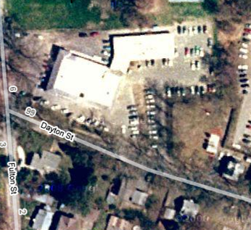
East Wing (1960s Addition)
West Wing (Original Building built in 1924)
Center Wing
(1950s Addition)

Location of Wings
Picture 1

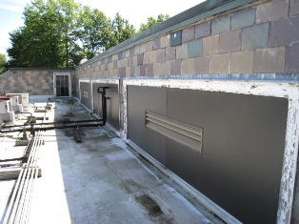

Fresh Air Intakes

Picture 2

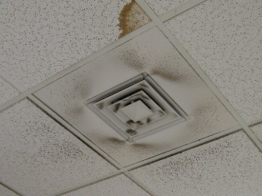

Fresh Air Diffuser
Note Accumulation of Dust on Diffuser and on Ceiling Tiles

Picture 3

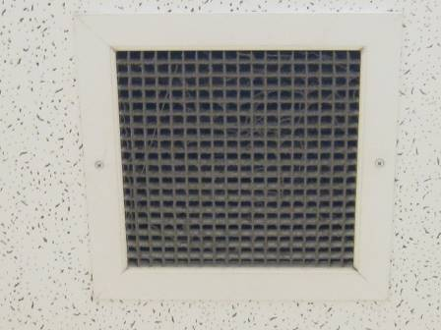

Ducted Exhaust Vent

Picture 4

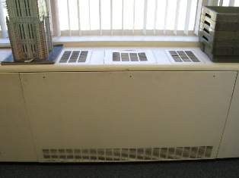

Univent
Picture 5

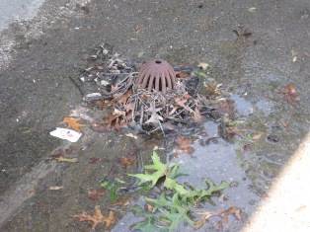

Obstructed Roof Drain on North Portion of Building
Note Standing Water

Picture 6

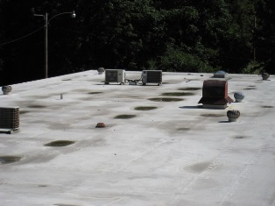

Standing Water on Roof of East Wing
Picture 7

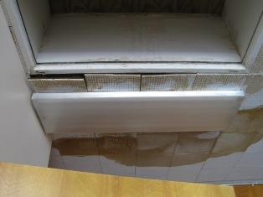

Buckled and Water Damaged Ceiling Tiles

Picture 8

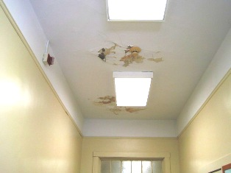

Water Damaged Ceiling

Picture 9

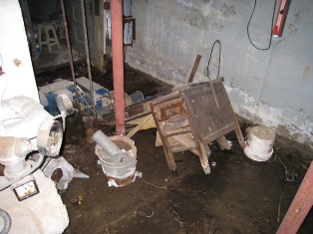

Debris stored on wet basement floor.

Picture 10

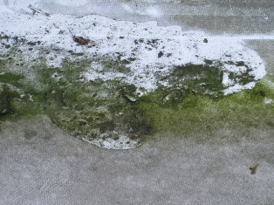

Moss Growth on Membrane Roof
Picture 11

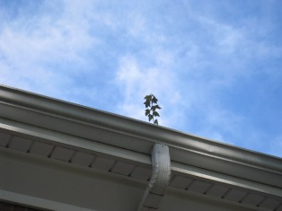

Plant Growth in Gutter

Picture 12

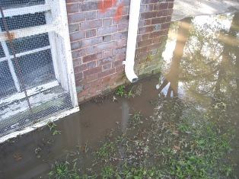

Downspout Deposits Water Adjacent to the Building
Note Standing Water
Picture 13

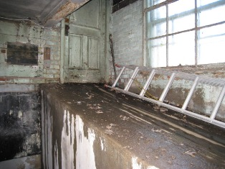

Standing Water Penetrates Building Envelope and Enters Basement

Picture 14

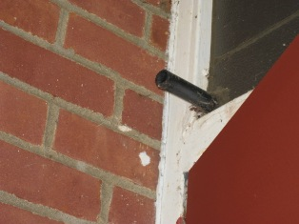

Condensation Line From Wall Mounted Air Conditioners

Picture 15

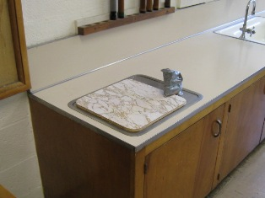

Abandoned Fountain

Picture 16

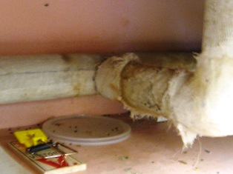

Rodent Droppings in Cabinet in East Wing, Note Evidence of Rodent Shredding Pipe Insulation (Potential Asbestos)
Picture 17

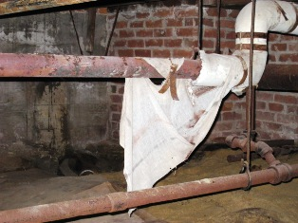

Friable Pipe Insulation

Picture 18

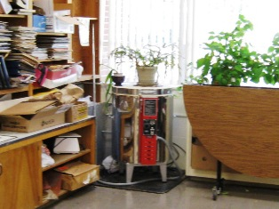

Kiln Stored in East Wing Is Not Currently In Use

Picture 19



Upholstered Furniture and Draperies in Library

Picture 20

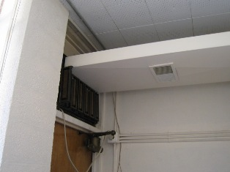

Duct Attached to Air Conditioner in Conference Room

Picture 21

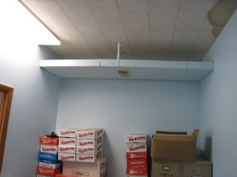

Air Conditioner Duct In Storage Room
Note Open Penetrations Through Walls
Location | Occupants  in Room | Carbon  Dioxide  (ppm) | Temp  (°F) | Relative  Humidity  (%) | Carbon Monoxide  (ppm) | PM2.5  (µg/m3) | Windows  Openable | Ventilation |  | Remarks
 |  |  |  |  |  |  |  | Supply | Exhaust | Remarks
Outside  (Background) | - | 396 | 65 | 41 | ND | 6 | - | - | -
Conference Room | 4 | 1091 | 70 | 57 | 3/2/ND | 12 | Y | Y | N | AC, DO, WDCT, sink, univent, copier
Foot Nurse’s Rm | 2 | 1256 | 70 | 61 | 2 | 13 | N | N | N | DO, WDCTs, AC
Board of Health Nurse’s Room | No access on 9/22/08 | - | - | - | - | - | N | N | N | DC, AD, WDCTs, WD materials (see Table 2), AC
File Room | No access on 9/22/08 | - | - | - | - | - | N | N | N | DC, WDCTs, AC
Card Room | 0 | 751 | 70 | 55 | 4/2/ND | 10 | Y | Y | N | DO, Univent, AC, WDCT
Ceramics Room | 0 | 906 | 70 | 56 | 4/2/ND | 9 | Y | Y | N | DC Plants near/on univent, Kiln unused, sink w dry trap
Billiards Room | 7 | 1575 | 70 | 59 | 2/1/ND | 11 | Y  1-open | Y | N | DC, Dry trap in sink, AC drains outside
Food Service Coord. | 1 | 1261 | 72 | 58 | 7/3/3 | 7 | N | N | N | DO, Idling Delivery truck outside
Stock Room | 0 | 867 | 71 | 55 | 4/2/2 | 8 | Y | N | N | DO
Custodian’s Room | 0 | 769 | 70 | 62 | 2/1 | 8 | N | N | N | DO, WDCTS, Missing CTs, Open Penetrations
Kitchen | 7 | 984 | 71 | 57 | 2/2 | 8 | Y | N | Y | DO, PF, AC, 2 Exhaust fans
Dish Room | 1 | 794 | 69 | 60 | ND | 8 | Y | N | Y  Fan in ext. wall | DO
Meals on Wheels Entrance | 0 | 675 | 72 | 53 | ND | 6 | N | N | N | WDCeiling
Hallway | 3 | 618 | 71 | 53 | ND | 6 | N | Y | Y
Women’s Bathroom | 0 | 666 | 70 | 55 | ND | 7 | Y | Y | Y | DC, AD
Cafeteria | 9 | 575 | 67 | 57 | ND | 5 | N | Y | Y | DO, WDCT, Plants
Meals on Wheels Coord. | 1 | 710 | 68 | 59 | ND | 5 | Y  1 open | Y | Y | DO, AD, 1 comp
Library | 0 | 494 | 67 | 57 | ND | 4 | Y | Y | Y | DO, UF, Plants
Conference Room 2 | 0 | 537 | 68 | 57 | ND | 5 | N | Y | Y | DC
Front Office | 2 | 673 | 68 | 60 | ND | 5 | Y | Y | Y | DO, 1 comp.
Asst. Dir. Office | 0 | 632 | 69 | 60 | ND | 6 | Y | Y | Y | Plants
Computer Lab | 0 | 576 | 68 | 56 | ND | 6 | Y | Y | Y | DC, 9 Comp., AD
Staff Kitchen | 0 | 549 | 67 | 61 | ND | 6 | Y | N | N | DO, suspended (modine)heater
Director’s Office | 1 | 618 | 69 | 59 | ND | 5 | Y | Y | Y | DO, Many plants, UF, Curtains
Social Services | 1 | 644 | 71 | 56 | ND | 5 | Y | Y | Y | DO, plants, curtains
Exercise Room | 0 | 532 | 69 | 52 | ND | 6 | Y | Y | Y | DO, WDCT
Laundry/Bathroom | 0 | 542 | 60 | 53 | ND | 6 | N | N | Y | DO

Room | Material | Moisture Measurement | Comments
Conference Room | Carpet | 7.2 (Low) | At exterior wall
Conference Room | Carpet | 6.3 (Low) | Adjacent to copy machine
Conference Room | Carpet | 15.0 (Med) | Near entrance to Nurse’s office
Conference Room | Wood | 6.2 (Low) | Door casing to file room
Nurse’s Room | Carpet | 18.5 (High) | In front of bookcase
Nurse’s Room | Carpet | 22.5 (High) | To left of bookcase
Nurse’s Room | Carpet | 23.3 (High) | To right of filing cabinet
Nurse’s Room | Carpet | 40.0 (High) | Beneath nurse’s desk
Nurse’s Room | Wood | 28.6 (High) | Door casing 1” above floor
Nurse’s Room | Gypsum Wallboard (GW) | 6.5 (High) | Wall, left of bookcase, 1” above coving
Nurse’s Room | GW | 0.5 (Med) | Wall, left of bookcase, 4” above coving
Nurse’s Room | GW | 7.2 (High) | Wall, right of bookcase, 1” above coving
Nurse’s Room | GW | 0.5 (Med) | Wall, right of bookcase, 3.5” above coving
Nurse’s File Room | Wood | 7.6 (Low) | Door casing, 2” above floor
Foot Nurse’s Room | GW | 0.4(Low) | Wall, 2”above coving
Foot Nurse’s Room | Wood | 7.6 (Low) | Door casing, 2” above floor

BUREAU OF ENVIRONMENTAL HEALTH
Indoor Air Quality Program

Mercury Spill Clean Up Procedure

February 2008

The Indoor Air Quality (IAQ) Program routinely receives inquiries concerning the accidental spill and clean up of small amounts of elemental mercury. Such spills are usually associated with mercury containing devices, such as thermometers, thermostats, barometers and medical equipment, such as older sphygmomanometer (blood pressure cuffs).

For cleaning, handling and disposal of broken fluorescent lights, including compact fluorescent lights, please refer to the Massachusetts Department of Environmental Protection’s (MDEP) guidelines. The MDEP has posted compact fluorescent light (CFL) information for consumers and cleanup guidance at http://mass.gov/dep/toxics/stypes/cflinfo.htm (Consumer Information CFL Bulbs) and http://mass.gov/dep/toxics/stypes/brkncfls.htm (Guidance for Cleaning up Broken CFL Bulbs) and info about recycling options at http://mass.gov/dep/toxics/stypes/cflrlocs.xls and (Municipal & Commercial Drop-Off Locations for Mercury-Added Product Recycling).

The IAQ Program recommends the following procedures to assess potential health impacts and to clean up small amounts of mercury from spills that occur in homes or other buildings.

Ventilation and Isolation
- Do Not Walk either on broken mercury-containing materials or on visible mercury.
- Do Not Use a vacuum cleaner or broom to remove or gather broken mercury-containing materials or on visible mercury.
- Close interior doors of spill areas.

How to Ventilate the Mercury Spill Location
Fan in Window
Door Closed
Spill
Airflow of Fan
Hallway

- Place a fan in the window operating in a manner to blow air directly outdoors.
- Interior doors should stay closed to prevent mercury contamination in other areas of house/building.
- Operate the fan in the spill areas for at least a day whether mercury is visible or not to ensure optimal ventilation (weather permitting).

Spill Clean up
If mercury was spilled on a hard, non-porous surface (e.g., metal, tile, plastic, etc.):
- Do not use a vacuum cleaner or broom to clean the area. Use of a vacuum cleaner can both contaminate the vacuum cleaner and spread the mercury contamination.
- Gather visible mercury together using a rigid material (e.g. squeegee, cardboard, thick paper).
- Work to gather spilled mercury beads toward a central location to form a large bead.
- Push the mercury beads into a plastic dustpan or use an eyedropper to pick up the beads.
- Tape can also pick up small mercury beads, but use caution due to problems associated with mercury adhering to tape.
- Collect all mercury into a used, wide-mouthed, plastic container with a screw-on lid.
- Optional step: Sprinkle sulfur powder (available at some lawn and garden stores) on the spill area after cleaning up the beads of mercury; a color change from yellow to brown indicates that mercury is still present and more cleanup is needed. If the sulfur powder stays yellow, this indicates clean up efforts were successful.
- After mercury is removed, clean area with soap and water. Discard bucket, sponge and rubber gloves as if mercury contaminated.
If the mercury was spilled on hardwood or other surfaces that may have crevices:
- If mercury accumulates in cracks in flooring or below floorboards, it cannot be completely removed using the methods described previously.
- Contacting an environmental remediation firm that possesses a mercury spill clean up kit may be necessary.

If the mercury was spilled on carpet or other cloth material:
- Cloth materials cannot be cleaned completely of mercury contamination and should be discarded.
- If the contaminated item is removable and disposable (throw rug, furniture cover, sheet, clothing, paper, cardboard, etc.), carefully place the contaminated material into a sealable plastic bag.
- Place the disposable container into a plastic bag that you can tie off at the top (to keep the contents inside) and transport to an outdoor trash bin right away.

Anything that has come in contact with mercury, including all clean up materials must be taken to a recycling facility or household hazardous waste program for proper disposal.

Once mercury clean up is completed, wash your hands and other parts of your body that may have come in contact with mercury.

Questions
If you have any questions concerning these guidelines, please contact:

Massachusetts Department of Public Health
Bureau of Environmental Health
Indoor Air Quality Program
250 Washington Street, 7th Floor
Boston, MA 02108

Phone: (617) 624-5757 Fax: (617) 624-5777

Document Reviewed: August 2008

