Background

INDOOR AIR QUALITY
ASSESSMENT

South Hadley High School
153 Newton Street
South Hadley, MA

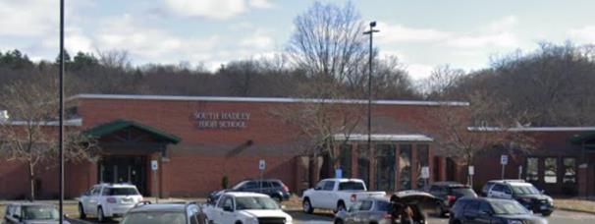

Prepared by:
Massachusetts Department of Public Health
Bureau of Environmental Health
Indoor Air Quality Program
November 2021
Building: | South Hadley High School (SHHS)
Address: | 153 Newton Street, South Hadley, MA
Assessment Requested by: | Sharon Hart, South Hadley Public Health Department
Date of Assessment: | September 21, 2021
Massachusetts Department of Public Health/Bureau of Environmental Health (MDPH/BEH) Staff Conducting Assessment: | Michael Feeney, Director, and Stefanie  Santora, Environmental Analyst, Indoor Air  Quality (IAQ) Program
Date of Building Construction/Renovation: | Constructed in 1955, with an addition in 2001.
Building Description: | The SHHS is a one-story red brick, multi-wing, building. The building contains general classrooms, science classrooms, an auditorium, gymnasium, cafeterias, kitchen, library, computer rooms, art room, café, guidance area, teachers’ room, and office space.
Windows: | Openable

Introduction
The IAQ Program was asked to assess the SHHS due to its closure for mold cleanup (HG, 2021). During the assessment, the building was unoccupied by students and faculty while clean up contractors were engaged in mold remediation. The cleanup contractors were observed using mold remediation methods described in the US EPA document, Mold Remediation in Schools and Commercial Buildings (US EPA, 2008), which included removal of bulletin boards as well as the cleaning of stored materials, desks, chairs, floors, and walls. The IAQ Program assessed the building to identify the possible causes of the mold growth as well as make recommendations regarding methods that may be used to limit future water damage during hot, humid conditions.

Methods
MDPH IAQ staff conducted a series of visual assessments, temperature, and relative humidity measurements to identify likely areas that could be prone to condensation in hot, humid weather. Please refer to the IAQ Manual for methods, sampling procedures, and interpretation of results (MDPH, 2015).

Results and Discussion
The following is a summary of testing results (Table 1):
- Temperature was within or close to the higher end of the MDPH recommended range of 70°F to 78°F in most areas tested.
- Relative Humidity was within the DPH recommended range of 40 to 60% in the majority of areas. In some areas, relative humidity was either close to the low end or lower than the recommended range on the day of assessment due to outside weather conditions (61%) as well as the use of dehumidifiers as part of the water damage remediation.

Ventilation
A heating, ventilating and air conditioning (HVAC) system has several functions. First it provides heating and, if equipped, cooling. Second, it is a source of fresh air. Finally, an HVAC system will dilute and remove normally occurring indoor environmental pollutants by not only introducing fresh air, but by filtering the airstream and ejecting stale air to the outdoors via exhaust ventilation. Even if an HVAC system is operating as designed, point sources of respiratory irritation may exist and cause symptoms in sensitive individuals.
Fresh air in the majority of classrooms is supplied by unit ventilators (univents) installed when the SHHS was renovated in 2001. Univents draw air from the outdoors through a fresh air intake located on the exterior wall of the building and return air through an air intake located at the base of the unit. Fresh and return air are mixed, filtered, heated, or cooled and provided to rooms through an air diffuser located in the top of the unit (Figure 1).
Mechanical exhaust ventilation in classrooms is provided by wall-mounted exhaust vents connected to rooftop motors. The MDPH IAQ Program recommends that supply and exhaust ventilation operate continuously during occupied periods to provide air exchange and filtration. Without sufficient supply and exhaust ventilation, normally-occurring environmental pollutants can build up and lead to indoor air quality/comfort complaints.
It is also important to note that despite ongoing maintenance and replacement of parts/components by South Hadley Public Schools facilities staff, many of the HVAC units are at the end of their life cycle. Efficient function of equipment of this age (> 20 years old) is difficult to maintain, since compatible replacement parts are often unavailable. According to the American Society of Heating, Refrigeration, and Air-Conditioning Engineering (ASHRAE), the service life of this type of unit is 15-20 years, assuming routine maintenance of the equipment (ASHRAE, 1991).
To maximize air exchange, the IAQ program recommends that both supply and exhaust ventilation operate continuously during periods of occupancy. To have proper ventilation with a mechanical ventilation system, the systems must be balanced after installation to provide an adequate amount of fresh air to the interior of a room while removing stale air from the room. It is recommended that HVAC systems be re-balanced every five years to ensure adequate air systems function (SMACNA, 1994). Based on the age and condition of the univents re-balancing of the HVAC system may not be possible.

Microbial/Moisture Concerns
The SHHS has experienced water damage from the following sources:
- Building materials prone to condensation during hot, humid weather;
- Building material prone to water vapor absorption in high humidity environments;
- Poor drainage of ground along the exterior walls and courtyards; and
- Dry drain traps.

Building materials prone to condensation during hot, humid weather

It is important to note that Massachusetts has experienced extended periods of relative humidity during the summer of 2021. This July was the wettest ever recorded in Massachusetts, and the three-month period from June through August, known as the meteorological summer, was the fourth wettest on record, according to the National Oceanic and Atmospheric Administration’s Centers for Environmental Information. The three-month period also was the third warmest ever in the state and was tied for the warmest on record across the United States (HG, 2021, NOAA, 2021).

The SHHS was assessed to determine if floors (cement on soil) were subject to developing condensation during extended (> 24 hours) hot, humid weather. The key to managing condensation in hot, humid weather indoors is understanding dew point. When warm, moist air passes over a cooler surface, condensation can form. Condensation is the collection of moisture on a surface at or below the dew point. The dew point is the temperature that air must reach for saturation to occur. If a building material/component has a temperature below the dew point, condensation will accumulate on that material. Over time, condensation can collect and form water droplets. Floor tiles show signs of chronic condensation exposure (Picture 1).

A method to locate areas in a building prone to condensation is to measure air and building material temperatures using a laser thermometer (Table 1). If a wide temperature range exists between measurements (>5°F), the building materials at the colder end of the range may be prone to becoming moistened with condensation if exposed to hot, humid weather for extended periods of time. According to the test results in Table 1, all floors measured in the building would appear to be prone to condensation under high-humidity conditions.

Building material prone to water vapor absorption in high humidity environments

This visit included a visual inspection for signs of water damage and microbial growth. Ceiling tiles in classrooms were bowed (Table 1), which is likely the result of moisture exposure from elevated relative humidity conditions. No mold growth was observed on bowed ceiling tiles. Water-damaged ceiling tiles were observed in a few areas including the wood shop. Water-damaged ceiling tiles indicate a leak from the roof or plumbing system. They should be replaced once the source of water is identified and repaired.

According to American Society of Heating, Refrigerating and Air-Conditioning Engineers (ASHRAE), if relative humidity exceeds 70%, mold growth may occur due to wetting of building materials even in the absence of liquid water (ASHRAE, 2019). Relative humidity measured in the building was below 70% in all but one location during this assessment (Table 1). In these conditions, porous materials such as ceiling tiles, gypsum wallboard, cardboard and other materials may develop mold colonization. It is recommended that porous material be dried with fans and heating within 24 to 48 hours of becoming wet (US EPA, 2008, ACGIH, 1989). If porous materials are not dried within this time frame, mold growth may occur, and they should be removed and discarded. Water-damaged porous materials cannot be adequately cleaned to remove mold growth.

Poor drainage of ground and windowsills along the exterior walls and courtyards
Of note are the heights of univent fresh air intakes, which are at ground level or within one foot of ground (Picture 1). As univents operate, water vapor from either evaporating pooling water or moist soil can be readily captured by and introduced into the SHHS due to the height of fresh air intakes, particularly if the ground at the building slab has poor drainage.
The SHHS has a tarmac apron around the base of the exterior wall to aid water drainage. Moss growing over the apron (Picture 2) indicates significant water exposure, including water accumulating against the building’s slab. Without sufficient drainage, water can pool against the building slab around the exterior wall perimeter. Over time, rainwater runoff from the exterior wall can compress soil to the building slab to cause the apron to settle, which then in turn, can result in increased puddling.
Areas of the exterior windowsills are also covered with moss (Picture 3), which can be indicative of chronic water exposure. Moss tends to form on brickwork that retains moisture due to lack of drainage and/or is not dried by solar heating. Many of the wall surfaces of the SHHS do not see extended exposure to sunlight due to the topography and forests that surround the building.

Dry drain traps

The SHHS has a science lab area that contains a number of sink drains, both abandoned and in use. It is highly likely that each of these drains has a dry trap, which can result in significant backflow of water vapor into the building from the sewer system, particularly during times of heavy rains. The purpose of a drain trap is to prevent sewer gasses from entering the building by having water fill the U-bend beneath the drain. Such an airtight seal also prevents excess water vapor from entering into the building. All drains should be wet with water at least once a week. Drains that are no longer needed should be sealed.

Recommendations
The SHHS has a number of issues related to moisture. One issue that is of significance, given the extreme relative humidity and rain of this summer, is that management of the building in such weather without air conditioning can be challenging. The following documents can provide guidance that can be used to reduce the impact of hot, humid weather in buildings:

- Preventing mold growth in Massachusetts schools during hot, humid weather: https://www.mass.gov/service-details/preventing-mold-growth-in-massachusetts-schools-during-hot-humid-weather
- Remediation and prevention of mold growth and water damage in public schools and buildings to maintain air quality: https://www.mass.gov/service-details/remediation-and-prevention-of-mold-growth-and-water-damage-in-public-schools-and
- Methods for increasing comfort in non-air-conditioned schools: https://www.mass.gov/doc/methods-for-increasing-comfort-in-non-air-conditioned-schools/download

To remedy the building’s problems, two sets of recommendations are made: short-term measures that may be implemented as soon as practicable and long-term measures that will require planning and resources to address overall IAQ concerns. In view of the findings at the time of the visit, the following recommendations are provided:

Short-Term Recommendations

Water damage recommendations

Continue with mold remediation efforts.
- Ensure that all plumbing drains are wetted at least once a week or permanently sealed if not to be used. Temporarily sealing shower drains with an appropriate material should be considered if these drains may be needed later.
- Remove all soil and mulch that has buried the exterior wall/slab joint from the entire exterior wall system by at least 5 feet to allow soil to dry.
- Examine the feasibility preventing rainwater pooling along the exterior walls by regrading soil. In general, a water-resistant material in a configuration of 1 foot in height and 5 feet in length is recommended to increase drainage of rainwater.
- Consider removing carpeting from the library and replace with an appropriate floor covering due to the potential for condensations.
- If porous floor coverings are desired, consider the use of those that can be easily taken up during hot, humid weather.
- Consider removing all plants from the tarmac apron to reduce water accumulation.
- Repair the water leak causing water damage to ceiling tiles in the woodshop area.
- Replace water-damaged ceiling tiles. Inspect the area above the tiles for any additional water damage and clean/repair as needed.

Other recommendations
- The U.S. Department of Education has released new guidance encouraging the use of American Rescue Plan (ARP) funds to improve ventilation systems and make other indoor air quality improvements in schools. More information can be found at this link: https://www.ed.gov/coronavirus/improving-ventilation
- The school should be tested for radon by a certified radon measurement specialist during the heating season when school is in session. Radon measurement specialists and other information can be found at: www.nrsb.org, and http://aarst-nrpp.com/wp.
- Consider forming an IAQ committee in each school building district wide. Committees should have an IAQ liaison/teacher representative, a member of maintenance/facilities and administration that conduct regular walk-throughs to identify on-going and/or potential environmental issues.
- Consider adopting the US EPA (2000) document, “Tools for Schools”, as an instrument for maintaining a good IAQ environment in the building available at: https://www.epa.gov/iaq-schools/indoor-air-quality-tools-schools-action-kit

Long Term Recommendations
Contact a building engineering firm for advice regarding the following conditions noted at the SHHS:
- Repair the tarmac apron with the installation of a drain system and/or a method that can improve drainage along all exterior walls of the SHHS.
- Consideration should be given to removing trees from the perimeter of the building or reducing tree height to reduce shade on exterior walls to increase drying.
- Consideration should be given to raising the univent fresh air intake heights to above the average snow accumulation height of greater South Hadley to prevent blockage and the draw of ground-level water vapor.
- Conduct a building-wide ventilation systems assessment. Based on historical issues with moisture exposure, age, physical deterioration, and availability of parts for ventilation components, such an evaluation is necessary to determine the operability and feasibility of replacing the equipment.

References
ACGIH. 1989. Guidelines for the Assessment of Bioaerosols in the Indoor Environment. American Conference of Governmental Industrial Hygienists, Cincinnati, OH.
ASHRAE, 2019. American Society of Heating, Refrigeration and Air Conditioning Engineers (ASHRAE) Ventilation for Acceptable Indoor Air Quality. ANSI/ASHRAE Standard 62.1-2019. Atlanta, GA.
ASHRAE. 1991. ASHRAE Applications Handbook, Chapter 33 “Owning and Operating Costs”. American Society of Heating, Refrigeration and Air Conditioning Engineers, Atlanta, GA.
HG. 2021. Mold Keeps South Hadley High School Shuttered. Hampshire Gazette. https://www.gazettenet.com/South-Hadley-High-School-still-closed-amid-mold-remediation-42413519
MDPH. 2015. Massachusetts Department of Public Health. Indoor Air Quality Manual: Chapters I-III. Available at: https://www.mass.gov/lists/indoor-air-quality-manual-and-appendices#indoor-air-quality-manual-.
NOAA. 2021. Summer 2021 Neck and Neck with Dust Bowl Summer for Hottest on Record. National Oceanic and Atmospheric Administration, 1401 Constitution Avenue NW, Room 5128, Washington, DC 20230 https://www.noaa.gov/news/summer-2021-neck-and-neck-with-dust-bowl-summer-for-hottest-on-record
SMACNA. 1994. HVAC Systems Commissioning Manual. 1st ed. Sheet Metal and Air Conditioning Contractors’ National Association, Inc., Chantilly, VA.
US EPA. 1993. Radon Measurement in Schools, Revised Edition. Office of Air and Radiation, Office of Radiation and Indoor Air, Indoor Environments Division (6609J). EPA 402-R-92-014. https://archive.epa.gov/epa/iaq-schools/radon-measurement-schools-revised-edition.html.
US EPA. 2000. Tools for Schools. Office of Air and Radiation, Office of Radiation and Indoor Air, Indoor Environments Division (6609J). EPA 402-K-95-001, Second Edition. http://www.epa.gov/iaq/schools/index.html.
US EPA. 2008. “Mold Remediation in Schools and Commercial Buildings”. Office of Air and Radiation, Indoor Environments Division, Washington, DC. EPA 402-K-01-001. September 2008. Available at: http://www.epa.gov/mold/mold-remediation-schools-and-commercial-buildings-guide
Figure 1

Unit Ventilator (Univent)

Mixed Air

Air Diffuser

Outdoors Indoors

Fan

Heating/Cooling Coil

Air Mixing Plenum

Filter

Outdoor Return
Air Air

Air
Flow
Control
Louvers

Air Flow

= Fresh Air/Return Air

= Mixed Air

Picture 1

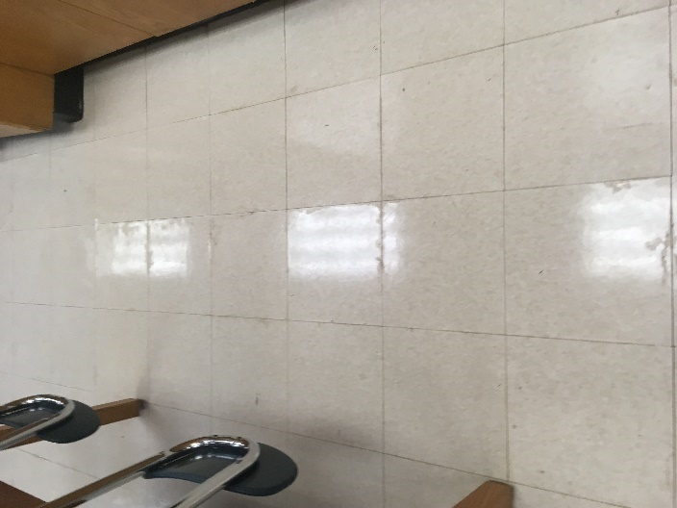

Floor tile likely exposed to condensation; note seams between tiles

Picture 2

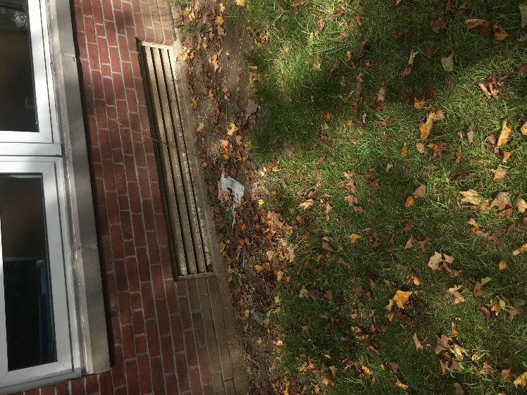

Univent fresh air intake at ground level

Picture 3

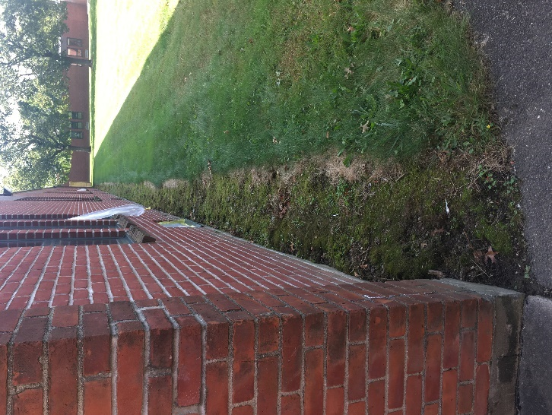

Moss overgrowth on tarmac apron along exterior wall base

Picture 4

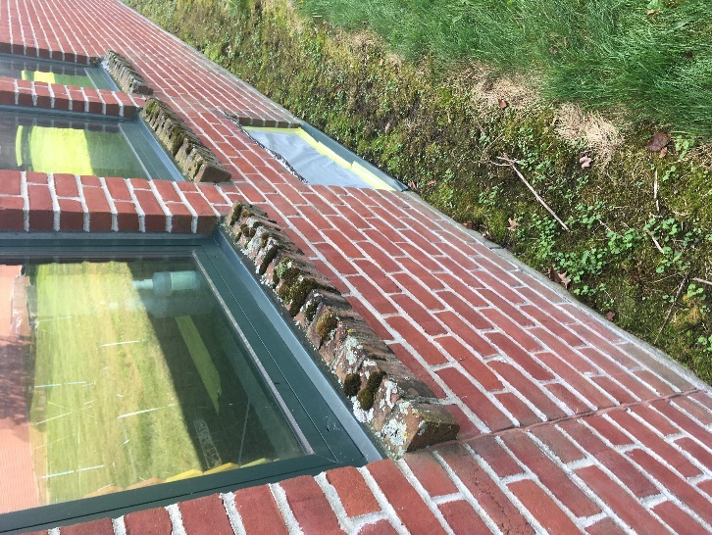

Moss growth on windowsill

Location | Air Temp  (ºF) | Relative Humidity  (%) | Dew Point  (ºF) | Floor Temp  (ºF) | Temp at Floor/ Exterior Wall Junction  (ºF) | Water-Damaged Ceiling Tiles-stained  (#) | Water-Damaged  Bowed Ceiling Tile | Ventilation |  |  | Floor to Air Temp  Difference  (ºF) | Comments
 |  |  |  |  |  |  |  | Windows openable | Supply | Exhaust
Background (outdoors) | 72 | 61 | 58
Faculty | 72 | 52 | 53 | 64 | 65 | 0 | Y | Y | Y | Y | -8 | Photocopier
Library | 72 | 56 | 56 | 54 | 64 | 0 | Y | Y | Y | Y | -18 | Carpet on carpet
300 | 74 | 53 | 57 | 64 | 64 | 0 | Y | Y | Y | Y | -10 | Floor tile water damage
302 | 76 | 49 | 55 | 62 | 63 | 0 | Y | Y | Y | Y | -14
303 | 71 | 53 | 53 | 63 | 62 | 2 | Y | Y | Y | Y | -8
306 | 71 | 53 | 53 | 64 | 64 | 0 | Y | Y | Y | Y | -7
308 | 69 | 55 | 52 | 58 | 57 | 0 | Y | N | Y | Y | -11
310 | 69 | 51 | 50 | 58 | 57 | 0 | Y | N | Y | Y | -11 | Dry trap  2 missing ceiling tiles
311 | 72 | 51 | 53 | 63 | 64 | 0 | Y | Y | Y | Y | -9
313 | 73 | 52 | 54 | 66 | 64 | 0 | Y | Y | Y | Y | -7 | Water-damaged tile
314 | 73 | 53 | 54 | 61 | 61 | 3 | Y | Y | Y | Y | -12
316 | 73 | 53 | 55 | 61 | 62 | 1 | Y | Y | Y | Y | -12
318 | 72 | 55 | 55 | 61 | 60 | 2 | Y | Y | Y | Y | -11
400 | 78 | 35 | 48 | 64 | 64 | 0 | Y | Y | Y | Y | -14 | Dehumidifier
401 | 76 | 39 | 49 | 68 | 66 | 0 | Y | Y | Y | Y | -8
402 | 78 | 35 | 49 | 63 | 65 | 0 | Y | Y | Y | Y | -15 | Dehumidifier
403 | 77 | 38 | 49 | 69 | 68 | 0 | Y | Y | Y | Y | -8
404 | 78 | 34 | 48 | 64 | 65 | 0 | Y | Y | Y | Y | -14 | Dehumidifier
405 | 77 | 38 | 50 | 69 | 68 | 0 | Y | Y | Y | Y | -8
406 | 78 | 34 | 47 | 66 | 67 | 0 | Y | Y | Y | Y | -12 | Dehumidifier
407 | 76 | 40 | 51 | 69 | 65 | 0 | Y | Y | Y | Y | -7 | Dehumidifier
408 | 74 | 33 | 47 | 67 | 68 | 0 | Y | Y | Y | Y | -7 | Dehumidifier
409 | 74 | 40 | 50 | 65 | 64 | 0 | Y | Y | Y | Y | -9 | Dehumidifier
504 | 74 | 42 | 49 | 64 | 63 | 0 | N | Y | Y | Y | -10
505 | 75 | 43 | 50 | 64 | 64 | 0 | N | Y | Y | Y | -11 | Photocopier
507 | 74 | 42 | 49 | 64 | 62 | 0 | Y | Y | Y | Y | -10 | Floor drain
510 | 73 | 40 | 49 | 66 | 64 | 0 | Y | Y | Y | Y | -7 | Dehumidifier
510 prep | 75 | 44 | 51 | 65 | 63 | 0 | N | N | Y | Y | -10 | Side sink
511 | 73 | 40 | 48 | 65 | 64 | 0 | Y | Y | N | N | -9 | Dehumidifier, floor drain
512 | 75 | 38 | 48 | 64 | 64 | 0 | Y | Y | Y | Y | -11
513 | 73 | 41 | 48 | 62 | 61 | 0 | Y | Y | Y | Y | -11
514 | 76 | 36 | 47 | 67 | 66 | 0 | Y | Y | Y | Y | -9 | Dehumidifier
515 | 76 | 35 | 47 | 63 | 61 | 0 | Y | Y | Y | Y | -13 | Dehumidifier
516 | 76 | 36 | 47 | 68 | 67 | 0 | Y | Y | Y | Y | -8 | Dehumidifier
517 | 76 | 37 | 48 | 64 | 64 | 0 | Y | Y | Y | Y | -12
518 | 76 | 36 | 47 | 67 | 68 | 0 | Y | Y | Y | Y | -9 | Dehumidifier
519 | 76 | 39 | 49 | 64 | 65 | 0 | Y | Y | Y | Y | -12 | Dehumidifier
520 | 76 | 37 | 54 | 67 | 66 | 0 | Y | Y | Y | Y | -9 | Dehumidifier, floor tile water damage
521 | 76 | 39 | 49 | 64 | 64 | 0 | Y | Y | Y | Y | -12 | Dehumidifier
523 | 77 | 36 | 48 | 63 | 63 | 0 | Y | Y | Y | Y | -14 | Dehumidifier
525 | 77 | 35 | 46 | 65 | 65 | 0 | Y | Y | Y | Y | -12 | Dehumidifier
527 | 75 | 39 | 49 | 62 | 61 | 0 | Y | Y | Y | Y | -13 | Dehumidifier
612 | 71 | 50 | 52 | 64 | 64 | 0 | Y | N | Y | Y | -7
Computer server room | 73 | 53 | 54 | 64 | 65 | 0 | N | N | Y | Y | -9 | Ductless air conditioner
100 Woodshop | 72 | 50 | 52 | 64 | 64 | 4 | Y | Y | Y | Y | -8 | Exhaust off, wood dust collector
Cafeteria 1 | 74 | 50 | 54 | 66 | 65 | 1 | Y | Y | Y | Y | -8
Cafeteria 2 | 75 | 54 | 57 | 64 | 63 | 3 | Y | Y | Y | Y | -11
Guidance 1 | 70 | 57 | 54 | 62 | 61 | 0 | Y | Y | Y | Y | -8 | Carpet
Guidance 2 | 70 | 57 | 54 | 61 | 60 | 0 | Y | Y | Y | Y | -9 | Carpet
Guidance 3 | 70 | 56 | 54 | 61 | 61 | 0 | N | Y | Y | Y | -9 | Carpet
Guidance 4 | 71 | 57 | 55 | 61 | 60 | 0 | Y | Y | Y | Y | -10
Guidance 5 | 72 | 55 | 54 | 62 | 62 | 0 | Y | Y | Y | Y | -10 | Carpet
Guidance 6 | 71 | 57 | 55 | 62 | 61 | 0 | Y | Y | Y | Y | -9 | Carpet
Guidance Main | 71 | 56 | 54 | 64 | 64 | 0 | Y | Y | Y | Y | -7
Gymnasium | 75 | 47 | 53 | 66 | 66 | n/a | n/a | n/a | Y | Y | -9 | Dehumidifier
Prep Room | 73 | 42 | 49 | 64 | 62 | 0 | Y | Y | Y | Y | -9
Tiger’s Den | 72 | 54 | 55 | 64 | 63 | 0 | N | Y | Y | Y | -8 | Ductless air conditioner

The service life is the median time during which a particular system or component of … [an HVAC] … system remains in its original service application and then is replaced. Replacement may occur for any reason, including, but not limited to, failure, general obsolescence, reduced reliability, excessive maintenance cost, and changed system requirements due to such influences as building characteristics or energy prices (ASHRAE, 1991).

