INDOOR AIR QUALITY ASSESSMENT

South Hadley Town Hall
116 Main Street
South Hadley, MA

February 2026

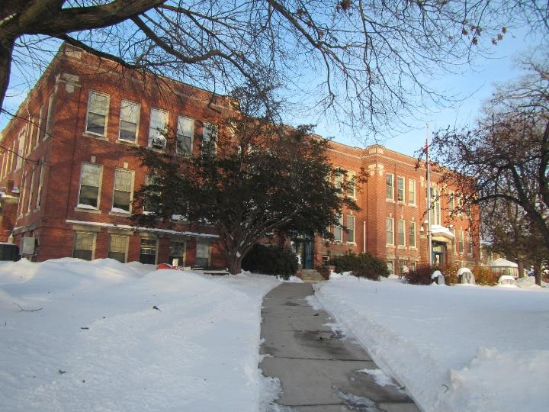

Prepared by:
Massachusetts Department of Public Health
Bureau of Climate and Environmental Health
Division of Environmental Health Regulations and Standards

Contents

EXECUTIVE SUMMARY 3
BACKGROUND 5
RESULTS AND DISCUSSION 6
Ventilation and HVAC System Maintenance 7
Water Damage and Moisture Concerns 7
Sources of Respiratory Irritants/Possible Asthma Triggers 10
CONCLUSIONS AND RECOMMENDATIONS 12
REFERENCES 16
PICTURES 18
Table 1 36
Table 2A 41
Table 2B 42
Table 2C 43
Table 3 44
Table 4 46

EXECUTIVE SUMMARY
The Massachusetts Department of Public Health’s Division of Environmental Health Regulations and Standards (MDPH/EHRS) conducted an indoor air quality (IAQ) assessment of the South Hadley Town Hall (SHTH). This assessment was requested by the South Hadley Director of Building Operations for the purpose of testing general IAQ conditions in the building.
It is important to note that the building was originally constructed with no mechanical ventilation components in work areas occupied by SHTH and was most likely dependent on natural cross-ventilation through operable windows. At least one window in each space was reported to be openable however SHTH staff stated a lot of them are broken and unable to be opened. These conditions make it difficult to control outside airflow, temperature, and relative humidity, particularly during hot, humid, summer conditions.
The assessment was conducted by evaluating several key elements within the building; a visual inspection of the heating, cooling, and ventilating (HVAC) systems, water/microbial damage, cleanliness, point sources of respiratory irritants such as chemicals, and electronic measurement of carbon dioxide (CO₂), carbon monoxide (CO), temperature, relative humidity (RH), small particulate matter (PM2.5), and total volatile organic compounds (TVOCs) all taken with a Qtrak XP monitor. Data is collected in this manner to identify potential asthma triggers, allergens, and other environmental factors that can cause indoor air quality symptoms. Please refer to the Indoor Air Quality Manual on the MDPH website for methods, sampling procedures, and interpretation of results.
As a result of this assessment, there are several findings: Fresh air supply to this building is limited, which means it relies on open windows during all times of the year to provide fresh air. This represents a balancing act – while opening windows can bring in fresh air, it can also allow in vehicle exhaust, pollen, mold spores, wildfire smoke, pests, and noise, as well as excess moisture that may damage building materials. Even if windows or exterior doors are closed, if they are broken or not correctly sealed, warm/cold air can enter in addition to odors, fumes, or exhaust from the outside. There was an odor reported on the first floor including in the Inspection Services room earlier in the morning prior to this assessment. Staff reported it smelled like oil, fumes, or exhaust. It was investigated by SHTH staff who thought it could have been due to a diesel truck idling outside the building. It is important to note that vehicles are parked near the building including right outside some SHTH offices and entrance doors.
SHTH staff reported a pre-demolition asbestos survey was done in the SHTH to identify asbestos containing material (ACM). A section of floor tiles in the auditorium were covered and taped off due to it being ACM. Other floor tiles in the auditorium were observed to be broken but not covered or taped off. Although the auditorium is not an occupied area, it is still used by SHTH staff to enter/exit the building. According to SHTH staff, no public access is allowed in the auditorium.
Ductless wall-mounted and ceiling-mounted mini-splits were observed in almost all offices of the SHTH with plans to install them in the remaining offices. It is important to note, ductless mini-splits allow temperature control of heating and cooling but do not provide fresh air.
Finally, water damage in the form of stained ceiling tiles were noted in numerous areas on all three floors of the building.
Based on the results of the assessment, the following primary recommendations are made:
- Repair/replace and seal any openings to the exterior of the building including exterior doors, office windows, and other any other potential gaps/openings to prevent the entry of odors, fumes, exhaust, drafts, water infiltration, pollen, pests, and dust.
- Use openable windows to supplement fresh air during temperate weather. Ensure all windows are tightly closed at the end of the day or during periods of elevated relative humidity to avoid condensation/mold issues.
- Continue to make available portable air purifiers equipped with high efficiency particulate arrestance (HEPA) filters for occupants who request them and maintain/clean them in accordance with manufacturer's instructions.
- Enforce anti-idling regulations and post signs to prevent exhaust and fumes from entering the building.
- Create a timely permanent solution to remediating the broken floor tiles and any other ACM material in the SHTH in a manner consistent with State and Federal asbestos remediation and disposal laws and regulations.
- All applicable laws, regulations, and guidance should be followed regarding identification, repair, and abatement of asbestos/ACM. Any other construction, water damage remediation, and movement of materials should be conducted using the DPH guidance https://www.mass.gov/info-details/construction-and-renovation-generated-pollutants-in-occupied-buildings.
- Continue installation of mini-splits in remaining offices to provide heating and cooling. Ensure routine maintenance of mini-splits.
- Identify the source of the water-damaged ceiling tiles and repair accordingly. Following repairs, replace all ceiling tiles. During replacement, the area above the ceiling tiles should be examined for additional water-damaged materials and sources of water, such as plumbing leaks, uninsulated pipes or ducts, or other issues.
(Conclusions and Recommendations)

BACKGROUND

Building: | South Hadley Town Hall (SHTH)
Address: | 116 Main Street, South Hadley, Massachusetts
Assessment Requested by: | Scott Moore, Director of Building Operations
Reason for Request: | General indoor air quality (IAQ)
Date of Assessment: | January 28, 2026
Massachusetts Department of Public Health/Bureau of Climate and Environmental Health/Division of Environmental Health Regulations and Standards (MDPH/BCEH/EHRS) Staff Conducting Assessment: | Thomas Murphy, Environmental Analyst, Indoor Air Quality Outreach and Education Unit
Building Description: | The SHTH is a brick building with a rubber membrane roof built in 1913 that originally served as a combined high school and town hall. Following a new high school being built in the 1950s, it has solely been used as a town hall with no major additions being reported. The building contains two floors and a ground floor which are all occupied as well as a large auditorium that is not used other than as an entrance/exit to the building for employees.
Windows: | Windows are openable, however a lot of them are heavy, broken, and unable to open. It was reported every room has at least one openable window.

RESULTS AND DISCUSSION
The following is a summary of indoor air testing results (Table 1)
- Carbon dioxide (CO₂) | a measure of the adequacy of ventilation | Levels were below the MDPH guideline of 800 parts per million (ppm) in majority of areas surveyed. In most areas with levels above 800 ppm, individuals were speaking with one another or on the phone/in a virtual computer meeting.
- Temperature | a measure of comfort | Was within the MDPH recommended range of 70°F to 78°F in almost all areas tested.
- Relative humidity | a measure of comfort and, when in excess for an extended period, a way to reflect the potential for mold and fungal growth | Was below the MDPH recommended range of 40 to 60% in all areas tested, which is common during the heating season.
- Carbon monoxide  (CO) | a product of combustion that can result in acute and long term cardiovascular, respiratory, and neurological symptoms | Levels were non-detectible in all areas assessed.
- Particulate matter (PM2.5) | a way to measure inhalable particle distribution in the air | Concentrations were below the National Ambient Air Quality Standard (NAAQS) of 35 micrograms per cubic meter (μg/m³) in all areas tested.
- Total Volatile Organic Compounds (TVOCs) | VOCs are carbon-containing substances that can evaporate at room temperature. Frequently, exposure to low levels of total VOCs (TVOCs) may produce eye, nose, throat and/or respiratory irritation in some sensitive individuals. | Levels were non-detectible in all areas assessed.

Ventilation and HVAC System Maintenance
Ventilation refers to both the supply of fresh air and the removal of stale air from a room. The introduction of fresh air into an occupied space will dilute normally occurring pollutants that are generated by occupancy and other activities. In addition, a heating, ventilation, and air conditioning (HVAC) system will remove pollutants from a building if operating appropriately.

The SHTH has no general mechanical ventilation system. Heat is provided by radiators in offices and in common areas. The SHTH space was most likely originally configured to use cross-ventilation to provide comfort for building occupants. As previously mentioned, the building is equipped with windows that are very heavy and difficult to open, which makes the introduction of fresh air during temperate weather difficult.
If windows are opened during temperate weather, they should be tightly closed at the end of the day or during periods of elevated relative humidity to avoid condensation/mold issues. Proper closing of windows also prevents the access of odors, fumes, exhaust, water infiltration, drafts, pollen, and pests.
With no fresh air supply, exhaust ventilation or easily openable windows, normally occurring indoor pollutants can build up. In addition, if a pollutant source is introduced into the building (such as water vapor during hot humid weather from open windows), there is no means to physically vent it. During hot, humid air weather, condensation moisten cooler surfaces.
Almost all SHTH offices have ductless wall-mounted or ceiling-mounted mini-split units (also known as ductless units; Pictures 1 and 2). These units provide both heating and cooling. A mini-split has a fan to draw air into its coils to either heat or cool it (Picture 3). Conditioned air is expelled though a vent at the top of each unit. A mini-split has no supply of fresh air; it is designed to recirculate air only.
The various types of ventilation components as well as devices that can move/redirect airflow are listed in Table 2A, Table 2B and Table 2C.

Water Damage and Moisture Concerns

Molds are found naturally in our environment both indoors and outdoors. Inside, mold growth may occur when items, particularly porous products such as paper or gypsum wallboard, are exposed to moisture. Typical water sources include leaks, floods, and condensation. To avoid mold growth, dry all water-damaged items and affected areas within 24-48 hours and reduce indoor humidity. Some people with chronic respiratory conditions, such as asthma, are more likely to experience health symptoms associated with molds, including allergic reactions and respiratory irritation. Controlling moisture is the key to preventing mold growth and potential health symptoms.

Hot humid summers are becoming more frequent due to climate change. Massachusetts has experienced hot, humid, and rainy summers in 2018, 2021, and 2023. July of 2021 was the wettest ever recorded in Massachusetts, and the three-month period from June through August, known as the meteorological summer, was the fourth wettest on record, according to the National Oceanic and Atmospheric Administration’s (NOAA) Centers for Environmental Information (NOAA, 2021). The summer of 2023 was also hot, and wet, being measured as the second rainiest on record (WBUR, 2023). The summers of 2024 and 2025 also had significant stretches of hot, humid weather.

During these hot and wet summers, extended periods of outdoor relative humidity above 70% occurred. Under these weather periods, public buildings experienced extended periods of water vapor exposure from high relative humidity. When exposed to these conditions, porous materials such as gypsum wallboard, cardboard, and other materials may become prone to developing mold colonization, particularly if located in areas that are prone to developing condensation on floors and walls (e.g., below grade space).
Please note that the IAQ Outreach and Education Unit does not recommend conducting mold testing in a typical water damage remediation. For details, please consult Guidance Regarding Testing for Mold in Water-Damaged Public Buildings | Mass.gov
The application of a mildewcide to moldy porous materials is not recommended.

Water Damage Issues
(see Water Damage and Moisture Concerns Pictures)

- Water damage from leaks and condensation was observed in the form of water-damaged and potentially mold-colonized ceiling tiles in various areas (Table 1; Pictures 4 through 8).
- Water-damaged ceiling tiles were observed near a ceiling-mounted mini-split (Picture 9). When these units operate in cooling mode, they generate condensation. They are equipped with tubing and sometimes a pump to drain the condensation. Leakage of water can occur when the condensate line is blocked or damaged, or the pump malfunctions. Ceiling-mounted mini-split tubing and pumps should be checked regularly to ensure proper drainage and repaired/cleaned when necessary.
- Plants were noted in some areas (Table 1; Pictures 10 through 12). Plants, soil, and drip pans can serve as sources of mold/bacterial growth. Plants should be properly maintained, over-watering of plants should be avoided, and drip pans should be inspected periodically for mold growth and cleaned/replaced as needed.
- A water bubbler was found in a carpeted area (Picture 13). Water bubblers can spill or leak and moisten carpeting. Use of a waterproof mat underneath this appliance, or moving it to a non-carpeted area, can help prevent water damage.
- Food/liquid stains were observed in a refrigerator (Picture 14) which can be a source of odors and mold growth. Also note that while these refrigerators are not covered by the food code, it is good practice to have a thermometer in each refrigerator that is visible to ensure refrigerated food temperatures are kept at 5ºC (41ºF) or less (US FDA, 2022).
- The interior of a microwave was dirty (Picture 15). Food preparation equipment should be kept clean and free from spills to prevent mold growth, pests, and odors.
- Crumbs were found in a toaster oven (Picture 16) and food was found in offices (Picture 17). To reduce the potential for rodent activity, all food and food items should be stored in closed, rodent-proof containers at all times other than active use. Food waste and crumbs should be cleaned up promptly.
- Even though the building can provide chilled air in locations with mini-splits, the SHTH, including rooms without any air conditioning, could still experience condensation on below grade floors and walls, particularly in areas where walls and floors have direct contact with soil, or where plumbing pipes with chilled water are present without adequate insulation.
- In general, any material that is porous and capable of supporting mold growth should not be stored on floors and against walls capable of becoming moistened by condensation. Such materials include: cardboard boxes (Pictures 18 and 19), cloth, paper, books, soft plastics (e.g., polyurethane), leather, upholstered furniture, and jute or latex-backed carpeting.

Several other conditions on the outside of the building were identified that can contribute to water infiltration issues, which are specified in Table 3 and are listed below.
Mold Growth
Porous materials (e.g., gypsum wallboard, ceiling tiles and carpeting) can be dried with fans and heating within 24 to 48 hours of becoming wet (US EPA, 2008).
If porous materials are not dried within this time frame, mold growth may occur.

An exterior evaluation was also conducted to identify potential pathways for water penetration and pest entry. The following issues were noted:
- A few exterior areas of the building showed signs of efflorescence and at least one area showed moss/algae growth as well (Picture 20). Efflorescence is a characteristic sign of water damage to brick and mortar, but it is not mold growth. As moisture penetrates and works its way through mortar and brick, water-soluble compounds in mortar and brick dissolve, creating a solution. As the solution moves to the surface of the mortar or brick, the water evaporates, leaving behind white, powdery mineral deposits. Evidence of moss/algae growth indicates moisture and a lack of drying or draining.
- Light penetrating through the spaces around exterior doors, which can provide a pathway for odors, fumes, exhaust, uncontrolled drafts, moisture, water infiltration, and pests into the building (Pictures 21 and 22).
- Trees/shrubbery were noted against exterior walls (Picture 23). The presence of trees is likely enhancing water retention, preventing drying of the exterior, and affecting drainage as well as overhanging the roof. These trees pose several hazards:
  - Leaves and other debris accumulate around gutters, (and roof drains where present, which inhibits rainwater drainage. Clogged gutters and/or ineffective drains can lead to water running off the roof to moisten exterior walls.
  - Trees prevent sunlight from drying walls and soil.
  - The trees are a possible danger due to the distance from exterior walls:
    - The recommended safe distance that any tree should be planted is the minimum of the expected maximum growth height of the species from the exterior of a building (BI, 2015).
    - Soil subsidence may also be caused by tree roots, which can undermine the structure of a building to cause wall and floor cracking and related damage. To prevent subsidence, a sufficient distance appropriate for the tree species is recommended (Williams, 2006).
    - Severe weather may result in the tree falling onto the building or the tree roots damaging the foundation. Due to the height of the trees, each is likely located closer than recommended distances.
    - In general, a tree root system will spread out in all directions from its trunk. In some cases, tree roots can extend over 100 feet from its trunk. Any structure disrupting the root structure may make the tree unstable if subjected to high winds from a certain direction. Based on the location, the foundation walls likely disrupt the roots of several trees.
    - The Federal Emergency Management Agency (FEMA) provides several recommendations to prepare for severe thunderstorms. Of note FEMA recommends “Cut down or trim trees that may be in danger of falling on your [building]” (FEMA, 2018). Given the proximity to exterior walls, removal of trees near the building should be considered.

Sources of Respiratory Irritants/Possible Asthma Triggers
Asthma is a lung disease that can make breathing difficult. Without careful management of asthma, some people can have symptoms, like a tight feeling in the chest, shortness of breath, coughing, or wheezing. Although there is no cure for asthma, people with asthma can live healthy, active lives. A safe and healthy environment helps to reduce asthma symptoms.

Possible asthma triggers and/or airborne pollutants exist in the building. These are listed below as well as in (Table 4).
(see Sources of Respiratory Irritant Pictures)

- In some areas, personal fans, and other items such as a keyboard had accumulated dust and debris (Pictures 24 and 25). This dust/debris can be re-aerosolized when units are activated/used and be a source of eye and respiratory irritation.
- A large amount of the SHTH is covered with wall-to-wall carpeting. Carpeting has a service life of approximately 10-11 years (IICRC, 2002). Carpeting that is beyond its service life becomes increasingly difficult to clean and may release fibers which can be irritating if airborne. Carpets should be vacuumed regularly with a high efficiency particulate arrestance (HEPA) filter equipped vacuum cleaner and cleaned annually (or semi-annually in soiled/high traffic areas) in accordance with Institute of Inspection, Cleaning, and Restoration Certification (IICRC) recommendations (IICRC, 2012).
- If carpeting is past its service life and removed, determine if carpeting is adhered to asbestos-containing floor tile prior to any carpet removal. If asbestos present in flooring, comply with all state and federal asbestos handling and disposal laws and regulations.
- Dust and debris were observed on area carpets located at entrance doors (Picture 26). Area carpets need to be cleaned regularly to remove dust, debris, and odors.
- Air purifier pre-filters were found occluded with dust and debris in some offices (Table 1; Picture 27). At least one air purifier had the “check pre-filter” light on (Picture 28). All air purifiers should be cleaned and maintained in accordance with manufacturers’ instructions. Air purifiers that may produce ozone should not be used (EPA, 2003).
- Prior to the assessment, SHTH staff smelled an odor described as oil, fumes, or exhaust in the Inspection Services area of the building. SHTH staff believed the odor could have come from a diesel truck idling outside the building in the morning. During the assessment they informed EHRS staff the odor was gone. As noted in Table 1, measurements of carbon monoxide and total volatile organic compounds were non-detectable in these areas. While walking around the building EHRS staff observed vehicles backing into parking spaces near SHTH windows and entry doors (Picture 29). A vehicle was parked with its exhaust tailpipe near the entrance door near the Select Board Office which is not tightly sealed (Pictures 30 and 31). It is also possible for an odor to enter the building via windows that are not sealed such as the Facility/Maintenance office (Picture 32) or through openings in the building where pipes or electric lines for the mini-splits are installed. During installation, if not all the gaps around the fluid pipes were sealed, or excess holes were punched in the wall to hang them, it is possible any gaps can let outside air in, which can then be pushed further into the SHTH by the unit.
- All windows, doors, gaps, and other openings in the SHTH should be checked and properly sealed to prevent the entry of odors. Anti-idling signs should be posted and enforced and vehicles should be parked so the exhaust tailpipe is facing away from the building.
- An area of the floor in the auditorium was covered and taped off due to it being reported as asbestos containing material (Picture 33). Other floor tiles in the auditorium were found to be broken but not covered or taped off (Pictures 34 and 35). According to SHTH staff, this area is not occupied or accessible to the public, but staff do use it to enter/exit the building. Due to the condition of the floor tiles, SHTH staff should create a more permanent solution to address all ACM in the SHTH and it should be handled in accordance with all state and federal asbestos handling and disposal laws and regulations.
- Personal products, particularly those with volatile organic compounds (VOCs) including scents, can also be a source of respiratory irritation. VOCs are carbon-containing substances that have the ability to evaporate at room temperature. Frequent exposure to low levels of total VOCs (TVOCs) may produce eye, nose, throat and/or respiratory irritation in some sensitive individuals. Products noted were sanitizers, air freshener sprays, disinfectant sprays, and cleaning products (Table 1; Picture 36). Consult “Clean Air Is Odor Free” for more information on fragrances in public buildings.

CONCLUSIONS AND RECOMMENDATIONS
Short-term Recommendations
HVAC System
 |  | Helpful links
 | Use openable windows for additional fresh air during temperate weather. However, care should be taken to avoid opening windows when air conditioning is in use to prevent condensation and mold growth, and during extreme cold to prevent freezing of pipes. | https://www.airnow.gov/
 | Repair/replace and seal any openings to the exterior of the building including office windows and exterior doors to prevent the entry of odors, fumes, exhaust, drafts, water infiltration, pollen, pests, and dust.
 | Continue with routine maintenance of mini-splits to ensure proper operation of heating and cooling in SHTH offices.
Water Damage Sources
 | Remove or clean water-damaged/mold-contaminated materials such as the ceiling tile in the Records Room in accordance with US EPA Guidance “Mold Remediation in Schools and Commercial Buildings” (e.g., ceiling tile in Records Room). | http://www.epa.gov/mold/mold-remediation-schools-and-commercial-buildings-guide
 | Replace water-damaged ceiling tiles. Repeated water damage to ceiling tiles indicates leaks from the roof, building envelope, or plumbing/mini-splits which should be repaired. | http://www.epa.gov/mold/mold-remediation-schools-and-commercial-buildings-guide
 | Ensure that condensation from mini-splits is draining properly. Check collector pans, piping, and any associated pumps for clogs and leaks and clean periodically to prevent stagnant water build-up and remove debris that may provide a medium for microbial growth.
 | Keep plants in good condition, avoid overwatering, and keep them away from the airstream of ventilation equipment.
 | Place a waterproof mat underneath water bubblers to protect the carpet from leaks.
 | Routinely clean food/liquid stains from the refrigerator, food residues from microwaves, crumbs from toaster oven, and any other appliances used to prepare or heat food.
 | Ensure all food and food packets are stored in pest-proof containers and clean up food waste and crumbs promptly to deter rodents.
 | Do not store porous items or other materials in the ground level of the building during summer months in direct contact with floors or exterior walls. Such materials include cardboard, paper, and other porous materials. These materials should be stored up off the floor and away from walls on shelving or other equipment including in the Records Room and other storage rooms. | Preventing mold growth in Massachusetts schools during hot, humid weather | Mass.gov
 | Clean/scrape efflorescence off the exterior of the building envelope.
 | Remove moss/algae off the exterior of the building to ensure drying of the building envelope.
 | Make sure all doors to the exterior are tight-fitting using weatherstripping to prevent water, moisture, odor, fumes, exhaust, drafts, and pest access.
 | Remove trees and plants away from exterior walls and windows to allow for better drying of building materials and prevent pollen and odors from being drawn into the building.
Respiratory Irritants/Possible Asthma Triggers
 | Clean dust/debris off personal fans and keyboards and periodically check them.
 | If necessary, replace worn, soiled, and damaged carpeting beyond its useful life. Until carpet can be replaced, clean in accordance with IICRC recommendations (IICRC, 2012); annually (or semi-annually in soiled/high traffic areas).
 | Determine if carpeting is adhered to asbestos-containing floor tile prior to any carpet removal. If asbestos present in flooring, comply with all state and federal asbestos handling and disposal laws and regulations.
 | Clean area carpets on a consistent basis and discard when worn out.
 | Clean/replace filters and equipment in air purifiers in accordance with manufacturers’ instructions. Continue to provide them to SHTH staff if they do not have them. While air purifiers do not supply fresh air, they can remove particles including mold spores and microbes. Avoid the use of air purifiers that may produce ozone. | https://www.epa.gov/indoor-air-quality-iaq/ozone-generators-are-sold-air-cleaners
 | To control for dusts, use a HEPA filter-equipped vacuum cleaner and wet wiping on all surfaces on a regular basis.
 | Enforce anti-idling regulations and post signs to give notice. Require vehicles to park face-in at building walls. | The Massachusetts Anti-Idling Law: FAQ
 | Tightly seal all openings in doors and windows. Check for gaps or openings in building envelope including where mini-split equipment has recently been installed and seal accordingly.
 | Install wall–mounted carbon monoxide detectors with digital readout capabilities in the SHTH.
 | Create a timely permanent solution to remediate the broken floor tiles and any other ACM material in the auditorium/SHTH in a manner consistent with State and Federal asbestos remediation and disposal laws and regulations. | https://www.mass.gov/guides/massdep-asbestos-construction-demolition-notifications  https://www.mass.gov/asbestos-safety-program
 | Use VOC-containing products in areas with good ventilation and keep tightly closed when not in use. Avoid products with strong scents and avoid mixing incompatible products. | Clean Air Is Odor Free
 | For buildings in New England, periods of low relative humidity during the winter are often unavoidable. Therefore, scrupulous cleaning practices should be adopted to minimize common indoor air contaminants whose irritant effects can be enhanced when the relative humidity is low. To control dust, HEPA filter equipped vacuum cleaner in conjunction with wet wiping of all surfaces is recommended. Avoid the use of feather dusters. Drinking water during the day can help ease some symptoms associated with a dry environment (throat and sinus irritations).
 | Refer to resource manual and other related IAQ documents located on the MDPH’s website for further building-wide evaluations and advice on maintaining public buildings. These documents are available at: Indoor Air Quality | Mass.gov
Long-term Recommendations
 | Consider installing sensor technology in the SHTH to provide continuous monitoring of indoor air parameters (particularly temperature and relative humidity). Sensors should be re-calibrated quarterly or according to manufacturers’ specifications and building management software updated as per manufacturers’ instructions, industrial standards, and/or change in operating systems. As an example, the following link illustrates how this technology is serving Boston Public Schools to improve air quality (i.e., carbon dioxide, temperature, relative humidity, carbon monoxide, and particulate matter). COVID-19 Health & Safety Information / Indoor Air Quality Sensor Dashboard (bostonpublicschools.org)
 | Consideration should be given to installing a mechanical ventilation system that provides all occupied areas of the SHTH with both a fresh air supply and exhaust.
 | Remove trees from close proximity to the building.

REFERENCES
ASHRAE. 1991. ASHRAE Applications Handbook, Chapter 33 “Owning and Operating Costs”. American Society of Heating, Refrigeration and Air Conditioning Engineers, Atlanta, GA.
BI. 2015. A List of Trees and the Recommended Safe Distance from Buildings. Bickers Insurance, Littlehampton, West Sussex, UK. https://www.bickersinsurance.co.uk/a-list-of-trees-and-the-recommended-safe-distance-from-buildings/.
FEMA. 2018. How to Stay Safe When a Thunderstorm Threatens. Federal Emergency Management Agency, Washington, DC. FEMA V-1009/May 2018.
IICRC. 2002. Institute of Inspection, Cleaning and Restoration Certification. A Life-Cycle Cost Analysis for Floor Coverings in School Facilities.
IICRC. 2012. Institute of Inspection, Cleaning and Restoration Certification. Carpet Cleaning: FAQ.
MDPH. 2015. Massachusetts Department of Public Health. Indoor Air Quality Manual: Chapters I-III. Available at: Indoor Air Quality Manual.
NOAA. 2021. Summer 2021 neck and neck with Dust Bowl summer for hottest on record. National Oceanic and Atmospheric Administration, 1401 Constitution Avenue NW, Room 5128, Washington, DC 20230 https://www.noaa.gov/news/summer-2021-neck-and-neck-with-dust-bowl-summer-for-hottest-on-record.
SMACNA. 1994. HVAC Systems Commissioning Manual. 1st ed. Sheet Metal and Air Conditioning Contractors’ National Association, Inc., Chantilly, VA.
US EPA. 2003. “Ozone Generators that are Sold as Air Cleaners: An Assessment of Effectiveness and Health Consequences”. United States Environmental Protection Agency, Office of Air and Radiation, Indoor Environments Division, Washington, DC. Last updated September, 2018. https://www.epa.gov/indoor-air-quality-iaq/ozone-generators-are-sold-air-cleaners.
US EPA. 2008. Mold Remediation in Schools and Commercial Buildings. US Environmental Protection Agency, Office of Air and Radiation, Indoor Environments Division, Washington, D.C. EPA 402-K-01-001. http://www.epa.gov/mold/mold-remediation-schools-and-commercial-buildings-guide.
US FDA. 2022. 2022 Food Code. U.S. Department of Health and Human Services. U.S. Food and Drug Administration. College Park, MD January 18, 2023 Version. https://www.fda.gov/media/164194/download
WBUR. 2023. “It's been a summer of rain and flooding misery in Mass.” WBUR local news. September 12, 2023. https://www.wbur.org/news/2023/09/12/summer-flooding-rain-massachusetts.
Williams. 2006. The Distance at Which Trees Can Affect a Building is Quite Significant. The Architects’ Journal. https://www.architectsjournal.co.uk/home/the-distance-at-which-trees-can-affect-a-building-is-quite-significant/130858.article

PICTURES
(Click to link back to report)
HVAC pictures
Picture 1
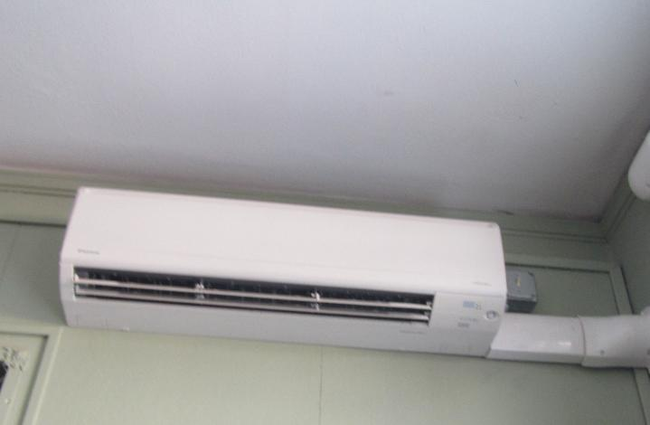
Ductless wall-mounted mini-split
Picture 2
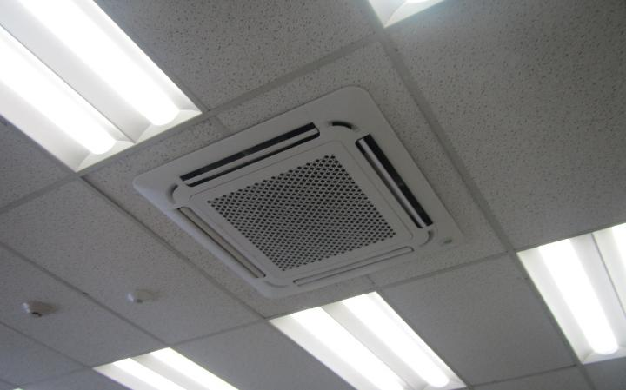
Ductless ceiling-mounted mini-split
Picture 3
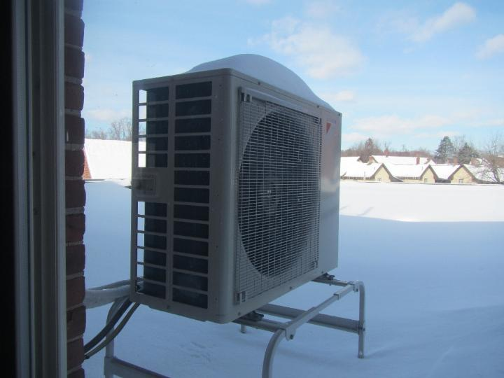
Exterior fan which connects to interior ductless mini-split
Water Damage and Moisture Concern Pictures
(click to link back to report)
Picture 4
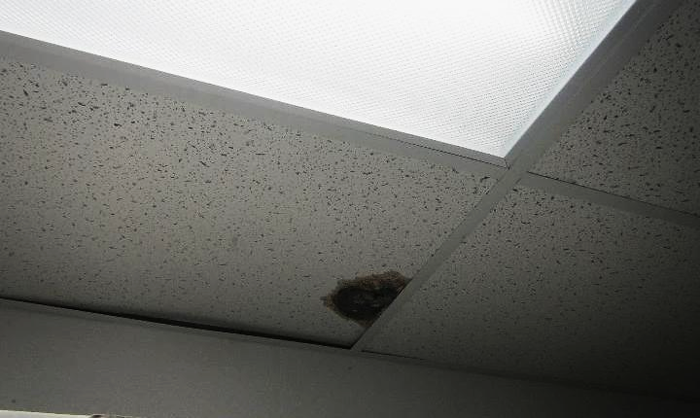
Water-damaged ceiling tile in Records Room, dark staining indicates likely mold growth
Picture 5
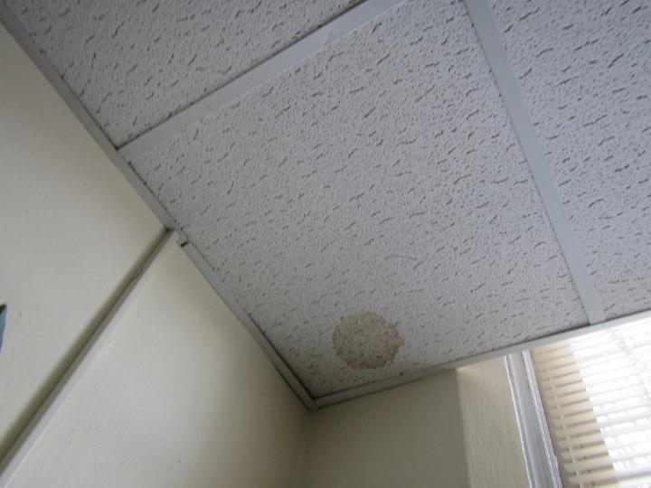
Water-damaged ceiling tile in Public Health Director Office
Picture 6
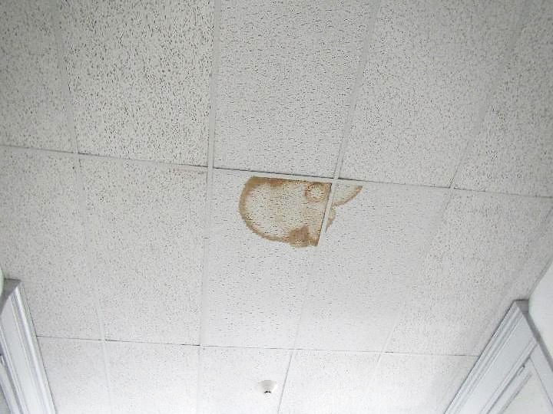
Water-damaged ceiling tiles in second floor hallway
Picture 7
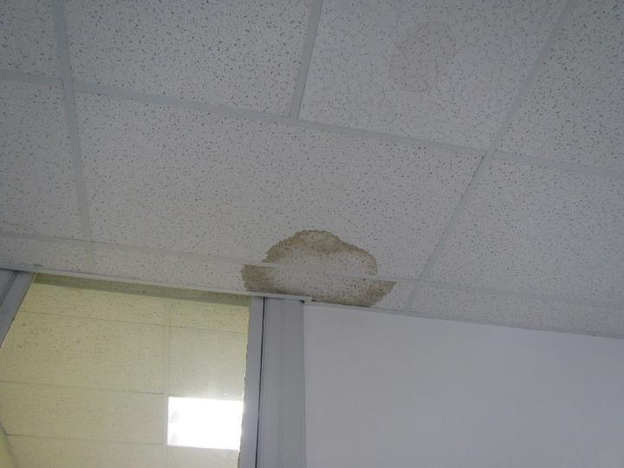
Water-damaged ceiling tiles in first floor hallway
Picture 8
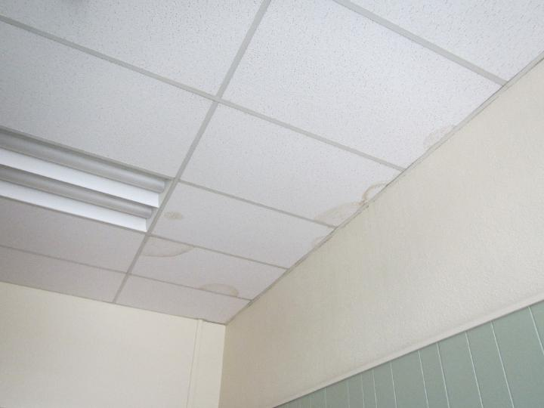
Water-damaged ceiling tiles in Inspection Services office
Picture 9
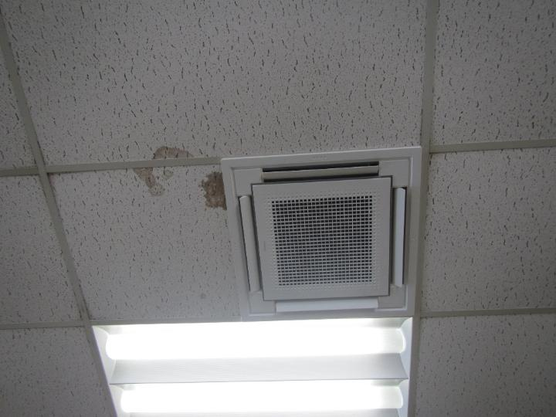
Water-damaged ceiling tiles in close proximity to mini-split
Picture 10
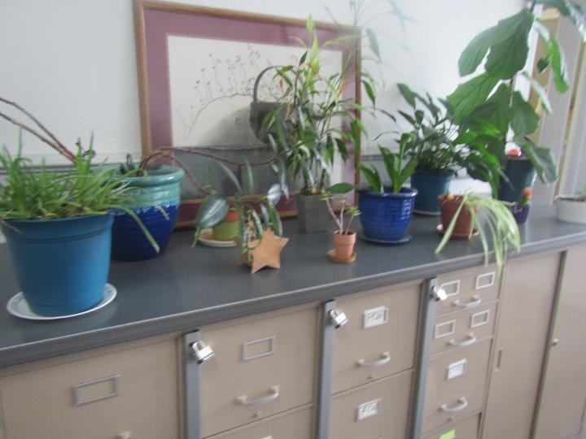
Plants on the second floor
Picture 11
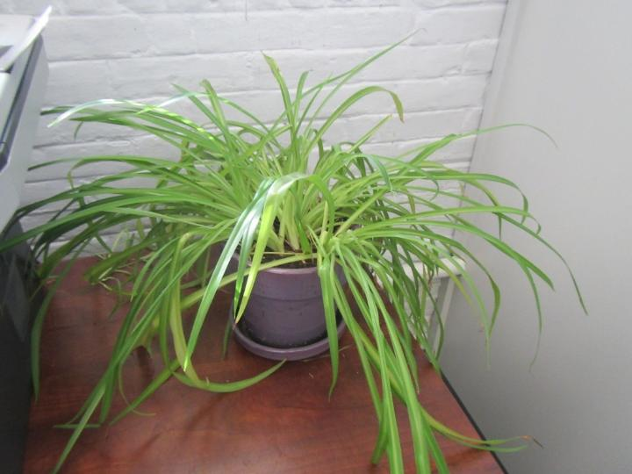
Plant in an office
Picture 12
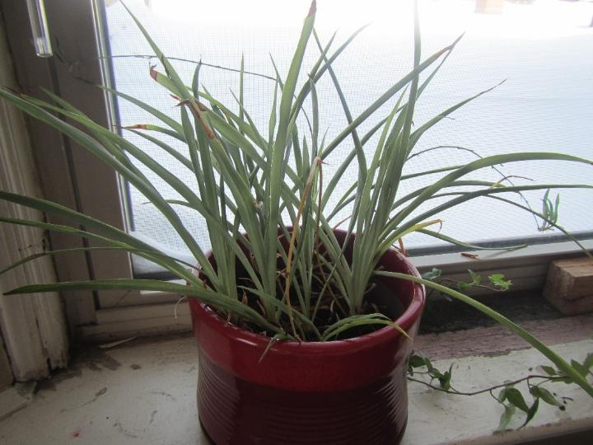
Plant on windowsill in an office
Picture 13
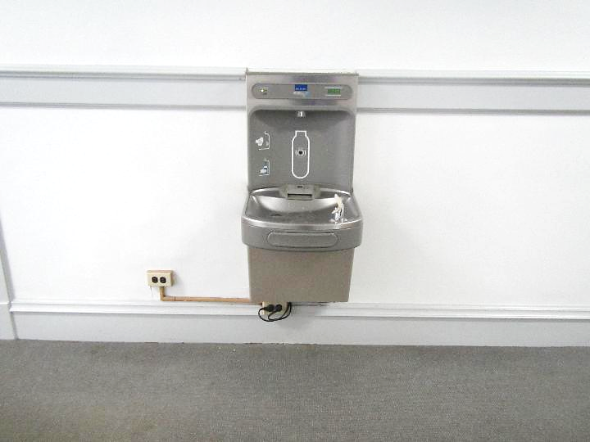
Water bubbler above carpeted floor
Picture 14
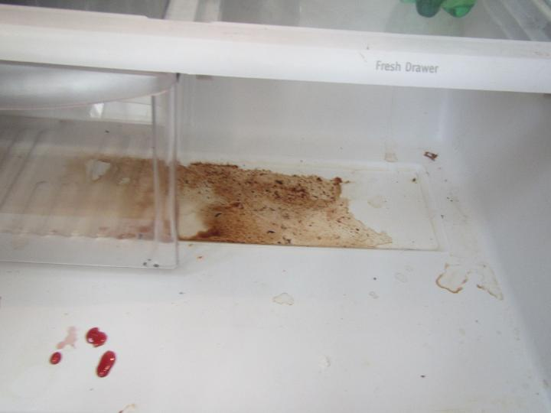
Food/liquid stains in a refrigerator
Picture 15
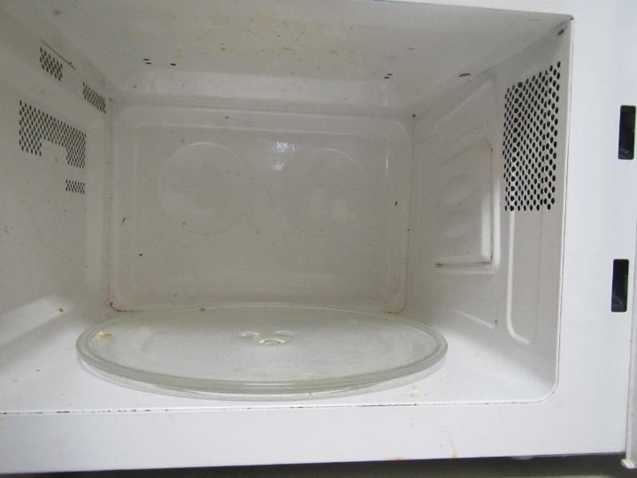
Dirty microwave interior
Picture 16
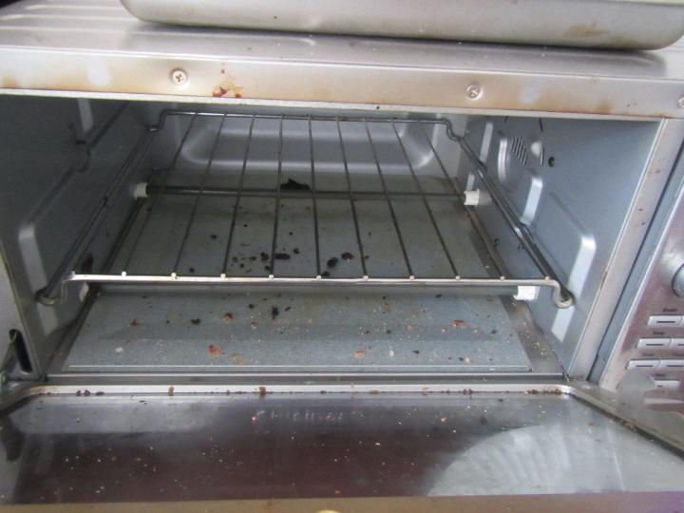
Crumbs in a toaster oven
Picture 17
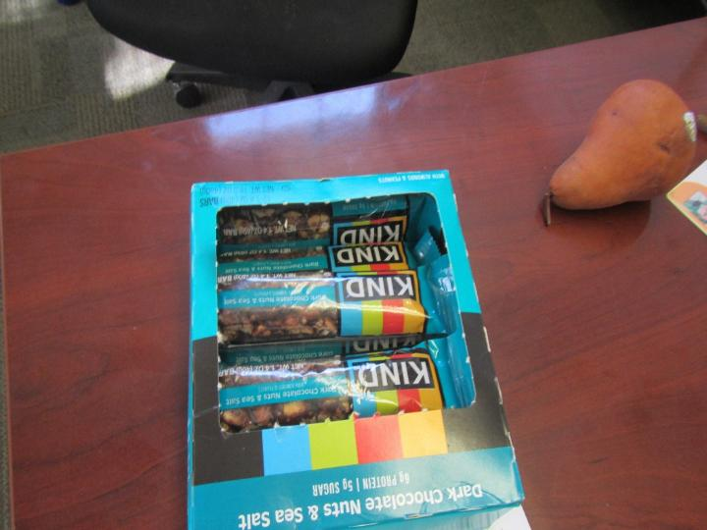
Food in an office
Picture 18
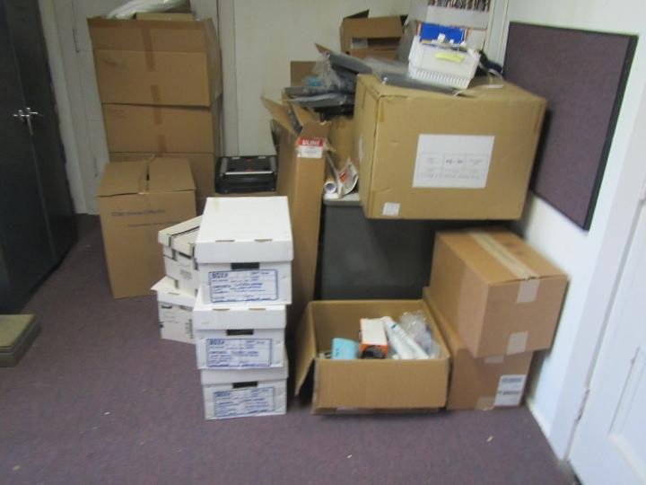
Cardboard boxes stored on carpeted floor in Records Room
Picture 19
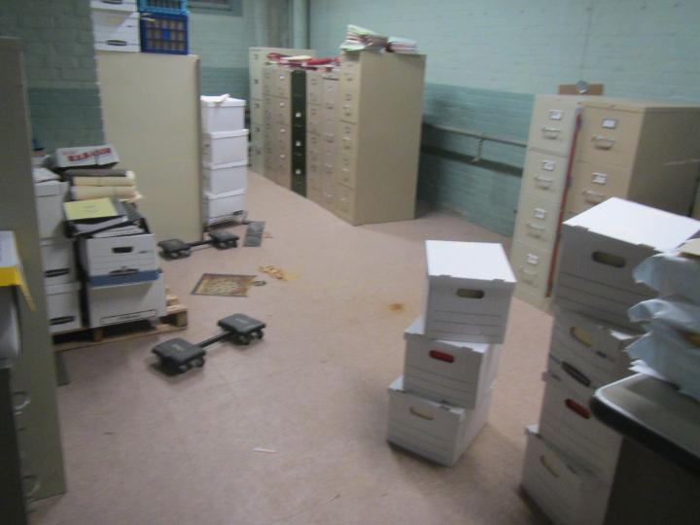
Cardboard boxes stored directly on floor in Storage Room
Picture 20
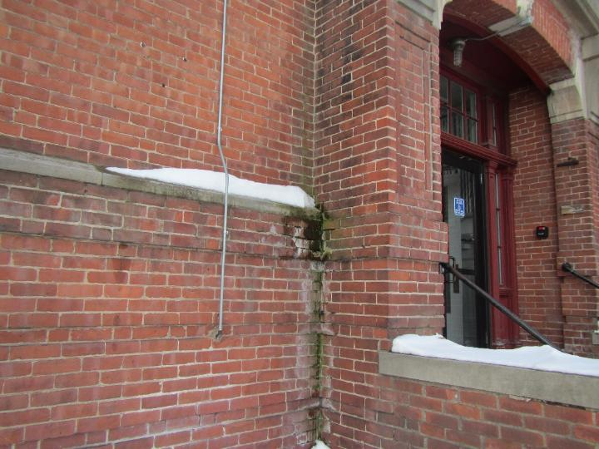
Efflorescence and moss/algae growth along right side of building
Picture 21
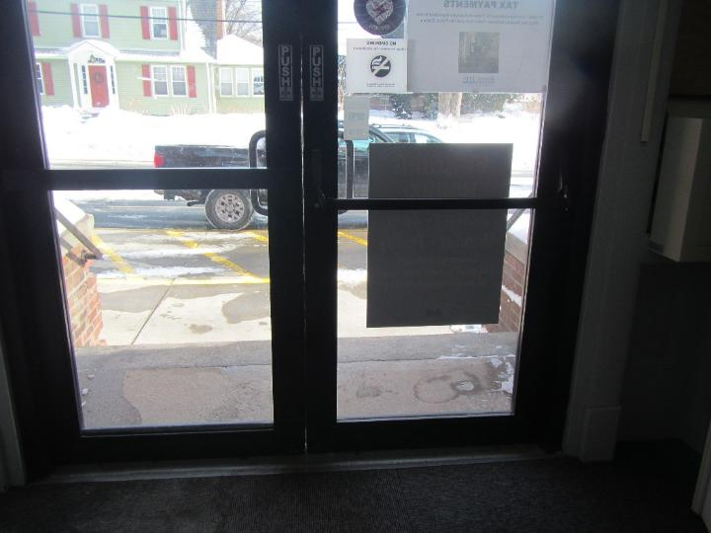
Light penetration through gap between exterior doors near Public Health office
Picture 22
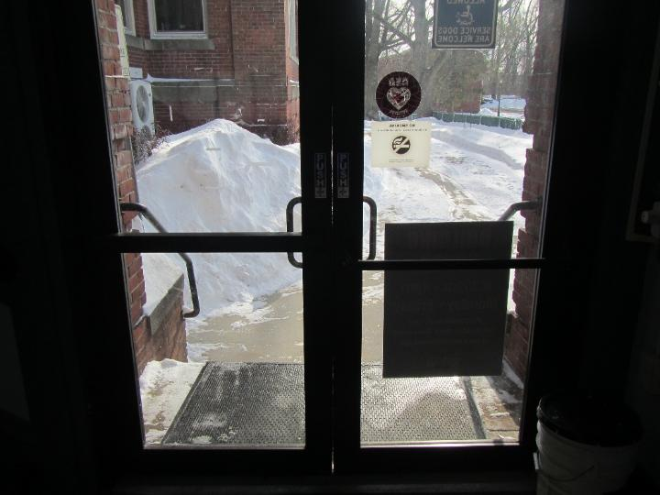
Light penetration through gap between exterior doors near Select Board Meeting Room
Picture 23
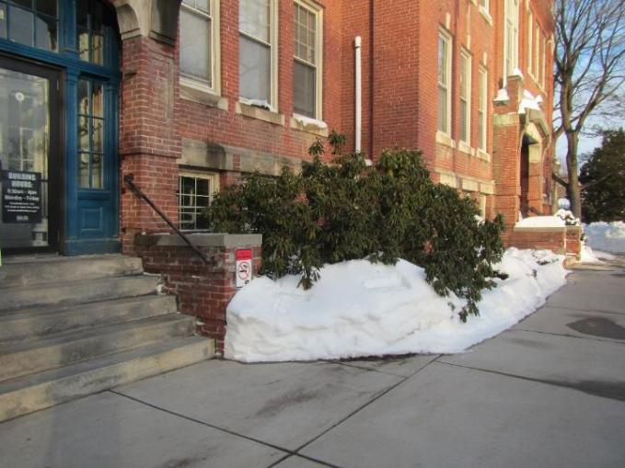
Shrubbery against exterior wall, note large tree on right side of building (blue arrow)
Sources of Respiratory Irritant Pictures
(Click to link back to report)
Picture 24
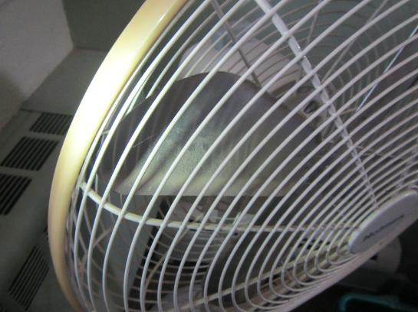
Dusty personal fan
Picture 25
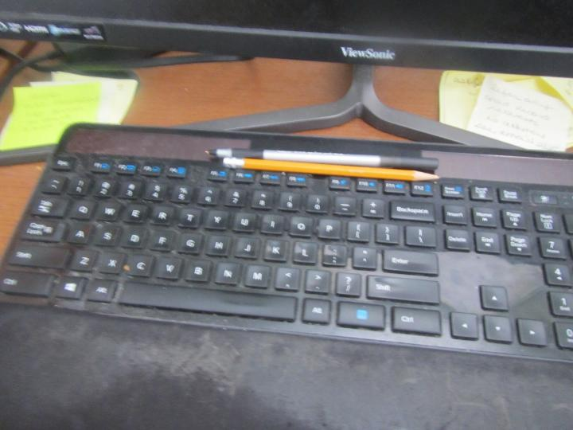
Dusty keyboard
Picture 26
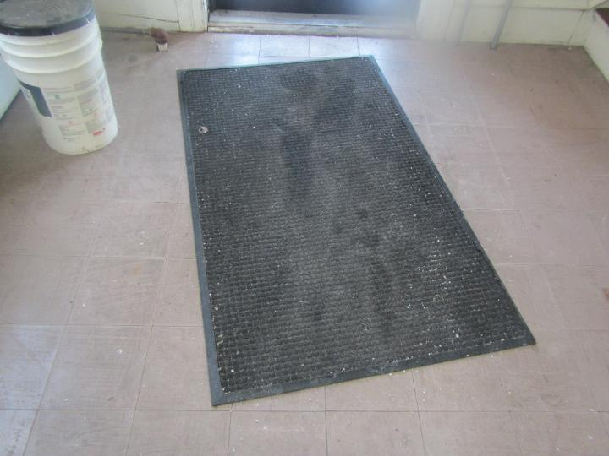
Dust and debris on area carpet
Picture 27
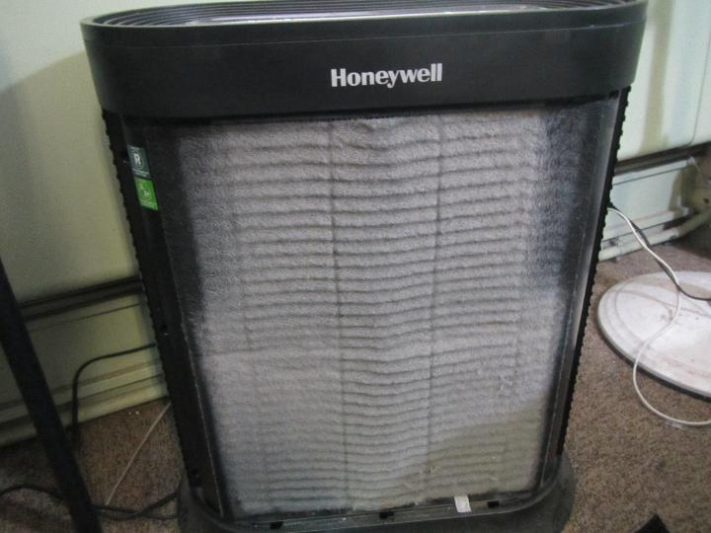
Air purifier occluded with dust and debris
Picture 28
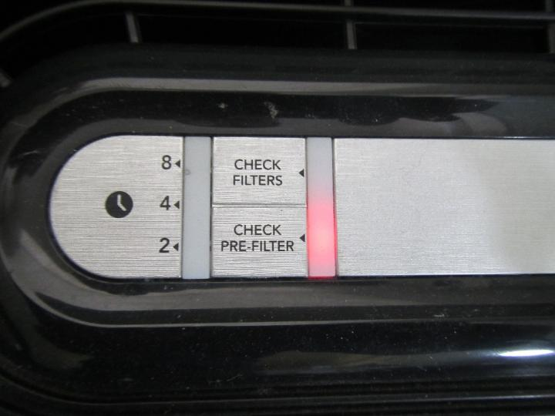
Air purifier check pre-filter red light on
Picture 29
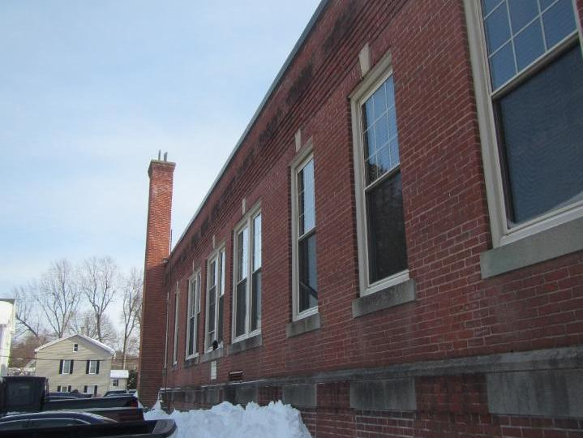
Vehicles (lower left) parked underneath windows
Picture 30
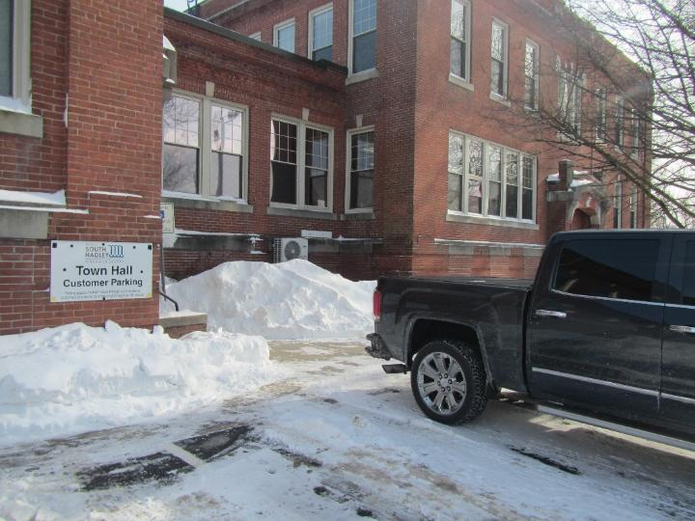
Vehicle tailpipe parked close to Inspection Services windows
Picture 31
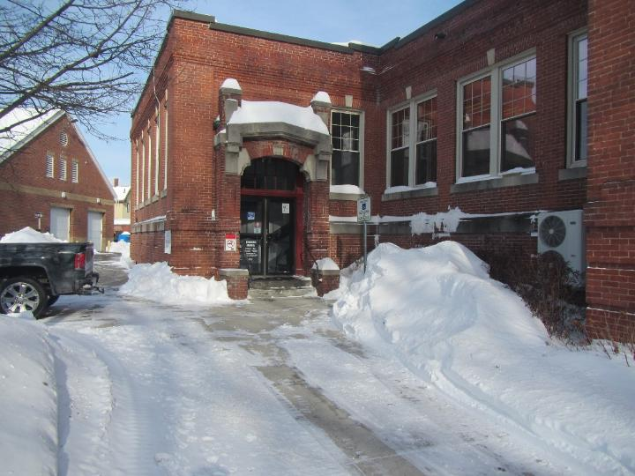
Vehicle parked close to entrance door near Select Board and Inspection Services windows
Picture 32
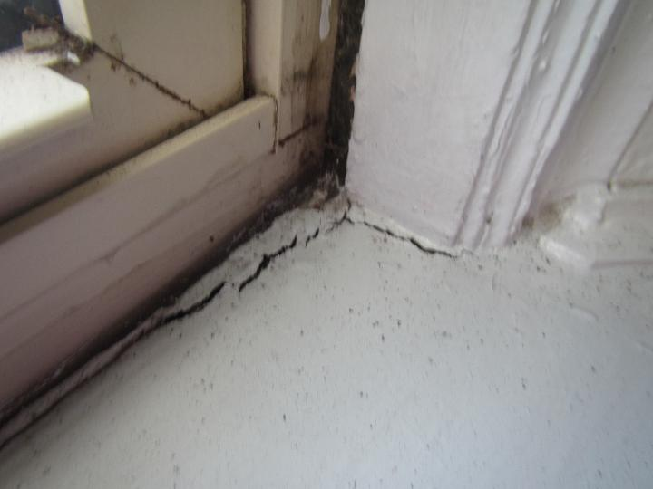
Crack around window in the Facilities/Maintenance office allowing draft to enter
Picture 33
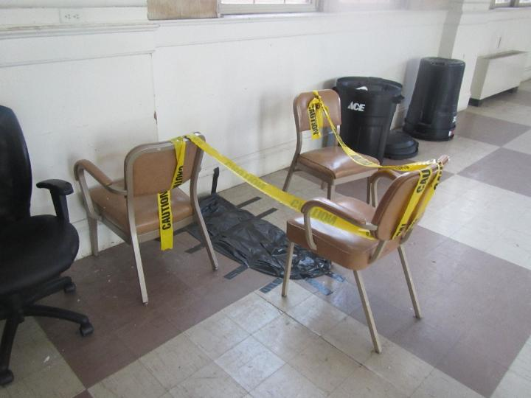
Reported asbestos-containing material floor tiles covered and taped off in auditorium
Picture 34
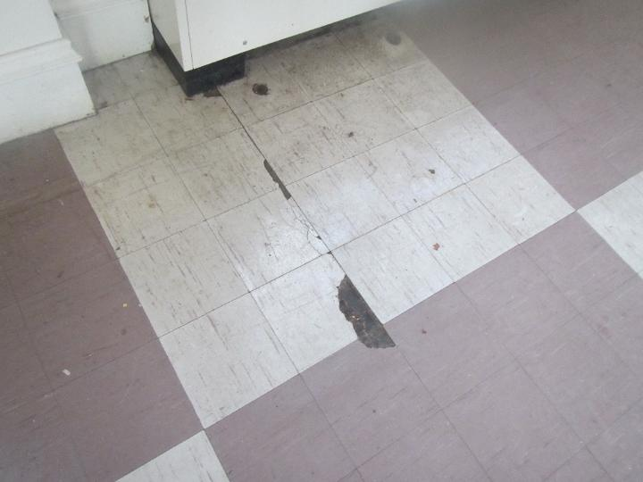
Broken floor tiles in auditorium
Picture 35
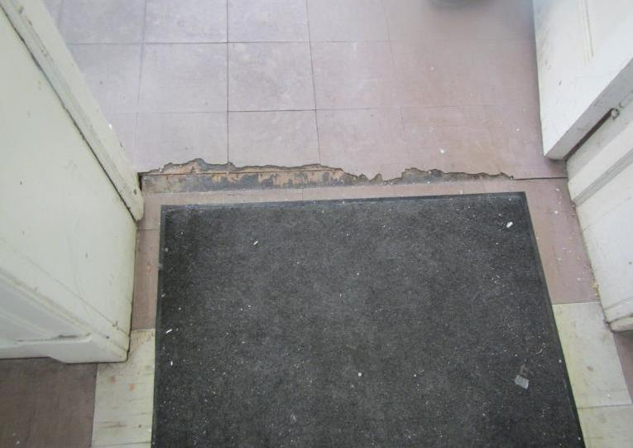
Broken floor tiles in auditorium
Picture 36
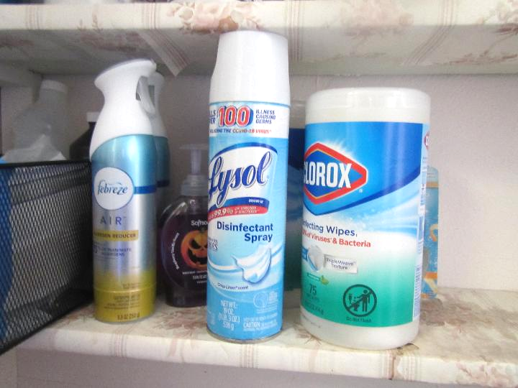
Air freshener spray, disinfectant spray, and cleaning wipes

Table 1 Location | Carbon  Dioxide  (ppm) | Carbon Monoxide  (ppm) | Temp  (°F) | Relative  Humidity  (%) | PM2.5  (µg/m³) | TVOC | Occupants  in Room | Windows  Openable | Ventilation |  | Remarks
 |  |  |  |  |  |  |  |  | Supply | Exhaust | Remarks
Background (outside) | 416 | 1 | 19 | 41 | 3 | ND |  |  |  |  | Significant snowstorm within past 3 days, moderate traffic
Ground Floor
Public Health Director Office | 562 | ND | 74 | 20 | 1 | ND | 0 | Y | N | N | Carpeted, WD CT, dusty/dirty pre-filter in air purifier, wall-mounted mini-split, cardboard boxes on floor, dehumidifier (not in use)
Records Room | 624 | ND | 77 | 21 | 1 | ND | 0 | N | N | N | Entrance carpeted, dark staining WD CT, missing CT
Facility Maintenance Office | 670 | ND | 74 | 21 | 1 | ND | 1 | Y | N | N | Drafts around windows, air purifier, wall-mounted mini-split, carpeted
Break Room | 528 | ND | 76 | 20 | 3 | ND | 0 | Y | N | N | Fridge, microwave, WD CT, toaster oven, coffee maker, air purifier
IT | 548 | ND | 74 | 20 | 1 | ND | 1 | Y | N | N | Air purifier, area carpet
Human Resources (HR) | 549 | ND | 71 | 21 | 2 | ND | 1 | Y | N | N | Air purifier, plants, carpeted
HR Office # 1 | 606 | ND | 72 | 20 | 2 | ND | 0 | Y | N | N | Plants, carpeted, food
HR Records | 670 | ND | 72 | 21 | 2 | ND | 0 | N | N | N
Storage Room | 478 | ND | 68 | 21 | 1 | ND | 0 | N | N | N | Cardboard boxes stored directly on floor
Boiler Room | 528 | ND | 68 | 20 | 1 | ND | 0 | N | N | N
First Floor
Public Health | 688 | ND | 73 | 19 | 3 | ND | 0 | Y | N | N | Air purifier, wall-mounted mini-split, fridge, microwave, personal fan, dusty keyboard
Veterans Services | 596 | ND | 75 | 20 | 2 | ND | 1 | Y | N | N | Wall-mounted mini-split, cardboard boxes on the floor
Auditorium | 701 | ND | 70 | 19 | 2 | ND | 0 | N | N | N | Reported asbestos containing material floor tile area covered and taped off, broken floor tiles, area carpets
Assessors | 904 | ND | 75 | 18 | 1 | ND | 2 | Y | N | N | Air purifier, ceiling-mounted mini-split, plant
Assessors’ Office # 1 | 906 | ND | 75 | 18 | 1 | ND | 1 | Y | N | N | Personal fan, cleaning wipes, fridge
Assessors’ Storage | 833 | ND | 75 | 18 | 1 | ND | 0 | N | N | N | Cleaning supplies
Town Clerk | 673 | ND | 72 | 19 | ND | ND | 1 | Y | N | N | WD CT next to ceiling-mounted mini-split, plant, air purifier, food
Town Clerk Vault | 670 | ND | 72 | 19 | ND | ND | 0 | N | N | N
Town Clerk Side Office | 681 | ND | 73 | 19 | ND | ND | 2 | Y | N | N | Ceiling-mounted mini-split
Collector/ Treasurer | 706 | ND | 76 | 18 | ND | ND | 2 | Y | N | N | Air purifier, large ceiling-mounted mini-split, plant
Collector/ Treasurer Vault | 716 | ND | 76 | 18 | 1 | ND | 0 | N | N | N
Inspection Services | 650 | 1 | 73 | 19 | ND | ND | 1 | Y | N | N | Report of odor early this morning possible fumes, exhaust, or oil smell, SHTH staff no longer smelled it at time of assessment, ceiling-mounted mini-split, plant, personal fan
Inspection Services Office # 1 | 548 | ND | 73 | 19 | ND | ND | 0 | Y | N | N | WD CT
Finance Office Left | 1034 | ND | 74 | 19 | ND | ND | 2 | Y | N | N | Wall-mounted mini-split, microwave, fridge, plant
Finance Office Middle (in hallway) | 886 | ND | 77 | 18 | ND | ND | 0 | N | N | N | Check pre-filter light on for air purifier, very dusty pre-filter, plant
Finance Office Right | 877 | ND | 78 | 18 | ND | ND | 0 | Y | N | N | Wall-mounted mini-split
Town Admin. Office | 625 | ND | 77 | 17 | ND | ND | 1 | Y | N | N | Wall-mounted mini-split
Town Admin. Main Area | 630 | ND | 77 | 17 | ND | ND | 0 | Y | N | N
Select Board Meeting Room | 485 | ND | 70 | 17 | ND | ND | 0 | Y | N | N
Second Floor
School Business (SB) Main Area | 664 | ND | 73 | 21 | 1 | ND | 1 | Y | N | N | Food, plant, ceiling-mounted mini-split
SB Office # 1 | 770 | ND | 74 | 20 | 2 | ND | 1 | Y | N | N | Ceiling-mounted mini-split, cleaning wipes
SB Office # 2 | 839 | ND | 74 | 20 | 1 | ND | 0 | Y | N | N | Personal fan
SB Office # 3 | 836 | ND | 75 | 20 | 1 | ND | 1 | Y | N | N | Personal fan
School Department Superintendent Office Main Area | 951 | ND | 76 | 19 | 5 | ND | 3 | Y | N | N | Wall-mounted mini-split, plants, cleaning wipes
Kitchenette | 851 | ND | 77 | 19 | 3 | ND | 1 | Y | N | N | Fridge, microwave, toaster, cleaning supplies
Planning/ Conservation (P/C) | 763 | ND | 71 | 20 | 1 | ND | 3 | Y | N | N | Cleaning wipes, plants
(P/C) Conference Room | 712 | ND | 71 | 19 | 1 | ND | 0 | Y | N | N | Printer, wall-mounted mini-split
Student Services Main Area | 764 | ND | 72 | 19 | 1 | ND | 2 | Y | N | N | Mini-split
Student Services Office # 1 | 669 | ND | 74 | 19 | ND | ND | 0 | Y | N | N | Mini-split, plants
Student Services Office # 2 | 695 | ND | 74 | 19 | ND | ND | 1 | Y | N | N | Mini-split, microwave
Copier Room | 712 | ND | 74 | 18 | 1 | ND | 0 | N | N | N | Fridge, microwave, dusty personal fan, dirty microwave, cardboard boxes on floor
Student Services Conference Room | 808 | ND | 76 | 17 | 2 | ND | 1 | N | N | N | Personal fan, dirty fridge,
Data Manager | 770 | ND | 77 | 18 | 2 | ND | 1 | Y | N | N
Office next to Data Manager | 751 | ND | 73 | 18 | 1 | ND | 0 | Y | N | N

(Click to link back to report)

Table 2A
Equipment Present in Building  (X = Yes) | Type of Heating/Cooling Ventilation  Equipment | Fresh  Air  Supply  (X = Yes) | Type of Location(s) | Air Filters Installed  MERV Rating  (1-15, U*)  (X = Yes) | Comments
 | Univents
 | Rooftop Air Handling Units
 | Outdoor, Ground-Installed Air Handling Units
 | Attic/Crawlspace Air Handling Units
 | Ceiling-Mounted Air Handling Units (including inside plenum)
 | Basement/Crawlspace-Installed Air Handling Units
 | Mechanical Room-installed Air Handling Units
 | Fan Coil Units
 | Window-Mounted Air Conditioners
 | Wall Louver-Controlled Gravity Air Supply
X | Windows | X |  |  | Repair/replace to allow easier to open
 | Fan in window (blowing in)
 | Built in wall fan (switched) | X
 | Heat recovery ventilator unit
 | Energy recovery ventilator unit
 | Chilled Beam
 | Passive combustion supply vent in basement/boiler room

*U = Filter Rating underdetermined due to inaccessibility during building visit

(Click to link back to report)

Table 2B
Equipment Present in Building  (X = Yes) | Type of Exhaust Ventilation  Equipment | Ducted  To Outdoors  (X = Yes) | Type of Location(s) | Comments
 | Rooftop Motors/Fans
 | Unit Exhaust
 | Ceiling Return Vent
 | Ceiling Return Vent, Plenum
 | Wall Return Vent
 | Kitchen Stove Hood
 | Restroom Exhaust Vent
 | Photocopier Exhaust Vent
 | Garage
 | Chemical Hood(s)
 | Locker Rooms
 | Showers
 | Lock up Cells
 | Clothes Dryers
 | Gas Water Heaters
 | Furnace-Flue to Chimney
 | Furnace/Boiler direct vent or power vent (no combustion air supply)
 | Kiln, Pottery
 | Dark Room
 | Generator Room
 | Wood Shop Dust Collector
 | Spray Paint Booths
 | Fan in window (blowing out)

Table 2C
Equipment Present in Building  (X = Yes) | Type of Equipment | Type of Location(s) | Comments
 | Floor Fans, pedestal
X | Portable fans | Various areas | Some dirty and dusty
X | Air Purifier (HEPA, other) | Majority of areas | Clean/replace filters on regular basis
 | Floor heaters, portable
X | Refrigerators, Cold Beverage Vending Machines | Break rooms and some offices | Clean food/liquid spills
X | Radiator, wall-mounted
X | Radiator, floor-mounted
 | Passive vents (Wall/Door)

(Click to link back to report)

Table 3
Found in Building  X = Yes | Water-Damaged Materials, Building Components or Stored Materials | Location | Visible Microbial Growth?  X = Yes | Musty odor detected?  X = Yes | Comments
 | Books-other bound materials
 | Brick walls – broken, missing mortar
 | Brick walls – blocked weep holes
 | Cardboard boxes
 | Carpet tiles
 | Carpet - Area rugs
 | Carpet wall-to-wall
 | Ceiling tiles - affixed directly to ceiling surface
 | Ceiling tiles - bowing-in suspended ceiling
 | Ceiling tiles - water-stained in splined ceiling
X | Ceiling tiles - water-stained in suspended ceiling | Various | X |  | Fuzzy substance, dark staining
 | Chairs - laminated
 | Cloth
 | Countertops (around sinks)
 | Curtains
 | Dust/debris within AHU, uninvent, HVAC, chilled beam units, etc. (WD through condensation, humidity, or leaks)
X | Efflorescence (i.e., mineral deposits) | Interior and exterior of building
 | Engineered woods - particleboard, plywood, Masonite
 | Flooring – loosened tiles
 | Flooring - wooden
 | Furniture - laminated
 | Furniture - upholstered
 | Gypsum wallboard - ceiling
 | Gypsum wallboard - restroom wall
 | Gypsum wallboard - interior wall
 | Gypsum wallboard – located on exterior wall
 | HVAC drain pan – lack of draining
 | HVAC filters
 | Insulation- attic (paper-backed)
 | Insulation - inside air handling unit
 | Insulation - on pipe(s) fiberglass
 | Insulation - on pipe(s) other/plaster-like material
 | Insulation - wall cavity
 | Insulation – ceiling plenum
 | Modular furniture – walls/cloth partitions
 | Musical instrument cases
 | Plaster ceilings
 | Plaster walls
 | Records/files
 | Refrigerator - door gasket
 | Refrigerator - drip pan
 | Refrigerator - Interior surfaces
 | Room divider - ceiling-mounted, sliding
 | Sink backsplash
 | Tables – laminated
 | Wallpaper
 | Wood - attic/roof materials
 | Wood - floor joists in basement ceiling
 | Wood - wall framing
 | Wood - window sills
 | Wood - window-mounted air conditioner framing
 | OTHER: Wooden baseboard

WHAT ARE ENVIRONMENTAL ASTHMA TRIGGERS?
Asthma triggers are any chemical, pollutant, or allergen that can make your asthma worse. Asthma triggers can also be strong chemical smells, dust, or pets. Your asthma triggers may be different from those of other people. Not all asthma triggers affect people the same way. Environmental asthma triggers are found both indoors and outdoors. DPH link: Asthma and Your Environment (mass.gov)

(click to link back to report)

Table 4
Condition Present  X = Yes | Possible asthma symptom-inducing environmental pollutant | Recommendation to reduce or eliminate the pollutant
X | Water Damage and/or Mold  (allergen) | Identify water source and repair to eliminate.  Clean non-porous materials.  Remove and replace porous materials susceptible to mold growth.  Perform regular water damage assessments as a tool to ensure timely mitigation as needed.  Use NIOSH water damage assessment protocol as a guide: NIOSH water damage assessment guideline.
X | Moistening of building components during hot, humid weather (>2 days in length) (mold, allergen) | Remove materials not dried in <2 days in a manner consistent with US EPA Mold Removal in Commercial Buildings guideline.  Use dehumidification in occupied basement areas and other areas with chronic dampness.
X | Vegetation against exterior of building (water damage-mold) | Remove all vegetation preventing building exterior drying.  Remove all vegetation capable of falling onto a building or depositing debris onto the roof.
 | Personal humidifiers (lack of proper maintenance)  (pollutant and allergen) | Clean and maintain properly.  Use distilled water to eliminate metal and water treatment odors.  Maintain hydration by increasing water consumption.
X | Drains: Floor drains, Sink drains (abandoned use)  Water bubblers (abandoned use) | If in use, pour water into drain at least twice a week.  If not in use, seal the drain with an appropriate material in accordance with Massachusetts Plumbing Code (248 CMR 10.00).
 | Live Animals (turtles, gerbils, birds, rabbits, etc.) | Ensure cleanliness or remove animals from the location.
 | Improperly maintained aquariums and terrariums (allergen) | Maintain such equipment properly to eliminate odor.  Discontinue use.
X | Plants and flowers  (allergen and mold) | Keep indoor plants well maintained and not overwatered. Monitor for signs of mold and pests.  Ensure water for cut flowers does not become stagnant.  Ensure dried plant material is free of odors, mold, and pests and handled carefully  If asthma risks are high, eliminate plants and flowers.
 | HVAC system moisture issues  (mold, allergen) | Consult ASHRAE’s minimum standards for HVAC maintenance and inspection of commercial HVAC systems (https://www.ashrae.org/technical-resources/bookstore/standards-180-and-211).
 | HVAC system contaminant issues (allergen) | Consult ASHRAE’s minimum standards for HVAC maintenance and inspection of commercial HVAC systems (https://www.ashrae.org/technical-resources/bookstore/standards-180-and-211).
 | Indoor swimming pool odors outside of swimming pool (mold, chemical) | Maintain and operate pool HVAC systems to vent odors from building.  Ensure locker room exhaust vents are operating during building hours.  All doors leading to pool should be rendered airtight and be closed.
X | Pollen (allergen) | Recommend installation of MERV 8 or better filters if HVAC engineer confirms HVAC system can be so equipped without adversely affecting function.  Cut grass after hours.  Cut grass in a pattern to direct clippings away from exterior wall.  Remove trees and shrubs from in front of windows and air intakes.
X | Dry air | Maintain hydration.  Avoid overheating of air.
 | Dust mites  (allergen) | Recommendation to remove non-official upholstered furniture, area rugs, pillows, cushions, etc.  Cleaning with use of HEPA-filtered vacuum cleaner.  Eliminating clutter, storing items in dust and moisture-proof containers, and regularly removing dust through wet wiping.
 | Pests, including rodents and cockroaches  (allergen) | Use of integrated pest management guidelines, including:  - Proper disposal of food containers  - Proper storage of food products in airtight containers  - Elimination of use of food as art projects  - Remove pest harborages/clutter  - Regular monitoring for pests  EPA IPM guideline link
 | Latex-containing materials | Remove tennis balls from furniture legs.
X | Fragrances  (chemical) | Eliminate point sources, such as:  - Plug-in air fresheners  - Aroma/oil reed diffusers  - Scented sprays  - Discontinue use of other scented materials  - Consult DPH fragrance guideline: Clean air is odor-free
 | Strong smells from /use of Chemicals (such as cleaning products)  (chemical) | Use building-issued cleaning products.  Use products in accordance with manufacturer’s instructions including dilution, application, and ventilation.  Avoid using products that are stronger than needed for the situation.
 | Strong odors from new building materials (carpeting/furniture)  (chemical) | Use low VOC-emitting materials.  Air out materials (outside or in unoccupied area) prior to installation.
 | Tobacco smoke  Secondhand Smoke  (pollutant) | Eliminate tobacco smoking.  Seal all shared wall penetrations.
X | Products with a strong odor such as paint, perfume, hairspray, air fresheners, bug-spray, laminators, candles, wax melters, dry erase markers and other VOC-containing products  (chemical) | If essential:  - Provide proper exhaust ventilation to eject aerosolized product directly outdoors.  - Avoid/reduce use during occupied hours.  If not necessary, remove and eliminate.
X | Vehicle exhaust  (pollutant) | Enforce anti-idling regulations and post signs to give notice.  Relocate vehicles away from fresh air intakes.  Require vehicles to park face-in at building walls.  Close doors to prevent vehicle exhaust from entering occupied spaces. idling-faq
 | Vapors and or fumes from gas, oil, or kerosene stoves  (pollutant) | Operate stove hood when stove in use.  Install stove hood if not present.  Ensure equipment is in good working order.
 | Ozone (pollutant) | Eliminate use of ozone generating equipment.
 | Window Air Conditioners (if not properly maintained) (allergen) | Equip with proper filter and clean periodically.  Clean drip pans.  Install in window with weathertight, non-mold-growth sustaining material.
 | Pottery (pollutant) | Do not operate kiln during occupied hours.  Operate kiln with exhaust system activated.  Seal all seams and holes in kiln vent.  Ensure kiln exhaust discharge terminates outdoors.
X | Carpeting (allergen) | Clean carpeting in a manner consistent with IICRC standards, including regular vacuuming with a high efficiency particulate air (HEPA) filtered vacuum in combination with annual cleaning or semi-annual cleaning in soiled high traffic areas.
X | Sweeping/dusting vs HEPA vacuuming/wet wiping  (allergen or pollutant) | Refrain from using feather dusters or brooms.  Utilize HEPA vacuums and wet wiping to minimize aerosolizing particulate matter.
 | Lack of adequate air exchange/mechanical ventilation | Make repairs as necessary and ensure all HVAC system components are operating continuously when building is occupied.
X | Lack of local exhaust at source of pollution (vocational shop activities, kitchen exhaust hood) (all) | Recommend installation of exhaust ventilation to direct pollutants directly outdoors.
 | Renovating buildings while occupied  (chemical) | Use all SMACNA guidelines for Renovation While Buildings Are Occupied. For information, visit https://www.mass.gov/service-details/construction-and-renovation-generated-pollutants-in-occupied-buildings.
 | Chemistry program chemical storage  (chemical) | Repair (if needed) and operate chemical storeroom vents appropriately.  Reduce or eliminate unneeded or overstocked chemicals.  Store all chemicals in a manner to separate incompatible chemicals.  Keep chemical storerooms clean.
X | Photocopiers/duplicating machines | All machines should have dedicated exhaust vents or be used in a well-ventilated area.

