ATTACHMENT 10

AFFIDAVIT OF TRUTHFULNESS AND COMPLIANCE

Massachusetts Department of Public Health Determination of Need
Version: 7-6-17
Affidavit of Truthfulness and Compliance with Law and Disclosure Form 1 oo.40S{B)
lIoncsktrtuhcetifoonrms:. CPorimntpFleotremI.nfEoarcmhaptieornsobnemlouws.t Wsighnenancdomdaptlettehechfoecrmk t.heWbhoexn "Talhl issigdnoactuumreesnhtaivserebaedeyntcoopllrectinte:"d. , Tschaisnwthilel ddaotceusmtaemnpt aanndd
e-mail to: dph.don@state.ma.us include all attachments as requested.o

Application Number: 21040109-HS
I 05/06/2021__.Io

Applicant Name: I South Shore Health System, Inc. ]
Original Application Date: L. _____

Appplliiccaniot'ns BTuyspien:esHsoTsyppieta: l/C[!)linCicorSpoubrasttiaonntial□ChLaimngiteedinPaSrtenrveircsehip D Partnership O Trust OLLC O0ther

Is the Applicant the sole member or sole shareholder of the Health Facility(ies) that are the subject of this Application? OX Yes
T1.hoe undeTrhsiegAnepdplciceartnitfiiessthuendseorlethceorppaoinrastaenmdepmenbaelrtoierssooflepeshrjaurryeh: older of the Health Facility[ies] that are the subject of this Application;o
QNo

2.
3.o
4.o
65..o
- have read 105 CMR 100.000, the Massachusetts Determination of Need Regulation;o I inhafovremreaatidonthcios natpapinliecdathioenrefionr iDs eatcecrumrainteataionnd otrfuNee;oed including all exhibits and attachments, and certify that all of the
- hhaavvee ssuubbmmiitttteedd tthhee rceoqrrueicret dFiclionpgieFseeofatnhdisuanpdpelircsatatinodn ittoisthneonDretfeurnmdianbalteiopnuorsfuNaenedt toPr1o0g5rCaMm,Ra1n0d0, .a4s05ap(8p)l;oicable, to all
I undersiand and agree to the expected and appropriate conduct of the Applicant pursuant to 105 CMfiJ 00.800;o

7.o IPhaartvi e coafuRseedco, ards raenqduoirtehde, rnpoatirtcieessoafsinretqenuitrteodbepurpsuubalnisthteodla0n5dCdMuRpl1i0ca0t.4e0c5o(p8i)e;os to be submitted to all Parties of Record, and
aAlpl pcallrcraie,rJrs coorntthriarcdt-sp, aartnyd awdimthinMisetdraictaorres,apnudbMliceadnicdaicdo,masmreerqcuiairle. dfobr tyh1e0p5aCyMmRen1t0o0f.4h0e5a(Clt)h, ectarseeqse.;orvices with which the

8.o
9.o 10.o
11.o
12.o
1143..o
i10ha0v.4e0c5a(Eu)seanddp3ro0p1 eCr MnoRti1fi1c.a00tio; nwaillnbdesmubamdeissifioanpspltiocatbheleoSecretary of Environmental Affairs pursuant to 105 CMRo aIfcscuobrdjeactncteo wMi.tGh.L1.OcS. 6CDM, R§ 11030a.4n0d59(G58);oCMR 7 .00, I have submined such Notice of Material Change to the HPC - in sPuubrssutaannttiatol c1o0m5pClMianRc1e0a0n.2d1g0{oAo)d(3s),taI ncedrtinifyg wthitaht rboelethvatnhte fAedpeprliacla, nsttaat,._ne,1datnhdeloPcroapl loaswesdaPnrdojreecgtualraetiionnms,aatserwiaelllaansdwoith all
I have read and understand the limitations on solicitation of funding from the general public prior to receiving a Notice of I understand that, if Approved, the Applicant, as Holder of the DoN, shall become obligated to all Standard Conditions
previous,.ly issued Notices of Determination of Need and the terms and Conditions attached therein;
Determination of Need as established in 1 OS CMR 100.415;o
pursuant to 1 OS CMR 10031 O, as well as any applicable Other Conditions as outlined within 105 CMR 100.000 or that
otherwise become a part of the Final Action pursuant to 105 CMR 100.360;o
PPuurrssuuanntt ttoo 1105 CCMMR 1l 0000..?7005S((AA)),, 1I ccertrtiifyfy tthhaat tthhee APrpoppliocsaendt PhraosjeSuctffiiscaieuntthIonrtiezreedstunindtehreaSpiptelicoarbfalecizliotny;inagndboy-laws or ordinancae.soI,fwthheetPhroerpoorsendotParosjpeectciiaslnpoetrmauitthIsorrizeqeudiruendd; eorr,applicable zoning by-laws or ordinances, a variance has been

Corporation:
b. The ProrepcoesiveeddPtroojpeecrtmisitexsuecmhpPtrforopmosezodnPinrogjebcty-;loawr, s or ordinances.o

Attach a copy of Articles of Organization/Incorporation�

7cfr.t',{/(J/{srlllttic
Signatur;_,,,,.--/_
CEO for Corporation Name: &
� Date

rKiln /MUan8er1:
Board Chair for Corporation Name:
Si__,gnatur�e�:
Da0t_e51_412_

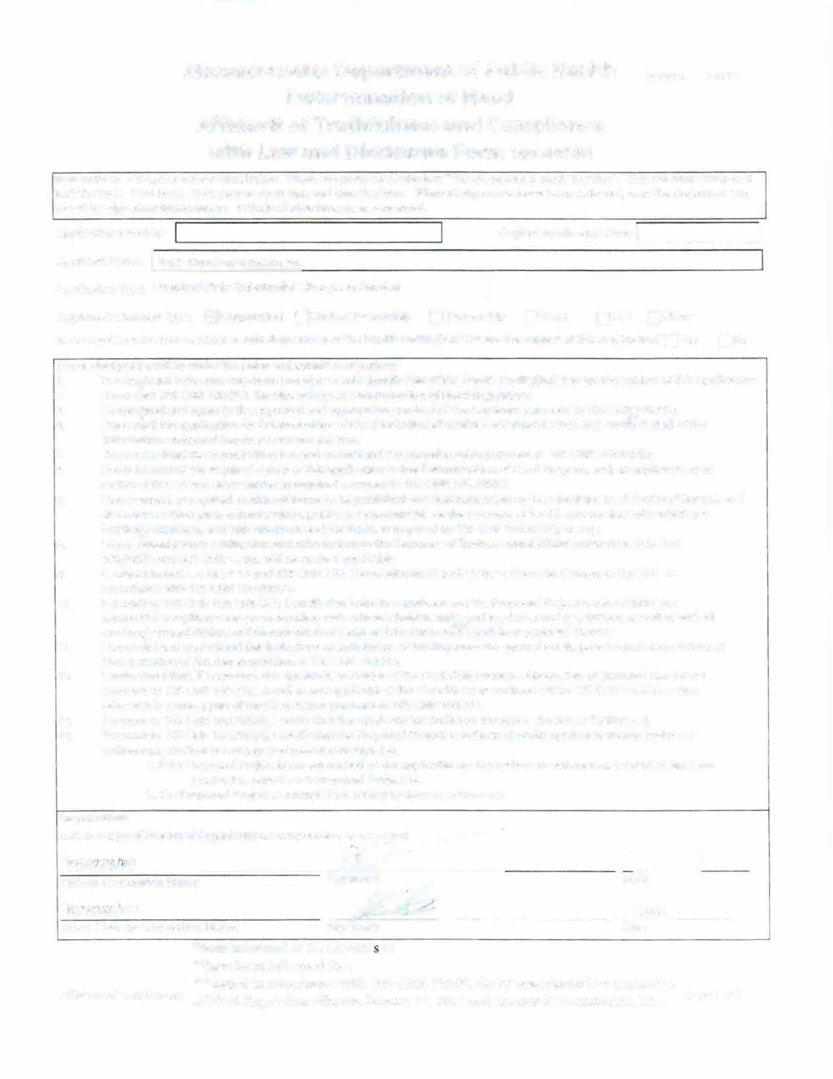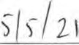
Affidavit ofTruthfulness
*,.b*heeanveinbfoeernminedfoorfmtehde tchoanttent of o,...f*NiseseudedRiengucolamtiopnliaenffceectwivitehJa10n5uaCryM2R7,12000I.070a, nthdeaMmaesnsdaecdhuDseetctesmDbeetrer2m8,in20at1i8on

Page 1 of 2o

Massachusetts Department of Public Health Version: 7-6-17

Determination of Need Affidavit of Truthfulness and Compliance with Law and Disclosure Form 1 oo.40S(B)
lIoncsktrtuhcetifoonrms:. CPorimntpFleotremIn. fEoarcmhaptieornsobnemlouws.t Wsighnenancdomdaptle ttehechfeocrmk t. heWbhoexn"Talhl sisigdnoactureesnhtaivserebaedeyntcoopllreinctte:"d. ,Tschaisnwthilel ddaotceusmtaemnpt aanndd
e-mail to: dph.don@state.ma.us Include all attachments as requested.

Application Number: I 21040109-HS
Applicant Name: I South Shore Health System, Inc.
I Original Application Date: _{L-}r 0-5/-06-/20-21 ---'

ApplicationType: Hospital/Clinic Substantial Change in Service ]
Applicant's BusinessType: [!]Corporation Olimited Partnership O Partnership O Trust OLLC OOther
Is the Applicant the sole member or sole shareholder of the Health Facility(ies) that are the subject of this Application? OX Yes ONo
The undTerhseigAnepdplcicearntitfiiesstuhnedsoerlethceorppaoinrasteanmdepmenbaelrtoierssooflepeshrjaurreyh: older of the Health Facility[ies] that are the subject of this Application;
1.
- I have r:ad 105 CMR 100.000, the Massachusetts Determination of Need Regulation;
understand and agree t the expected d appropriate conduct of the Applican pursua to 105 CMR 100.800;*
- I have re*ad this application for Determination of Need including all exhibits and attachments, and certif*y that all of the
4.
5. IinhfaovremsautbiomnitctoendttahineecdohrreercetinFiliisnagccFuereaatendanudndtreures;tand it is nonrefundable pursuant to 105 CMR 100.405(8);

6.
7.

8.
9.
10.

11.
12.

13.
14.
PI haratviessoufbRmeictoterd tahnedroetqhueirrepdarctoiepsieassoref qthuiisreadp puicrasutiaontttoot1h0e5DCeMteRrm10in0a.4t0io5n(8o)f; Need Program, and, as applicable, to all
aI hllacvaerrciearussoerdt,haisrdre-pqauritryeda,dnmoitnicisetsraotfoirnst, epnutbtloicbaenpducbolmishmeedrcainadl, fdourpthliceapteaycmopeinetsotof hbeeasltuhbcmaritetesdertvoicaelsl PwairtthiewshoifcRhetchoerd, and AI hpapvleicac*na*ut sceodntprraocptse,ranodtwifiictahtiMonedaincdarseuabnmdisMsieodniscatiod,thaes rSeeqcureirteadryboyf1EOnSviCroMnRm1e0n0t.4al0A5f(fCa)i,res tpsuerqs.u; ant to 105 CMR 1If0s0u.b4j0e5c(tEt)oanMd.G3.0L1. cC. 6MDR, 1§11.030a;nwdi9ll5b8eCmMaRde7.i0f0a,pI phlaicvaebsluebmitted such Notice of Material Change to the HPC - in
aPcucrosurdaannt ctoe w10it5hC1MOSR C1M00R.2110O0(A.4)0(35)(,GI)c; ertify that both the Applicant and the Proposed Project are in material and
substantial compliance and good standing with r levant federal, ta\e* and local laws and regulations, as well as with all
previously issued Notices of Determination of Need and the terms and 'tonditions attached therein;
I have re*ad and understand the limitations on solicitation of funding from the general public prior to receiving a Notice of
DI uentedremrsitnaantdiotnhoaft,NifeAepdparsoevsetda,btlhisehAedppinlic1aOnSt,CaMs RHo10ld0e.4r 1o5f ;the DoN, shall become obligated to all Standard Conditions potuhrseurwanistetobe1cOoSmCeMaRp1a0r0t .o3f1t0h, easFiwneal Aacstaionny pauprpsluicaanbtletoO1t0h5erCCMoRnd10it0io.3n6s0a;s outlined within 105 CMR 100.000 or that Pursuant to 110OS5 CMR 100.?0S((A),, I certify that the PArpopploicsaendt PhraosjeScutffiiscaieuntthIonrtiezeredstuinndtehreaSpiptelicoarbfalecizliotny;inagndby-laws or ordinancae.sI,fwthheetPhreorposendotParosjpeecct iiaslnpoetrmauithisorreizqeudiruendd; eorr,applicable zoning by-laws or ordinances, a variance has been
b.The ProrepcoesiveeddPtroojpeecrtmisitexsuecmhpPtrforopmosezodnPinrogjebcyt-;loawr, s or ordinances.

Corporation:
Attach a copy of Articles of Organization/Incorporation, as amended

CEO for Corporation Name: Signatu��L

Date

_rr<_Q' _��K_frk· _J�_'n_li....,._e ,e --.�=-"--------------- _Daot_eS/_41_21 __
Board Chair for Corporation Name: Signature:
*been informed of the contents of
**have been informed that

Affidavit ofTruthfulness
***issued in compliance with 105 CMR 100.00, the Massachusetts Determination of Need Regulation effective January 27, 2017 and amended December 28, 2018
Page 1 of 2

