ATTACHMENT 9

ARTICLES OF ORGANIZATION, RESTATED AND AMENDED

Smith, Patrick J. Derrig, o.nd '.7i.ll.iam J. Fitzsi.mmons.

Trustees
being a majority of thc/41:mtltirS, or (having the powers of directors), of

the Weymouth Hospital
in compliance with the requirements of the seventh section of chapter one hundred and eighty of the General Laws, do hereby certify that the following is a true copy of the agreement of association to constitute said Corporation, with the names of the subscribers thereto:-
"We, whose names are hereunto subscribed, do by this agreement associate ourselves with the intention to constitute a Corporation according to the provisions of chapter one hundred and eighty of the General Laws, and the Acts in amendment thereof and in addition thereto.
The name by which the Corporation shall be known is ·,7eymou th Hos pi. tal

The Corporation is constituted for the purposcSof mai.ntai.ni.ng, managing and carrying on a hospital or hospi.tals for the treatment of medical, surgi.cal and obstetrical cases; to receive and hold title to anyreal estate or
personal property that maybe found necessary or convenient for the uses of sai.d hospital, whether by purchase or exchange, lease, gi.ft or other­ wi.se; and to recei.Ye and hold any endowments, funds, money or property tlmt maybe donated tq, the hospital or for the use the·reof; and to do a:ny and all things nece·ssary or conveni.ent i.n connection '\'ii.th any and
all of the foregoi.ng purposes.
The place within which the Corporation is established or located is the Town of 'deymouth . within said Conunonwealth.

The amount of its capital stock is
Fi.fty Thousand
($50,000)

dollars. The par value of its shares is ·Ten its shares is f i.ve thou sand ( 5000) ,
(10)
dollars. The number of

(1£ seven days' notice is waived, use the following form:)
We hereby waive all requirements of the stat tes of J\1 chusctts for notice· of the first meeting for

organization, and appoint the s j xth
day of Febi:l;lary:_.- ' 192 2,

at 8 00 o'clock PM., at Tovm Qffi.ces, East ·,teymouth,l.'iass. ,as the
..
time and place of holding said first meeting.

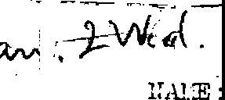IN _{WITNESS} WHEREOF, we have hereunto set our hands, this s i.xth 1e1:tru::i.ry in the year nineteen hundred and twenty two.
day of

, . ·-;
- -

!
'J -4D; ."J.'.'.t':CE :
'
- -- -L·- ,.. _
v,.-:H'. "-
,·('.OONT OF 3 TOCK
SFBSGRIBED FOR:

.. Parket T. Pearson, l orth ','/eymouth,
--:ti.lli¢.m J. Fi.tzsimmoris,East ·.7eymouth,
-....James B. B. Smi.th, " _{u}
-· !.:idney G. Dunbar, North ,leymouth,
.--i'rince H. Tirrell, - th '.7eymouth,
.:..dI
I
::ass. 1
" 1
II 1
II 1
II 1

Smith, Patrick J, Derrig, and ',7i.lli.am J. Fi.tzsi.rnmons,

Trustees
being a majority of the/ . or (having the powers of directors), of

the 'lleymouth Hospital
..... in complinncc with the requirements of the seventh section of
chapter one hundred and eighty of the General Laws, do hereby certify that the following is a true copy of the
agreement of association to constitute snid Corporation, with the nnmes of the subscribers thereto:-
" \Ve, whose names are hereunto subscribed, do by this agreement nssocin-te ourselves with the intention

to constitute a Corporation according to
'
the provisions of chapter one hundred and eighty of the General Laws,

and the Acts in amendment thereof and in addition thereto.
The name by which the Corporation shall be known is Weymouth Hospital

The Corporation is constituted for the purposeSof maintaining, managing and carrying on a hospital or hospitals for the treatment of medical, surgical and obstetrical cases; to receive and hold title to anyreal estate or
personal property that may be found necessary or convenient for the uses of said hospital, v,hether by purchase or exchange, lease, gi.ft or other­ vli.se; and to recei.Ye and hold any endowments, funds, money or property that maybe donated tq, the hospital or for the use the·reof; and to do any and all things nece·ssary or convenient in connection vii.th any and
all of the foregoing purposes.
The place within which the Corporation is established or located is the Tov,n
of 7/eymouth · within said Commonwealth.

The amount of its capital stock is
Fi.fty Thousand
( 50, 000)

dollars. The par value of its shares is ·Ten
its shares is five thousand ( 5000) .
(10)
dollars. The number of

(If seven days' notice is waived, use the following form:)
We hereby waive all requirements of the stati,ites of. J\1 chusetts for notice· of the first meeting for
organization, and appoint the si.xth day of February:,·
t 8 0,0' o'clock PM., at Tovm Qffi.ces, East i/eymouth,l.'ia.ss. ,as the

e and place of holding said first meeting.
IN WITNESS WHEREOF, we have hereunto set our bands, this s i. xth
,.. -ru:i.ry in the year nineteen hundred nnd twenty t WO•

day of

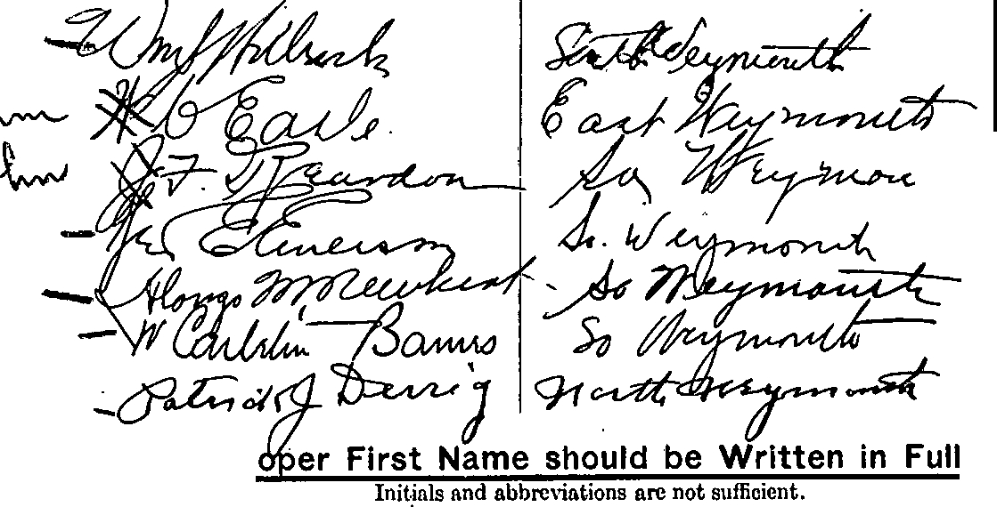
AMOUNT OF STOCK
SunscmDED Fon
/'
.v
,/
/
'-t,--1--t,,<..t>, -I
1
I
I
I
Pr
(OVER)

RESIDENCE

That the first meeting of the subscribers to said agreement.was held on the s i xth
in the year nineteen hundred and twenty two.
'
(If the corporatiop. has a capital stock fill in the following:)

·· That the amount of capital stock now to be issued is
' '
. '
" . ..
.,.....

J ,,Q0O,.
to be paid for as follows: -

AMOUNT AND CLASS OF STOCK ISSUED:
-
shares of preferr d stoc'
. ' .
-.
- shar.es,of co=on stoc
( . . . ..)
. •

J

• • - . ,I

llllA.Dd OOllif.110,t,.
•
•

IN CAsn:
In lull · .

-···-·· .
'
·, 500 . .--

By .mstalments ...

• ..
•
. : . . .
. .
. 5"00 .,
0

Amount or instalrile ts to be paid before commencing business JJDne o.
. . ... t"' ' 0

...
1N PROPERTY: •
4
1
Real estate: ~ I

Locntion _Q(_;!i-j4.n. . 1;, .,._.?.Q].l_'l;:ti, 1J .Ytl1Q1,l_'l;:ti,_, !- !>-, . . . _ ----.-- .,_2-QO.Q. (
' /1 . .

1
Arca _ _ '2... -----··-··-·--·--··--,---- !
... .- ,•-----._:_

Personal Property: .
I . • • •
,

Machinery_. . \ _ ... . _ - _. .. _. - . - - - - --- -------.. _ ·,- --- .. - . ---- -1- ·. • --- --- -
J
. ,....._¥:erchnndise_. - :! -- :': ;----- ---=: -·- ------• -·•--a -i--------------1- --·;--.-· -· ;
Bills receivable ·_ .. , - . . -.- . _. . . ,,,_ .. --:-:-.--. :

.. ._
II ••
,1.

Setko s nnd
secunt,cs... - - - - - . - . - - - . - . - - - - - - - · - --i,:--1 - ---

Patent rights ·----·---.---·---------------------------------·-··--··-.------------

Trade marks .·- -- - - ·-. - - - - - ·-. - -- - -C ------ - - -- - -- -- - ·----- - ' • -- - -- ---- -----· -------"-- -•• --

......,.
'Cop Tights , ·
;_ ·,

:Good will . .. • -- --- - - -- - - -·- - :":: - - --- - - - -·- :_-;_ - --- - ------ -. ------ - _{a-} ₋ _: -- - - -:

_,g_ujP.!l! n!, ... .
. :_i9_Q9 _

Expenses . ' ·---- '!._ . _

.,., . ,
' '
_', t • .
.

[NOTE. - State clearly the nature of such services or expe ses nnd the amount of stock to be issued therefo

. l ..
! ._# ",

..,I :t
...,. '. ..
  - ..... ..

.. '

•_,A. 'SI
--·,..>..
-
•'

.
•..
't
•.. f ' , .

...
·
..,,..' . ' , ·' .. •

h... I r . . '
_.

,....:..-.,.. ..
. - ··,,.-::a.- ....

>resident, i7illi C, Earle- East ;1ey;nouth,l!uss,, East ileymouth,'.1ass.

['rea.surer, Gcor··} E. Emerson, South
i
:::Jerk (or secretary), 'Jj 1.1.j JJ Holbrook, 11
·• ,::c.1:lresjdent. W, Carletqn Harnes, •_,.
.• .,,iff"l',.,::<'!"'-OflicP-rS having the powers of a1retJto1.sJ,
" II l:louth II II
II II II II II
?Jymouth, II " 17eymouth, ti
' ,

.,:. _.) .J
----- _ J.t.. SIDE11 I\_-:_·_-, ... ICL .-..J..JI.. :33)',,,rl{,:_
d.c.k...: · ".o ·t11_ _,.:-..:.:...2 1- .r,.::· , ! B . forth ·:reymou1Jb_Jfass. Trustees
t:t..1.• ••; ._. :.) ., !;. :_ .,L_(Q,ll_tJ1••. - ,: - -- . r-!C1_t_ ';,' .JJL__J_la_ss. )_ f r

r,:J- ;:;:).l.ey_.'.::==:=:n:mi:m:!.h==== " .. _{ey:_111.0.\l.th..} " ₎
years

., '2.,•. rt,!lardo!J_, u.th.. 8.o:u.th.2eYr.Ull.Ub. l!lil.ss. /
.. 'l;. .•1:i ; ...sth !.!.D-S .· .... ., " 11 .9r..:th .. " J
/
,r· T. PearGon

·iamJ., Fitzsimmo
!!_F _P.EY-..::e.::r-''----
s?.aJL B. Smi¹.iJl,,
nzo ]L llc\7bert,
II Trustees
for
2
yearn

Leon:trd Bj ckne+l..,.S.O
nce !L r.i' i rrell , II
'
r
----=¢=-;;ii'

,..
(

\

?:,.. )--- -
VJ t-l Ll L- t
;
; ,.)
r. ., . '"' rn22 •

l \ .,,.,---fj-----
(-,/
, 5 9, 1922.
C
'. (.l
s.s.
I '
·_• .,,...
)['-t)
- .. -
I
.,k,

.. t
Then :personally
!r.-r· cd .lilliam ,T.
Tiolbr
-n'\r
,2i

ie
\
f• -G bcst of

_,._ ,.. ,....
e by him subscribed is I
I
I

r'::· : r-, ,..

•

"' oo
),

- - foregoii
,·

Ilr'
, be,I {
I

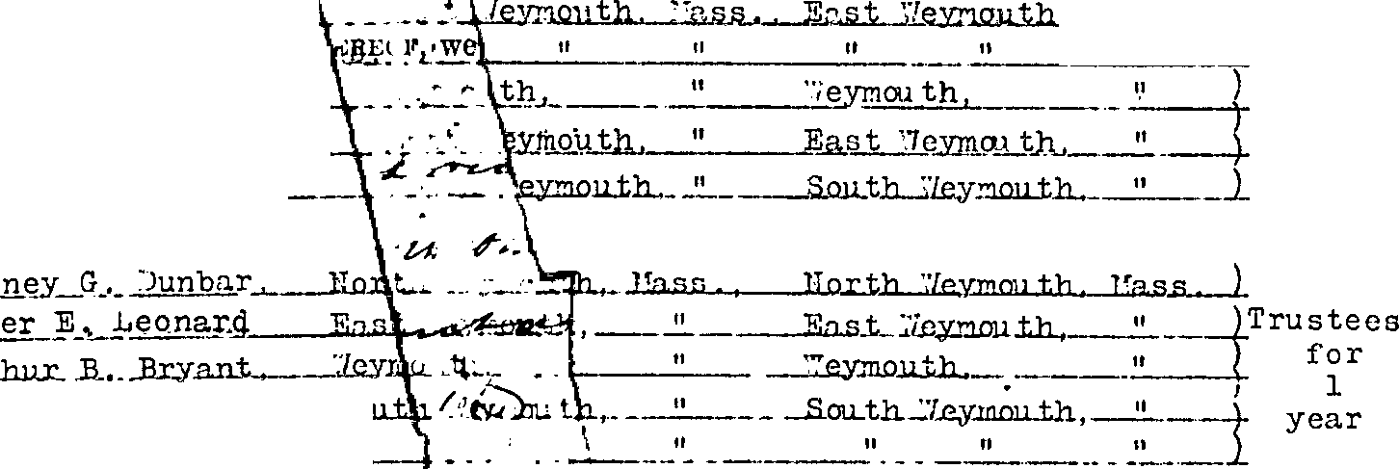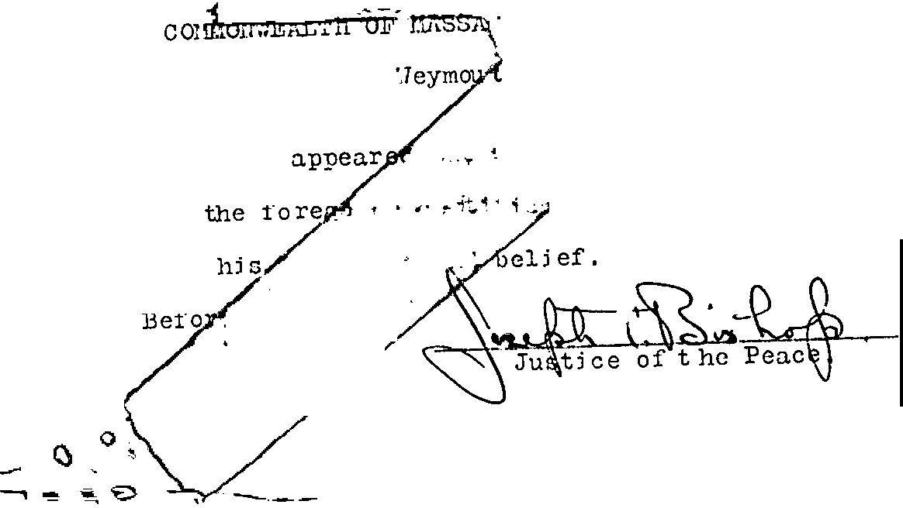

Justice of the Peace._

'resident,
Willia.n;t C, Earle. East i7eymouth,Mass,, East '\'i'eymouth,!Iass.

rreasurer,
Geor.sJ'
- Emerson, South " " South 11 11
.

)lerk (or secretary), 7/il.l...i 1ni JJ Holbrook, 11
II " ..
.. II

·1-cc---Prei:;jdent, W; Carleton Barnes, • -·- Weymouth, _{n}
n _i.7eymou th, ri

. tl.,.'t--- !"l ('ffirArS having the po,\"ei-S cifoirectoi-SJ-;') ,.. cc, - •
".::,'!, _.;,..,, ,:,
I•-· , .

_,,,, "" _; i "' "" '"" ImSIDENCE Pc l."-0"'7'ICE AD:;)f ']JS}'" rw-- -
Qk.5:.,_ Ue'"t;i', :o:::th.4kr:1outh. Yp_s _ }rorth Weymouth. Hass.
,L .. Ti l d ii, _ $;.•,ut .l lQJ.Lt]lJ J(L§.fl_._. . -.ll.E!Y-!1!.Ql!.t..lb. JlaM..._ l
.r._J e:i,,,: ^{l} ,,e9wm1tlx, _!,l lL{emo_ tl'l, 11
.• G(,_F,eardo_l]_, ·•,,u..tb...:l.ey.r.tQu.t.p_ 11 f; • _{--H,} •:1 --
,... ,,. ----u,..,_ .,., _,,. .,. --.,.. '":_ · -

IN WITNESS WHER•EOF, we have hereunto signed our names, this sj xth

lay of
Eebruary,
in the year nineteen hundred and twenty two.
)f: /2

THE COMMONWEALTH OF MASSACHUSETTS.
#
Norfolk ss. ebruc.ry
Then personally appeared the above-named "'-· c.P- rle, .T. F. Rec.rclon,
s Emerson, ·,7. C'.\rleton Barnes.. Patr.ick,J,.Derrig, T Alonzo J.;,

1922.
, )
G' ear ce
I

Tewbert, P,J.rker :;' •. Pearson,, ·:iill.i am .T. 'i'_i tzsjmmons, Si clney G. Dunbc.r, I·
rames B. B. Smith, and Prince H. Tirrell. \

nd severally made oath that- )le foregoing certificate, by them subscribed, is true to the best
' .

of their knowledge and belie
1.,
,·

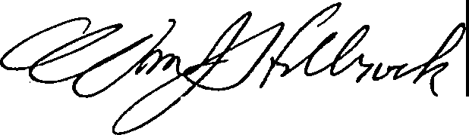
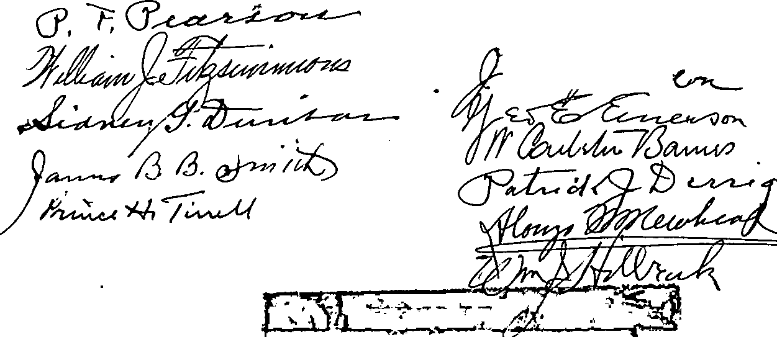Before me,

Justice of the Peace._

V ED
1Y22
CQJll•O.JlA7'JO.,,_y l•'Oll C1/Altl'TAJl1.,JC AZ'OJ C1:;.UJ'A.1N
uT1J1:;1, 1•un1•os1:;s
•
!.
w. v,0,'. 1.t.Ztt.u J=bo11

()!VISION
OFFICE
.... ...,_
..
--------'""-'· sJ/<$.,O..Q4>r!,
Certificate of Organization
[FULL FORM]
GxNERAL LAws, CHAP. 180, SECT. 7

Filed in the office of the Secretary of the Com­
monwealth, )S,92';}­
I

I hereby certi£y that it appears, upon an e:a:amination of the within written certificate and the records of the corporation duly submitted to my inspection, that the re­ qu.irements of sections one, two and three of chapter one hundred and eighty, section nine of one hundred fifty­ five, and sections six, eight, nine, ten, eleven, and twelve of chapter one hundred fifty-six of General Laws ha\·e cen com li th ..Ed ,I he_reby ap,ii..ove said cer-
I .
Uficale, th,t .r,y. -

'j": 7 ...
·_) '• l
t; s•
r7-·
q :.
.l
- ...-·- ....
;.. ..
.
I ' . .• ,,
i.:', - 1
...\ j
•.
..
'.· 1·
.
\'
f ,;

cc1-- !,,..,:-•"' -,... I
day of -r"-"V • , /7
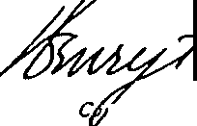
A.D. 192 // ..
ttL-?(r

1 ,miu i oner of Co- s
. . ,
t(' .•
.. ,,, ..
-j:•: .
.,
f f.··.' r,
. i
( ·:. '·-

'0 ...,'.'=

'\ON
r) l/./
- a11d T :rah·Z?mum

PDHJ...'l'tVff;:; !\,,V i·J /..
1 J_w-.i:I)._

FEB 2 71922
/
V, ' -iD Jv.
d J- .s oot 1s nt \lt
0i ) [p

Wl'rH FEE OF $ .• --- -----

rE.B ,2..
921
-,
'

\}\~)•\'\1?',u"l>iTl"I". '
I, ,.'.•
y:
1;., , .,11.!I••
. .,,
- - ..
··,

C:it I"' w-,,,.;_ _,,Ir:,I.,_=

--,

F--* I ·- ----
-.•• •-•---•r -:-- -•:-

,.
f..
,, 1P-(j()QQIQA.L'?B Of .MAINC86BJ\8
oe it Known that whereas
_'l!JJlil9t;ath·. P;Rl,: ·
•·E" µ
,w .·" -, S-;Qt' - r"-c :<1.. eltlr.Au::; - c;

";.:..-0:.,,r,. s­

epft.I ....

!. ...

win,
( "G k l'1.tL. ., ptff·:oi.L dDqllt

ti ·
-Iba .-ra;L
.s .. ..· ti ., u wlllle4. u.,-,,.ar

'i':l

_ .:•. U,10!la 41ilJ'.: e :J?r - aide
I'a q
d t. oa - •'Nlfl' l\,_uue_
emofaa14, .-..U.r-:., ­
.. .;.;;.
·:.;-'" t.. 1
.-..,!

' . . ,·- •·hsp1tel, . _ · '· · · · ' -1
c ti I
d.Jl.7 approffd and filed in this office., and said 0.fficer ot 1:be corporat
:•lW 11 ..,-uc-nottq oC:nw ob•nc11.ot MM_., 111 aa.....
•:Ut.l_ln U--'kiw..tla Gal8t'8 allll bans--rl,t_:a .DHSMJIP ,aKJtc111
6
., , ,.u- e L ••d*l
.r - . I
1D -- - u Qeaau\'-Gf lortoD·:in".aal« Ccttsot •altas::;r;
. , Ioli, !hereton•.l .. •' ,QO(I(., :,.8eeretaq .ot ,- .• I
•,or•-
ibiii
'ot 'f•1,11• Ntts,-90 (XMQlf;., .that Dll .... llldab. -..U I
I
,_ ,1n .• ,11 -..r ₁₈ c_. • . . . . -·i :; /,,''.
South Shore Hospital, ·
...·-.;
-1
..
-J
i--.«-1
-- tj
- -:c?:
: i

--
- -:
-.: ··.·
'-(:-·

·r:_.

'.ti
I which

I
I
sball bereatter be its legal naN.
•1 toess !ll1= off1c1...a1&11ature .liaNaatloi.auacritl!IN
uld r.t.he ;,GM.al. s.ai et the C011110nwealt.h of. . M4asaomasetts.h&NUAH a.f.fixed, this twentieth 4a1 Qt .it.uauo,·ln'.;,\!le.rJ(ear of our Lord om tbousam ·nloe :i'»1:Qllr :and torty-f1'1'8.
·1
'
i
.·:<
if.
) \

-t.:: :
. (L. 8 )
. .
,._. , H .: . I
- •• Cook
o.r
Secretaey the C th.
.. ::-,_J).I'
. .:-·;.,·._·'.:

;i:.
. . ·' '' 1·-,,:: ..

·1i
:f.. '.(: '; --t:

'

-ti[.;- COHMH*Et.L1m-OF llASSACHUSEiiS- .- -- ··--·---
.. .-.-f

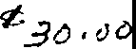
FOAM CD-180-S.7-1 2500-5-77-0405106
'illqr Qlommonfuraltq of assacqusrtts
I· MICHAEL JOSEPH coiioLLYI FEDERAL IDENTIFICATION

Secretary of the Commonwealth N o ·
ONE ASHBURTON PLACE, BOSTON, MASS. 02108

RESTATED ARTICLES OF ORGANIZATION
General Laws, Chapter 180, Section 7
0'-l--.:li05C\l -

This certificate must be submitted to the Secretary of the Commonwealth within sixty days after the date of the vote of members or stockholders adopting the restated articles of organization. The fee for filing this certificate is
•
$30. Make check payable to the Commonwealth of Massachusetts.

We,

vJilliam F, Meara, Jr. Frederick C. Truelove

Sc:>1J:t;)1 .S._11_Clr..e.. _Hosoit_aJ
(Name of Corporal ion)

, Preside nt/lti:ce::Rcellicteox:iaKd:
, Clerk/ !!ll,/li:lf,f
! ?.??

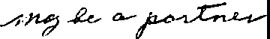
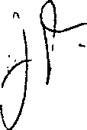
located at ....?.?....:f_Clgg B,c:>i;l,cJ..,....W<=.YIB9hl.th.,....Mia\$.B.i!.C.hJJ$. tt.s....
do hereby certify that the following restatement of the articles of organization of the corporation was duly adopted at
a meeting held on September 27 , 19 82 , by vote of ..69 members !'"1alli&h11hll!lrs,
being at least two thirds of its members legally qua ified to vote in meetings of the corporation (or, in the case of a corporation having capital stock, by the holders of at least two thirds of the capital stock having the right to vote thereon):

  - The name by which the corporation shall be known is:-

South Shore P.eal th and Educational Corporation·[/
  - The purposes for which the corporation is formed are as follows:-

To support the advancement of the knowledge and practice of and education and research in, medicine, surgery, nursing and all other subjects relating to the care, treatment and healing of humans, to improve the health and welfare of all persons, and to sponsor, develop and promote services and programs which are charitable, scientific or educational and which address the physical and mental needs of the co!TII!lunity at large, provided, however, that the corporation shall not en0age in the practice
•
of medicine, and provided further, that it shall operate exclusively for the benefit of South Shore Hospital, Inc. and its affiliated organizations, including medical centers, health care centers, nursing centers, laboratories, clinics and other medical, surgical or dental facilities, in the conduct of their charitable, educational and scientific functions.

q
NOTE: If provisions for which the space provided under Articles 2, 3 and 4 is not sufficient additions should be set out on continuation sheets to be numbered 2A, 2B, etc. Indicate under each Article where the provision is set out. Continuation sheets shall be on 81/," x 11" paper and must have a left-hand margin I inch wide for binding, Only one side should be used.

  - If the corporation has more than one class of members, the designation of such classes, the manner of election or appointment. the duration of membership and the qualification and rights, including voting rights, of the members· of each class, are as follows:-

Not Applicable

•

  - 4. Other lawful provisions, if any, for the conduct and regulation of the business and affairs of the corporation, for its voluntary dissolution, or for limiting, defining, or regulating the powers of the corporation, or of its directors or members, or of any class of members, are as follows:-

See pages 4A through 4F attached hereto and made part hereof.

•

    - If there are no provisions state "None".

  - The corporation shall have the following powers in furtherance of its corporate purposes:

- The corporation shall have perpetual succession in its corporate name.
•
- The corporation may sue and be sued.

- The corporation may have a corporate seal which it may alter at pleasure.

- The corporation may elect or appoint directors, officers, employees and other agents, fix their compensation and define their duties and obligations.

- The corporation may purchase, receive or take by grant, gift, devise, bequest or otherwise, lease, or otherwise acquire, own, hold, improve, employ, use and otherwise deal in and with, real or personal property, or any interest therein, wherever situated, in an unlimited amount.

- The corporation may solicit and receive contributions from any and all sources and may receive and hold, in trust or otherwise, funds received by gift or bequest.

- The corporation may sell, convey, lease, exchange, transfer or otherwise dispose of, or mortgage, pledge, encumber or create a security interest in, all or any of its property, or any interest therein, wherever situated.

- The corporation may purchase, take, receive, subscribe for, or otherwise acquire, own, hold, vote, employ, sell, lend, lease, exchange, transfer, or otherwise dispose of, mortgage, pledge, use and otherwise deal in and with, bonds and other obligations, shares, or other securities or interests issued by others, whether engaged in similar or different business, governmental, or other activities.
•

4A

\

  - The corporation may make contracts, give guarantees and incur liabilities, borrow money at such rates of interest as the corporation may determine, issue its notes, bonds and other obligations, and secure any of its obligations by mortgage, pledge or encumbrance of, or security interest in, all or any of its property or any interest therein, wherever situated.
- The corporation may lend money, invest and reinvest its funds, and take and hold real and personal property as security for the payment of funds so loaned or invested.
•

- The corporation may do business, carry on its operations, and have offices and exercise the powers granted by Massachusetts General Laws, Chapter 180, in any jurisdiction within or without the United States, although the corporation shall not be operated for the primary purpose of carrying on for profit a trade or business unrelated to its tax exempt purposes.

  - The corporation may pay pensions, establish and carry out pension, savings, thrift and other retirement and benefit plans, trusts and provisions for any or all of its directors, officers and employees.

- The corporation may make donations in such amounts as the members or directors shall determine, irrespective of corporate benefit, for the public welfare or for community fund, hospital, charitable, religious, educational, scientific, civic or similar purposes, and in time of war or other national emergency in aid thereof; provided that, as long as the corporation is entitled to exemption from federal income tax under Section 50l(c)(3) of the Internal Revenue Code, it shall make no contribution for other than religious, charitable, scientific, testing for public safety, literary, or educational purposes or for the prevention of cruelty to children or animals.

- The corporation may be an incorporator of other corporations of any type or kind.
•

- The corporation may be a partner in any business enterprise which it would have power to conduct by itself.

- The directors may make, amend or repeal the by-laws in whole or in part, except with respect to any provision thereof which by law or the by-laws requires action by the members.

- Meetings of the members may be held anywhere in the United States.

4B

- No person shall be disqualified from holding any office by reason of any interest. In the absence of fraud, any director, officer, or member of this corporation individually, or any individual having any interest in any concern in which any such directors, officers, members, or individuals have any interest, may be a party to, or may be pecuniarily or otherwise interested in, any contract,
t ansaction, or other act of this corporation, and

- such contract, transaction, or act shall not be in any way invalidated or otherwise affected by that fact;
•

- no such director, officer, member, or individual shall be liable to account to this corporation for any profit or benefit realized through any such contract, transaction, or act; and
- any such director of this corporation may be counted in determining the existence of a quorum at any meeting of the directors or of any committee thereof which shall authorize any such contract, transaction, or act, and may vote to authorize the same;

provided, however, that any contract, transaction or act in which any director or officer of this corporation is so interested individually or as a director, officer, trustee or member of any concern which is not a subsidiary or affiliate of this corporation, or in which any directors or officers are so interested as holders, collectively, of a majority of shares of capital stock or other beneficial interest at the time outstanding in any concern which is not a subsidiary or affiliate of this corporation, shall be duly authorized or ratified by a majority of the directors who are not so interested and to whom the nature of such interest has been disclosed and who have made any findings required by law:

the term ''interest'' including personal interest and interest as a director, officer, stockholder, shareholder, trustee, member or beneficiary of any concern;
•

the term 11 concern 11 meaning any corporation, association, trust, partnership, firm, person or other entity other than this corporation; and

the phrase "subsidiary or affiliate'' meaning a concern in which a majority of the directors, trustees, partners or controlling persons is

4C

elected or appointed by the directors of this corporation, or is constituted of the directors or officers of this corporation.

To the extent permitted by law, the authorizing or ratifying vote of a majority of each class of members of this corporation entitled to vote for directors at any annual meeting or a special meeting duly called for the purpose (whether such vote is passed before or after judgment rendered in a suit with respect to such contract, transaction or act) shall validate any contract, transaction or act of this corporation, or of the board of directors or any committee thereof, with regard to all members of this corporation, whether or not members at the time of such vote, and with regard to all creditors and other claimants under this corporation; provided, however, that
•

- with respect to the authorization or ratification of contracts, transactions or acts in which any of the directors, officers or members of this corporation have an interest, the nature of such contracts, transactions or acts and the interest of any director, officer or member therein shall be summarized in the notice of any such annual or special meeting, or in a statement or letter accompanying such notice, and shall be fully disclosed at any such meeting;
- the members so voting shall have made any findings required by law;

- members so interested may vote at any such meeting except to the extent otherwise provided by law; and

- any failure of the members to authorize or ratify such contract, transaction or act shall not be deemed in any way to invalidate the same or to deprive this corporation, or its directors, officers or employees of its or their right to proceed with such contract, transaction or act.
•

No contract, transaction or act shall be avoided by reason of any provision or provisions of this paragraph (s) which would be valid but for such provision or provisions.

- No part of the assets of the corporation and no part of any et earnings of the corporation shall be divided among or inure to the benefit of any officer or director of

4D

the corporation or any private individual or be appropriated for any purposes other than the purposes of the corporation as herein set forth; and no substantial part of the activities of the corporation shall be the carrying on of propaganda, or otherwise attempting, to influence legislation except to the extent that the corporation makes expenditures for purposes of influencing legislation in conformity with the requirements of Section S0l(h) of the Internal Revenue Code; and the corporation shall not participate in, or intervene in (including the publishing or distributing of statements), any political campaign on behalf of any candidate for public office. It is intended that the corporation shall be entitled to exemption from federal income tax under Section 50l(c)(3) of the Internal Revenue Code and shall not be a private foundation under Section 509(a) of the Internal Revenue Code.
•
'(t) Upon the liquidation or dissolution of the corporation, after payment of all of the liabilities of the corporation or due provision therefor, all of the assets of the corporation shall be disposed of to one or more organizations exempt from federal income tax under Section 50l(c)(3) of the Internal Revenue Code.

- In the event that the corporation is a private foundation as that term is defined in Section 509 of the Internal Revenue Code, then notwithstanding any other provisions of the articles of organization or the by-laws of the corporation, the following provisions shall apply:
The directors shall distribute the income for each taxable year at such time and in such manner as not to become subject to the tax on undistributed income imposed by Section 4942 of the Internal Revenue Code.

The directors shall not engage in any act of self dealing as defined in Section 494l(d) of·the Internal Revenue Code; nor retain any excess business holdings as defined in Section 4943(c) of the Internal Revenue Code; nor make any investments in such manner as to incur tax liability under Section 4944 of the Internal Revenue Code; nor make any taxable expenditures as defined in Section 4945(d) of the Internal Revenue Code.
•
- The corporation shall have and may exercise all powers necessary or convenient to effect any or all of the purposes for which the corporation is formed; provided, however, that no such power shall be exercised in a manner inconsistent with Massachusetts General Laws, Chapter 180 or any other ch9pter of the General Laws of The Commonwealth of
Massachusetts; and provided, further, that the corporation

4E

shall not engage in any activity or exercise any power which would deprive it of any exemption from federal income tax which the corporation may receive under Section 501(c)(3) of the Internal Revenue Code.

- All references herein: (i) to the Internal Revenue Code shall be deemed to refer to the Internal Revenue Code of 1954, as now in force or hereafter amended; (ii) to the General Laws of The Commonwealth of Massachusetts, or any chapter thereof, shall be deemed to refer to said General Laws or chapter as now in force or hereafter amended; and
•
(iii) to particular sections of the Internal Revenue Code or the General Laws of The Commonwealth of Massachusetts shall be deemed to refer to similar or successor provisions hereafter adopted.

•

4F

,,,
*We further certify that the foregoing restated articles of organization effect no amendments to the articles of
organization of the corporation as heretofore amended, except amendments to the following articles
..1, ...2., ...3.,..."11...4...
(*If there are no such amendments, state "None".)

The Articles of Organization have been restated in their entirety.

Article I Change of. Name

Article II Arndt. of purpose Article III Arndt. of membership
•
Article IV Arndt. of other lawful provisions.

IN WITNESS WHEREOF AND UNDER THE PENALTIES OF PERJURY, we have hereto signed our names this

3o'
da
in the year 19 :ii'-=l

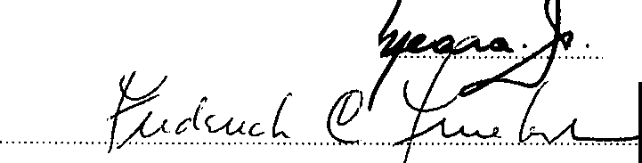.........

•
......... .
................... President X

..... Clerk imt:£1lut

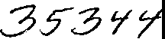

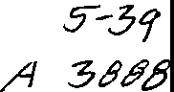
$E.cR-t.TAR'{ oc
1 ,1,.:-t..:, -:, 1
-1,c:: COMM 0r ·' "'·'.
\ , . E COMMONWEALTH OF MASSACHUSETTS

1 82 OC1 - I Ml II. .
cor,ro?.P.1\0N D\V\Slm ESTATED ARTICLES OF ORGANIZATION
(General Laws, Chapter 180, Section 7)

hereby approve the within restated articles of J_
organization and, the filing fee in the amount ot._3t}"° f'
having been paid, said articles are deemed to have been filed wilh t_);)is Sftr day
•
of ,() 19.6';;2

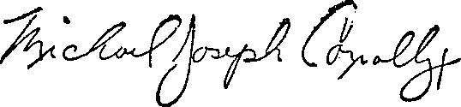

I MICHAEL JOSEPH CONNOLLY I
Secretary of the Commonwealrh

State House. Boston, Mass.

;

TO BE FILLED IN BY CORPORATION

PHOTO COPY OF RESTATED ARTICLES OF ORGANIZATION TO BE SENT
•

ro Ronald B. Schram, Esquire
... ...........Ropes .& Gray..

. ... ....... 2.2.5....F.rankl.in..Street .

...............Boston ,.... Nassachusetts. 02110

--
C0-180-S. 1•'2 I

MICHAEL JOSEPH CONNO.LLV
s crt1ary of S1a1r

ARTICLES OF AMENDMENT
General aw,, Ch.aJ,ter 1.80, Section 7
.

FEDERAL IDENTIFICATION NO._ 04-210-5926
I
I

This certificate must be submitted to the Secretary of the Commonwemlth within sixty days after the dato of the vote of members or stockhol era adopting the amendment. The tea forllllng this cenlticate is S10.00 as prescribed by General Laws, Chapter 180, Section t 1C(b). Make check payable to the Commonwealth of Masaachuaetts..

We,

... \ ·
David T. Hannan
_':!_en,y Hoffman

, P•e,ident1Mioclhnidl:KDCand
,Clerk Qf
,.
,i.;

Name
Approved

e □.

P.C.
South Shore Health and El:l.ucational Cbrporation
- INaffll ot Corporl'tlonl

8 Main Street, WeVI!onth, M3.ssachusetts 02190
located at ................................................:.................................................................
do hereby urtify that the followil"lg ur.endl'ilfflt to thie articlu of orpnization of the corporation was duly adopted at
ameetinghelrlon March 23 ,1987 ,byvoteof member,
............... A i!!c..at leHt two lbJrds pf iu rne:mbers legall.Y qualified to vote in meetings of the co por tiorf
(U,:llllmt>UIICld'»'f...,.,._:&aWflll )ll'liffilllllt¥iDIJ<_lllt_»IUllf•IUl--..,.,;t
>llUll>Ulmwai!KKIII):

Vl"'!'F:D: '!hat the articles of orqanization of South Sh:>re Health and El:l.ucational .:nrp:,ration oe anii Lln:y .:...: !:.e.. • to add the followina languaqe as Par ph 4 (x) : No director-, officer or trustee shall be personally liable to the =rporation or its members for m:metary damaqes for any breach of fiduciary duty by such person as
a direct.or, officer or trustee notwithstandinq any provision of law
.U!l!X)s:inq such liability, exa!pl (to the extent provided by applicable law) for liability (i) for breach of such person's duty
ot 1oyalt.y t.e t.h eo..jsos:atior1 or it.s membere, (ii) toraet.s or
anissions not in <rood faith Ol:wh:i.chinvolve intentional rnisoorduct or a kncMinq violai:ion of law, (iii) for any transaction f:ran which such person derived an .ut\J?Xope.c personal benefit.

Nctc: If the spuc provided under any artrlc or item on this rorm ia..'ivfficieru., additions shaU be scl rortb on separaic 8½. x 11
U'leet:. of paper leaving B left band r.'1Brgin of at lc.ast I inch ror binding. Additions to more than onir anic:le may be continued on
- s e 1bffl so long u ,,.r"', anicle !'"'quiring each 1ucb addition is elf.arty indiuted.

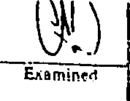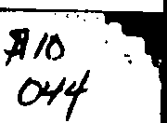

.\ J

,,,.
-
  - ··rlJ

l

•,:.'

The forqoln11 •mendrnent will become effectiwe when the,e artidn of arnendll'l".nl are filed in ac:cordanco wilh
... ...... ..

,
Chapter 180, Section 7 of the Gener.ii L,... llftieu lhe,e arlide> ,per!(y, in iccordanoc with the ,ote idoplln3 the
arnond.m,.r..11, a late.r_e,f.f.e_ct.lw.,e_d.ale not more than thirty day> after >uc:h fillns, in which event the ,rnondment will be­
IN WITNESS WHEREOF AND UNDER THE PENALTIES OF PERJURY, we haw hereto >ilP'led o .. n&rno>.this
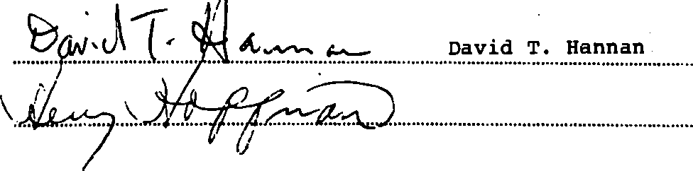
20th · day of May , in "1e yur 1987

Preside,..,_n r D if t

Cler : ,'111,0-•IFCBllll&AL

M-d

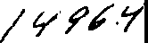
:- •,. . . ....
"°t(; •.:,•:.::,·;.

.. 3•I

Ir:!il\'1' -, _{I}
t.,
r;i J I 1, I

,,.,""lnr" ,_Tit,•';-,\\/'.:·,.•:
••I\• .... ••" • w•• •

THE COMMONWEALTH OF MASSACHUS[TTS

ARTICLES OF AMENDMENT
(Gencr•I l•w•, Chapter t80, Section 7)
I hereby ,1pprove the within vlicles of amet1dmen1
Uld, the fililll! fee in the •mount of S /0 , 0 c)
tw.wing been p,1id, 1aid articles are dcc d to hive been

filed with ,,,. ,his ;;} / diyol tv\.._
6
. -•·,
jg·'(7

-&114
MICHAEL JOSEPH CONNOLLY
S«reraryof SUIUI

'PO IIB f'ILLl!D IN D• COIIPellA'rlOI•
PHOTO COPY OF AMENDMENT TO BE SENT

TO: Ronald B. Schram
......Ropes.. & .Gr.a1,i .. : . . . . . . . . . . . . . . . . . . . . . . . .
225 Franklin Street
......i:IO.fit.on,.. Ml\.ll ll.O.....................

' ............................ ........................
Telephor,e ..(..6.1..7..)...4.2..3..-.6..1..0.0....................

Copy Mtile.J

' ..,..,
...,;.. _

•'

AACR.6

Name
Approved

FEDERAL IDENTIFICATION NO. 042105926
Fee: $15.00
QC'be <itommonu:iealtb of fflassacbusetts
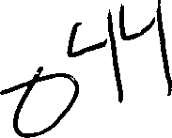
WiJHam Francis Galvin
Secretary of the Commonwealth
One Ashburton Place, Boston, Massachusetts 02108-1512

ARTICLES OF AMENDMENT
(General Laws, Chapter 180, Section 7)

Jacqueline H. Haley
and-------------------------------
o f South Shore Health and Educational Corporation
(Exact name of corporation)

located at 55 Fogg Road, South Weymouth, MA 02190

"Clerk XMsdllOlUC£1c:Jdm;

_

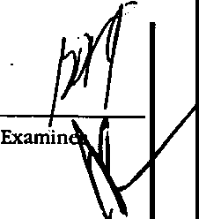(Address of corporation' in Massachusetts)

do hereby cenify that these Articles of Amendment affecting anides numbered:
4
(Number tbose articles 1, 2, 3, and,/or 4 being amended)

of the Articles of Organization were duly adopted at a meeting held on August 28 :i:902000. by vote of:

--- ---- members, ;,dtccxl>OlOtxw --.ll tlltl!d!IHl<IEJ!5X

being at least twe>thirds of its membe legally qualified to vote in meetings of the corporation (or, in the case of a corporation having capital stock, by the holders of at least two thirds of the capital stock having the right to vote therei_n):

-See Attached Sheet-

C 0
p n
M n
R.A. 0

"tlrlJe/ete t6e inapplicable words.
J_.
Note: lftbe space provitkd under any ar-ticle or item on tbisfonn is insufficient., addttloru sball be setfo"b ononeside only of sepa,-ate 8 1/2 :r 11 sheets of paper wttb a kft margin of at kast I tncb. Additions to more tban one a,.,tck may be
  - inade on a single sbeet so long as eacb a,-,icle requiring eacb addition ts clea,-ly Indicated
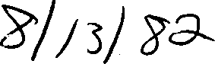

That the Articles of Organization of South Shore Health and Educational Corporation be and they are hereby amended by deleting the provisions of Paragraph 4(r) and adding the following in their place: (r) The Corporation shall adopt, and may amend from.time to time, by-law provisions that address conflicts of interest on the part of directors and officers.

The foregoing amendment(s) will become effective when these Articles of Amendment are filed in accordance with General Laws, Chapter 180, Section 7 unless these articles specify, in accordance with the vote adopting the amendment, a later effec• tive date not more than thirty days after such filing, in which event the amendment will become effective on such later date.

Later effective date: _

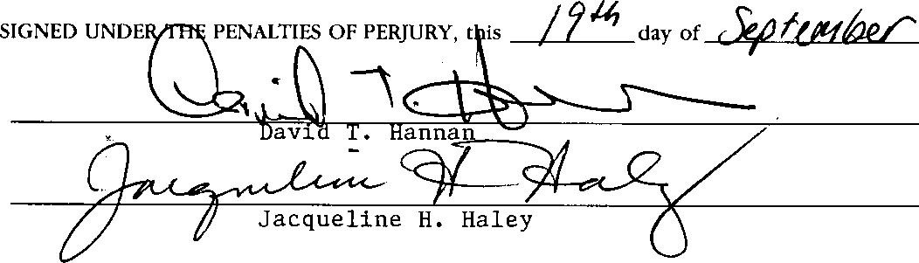
. 2000

*Delete lbe inapplicable ll'ortls.

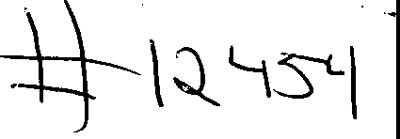
..

THE COMMONWEALTH OF MASSACHUSETTS

ARTICLES OF AMENDMENT
(General Laws, Chapter 180,Section 7)

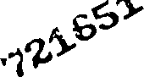
I hereby approve the within Articles of Amendment and, the filing fee in the amount of$ /:S::OCJ having beeq paid, said anicles are deemed
; h oo e with me thisr day of S£-J'i.&16 7f

Effective date:

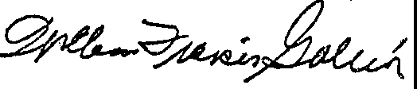

WILLIAM FRANCIS GALVIN
Secretary of the Commonwealth

C,
C,
,U...),,
-0

Cl'.>
-, r-i
·<r:-)
    - :-.J
'•:

c.n
Ol

·•-)
I ·• -; J
-1 _,
==:.:r--..,:

TO BE FILLED IN BY CORPORATION
Photocopy ofdocument to besent to: Kathleen A. Bugden, Health Care Paralegal
Kintz, Levin, Cohn, Ferris, Glovsk:y & Popeo, P.C. One Financial Center
Boston HA 02111

Telephone: {617) 348-4731
,

MA SOC Filing Number: 201678371700 Date: 3/31/2016 2:17:00 PM
Mar. 31. 2016 2:0UM No. 7232 P. 2

10:ENUPlCA.TlON
M,
C
p
M
RA
□□:
□
□

fil.lng Fell;; $15.00
utbe <itommontvcaJth of fflags-acbtt£ttt$
William Francis Galvin
me
Secretary of Coromonw ahh
One Ashbur.ton Pb.cc, Room 1717, Bosi:on, Massachu.sem 02108..1512

ARTICLES OF AMENDMENT
(General Laws. Chapter l80. Section 7)

Gene E. G.teen, M.b.
Wt., ..

d Margaret Holda
:rn - - ------------------------• Clr:rk/ ,

of_s ou t-·h_s_:h_o_re_H e_a_11_h_a_n_d E_d_.u c_a_ti_on_.a_l_C_o_r_p_or_.a_ti_a_n ­
(Er,ut na,nt uf ce. }P'rlt.lir;>n)
loo.red S5 Fogg Road_, We!ymauth,.M ssachusetts
t , ••·,.·,·w• --- -------- ---
(-.A.ddrrm 11_fco,poration tn. Mfl.J fl.thw ts)
0M(1)
of ,bi: Ar.Jdci of Otg;inlz.:,iot; w-1:.;i: duty a.doptd at :;i. rilc.:dng hdd on . December 9 20 15 , by -,:or of;
Fift.aen (15) d Id
----- --- memuLe.r:s,_ 6 i·
-------- ·irec:rors, o·r -- -----s·an: q, c:rs •,

_[ZI B1;1;i: g:at ieasr rwo-rhird; ofit _.di,rtcw.,s where there are no mern rs p11m;.ant H;l Gcntr;il .La:ws,
Cha.pri::r l 80, Se:i;;don 3; OR
0 In h(! ¢1 of _{3.} c.oq:io:!"adbn h viri.g pit l sto-:k, by r.he hoid rs of.1t lea.st tYIO•rhitds of the capital st,xk b:ivlnt
rhe right to _{M[f:} hNein.

Artlcle 1" The name by which the corporation sh·aU be k.nOV111, is hereby amended to read; South Shore Health System. Inc.

•D,""' d,, :ilJtIPpli,<J/JII ..wrdi.
••Cl,,d,: 0'11/ ""' ba:.-.1htt1 IIf./'ffri.
Nr, , lf ti,,!!pa P""- 1,1,,,/",m,l.,,.",:,Y .a:riic r; (ilJ'I> !I ,l i fa,..,. # ,,.,_,,.ffititro ,. #-mtiJ! b, ,,.tfortb a,. ,,_N,dr
/J!'>Jy ,ef pll"•ti'.IJ l!.l 11 ;Mffl:l>ffd.f'l!I' uisl,.it. lf-ft .-p,.efa·t !..air 1 i,:r,l.c A.dJitiwu:t1> :Jf{lau t6= ""• <D'#cbc """"-1'·IR rr,id(> (>fl A" dt1/':k di= ­
k.»t_<).I .,.if, ,n<.fi. .-i" •mg d,d, ,J,p,;o,,_ is- ,1,,,r.rl,y i,µJ,",,,, ,l-

Mar. 31. 2016 2:02PM No. 7232 p' 3

TI-.i for going 3:m.1;nd.mi;;r.)l(s) wm.becom. df "Cri-vt wh. n -r.h Arridt'!-'' of A.m ndm!:!m !'l:.fil1::d in o::cmlan<:c: wid1 Gc:n ral Laws, Ch.i.pre:r 180 Seedon 7 1.1.nless the:S? ankles specify, in eiccoi:da.ic.e t h .th wote .:adopting he amc=ndm ri(, ;y, ki&<1r cff-c.cci1.tt dS.tC _{·MC} ir,q-rc tha.n :hirty My1:afre.r 1:i.lch fi.liri.g, ih whidi t:VCi:it rh 3mc-.I1dmi::r1( w:ll bi=ca.nc..-effc-.cr:\v .Ot .!i1,it'h 1.i. c:t ChiJ:i:i,

b. r dlecr:iv dau=: A_,ps_r_il_l-',_2~0_16 _

S!GNEO lJNl)ER THE PFNALTicS OF n:RJURY,,,hi, ..3{ 'ef:: &y of_;1J:_._L_ah_ _< -'-------· zo _1' _6 _

_G:e_n:::__:eE=_:.-_G• =r._:e_::en:._,M.:..;;J;,:)· ~.,- -- ;j::i,:c- - .'::'.:.--=:::=:;::;::::::'.,:-::-::-_ ,, _,'Pr<sidontl

t,,,1arg.aret Holda
- · w}q1_' (f )d

------------t-f-₆1 --------2---"--------.c.. '_{•Cbk!•}

MA SOC Filing Number: 201678371700 Date: 3/31/2016 2:17:00 PM

THE COMMONWEALTH OF MASSACHUSETTS

I hereby certify that, upon examination of this document, duly submitted to me, it appears that the provisions of the General Laws relative to corporations have been complied with, and I hereby approve said articles; and the filing fee having been paid, said articles are deemed to have been filed with me on:
March 31, 2016 02:17 PM

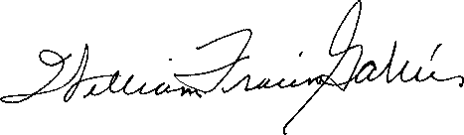

WILLIAM FRANCIS GALVIN

Secretary of the Commonwealth

IDFN,fll.CATION
VU-/ 0.5924,
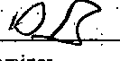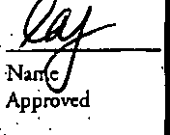no.
EXllIIlincr
.
C O
FUing Fee: $15.00 · ·
QC'bt ommonwtaltb of massacbusttts
Wllllam Francis <ialvin
Secretary of the Commonwealth .
OneAshburton Place, Room 1717, Boston; Massachusetts 02108-1512

ARTICLES OFAMENDMENT
(General Laws, Chapter 18!), Section 7)

' Gena E. Green, M.D..
We, . . : . *President/ "'Vice Presid nt,

and Joseph R. Driscoll, Esq.

, "'derk / "'Assiru.nc Cl.erk,

of South Shore Health System, Inc.
(F.xact name of rorporawm)
. . .
located at 55.Fogg Road, South Weymouth, Massachusetts 02190
·. (Add,,,, of corporation ;;, Massaehwm,)

do hereby cenify that th_ese Articles of Ame.ndmenr·affeccing articles numbered:
Two (2) and Four (4)

(Number those articlt1 I, 2, 3, and/or 4 bring ammd.d)

·: f theArtide.s_ofO i: a(ion were duly ado"pte4 at a meetiri hel OD °December 13

20 17 , by vore·of:

mebers, U• nanimous con•sent of

directors, or shareholders• .

·

)<,
. . .
B ing at l I:two- irds of its m bers legally qU:alificd to vote i mecci'W of che oqloration; OR
. .
Bc g :i.c least twO-:chlrds ofic;, directors _where tb.Crc arc no memben pursuant-to General Laws,
Chaprer 180, Section 3; OR

P •. d
□
· M ·-
RA 0

·--
In the case :Of a corporation having capital stock, by che holders .of at least-two-third5 of the capital stock having the:right to vo_te therein. ·
. ARTICLE II: The purpose.of South Shore Health System, Irie., as previously set forth in Article II of its Ar.ticles of Organization, is hereby .amended. in Its entirety to rea.d·a.s follows: . .
T.he Corporation .is fonned and shall be operated exclusively for the following charitable, educational and
_.scientific_purposes:_. . , .. .. . ·--·-·---·· -·---· .. --·

3 No : Iftl,11 ,Pila prtwitud.rmd.n- tal'J)' artic/11 or ibrm on ,hisfor'ffl is inntffidm,."'1Jhia,u J,oU be ni ford,oft on. dde
·DNi,lht in pplicable rwrr/s, | V
.:··c/udtrm!Jone"bo:rthatoppfu:s,' | ' | .' | .

onl.,of 8 112" 11 mntJ afJ)4pff' u,td,11 lef,,amp,: of tit kdlt 1 ind,, Add.hJoru to ,,,_ th•r, Pn, 11mm mdJ r,,'7UUb 01:1-d Ji11-g/a sbnt m
-----1
£,11g ,u NU/, art:k f'f!f/'U'fflg t11Zeb tlddmonh ckdrly ·;mlieJued. ·
.P.C.

. . . . . . . .

. (a) To organize, operate and support a comprehensive health care delivery.systeni (the "System"), including without limitation hospital and other tiealth care services for all persons; to support the advancement of the knowledge and practice o(and education and research in; medicine, surgery, nursing, and all other subjects relating to the care,
- treatnient, and healing of humans; to improve the health and welfare of all persons; to develop, sponsor, and promote services and programs that are charitable, scientific, or educational and that address the physical and mental health needs of the community at large, provided that the corporation shall operate exclusively for the benefit of South Shore Hospital, Inc. (the "Hospltal") and its other affiliated charitable organizations in the conduct of their chariltable, ·
.· educational, and scientific functions. ·
. . . . . ·, . . . . . . . .
(b). To serve as the controlling and coordinating organization for the System, including the Hospital and such other health care services, professional services, managed and accountable care, charitable, scientific, educational, research, management, real estate organizations, and other entities that are controlled, directly or indirectly, through sol.a corporate membership, stock ownership or otherwise, by the Corporation;
. .
- To receive in irust or otherwise and from whatever source, and administer, gilts, legacies and devises, grants·and grants-in-aid, whether unrestricted or:for specific purposes; to cooperate with, contribute to and support other · organizations in promoting the purposes of this corporation, including all corporations affiliated with this corporation that are determined to be exempt from federal income taxation under Section 501(c)(3) of the Code of 1986, as amended (the "Code"); and to do all things incidental to the foregoing; and ·

- To conduct any business that may lawfully be carried on by a corporation formed under Chapter 180 of the General Laws of.Massachusetts arid that is not inconsistent with this corporationis qualification as an organization described in Section 501(c)(3) of.the Code Cir expressly prohibited hereinabove. ·

. . .. . . . .· . . . .
: ARTiCLE IV: .The other lawful provisions for the conduct and regulation of the business and affairs of South Shore Health Systeni, Inc., as previously set forth in:Article IV of its Articles of Organization, are hereby amended to add the following paragraph: · ·
. . .
Pursuant to Section 3 of Chapter 180 of ihe General Laws of Massachusetts, no officer of director.ofthe Corporation shall be personally liable tci the Corporation for monetary damages for breach offiduciary duty as an officer or director, notwithstanding any provision of law imposing such liability; provided, however, that the foregoing provision shall not eliminate or limit the liability of an officer or director of the Corporation: (1) for any breach of the oflice s or directo s duty of loyalty to the Corporation; (2) for acts or. omissions not in good faith or which involve intentional misconduct or a . knowing violation:of the law; or (3) for any transaction from which the officer or director derived an improper personal benefit. The foregoing provision shall not eliminate or liniit the liability of an officer oi director of the Ccrporation for any · actor omission occurring prior.to the date upon which the foregoing provision became effective.·To the extent permitted by law, no amendment or deletion of the foregoing provision shall apply or ba effective With respect to actions or
. omissions of any officer or director of the Corporation occuring.prior to the date said amendment or deletion became
effective.

. . .
. The - rt:going arriendment( ) will become effective when these Ar icles of Amendment arc filed'in accordance with General Laws, chapter 180, Section 7 unless these arrides specify, in accordance with the vote adopting the amendment, a Ulttr effective dace not more than thirty days after such g. in. which ev _nr e amendment will become effective on such later date.

Later effccriVe da -:·..-.-..---.·--···-···-···-··-.-.=.=...=-·-·=-=·--···-·=--=-···-···=--·=-·-·=··=..-
SIGNED UNDER THE PENALTIES OF PERJURY, this { day of_ _t:.=c-rp k.-, 6.c-_e._r ----,20 /8'

. G_::' :e:n0:_:E:·G:_::r,_e::0:n '...:M, :::.:::D •- · · =='·_:· · ::·=·:\:·:·:l;,:,:,',.,'.. ====:.._:.._ _{:..:_,,•President/} _{"Vice} _{President,}

-J-os-e-p-h-R-.-Dr-iscoU",f-: =r'J&)."-"...,_ -1''--"'"'"' ""'"--.,.., • ·*Clerk/ •Assistant Clerk.

'"Dtk r:ht 1Ntppliazbk wordL

/3570

THE COMMONWEALTH OF MASSACHUSETTS

3 8G61

ARTICLES OF AMENDMENT
(General Laws, Cb"Pter 180, Section 7)

I hereby approve rhc withiri Ankles of Amendment and. the filing fee iri clie a ounc of$ f?.00 having been paid, said articl:bi1deemed
- ooJ7n£led wich nie•tlm /Ht< day of tJ@ _

Effective,Um: ---------'-----------

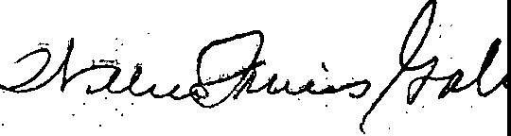
,.

WILLIAM FRANCIS GALVIN
Secretary of rht Commonwealth

TO BE FILLED IN BY CORPORATION
Contact lnfurmatioD;

William M. Mandell, Esq.

=========cc=- ==-="======-=,--······--······
Pierce & Mandell, P:C-.
11 Beacon Street, Suite 800, Boston, MA 02108

0
-::,:,
"
·C:

- 1
g=-
-,

..·.:r•• -.
-

. Telephone, (617} 720c2444
Email, bill@piercemandell.com

Upori fillng, a copy of this filing wi.11 be available at www.sec.scate.ma.w/cor. If the documenc is rejected, a copy of the Jci:.."'tion shccc and rejected document will be available in thc,rcjecred queue. ·.

