**ATTACHMENT 3A**

**PFAC MEETING PRESENTATION**



**Purpose**

* Improve Patient Access to MRI Services for the South Shore Area
* Replace scanner at SSH
* Add Second scanner at SSH
* Upgrade both Outpatient scanners

2



**Current** – 1.5 T

* 1 MRI on campus at 55 Fogg
* 1.5 T that is approx. 15 years old
* A new 1.5T scanner would be installed to maintain MRI Services
* Replacement parts are no longer made, and if they are, they are out of state which increases machine down time.
* Upon completion of installation of the new 1.5T scanner, a second scanner, 3T, would be installed
* No 3T within South Shore Health System
* MR Imaging operations on at least 1 scanner would be maintained.

3



**Proposal**

Build a new MRI suite and replace the MRI scanner at SSH while maintaining

operations on existing equipment. Apply for and obtain DON for second 3T scanner and upgrade MRI scanners located at 2 Pond Park in Hingham and the Dana Farber Cancer Institute.

4



**Continuity of Operations**

* 2 scanners at SSH provide uninterrupted MRI services for admitted and ED patients

•

During downtime admitted and Emergency Department patients are sent to the Cancer Center for

MR imaging displacing scheduled outpatients who may have already waited several days for their appointment. This has a greater impact for patients having breast or prostate MRI exams

During the (4) quarterly preventative maintenance on the hospital MR scanner, 16 hours/annum, admitted and emergency department patients are sent to Dana Farber Cancer Institute vis ambulance.

•

5



**Turn around Time**

•

Shorter turn around times will increase patient satisfaction

* positive impact on HCAPS and Press Ganey surveys

•

Have a positive impact on the amount of time a patient is in Emergency department

* Potentially discharge patients from ED versus admitting waiting for MRI

•

Potential impact to Length of stay

* Decreasing cost

•

During peak times admitted and emergency patients may wait up to 72 hours for an MRI

* The average wait time is 21 hours and median wait time is 18 hours
* On average 41% of the patients are scanned more than 18 hours from time order is placed

The data shows capacity is near 100%. As demand for MRI services increase the time from ordered to scan completion increases. Adding a second scanner will reduce the ordered to scan completion time.

•

6

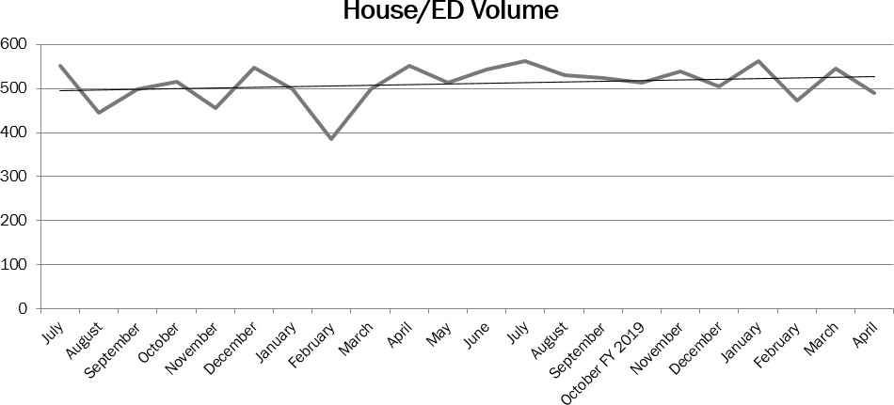

**Capacity and Length of Stay**

•

•

House /ED MRI Volume remains relatively flat

SSH MR scanner is at capacity with 112 hours of operation per week

•

Adding second scanner will increase capacity two-fold.

* Shorten length of stay for admitted patients and decrease wait times for ED and observation patients.

7

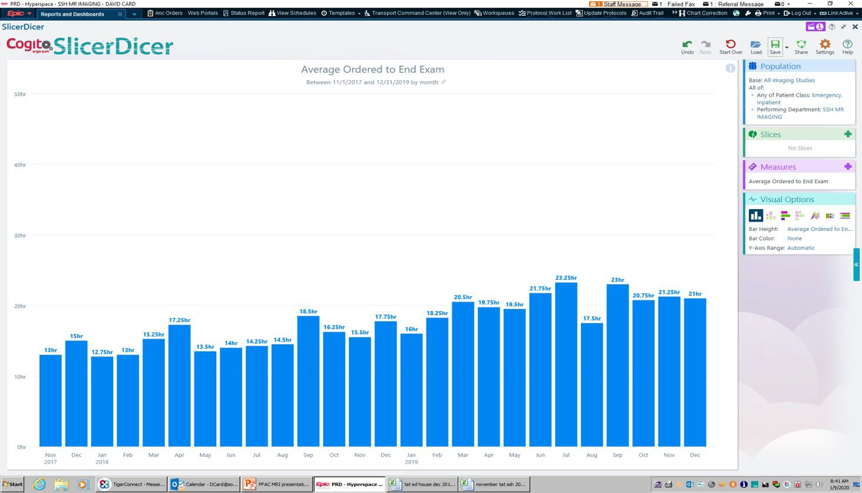

**Average Ordered to Scan Completion**

•

2017-2019

8

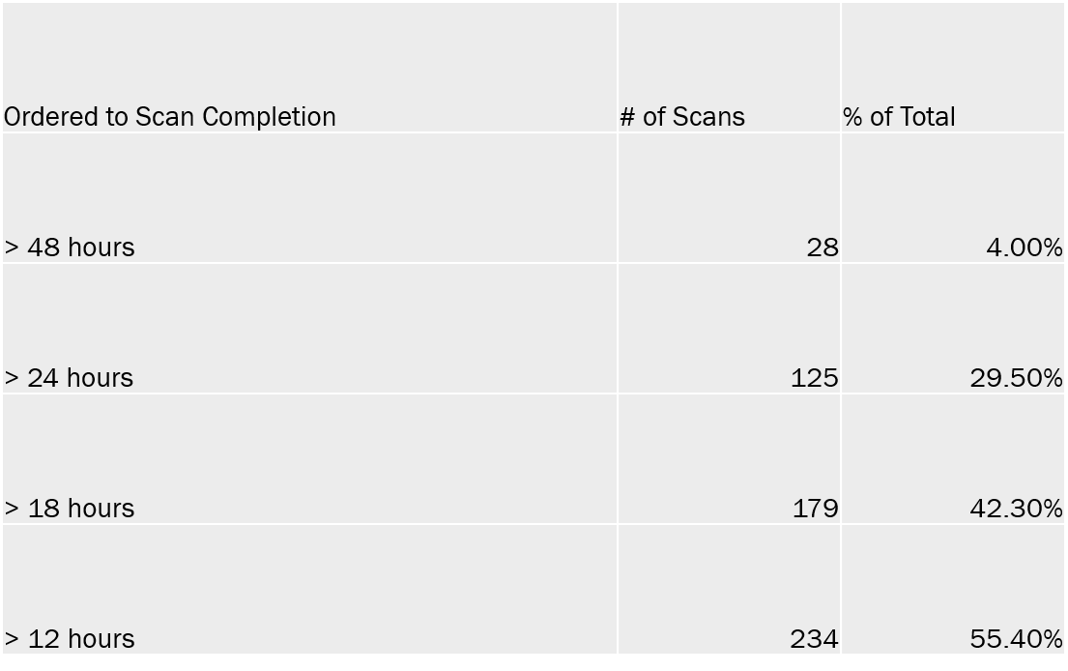

**Ordered to Scan Completion**

•

Dec. 2019

9

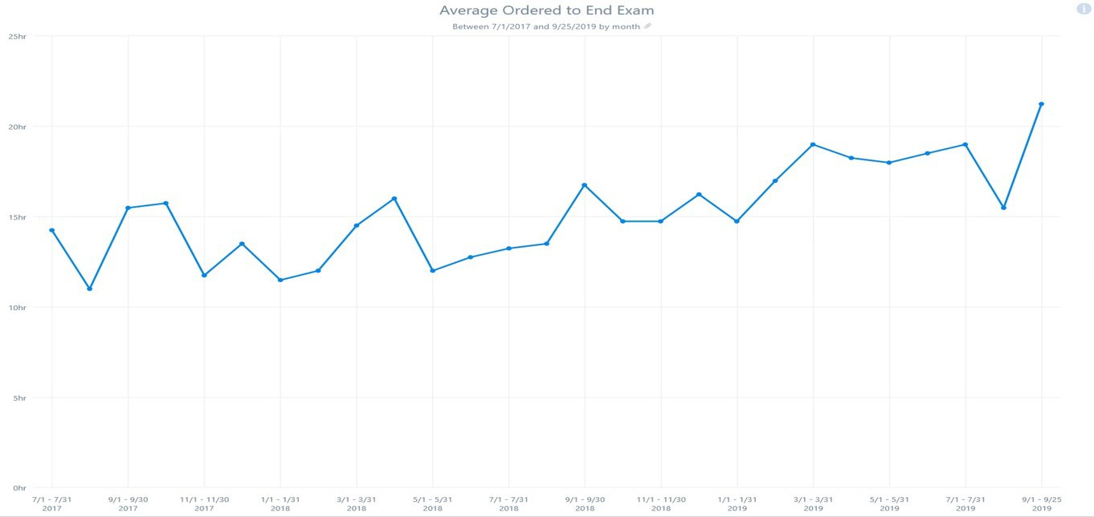

**Average TAT ordered to Scanned**

•

July 2017 thru September 2019

10



Why 3T?

•

Move prostate imaging from the Cancer Center to the hospital

o This will increase availability of Breast MRI appointments at the Cancer Center

-

-

Retain competitive edge with area MRI imaging centers

Prostate imaging

•

•

No endo rectal coil

Shorter exam time for patients

o Increased patient satisfaction Improved Image quality

•

-

Neuro Imaging

* New imaging techniques
* Increased sensitivity for stroke and hemorrhage

11



Growth Opportunities

•

Perfusion brain tumor imaging – critical to distinguish treatment changes from disease progression. Currently these cases go into town.

Seizure imaging for subtle malformations and dysplasia.

Inflammatory arthorpathies – rheumatoid arthritis, gout, psoriatic arthritis Cartilage mapping for arthroscopic cartilage transplants

Small joint MRI- referred from podiatry

More pediatric MSK injuries – growth plate injuries

MR Enterography for Crohns surveillance in young patients – this would be a major growth potential

Acute abdomen MRI in children at Boston's Children’s all acute abdomens are imaged by MRI, not CT (eg appendicitis)

Prostate – rectal cancer, bladder cancer, cervical cancer, endometrial cancer staging

•

•

•

•

•

•

•

12





Program Requirement

PROGRAM

•

•

New 1.5 T to replace

outdated New 3.0 T

New and additional holding bays for both MRI’s

Offices Break Room

Control Room serving both MRI’s

Electrical and equipment

room for both MRI

•

•

•

•

•

13



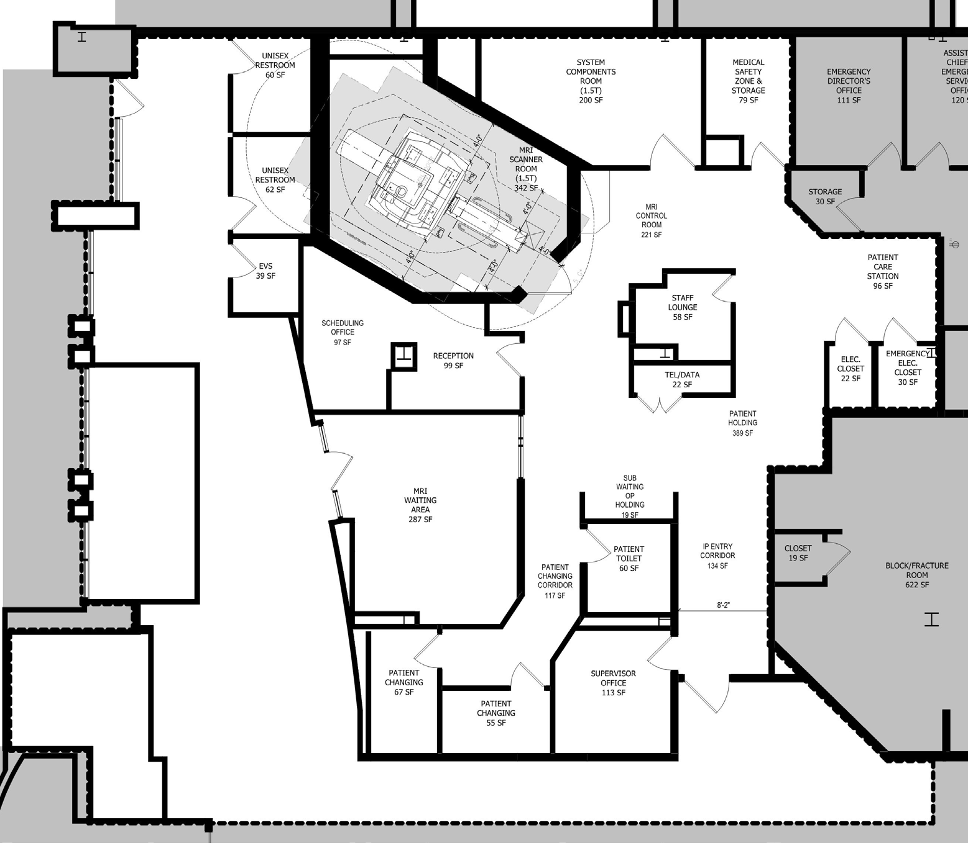

**Current** – 1.5 T Conditions

**ANY CONSTRUCTION ON THE SCANNER ROOM TRIGGERS DPH FOR THE ENTIRE**

**SPACE**

DPH DEFICIENCIES

•

SHEILDED VIEW WINDOW DESIGNED TO PROVIDE FULL VIEW OF PATIENT AT ALL TIMES (2.2-3.4.1.3(1)c)

•

CONTROL ROOM IS NOT ENCLOSED WITH WALLS & DOOR (2.2- 3.4.1.3(1)d)

•

SYSTEM COMPONENT ROOM ACCESSED ONLY FROM UNRESTRICTED OR SEMI-RESTRICTED SPACE (2.2-3.4.2.5 (1a))

•

PHYSICAL RESTRICTIONS BETWEEN ZONES II &III TO PREVENT FREE ACCESS (2.2-3.4.5.1(1))

•

SUPPORT SPACE FOR PATIENT INTERVIEWS AND CLINICAL SCREENING (2.2-3.4.5.1 (3a))

•

PATIENT TREATMENT/RESUSCITATION AREA ADJACENT TO MRI ROOM (2.2-3.4.5.6)

•

•

NO DEDICATED CONSULT ROOM (2.2-3.4.8.4)

CLEAN SUPPLY NOT READILY ACCESSIBLE TO IMAGING ROOMS (2.2- 3.4.8.11(2))

•

•

•

SOILED HOLDING (2.2-3.4.8.12)

STAFF TOILET DIRECTLY ACCESSIBLE TO STAFF LOUNGE (2.2-3.4.9.2 (1))

DEDICATED STAFF CHANGING AREA (2.2-3.3.9.4)

14





**Current** – 1.5 T Conditions

SAFETY

•

VISIBILITY RESTRICTIONS TO PATIENT HOLDING DUE TO

ROOMS LOCATED BETWEEN HOLDING AND MRI CONTROL

NEED VISUALIZATION DOWN THE BORE LACK OF APPROPRIATE MRI ZONES

PATIENT HOLDING LOCATED IN FRONT OF NORMAL AND ELECTRICAL CLOSETS

LACK OF RESUSCITATION SPACE

•

•

•

•

PATIENT AND STAFF SATISFACTION

•

LIMITED PRIVACY AND INADEQUATE SPACE AT SUB-

WAITING AREA AND PATIENT HOLDING

STAFF LOUNGE INADEQUATELY SIZED @ 58 SF STAFF VISIBILITY – NO STAFF OVERSITE FOR PATIENT

SAFETY (JOINT COMMISSION AND DPH REQUIREMENT) INADEQUATE SPACE FOR SCHEDULERS

NO HANDICAP ACCESSIBILITY IN PATIENT SPACES

•

•

•

•

15

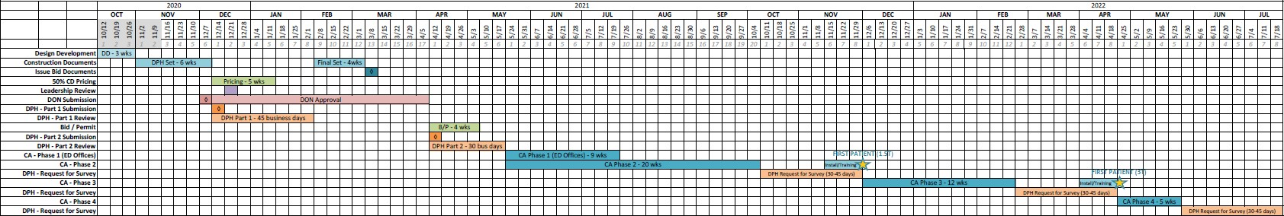

Proposed Timeline

16

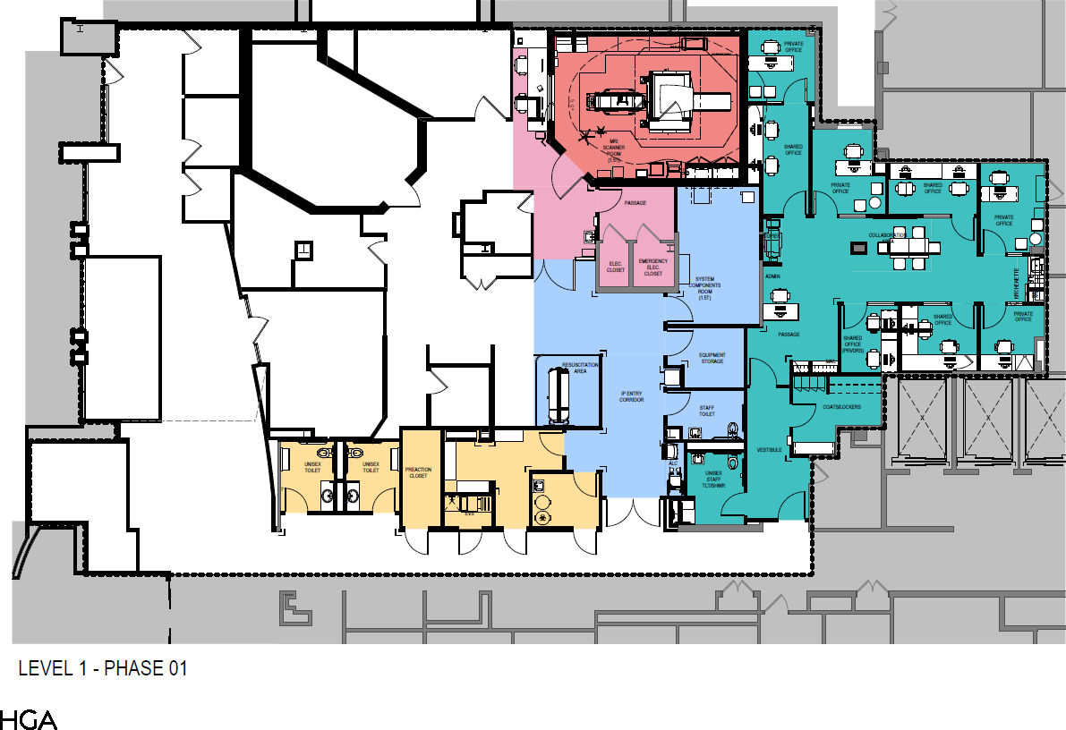

**Phasing Plan –** Phase 1

•

•

•

•

•

Office space

1.5 MRI Support Space Public Spaces Patient Bay

17

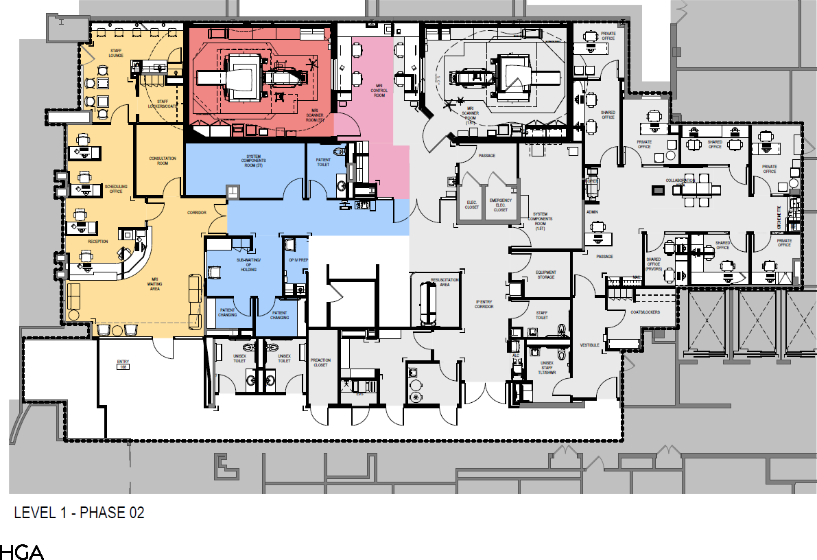

**Phasing Plan –** Phase 2

•

•

•

•

Reception Area

Changing Areas 3T MRI

Staff Support spaces

18

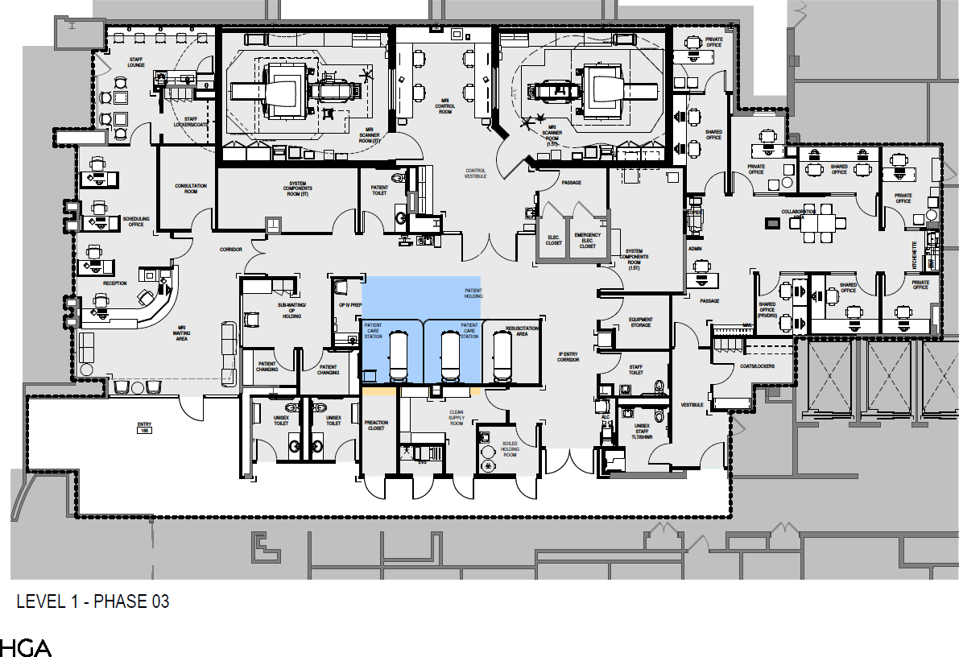

**Phasing Plan –** Phase 3

•

•

•

•

Reception Area

Changing Areas 3T MRI

Staff Support spaces

19

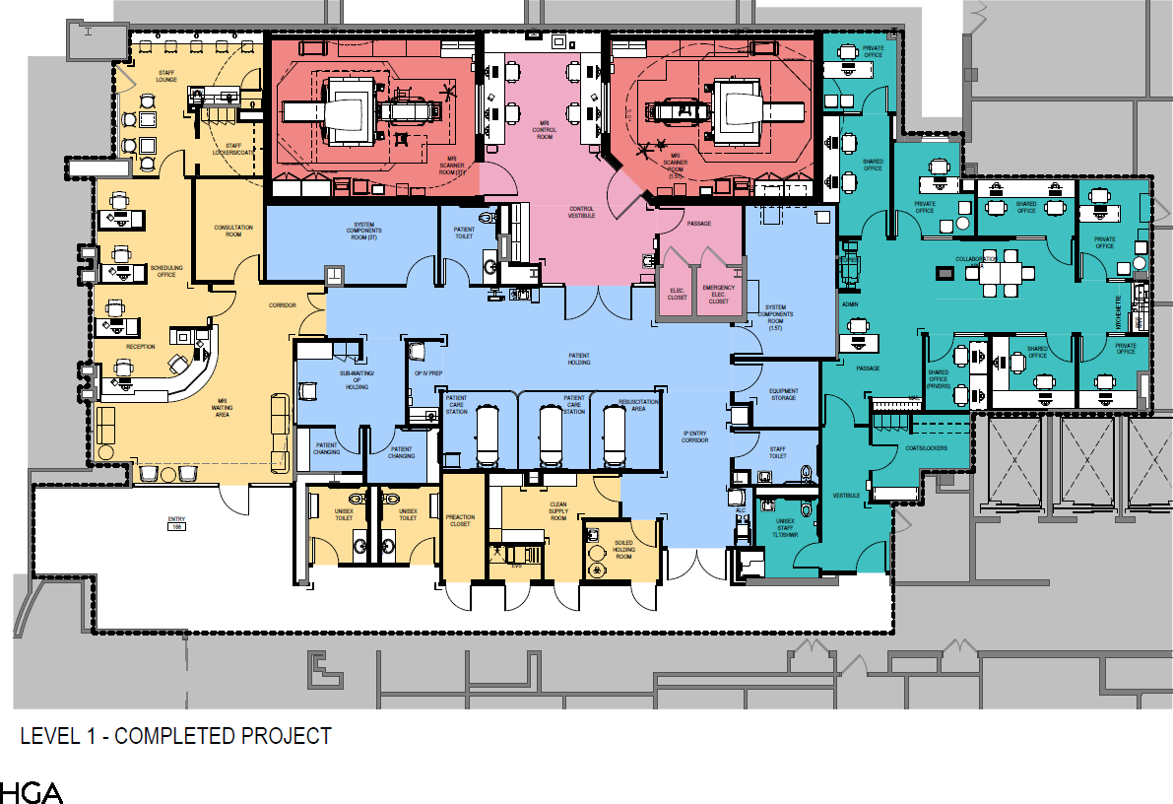

Floor Plan - Proposed

20

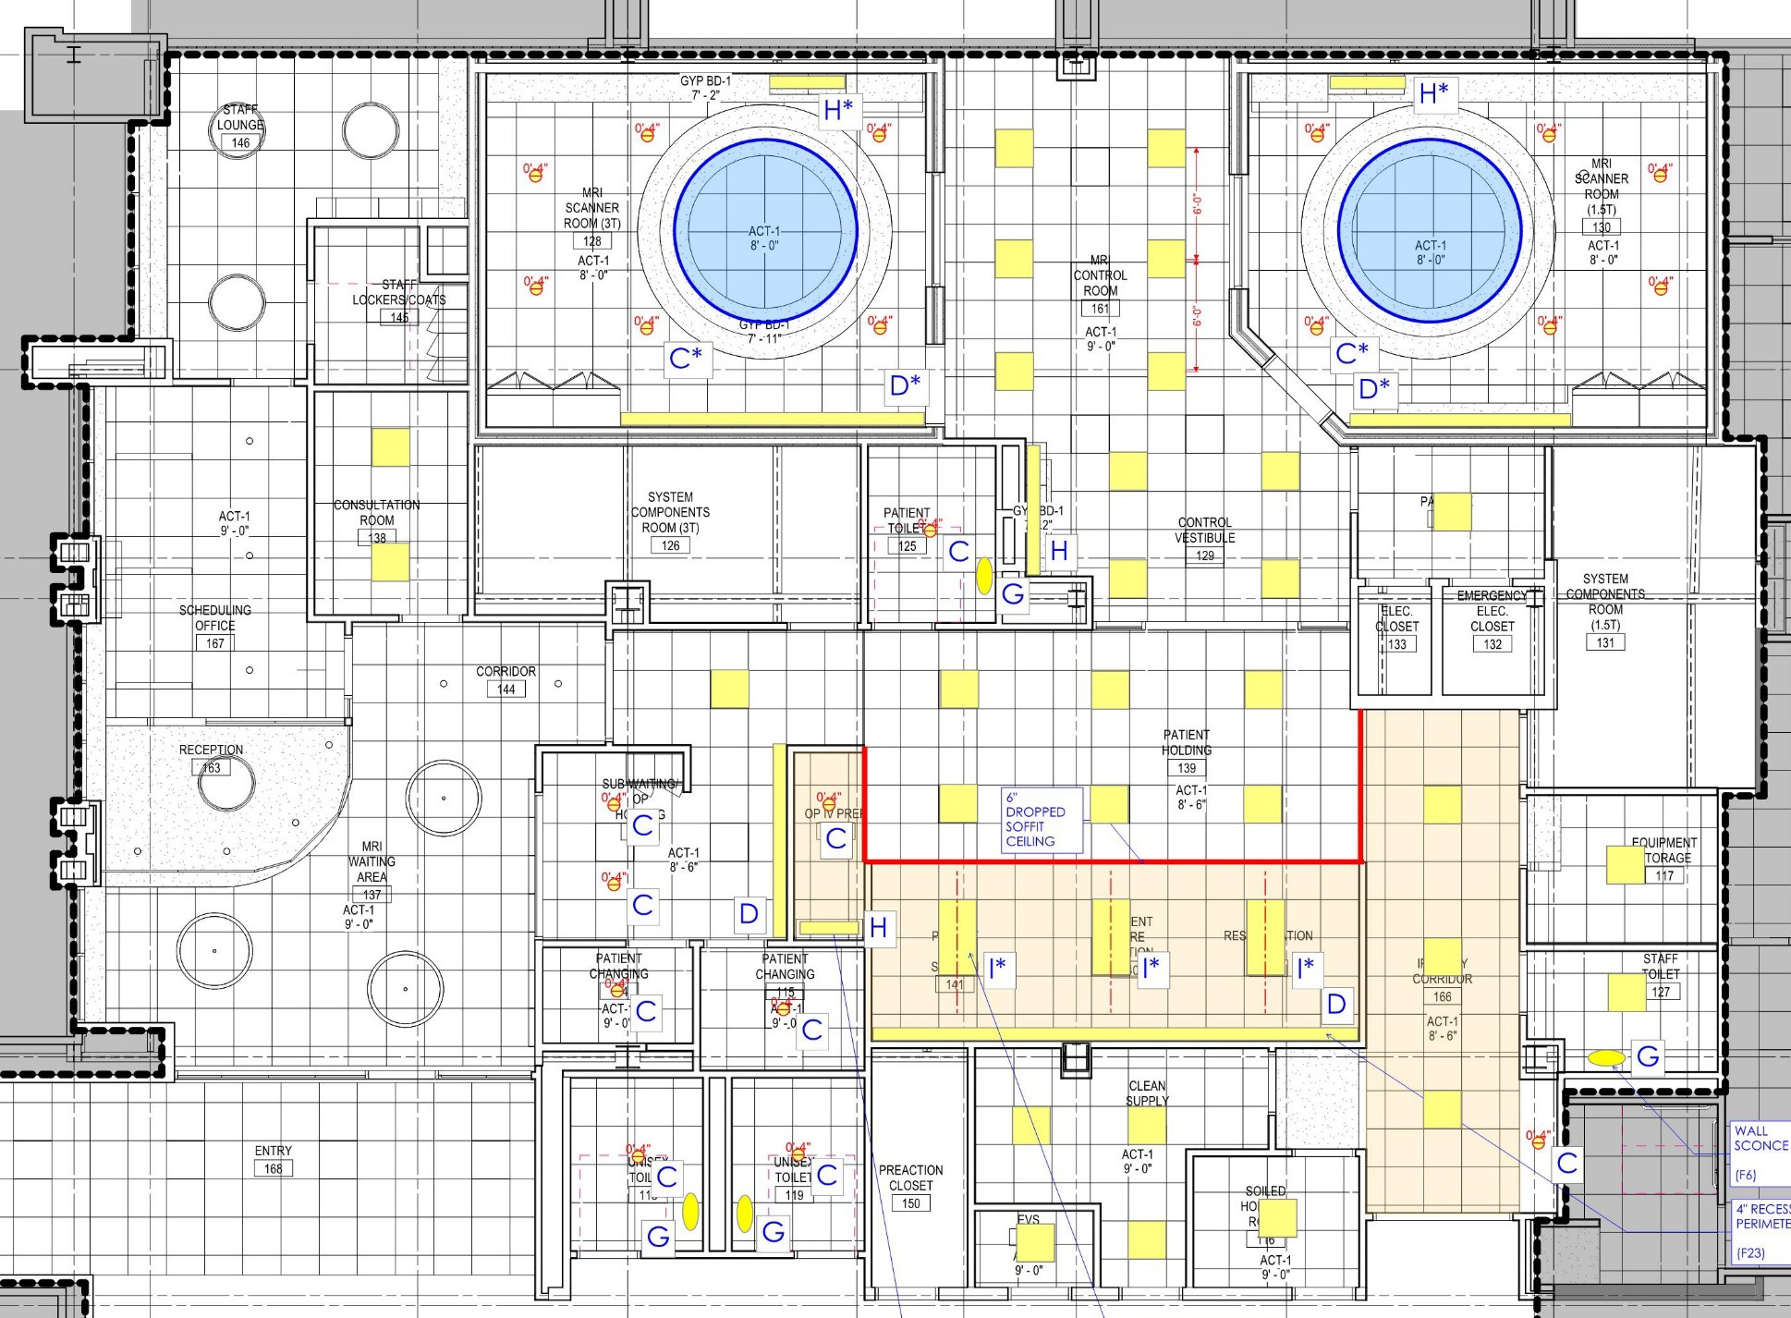

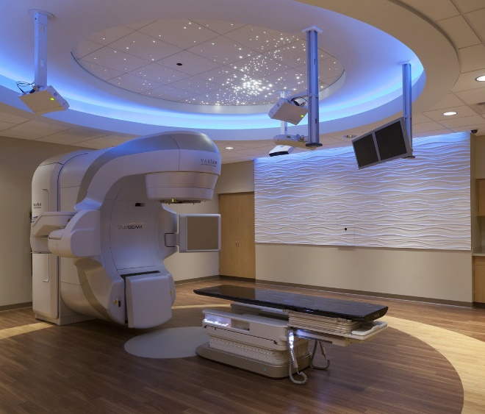

Ceiling Plan

* Proposed

21

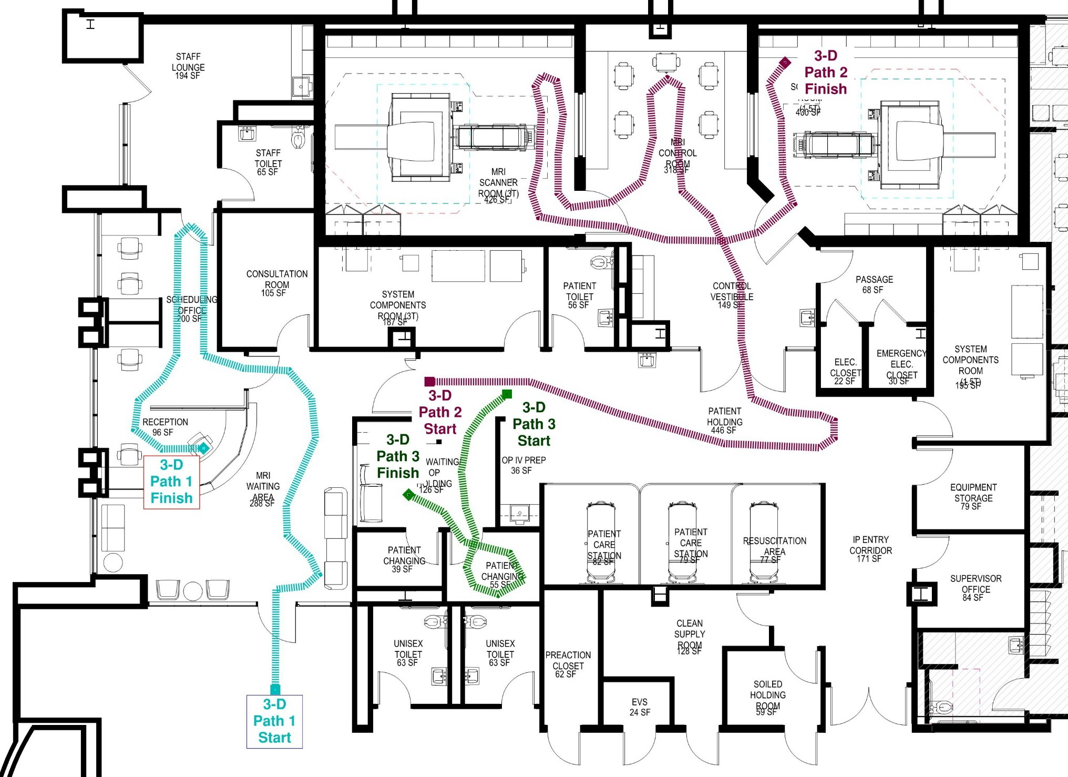

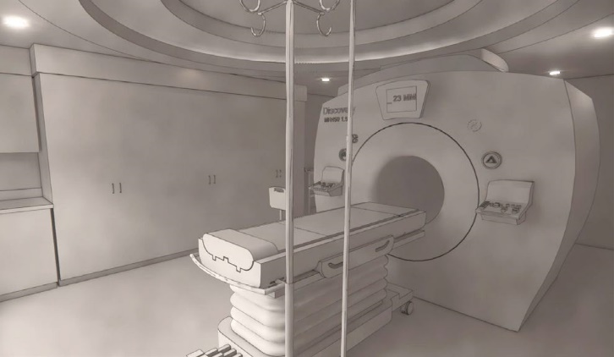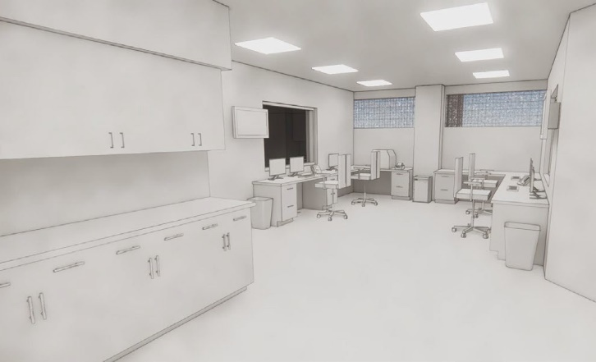

Proposed Plan

* 3D Walkthroughs

22



Design and Material Concepts

23



Design and Material Concepts

* Concept 1

24



Design and Material Concepts

* Concept 2

25



Design and Material Concepts

* Concept 3

26



Design and Material Concepts

* Concept 4

27



DFCC and 2PPK

* Scanners at both locations approaching end of life and need to be replaced
* Expected Completion of MR project at SSH replacing / adding new scanners is early 2020

•

•

•

•

DFCI scanner installed 2010 age 10 yrs, age at time of SSH MR project completion 12yrs

PP scanner installed 2011, age 9 yrs, age at time of SSH MR project completion 11 yrs Avg. age of MR scanners in US 11.5 years

50% of facilities replace scanners at an avg. age of 11.5 years

28



DFCC and 2PPK

* 1 imaging platform across all MR scanners

•

•

•

Providing same image quality

Advanced scanning capability at all locations Patients can choose any location

* Exception: breast and prostate imaging, (DFCI and SSH)
* Upgrades will extend useful life up to 13 additional years

•

Significant cost saving versus replacing both scanners

29



Thank You