**ATTACHMENT 3B**

**PUBLIC FORUM PRESENTATION**



South Shore Health

Determination of Need (DoN) Public Forum

March 18, 2021



Agenda

* Welcome and Introductions

- Art Mombourquette, Vice President, Support Services and Site Management

* South Shore Health Determination of Need (DoN) Project Overview
  + Maureen Shorrock, Executive Director, Diagnostic Imaging
  + Elizabeth Bahnuk, Executive Director, Facilities
* Public Comment

- Tina Dwyer, Director, Care Coordination/Community Benefits Officer

2

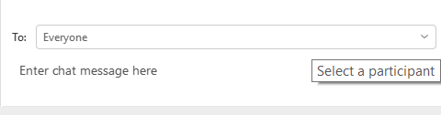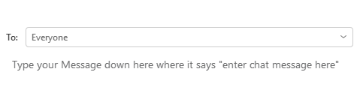

**WELCOME!**

**PLEASE REVIEW THESE IMPORTANT INSTRUCTIONS FOR TODAY’S MEETING:**

1.

2.

Please **STAY MUTED** at all times to avoid disruptions.

Questions/answers will be done via the chat feature.

3.

You can **CHAT TEXT** a question to **Karen Curran** at anytime during the meeting. Submitted questions

will be answered at the end by our presenters.

If you would like to speak, please indicate that with your question/comment in the chat room. Today’s Forum is being recorded.

4.

5.

**HOW TO SEND**

**A QUESTION USING CHAT:**

Lisa Rabideau

**Step 3: Type your question into the space where it says “enter chat message here” and then hit your Enter key to submit.**

**Step 2: Click the drop-down arrow to the right of the “to” field and Click on “Lisa Rabideau” at the top of the list.**

**Step 1: Click on “Chat” at the lower right of your screen**



Q&A

**HOW TO SEND**

**A QUESTION USING CHAT:**

Lisa Rabideau

**Step 3: Type your question into the space where it says “enter chat message here” and then hit your Enter key to submit.**

**Step 2: Click the drop-down arrow to the right of the “to” field and Click on “Lisa Rabideau” at the top of the list.**

**Step 1: Click on “Chat” at the lower right of your screen**



South Shore Health Attendees

* Art Mombourquette, Vice President, Support Services and Site Management
* Elizabeth Bahnuk, Executive Director, Facilities
* Maureen Shorrock, Executive Director, Diagnostic Imaging
* Tina Dwyer, Director, Care Coordination/Community Benefits Officer
* Suzanne Cray Tessier, Director, Government Relations and Regulatory Affairs
* Lauren Corolla, Esq., Associate General Counsel
* Walter Byrne, Senior Project Manager

5



Purpose

* Under the Massachusetts Determination of Need (DoN) law and regulation, Health Care Facilities are required to go through an application, review and approval process when implementing a substantial capital expenditure.
* As part of this process, Health Care Facilities are required to solicit public comment and hold a community forum to get feedback on the proposed expenditure from key stakeholders and members of their community.
* South Shore Health is holding this forum to seek public comment on its DoN proposal to modernize its existing MRI services and add additional MRI capacity and capabilities.

6



South Shore Health

Determination of Need (DoN) Project Overview

7



Project Goal

* South Shore Health’s goal is to ensure access to high-quality care, including vital imaging services.
* To meet this goal, South Shore Health must modernize its existing MRI services and add additional MRI capacity and capabilities. This will ensure access and enhance the care provided to patients across the region.

8



Proposal

* South Shore Health’s proposal is to update and expand its MRI services by:

-

Building a new MRI suite and replacing the existing, 15-year old 1.5T scanner which is

nearing the end of its useful life with a newer model that has updated capabilities. South Shore Health will maintain operations on existing equipment during construction;

Adding an enhanced 3T MRI scanner with a broader range of capabilities to address increased volume needs in the region and provide additional services; and

Upgrading MRI scanners located at 2 Pond Park in Hingham and the Dana Farber Cancer Institute in Weymouth. These upgrades will create efficiencies allowing performance of any exam at all locations.

-

-

* By taking these actions, it will increase access to care and reduce potential barriers to imaging services.

9



Benefits to Patients

* South Shore Health is nearly at 100% capacity to meet MRI demand.
* Replacing the 15-year old, 1.5T scanner and adding a second, 3T scanner will reduce the “ordered to scan” completion time.
* Enhanced access will result in:

-

Shorter turnaround times

* Increased patient satisfaction

Positive impact on the amount of time a patient is in Emergency Department (ED)

* Potentially discharge patients from ED versus admitting waiting for MRI

Shorter hospital stays, reducing costs for the patient

A decreased need to transport patients for imaging at other locations.

-

-

-

10



Current MRI Capabilities vs. Proposal

* 1 1.5T scanner on South Shore Hospital’s campus, located at 55 Fogg Road in Weymouth.
* Currently, there is no 3T within South Shore Health.
* Under the proposal:
  + A new MRI suite will be constructed and a new 1.5T scanner would be installed to maintain MRI services, while temporarily maintaining the current 1.5T scanner and location to prevent any downtime.
  + Upon completion of installation of the new 1.5T scanner, the current 1.5T location will be renovated and a second scanner, 3T, would be installed.
* MRI Imaging operations on at least 1 scanner would be maintained throughout the project.

11



Why 3T?

* Adding a 3T scanner will allow South Shore Health to provide more comprehensive, high-tech imaging that cannot be done by the 1.5T scanner, including:

-

Prostate imaging will now be done at the Hospital versus the Cancer Center. This will

increase availability of Breast MRI appointments at the Cancer Center.

Conduct neuro imaging using new imaging techniques with increased sensitivity for stroke and hemorrhage.

Generally improved image quality.

-

-

* Additionally, the 3T scanner will increase the capacity of patients able to receive a scan on-site, minimizing transfers and wait times.

12



Other Enhanced Capabilities of the 3T

* Perfusion brain tumor imaging, which is critical to distinguish treatment changes from disease progression. Currently, patients have to travel into Boston for this service
* Seizure imaging for subtle malformations and dysplasia
* Inflammatory arthropathies to address rheumatoid arthritis, gout, psoriatic arthritis, and cartilage mapping for arthroscopic cartilage transplants
* Small joint MRIs as part of podiatry treatment
* More pediatric Musculoskeletal Medicine (MSK) injuries, including growth plate injuries, and pediatric acute abdomen conditions (i.e. appendicitis)
* MR Enterography for Crohns surveillance in young patients
* Prostate, including scanning for rectal cancer, bladder cancer, cervical cancer, endometrial cancer

13



Other System MRI Locations

* MRI services are also available at:
  + The Dana-Farber/Brigham and Women’s Cancer Center (DFCI) in clinical affiliation with South Shore Hospital, located at 101 Columbian Street in Weymouth.
  + South Shore Health at 2 Pond Park in Hingham.
* Through this project, the scanners at these locations will receive technology upgrades.
* The upgrades will allow South Shore Health to have one imaging platform across all MRI scanners:

-

-

-

Provide same image quality

Advanced scanning capability at all locations Patients can choose any location

* Exception: breast and prostate imaging, (DFCI and SSH)
* Upgrades will extend useful life.

14



Architectural Requirements

* Upgraded 1.5T scanner to replace existing 1.5T
* New 3.0T scanner
* New and additional holding bays for both MRI scanner
* Offices
* Break Room
* Control Room serving both MRI scanners
* Electrical and equipment room for both MRI scanners
* New Waiting and Reception Area

15





Schedule

* Highlights – MRI Renovation

DPH

Request for Survey

DPH

Request for Survey

Construction

Start

**First Patient** Construction

**First Patient**

**(3T)**

**DON**

**Approval**

DPH

Part 1

Permit

DPH

Part 2

**DON**

**Submission**

**(1.5T)**

Complete

**April 5, 2021**

May 3 – June 21

**Sept 6, 2021**

Sep 13 – Oct 4

Jul 5 – Jul 30

Nov 1 – March 28, 2022

Apr 4 – May 23

**May 30, 2022**

August 2022

Aug 22 – Oct 17

**October 17, 2022**

Mar 18, 2021

Community Presentation



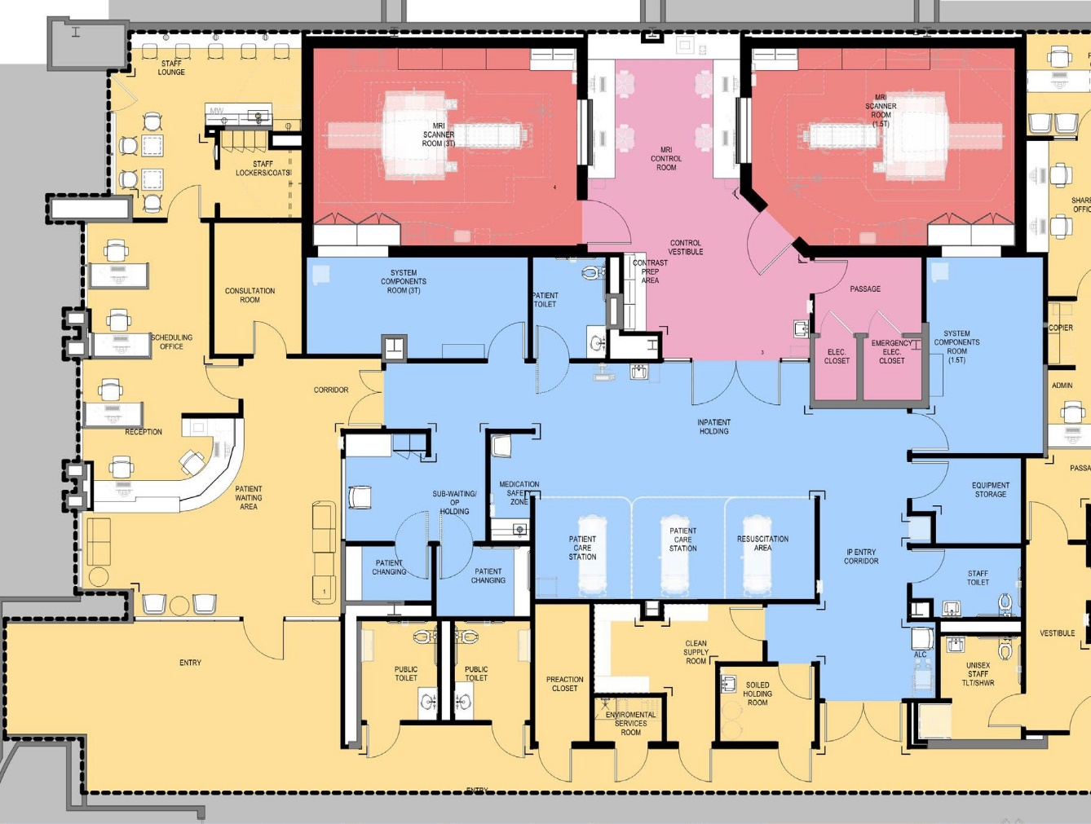

Floor Plan – MRI Suite

ZONE LEGEND

Zone 1 – Public /Staff

Zone 2 - Support

Zone 3 – Tech Area

Zone 4 – Scan Room

17



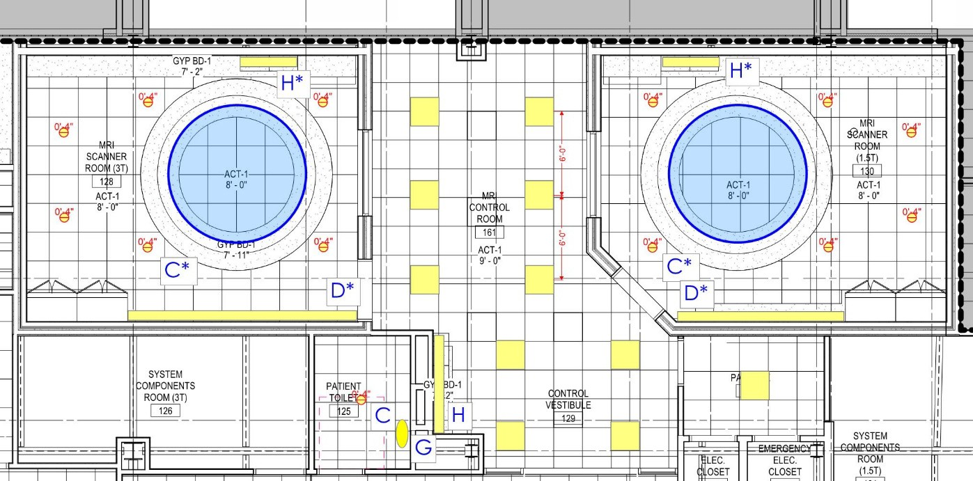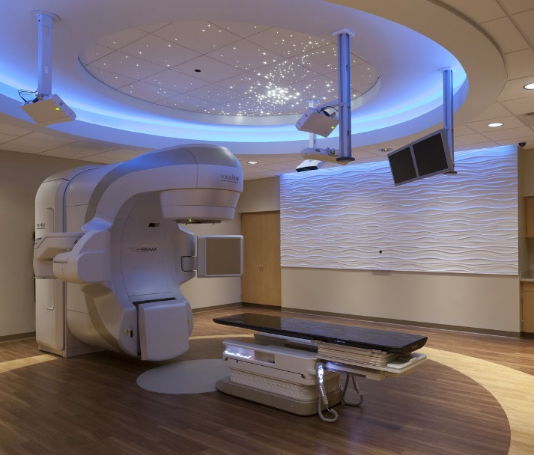

MRI Ceiling Plan

18



Interior Finishes

19

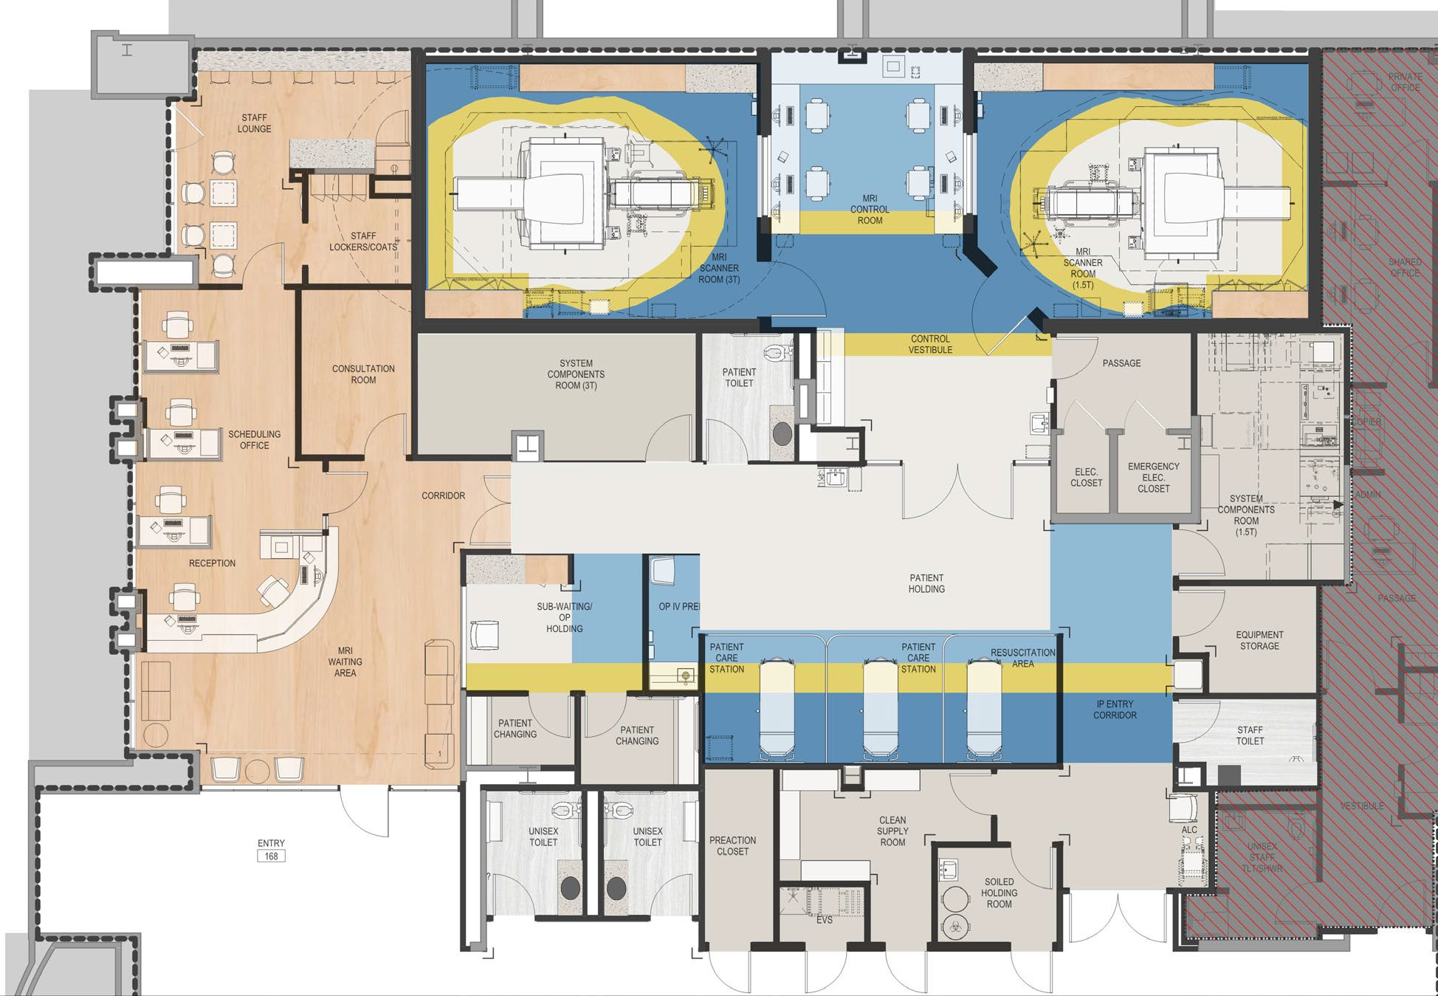

Floor Finish Plan

20

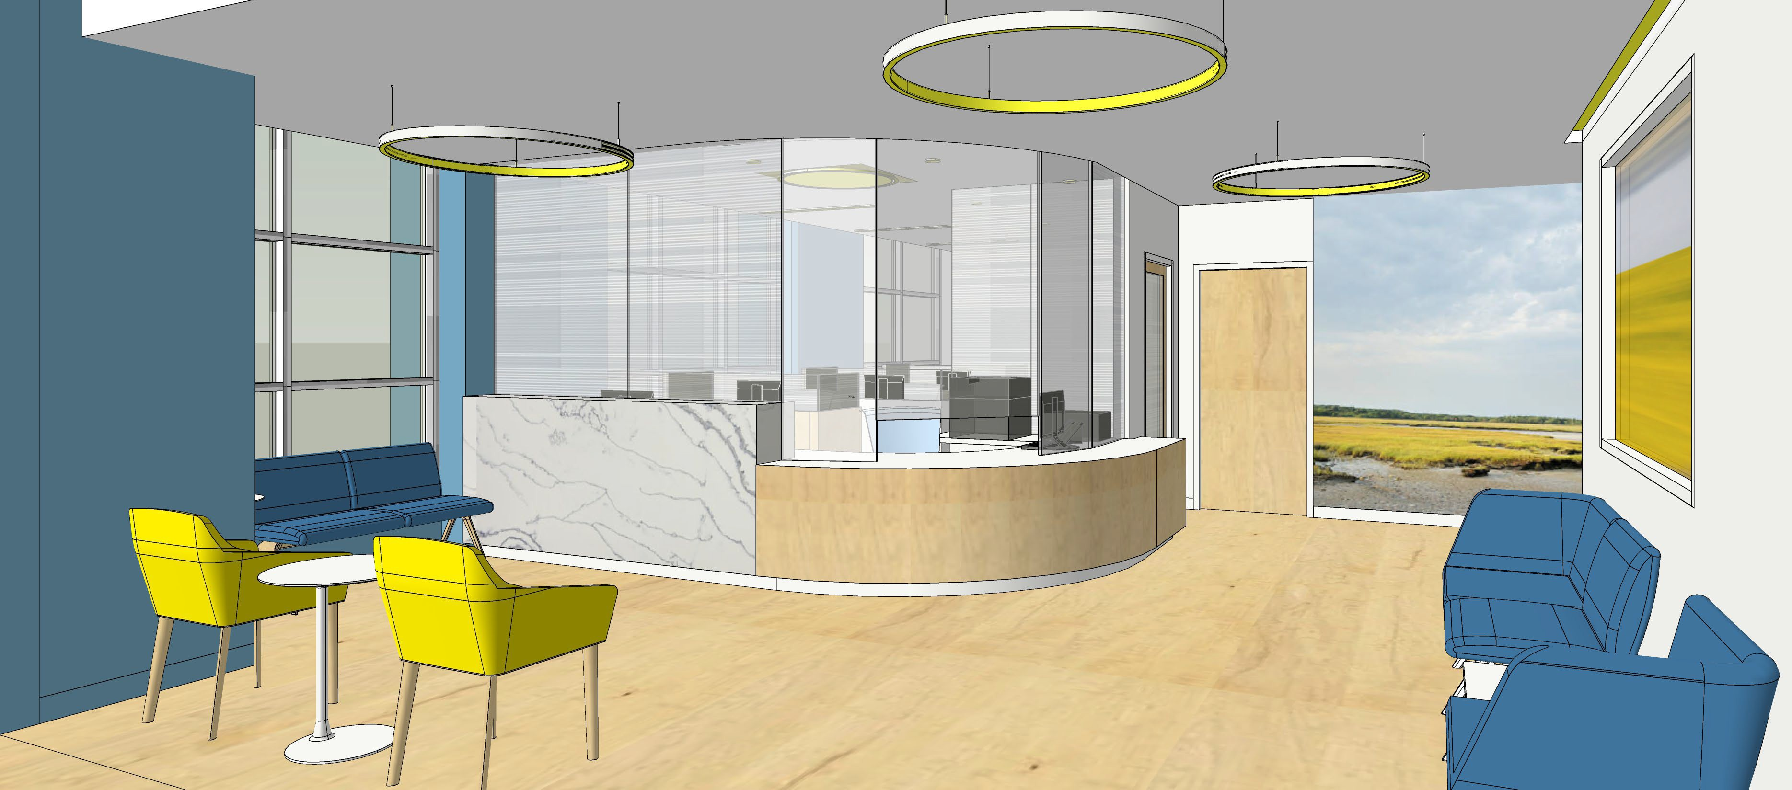

Registration and Waiting

21



Public Comment



Public Comment

* If you have any additional questions or comments, please contact:

Karen Curran

[kcurran2@southshorehealth.org](mailto:kcurran2@southshorehealth.org) 781-624-7445

* We respectfully request all written comments by Friday, March 26.

23



Thank You