APPLICANT RESPONSES
Responses should be sent to DoN staff at DPH.DON@State.MA.US
While you may submit each answer as available, please
- List question number and question for each answer you provide
- Submit responses using the above application title and number as a running header and page numbers in the footer
- When providing the answer to the final question, submit all questions and answers in one final document
- Whenever possible, include a table with the response
- Responses must be available in PDF and source document (Excel preferred for data and Word for narrative).

FACTOR 1
Factor 1a. Patient Panel and Need
- Race/ethnicity data for South Shore Health System and South Shore Health System MRI patients contain the category “Other” (pgs. 4 and 5). Provide a definition of this category.

  - The Race/ethnicity categorized as “Other” is identified by our patients. For Race, the system used by South Shore Health System (“SSHS”) has the following options to select: American Indian or Alaska Native, Asian, Black or African American, Decline to Answer, Native Hawaiian or Other Pacific Islander, Other, Unknown, White Caucasian. If the patient does not fit the above options, “Other” is typically used. “Other” is not broken out in SSH’s system.
For Ethnicity, SSH provides numerous options; however, “Other” is not an option. Images of the SSH system are below for reference (Figure 1).

Figure 1. South Shore Health System EMR System Images
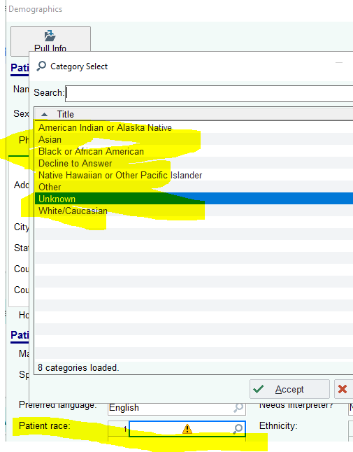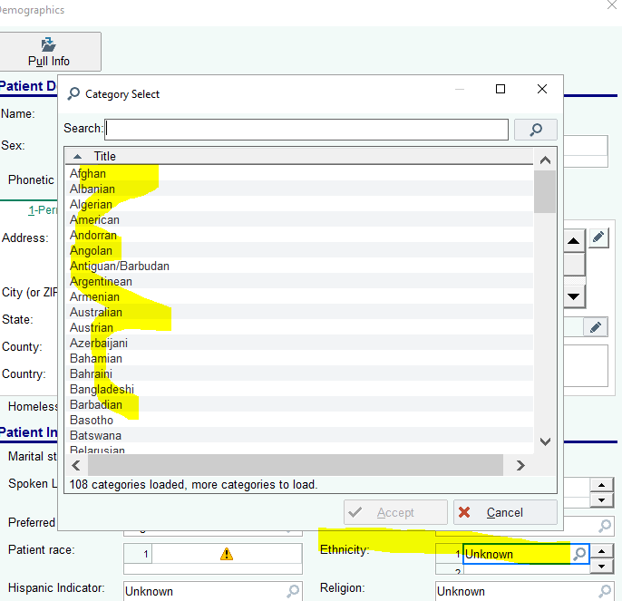

- Provide the payer mix for SSHS MRI patients.

  - Please see below table with payer mix for SSHS MRI Patients.

Table 1: SSHS MRI Payer Mix for FY20
ACO and APM Contracts | 4.4% | Non-ACO and Non-APM Contracts
 |  | Commercial PPO/Indemnity | 20.6%
 |  | Commercial HMO/POS | 29.3%
 |  | MassHealth | 1.8%
Non-ACO and Non-APM Contracts | 95.6% | Managed Medicaid | 1.1%
 |  | Commercial Medicare | 9.1%
 |  | Medicare FFS | 33.5%
 |  | All Other | 0.2%
TOTAL | 100% | TOTAL | 95.6%

- South Shore Health MRI scans by location (pg.6)

Table 2: SSHS Location of MRI Scans
 | FY2018 | FY2019 | FY2020
South Shore Hospital Main Campus | 7,497 | 7,471 | 6,497
Cancer Center | 4,019 | 4,386 | 4,285
South Shore Orthopedics | 3,716 | 3,697 | 3,315
Total | 15,232 | 15,554 | 14,097

  - Provide the number of unique patients at SSH Main campus, the Cancer Center, and South Shore Orthopedics for FY19.

APPLICANT RESPONSES
Table 3: Unique MRI Patients for FY2019
Cancer Center MR Imaging | 3,432
South Shore Orthopedics MR Imaging | 3,164
South Shore Hospital MR Imaging | 4,896

  - The application states the addition of an MRI unit will address the imaging needs of an aging population. In order to understand Patient Panel utilization of MRI services by age, provide FY19 MRI data at South Shore Hospital Main Campus, Cancer Center, and South Shore Orthopedics, by the following age cohorts: 0-17, 18-54, 55-64, 65-74, 75-84, and 85+.
Table 4. SSHS MRI Patient Ages
Age Cohort | Cancer Center | South Shore Orthopedics | South Shore Hospital Main Campus
0-17 | 52 | 35 | 92
18-54 | 1370 | 1102 | 1324
55-64 | 815 | 725 | 863
65-74 | 680 | 678 | 1022
75-84 | 408 | 458 | 954
85+ | 107 | 166 | 641
Total | 3432 | 3164 | 4896

  - Provide South Shore Hospital MRI scan volume and unique patients by specialty for FY19.
    - There were 7,472 total scans performed on 4,901 unique patients at SSH man campus in calendar year 2019. Specialties included:
      - Neurological disease processes - 3858 (78.7%)
      - Abdominal/genitourinary disease process - 684 patients (13.9%)
      - Musculoskeletal disease processes - 359 patients (7.4 %)

  - Provide data on operating capacity of the 3 units, including scans to reach maximum capacity, and hours of operation.
The table below provides each MRI center’s hours of operations, scan capacity, and the weekly average of scans using data from January 2021 through June 2021. As illustrated by the table, each center is operating at nearly 100% capacity. For each center, no-shows and/or last minute cancellations prevent the center from reaching 100% capacity.
Table 5: SSHS MRI Operating Capacity
 | Days/Hours of Operation | Capacity Per Week | Average Exams/Week (Jan-Jun 2021)
Cancer Center | M-Th: 7am – 11pm  F-Sa: 7am – 3:30pm | 90 exams | 89 exams
South Shore Orthopedics | M-Th: 7am – 11pm  F-Sa: 7am – 3:30pm | 85 exams | 84 exams
South Shore Hospital Main Campus | Su-Sa: 7am – 11pm | 136 exams | 135 exams

- South Shore Health MRI scans by patient status (pg.7)

  - Provide the number of unique patients for FY19.
Table 6: FY2019 Unique MRI Patients
 | FY2018 | FY2019 | FY19 Unique patients | FY2020
Inpatient Scans | 4,164 | 4,181 | 2,544 | 3,839
Outpatient Scans | 11,068 | 11,373 | 8,293 | 10,258
Total | 15,232 | 15,554 | 10,837 | 14,097

- Average Wait times (South Shore Hospital)

Table 7: SSHS Average Wait Time
 | FY2020
Inpatient | 24 hours
Outpatient | 6 days
Emergency patients | - hours

- The Application mentions average wait times for inpatients and emergency patients at the main campus (pg.7). What is the average wait time for outpatients at the main campus? Include a description of how wait time is calculated.
  - The average wait time for outpatients at SSH is 6 calendar days. This is calculated by determining the span of time from the current day to the first available appointment at the SSH location.

- The Application states SSHS currently has three 1.5T MRI units, but demand has created significant wait times and inefficiencies for all MRI services (pg.6). Provide wait times at the Cancer Center and South Shore Orthopedics. Include a description of how wait time is calculated.

  - The average wait time for outpatients at Cancer Center and South Shore Orthopedics is 6 calendar days. This is calculated by determining the span of time from the current day to the first available appointment at the SSH location. This is the same process for all patients.

APPLICANT RESPONSES
- The application states there were 190 patient transfers from SSH to SSH’s outpatient MRI facilities due to the following reasons: Weight limit on current unit and age of the unit (18 years old) requiring significant downtime for maintenance (pg.7).

  - Provide the time period for the transfer data.

    - 190 patients were transferred in calendar year 2020. In calendar year 2019, South Shore Hospital transferred 244 patients to an outpatient MRI facility. Although 2020 was a pandemic year, inpatient volume at the Hospital remained roughly the same. Additionally, overall transfer volume did not change.

  - Provide transfer data by the reason for transfer.

    - The reason for each patient’s transfer is not tracked in their medical record. The most common reasons for patient transfers are as follows: (1) Patient over table limit at SSH; (2)Patient does not physically fit inside the MRI scanner at SSH due to body habitus; and (3) Patient has severe claustrophobia (the scanner at Cancer Center is shorter in length and wider providing the sense or a more open space).

  - How much downtime is there on the existing MRI unit? Include a description of how it is calculated.

    - There is 4% downtime on the existing MRI Unit as validated by GE Service reports. Additionally, calculations by the SSH clinical team also reflect that out of 5,824 hours a year of operation (16 cases a day, 7 days a week, 52 weeks), there are approximately 232 hours of downtime a year, which is 3.98% of the machine’s operating capacity. Downtime is calculated by tallying the number of per annum the scanner is unavailable due to scheduled or unscheduled downtime.

- The application states that in 2020, approximately 975 patients were referred outside of South Shore Health System for MRI imaging of the prostate (pg.8).

  - Does this number represent the total number of patient referrals outside of South Shore Health System for MRI imaging in 2020? If not, provide the total number referred outside of SSHS for MRI imaging in 2020.
    - No. The total number of patients referred outside of SSH was 1,512 for FY 2020. This includes 984 patients transferred for MR imaging of the prostate (approximately 82 patients per month) and 528 patients for all other imaging needs (approximately 44 patients per month.
  - The application states that with the addition of a 3T MRI unit, fewer patients will need to be transferred for MRI or admitted longer, thereby further reducing the Hospital’s costs (pg.7). By how much will the Proposed Project reduce the need to transfer patients for imaging?

    - The proposed project is to greatly reduce or completely eliminate the need to transfer the patients to SSHS outside facilities. The new scanners located at SSH will be able to accommodate all the reasons for transfers as noted above in Factor 1.1a section 6b.

APPLICANT RESPONSES
- Projected MRI Scans at Main Campus – South Shore Hospital (SSH) (pg.8)

Table 8: MRI Projects at SSH Main Campus
 | Year 1 | Year 2 | Year 3 | Year 4 | Year 5
SSH 3T MRI | 6,720 | 6,854 | 6,991 | 7,131 | 7,273
SSH 1.5T MRI | 6,295 | 6,421 | 6,549 | 6,680 | 6,814
Total | 13,015 | 13,275 | 13,640 | 13,811 | 14,087

- Explain (with data) how you calculated the projected MRI scans at the main campus. What factors were taken into consideration?

  - SSH used data from its health information system to project the MRI volume at the Hospital’s Main Campus. First, SSHS looked at scan volume and determined the Main Campus has been operating above capacity for the past four years (Table 9.) Moreover, wait times have increased year-over-year during the same time period (Table 10). In addition to right-sizing operating capacity for the Main Campus MRI, SSHS also anticipates wait times for both admitted and emergency patients will be reduced (Table 11).

Table 9: MRI Volume at South Shore Hospital Main Campus
Year | 2017 | 2018 | 2019 | 2020
# of Scans | 7,284 | 7,497 | 7,471 | 6,497

Table 10: Wait Times for Emergency and Inpatients at South Shore Hospital Main Campus
Year | 2017 | 2018 | 2019 | 2020
Hours Order to Exam | 13.75 | 14 | 18 | 15.5

Table 11: Projected Wait times Following Implementation
 | Year 1 | Year 2 | Year 3
Admitted Patients | 14 | 12 | 8
Emergency and Observations | 8 | 6 | 6

  - Additionally, SSHS anticipates an additional 1,700 scans at the Main Campus because of the 3T scanner. As discussed above, 1,512 patients were referred outside of the System and another 190 were transferred to off-campus facilities. Those patients will no longer need to be transferred with the addition of a larger, more advanced MRI unit.
  - SSH considered population growth as a primary factor SSHS in calculating scan volume projections at the Main Campus. According to the University of Massachusetts Donahue Institute’s Long Term Population Projections for Massachusetts Regions and Municipalities, the statewide population is projected to grow a total of 11.8% from 2010 through 2035. Moreover, the bulk of the Commonwealth’s population growth is expected to cluster around residents that are 50 or older. Between 2015 and 2035 the Commonwealth 65+population is expected to increase at a higher rate compared to all other age groups. By 2035, the 65+ population will

APPLICANT RESPONSES
represent approximately a quarter of the Massachusetts’ population. Given the majority of MRI patients at South Shore Hospital are older adults, SSH believes the need for MR imaging will only increase as its patient population continues to age.
  - Lastly, SSH has experienced growth in its breast care program at the Cancer Center. Data demonstrates a 150% increase over the past 4 years in breast MRI scans and a 394% increase in breast biopsies (see Table 12). SSHS expects this trend to continue, further increasing the demand for services at the Cancer Center, which will increase demand at our main campus.

Table 12: Breast Care at the Cancer Center
 | 2017 | 2018 | 2019 | 2020
Breast MRI Volume | 630 | 731 | 996 | 971
Breast Biopsy MRI Volume | 18 | 33 | 56 | 71

Factor 1 b Public Health Value

- Describe access to interpreter services for patients transferred from South Shore Hospital to South Shore Hospital’s outpatient MRI facilities for imaging.
  - The same access for interpreter services is available for SSHS MRI patients regardless of scanning location. Interpreter services are offered in multiple way: in person thru Benoit Interprets, video conferencing, and 3-way phone call, provide by CyraCom Interpreter Services. As per hospital policy on availability of interpreter services.

- South Shore Health System has implemented several population health initiatives to further promote health equity. One such initiative is Social Determinant of Health (SDoH) screening for Medicaid Accountable Care Organization (ACO) patients (pg.14). Describe other population health initiatives to promote health equity among the Patient Panel.

- Over this last fiscal year, South Shore Health tackled two initiatives specific to the Thrive screening tool and the requirements of the Medicaid ACO. The first initiative incorporated positive screens for food insecurity. Positive screened patients are reviewed for eligibility to participate in our Flexible Services Program. In partnership with a local social services organization, this program delivers nutritious food to a large geographic area of the South Shore. Patients receive a follow up phone call from the Social Worker after 12 weeks to screen for improvement of food insecurity and behavioral health status. This program, which started in November of 2020, has been successful enough to reach near capacity. Patients can also be referred to Project Bread, which includes transportation to the grocery store and gift cards for purchases.
- The second initiative involved screening for the Experience of Violence via the Thrive tool. SSH brought in representatives from DOVE to educate providers on having these conversations related to domestic violence with patients. In addition, a blog has been included on the website for all community audiences. Posters with domestic violence resources have been posted in all primary care exam rooms and bathrooms.
- Another population health initiative is SSH’s Mobile Integrated Health (MIH) program which launched in March 2020. With the goal of providing increased access to healthcare to those patients

APPLICANT RESPONSES

- with transportation or other SDOH challenges. The MIH program dispatches paramedics out to the patient home where they are able to provide patient care under the direct supervision of a physician Medical Director including facilitated telehealth with providers, labs, IV treatments and mobile imaging services to avoid the need for unnecessary ED visits or inpatient hospitalization. The MIH team actively completes additional SDoH screening via the THRIVE tool with patients that they serve.
- Lastly, SDoH screening occurs in various forms within Care Management of patient populations across the System of Care. Hospital discharge planning incorporates elements of SDoH assessment to develop an appropriate discharge plan. Patients who are engaged in one of our Care Management programs: Transitional Care, Complex Care, Advanced Illness Care or within our preferred SNF network will be assessed for SDoH considerations in the development of their overall care plan.
- South Shore Health has engaged in a number of community-based health equity initiatives as follows:
  - The Brazilian Community Health project is in the 6th year. Starting in the basement of a local Brazilian Church the program has expanded and focused on English Second Other Languages (ESOL) for the past three years. Partnering with Jewish Vocational Services (JVS) it has expanded to meet the language needs of other non-English speaking/early adopters of the English language. The program is community driven with at minimum an annual meeting to drive the strategic direction and focuses on language that will help non-English speakers navigate the health care system.
  - South Shore Health (SSH) has worked for the past 3 years as a “convener” impacting homelessness and housing insecurity. Bringing the community together and all the work that is being done prevents overlap, duplication and reveals gaps. The goal is small steps that will grow and lead to systemic change. Small changes such as creating a private area for exam in Father Bill’s homeless shelter when SSH’s Mobile Integrated Health is on site enhances dignity, reduces refusal for care and keeps people out of the emergency room. SSH is working closely with Manet Community Health Center (a federally funded community health center) to help fill in gaps for mobile care to homeless encampments and other homeless in the community. Providing flu vaccine and other preventative care reduces the barriers with the potential of keeping people out of the emergency room and in more appropriate settings to meet their needs.
  - Through the Youth Health Connection, SSHS provides outreach and education to build resiliency in youth, provide tools for suicide prevention, at risk behaviors, bullying and to meet the needs of the LGBTQ youth community. Working with schools, coalitions and other youth focused organizations focuses on a population that is often missed because of a so-called “lack of health-related problems” and provides a long-lasting foundation that will hopefully have a lifelong impact.
  - During the pandemic, social isolation and reduction in preventable health care revealed a large, underserved population. The Healthy Aging Connection began before the Pandemic, but quickly became even more relevant. Through connections with local Council of Aging’s Aging Services Access Points (ASAP) and other organizations such as Enhanced Asian Community on Health (EACH), SSHS was able to reach many seniors. With technology and outreach, seniors were able to participate in Best Practice programs such as “A Matter of Balance” and “Diabetes Self Management”. These programs did more than preventative physical health but had a strong impact on mental health, social engagement and support. The program is continuing to grow and will continue as a community driven strategic initiative. The goal is through providing needed social and mental health support, common physical health will benefit.

APPLICANT RESPONSES

APPLICANT RESPONSES
Factor 1c - Operate Efficiently and Effectively

- The Application states, both of these objectives (increasing the number and type of imaging appointments available) will help to keep patients within the South Shore Health System, which is necessary for optimizing care coordination (pg.18).

  - Describe current care coordination processes for patients requiring imaging, including those transferred or referred to other sites for imaging.
- The transfer of a patient from SSH to any other imaging locations within SSHS is coordinated with the MRI department, the clinician taking care of the patient and Emergency Medical Services. All imaging is stored centrally in SSHS PACS system and accessible form the patient’s chart.

  - Describe the existing system of record sharing for patients referred out of South Shore Health System for an MRI scan.
- The transfer of a patient from SSH to a non-SSHS facility for MRI imaging is coordinated with the MRI department, the clinician taking care of the patient, and Emergency Medical Services. Images acquired at the outside facility are obtained by SSHS via CD, which includes the imaging result. The outside images and reports are uploaded in to the patient’s SSHS chart. If an outside facility needs prior imaging performed at SSHS for comparison purposes, SSHS has the ability to send images and reports electronically to the requestor via CD. The Radiology Department coordinates all aspects of the transfer, including the images and any reports.

- Describe any Clinical Decision Support tools or Preauthorization tools in use currently and their effectiveness in curbing unnecessary MRI imaging.

    - Change Healthcare Care Select Decision Support Software is utilized for all orders placed by a clinician within SSHS’s HIS. This software assesses the medical necessity of the exam and provides feedback to the clinician. This feedback incudes whether the MRI is recommended, or if alternate imaging is recommended given the clinical information. SSHS follows the requirements of insurance providers to determine if prior authorization is required. Unless emergent, MRI appointments are not provided unless the exam is preauthorized by the patient’s insurance provider. SSHS’s Decision Support software has been effective in reducing unnecessary MRI exams as evidenced by the following data: In 2020, our decision support software was consulted 5,842 times and resulted in 83 instances of an alternate order being placed (CT, MR, Nuclear Med, and select x-rays).
  - The number of MRI exams not pre-authorized by a patient’s insurance provider is not individually tracked. Anecdotally there are MRI orders whereby the insurance carrier denies the approval and the exam is not performed or alternative imaging is ordered by the clinician. If a patient wishes to proceed with an MRI exam without prior authorization, the patient is personally response for the cost of the exam.

APPLICANT RESPONSES
Factor 1e – Community Engagement
- The Application states the Proposed Project was presented at the South Shore Hospital’s Patient Family Advisory Committee (PFAC)(pg.16). How many members are there on the PFAC and explain how they are representative of the Patient Panel.

- Our PFAC currently has 10 community members and two organization members. The committee is composed of six (6) women and four (4) men. 70% of community members are retired; (30%) are currently employed. The Committee is also predominantly middle-class, Caucasian, and is comprised of former and current South Shore Health patients or family members of patients.

Factor 1f – Competition

- The Application states Hospital patients may be transferred to SSH’s outpatient MRI facilities and that this leads to increased costs (pg.8). In order to understand the impact of the Proposed Project on costs, provide costs incurred to transport admitted and emergency patients to SSH satellites for MRI imaging, if possible. Include a date/time period.

- During Calendar Year 2020 SSHS, transferred 190 patients to a SSHS outside imaging facility as noted in Factor 1, 1a section 6 above. The cost per transfer is $350 per trip. In CY2020, the total costs for transfers was $66,500.

FACTOR 2

Delivery System Transformation
- The application describes SDoH screening for MassHealth ACO patients.
  - At what one point in their care are patients screened using the THRIVE screener?
The THRIVE screening regularly occurs for Medicaid ACO (BACO) patient as part of their annual physical visit or new patient appointment. If a patient is flagged for a social determinant need, a referral can be placed to the social work team for further intervention. Upon social work intervention, a repeat THRIVE screening can be done as appropriate in follow-up. Additionally, at any point patients who are engaged in one of our Care Management programs: Transitional Care, Complex Care, Advanced Illness Care or within our preferred SNF network can be assessed for SDoH considerations in the development of their overall care plan.

    - Does SDoH screening rely on IT? If so, how do you ensure screening is accessible to all (aging, IT illiterate)?
- The THRIVE screening can occur in various delivery methods and is not solely dependent on IT. Typically, at the annual or new patient appointment, the patient is asked to complete the THRIVE screening. This can be accomplished via a handheld tablet while the patient waits for their visit or via My Chart access on their own personal device up to 3 days prior to their scheduled appointment. A paper tool is also available which is manually entered into the electronic EMR tool by SSHS staff. The THRIVE screening can occur via verbal prompted questions in person, telephonically, or virtually by the care team and entered into the EMR.
- The medical assistant will check for completed responses during the rooming process. If they are not completed the MA verbally asks the patient and enters patient responses into the EMR.

    - The application states a Community Resources Directory can be accessed through the System’s webpage (pg.15). How are patients without access to technology able to access the Community Resources Directory?

  - The Community Resource Directory can be access within SSHS’s so that any member of the care team can perform a search on a patient’s behalf. This can occur from any point in the System of Care (ambulatory, hospital, community). A resource list can be printed, and or emailed to the patient or patient representative. Additionally, the EMR has built in to the After Visit Summary (AVS) a specific list of resources. When prompted by positive indicators in the THRIVE tool, a list will print out on the AVS that is provided to the patient. Specifically, if a patient qualifies for the food insecurity flexible service program, SSH will perform direct referrals to the local social service agency contracted with SSHS to provide services.
  - Describe the SDoH screening for non-ACO patients.

- Population Health is committed to expanding and standardizing screening for Social Determinants of health. At this time, non – ACO patients are screened for SDoH across the system of care at various access points, using other various assessments. As written in response to Factor 1b, both MIH and Care Management interventions incorporate SDoH assessments in the establishment of patient plans of care as it relates to the service provided, care management outreach, or development of a hospital discharge plan.

The two organization members are women.

