Picture 1

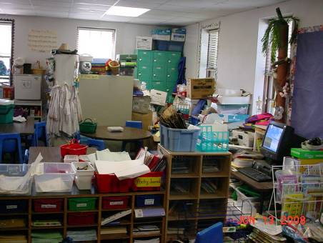

Stored Materials Blocking a Unit Ventilator

Pitcher 2

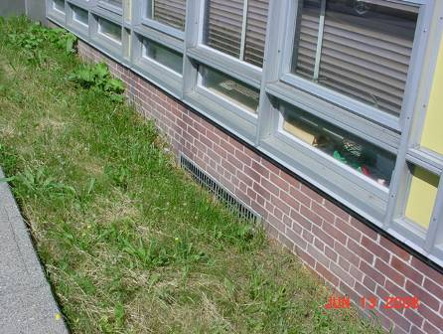

Fresh Air Intakes Located Below Grade

Picture 3

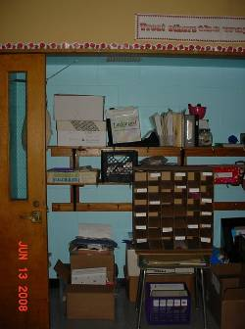

Exhaust Vents Located In Closet Ceiling

Picture 4

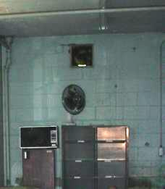

Exhaust Fan in Copy Room

Picture 5

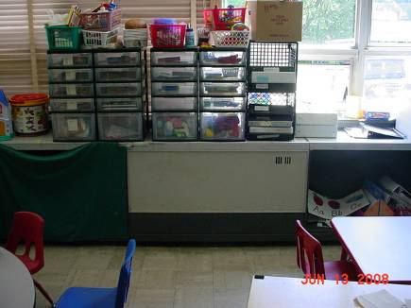

Unit Exhaust Ventilator

Picture 6

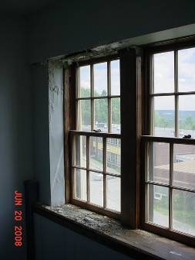

Water Damage Due To Window Leaks

Picture 7

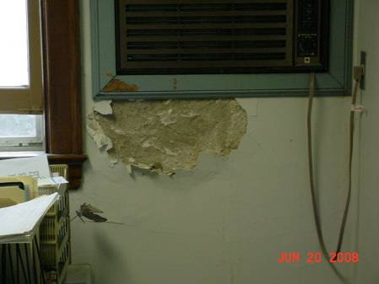

Water Damage Plaster through Air Conditioning Installation

Picture 8

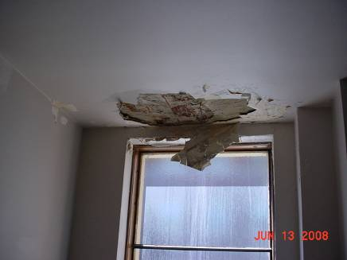

Example of Damaged Plaster in Rear Area of Former Altar

Picture 9

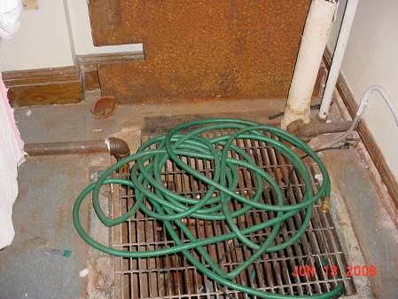

Sump Pump in Nurse’s Office Closet

Picture 10

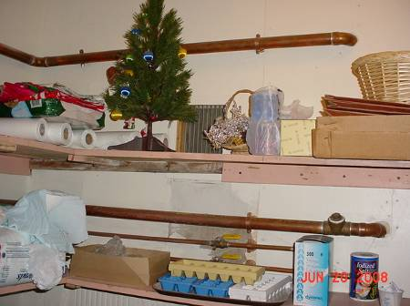

Vent in Closet in Nurse’s Office

Picture 11

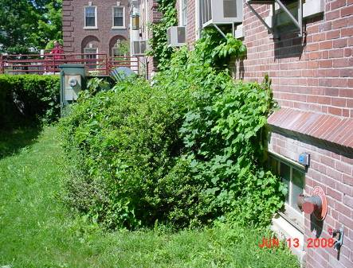

Plants against Exterior Wall, West Building

Picture 12

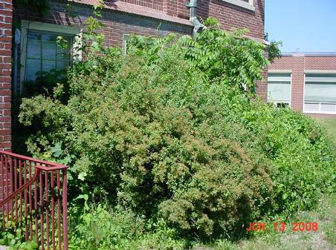

Plants against Exterior Wall and Windows Systems, West Building

Picture 13

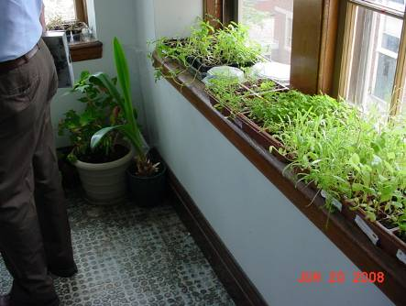

Plants Located At the Top of a Stairwell in the West Building

Picture 14

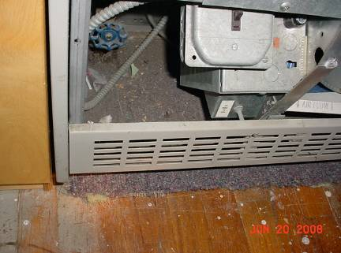

Unit Ventilator Installed Over Wall To Wall Carpeting

Picture 15

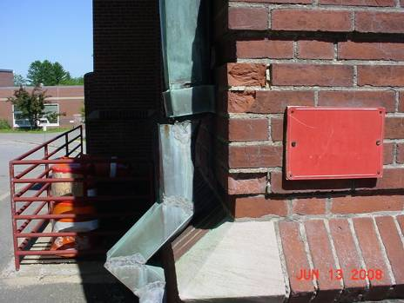

Hole in Downspout

Picture 16

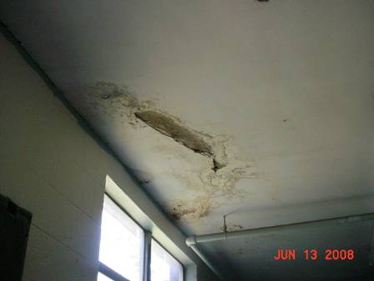

Example of Water-Damage on Ceiling of the Copier Room
Picture 17

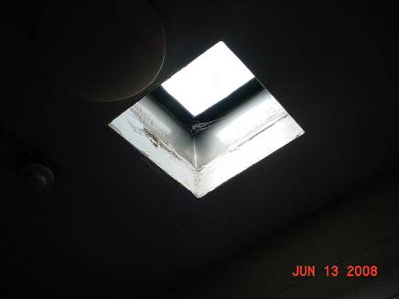

Water-Damage Around Skylight Outside Of Copier Room

Picture 18

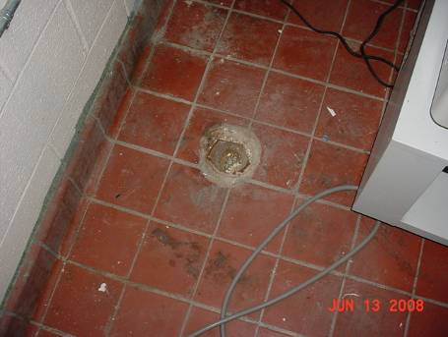

Capped Drain in Copier Room

Picture 19

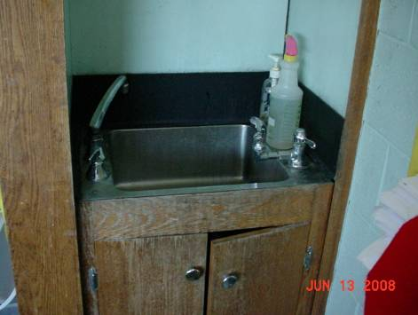

Example of Water-Damaged Sink Cabinet

Picture 20

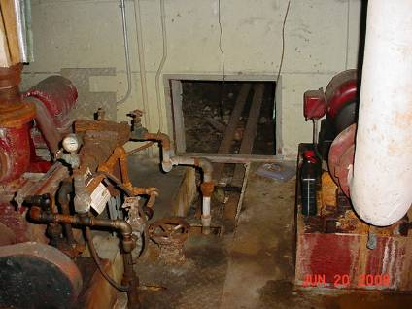

Entrance to Crawlspace beneath the North Building in the Boiler Room

Picture 21

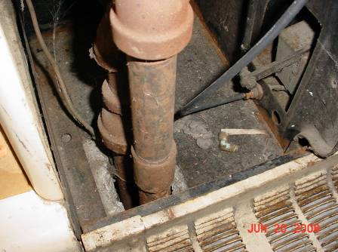

Hole in the Floor Around Heating Pipe Inside Of Unit Ventilator

Picture 22

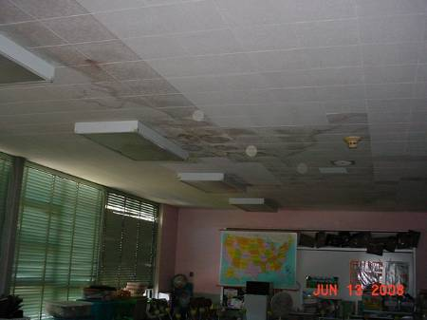

Water Damaged Ceilings in the Top Floor of the South Building

Picture 23A

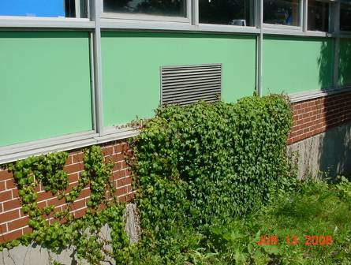

Plants Obstructing Unit Ventilator Fresh Air Intake

Picture 23B

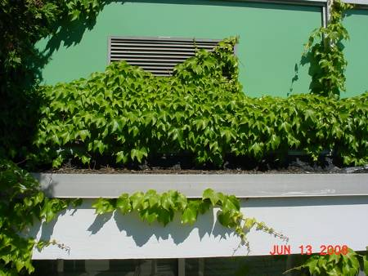

Plants Obstructing Unit Ventilator Fresh Air Intake

Picture 24

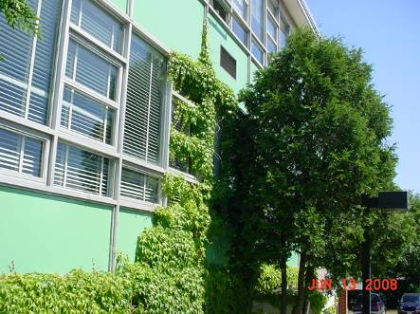

Ivy Growth of the Exterior Wall of the South Building

Picture 25

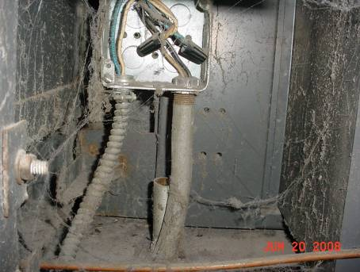

Open Electrical Conduit in Unit Ventilator

Picture 26

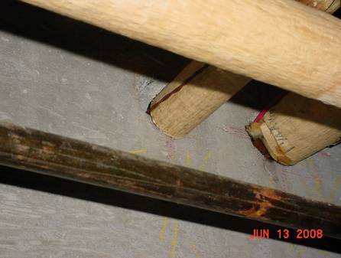

Space in Wall of Room 25 and Crawlspace

Picture 27

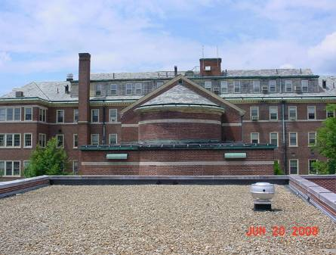

Parapet That Forms the Library Roof

Picture 28

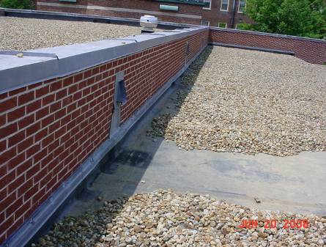

North Parapet Wall That Forms the Library Roof with Three Scuppers

Picture 29

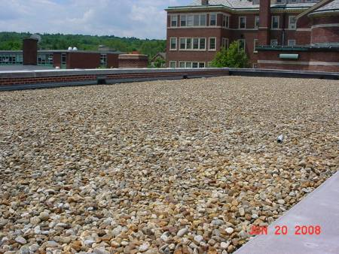

South Parapet Wall That Forms the Library Roof with Two Scuppers

Picture 30

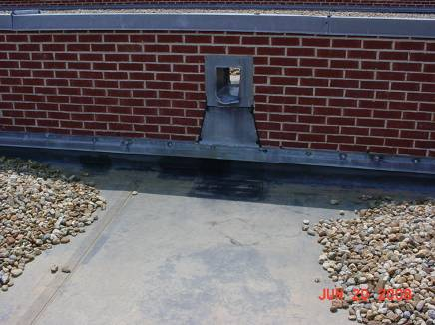

The Parapet Scupper That Empties Water onto the Lower Roof above Room 115, Note Patching In Roof Membrane

Picture 31

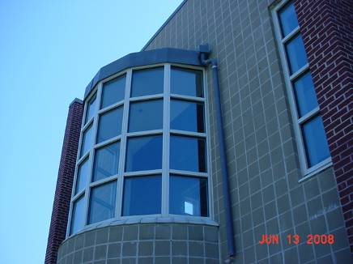

Library Balcony, View from Ground Level

Picture 32

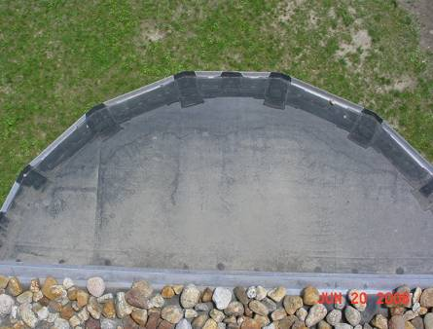

Roof Of The Library Balcony, Note Staining Pattern On The Roof Membrane Indicating The Water Is Being Directed Toward The Building Exterior Wall

Pictures 33

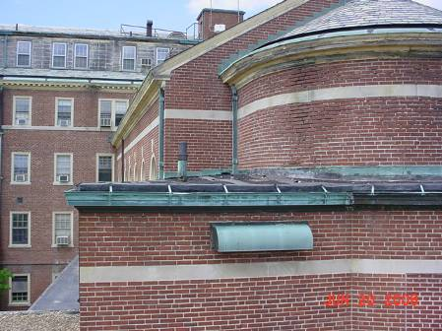

Example of Copper Flashing On the West Building Roof
Picture 34

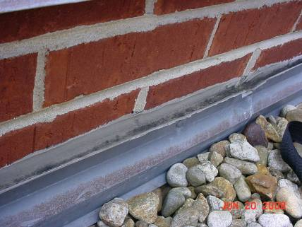

Roof Membrane On The East Building Attached To The Next Year Wall Of The North Building By Mechanical Fasteners, Note The Sealant Compound Installed Between The Seem Of The Metal Fasteners And Exterior Brick Wall

Picture 35

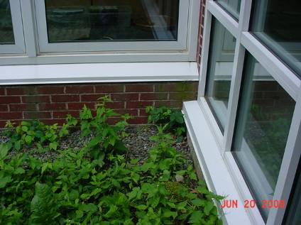

Exterior Brick Wall of the East Building, West Facing Exterior Wall

Picture 36

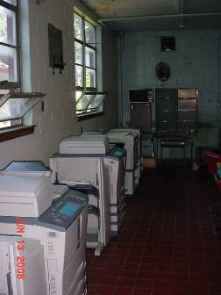

Photocopiers in the Copier Room

Picture 37

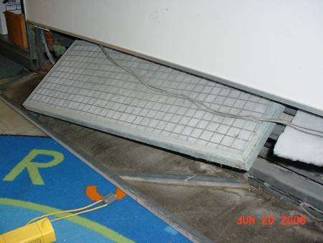

Filter Media in Metal Frame Installed Inside Unit Ventilators

Picture 38

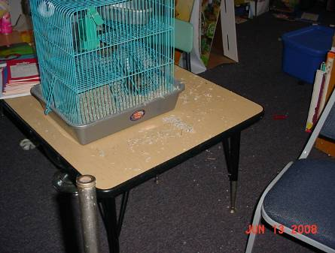

Pet Bedding on Table and Wall To Wall Carpeting

Picture 39

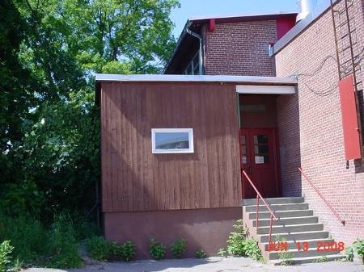

Structure That Forms the Copier Room/Gymnasium Equipment Storage Room

Picture 40

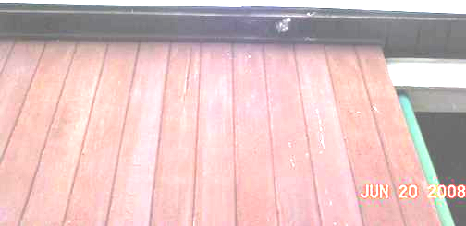

Damaged Soffit of Copier Room/Gymnasium Equipment Storage Room where Birds were Observed Roosting

