INDOOR AIR QUALITY ASSESSMENT

South Street Elementary School
376 South Street
Fitchburg, MA

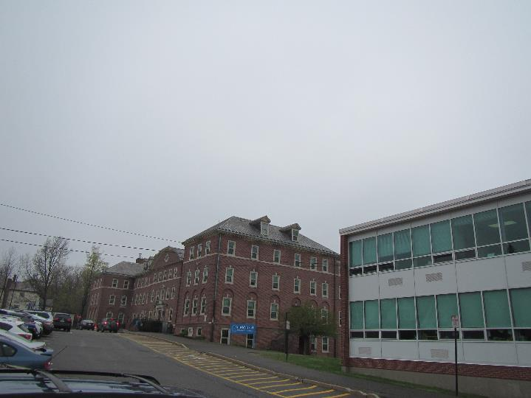

Prepared by:
Massachusetts Department of Public Health
Bureau of Environmental Health
Indoor Air Quality Program
June 2019

Background

Building: | South Street Elementary School (SSES)
Address: | 376 South Street, Fitchburg, MA
Assessment Requested by: | Robert M. Jokela  Acting Superintendent  Fitchburg Public Schools
Reason for Request: | General indoor air quality (IAQ)
Date of Assessment: | May 3, 2019
Massachusetts Department of Public Health/Bureau of Environmental Health (MDPH/BEH) Staff Conducting Assessment: | Mike Feeney, Director, IAQ Program and Jason Dustin, Environmental Analyst/Inspector, IAQ Program
Building Description: | The SSES is a building complex that consists of four wings that were constructed at various times (1940, 1950’s, 1960’s, and 1990’s). The school contains classrooms, a gym, a music hall, a cafeteria, and a variety of offices. The North Wing was closed at the time of this assessment.
Building Population: | Approximately 720 total students and staff
Windows: | Most windows are openable

This building has been visited previously, most recently in 2009. Reports from previous visits are available on request.

IAQ Testing Results
Please refer to the IAQ Manual for methods, sampling procedures, and interpretation of results (MDPH, 2015). The following is a summary of indoor air testing results (Table 1).
- Carbon dioxide levels were above the MDPH guideline of 800 parts per million (ppm) in the majority of occupied areas, indicating inadequate air exchange in those areas.
- Temperature was within or close to the MDPH recommended range of 70°F to 78°F the day of the assessment, however many occupants expressed temperature complaints.
- Relative humidity was within or just below the MDPH recommended range of 40 to 60% in all areas the day of assessment.
- Carbon monoxide levels were non-detectable (ND) in all areas tested.
- Fine particulate matter (PM2.5) concentrations measured were below the National Ambient Air Quality (NAAQS) limit of 35 μg/m³ in all areas tested.

Ventilation
A heating, ventilating and air conditioning (HVAC) system has several functions. First it provides heating and, if equipped, cooling. Second, it is a source of fresh air. Finally, an HVAC system will dilute and remove normally occurring indoor environmental pollutants by not only introducing fresh air, but by filtering the airstream and ejecting stale air to the outdoors via exhaust ventilation. Even if an HVAC system is operating as designed, point sources of respiratory irritation may exist and cause symptoms in sensitive individuals.
Fresh air to classrooms along exterior walls in most areas is supplied by unit ventilator (univent) systems (Picture 1). A univent draws air from the outdoors through a fresh air intake located on the exterior wall of the building (Picture 2). Return air from the classroom is drawn through an air intake located at the base of the unit (Figure 1). Fresh and return air are mixed, filtered, heated and provided to classrooms through an air diffuser located in the top of the unit. Univents were found deactivated in many rooms in the school at the time of the assessment. Most occupants reported that due to extremely hot temperatures in the units, they shut down the univent fans. In addition, some univents were found obstructed by furniture and other items on top of air diffusers and/or in front of return vents along the bottom of the units (Picture 3). Some univents were also found with missing/damaged covers and panels ajar (Picture 4), which can allow air to bypass the filter and allow dust and dirt to be entrained inside. Univent cabinets, intakes and diffusers should be vacuumed out each time the filter is changed to remove dust and debris. In order for univents to provide fresh air as designed, they must remain “on” and operating while rooms are occupied. Furthermore, units must remain free of obstructions.
Exhaust ventilation in classrooms with univents is provided by either unit exhaust ventilators or wall- or ceiling-mounted exhaust vents ducted to rooftop motors. While similar in appearance to a univent, unit exhaust ventilators lack a fresh air supply on the top of the unit and are designed to draw air directly to the outside of a building. Some wall-mounted exhaust vents were blocked at the time of assessment (Picture 5), many were found off/not drawing air, and a few were in very bad condition, allowing debris to be inserted into the ductwork (Table 1). As with supply ventilation, exhaust ventilation must be free of blockages and allowed to operate while the building is occupied.
Note that the univents and unit exhausts are original equipment, and therefore greater than 40 years old. Function of equipment of this age is difficult to maintain, since compatible replacement parts are often unavailable. According to the American Society of Heating, Refrigeration and Air-Conditioning Engineers (ASHRAE), the service life for a unit heater, hot water or steam is 20 years, assuming routine maintenance of the equipment (ASHRAE, 1991). Despite repeated attempts to maintain these units, the operational lifespan of the equipment has been exceeded. Maintaining the balance of fresh air to exhaust air as well as controlling temperature becomes more difficult as the equipment ages and as replacement parts become increasingly difficult to obtain.
Mechanical ventilation for interior classrooms and common areas (e.g., cafeteria, gymnasium) is provided by rooftop air-handling units (AHUs). Fresh air is distributed via ceiling or wall-mounted air diffusers (Picture 6) and ducted back to AHUs via ceiling or wall-mounted return vents. Many of the supply vents and nearby ceiling tiles were dusty.
In order to have proper ventilation with a mechanical supply and exhaust system, these systems must be balanced to provide an adequate amount of fresh air while removing stale air from a room. It is recommended that existing ventilation systems be re-balanced every five years to ensure adequate air systems function (SMACNA, 1994).

Microbial/Moisture Concerns
Water-damaged ceiling tiles were observed in many areas (Pictures 7 and 8; Table 1), which indicate leaks from the building envelope or plumbing system. A few of the stains were dark which may indicate microbial colonization. Stained tiles should be discarded and replaced. Occupants are advised not to store/place items in areas where leaks occur and to report any leaks or water infiltration promptly.
The Nurse’s office is below grade and was noted to have a slight musty odor which was reported to come from the closet area. A sump/utility pit with a metal cover was located in this closet. There were pathways in this closet which appear to lead to moist soil which is the likely source of the odor (Picture 9). Any sump pits should be sealed to prevent moisture, odors, and soil gases from entering occupied space.
Some areas of the school have carpeting. Carpeting in some rooms appeared to be water-damaged (Picture 10). Carpeting should not be installed in areas subject to condensation (e.g., below grade or on a concrete slab lacking vapor barrier/insulation). Carpet backing and debris within the carpeting may become colonized with mold due to chronic exposure to moisture.
Indoor plants were observed in a few areas (Table 1). Plants can be a source of pollen and mold, which can be respiratory irritants to some individuals. Plants should be properly maintained, equipped with non-porous drip pans, and should be located away from air diffusers to prevent the aerosolization of dirt, pollen and mold.

Other IAQ Evaluations
Exposure to low levels of total volatile organic compounds (TVOCs) may produce eye, nose, throat, and/or respiratory irritation in some sensitive individuals. To determine if VOCs were present, BEH/IAQ staff examined rooms for products containing VOCs. BEH/IAQ staff noted hand sanitizers, scented cleaners, air fresheners, and dry erase materials in use within the building. All of these products have the potential to be irritants to the eyes, nose, throat, and respiratory system of sensitive individuals (e.g., asthmatics).
It is important to note that due to the age of most of the building, asbestos-containing materials (ACM) may be present. Ensure the school is in compliance with the Asbestos Hazard Emergency Response Act (AHERA), which requires inspection of asbestos containing materials every three years as well as a semi-annual walkthrough to determine current conditions of asbestos-containing materials.
In many areas, accumulated items including books, papers, and decorative items were observed on floors, windowsills, tabletops, counters, bookcases, and desks. Excess items on surfaces can make it more difficult for custodial staff to clean. Items should be stored neatly (e.g., shelves, totes) and moved periodically to allow wet wiping of surfaces. Some chalk trays had debris from chalk or dry erase markers; this material should be wet-wiped frequently to prevent it becoming aerosolized. Pencil shavings on flat surfaces were also found in a few classrooms.
Tennis balls were found sliced open and placed around chair legs to reduce noise in some areas. Tennis balls are made of a number of materials that are a source of respiratory irritants. Constant wearing of tennis balls can produce fibers and off-gas VOCs. Tennis balls are made with a natural rubber latex bladder, which becomes abraded when used as a chair leg pad. Use of tennis balls in this manner may introduce latex dust into the school environment. Some individuals are highly allergic to latex (e.g. spina bifida patients) (SBAA, 2001). It is recommended that the use of materials containing latex be limited to reduce the potential for symptoms in sensitive individuals (NIOSH, 1997). Latex-free glides should be used for this purpose.
Some areas had personal fans and air purifiers which should be cleaned and maintained according to manufacturer recommendations. Certain air purifiers (electrostatic precipitators or ionizers) should be avoided since they may produce ozone which is a known lung irritant (US EPA, 2003).
Of note was the presence of peeling paint in a number of locations. IAQ staff could not identify whether the paint may contain lead. Given age of the SSES, is possible that classroom paint contains lead and would be require remediation in a manner consistent with Massachusetts lead paint laws and regulations.
Carpets should be cleaned annually (or semi-annually in soiled/high traffic areas) in accordance with Institute of Inspection, Cleaning and Restoration Certification (IICRC) recommendations, (IICRC, 2012). Regular cleaning with a high efficiency particulate air (HEPA) filtered vacuum in combination with an annual cleaning will help to reduce accumulation and potential aerosolization of materials from carpeting.
Note that the Environmental Protection Agency (EPA) conducted a National School Radon Survey in which it discovered nearly one in five schools had “…at least one frequently occupied ground contact room with short-term radon levels above 4 [picocuries per liter] pCi/L” (US EPA 1993). The BEH/IAQ Program therefore recommends that every school be tested for radon, and that this testing be conducted during the heating season while school is in session in a manner consistent with USEPA radon testing guidelines. Radon measurement specialists and other information can be found at www.nrsb.org and http://aarst-nrpp.com/wp, with additional information at: http://www.mass.gov/eohhs/gov/departments/dph/programs/environmental-health/exposure-topics/iaq/radon.

Conclusions/Recommendations
The following recommendations are made to assist in improving IAQ:
- Consult with an HVAC contractor to troubleshoot heating control issues for unit ventilators which is currently preventing staff from utilizing the units as designed for adequate ventilation. Once these repairs are made, investigate methods to restrict access to the fan controls so that occupants cannot shut them off.
- Ensure there is a method for staff to report issues with temperature control, broken ventilation equipment, leaks and other building related concerns to facilities staff. This should include a tracking method to ensure follow-up and communication back to the reporter regarding the status of issues.
- Operate all supply and exhaust ventilation equipment continuously during occupied hours.
- Remove items and furniture blocking univents, unit exhausts and exhaust vents.
- Use openable windows to supplement fresh air during temperate weather. Ensure all windows are tightly closed at the end of the day.
- Check return and exhaust vents for draw periodically and repair any non-operating motors/vents.
- Replace missing vent covers, fix door panels and otherwise ensure ventilation equipment parts fit together to avoid short-circuiting of airflow around filters, entrainment of dust or debris, or insertion of objects into system components.
- Consider adopting a balancing schedule of every 5 years for all mechanical ventilation systems, as recommended by ventilation industrial standards (SMACNA, 1994).
- Ensure filters for univents and air handling units are changed a minimum of twice a year, or more often if possible. Vacuum out univent and AHU cabinets during filter changes to remove dust and debris. The MDPH recommends using pleated filters of Minimum Efficiency Reporting Value (MERV) of 8, which are adequate in filtering out pollen and mold spores (ASHRAE, 2012), if these can be used with current equipment.
- Given the age of ventilation equipment significantly past its service life, consideration should be given to a building-wide upgrade of equipment such as univents, unit exhausts and air handling units.
- Ensure any roof and plumbing leaks are repaired promptly and replace any water-damaged ceiling tiles or other porous building materials.
- Avoid storing any items, particularly porous items in areas with known leaks.
- Properly maintain plants, including drip pans, to prevent water damage to porous materials. Plants should also be located away from air diffusers to prevent the aerosolization of dirt, pollen, and mold.
- Reduce the use of products and equipment that contain VOCs and eliminate the use of scented products such as air fresheners, reed diffusers and similar products. Ensure only school-supplied cleaning products are used in the building and that they are used in accordance with package instructions, including any need for dilution or ventilation.
- Ensure that the school is in compliance with AHERA regulations for asbestos-containing materials including inspection and planning.
- Regularly clean supply/return/exhaust vents and fans to avoid aerosolizing accumulated particulate matter.
- Personal fans and air purifiers should be cleaned/maintained according to manufacturer recommendations. Avoid any air purifier that may produce ozone, a known lung irritant.
- Consider reducing the amount of items stored in rooms to make cleaning easier. Periodically move items to clean flat surfaces. Store porous items on shelving and away from walls.
- HEPA vacuum carpeting daily and clean carpeting annually (or semi-annually in soiled high traffic areas). Clean area rugs similarly.
- For buildings in New England, periods of low relative humidity during the winter are often unavoidable. Therefore, scrupulous cleaning practices should be adopted to minimize common indoor air contaminants whose irritant effects can be enhanced when the relative humidity is low. To control dusts, a high efficiency particulate arrestance (HEPA) filter equipped vacuum cleaner in conjunction with wet wiping of all surfaces is recommended. Avoid the use of feather dusters. Drinking water during the day can help ease some symptoms associated with a dry environment (throat and sinus irritations).
- Determine if peeling paint contains lead. If paint contains lead, remove paint in a manner consistent with Massachusetts lead paint laws and regulations. If no lead is present, remove peeling paint.
- The school should be tested for radon by a certified radon measurement specialist during the heating season when school is in session. Radon measurement specialists and other information can be found at: www.nrsb.org, and http://aarst-nrpp.com/wp.
- Consider adopting the US EPA (2000) document, “Tools for Schools”, as an instrument for maintaining a good IAQ environment in the building available at: http://www.epa.gov/iaq/schools/index.html
- Refer to resource manual and other related IAQ documents located on the MDPH’s website for further building-wide evaluations and advice on maintaining public buildings. These documents are available at: http://mass.gov/dph/iaq.

References
ASHRAE. 1991. ASHRAE Applications Handbook, Chapter 33 “Owning and Operating Costs”. American Society of Heating, Refrigeration and Air Conditioning Engineers, Atlanta, GA.
ASHRAE. 2012. American Society of Heating, Refrigeration and Air Conditioning Engineers (ASHRAE) Standard 52.2-2012 -- Method of Testing General Ventilation Air-Cleaning Devices for Removal Efficiency by Particle Size (ANSI Approved).
IICRC. 2012. Carpet Cleaning FAQ 4 Institute of Inspection, Cleaning and Restoration Certification. Institute of Inspection Cleaning and Restoration, Vancouver, WA.
MDPH. 2015. Massachusetts Department of Public Health. “Indoor Air Quality Manual: Chapters I-III”. Available at: http://www.mass.gov/eohhs/gov/departments/dph/programs/environmental-health/exposure-topics/iaq/iaq-manual/.
NIOSH. 1997. NIOSH Alert Preventing Allergic Reactions to Natural Rubber latex in the Workplace. National Institute for Occupational Safety and Health, Atlanta, GA.
SBAA. 2001. Latex In the Home And Community Updated Spring 2001. Spina Bifida Association of America, Washington, DC.
SMACNA. 1994. HVAC Systems Commissioning Manual. 1st ed. Sheet Metal and Air Conditioning Contractors’ National Association, Inc., Chantilly, VA.
US EPA. 1993. Radon Measurement in Schools, Revised Edition. Office of Air and Radiation, Office of Radiation and Indoor Air, Indoor Environments Division (6609J). EPA 402-R-92-014. https://www.epa.gov/sites/production/files/2014-08/documents/radon_measurement_in_schools.pdf
US EPA. 2000. Tools for Schools. Office of Air and Radiation, Office of Radiation and Indoor Air, Indoor Environments Division (6609J). EPA 402-K-95-001, Second Edition. http://www.epa.gov/iaq/schools/index.html.
Picture 1
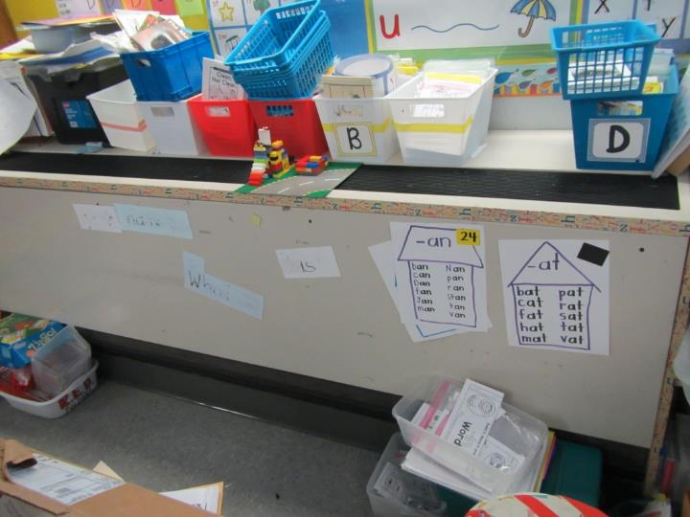
Unit ventilator (univent); note items on top and in front
Picture 2
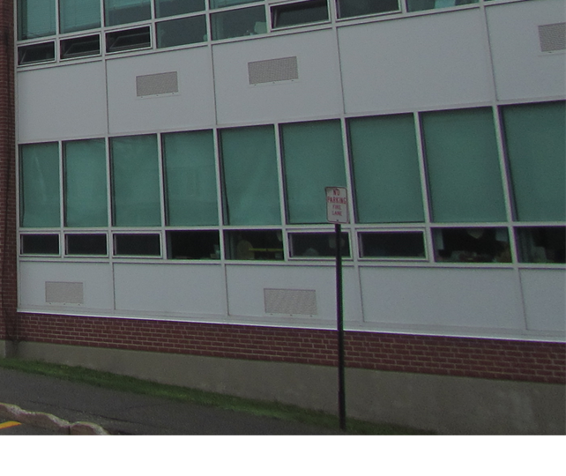
Fresh air intake grills (arrows) for univents
Picture 3
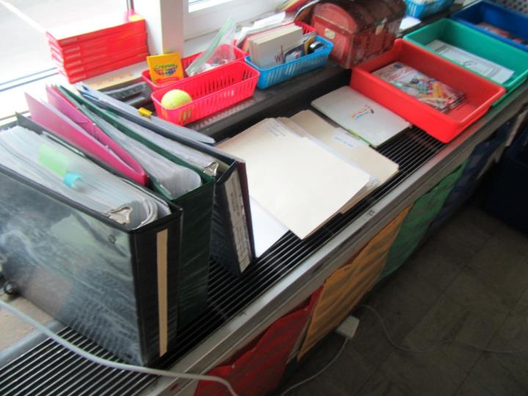
Unit ventilator blocked by items
Picture 4
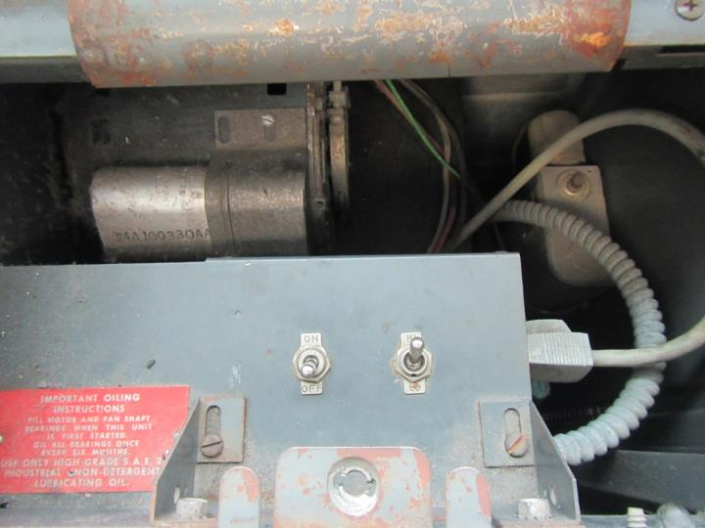
Unit ventilator with open cover, note switch in “off” position
Picture 5
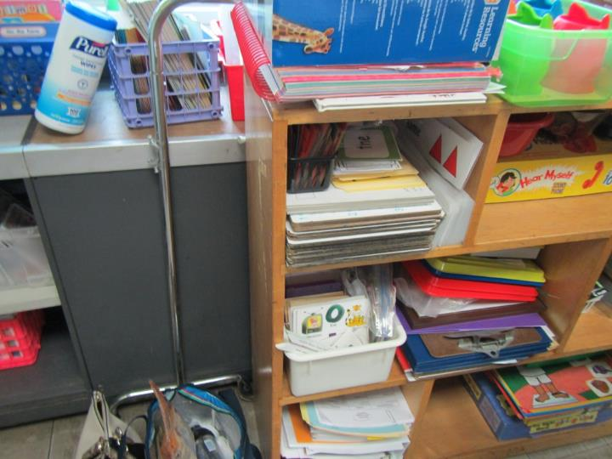
Blocked exhaust unit
Picture 6
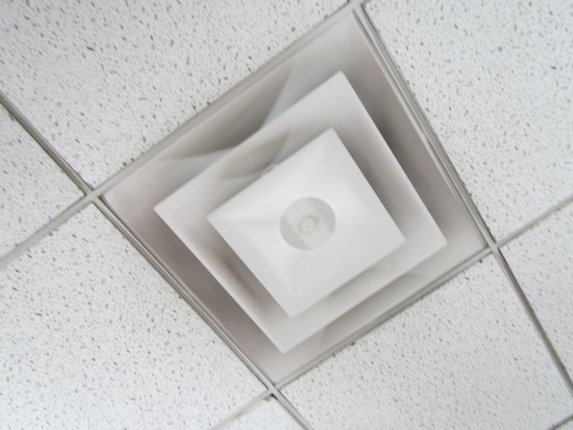
Supply vent ducted to AHU
Picture 7
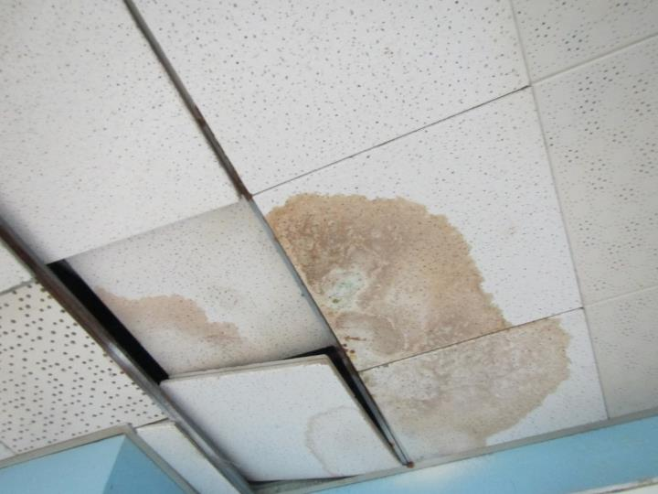
Water-damaged and ajar ceiling tiles
Picture 8
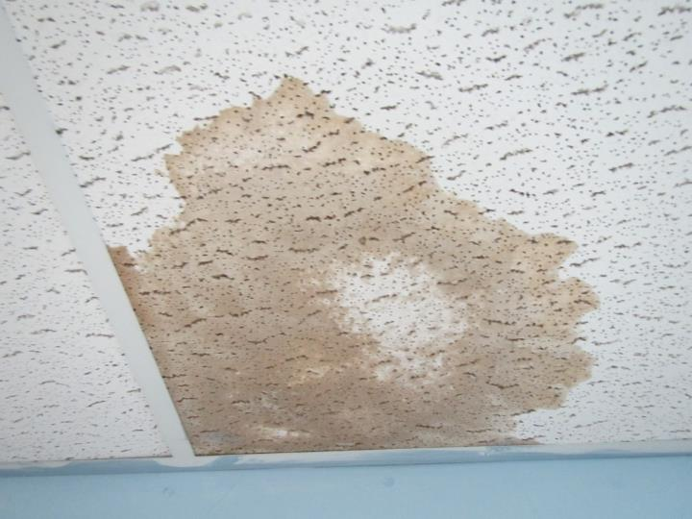
Water-damaged ceiling tile
Picture 9
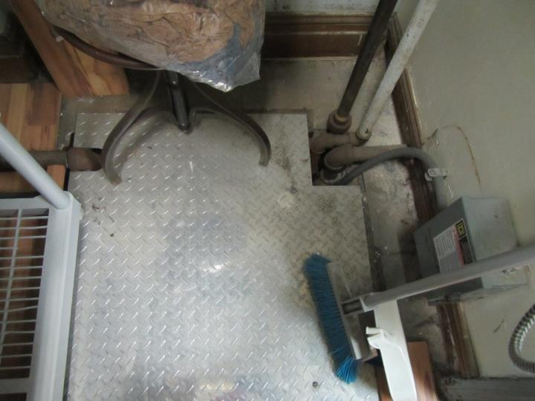
Sump/utility pit with metal cover with pathways to space below
Picture 10
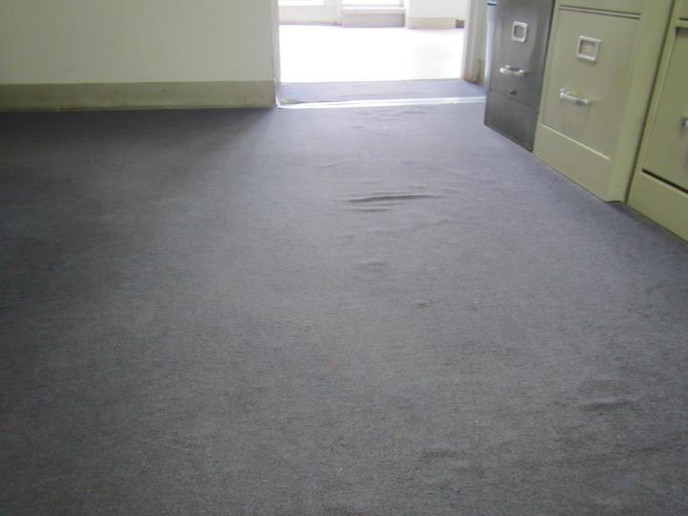
Water-damaged carpeting on concrete slab (note ripples)
Location | Carbon  Dioxide  (ppm) | Carbon Monoxide  (ppm) | Temp  (°F) | Relative  Humidity  (%) | PM2.5  (µg/m³) | Occupants  in Room | Windows  Openable | Ventilation |  | Remarks
 |  |  |  |  |  |  |  | Supply | Exhaust
Background (outside) | 403 | ND | 52 | 73 | 25 | - | - | - | - | Overcast, misty
Art | 446 | ND | 66 | 46 | 7 | 3 | Y | Y off | Y off | HS, art supplies
105 | 1049 | ND | 70 | 45 | 3 | 20 | Y | Y off | Y | AI, CPs
106 | 1059 | ND | 71 | 46 | 4 | 15 | Y | Y off | Y | AI, carpet on slab
107 | 1067 | ND | 71 | 46 | 2 | 21 | Y | Y off | Y | CPs, AI, NC
108 | 1162 | ND | 72 | 46 | 3 | 18 | Y | Y | Y | PF
255 | 1113 | ND | 75 | 42 | 7 | 17 | Y open | Y off | Y | DEM, HS, plant, blocked exhaust and supply, 9x9 tiles
256 | 709 | ND | 76 | 36 | 7 | 0 | Y open | Y off | Y off | CPs, DEM
257 | 646 | ND | 76 | 35 | 5 | 0 | Y | Y off | Y off | AI, storage, UF
258 | 655 | ND | 76 | 36 | 9 | 0 | Y | Y off | Y off | AI, UF, storage
244 | 1174 | ND | 76 | 41 | 7 | 1 | Y | Y off | Y off | Blocked exhaust
243 | 1161 | ND | 75 | 40 | 7 | 1 | Y | Y off | Y off | Plants
242 | 1535 | ND | 75 | 43 | 6 | 20 | Y | Y off | Y | UV has AI on it
215 | 984 | ND | 73 | 43 | 8 | 17 | Y | Y off | Y | UV blocked at bottom, CPs, carpet
223 | 775 | ND | 73 | 41 | 4 | 0 | N | N | N | Space heater
2-6 | 525 | ND | 73 | 39 | 4 | 0 | Y | Y off | Y off | WD CTs, Area rug on slab, plants
2-7 | 557 | ND | 74 | 39 | 5 | 3 | Y | Y on | Y | CPs, HS, DEM, MT
231 | 1309 | ND | 73 | 44 | 8 | 8 | Y | Y off | Y off | Tennis balls on chairs
Café 123 | 759 | ND | 76 | 39 | 5 | 60+ | Y | Y | Y
B-11 | 528 | ND | 76 | 43 | 4 | 2 | Y | Y off | Y | Peeling paint
B-9 | 1839 | ND | 75 | 51 | 4 | 9 | Y some | N | N | CPs, DEM, WD
124 | 1340 | ND | 76 | 44 | 10 | 25 | Y | N | N | DEM
123 | 1151 | ND | 77 | 46 | 4 | 0 | Y | Y off | N | Carpet, DEM
122 | 1153 | ND | 77 | 40 | 3 | 0 | Y | N | N | DEM, carpet
125A | 821 | ND | 78 | 41 | 3 | 2 | N | N | N
118 | 807 | ND | 77 | 41 | 2 | 0 | Y | N | N | Carpet
117 | 785 | ND | 77 | 41 | 2 | 0 | Y | N | N | Plants
115 | 976 | ND | 76 | 42 | 10 | 23 | Y | Y off | N | DEM, HS
203 | 551 | ND | 73 | 34 | 2 | 0 | Y | Y off | N | HS, carpet, mats
228 | 851 | ND | 74 | 37 | 1 | 0 | Y | Y off | N | CPs, carpet, UV, AI
225 | 1203 | ND | 75 | 44 | 4 | 17 | Y open | Y off | N | UV, WD CT
224 | 834 | ND | 77 | 42 | 5 | 9 | Y open | Y off | N | Carpet, PF
207 Nurse | 653 | ND | 76 | 41 | 3 | 5 | Y | Y off | Y off | Pathways in closet (plate around utilities), slight musty odor in closet
Library | 740 | ND | 75 | 39 | 5 | 30+ | Y | Y | Y | Water plaster damaged  Damaged carpet
115 | 907 | ND | 74 | 41 | 8 | 11 | Y | Y off | Y | Supply blocked by bean bag
114 | 425 | ND | 70 | 41 | 5 | 1 | Y | Y off | Y off
113 | 499 | ND | 70 | 43 | 5 | 8 | Y | Y off | Y off
112 | 889 | ND | 70 | 45 | 7 | 23 | Y | Y off | Y
252 | 1676 | ND | 75 | 45 | 7 | 23 | Y | Y off | Y off
253 | 1073 | ND | 75 | 39 | 5 | 1 | Y | Y off | Y
248 | 991 | ND | 75 | 39 | 6 | 0 | Y | Y off | Y off
247 | 1387 | ND | 76 | 41 | 7 | 26 | Y | Y off | Y off
246 | 814 | ND | 74 | 38 | 9 | 22 | Y | Y off | Y off | Ionizer
216 | 978 | ND | 74 | 41 | 6 | 22 | Y | Y | Y | Tennis balls
223 | 617 | ND | 74 | 36 | 7 | 0 | Y | Y | Y | Gym equipment odors
Gym | 915 | ND | 74 | 41 | 7 | 20+ | N | N | Y
236 | 1460 | ND | 75 | 40 | 7 | 23 | Y | Y | N
232 | 1446 | ND | 75 | 43 | 9 | 19 | Y | Y | Y
B-10 | 434 | ND | 73 | 45 | 8 | 4 | Y | Y | N | 4 fan coil units deactivated, 1 WD CT
B-2 | 471 | ND | 75 | 41 | 6 | 0 | Y | N | N | Peeling paint
104 | 640 | ND | 76 | 34 | 5 | 0 | Y | N | N
105 | 868 | ND | 77 | 43 | 7 | 24 | Y | Y | Y
111 | 748 | ND | 77 | 43 | 9 | 0 | Y | N | N
113 | 670 | ND | 77 | 41 | 8 | 2 | Y | N | N
114 | 770 | ND | 76 | 40 | 12 | 26 | Y | N | N
210 | 781 | ND | 76 | 38 | 8 | 0 | Y | N | N
211 | 903 | ND | 76 | 39 | 8 | 2 | Y | N | N | Peeling paint
215 | 963 | ND | 76 | 40 | 9 | 3 | Y | N | N | Fan coil unit
221 | 1107 | ND | 78 | 41 | 11 | 25 | Y | N | N | Fan coil unit

The service life is the median time during which a particular system or component of …[an HVAC]… system remains in its original service application and then is replaced. Replacement may occur for any reason, including, but not limited to, failure, general obsolescence, reduced reliability, excessive maintenance cost, and changed system requirements due to such influences as building characteristics or energy prices (ASHRAE, 1991).

