# BACKGROUND

**INDOOR AIR QUALITY**

**ASSESSMENT**

**Southampton Fire Department**

**204 College Highway**

**Southampton, MA**

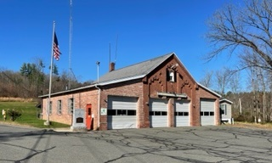

Prepared by:

Massachusetts Department of Public Health

Bureau of Climate Change and Environmental Health

Indoor Air Quality Program

February 2023

|  |  |
| --- | --- |
| Building: | Southampton Fire Department (SFD) |
| Address: | 204 College Highway, Southampton |
| Assessment Requested by: | Edward Gibson, Town Administrator, Southampton |
| Reason for Request: | Water damage and general indoor air quality (IAQ) assessment |
| Date of Assessment: | November 3, 2023 |
| Massachusetts Department of Public Health/Bureau of Climate and Environmental Health (MDPH/BCEH) Staff Conducting Assessment: | Mike Feeney, Director and Stefanie Santora, Environmental Analyst/Inspector, IAQ Program |
| Building Description: | The SFD was originally constructed as a brick schoolhouse in 1865. It became a fire department in 1949 and a concrete block addition consisting of office space was built in the 1970’s at the rear of the building. The building is one story with three engine bays to the front of the building and office space in the rear. In 2018, a stand-alone modular facility connected by a covered breezeway was placed adjacent to the SFD containing a kitchenette, bathroom, bedrooms, and storage. |
| Windows: | Openable |

# METHODS

Please refer to the IAQ Manual for methods, sampling procedures, and interpretation of results (MDPH, 2015).

**RESULTS and DISCUSSION**

The following is a summary of indoor air testing results (Table 1).

* ***Carbon dioxide*** levels were close to or above the MDPH guideline of 800 parts per million (ppm) in the office space and below the guideline in the engine bays and modular building.
* ***Temperature*** was below the MDPH recommended range of 70°F to 78°F in areas tested.
* ***Relative humidity*** was within the MDPH recommended range of 40 to 60%.
* ***Carbon monoxide*** levels were non-detectable (ND) in all areas tested.
* ***Fine particulate matter (PM2.5)*** concentrations measured were below the National Ambient Air Quality Standard (NAAQS) limit of 35 μg/m3 in all areas tested.

## Ventilation

The SFD has no mechanical ventilation system, so the building relies on openable windows for fresh air supply. Openable windows exist in Engine Bay 3. Engine Bays 1 and 2 do not have openable windows. Offices 1 and 2 have openable windows that have broken windowpanes (Pictures 1 and 2), which can present a sharps hazard if opening/closing is attempted. Carbon dioxide levels were close to or above the recommended level of 800 ppm in all office space, indicating a need for increased fresh air.

Two ceiling-mounted gas-fired Modine High Efficiency heaters were located in two of the bays (Pictures 3 and 4). All combustion equipment that uses combustible fuel indoors should be used with adequate ventilation and a carbon monoxide detector. Such equipment should be maintained in the manner recommended by the manufacturer and/or installer to ensure proper combustion and venting various pollutants, (including CO) from the building.

## Microbial/Moisture Concerns

Extensive water damage was noted in the building. Some of this is due to the configuration and location of the SFD as well as recent weather conditions in New England. It is important to note that extended periods of hot, humid weather were experienced in recent summers. July of 2021 was the wettest ever recorded in Massachusetts, and the three-month period from June through August, known as the meteorological summer, was the fourth wettest on record, according to the National Oceanic and Atmospheric Administration’s (NOAA) Centers for Environmental Information (HG, 2021, NOAA, 2021). The summer of 2023 was also hot, and wet, being measured as the second rainiest on record (WBUR, 2023). These conditions are challenging for buildings, particularly those without air conditioning.

During the summers of 2018, 2021 and 2023, extended periods of outdoor relative humidity above 70% occurred. Under these excessively moist weather periods, public buildings experienced extended periods of water vapor exposure. When exposed to these conditions, porous materials such as gypsum wallboard, cardboard, and other materials may develop mold colonization, particularly if located in areas that are prone to condensation such as floors and walls in below-grade space. According to the American Society of Heating, Refrigerating and Air-Conditioning Engineers (ASHRAE); if relative humidity exceeds 70%, mold growth may occur due to wetting of building materials (ASHRAE, 2022) even in the absence of liquid water.

If a building does not have either adequate exhaust ventilation and/or air chilling capacity to remove/reduce relative humidity from outside air, then hot, moist air can be introduced into a building and linger to increase occupant discomfort as well as moisten materials that may lead to mold growth.

The rear wall of the building is a focal point of water accumulation. Groundwater and runoff during weather events is likely to move down the slope of the hill behind the SFD and encounter the exterior wall which acts as a dam resulting in the rear wall being continuously exposed to water. Water then flows down the pavement on both sides of the SFD and pools toward the front of the building, eroding the mortar at the base of the building (Pictures 5 and 6). Such erosion can undermine the ability of these walls to support weight, which may lead to settlement of the walls and connected roof.

The SFD has an angled roof sloped toward the back of the building with no existing roof drains or gutter/downspout system beneath the roof edge. The roof is pitched, with its low edge located above the exterior wall of the rear of the building. This area of the roof was shaded with snow/ice accumulation during the assessment, indicating that there is not a sufficient amount of sunlight to adequately dry the roof (Picture 7). This can potentially cause ice dams and lead to roof leaks. Peeling paint on the entirety of the cement block exterior wall indicates frequent water runoff from the roof (Picture 8).

The ground at the rear of the building was spongy when trod upon and extensive moss buildup at the base of the structure was observed indicating substantial water exposure during rainstorms or ground water accumulation from the hill at the rear of the SFD (Picture 8).

As reported by SFD staff, the building has experienced water damage in office space that shares the rear exterior wall and roof. There is extensive water damage/mold to the interior ceilings of these rooms likely the result of water infiltration due to roof leaks. Ceiling tiles were bowed, damaged, or missing while the area behind the ceiling tiles was observed to have water damage and mold (Pictures 9 and 10). The refrigerator in the office space also had mold growth on the interior along the rubber gaskets (Picture 11).

The restroom adjacent to the office space showed signs of significant water exposure. The floor and baseboard heater had rust/corrosion most likely due to either water infiltration at the sidewall or condensation due to hot, humid weather (Pictures 12 and 13). The front engine bay also has water-damaged ceilings (Picture 14).

Of note is the extensive water damage observed in the crawlspace area accessible from the engine bays (Pictures 15 and 16). Significant water damage occurred to the fiberglass insulation shown by the amount of mold growth observed at the time of the visit. This is also likely the result of persistent water infiltration from roof leaks over extended periods of time.

## Products of combustion

Under normal conditions, a firehouse can have several sources of environmental pollutants present from the operation of fire vehicles. These sources of pollutants can include:

* Vehicle exhaust containing carbon monoxide and soot.
* Vapors from diesel fuel, motor oil and other vehicle liquids which contain volatile organic compounds.
* Water vapor from drying hose equipment.
* Rubber odors from vehicle tires; and
* Residues from fires on vehicles, hoses, and fire-turnout gear.

Of particular importance is vehicle exhaust which involves the process of combustion. The engine bays are not equipped with a tailpipe exhaust collection system to remove exhaust during idling. Pathways for vehicle exhaust and other pollutants to migrate into adjacent/occupied areas exist in the SFD. The door area separating the engine bays from occupied space is not tightly sealed. This space should have a door with attached weather-stripping to prevent the migration of products of combustion.

## Other concerns

Some office space is covered with wall-to-wall carpeting that is in poor condition (Picture 17). In general, it is not recommended for fire departments and other emergency response agencies to have carpeted floors due to the possible cross-contamination that may occur from footwear contact with automotive products, chemicals, or biological contamination. In addition, the Institute of Inspection, Cleaning and Restoration Certification (IICRC) discusses floor covering in its guideline, “Standard for Professional Cleaning of Textile Floor Coverings” (IICRC, 2015). Based on this standard, the IICRC recommends twice-daily vacuuming and/or pile-lifting cleaning for commercial carpeting in heavy traffic areas. This frequency of cleaning of the building as well as the use of vacuum cleaners equipped with high-efficiency particulate arrestance (HEPA) filters would prevent respirable dust from carpeting from impacting the indoor air.

# CONCLUSIONS AND RECOMMENDATIONS

The SFD presents a multifaceted combination of issues due to its location, lack of mechanical ventilation including vehicle exhaust control systems, and extensive chronic water and water vapor infiltration that can affect IAQ. Please note that many of these observations were made during the heating season in November. Some of these conditions related to condensation/water-damage would occur during hot, humid weather during summer months.

The following documents can provide guidance that can be used to reduce the impact of hot, humid weather in buildings.

* Mold Growth Prevention During Hot, Humid Weather <https://www.mass.gov/service-details/preventing-mold-growth-in-massachusetts-schools-during-hot-humid-weather>
* Remediation and Prevention of Mold Growth and Water Damage in Public Schools <https://www.mass.gov/service-details/remediation-and-prevention-of-mold-growth-and-water-damage-in-public-schools-and>
* Methods for Increasing Comfort in Non-air-conditioned Schools <https://www.mass.gov/doc/methods-for-increasing-comfort-in-non-air-conditioned-schools/download>

To remedy building problems, two sets of recommendations are made: short-term measures that may be implemented as soon as practicable and long-term measures that will require planning and resources to address overall IAQ concerns if the building is to continue to be used:

## Short-term recommendations

### **Ventilation recommendations**

1. Install carbon monoxide detectors in appropriate locations (e.g., Engine Bays) if not already done.
2. Repair broken windowpanes and use openable windows for fresh air during temperate weather. Tightly close windows at the end of the day and avoid opening windows during freezing temperatures or high humidity.

### **Water damage recommendations**

1. Repair building envelope leaks including roof leaks.
2. Remove all water-damaged materials. Remove materials in accordance with the EPA Guidance “Mold Remediation in Schools and Commercial Buildings” (US EPA, 2008).
3. Repair water-damaged structural ceiling and replace all water-damaged ceiling tiles.
4. It is recommended that porous material be dried with fans and heating within 24 to 48 hours of becoming wet (US EPA, 2008, ACGIH, 1989). If porous materials are not dried within this time frame, mold growth may occur. Water-damaged porous materials cannot be adequately cleaned to remove mold growth. If porous materials are not dried within this time frame, they should be removed and discarded.

### **Other recommendations**

1. Seal all pathways between the crawlspace and occupied areas (holes, breaches, conduits, etc.)
2. Install door between engine bays and office space to properly seal off pollutants from the engine bays.
3. Pathways (gaps around utilities, holes, crevices, etc.) in occupied areas which lead to engine bays or unconditioned areas should be sealed completely to prevent moisture, particulate matter, and odors from entering occupied areas. Tight-fitting door sweeps or weather stripping should be installed on doors which communicate with engine bays, the attic, or outdoors.
4. Replace carpeting with a different type of floor covering that can be readily cleaned. Until that time, clean high traffic areas frequently in accordance with IICRC recommendations,
5. If current office space cannot be adequately repaired, use modular facility for office space.
6. Refer to resource manual and other related IAQ documents located on the MDPH’s website for further building-wide evaluations and advice on maintaining public buildings. These documents are available at: <http://mass.gov/dph/iaq>.

## Long Term Recommendations

1. Consult with a professional regarding the installation of an HVAC system into the building.
2. Install a mechanical exhaust ventilation system to remove vehicle exhaust, such as one that has flexible hoses that attach to fire equipment exhaust pipes (Plymovent™).
3. Install gutters and downspouts.
4. Have mason examine the base of walls with eroded brick and mortar for the best method to repoint or replace water-eroded materials.

**REFERENCES**

ASHRAE. 1991. ASHRAE Applications Handbook, Chapter 33 “Owning and Operating Costs”. American Society of Heating, Refrigeration and Air Conditioning Engineers, Atlanta, GA.

ASHRAE, 2022. American Society of Heating, Refrigeration and Air Conditioning Engineers (ASHRAE) Ventilation for Acceptable Indoor Air Quality. ANSI/ASHRAE Standard 62.1-2022. Atlanta, GA.

IICRC. 2012. Institute of Inspection, Cleaning and Restoration Certification. Carpet Cleaning: FAQ.

IICRC. 2015. Institute of Inspection, Cleaning and Restoration Certification. Commercial Carpet Cleaning: FAQ.

MDPH. 2015. Massachusetts Department of Public Health. “Indoor Air Quality Manual: Chapters I-III”. Available at: [Indoor air quality - manual and appendices | Mass.gov](https://www.mass.gov/lists/indoor-air-quality-manual-and-appendices)

NOAA. 2021. Summer 2021 neck and neck with Dust Bowl summer for hottest on record. National Oceanic and Atmospheric Administration, 1401 Constitution Avenue NW, Room 5128, Washington, DC 20230 <https://www.noaa.gov/news/summer-2021-neck-and-neck-with-dust-bowl-summer-for-hottest-on-record>

US EPA. 2008. “Mold Remediation in Schools and Commercial Buildings”. Office of Air and Radiation, Indoor Environments Division, Washington, DC. EPA 402-K-01-001. September 2008. Available at: <http://www.epa.gov/mold/mold-remediation-schools-and-commercial-buildings-guide>.

WBUR. 2023. “It's been a summer of rain and flooding misery in Mass.” WBUR local news. September 12, 2023. <https://www.wbur.org/news/2023/09/12/summer-flooding-rain-massachusetts>.

**Picture 1**

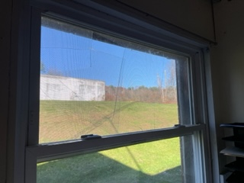

**Broken windowpane in Office 1**

**Picture 2**

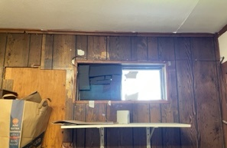

**Broken windowpane in Office 3**

**Picture 3**

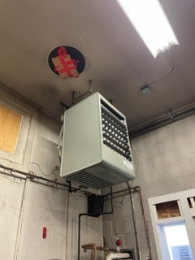

**Gas-fired heater in engine bay**

**Picture 4**

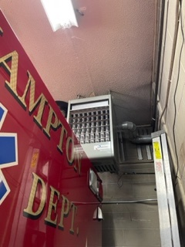

**Gas-fired heater in engine bay**

**Picture 5**

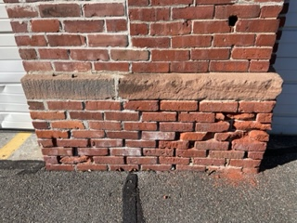

**Eroded mortar at front right of SFD from water pooling**

**Picture 6**

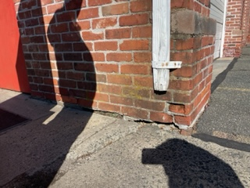

**Eroded mortar at front left of SFD from water pooling**

**Picture 7**

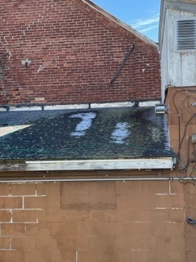

**Rear angled roof showing shade and snow/ice accumulation**

**Picture 8**

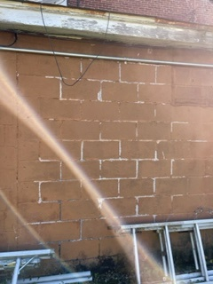

**Rear exterior wall with peeling paint**

**Picture 9**

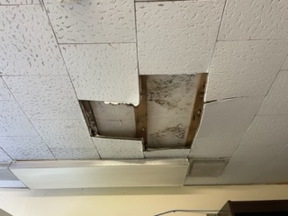

**Water-damaged ceiling tiles in office space; note mold growth under tiles**

**Picture 10**

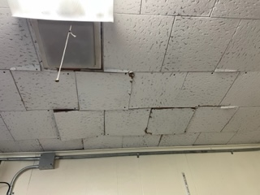

**Water-damaged ceiling tiles in office space**

**Picture 11**

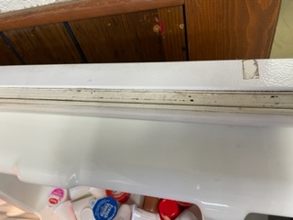

**Mold growth on refrigerator gasket**

**Picture 12**

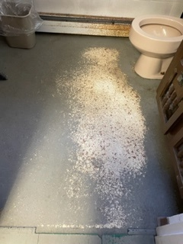

**Rust on bathroom cement floor**

**Picture 13**

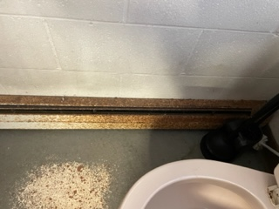

**Rust on bathroom baseboard heater**

**Picture 14**

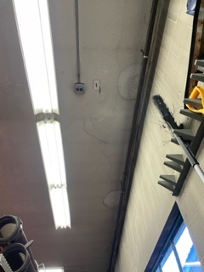

**Water-stained ceiling tiles in engine bay**

**Picture 15**

Extensive water damage and mold in crawlspace



**Extensive water damage and mold in crawlspace**

**Picture 16**

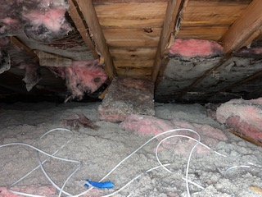

**Extensive water damage and mold in crawlspace**

**Picture 17**

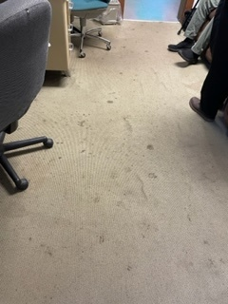

**Stained wall-to-wall carpet in office area**

| Location | **Carbon**  **Dioxide**  **(ppm)** | **Carbon Monoxide**  **(ppm)** | **Temp**  **(°F)** | **Relative**  **Humidity**  **(%)** | **PM2.5**  **(µg/m3)** | **Occupants**  **in Room** | **Windows**  **Openable** | **Ventilation** | | **Remarks** |
| --- | --- | --- | --- | --- | --- | --- | --- | --- | --- | --- |
| **Supply** | **Exhaust** |
| Background | 425 | ND | 63 | 35 | 5 |  |  |  |  |  |
| **Main Building** | | | | | | | | | | |
| Office #1 | 890 | ND | 64 | 48 | <1 | 0 | Y broken pane | N | N | Wall-to-wall carpet, water-damaged ceiling tiles, visible mold growth |
| Office #2 | 766 | ND | 66 | 46 | 2 | 2 | N/A | N | N | Wall-to-wall carpet, air purifier, space heater |
| Office #3 | 803 | ND | 64 | 47 | 1 | 0 | Y broken pane | N | N | Tile |
| Engine Bay 1 | 679 | ND | 62 | 49 | 1 | 3 | Y | N | N |  |
| Engine Bay 2 | 552 | ND | 60 | 49 | 2 | 0 | N/A | N | N | Lockers |
| Engine Bay 3 | 527 | ND | 60 | 49 | 2 | 0 | Y | N | N |  |
| **Modular Facility** | | | | | | | | | | |
| Kitchen/common area | 500 | ND | 66 | 47 | 1 | 1 | Y | N | N | Propane heat, vinyl flooring |
| Bedroom | 503 | ND | 68 | 45 | 1 | 0 | Y | N | N |  |