# BACKGROUND

**INDOOR AIR QUALITY**

**ASSESSMENT**

**Southbridge Police Department**

**1 Mechanic Street**

**Southbridge, MA**

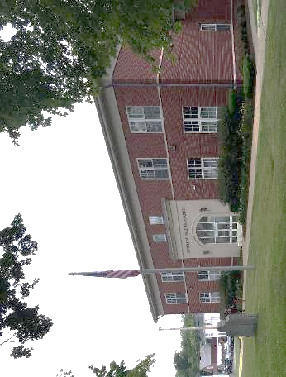

Prepared by:

Massachusetts Department of Public Health

Bureau of Climate Change and Environmental Health

Indoor Air Quality Program

September 2023

|  |  |
| --- | --- |
| Building: | Southbridge Police Department (SPD) |
| Address: | 1 Mechanic Street, Southbridge, MA |
| Assessment Requested by: | Shane Woodson, Chief of Police, Southbridge |
| Reason for Request: | Symptoms of headache reported by SPD staff |
| Date of Assessment: | June 30, 2023 |
| Massachusetts Department of Public Health/Bureau of Climate and Environmental Health (MDPH/BCEH) Staff Conducting Assessment: | Michael Feeney, Director, IAQ Program and  Stefanie Santora, Environmental Analyst, IAQ Program |
| Building Description: | The SPD is a two-story, brick-faced building with basement constructed in 1997. |
| Windows: | Not openable |

# METHODS

Please refer to the IAQ Manual for methods, sampling procedures, and interpretation of results (MDPH, 2015). Light intensity was measured with an Extech Instruments Foot Candle/Lux Meter. Light measurements were taken approximately 3 feet above floor or at the desk level.

# RESULTS AND DISCUSSION

The following is a summary of indoor air testing results (Table 1).

* ***Carbon dioxide*** levels were below the MDPH guideline of 800 parts per million (ppm), in all areas tested at the time of assessment.
* ***Temperature*** was within the MDPH recommended range of 70°F to 78°F in areas tested.
* ***Relative humidity*** was slightly above the MDPH recommended range of 40 to 60% in some areas indicating the HVAC units may not be operating at proper capacity to reduce moisture in indoor air. This is discussed further in both the *Ventilation* and *Moisture Concerns* section of this report.
* ***Carbon monoxide*** levels were non-detectable (ND) in all areas tested.
* ***Fine particulate matter (PM2.5)*** concentrations measured indoors were below the National Ambient Air Quality Standard (NAAQS) limit of 35 μg/m3 in all but one area tested (the Garage) and all were less than the PM2.5 measured outside. Please note, air quality in the Northeast United States was greatly affected by Canadian wildfires over the summer of 2023 (NY Times, 2023).

## Ventilation

A heating, ventilating, and air conditioning (HVAC) system has several functions. First it provides heating and, if equipped, cooling. Second, it is a source of fresh air. Finally, an HVAC system will dilute and remove normally occurring indoor environmental pollutants by not only introducing fresh air, but by filtering the airstream and ejecting stale air to the outdoors via exhaust ventilation. Even if an HVAC system is operating as designed, point sources of respiratory irritation may exist and cause symptoms in sensitive individuals.

The heating, ventilation, and air conditioning (HVAC) system consists of rooftop air-handling units (AHUs) ducted to ceiling-mounted diffusers. Air from the space is ducted back to the AHUs via ceiling-mounted return vents.

Components of the ventilation system are around 26 years old. According to the American Society of Heating, Refrigeration, and Air-Conditioning Engineers (ASHRAE), the service life[1] of this type of unit is 15-20 years, assuming routine maintenance of the equipment (ASHRAE, 1991).

IAQ staff noted a mechanical room with a non-functioning exhaust vent. In this condition, waste heat from mechanical equipment can build up.

AHUs have filters, which should be changed 2-4 times a year or per the manufacturer’s recommendations. Filters should be at least a Minimum Efficiency Rating Value (MERV) of 8 *or higher*, if they fit and the equipment can handle the pressure reductions caused by more restrictive filters.

In order to have proper ventilation with a mechanical ventilation system, the systems must be balanced after installation to provide an adequate amount of fresh air to the interior of a room while removing stale air from the room. It is recommended that HVAC systems be re-balanced every five years to ensure adequate air systems function (SMACNA, 2013).

## Moisture Concerns

Based on the relative humidity measurements indoors (above or near the upper range of the MDPH comfort guideline of 40-60%) the HVAC system does not appear to be able to sufficiently remove excess moisture. Please note, that even in the absence of liquid water, humidity above 70% for an extended period of time can lead to water damage and mold growth in susceptible materials (ASHRAE, 2019).

Relative humidity was measured indoors in a range of 53% to 68% with a temperature range of 70°F to 78°F when the outdoor measurement was 48% at a temperature of 86°F (Table 1). This would represent air with about the same dew point temperature (the temperature at which water would condense from the air, calculated at about 63°F), indicating that while air conditioning is reducing the temperature of the air, it is not removing any moisture. These relative humidity measurements may also indicate that water vapor sources exist inside the building.

The HVAC system shows signs of water stains on its exterior (Picture 1), which may indicate that insulation is not adequate to prevent condensation. Insulation inside AHU appears to be water-damaged (Picture 2). The ability of insulation to prevent temperature transfer is expressed with an R-value rating. The material of the insulation as well as the thickness determine the R-value. Water exposure/moistening will also reduce the ability of insulation to prevent temperature transfer. Insufficient R rating, or damaged/wet insulation may cause the outer surface of insulation on chilled fluid pipes to have a temperature at or below the dew point, which would allow for condensation on this material.

Increased indoor relative humidity may occur for some or all of the following reasons:

* Dedicated exhaust ventilation for restrooms, showers or lockup is not functioning to remove water vapor from toilets, sinks, or showers from the building.
* The general ventilation system has insufficient exhaust ventilation to eject water vapor from the building.
* Fresh air intakes of the general ventilation system are excessively open to draw a volume of hot, moist air that exceeds the chilling capacity of the AHUs to remove water vapor.
* A water vapor source exists inside the building that is drawn into the general HVAC system.
* Windows are opened while the HVAC system is in chilling mode allowing hot, humid outdoor air into the building.

IAQ staff noted the presence of a number of return vents located in the locker room that are connected to the man HVAC system. Of note is that the locker room shower area does not have a dedicated exhaust system. Water vapor from showering appears to be drawn to a vent over the toilet stalls. In addition, the locker room has return vents connected to the general ventilation system including one return vent located over the shower entrance (Picture 2). This configuration may result in water vapor from showers and other locker room facilities being drawn into the general ventilation system. This will increase indoor relative humidity indoors when showers are in use whenever either the locker room exhaust vent is deactivated or the draw of air HVAC return system is greater than the exhaust system.

In order to vent water vapor and odors from locker rooms, dedicated exhaust vents should be installed to vent these pollutants directly outdoors therefore preventing capture and distribution to occupied areas on the building.

## Lighting

IAQ staff noted during an initial visit to this building that the dispatch areas appeared to be significantly darker than other work areas in the building. Several overhead ceiling lights were deactivated in the dispatch area (Picture 3). To assess this, IAQ staff conducted light measurements at various workstations in the operations centers and at a variety of other areas within the building at tabletop level (approximately 3 feet above the floor). Work areas in interior rooms with no windows had light measurements ranging from 25-98 lux compared to other work areas, which had measurements of 590 to 1960 lux (Table 2). Of areas measured, 4 of 13 work areas had light measurements below 300 lux.

The American National Standard Institute (ANSI) recommends 300-1,000 lux for general work areas. Increasing lighting may reduce the reported symptoms in these work areas. Low light conditions are associated with headaches, tired eyes, and/or irritation (NIOSH, 1998).

## Other Concerns

A number of areas are covered with carpeting, including the locker room, where carpeting was water-damaged (Picture 4). In general, it is not recommended for public safety/emergency response agencies to have carpeted floors due to the possible cross-contamination that may occur from footwear contact with automotive products, chemicals, or biological contamination. In addition, the Institute of Inspection, Cleaning and Restoration Certification (IICRC) discusses floor covering in its guideline, “Standard for Professional Cleaning of Textile Floor Coverings” (IICRC, 2015). Based on this standard, the IICRC recommends twice-daily vacuuming and/or pile-lifting cleaning for commercial carpeting in heavy traffic areas. This frequency of cleaning of the building as well as the use of vacuum cleaners equipped with high-efficiency particulate arrestance (HEPA) filters would remove respirable dust from the indoor air.

Office areas were also mostly carpeted. Carpets in these areas should be cleaned annually (or semi-annually in soiled/high traffic areas) in accordance with Institute of Inspection, Cleaning and Restoration Certification (IICRC) recommendations, (IICRC, 2012).

# CONCLUSIONS AND RECOMMENDATIONS

In view of the findings at the time of assessment, the following recommendations are made:

## Lighting

1. Provide an adequate amount of light at workstations. In order to soften fluorescent lights, consider installing glare shields on all computer screens in this area as well as additional lamps.

## Ventilation recommendations

1. A preventative maintenance plan should be developed for general HVAC systems where one does not already exist.
2. Operate all supply and exhaust ventilation equipment continuously during occupied hours if not already done.
3. Make necessary adjustments to HVAC controls/air intakes to reduce relative humidity, particularly when weather condition has extended periods of high (>70%) relative humidity.
4. Consider removing general return vent(s) near shower/toilet area of the locker room to prevent capture of water vapor and odor by the general HVAC system.
5. Have the electrical room exhaust vent repaired. Operate to remove waste heat.
6. Periodically check other exhaust vents in restrooms for draw and make adjustments/repairs as needed.
7. Clean the interior of AHUs during regular filter changes using a HEPA-filtered vacuum cleaner with brush attachment or compressed air.
8. Have the HVAC system balanced every 5 years in accordance with SMACNA recommendations (SMACNA, 2013).
9. Due to water damage to AHU interior insulation and the age/lack of efficiency, consult with an HVAC engineering firm to conduct a full evaluation of HVAC components, for developing a plan for replacement or overhaul of systems and controls. Consultation should include repair/replacement of interior AHU insulation.

## Water damage recommendations

1. Do not open windows during hot, humid weather when the HVAC system is in chilling mode.
2. Work with HVAC vendor/engineer to monitor and adjust temperature set points to better manage/reduce indoor relative humidity and improve comfort.

## Other recommendations

1. Consideration should be given to replacing carpeting with a different type of floor covering that can be readily cleaned. Until that time, clean carpeting in accordance with IICRC recommendations (IICRC, 2012); annually (or semi-annually in soiled/high traffic areas). Worn carpeting past its lifespan (>11 years) should be replaced.
2. For buildings in New England, periods of low relative humidity during the winter are often unavoidable. Therefore, scrupulous cleaning practices should be adopted to minimize common indoor air contaminants whose irritant effects can be enhanced when the relative humidity is low. To control for dusts, a high efficiency particulate arrestance (HEPA) filter equipped vacuum cleaner in conjunction with wet wiping of all surfaces is recommended. Avoid the use of feather dusters. Drinking water during the day can help ease some symptoms associated with a dry environment (throat and sinus irritations).
3. Refer to resource manual and other related IAQ documents located on the MDPH’s website for further building-wide evaluations and advice on maintaining public buildings. These documents are available at: <http://mass.gov/dph/iaq>.

# REFERENCES

ASHRAE. 1991. ASHRAE Applications Handbook, Chapter 33 “Owning and Operating Costs”. American Society of Heating, Refrigeration and Air Conditioning Engineers, Atlanta, GA.

ASHRAE. 2019. American Society of Heating, Refrigeration and Air Conditioning Engineers (ASHRAE) Ventilation for Acceptable Indoor Air Quality. ANSI/ASHRAE Standard 62.1-2019. Atlanta, GA.

IICRC. 2012. Institute of Inspection, Cleaning and Restoration Certification. Carpet Cleaning: FAQ.

IICRC. 2015. Institute of Inspection, Cleaning and Restoration Certification. Commercial Carpet Cleaning: FAQ.

MDPH. 2015. Massachusetts Department of Public Health. “Indoor Air Quality Manual: Chapters I-III”. Available at: [Indoor air quality - manual and appendices | Mass.gov](https://www.mass.gov/lists/indoor-air-quality-manual-and-appendices)

NIOSH. 2013. Health hazard evaluation report: lighting, indoor environmental quality concerns, and job stress at a call center – California. By Wiegand D, Ramsey J, Burr G, Choi J. Cincinnati, OH: U.S. Department of Health and Human Services, Centers for Disease Control and Prevention, National Institute for Occupational Safety and Health, NIOSH HETA No. 2012-0081-3169. <https://www.cdc.gov/niosh/hhe/reports/pdfs/2012-0081-3169.pdf>

NY Times. 2023. Maps: Tracking Air Quality and Smoke from Wildfires. <https://www.nytimes.com/interactive/2023/us/smoke-maps-canada-fires.html>

SMACNA. 2013. HVAC Systems Commissioning Manual. 2nd ed. Sheet Metal and Air Conditioning Contractors’ National Association, Inc., Chantilly, VA

**Picture 1**

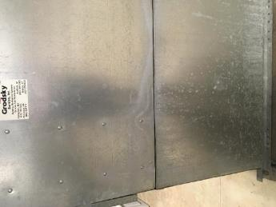

**Water staining on outside of AHU cabinet, possibly from condensation**

**Picture 2**

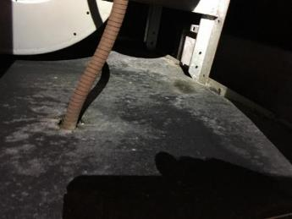

**Example of water-damaged insulation inside AHU; note corrosion on cable**

**Picture 3**

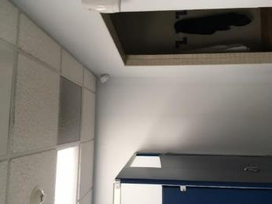

**General HVAC system return vent located near shower entrance**

**Picture 4**

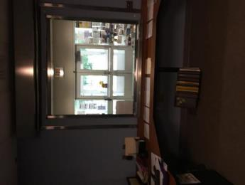

**Lighting in dispatch area**

**Picture 5**

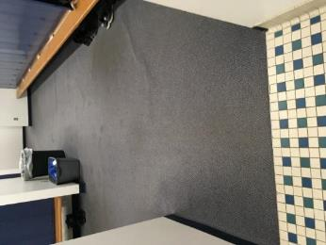

**Water-damaged carpet in locker room**

| Location | **Carbon**  **Dioxide**  **(ppm)** | **Carbon Monoxide**  **(ppm)** | **Air Temp**  **(°F)** | **Relative**  **Humidity**  **(%)** | **PM2.5**  **(µg/m3)** | **Water-Damaged Ceiling Tiles-stained** | **Water-Damaged Bowed Ceiling Tiles** | **Windows**  **Openable** | **Ventilation** | | **Remarks** |
| --- | --- | --- | --- | --- | --- | --- | --- | --- | --- | --- | --- |
| **Supply** | **Exhaust** |
| Background | 398 | ND | 86 | 48 | 62 |  |  |  |  |  |  |
| 2nd floor |  |  |  |  |  |  |  |  |  |  |  |
| Common Area | 495 | ND | 73 | 61 | 16 | 0 | 0 | N/A | Y | Y | Carpet, copier |
| Deputy Chief Office | 529 | ND | 74 | 68 | 15 | 1 | 1 | N | Y | Y | Carpet |
| Chief’s Office | 544 | ND | 76 | 57 | 15 | 0 | 0 | Y | Y | Y | Carpet, floor plant |
| Cube 1-2 | 484 | ND | 72 | 62 | 19 | 2 | 0 | N | Y | Y | Carpet |
| Interview Room 2 | 511 | ND | 72 | 62 | 14 | 0 | 2 | N/A | Y | Y | 1 CT missing |
| Cube 3-4 | 466 | ND | 72 | 62 | 18 | 0 | 0 | Y | Y | Y | Carpet |
| Lieutenant’s Office | 549 | ND | 78 | 53 | 16 | 0 | 0 | N | Y | Y | Carpet |
| Executive Asst. | 488 | ND | 72 | 63 | 13 | 0 | 0 | 0 | Y | Y | Carpet |
| Sergeant’s Office | 470 | ND | 73 | 60 | 15 | 0 | 0 | Y | Y | Y | 2 missing CT’s |
| Room Adjacent to Sergeant’s Office | 498 | ND | 74 | 59 | 18 | 0 | 0 | Y | Y | Y | Carpet |
| Common Room 2 | 544 | ND | 77 | 56 | 18 | 1 | 0 | N/A | Y | Y | Carpet |
| First Floor |  |  |  |  |  |  |  |  |  |  |  |
| Dispatch | 652 | ND | 74 | 61 | 21 | 0 | 0 | N/A | Y | Y | Carpet, copier |
| Dispatch Bathroom |  |  |  |  |  |  |  | N/A | N | Y |  |
| Breathalyzer Room | 486 | ND | 73 | 62 | 17 | 0 | 0 | N/A | Y | Y |  |
| Booking | 528 | ND | 74 | 60 | 17 | 0 | 0 | N/A | Y | Y |  |
| Room Adjacent to Sallyport | 491 | ND | 74 | 58 | 20 | N/A | N/A | N/A | Y | Y |  |
| Garage | 419 | ND | 75 | 58 | 53 | 1 | 1 | N/A | Y | Y |  |
| Animal Control | 538 | ND | 74 | 59 | 17 | 0 | 0 | N/A | Y | Y | Carpet |
| Court Officer | 503 | ND | 76 | 57 | 17 | 0 | 0 | Y | Y | Y | Carpet |
| Room Adjacent to Court Officer | 497 | ND | 77 | 56 | 18 | 2 | 0 | Y | Y | Y | Carpet |
| New Hope | 490 | ND | 74 | 58 | 17 | 0 | 0 | Y | Y | Y | Carpet |
| Community Room | 457 | ND | 73 | 61 | 17 | 1 | 0 | Y | Y | Y |  |
| Server | 419 | ND | 71 | 56 | 15 |  |  | Y | Y | Y | Minisplit, carpet |
| Detective’s Office | 390 | ND | 71 | 57 | 18 |  |  | Y | Y | Y |  |
| Reading | 393 | ND | 71 | 57 | 16 |  |  | Y | Y | N |  |
| Men’s Locker | 396 | ND | 71 | 60 | 15 |  |  | N | Y | Y | Carpet water damage |
| Electrical Room |  | ND | 77 | 53 |  |  |  | N | N | Y off |  |
| Report | 407 | ND | 73 | 58 | 14 |  |  | N | Y | N |  |
| Juvenile Interview | 420 | ND | 71 | 61 | 16 |  |  | N | Y |  |  |
| Interview Room | 766 | ND | 75 | 56 | 14 | 0 | 0 | N/A | N | Y | CT attached, carpet |
| Fitness Room | 510 | ND | 76 | 57 | 13 | 0 | 0 | N/A | Y | Y | Carpet |
| Kitchen | 515 | ND | 76 | 56 | 17 | 0 | 0 | N/A | Y | Y |  |
| Women’s Locker | 532 | ND | 77 | 56 | 16 | 0 | 0 | N/A | Y | Y |  |

| Location | **Light (Lux)** | **Ceiling Lights on?** | **Window?** |
| --- | --- | --- | --- |
| 2nd fl Common Area | 835 | Yes | No |
| Deputy Chief’s Office | 1004 | Yes | Yes |
| Chief’s Office | 1080 | Yes | Yes |
| Cubes 1-2 | 867 | Yes | Yes |
| Lieutenant’s Office | 1960 | Yes | Yes |
| Executive Assistant | 1064 | Yes | Yes |
| Server | 590 | Yes | Yes |
| Reading | 884 | Yes | Yes |
| Dispatch: front | 25 | No | No |
| Dispatch: workstation 1 | 72 | No | No |
| Dispatch: workstation 2 | 98 | No | No |
| Breathalyzer Room | 42 | No | No |
| Animal Control | 957 | Yes | No |

1. The service life is the median time during which a particular system or component of … [an HVAC]… system remains in its original service application and then is replaced. Replacement may occur for any reason, including, but not limited to, failure, general obsolescence, reduced reliability, excessive maintenance cost, and changed system requirements due to such influences as building characteristics or energy prices (ASHRAE, 1991).