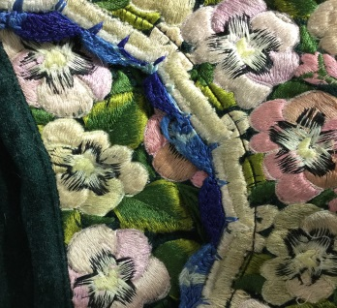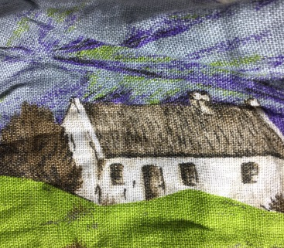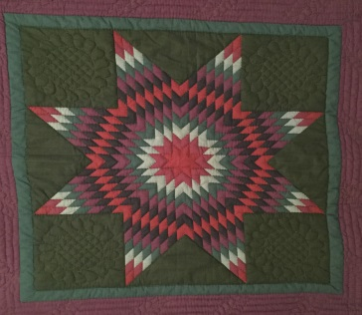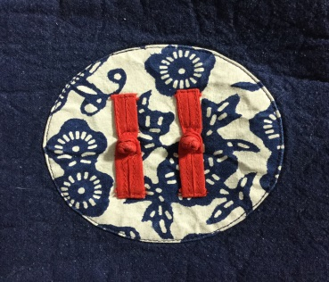

**2018 Multicultural Mental Health**

**Resource Directory**

MA Department of Mental Health

**Southeast Massachusetts Area**

|  |  |  |  |  |
| --- | --- | --- | --- | --- |
| Abington | Dennis | Holbrook | Orleans | Taunton |
| Acushnet | Dighton | Hull | Osterville | Tisbury |
| Aquinnah | Duxbury | Hyannis | Pembroke | Truro |
| Attleboro | East Bridgewater | Lakeville | Plymouth | Vineyard Haven |
| Avon | Eastham | Mansfield | Plympton | Wareham |
| Barnstable | Easton | Marion | Pocasset | Wellfleet |
| Berkley | Edgartown | Marshfield | Provincetown | West Bridgewater |
| Bourne | Fairhaven | Mashpee | Quincy | West Tisbury |
| Braintree | Fall River | Mattapoisett | Randolph | Weymouth |
| Brewster | Falmouth | Middleborough | Rehoboth | Whitman |
| Bridgewater | Freetown | Milton | Rochester | Woods Hole |
| Brockton | Gay Head | Nantucket | Rockland | Yarmouth |
| Carver | Gosnold | New Bedford | Sandwich |  |
| Chatham | Halifax | North Attleboro | Scituate |  |
| Chilmark | Hanover | Norton | Seekonk |  |
| Cohasset | Hanson | Norwell | Somerset |  |
| Cotuit | Harwich | Oak Bluffs | Stoughton |  |
| Dartmouth | Hingham | Onset | Swansea |  |

|  |  |  |
| --- | --- | --- |
|  | | |
| **Organization** | Services Offered | **Languages****Other Than English** |
| Abelard Psychotherapy, LLC  450 Pearl Street, Suite 3  Stoughton, MA 02072  781-344-0057  [abelardpsychotherapy.com](http://www.abelardpsychotherapy.com) | * Individual therapy * Medication management * In-home therapy * Therapeutic mentoring services | * Haitian Creole * Portuguese * Spanish |
| Arbour Counseling Center  134 Ansel Hallet Road  West Yarmouth, MA 02673  774-470-2294  1082 Davol Street  Fall River, MA 02720  508-678-2833  [arbourhealth.com](http://www.arbourhealth.com) | * Substance abuse counseling services * Community support programs * In-home therapy * Therapeutic mentoring * Home-bound outpatient therapy * Partial hospitalization and intensive outpatient programs * School based services * Structured outpatient addiction program | * Portuguese * Spanish * Haitian Creole |
| BAMSI (Brockton Area Multi-Services, Inc.)  24 Mercedes Road  Brockton, MA 02301  508-580-8700  [bamsi.org](https://www.bamsi.org/) | * Peer recovery support * Individual and family counseling * Adult day treatment center * Employment services * Parent information network * Services for Parents of transitional aged youth | * Cape Verdean Creole * Haitian Creole |
| **Organization** | Services Offered | **Languages** **Other Than English** |
| Boston Chinatown Neighborhood Center  38 Ash Street  Boston, MA 02111  617-635-5129  275 Hancock Street, Suite 200  Quincy, MA 02171  617-770-0091  [bcnc.net](http://www.bcnc.net/) | * Adult education * After school and summer programs * Early education and care * Childcare services * Family services * Recreation and fitness * Youth center | * Cantonese Chinese * Mandarin Chinese * Vietnamese |
| Bristol Elder Services  1 Father Devalles Blvd, #8  Fall River, MA 02723  508-675-2101  [bristolelder.org](http://bristolelder.org/) | * Information and referrals * Crisis intervention * Outreach and education * Intake, assessment, and service planning * Advocacy * Caregiver support * Legal services | * Portuguese * Spanish * Khmer (Cambodian) |
| Cape Cod Behavioral Health Services Psychiatric Center  27 Park Street  Hyannis, MA 02601  508-862-5566  [capecodhealth.org](http://www.capecodhealth.org/care-treatment/behavioral-health/) | * 24 hour mental health assessments and referrals * Psychiatric assessment * Adult inpatient psychiatric care * Geriatric outpatient psychiatry * Child, adolescent, and adult outpatient psychiatric services | * Interpreter services available including American Sign Language (ASL) |
| **Organization** | Services Offered | **Languages** **Other Than English** |
| Catholic Charities  169 Court Street  Brockton, MA 02302  508-587-0815  [ccab.org](https://www.ccab.org/) | * Family counseling and guidance center * Family intervention program * Case management * Support groups * English for Speakers of Other Languages (ESOL) * Refugee resettlement * Immigration legal services * Employment services * Shelter services * Community interpreter services | * Haitian Creole * French * Spanish * Cape Verdean Creole |
| Child & Family Services  3057 Acushnet Avenue  New Bedford, MA 02740  508-990-0894  1061 Pleasant Street  New Bedford, MA 02740  508-996-8572  543 North Street  New Bedford, MA 02740  508-996-3154  [child-familyservices.org](http://www.child-familyservices.org) | * Specialized mental health services * Emergency mental health services * Adoption services * Outreach and counseling for youth and families * Psychiatric services * Open support groups for the public * Closed support groups available only to clients after referral by a psychiatrist or therapist | * Spanish * Portuguese * Cape Verdean Creole |
| **Organization** | Services Offered | **Languages** **Other Than English** |
| Community Counseling of Bristol County  1 Washington Street  Taunton, MA 02780  508-828-9116  19 Cedar Street  Taunton, MA 02780  508-823-6124  5 Bank Street  Attleboro, MA 02703  508-222-8812  [comcounseling.org](http://www.comcounseling.org) | * Mental health and substance abuse treatment * Community support services * Acute care services (adult partial hospitalization) * Rehabilitation and recovery * Adult behavioral health services * Child and family treatment services * Adult/child case management | * Spanish * Portuguese * American Sign Language (ASL) |
| Fairwinds-Nantucket’s Counseling Center  20 Vesper Lane, #L1  Nantucket, MA 02554  508-228-2689  [fairwindscenter.org](http://fairwindscenter.org) | * Addiction and substance abuse rehabilitation program * Couples therapy sessions * Emergency services * In-home family services * Medication management * Mentoring Youth Nantucket Programs * Outpatient counseling * Urgent behavioral healthcare clinic | * Korean * Spanish |
| **Organization** | Services Offered | **Languages** **Other Than English** |
| Family Continuity Program (FCP)  118 Long Pond Road, Suite 106  Plymouth, MA 02360  508-747-6762  29 Bassett lane  Hyannis, MA 02601  508-862-0273  [familycontinuity.org](http://familycontinuity.org/) | * Children’s Behavioral Health Initiative (CBHI) * Family/community based services * Outpatient mental health clinics * Integrated care services * Workplace safety training * Specialized community programs | * Spanish * Interpreter services available |
| **Family Service Association**  101 Rock Street  Fall River, MA 02720  508-677-3822  [frfsa.org](http://frfsa.org) | * In-home therapy * Therapeutic mentoring * Employment support * Family resource and home assistance program * Adult day health and family care program * Behavioral health center | * Spanish * Portuguese * Khmer (Cambodian) * Cape Verdean Creole |
| **Health Imperatives**  942 West Chestnut Street  Brockton, MA 02301  508-583-3005  24/7 Hotline: 508-588-8255  Other locations in Falmouth, Vineyard Haven, Nantucket, Plymouth, and New Bedford  [**healthimperatives.org**](http://healthimperatives.org/) | * Penelope’s Place Domestic Violence Center * LGBTQ support/BrAGLY group * Sexual and reproductive health services * LGBTQ youth crisis counseling and advocacy * 24-hour domestic violence hotline * Court advocacy services |  |
| **Organization** | Services Offered | **Languages** **Other Than English** |
| High Point Treatment Center  1233 State Road  Plymouth, MA 02360  508-224-7701  [hptc.org](http://hptc.org) | * Outpatient and community based services * Women’s and men’s addiction treatment centers * The CASTLE (Clean and Sober Teens Living Empowered) * Children’s Behavioral Health Initiative (CBHI) | * Spanish * Portuguese |
| Immigrants Assistance Center  58 Crapo Street  New Bedford, MA 02740  508-996-8113  [immigrantsassistancecenter.org](http://www.immigrantsassistancecenter.org/) | * Citizenship services * Free English for Speakers of Other Languages (ESOL) and Civic classes * Advocacy * Interpretation assistance * Case management * Counseling * Crisis management | * Interpreter and translation services available |
| Independence House, Inc.  160 Bassett Lane  Hyannis, MA 02601  508-771-6507  24/7 Hotline: 800-439-6507  [independencehouse.org](http://independencehouse.org/) | * Domestic and sexual violence services * Individual counseling, advocacy, and groups for survivors, children, and adolescents * Housing stabilization * Medical/police accompaniment * Primary prevention practices * Education and outreach | * Brazilian * Portuguese * Spanish |
| **Organization** | Services Offered | **Languages** **Other Than English** |
| Italian Home for Children  5 Palmer Court  East Freetown, MA 02717  508-763-4217  [italianhome.org](http://italianhome.org) | * Milieu therapy * Individual and group therapy * Intensive family treatment * Family preservation services | * American Sign Language (ASL) * Cape Verdean Creole * Greek * Spanish |
| Luminosity Behavioral Health  157 Main street  Brockton, MA 02301  781-344-0102  [luminosity](http://luminosity)ma.org | * Mental health and substance abuse counseling services * Clinical services * Specialty programs * Children’s Behavioral Health Initiative (CBHI) * Therapeutic mentoring * In-home therapy | * French * Haitian Creole * Portuguese * Spanish |
| Martha’s Vineyard Community Services  111 Edgartown Road  Oak Bluffs, MA 02557  508-693-7900  24/7 Hotline: 508-696-7233  [mvcommunityservices.com](https://www.mvcommunityservices.com/) | * 24 hour emergency domestic & sexual violence hotline * Assessments, diagnosis and treatment * Medication monitoring * Substance use programs * Individual and family therapy * In-home therapy * Veterans Outreach program | * Portuguese |
| **Organization** | Services Offered | **Languages** **Other Than English** |
| New Life Counseling  400-402 North Main Street  Randolph, MA 02368  781-986-4800  [newlifecounselingcenter.org](http://www.abelardpsychotherapy.com) | * In-home therapy * Outpatient services * Family stabilization and support services * Individual and family flexible support services * Therapeutic mentoring | * Haitian Creole * Mandarin Chinese * Cantonese Chinese |
| Northeast Family Services  145 Faunce Corner Road  Dartmouth, MA 02747  774-206-1125  [northeastfamilyservices.com](http://www.comcounseling.org) | * In-home behavioral services * Therapeutic mentoring * In-home therapy | * Haitian Creole * Spanish |
| Pyramid Builders Counseling  425 Pleasant street  Brockton, MA 02301  617-481-8566  [pyramidbuilderscounseling.com](http://pyramidbuilderscounseling.com/favicon.ico) | * Individual therapy * In-home therapy * Therapeutic mentoring * Community support programs * Family, group and couples therapy | * Cape Verdean Creole * Spanish * Haitian Creole |
| **Organization** | Services Offered | **Languages** **Other Than English** |
| Seven Hills Behavioral Health  10 Welby Road 1st Floor  New Bedford, MA 02745  508-995-6360  [sevenhills.org](http://www.sevenhills.org/) | * Mental health counseling * Education services * Psychiatric day treatment program * Children’s residential programs * Adult residential programs | * Portuguese * Spanish |
| South Shore Mental Health  500 Victory Road  Quincy, MA 02171  617-847-1950  [ssmh.org](http://www.ssmh.org/) | * Early intervention * Outpatient counseling * Trauma services * Substance abuse services * Specific services for the Asian community | * Spanish * American Sign Language (ASL) * Haitian Creole * French * Cantonese Chinese * Mandarin Chinese * Vietnamese |
| St. Vincent’s Home  2425 Highland Avenue  Fall River, MA 02720  508-679-8511  [stvincentshome.org](http://stvincentshome.org/) | * Pre-independent living support for youth * Support and stabilization services * Children’s Behavioral Health Initiative (CBHI) * Mental health clinic * Life skills program * Spiritual development | * Spanish * Cape Verdean Creole * Cantonese |
| **Organization** | Services Offered | **Languages** **Other Than English** |
| The Women’s Center (Greater New Bedford Women’s Center)  405 County Street  New Bedford, MA 02740  508-996-3343  24/7 Hotline: 508-999-6636  [thewomenscenters.com](http://www.thewomenscentersc.com/) | * Counseling, education, outreach, referrals and resources * Sexual and domestic violence program * Child trauma program * Residential services * Legal and medical advocacy | * Spanish * Portuguese |