INDOOR AIR QUALITY ASSESSMENT

Southwick Town Hall
454 College Highway
Southwick, Massachusetts



Prepared by:
Massachusetts Department of Public Health
Bureau of Environmental Health
Indoor Air Quality Program
December 2009

Background/Introduction
At the request of Thomas Fitzgerald, Health Agent for the Southwick Board of Health, the Massachusetts Department of Public Health (MDPH), Bureau of Environmental Health (BEH) provided assistance and consultation regarding indoor air quality concerns at Southwick Town Hall (STH), 454 College Highway, Southwick, Massachusetts. The request was prompted by concerns regarding moisture within the building. On September 1, 2009, a visit to conduct an assessment was made to the STH by Lisa Hébert, Environmental Analyst/Indoor Air Quality (IAQ) Inspector in BEH’s Indoor Air Quality (IAQ) Program. BEH staff was accompanied by John Wescott, Superintendent of Buildings and Grounds.
The STH is a brick, four level building that was originally built as the Southwick Consolidated School in the late 1920’s. In 1955, the building was renovated to construct an addition. In 1999, the entire building was completely renovated to become the STH.
The first and second floors include the town offices and auditorium. The main floor houses the Senior Center, kitchen and cafeteria. The ground floor includes Community Center rooms, Family Support Coalition Office and Emergency Operations Center. A notable feature of the building is that a portion of the study/media room on the ground floor was “dug out” after World War II by workers in the Comprehensive Employment and Training Act (CETA) program (Picture 1). An additional foundation was built to create necessary height (Figure 1). As part of the 1999 renovation, the area under the auditorium was excavated to create the Teen Room. The lawn on the west side of the building was originally all one elevation. As part of the 1999 renovation, retaining walls were created and the entrance to the ground floor lowered on that side of the building (Picture 2). The STH roof surfaces are composed of asphalt shingles. Windows are openable throughout the building.
STH staff had previously reported physical complaints and IAQ concerns. In response to these concerns, STH personnel contacted Northeast Laboratories, Inc. (NLI), an environmental consulting firm, to conduct an IAQ assessment in January 2001. The NLI report recommended:
- Increase fresh outside air;
- Increase inspection/changing of filters; and
- Clean carpets on an annual basis (Northeast Laboratories, 2001).

Methods
Air tests for carbon monoxide, carbon dioxide, temperature and relative humidity were conducted with the TSI, Q-Trak, IAQ Monitor, Model 7565. BEH staff also performed visual inspection of building materials for water damage and/or microbial growth. Moisture content of carpeting was measured with a Delmhorst, BD-2000 Model, Moisture Detector equipped with a Delmhorst Standard Probe.

Results
The STH has an employee population of approximately 29 and is visited by up to approximately 200 people a day. Tests were taken under normal operating conditions and results appear in Table 1. Moisture testing results of carpeting are included as Table 2.

Discussion

Ventilation
It can be seen from Table 1 that carbon dioxide levels were under 800 parts per million (ppm) in all areas at the time of the assessment, indicating adequate air exchange in all of the areas surveyed. It is important to note, however, that several rooms were empty/sparsely populated, which can greatly reduce carbon dioxide levels. Carbon dioxide levels would be expected to increase with full occupancy and windows closed.
Ventilation is provided by two heating, ventilating, and air-conditioning (HVAC) systems. Fresh air is supplied to most of the building by an air handling unit (AHU) located in the attic (Picture 3). The primary AHU for the activities room is located in a tunnel on the ground floor (Pictures 4 and 5). The large AHU located in the attic also serves as a backup system for the activities room. Fresh air is distributed to offices and other areas by ceiling-mounted fresh air diffusers and returned to the respective units via ductwork. The AHUs are controlled by a computerized system. Each room contains a wall-mounted sensor that monitors temperatures (Picture 6). Filter changes reportedly occur twice yearly, as provided under a maintenance agreement. Ducts are cleaned every other year and are due for servicing in 2010.
To maximize air exchange, the MDPH recommends that both supply and exhaust ventilation operate continuously during periods of building occupancy. In order to have proper ventilation with a mechanical supply and exhaust system, the systems must be balanced to provide an adequate amount of fresh air to the interior of a room while removing stale air from the room. It is recommended that HVAC systems be re-balanced every five years to ensure adequate air systems function (SMACNA, 1994). The systems at STH were reportedly last balanced upon installation in 1999.
The Massachusetts Building Code requires a minimum ventilation rate of 20 cubic feet per minute (cfm) per occupant of fresh outside air or have openable windows in each room (SBBRS, 1997; BOCA, 1993). The ventilation must be on at all times that the room is occupied. Providing adequate fresh air ventilation with open windows and maintaining the temperature in the comfort range during the cold weather season is impractical. Mechanical ventilation is usually required to provide adequate fresh air ventilation.
Carbon dioxide is not a problem in and of itself. It is used as an indicator of the adequacy of the fresh air ventilation. As carbon dioxide levels rise, it indicates that the ventilating system is malfunctioning or the design occupancy of the room is being exceeded. When this happens, a buildup of common indoor air pollutants can occur, leading to discomfort or health complaints. The Occupational Safety and Health Administration (OSHA) standard for carbon dioxide is 5,000 parts per million parts of air (ppm). Workers may be exposed to this level for 40 hours/week, based on a time-weighted average (OSHA, 1997).
The MDPH uses a guideline of 800 ppm for publicly occupied buildings. A guideline of 600 ppm or less is preferred in schools due to the fact that the majority of occupants are young and considered to be a more sensitive population in the evaluation of environmental health status. Inadequate ventilation and/or elevated temperatures are major causes of complaints such as respiratory, eye, nose and throat irritation, lethargy and headaches. For more information concerning carbon dioxide, consult Appendix A.

Temperature and Relative Humidity
Temperature measurements in the STH ranged from 66° F to 76° F, which were within the MDPH recommended range in the majority of areas surveyed (Table 1). The MDPH recommends that indoor air temperatures be maintained in a range of 70º F to 78º F in order to provide for the comfort of building occupants. In many cases concerning indoor air quality, fluctuations of temperature in occupied spaces are typically experienced, even in a building with an adequate fresh air supply.
The relative humidity measured in the building ranged from 39 to 52 percent at the time of the assessment, which was within or very close to the lower end of the MDPH recommended comfort range (Table 1). The MDPH recommends a comfort range of 40 to 60 percent for indoor air relative humidity. Relative humidity levels in the building would be expected to drop during the winter months due to heating. The sensation of dryness and irritation is common in a low relative humidity environment. Low relative humidity is a very common problem during the heating season in the northeast part of the United States.

Microbial/Moisture Concerns
A number of exterior conditions were identified that may contribute to moisture entering the STH. BEH staff was informed by STH staff that the building is located upon a layer of clay, which is essentially a water impermeable surface. If so, surface waters will flow primarily on top of the clay layer resulting water from melted snow and storms moving across a clay layer until it reaches either an outlet or a soil with higher permeability, such as soils containing sands or loams. This condition produces a high water table upon which the building was sited. STH officials reported that the high groundwater that occurred with the spring rains caused enough hydraulic pressure to create structural damage to the front patio, resulting in water entering the Media/Study room and Park and Recreation office.
At the time of the assessment, a new concrete patio had recently been installed (Picture 7), in addition to a new drainage system below the patio. This system connects to a 10″ conveyance line and drains into a storm drain at the southwest corner of the property. An overflow pipe disperses additional groundwater at the top of the slope on the west side of the building (Picture 8). Of note in Picture 8, land sloped downward to the storm drain as well as toward the west side of the building, potentially allowing the overflow waters to saturate the soils closest to the building.
BEH staff examined the exterior of the building to identify conditions in or around the building envelope that could provide a source of water penetration. Several potential sources were identified:
- Cracks were observed in the foundation (Picture 9).
- Weep holes in the exterior brick wall were plugged with soil/debris (Picture 10). Weep holes allow for accumulated water to drain from a wall system (Dalzell, 1955). When blocked, the drainage capacity of the wall system is compromised.
- Three dehumidifiers are used on the ground floor. These dehumidifiers empty water through tubing to the exterior of the building in close proximity to the foundation (Picture 11).
- A heavy layer of wood mulch was observed adjacent to the foundation (Picture 12). One characteristic of wood mulch is its ability to retain water, which can hold moisture against the building envelope. In addition to causing erosion of soil adjacent to the building, moisture adjacent to a building can eventually penetrate the foundation.
- Shrubs and plants were observed adjacent to the building (Pictures 13 and 14). Over time, the roots from these plants can compromise the building’s foundation.
- Exterior doors exhibit gaps (Picture 15), allowing unconditioned air into the building.
- Water had previously leaked into the building from the bulkhead, which had recently been repaired (Picture 16).
The aforementioned conditions represent potential water penetration sources. Over time, these conditions can undermine the integrity of the building envelope and provide a means of water entry into the building via capillary action through foundation concrete and masonry (Lstiburek & Brennan, 2001). In addition, these breaches may provide a means for pests/rodents to enter the building.
Several potential sources of water damage and/or mold growth were observed indoors at the STH. Water damaged ceiling tiles were observed in some areas (Table 1/Picture 17). Water-damaged ceiling tiles can indicate leaks from either the roof or plumbing system. Water damaged tiles can provide a medium for mold growth and should be replaced after a water leak is discovered and repaired. STH staff stated that they believed the water damage observed was located in areas that were damaged prior to the recent replacement of the gutter system, and that they likely did not represent active leaks. Historic water damage was visible on walls in some areas as well.
A cardboard box of filters was observed in the tunnel leading to the AHU on the ground floor. Additionally, a section of a separate tunnel had been removed to facilitate storage of cleaning supplies, some in cardboard boxes (Picture 18). Storage of cardboard or other porous materials in unconditioned spaces may become moistened and encourage the growth of mold.
The US Environmental Protection Agency (US EPA) and the American Conference of Governmental Industrial Hygienists (ACGIH) recommend that porous materials be dried with fans and heating within 24 to 48 hours of becoming wet (US EPA, 2001; ACGIH, 1989). If not dried within this time frame, mold growth may occur. Once mold has colonized porous materials, they are difficult to clean and should be removed/discarded.
In an effort to ascertain the moisture content of carpeting located on the ground floor, moisture measurements of select carpets were taken with a Delmhorst Moisture Detector equipped with a Delmhorst Standard Probe. The Delmhorst probe is equipped with three lights that function as visual aids that indicate moisture level. Readings that activate the green light indicate a sufficiently dry or low moisture level, those that activate the yellow light indicate borderline conditions and those that activate the red light indicate elevated moisture content. No elevated moisture readings were measured (Table 2). Please note that moisture content of materials is a real-time measurement of the conditions present at the time of the assessment.
Although carpets were dry, consideration should be given to removal of porous materials from below grade areas, for carpeting is generally not recommended in sub-grade areas that are prone to chronic dampness such as basements (US EPA, 2001; MDPH, 2006). In order to ensure fungal growth on porous materials does not occur, it may be prudent to avoid placing wall-to-wall carpeting or other porous materials (such as upholstered furniture) in below grade areas.
A musty odor was noted upon entering the activities room. As previously stated, this room is served by an AHU located in a tunnel on the ground floor. It may be prudent to examine the AHU and associated components for proper drainage and/or breaches to ensure that musty air from the tunnel is not becoming entrained into the unit and thereby being dispersed throughout the activities room.
Numerous plants were observed throughout the STH. Plant soil and drip pans can serve as a source of mold growth. Therefore, plants should be properly maintained and drip pans should be cleaned on a regular basis. Plants should also be located away from the air stream of mechanical ventilation to prevent aerosolization of dirt, pollen or mold.

Other IAQ Evaluations
Indoor air quality can be negatively influenced by the presence of respiratory irritants, such as products of combustion. The process of combustion produces a number of pollutants. Common combustion emissions include carbon monoxide, carbon dioxide, water vapor and smoke (fine airborne particle material). Of these materials, exposure to carbon monoxide can produce immediate, acute health effects upon exposure. To determine whether combustion products were present in the indoor environment, BEH staff obtained measurements for carbon monoxide.

Carbon Monoxide
Carbon monoxide is a by-product of incomplete combustion of organic matter (e.g., gasoline, wood and tobacco). Exposure to carbon monoxide can produce immediate and acute health effects. Several air quality standards have been established to address carbon monoxide and prevent symptoms from exposure to these substances. The MDPH established a corrective action level concerning carbon monoxide in ice skating rinks that use fossil-fueled ice resurfacing equipment. If an operator of an indoor ice rink measures a carbon monoxide level over 30 ppm, taken 20 minutes after resurfacing within a rink, that operator must take actions to reduce carbon monoxide levels (MDPH, 1997).
The American Society of Heating Refrigeration and Air-Conditioning Engineers (ASHRAE) has adopted the National Ambient Air Quality Standards (NAAQS) as one set of criteria for assessing indoor air quality and monitoring of fresh air introduced by HVAC systems (ASHRAE, 1989). The NAAQS are standards established by the US EPA to protect the public health from six criteria pollutants, including carbon monoxide and particulate matter (US EPA, 2006). As recommended by ASHRAE, pollutant levels of fresh air introduced to a building should not exceed the NAAQS levels (ASHRAE, 1989). The NAAQS were adopted by reference in the Building Officials & Code Administrators (BOCA) National Mechanical Code of 1993 (BOCA, 1993), which is now an HVAC standard included in the Massachusetts State Building Code (SBBRS, 1997). According to the NAAQS, carbon monoxide levels in outdoor air should not exceed 9 ppm in an eight-hour average (US EPA, 2006).
Carbon monoxide should not be present in a typical, indoor environment. If it is present, indoor carbon monoxide levels should be less than or equal to outdoor levels. On the day of assessment, outdoor carbon monoxide concentrations were non-detect (ND) (Table 1). No measurable levels of carbon monoxide were measured at the STH during the assessment (Table 1).

TVOCs
Indoor air concentrations can be greatly impacted by the use of products containing volatile organic compounds (VOCs). VOCs are carbon-containing substances that have the ability to evaporate at room temperature. Frequently, exposure to low levels of total VOCs (TVOCs) may produce eye, nose, throat and/or respiratory irritation in some sensitive individuals. For example, chemicals evaporating from a paint can stored at room temperature would most likely contain VOCs. In an effort to identify materials that can potentially increase indoor VOC concentrations, BEH staff examined the building for products containing these respiratory irritants.
Some rooms contained dry erase boards and dry erase markers. Materials such
as dry erase markers and dry erase board cleaners may contain volatile organic compounds (VOCs) (e.g., methyl isobutyl ketone, n-butyl acetate and butyl-cellusolve), which can be irritating to the eyes, nose and throat (Sanford, 1999).
Deodorizing materials were observed in several areas (Picture 19). Air deodorizers contain chemicals that can be irritating to the eyes, nose and throat of sensitive individuals. Many air fresheners contain 1,4-dichlorobenzene, a VOC which may cause reductions in lung function (NIH, 2006). Furthermore, deodorizing agents do not remove materials causing odors, but rather mask odors that may be present in the area.
Photocopiers were observed in the STH. In particular, a large photocopier was observed in the Park & Recreation office (Picture 20). Photocopiers can produce VOCs and ozone, particularly if the equipment is older and in frequent use. VOCs and ozone are respiratory irritants (Schmidt Etkin, D., 1992). The office currently lacks mechanical air supply and exhaust, therefore, there is not an adequate means of removing these irritants from the interior of the office exists. Although the office has one window, utilizing a window for ventilation in the winter months is not practicable. Consideration might be given to moving the copier out of the office to an area with ventilation. It is recommended that local separate exhaust systems that do not recirculate into the general ventilation system be used (US DOE, unknown).

Other Conditions
Other conditions that can affect indoor air quality were observed during the assessment. A number of rooms contained upholstered furniture (Picture 21). Upholstered furniture is covered with fabric that comes in contact with human skin. This type of contact can leave oils, perspiration, hair and skin cells. Dust mites feed upon human skin cells and excrete waste products that contain allergens. In addition, if relative humidity levels increase above 60 percent, dust mites tend to proliferate (US EPA, 1992). In order to remove dust mites and other pollutants, frequent vacuuming of upholstered furniture is recommended (Berry, M.A., 1994). It is also recommended that upholstered furniture be professionally cleaned on an annual basis. If an excessively dusty environment exists due to outdoor conditions or indoor activities (e.g., renovations), cleaning frequency should be increased (every six months) (IICRC, 2000).
Ceiling tiles were found to be ajar in some rooms. In addition, some open penetrations through walls and ceilings were observed (Pictures 21 and 22). These conditions can allow odors, vapors, dusts and particulates to enter the occupied space. In addition, personal fans were noted in several areas. Personal fans often accumulate dust and debris. Dust can be a source for eye and respiratory irritation.
Finally, containers of food were observed in STH. Rodent infestation can result from easy access to food and water in a building.

Conclusions/Recommendations
In view of the findings at the time of the assessment, the following recommendations are made:
- Use openable windows, where available, in conjunction with mechanical ventilation to facilitate air exchange. Care should be taken to ensure windows are properly closed at night and weekends to avoid the freezing of pipes and potential flooding.
- Consider adopting a balancing schedule of every 5 years for all mechanical ventilation systems, as recommended by ventilation industrial standards (SMACNA, 1994).
- Change filters for air-handling equipment (e.g., AHUs and ACs) as per the manufacturer’s instructions or more frequently if needed. Vacuum interior of units prior to activation to prevent the aerosolization of dirt, dust and particulates. Ensure filters fit flush in their racks with no spaces in between allowing bypass of unfiltered air into the unit.
- Contact an HVAC engineering firm to examine the AHU in the tunnel to ensure structural integrity (e.g., no breaches in ductwork) as to not draw air from the tunnel into the ventilation system.
- Consider providing ventilation to Park & Recreation office.
- For buildings in New England, periods of low relative humidity during the winter are often unavoidable. Therefore, scrupulous cleaning practices should be adopted to minimize common indoor air contaminants whose irritant effects can be enhanced when the relative humidity is low. To control for dusts, a high efficiency particulate arrestance (HEPA) filter equipped vacuum cleaner in conjunction with wet wiping of all surfaces is recommended. Avoid the use of feather dusters. Drinking water during the day can help ease some symptoms associated with a dry environment (throat and sinus irritations).
- Consider extending overflow pipe to drainage system further down the slope to decrease potential impact of moist soils adjacent to the building.
- Repair cracks in foundation.
- Remove blockages from affected weep holes.
- Consider either extending drainage lines for dehumidifiers further away from the building or manually emptying reservoirs. Clean reservoirs periodically in accordance with manufacturer’s specifications.
- Consider reducing or eliminating mulch from areas adjacent to building.
- Remove plants/weeds at juncture of building and ground surface.
- Ensure shrubs are at least five feet away from building.
- Seal exterior door gaps.
- Test new bulkhead repair for water tightness and seal as necessary.
- Ensure leaks are repaired and replace water damaged ceiling tiles.
- Eliminate storage of cardboard boxes from unconditioned spaces.
- Consider removing wall-to-wall carpeting and other porous materials such as upholstered furniture from below grade areas.
- Examine drip pans periodically for mold growth. Clean and disinfect with an appropriate antimicrobial where necessary.
- Plants should be located away from the air stream of mechanical ventilation to prevent aerosolization of dirt, pollen or mold.
- Clean dry erase marker trays regularly to prevent the build-up of excessive debris and particulates.
- Refrain from using strongly scented products (deodorizers) in the STH.
- Consider installing local exhaust ventilation for copier or moving copier out of Park & Recreation office into room with adequate exhaust.
- In order to remove dust mites and other pollutants, vacuum upholstered furniture frequently (Berry, M.A., 1994). Professionally clean upholstered furniture on an annual basis.
- Seal gaps created by ill-fitting ceiling tiles.
- Seal open utility holes.
- Ensure personal fans are periodically cleaned to remove dust accumulation.
- Food items should be stored in containers with tight fitting covers.
- Refer to resource manual and other related indoor air quality documents located on the MDPH’s website for further building-wide evaluations and advice on maintaining public buildings. These documents are available at: http://mass.gov/dph/indoor_air.

References
ACGIH. 1989. Guidelines for the Assessment of Bioaerosols in the Indoor Environment. American Conference of Governmental Industrial Hygienists, Cincinnati, OH.
ASHRAE. 1989. Ventilation for Acceptable Indoor Air Quality. American Society of Heating, Refrigeration and Air Conditioning Engineers. ANSI/ASHRAE 62-1989.
Berry, M.A. 1994. Protecting the Built Environment: Cleaning for Health, Michael A. Berry, Chapel Hill, NC.
BOCA. 1993. The BOCA National Mechanical Code/1993. 8th ed. Building Officials and Code Administrators International, Inc., Country Club Hill, IL.
Dalzell, J.R. 1955. Simplified Masonry Planning and Building. McGraw-Hill Book Company, Inc. New York, NY.
IICRC. 2000. IICRC S001. Reference Guideline for Professional On-Location Cleaning of Textile Floor Covering Materials Institute of Inspection, Cleaning and Restoration Certification. Institute of Inspection Cleaning and Restoration, Vancouver, WA.
Lstiburek, J. & Brennan, T. 2001. Read This Before You Design, Build or Renovate. Building Science Corporation, Westford, MA. U.S. Department of Housing and Urban Development, Region I, Boston, MA.
NIH. 2006. Chemical in Many Air Fresheners May Reduce Lung Function. NIH News. National Institute of Health . July 27, 2006. http://www.nih.gov/news/pr/jul2006/niehs-27.htm.
Northeast Laboratories. 2001. Indoor Air Quality Evaluation. Southwick Town Hall, Southwick, MA Northeast Laboratories, Inc. January 2001.
MDPH. 1997. Requirements to Maintain Air Quality in Indoor Skating Rinks (State Sanitary Code, Chapter XI). 105 CMR 675.000. Massachusetts Department of Public Health, Boston, MA.
MDPH. 2006. Preventing Mold Growth in Massachusetts Schools During Hot, Humid Weather. Massachusetts Department of Public Health, Boston, MA. June 2006.
OSHA. 1997. Limits for Air Contaminants. Occupational Safety and Health Administration. Code of Federal Regulations. 29 C.F.R 1910.1000 Table Z-1-A.
Sanford. 1999. Material Safety Data Sheet (MSDS No: 198-17). Expo® Dry Erase Markers Bullet, Chisel, and Ultra Fine Tip. Sanford Corporation. Bellwood, IL.
SBBRS. 1997. Mechanical Ventilation. State Board of Building Regulations and Standards. Code of Massachusetts Regulations. 780 CMR 1209.0.
Schmidt Etkin, D. 1992. Office Furnishings/Equipment & IAQ Health Impacts, Prevention & Mitigation. Cutter Information Corporation, Indoor Air Quality Update, Arlington, MA.
SMACNA. 1994. HVAC Systems Commissioning Manual. 1st ed. Sheet Metal and Air Conditioning Contractors’ National Association, Inc., Chantilly, VA.
US DOE. Unknown. School Design Guidelines for Hot, Dry Climates. US. Department of Energy, High Performance School Initiative, Washington, DC
US EPA. 1992. Indoor Biological Pollutants. US Environmental Protection Agency, Environmental Criteria and Assessment Office, Office of Health and Environmental Assessment, Research Triangle Park, NC. ECAO-R-0315. January 1992.
US EPA. 2001. “Mold Remediation in Schools and Commercial Buildings”. Office of Air and Radiation, Indoor Environments Division, Washington, DC. EPA 402-K-01-001. March 2001. Available at: http://www.epa.gov/iaq/molds/mold_remediation.html
US EPA. 2006. National Ambient Air Quality Standards (NAAQS). US Environmental Protection Agency, Office of Air Quality Planning and Standards, Washington, DC. http://www.epa.gov/air/criteria.html.
Figure 1
Cross-Section of Foundation

Foundation added in 1940s after CETA program work
New floor level
Original Foundation
(1920s)

Picture 1

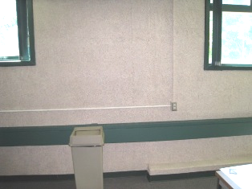

Footing is Visible from Area Dug Out by CETA Workers in the 1940s

Picture 2

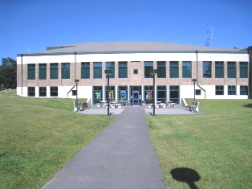

Renovation (1999) Lowered Elevation of Lawn to Provide Access
to the Ground Floor
Picture 3

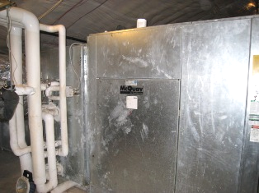

AHU in Attic

Picture 4

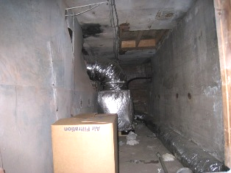

AHU Located in Tunnel
Note Cardboard Box Stored in Unconditioned Space
Picture 5

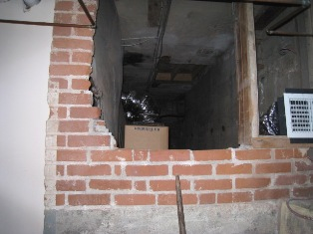

Entrance to Tunnel

Picture 6

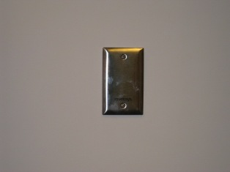

Temperature Sensor

Picture 7

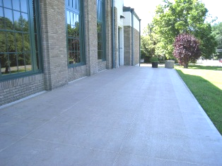
Newly Installed Concrete Patio

Picture 8

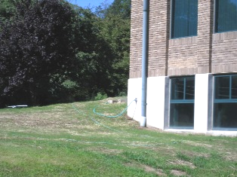

Overflow Pipe to Drainage System below Patio
Note Slope of Ground toward Building
Picture 9

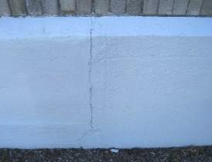

Crack in Foundation

Picture 10

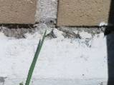

Weep Hole in Exterior Brick Blocked With Debris

Picture 11

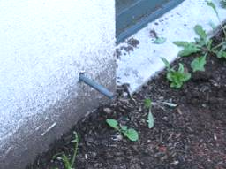

Drain Line from Dehumidifier

Picture 12

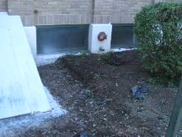

Thick Accumulation of Mulch against Foundation

Picture 13

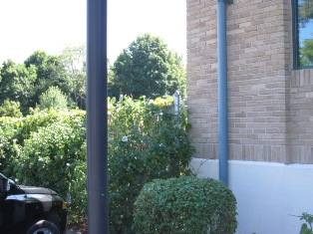

Shrubs and Plants in Close Proximity to Building

Picture 14

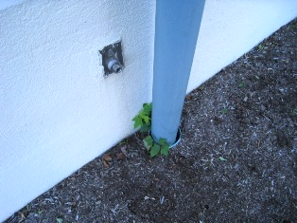

Plants Growing Adjacent to Building

Picture 15

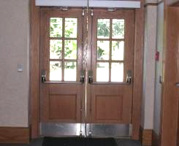

Gaps between Exterior Doors

Picture 16

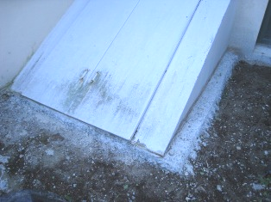

Newly Installed Concrete Pad around Bulkhead

Picture 17

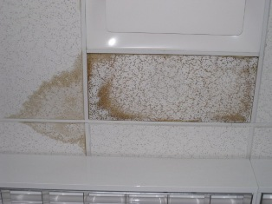

Water Damaged Ceiling Tiles

Picture 18

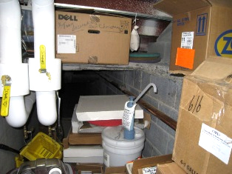

Cardboard Boxes and Filters Stored in Tunnel

Picture 19

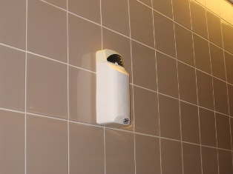

Wall Mounted Air Deodorizer

Picture 20

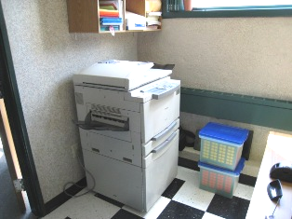

Photocopier in Room with No Mechanical Ventilation
Picture 21

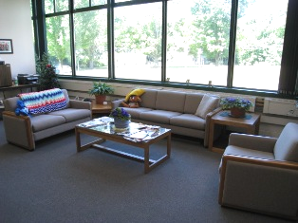

Upholstered Furniture in Senior Center

Picture 22

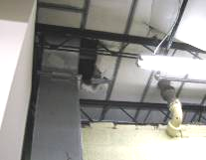

Open Penetrations of Utilities through Ceiling

Picture 23

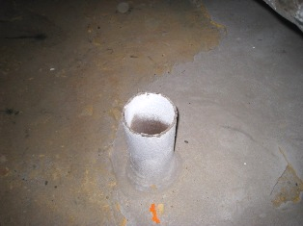

Discontinued Pipe Located in Attic
Location | Occupants  in Room | Carbon  Dioxide  (ppm) | Temp  (°F) | Relative  Humidity  (%) | Carbon Monoxide  (ppm) | Windows  Openable | Ventilation |  | Remarks
 |  |  |  |  |  |  | Supply | Exhaust | Remarks
Outside  (Background) |  | 376 | 66 | 46 | ND | -
Second Floor  Health Agent’s Office | 2 | 604 | 73 | 44 | ND | Y | Y | N | DO, WD CT
Board of Health  Main Office | 1 | 567 | 72 | 44 | ND | Y | Y | Y | DC, plants
Nurse’s Office | 0 | 628 | 71 | 45 | ND | N | Y | N | DO, sink
Building Inspector | 1 | 505 | 71 | 45 | ND | Y | Y | Y | DO, CD, PF
Boards Room | 4 | 513 | 72 | 46 | ND | Y | Y | Y | DO, CT ajar, PF, plants
Women’s room | 0 | 599 | 72 | 46 | ND | Y | N | Y | DC, exhaust operates 24/7, radiant panel in ceiling to provide heat
Boards Meeting Room | 0 | 433 | 70 | 45 | ND | Y | Y | Y | DC, plant
Channel 15 | 1 | 632 | 71 | 51 | ND | Y | Y | N | DO
First Floor  Conference Room 2 | 0 | 490 | 71 | 45 | ND | N | Y | N | DC, CT ajar
Town Clerk Vault | 0 | 578 | 72 | 49 | ND | N | N | N | DO, WD CTs, space heater
Town Clerk Main Office | 2 | 465 | 71 | 43 | ND | Y | Y | Y | DC, plants
Town Clerk Office | 1 | 462 | 71 | 44 | ND | Y | Y | Y | DO, DEM, PF
Break Room | 0 | 452 | 71 | 44 | ND | Y | Y | Y | DO, FC
North Lobby | 0 | 607 | 70 | 46 | ND | Y | Y | Y | DC
Board of Assessors | 2 | 548 | 71 | 47 | ND | Y | Y | Y | DC, plants
Assessor’s Office | 0 | 532 | 71 | 46 | ND | Y | Y | N | WD CTs
Auditor’s Office | 0 | 434 | 70 | 47 | ND | N | Y | Y | DC
Main Lobby | 0 | 486 | 69 | 45 | ND | N | Y | Y | DC, CF, gap in door, 2 heaters
Conference Room 101 | 0 | 450 | 67 | 51 | ND | Y | Y | Y | DC, WD CT, WD wall
Board of Selectmen Meeting Room | 0 | 470 | 66 | 50 | ND | Y | Y | Y | DC
Chief Administrator | 0 | 459 | 67 | 52 | ND | Y | Y | Y | DO
Selectmen’s Office | 3 | 489 | 68 | 46 | ND | Y | Y | Y | DC, PF, FC, CT ajar, plants
DPW Director | 0 | 517 | 69 | 47 | ND | Y | Y | Y | DO, DEM
DPW Office | 1 | 620 | 70 | 47 | ND | Y | Y | Y | DO, PF, DEM
Accounting | 3 | 650 | 71 | 45 | ND | Y | Y | Y | DO, many plants
Town Accountant | 1 | 479 | 73 | 43 | ND | Y | Y | Y | DO
Main Floor (Senior Ctr.)  COA Meeting Room | 0 | 513 | 72 | 44 | ND | Y | Y | Y | DO, UF, plants
COA Director | 1 | 547 | 71 | 44 | ND | Y | Y | Y | DO
COA Transportation | 2 | 641 | 71 | 45 | ND | N | Y | Y | DO
Bread Room | 0 | 476 | 71 | 45 | ND | N | Y | N | DC
Multi-Purpose Room | 0 | 464 | 71 | 43 | ND | Y | Y | Y | DO
Cafeteria | 6 | 506 | 71 | 48 | ND | Y | Y | Y | DO
Kitchen | 2 | 504 | 72 | 50 | ND | N | Y | Y | DO
Ground Floor  Maintenance Office | 1 | 538 | 76 | 42 | ND | N | Y* | N | *Only when community center AHU is on
Community Center Café | 0 | 598 | 74 | 39 | ND | Y | Y | Y | DC
Family Support Coalition | 2 | 588 | 73 | 43 | ND | Y | Y | Y | DC, plants, carpet
Main Com. Ctr. Room | 0 | 424 | 72 | 39 | ND | Y | Y | Y | DC
Study Room | 0 | 472 | 71 | 39 | ND | Y | Y | Y | DO, carpet
Park & Rec | 0 | 461 | 70 | 44 | ND | Y | N | N | DC, copier, new tile floor
Activities Room | 0 | 546 | 70 | 47 | ND | Y | Ymain/Ysep | Ymain/N sep | DC, UF, dehumidifier
Teen Room | 0 | 442 | 70 | 43 | ND | N | Y | Y | DO, UF
EOC | 0 | 431 | 70 | 44 | ND | N | Y | Y | DC, DEM

Location | Moisture Measurement  (Low = Normal) | Material/Comments
Study/Media Room | Northwest Wall – Low  Northwest Side Wall - Low  North Wall - Low  Northeast Side Wall – Low  Northeast Wall - Low  Southwest Wall – Low  Southeast Wall - Low  East Wall – Low  West Wall – Low | Carpet/All measurements taken at base of wall.
Study/Media Room | Northwest Wall – Low  Northwest Side Wall - Low  North Wall - Low  Northeast Side Wall – Low  Northeast Wall - Low  Southwest Wall – Low  Southeast Wall - Low  East Wall – Low  West Wall– Low | Carpet/All measurements taken six inches from base of wall.
Family Support Coalition | Northeast Wall - Low  Northwest Wall - Low  So Wall – Low  East Wall – Low  West Wall – Low | Carpet/All measurements taken at base of wall.
Family Support Coalition | Northeast Wall - Low  Northwest Wall - Low  So Wall – Low  East Wall – Low  West Wall – Low | Carpet/All measurements taken six inches from base of wall.

