INDOOR AIR QUALITY ASSESSMENT

Southworth Library
732 Dartmouth Street
South Dartmouth, Massachusetts



Prepared by:
Massachusetts Department of Public Health
Bureau of Environmental Health
Indoor Air Quality Program
December 2010

Background/Introduction
At the request of Ms. Wendy Henderson, Director of Public Health, Dartmouth Board of Health, the Massachusetts Department of Public Health (MDPH), Bureau of Environmental Health (BEH) provided assistance and consultation regarding indoor air quality concerns at the Southworth Library (SL), located at 732 Dartmouth Street, South Dartmouth, MA. On September 10, 2010, a visit to conduct an assessment was made to this building by Cory Holmes, Environmental Analyst/Regional Inspector for BEH’s Indoor Air Quality (IAQ) Program. Mr. Holmes was accompanied by Ms. Henderson for the majority of the assessment.
The assessment was prompted by mold concerns, (primarily in the basement) due to excess heat and humidity after the heating, ventilation and air conditioning (HVAC) system failed over the summer, resulting in temporary closure of the building. At the time of the assessment the library was open for business.
The SL is a two-story, red brick structure with basement constructed in the early 1970s. Located on the upper level are the main library stacks, computer banks, circulation desk and office space. The lower/basement level contains the children’s library, staff lounge, book mobile garage and storage space. Windows are openable in the building. Current building improvement projects reportedly include replacement/upgrading of the building’s HVAC system and controls.

Methods
Air tests for carbon monoxide, carbon dioxide, temperature and relative humidity were conducted with the TSI, Q-Trak, IAQ Monitor, Model 7565. Air tests for airborne particle matter with a diameter less than 2.5 micrometers were taken with the TSI, DUSTTRAK™ Aerosol Monitor Model 8520. BEH staff also performed visual inspection of building materials for water damage and/or microbial growth.

Results
The building has an employee population of approximately 15 to 20 and can be visited by several hundred members of the public daily. Tests were taken during normal operations and results appear in Table 1.

Discussion

Ventilation
Carbon dioxide levels were below 800 parts per million (ppm) in all areas surveyed, indicating adequate air exchange in the building at the time of the assessment (Table 1). However, it is important to note that windows were open in a number of areas and several areas were empty/sparsely populated, which can greatly reduce carbon dioxide levels. Carbon dioxide levels would be expected to increase with windows shut and higher occupancy.
The HVAC system consists of a large air handling unit (AHU) located in the basement (Picture 1). Heated/cooled air is distributed to occupied areas via ducted supply diffusers (Picture 2). Air is returned back to the AHUs via ceiling or wall-mounted return vents (Pictures 3 and 4). It was reported that significant efforts were made to repair the HVAC system over the summer; however it is original to the building making it nearly 40 years old. Equipment of this age can be difficult to maintain because replacement parts are often unavailable. At the time of the assessment the system was not activated, therefore no means of mechanical ventilation was being provided. Fresh air was being introduced via open windows.
Fan coil units (FCUs) along exterior walls facilitate airflow and temperature control (Picture 5). FCUs do not provide fresh air to rooms; rather, FCUs re-circulate air and provide auxiliary heating and cooling. Each FCU is controlled by a switch with settings for “low”, “high” and “off”. Air is drawn into a return vent at the base of the unit. It is then conditioned, filtered and provided to the room via a diffuser atop the unit (Figure 1).
To maximize air exchange, the MDPH recommends that both supply and exhaust ventilation operate continuously during periods of occupancy. In order to have proper ventilation with a mechanical supply and exhaust system, the systems must be balanced to provide an adequate amount of fresh air to the interior of a room while removing stale air from the room. It is recommended that HVAC systems be re-balanced every five years to ensure adequate air systems function (SMACNA, 1994). The date of the last balancing of these systems was not available at the time of the assessment.
The Massachusetts Building Code requires that each room have a minimum ventilation rate of 20 cubic feet per minute (cfm) per occupant of fresh outside air or openable windows (SBBRS, 1997; BOCA, 1993). The ventilation must be on at all times that the room is occupied. Providing adequate fresh air ventilation with open windows and maintaining the temperature in the comfort range during the cold weather season is impractical. Mechanical ventilation is usually required to provide adequate fresh air ventilation.
Carbon dioxide is not a problem in and of itself. It is used as an indicator of the adequacy of the fresh air ventilation. As carbon dioxide levels rise, it indicates that the ventilating system is malfunctioning or the design occupancy of the room is being exceeded. When this happens, a buildup of common indoor air pollutants can occur, leading to discomfort or health complaints. The Occupational Safety and Health Administration (OSHA) standard for carbon dioxide is 5,000 parts per million parts of air (ppm). Workers may be exposed to this level for 40 hours/week, based on a time-weighted average (OSHA, 1997).
The MDPH uses a guideline of 800 ppm for publicly occupied buildings. A guideline of 600 ppm or less is preferred in schools due to the fact that the majority of occupants are young and considered to be a more sensitive population in the evaluation of environmental health status. Inadequate ventilation and/or elevated temperatures are major causes of complaints such as respiratory, eye, nose and throat irritation, lethargy and headaches. For more information concerning carbon dioxide, please see Appendix A.
Temperature readings in the building ranged from 71º F to 76 º F, which were within the MDPH recommended comfort guidelines the day of the assessment. The MDPH recommends that indoor air temperatures be maintained in a range of 70 º F to 78 º F in order to provide for the comfort of building occupants. In many cases concerning indoor air quality, fluctuations of temperature in occupied spaces are typically experienced, even in a building with an adequate fresh air supply. However, as mentioned previously major mechanical issues with the existing HVAC system resulting in excessive heat lead to the closure of the library over the summer.
It is also important to note that AC systems also facilitate cooling by removing moisture. Without a functioning ventilation system, indoor relative humidity levels can become elevated. While temperature is mainly a comfort issue, relative humidity in excess of 70% for extended periods of time can provide an environment for mold and fungal growth (ASHRAE, 1989). The relative humidity measured in the building ranged from 44 to 51 percent, which was within the MDPH recommended comfort range in all areas surveyed during the assessment. The MDPH recommends a comfort range of 40 to 60 percent for indoor air relative humidity. Relative humidity levels in the building would be expected to drop during the winter months due to heating. The sensation of dryness and irritation is common in a low relative humidity environment. Low relative humidity is a very common problem during the heating season in the northeast part of the United States.

Microbial/Moisture Concerns
As previously mentioned, the assessment was requested due to concerns of possible mold growth in the lower level of the building. At the time of the MDPH visit several dehumidifiers and an industrial fan were being utilized for moisture removal and air circulation, respectively. Dehumidifiers contain a reservoir for standing water, a number of which were full and in need of emptying. This equipment should be cleaned/maintained as per the manufactures instructions to prevent mold/bacterial growth and associated odors.
BEH staff examined both area and wall to wall carpeting as well as other building materials for water damage and/or mold growth. Area carpeting was removed to observe conditions beneath them and moisture testing was conducted. At the time of the assessment all carpeting tested had normal moisture content (i.e., dry) and no visible mold growth or associated odors were observed/detected. Although the majority of wall-to-wall carpeting in the basement has been removed, it is still present in the office and “friend’s” work/storage room. Wall to wall carpeting in below grade space is generally not recommended if that space is subject to chronic dampness due to water leaks or condensation accumulation (US EPA, 2001). To prevent moistening and/or potential mold growth in the future replacing this carpeting with a non-porous material should be considered.
A water-damaged ceiling tile was observed in the children’s library that appeared to be colonized by mold (Picture 6). BEH staff recommended that the damaged/mold colonized tile be removed. The source of moisture appeared to be a leaking pipe above the ceiling tile. At the time of the assessment, the pipe was not leaking and wrapped with a water proof media (Picture 7). Water-damaged ceiling tiles can provide a source of mold and should be replaced after a water leak is discovered and repaired.
An open seam between the sink countertop and wall was observed in the staff lounge (Picture 8). Improper drainage or sink overflow can lead to water penetration into the countertop, cabinet interior and areas behind cabinets. If not watertight, moisture can penetrate through the seam, causing water damage and potential mold growth.
The US Environmental Protection Agency and the American Conference of Governmental Industrial Hygienists (ACGIH) recommends that porous materials (carpeting, ceiling tiles, etc.) be dried with fans and heating within 24 to 48 hours of becoming wet (US EPA, 2001; ACGIH, 1989). If porous materials are not dried within this time frame, mold growth may occur. Water-damaged porous materials cannot be adequately cleaned to remove mold growth. The application of a mildewcide to moldy porous materials is not recommended.

Other IAQ Evaluations
Indoor air quality can be negatively influenced by the presence of respiratory irritants, such as products of combustion. The process of combustion produces a number of pollutants. Common combustion emissions include carbon monoxide, carbon dioxide, water vapor, and smoke (fine airborne particle material). Of these materials, exposure to carbon monoxide and particulate matter with a diameter of 2.5 micrometers (μm) or less (PM2.5) can produce immediate, acute health effects upon exposure. To determine whether combustion products were present in the indoor environment, BEH staff obtained measurements for carbon monoxide and PM2.5.

Carbon Monoxide
Carbon monoxide is a by-product of incomplete combustion of organic matter (e.g., gasoline, wood and tobacco). Exposure to carbon monoxide can produce immediate and acute health effects. Several air quality standards have been established to address carbon monoxide and prevent symptoms from exposure to these substances. The MDPH established a corrective action level concerning carbon monoxide in ice skating rinks that use fossil-fueled ice resurfacing equipment. If an operator of an indoor ice rink measures a carbon monoxide level over 30 ppm, taken 20 minutes after resurfacing within a rink, that operator must take actions to reduce carbon monoxide levels (MDPH, 1997).
The American Society of Heating Refrigeration and Air-Conditioning Engineers (ASHRAE) has adopted the National Ambient Air Quality Standards (NAAQS) as one set of criteria for assessing indoor air quality and monitoring of fresh air introduced by HVAC systems (ASHRAE, 1989). The NAAQS are standards established by the US EPA to protect the public health from six criteria pollutants, including carbon monoxide and particulate matter (US EPA, 2006). As recommended by ASHRAE, pollutant levels of fresh air introduced to a building should not exceed the NAAQS levels (ASHRAE, 1989). The NAAQS were adopted by reference in the Building Officials & Code Administrators (BOCA) National Mechanical Code of 1993 (BOCA, 1993), which is now an HVAC standard included in the Massachusetts State Building Code (SBBRS, 1997). According to the NAAQS, carbon monoxide levels in outdoor air should not exceed 9 ppm in an eight-hour average (US EPA, 2006).
Carbon monoxide should not be present in a typical, indoor environment. If it is present, indoor carbon monoxide levels should be less than or equal to outdoor levels. Outdoor carbon monoxide concentrations were non-detect (ND) the day of the assessment (Table 1). No measureable levels of carbon monoxide were detected in the building during the assessment (Table 1).

Particulate Matter
The US EPA has established NAAQS limits for exposure to particulate matter. Particulate matter is airborne solids that can be irritating to the eyes, nose and throat. The NAAQS originally established exposure limits to particulate matter with a diameter of 10 μm or less (PM10). According to the NAAQS, PM10 levels should not exceed 150 micrograms per cubic meter (μg/m³) in a 24-hour average (US EPA, 2006). These standards were adopted by both ASHRAE and BOCA. Since the issuance of the ASHRAE standard and BOCA Code, US EPA established a more protective standard for fine airborne particles. This more stringent PM2.5 standard requires outdoor air particle levels be maintained below 35 μg/m³ over a 24-hour average (US EPA, 2006). Although both the ASHRAE standard and BOCA Code adopted the PM10 standard for evaluating air quality, MDPH uses the more protective PM2.5 standard for evaluating airborne particulate matter concentrations in the indoor environment.
Outdoor PM2.5 concentrations were measured at 2 μg/m³ (Table 1). PM2.5 levels measured indoors ranged from 1 to 3 μg/m³ (Table 1), which were below the NAAQS PM2.5 level of 35 μg/m³. Frequently, indoor air levels of particulates (including PM2.5) can be at higher levels than those measured outdoors. A number of mechanical devices and/or activities that occur indoors can generate particulate during normal operations. Sources of indoor airborne particulates may include but are not limited to particles generated during the operation of fan belts in the HVAC system, use of stoves and/or microwave ovens in kitchen areas; use of photocopiers, fax machines and computer printing devices; operation of an ordinary vacuum cleaner and heavy foot traffic indoors.

Other Conditions
Other conditions that can affect indoor air quality were observed during the assessment. A number of air diffusers/surrounding ceiling tiles, exhaust and return vents were observed to have accumulated dust/debris (Pictures 2, 9 and 10). If exhaust/return vents are not functioning, backdrafting can occur, which can re-aerosolize accumulated dust particles. Re-activated supply vents can also aerosolize dust accumulated on vents louvers.
BEH staff inspected filters for AHUs and FCUs; they were found occluded with dust/debris and appeared not to have been changed for some time (Pictures 11 and 12). Debris-saturated filters can obstruct airflow and may serve as a reservoir of particulates that can be re-aerosolized and distributed to occupied areas via the ventilation system. In addition, the type of filters installed in AHUs and FCUs provide minimal filtration of respirable dusts. In order to decrease aerosolized particulates, disposable filters with an increased dust spot efficiency can be installed. The dust spot efficiency is the ability of a filter to remove particulates of a certain diameter from air passing through the filter. Filters that have been determined by ASHRAE to meet its standard for a dust spot efficiency of a minimum of 40 percent (Minimum Efficiency Reporting Value equal to 9) would be sufficient to reduce many airborne particulates (Thornburg, D., 2000; MEHRC, 1997; ASHRAE, 1992). Note that increasing filtration can reduce airflow (called pressure drop), which can subsequently reduce efficiency due to increased resistance. Prior to any increase of filtration, each piece of air handling equipment should be evaluated by a ventilation engineer to ascertain whether it can maintain function with more efficient filters.
Finally, pipe insulation near the AHU in the boiler room was found damaged exposing a white chalky material that likely contains asbestos (Pictures 13 and 14). Upon discovery, BEH staff recommended that the insulation be inspected and remediated by a licensed member of the Dartmouth Maintenance Department or an asbestos abatement contractor. It subsequent correspondence with Ms. Henderson, it was reported that the material was remediated by a licensed asbestos abatement contractor.

Conclusions/Recommendations
In view of the findings at the time of the visit, the following recommendations are made:
- Continue with plans to conduct a full HVAC engineering/ventilation systems assessment, particularly the efficiency of AC components during the cooling season. Based on the age, physical deterioration and likely lack of availability of parts for ventilation components, such an evaluation is necessary to determine the operability and feasibility of repairing the equipment.
- Change filters for air-handling equipment (e.g., AHUs, and FCU) as per the manufacturers’ instructions or more frequently if needed. Vacuum interior of units prior to activation to prevent the aerosolization of dirt, dust and particulate matter. Ensure filters fit flush in their racks with no spaces in between allowing bypass of unfiltered air into the unit.
- Consider upgrading the AHU and FCU filters to pleated MERV 9 (or higher) dust-spot efficiency. Prior to any increase of filtration, each unit should be evaluated by a ventilation engineer as to whether it can maintain function with more efficient filters.
- Consider adopting a balancing schedule of every 5 years for all mechanical ventilation systems, as recommended by ventilation industrial standards (SMACNA, 1994).
- For buildings in New England, periods of low relative humidity during the winter are often unavoidable. Therefore, scrupulous cleaning practices should be adopted to minimize common indoor air contaminants whose irritant effects can be enhanced when the relative humidity is low. To control for dusts, a high efficiency particulate arrestance (HEPA) filter equipped vacuum cleaner in conjunction with wet wiping of all surfaces is recommended. Drinking water during the day can help ease some symptoms associated with a dry environment (e.g., throat and sinus irritations).
- Ensure leaking pipe above damaged ceiling tile in children’s library is repaired. Replace water-damaged/mold-colonized ceiling tile below pipe.
- Seal spaces between sink countertop and backsplash in staff lounge.
- Clean and maintain dehumidifiers as per manufacturer’s instructions.
- Clean accumulated dust and debris periodically from the surface of air diffusers, exhaust/return vents and surrounding ceiling tiles. If soiled ceiling tiles cannot be cleaned, replace.
- Clean carpeting annually or semi-annually in soiled high traffic areas as per the recommendations of the Institute of Inspection, Cleaning and Restoration Certification (IICRC). Copies of the IICRC fact sheet can be downloaded at: http://www.cleancareseminars.com/carpet_cleaning_faq4.htm (IICRC, 2005)
- Consider a long-term plan to replace remaining wall-to-wall carpeting in the lower level. Consider replacing carpeting with a non-porous surface such as vinyl tile as funds become available.
- Refer to resource manuals and other related indoor air quality documents for further building-wide evaluations and advice on maintaining public buildings. Copies of these materials are located on the MDPH’s website: http://mass.gov/dph/iaq.

References
ACGIH. 1989. Guidelines for the Assessment of Bioaerosols in the Indoor Environment. American Conference of Governmental Industrial Hygienists, Cincinnati, OH.
ASHRAE. 1989. Ventilation for Acceptable Indoor Air Quality. American Society of Heating, Refrigeration and Air Conditioning Engineers. ANSI/ASHRAE 62-1989.
ASHRAE. 1992. Gravimetric and Dust-Spot Procedures for Testing Air-Cleaning Devices Used in General Ventilation for Removing Particulate Matter. American Society of Heating, Refrigeration and Air Conditioning Engineers. ANSI/ASHRAE 52.1-1992.
BOCA. 1993. The BOCA National Mechanical Code/1993. 8th ed. Building Officials and Code Administrators International, Inc., Country Club Hill, IL.
IICRC. 2005. Carpet Cleaning FAQ 4 Institute of Inspection, Cleaning and Restoration Certification. Institute of Inspection Cleaning and Restoration, Vancouver, WA.
MDPH. 1997. Requirements to Maintain Air Quality in Indoor Skating Rinks (State Sanitary Code, Chapter XI). 105 CMR 675.000. Massachusetts Department of Public Health, Boston, MA.
MEHRC. 1997. Indoor Air Quality for HVAC Operators & Contractors Workbook. MidAtlantic Environmental Hygiene Resource Center, Philadelphia, PA.
OSHA. 1997. Limits for Air Contaminants. Occupational Safety and Health Administration. Code of Federal Regulations. 29 C.F.R 1910.1000 Table Z-1-A.
SBBRS. 1997. Mechanical Ventilation. State Board of Building Regulations and Standards. Code of Massachusetts Regulations. 780 CMR 1209.0.
SMACNA. 1994. HVAC Systems Commissioning Manual. First Edition. Sheet Metal and Air Conditioning Contractors’ National Association, Inc., Chantilly, VA.
Thornburg, D. 2000. Filter Selection: a Standard Solution. Engineering Systems 17:6 pp. 74-80.
US EPA. 2001. Mold Remediation in Schools and Commercial Buildings. Office of Air and Radiation, Indoor Environments Division, Washington, DC. EPA 402-K-01-001. March 2001. Available at: http://www.epa.gov/iaq/molds/mold_remediation.html
US EPA. 2006. National Ambient Air Quality Standards (NAAQS). US Environmental Protection Agency, Office of Air Quality Planning and Standards, Washington, DC. http://www.epa.gov/air/criteria.html
Picture 1

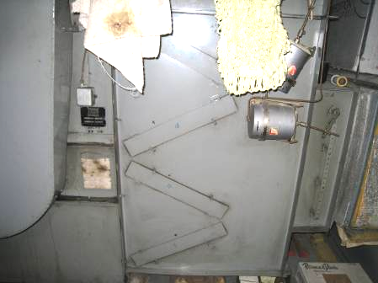

Air Handling Unit Located in Basement

Picture 2

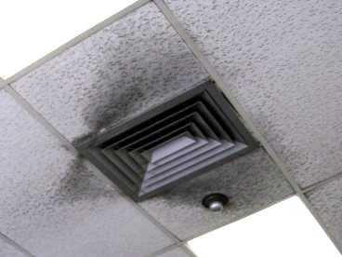

Ceiling-Mounted Supply Diffuser, Note Dust/Debris Accumulation on Vent and Surrounding Ceiling Tiles

Picture 3

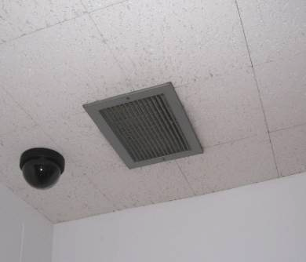

Ceiling-Mounted Return Vent

Picture 4

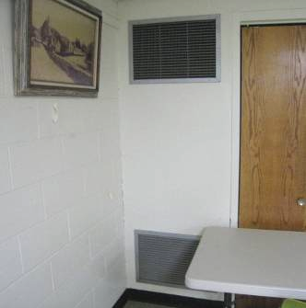

Wall-Mounted Supply and Return Vent (Bottom) in Auditorium

Picture 5

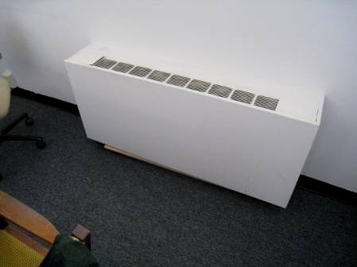

Fan Coil Unit

Picture 6

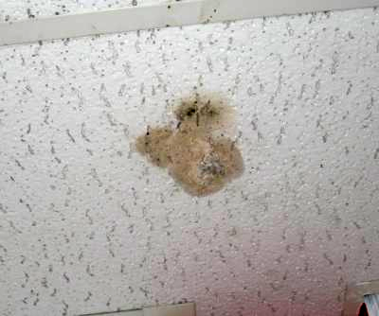

Water-Damaged/Mold Colonized Ceiling Tile in Children’s Library

Picture 7

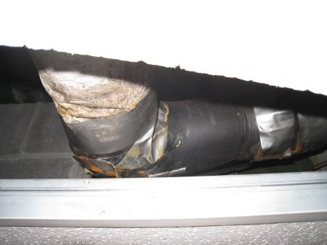

Wrapped Pipe Located above Water-Damaged Ceiling Tile in Preceding Picture

Picture 8

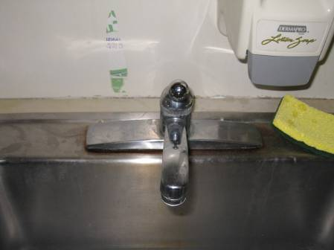

Space between Sink Countertop and Backsplash in Staff Lounge

Picture 9

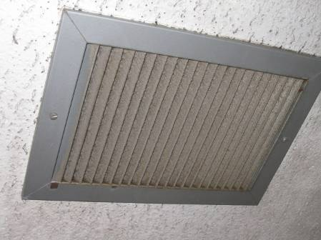

Exhaust Vent with Accumulated Dust/Debris

Picture 10

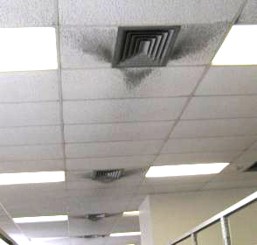

Accumulated Dust/Debris on Supply Diffusers and Surrounding Ceiling Tiles

Picture 11

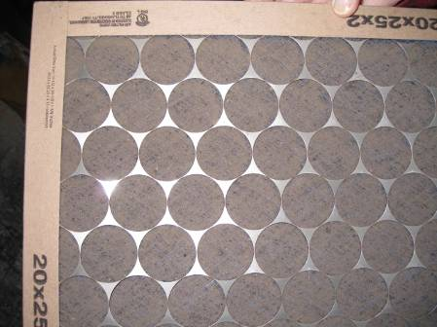

Debris Saturated Filter for AHU

Picture 12

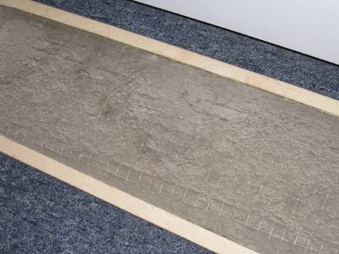

Debris Saturated Filter for FCU

Picture 13

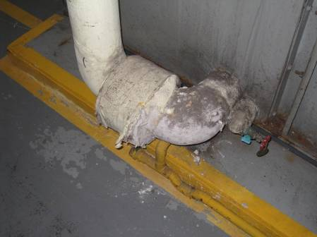

Damaged Pipe Insulation in Boiler Room

Picture 14

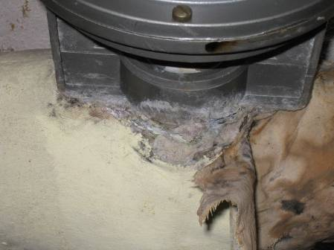

Damaged Pipe Insulation in Boiler Room
Location | Occupants  in Room | Temp  (°F) | Relative  Humidity  (%) | Carbon  Dioxide  (ppm) | PM2.5  (µg/m3) | Carbon Monoxide  (ppm) | Windows  Openable | Ventilation |  | Remarks
Outside  (Background) |  | 75 | 49 | 333 | 2 | ND |  |  |  | Cool, sunny, scattered clouds
Meeting Room | 0 | 71 | 48 | 460 | 1 | ND | Y | N | N | FCU-filters dirty, window open
Work Room | 3 | 72 | 47 | 410 | 1 | ND | Y | Y | Y | Spaces sink countertop/backsplash, DO, PF, FCU, window open
Delivery Room | 0 | 75 | 45 | 388 | 1 | ND | Y | N | N | Window open, DO
Main Library
Fiction | 4 | 74 | 46 | 381 | 1 | ND | Y | Y | Y | PF, dust/debris accumulation on vents/CTs
Large Print Books | 0 | 74 | 46 | 400 | 1 | ND | N | Y | Y
Biographies | 2 | 74 | 45 | 387 | 3 | ND | Y | Y | Y
Non Fiction | 0 | 74 | 46 | 397 | 1 | ND | Y | Y | Y | Window open
Computer Banks | 2 | 73 | 45 | 418 | 2 | ND | N | Y | Y
Center Reading Area | 3 | 73 | 45 | 384 | 2 | ND | N | Y | Y
Young Adult | 3 | 73 | 45 | 372 | 1 | ND | Y | Y | Y | Window open, dehumidifier-full
Restrooms |  |  |  |  |  |  | N | Y | Y | Dust/debris accumulation on vents
DVD/Video Area | 0 | 74 | 44 | 401 | 3 | ND | N | Y | y
Lower Level
Auditorium | 0 | 74 | 46 | 398 | 2 | ND | N | Y | Y
Boiler Room |  |  |  |  |  |  |  |  |  | Damaged/exposed pipe insulation, AHU filters dirty
Story Time Room | 0 | 74 | 47 | 426 | 2 | ND | Y | Y | Y | Window open, dehumidifier
Children’s Library Circulation Desk | 1 | 74 | 47 | 402 | 1 | ND | N | Y | Y | Dehumidifier-full/odors, dust/debris accumulation on vents/CTs
Children’s Library Office | 0 | 76 | 45 | 477 | 2 | ND | N | Y | Y | Wall to wall carpeting-low (normal) moisture measurement, 1 WD CT
Friend’s Workroom (book donation/storage) | 1 | 76 | 51 | 545 | 3 | ND | Y | N | N | Old/soiled wall to wall carpeting, donations old books (dusty)
Children’s Library Reading/Tables | 1 | 76 | 44 | 401 | 2 | ND | N | Y | Y | Area carpet inspected-no WD or visible mold on/beneath carpet-dry (normal) moisture measurement, 1 WD CT visible mold growth-beneath leaking pipe-wrapped
Staff Lounge | 1 | 75 | 44 | 413 | 2 | ND | y | Y | Y

