INDOOR AIR QUALITY ASSESSMENT

Spaulding Memorial School
1 Whitcomb Street
Townsend, MA

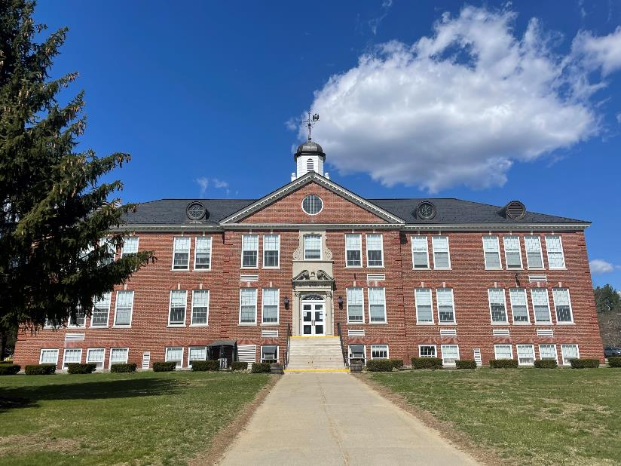

Prepared by:
Massachusetts Department of Public Health
Bureau of Environmental Health
Indoor Air Quality Program
August 2022

BACKGROUND

Building: | Spaulding Memorial School (SMS)
Address: | 1 Whitcomb Street, Townsend, MA
Assessment Requested by: | Brad Morgan, Superintendent, North Middlesex Regional School District
Reason for Request: | General indoor air quality (IAQ) issues
Dates of Assessment: | February 11, 2022, April 15, 2022, and  April 22, 2022
Massachusetts Department of Public Health/Bureau of Environmental Health (MDPH/BEH) Staff Conducting Assessment: | Michael Feeney Director, and Jennifer Lajoie, Environmental Analyst/Inspector, IAQ Program
Building Description: | SMS is a three-story brick school originally constructed in 1932 with an addition added in 1994. Approximately 420 students in grades K-5 attend the school. The school contains classrooms, offices, and accessory areas including a gymnasium/auditorium and a cafeteria
Windows: | Windows in most areas are openable.

METHODS
Please refer to the IAQ Manual for methods, sampling procedures, and interpretation of results (MDPH, 2015).

IAQ TESTING RESULTS
The following is a summary of indoor air testing results (Table 1).
- Carbon dioxide levels were below the MDPH guideline of 800 parts per million (ppm) in most occupied areas assessed.
- Temperature was within the recommended range of 70°F to 78°F in all areas assessed.
- Relative humidity was below the recommended range of 40 to 60% in all areas assessed.
- Carbon monoxide levels were non-detectable (ND) in all indoor areas assessed.
- Fine Particulate matter (PM2.5) concentrations measured were below the National Ambient Air Quality Standard (NAAQS) level of 35 μg/m³ in all areas assessed.
- Volatile Organic Compounds (VOCs) were non-detectable (ND) in all indoor areas assessed.

Ventilation
A heating, ventilating and air conditioning (HVAC) system has several functions. First it provides heating and, if equipped, cooling. Second, it is a source of fresh air. Finally, an HVAC system will dilute and remove normally occurring indoor environmental pollutants by not only introducing fresh air, but by filtering the airstream and ejecting stale air to the outdoors via exhaust ventilation. Even if an HVAC system is operating as designed, point sources of respiratory irritation may exist and cause symptoms in sensitive individuals.
Fresh air in the majority of classrooms is supplied by unit ventilators (univents) installed when SMS was renovated in 1994. Univents draw air from the outdoors through a fresh air intake located on the exterior wall of the building and return air through an air intake located at the base of the unit. Fresh and return air are mixed, filtered, heated, or cooled and provided to rooms through an air diffuser located in the top of the unit (Figure 1).
Mechanical exhaust ventilation in classrooms is provided by wall-mounted exhaust vents connected to motors located in the attic. The MDPH IAQ Program recommends that supply and exhaust ventilation operate continuously during occupied periods to provide air exchange and filtration. Without sufficient supply and exhaust ventilation, normally-occurring environmental pollutants can build up and lead to indoor air quality/comfort complaints.
It is also important to note that many of the HVAC units are at the end of their life cycle. Efficient function of equipment of this age (> 20 years old) is difficult to maintain, since compatible replacement parts are often unavailable. According to the American Society of Heating, Refrigeration, and Air-Conditioning Engineering (ASHRAE), the service life of this type of unit is 15-20 years, assuming routine maintenance of the equipment (ASHRAE, 1991).
To maximize air exchange, the IAQ program recommends that both supply and exhaust ventilation operate continuously during periods of occupancy. To have proper ventilation with a mechanical ventilation system, the systems must be balanced after installation to provide an adequate amount of fresh air to the interior of a room while removing stale air from the room. It is recommended that HVAC systems be re-balanced every five years to ensure adequate air systems function (SMACNA, 1994). Based on the age and condition of the univents, re-balancing of the HVAC system may not be possible.

Temperature control issues
Building occupants report temperature control difficulties in the 1932 section of the building. As reported to IAQ staff, heat is controlled by a pneumatic system that is attached to thermostats in each classroom. In the experience of IAQ staff, as pneumatic systems age, leaks can develop in thermostats and univent control systems which render the system inoperable. For this reason, the installation of HVAC pneumatic control systems has been abandoned in favor of electric (wire) controls.
The HVAC system at the SMS does not have the capacity to chill air. The IAQ Program routinely receives inquiries concerning the problem of high temperatures in schools and other buildings during hot, humid weather. These concerns are usually raised in late spring/early summer or late summer/early fall.
Many schools in Massachusetts do not have mechanical air-conditioning building-wide, but rather rely on open windows to provide heat relief during hot weather. The IAQ Program recommends that indoor air temperatures be maintained in a range of 70°F to 78°F to provide for the comfort of building occupants. Frequently, the upper limit of this comfort range is exceeded in warm weather, since control of temperature in non-air-conditioned buildings is difficult. Relying on openable windows and cross ventilation in hot weather will at best, render indoor temperature to a level equal to outdoor temperature. The heat load carried by building materials exposed to direct sunlight further increases the internal temperature of buildings. Building components, such as single-paned window glass, insulated window frames, skylights and exterior brick, can radiate heat into the interior, resulting in increased indoor temperatures over the course of a school day. Frequently, older school buildings are not designed to prevent transfer of heat from solar heated exterior walls and windows to interior occupied space. Therefore, many buildings (particularly schools) are not equipped to provide for the comfort of building occupants during hot/humid weather during summer months.

Moisture/Microbial Issues
The SMS has experienced water damage from the following sources:
- Building materials prone to condensation during hot, humid weather;
- Building material prone to water vapor absorption in high humidity environments; and
- Poor drainage of the ground along the exterior walls and courtyards.

Building materials prone to condensation during hot, humid weather

It is important to note that Massachusetts experienced extended periods of high relative humidity during the summer of 2021. July 2021 was the wettest ever recorded in Massachusetts, and the three-month period from June through August 2021, known as the meteorological summer, was the fourth wettest on record, according to the National Oceanic and Atmospheric Administration’s Centers for Environmental Information. That three-month period also was the third warmest ever in the state and was tied for the warmest on record across the United States (HG, 2021, NOAA, 2021).

The SMS was assessed to determine if floors on the lowest level (cement on soil) were subject to developing condensation during extended (> 24 hours) hot, humid weather. The key to managing condensation in hot, humid weather indoors is understanding dew point. When warm, moist air passes over a cooler surface, condensation can form. Condensation is the collection of moisture on a surface at or below the dew point. The dew point is the temperature that air must reach for saturation to occur. If a building material/component has a temperature below the dew point, condensation will accumulate on that material. Over time, condensation can collect and form water droplets.

A method to locate areas in a building prone to condensation is to measure air and building material temperatures using a laser thermometer (Table 2). If a wide temperature range exists between measurements (>5°F), the building materials at the colder end of the range may be prone to becoming moistened with condensation if exposed to hot, humid weather for extended periods of time. According to the results in Table 2, all floors (except the cafeteria and gym hallway) on the lowest level of the SMS are likely to be prone to condensation under high-humidity conditions. In addition, floor tiles show signs of chronic moistening.

Building materials prone to water vapor absorption in high humidity environments

Most areas, apart from the facility supervisor’s office, gymnasium, and cafeteria, have carpeting. Carpeting in areas that are prone to condensation can become moistened during extended periods of hot, humid weather. Therefore, carpeting should not be used as a floor covering in below-grade spaces, particularly in buildings that were constructed without insulated floors, such as the 1932 section of the building. Wall-to-wall latex/jute backed carpeting is not recommended for use near exterior doors as well.
During the visit(s) visual inspections were conducted for signs of water damage and microbial growth. Ceiling tiles in classrooms and common hallways were bowed (Table 1, Picture 1), which is likely the result of moisture exposure from extended elevated relative humidity. No mold growth was observed on bowed ceiling tiles.
Water-damaged ceiling tiles were observed in a few classrooms and hallways (Table 1). Given the locations, many of these tiles were likely moistened by leaks or condensation from the HVAC system. Areas above water-damaged ceiling tiles should be examined for HVAC leaks and piping that lacks appropriate insulation. Some water-damaged ceiling tiles were noted in the gymnasium hallway, which may indicate a leak from the roof or plumbing system. Water-damaged ceiling tiles should be replaced once the source of water is identified and repaired.

According to American Society of Heating, Refrigerating and Air-Conditioning Engineers (ASHRAE), if relative humidity exceeds 70%, mold growth may occur due to wetting of building materials even in the absence of liquid water (ASHRAE, 2019). Relative humidity measured in the building was below 70% in all locations. (Table 1) at the time of the assessment.

Poor drainage of ground and windowsills along the exterior walls and courtyards
The exterior of the building was examined for potential sources of water infiltration and other IAQ issues. Water damage and deterioration was noted in a few areas including:
- Efflorescence on brick in a few areas showing that water is draining out through the brick rather than the weep holes as designed,
- Damage to the flashing along the top edge of the building,
- Moss growth against the side of the building.
Efflorescence is a characteristic sign of water damage to building materials such as brick, mortar, or plaster. As moisture penetrates and works its way through mortar around brick, water-soluble compounds dissolve, creating a solution. As the solution moves to the surface of the brick or mortar, water evaporates, leaving behind white, powdery mineral deposits. This condition indicates that water from the exterior has penetrated into the building. When present, efflorescence can be readily cleaned.
The SMS has a tarmac apron around the base of the exterior wall to aid water drainage. Moss growing over the apron (Picture 2) indicates significant water exposure, including water accumulating against the building’s slab. In addition, the slab is cracked and tilted towards the building rather than away (Picture 3). Without sufficient drainage, water can pool against exterior walls. Over time, rainwater runoff from the exterior wall can compress soil to the building slab causing the apron to settle, which in turn, can result in increased puddling and exposing cement to prolonged periods of water exposure. Pooling water can enter below grade space as cement erodes.
It was also noted that the building exterior has areas of different color brick. Where dissimilar materials meet on a building envelope, the building is more likely to leak.

Other moisture issues
Plants were found in several classrooms and offices (Table 1). Plants should be well maintained and not overwatered to prevent water damage and pests. This includes plants used for science experiments.

Other issues

Previous relevant environmental history
IAQ staff examined whether any hazardous waste sites exist on or near school property. At the time of this review, no current/active Massachusetts Contingency Plan projects for this building or property were found in the Massachusetts Department of Environmental Protection database (MDEP, 2022a). A review of other environmental data indicates that no specific source of emissions from chemicals spills, industry or possible hazardous waste sites exist in proximity to the SMS (MDEP, 2022b). In addition, given the wind patterns in Massachusetts are primarily westerly, no emission source that could impact the SMS could be identified upwind from the SMS.

Volatile organic compounds
The IAQ staff conducted air sampling for total volatile organic compounds (TVOCs) (Table 1) to identify whether any unusual pollutant sources exist in the SMS. All TVOC measurements indoors and outdoors were non-detectable.
While TVOCs were not detected, products observed in the building can contain VOCs which can become airborne when used. BEH/IAQ staff examined spaces for products containing VOCs. BEH/IAQ staff noted hand sanitizers, cleaning products, and plug-in air fresheners (Table 1). All of these products have the potential to be irritants to the eyes, nose, throat, and respiratory system of sensitive individuals. Scented products such as plug-in air fresheners should not be used in schools, as many people are sensitive to the chemical compounds used in them. Consult the document “Clean Air Is Odor Free” for more information on use of scented products. While hand sanitizers may be necessary, these should be used in areas with good ventilation, with the containers kept closed when not in use.
Photocopiers were noted in some office/staff areas. Photocopiers can be a source of odors, particulates and VOCs, particularly if older or heavily used. Photocopiers should be placed in well-ventilated areas away from occupants and near an exhaust vent whenever possible.

Other conditions
Air purifying units were noted in several classrooms, offices and other areas (Table 1). Some of the units were of a type that operates by ionizing air. These can produce ozone. Ozone is a respiratory irritant that may also react with other chemicals in the air to create potentially harmful byproducts. Air purifiers that may produce ozone should not be used in occupied areas (US EPA, 2003). Air purifiers using high-efficiency particulate arrestance (HEPA) filters are a good choice to remove suspended particles in the air. They should be used and maintained, including filter changes, in accordance with manufacturer's instructions.
Items were observed on flat surfaces and, in many rooms, blocking univents (Table 1). Items stored in classrooms, offices, and common areas provide a source for dusts to accumulate and make it difficult for custodial staff to clean. Items should be stored neatly and sorted frequently to remove items that are no longer needed.
Many classrooms had area rugs. Carpets and area rugs should be vacuumed regularly with a HEPA-filter-equipped vacuum cleaner and cleaned annually (or semi-annually in soiled/high traffic areas) in accordance with Institute of Inspection, Cleaning and Restoration Certification (IICRC) recommendations (IICRC, 2012). Second-hand area rugs should not be used in classrooms, as they may bring allergens such as pet hair into the school. In addition, area rugs should be rolled and stored off the floor in a dry environment during summer break. Fabric covered furniture was also present in many common areas. Items such as chairs and couches need to be cleaned periodically to remove the build-up of dust, dirt, and debris.
Food can be attractive to pests. Evidence of food was found on a classroom floor (Table 1).
The Environmental Protection Agency (EPA) conducted a National School Radon Survey in which it discovered nearly one in five schools had “…at least one frequently occupied ground contact room with short-term radon levels above 4 [picocuries per liter] pCi/L” (US EPA, 1993). The BEH/IAQ Program therefore recommends that every school be tested for radon, and that this testing be conducted during the heating season while school is in session in a manner consistent with USEPA radon testing guidelines. Radon measurement specialists and other information can be found at www.nrsb.org and http://aarst-nrpp.com/wp, with additional information at: http://www.mass.gov/eohhs/gov/departments/dph/programs/environmental-health/exposure-topics/iaq/radon.

Conclusions and Recommendations
In view of the findings at the time of the visit, the following recommendations are made. These recommendations are separated into short-term and long-term recommendations that may require planning and capital funds to achieve.
The SMS has issues related to moisture. One issue that is of significance is that management of the building without air conditioning can be challenging. The following documents can provide guidance that can be used to reduce the impact of hot, humid weather in buildings:
- Preventing mold growth in Massachusetts schools during hot, humid weather: https://www.mass.gov/service-details/preventing-mold-growth-in-massachusetts-schools-during-hot-humid-weather
- Remediation and prevention of mold growth and water damage in public schools and buildings to maintain air quality: https://www.mass.gov/service-details/remediation-and-prevention-of-mold-growth-and-water-damage-in-public-schools-and-buildings-to-maintain-air-quality
- Methods for increasing comfort in non-air-conditioned schools: https://www.mass.gov/doc/methods-for-increasing-comfort-in-non-air-conditioned-schools/download

Short-Term Recommendations

Ventilation
- Operate supply and exhaust ventilation continuously when the building is occupied.
- Remove blockages from the top and front of the univents in classrooms.
- Check the functioning of exhaust vents and repair as needed.
- Continue with regular filter changes for HVAC units using the best quality/highest Minimum Efficiency Reporting Value (MERV) rated filters that can be used with current equipment. During filter changes, vacuum debris out from AHU and univent cabinets.
- Use openable windows to supplement fresh air ventilation during periods of mild weather. Ensure all windows are closed tightly at the end of each day.
- Consider adopting a balancing schedule of every 5 years for all mechanical ventilation systems, as recommended by ventilation industrial standards (SMACNA, 1994).

Water damage recommendations
- Replace water-damaged (stained) ceiling tiles. Inspect the area above the stained tiles for other signs of water damage and clean/repair as needed. Use methods from US EPA’s “Mold Remediation in Schools and Commercial Buildings” during any mold removal activities (US EPA, 2008).
- Repair exterior surface of the building as needed.
- Plants should be properly maintained and equipped with drip pans and should be located away from air diffusers to prevent the aerosolization of dirt, pollen and mold.
- Ensure items are not stored on floors during hot, humid weather such as over summer break.

Other recommendations
- Ensure that filters in all air purifiers are changed at a frequency as recommended by the manufacturer. Avoid using any air purifier in a mode (e.g. ionizing mode) that may produce ozone.
- Reduce and remove clutter from classrooms to aid in efficient cleaning.
- Keep food stored in tightly closed pest-proof containers.
- Keep food storage and preparation equipment clean.
- Clean area rugs and carpets in accordance with IIRC recommendations. Store area rugs rolled up and off the floor in a dry area during summer break.
- The school should be tested for radon by a certified radon measurement specialist during the heating season when school is in session if not already done. Radon measurement specialists and other information can be found at: www.nrsb.org, and http://aarst-nrpp.com/wp.
- Consider adopting the US EPA document, “Tools for Schools” as a method for maintaining a good indoor air quality environment. This document can be downloaded from the Internet at http://www.epa.gov/iaq/schools/index.html.
- Refer to the resource manual and other related indoor air quality documents located on the MDPH’s website for further building-wide evaluations and advice on maintaining public buildings. These documents are available at http://mass.gov/dph/iaq.

Long Term Recommendations
- Repair the tarmac apron with the installation of a drain system and/or a method that can improve drainage along all exterior walls of the building.
- Conduct a building-wide ventilation systems assessment. Based on historical issues with temperature control, moisture exposure, age, physical deterioration, and availability of parts for ventilation components, such an evaluation is necessary to determine the operability and feasibility of replacing the equipment.
- Consider removing carpeting from all below grade space. Install a floor coving that would not be prone to mold growth during hot, humid weather, such as floor tile, carpet tile or other appropriate materials. Consideration should also be given regarding carpet replacement in other areas.

REFERENCES
ASHRAE. 1991. ASHRAE Applications Handbook, Chapter 33 “Owning and Operating Costs”. American Society of Heating, Refrigeration and Air Conditioning Engineers, Atlanta, GA.

ASHRAE, 2019. American Society of Heating, Refrigeration and Air Conditioning Engineers (ASHRAE) Ventilation for Acceptable Indoor Air Quality. ANSI/ASHRAE Standard 62.1-2019. Atlanta, GA.
HG. 2021. Mold keeps South Hadley High School shuttered. Hampshire Gazette. https://www.gazettenet.com/South-Hadley-High-School-still-closed-amid-mold-remediation-42413519.

IICRC. 2012. Institute of Inspection, Cleaning and Restoration Certification. Carpet Cleaning: FAQ.

MDEP. 2022a. Energy and Environmental Affairs Data Portal. “Search for Waste Site & Reportable Releases”. https://eeaonline.eea.state.ma.us/portal#!/search/wastesite

MDEP. 2022a. Energy and Environmental Affairs Data Portal. https://eeaonline.eea.state.ma.us/Portal/#!/home

MDPH. 2015. Massachusetts Department of Public Health. Indoor Air Quality Manual: Chapters I-III. Available at: https://www.mass.gov/lists/indoor-air-quality-manual-and-appendices#indoor-air-quality-manual-

NOAA. 2021. Summer 2021 neck and neck with Dust Bowl summer for hottest on record. National Oceanic and Atmospheric Administration, 1401 Constitution Avenue NW, Room 5128, Washington, DC 20230 https://www.noaa.gov/news/summer-2021-neck-and-neck-with-dust-bowl-summer-for-hottest-on-record
SMACNA. 1994. HVAC Systems Commissioning Manual. 1st ed. Sheet Metal and Air Conditioning Contractors’ National Association, Inc., Chantilly, VA.

US EPA. 1993. Radon Measurement in Schools, Revised Edition. Office of Air and Radiation, Office of Radiation and Indoor Air, Indoor Environments Division (6609J).

US EPA. 2003. “Ozone Generators that are Sold as Air Cleaners: An Assessment of Effectiveness and Health Consequences”. US Environmental Protection Agency, Office of Air and Radiation, Indoor Environments Division, Washington, D.C. https://www.epa.gov/indoor-air-quality-iaq/ozone-generators-are-sold-air-cleaners last updated on March 17, 2016

US EPA. 2008. “Mold Remediation in Schools and Commercial Buildings”. Office of Air and Radiation, Indoor Environments Division, Washington, DC. EPA 402-K-01-001. September 2008. Available at: http://www.epa.gov/mold/mold-remediation-schools-and-commercial-buildings-guide.

Figure 1
Unit Ventilator (Univent)

Mixed Air

Air Diffuser

Outdoors Indoors

Fan

Heating/Cooling Coil

Air Mixing Plenum

Filter

Outdoor Return
Air Air

Air
Flow
Control
Louvers

Air Flow

= Fresh Air/Return Air

= Mixed Air

Picture 1
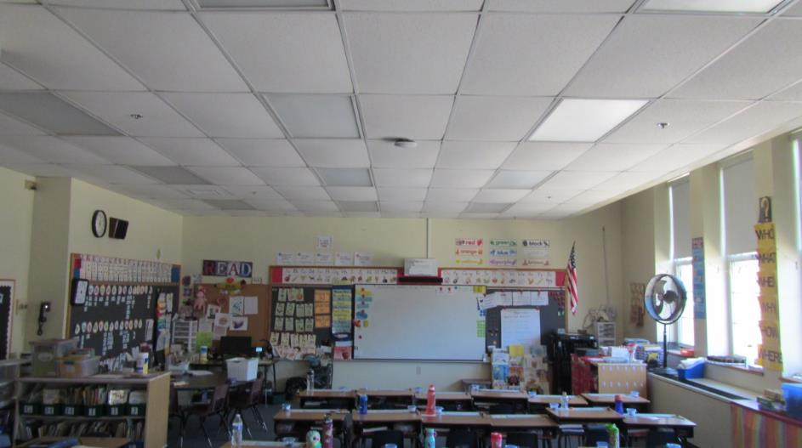
Bowed and damaged ceiling tiles
Picture 2
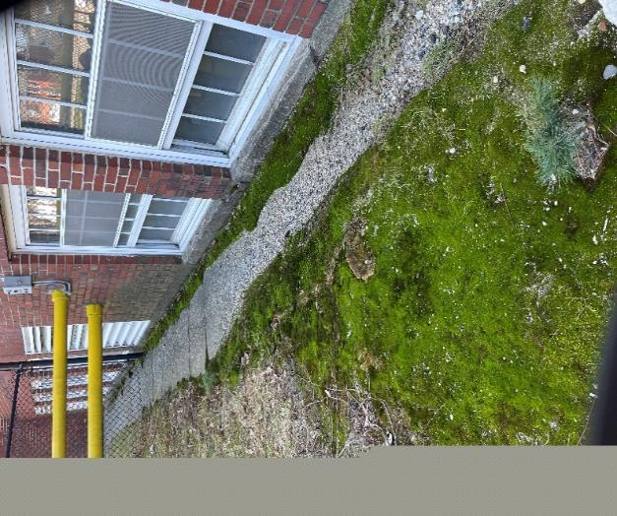
Outdoor apron, note moss growth indicating prolonged water exposure
Picture 3
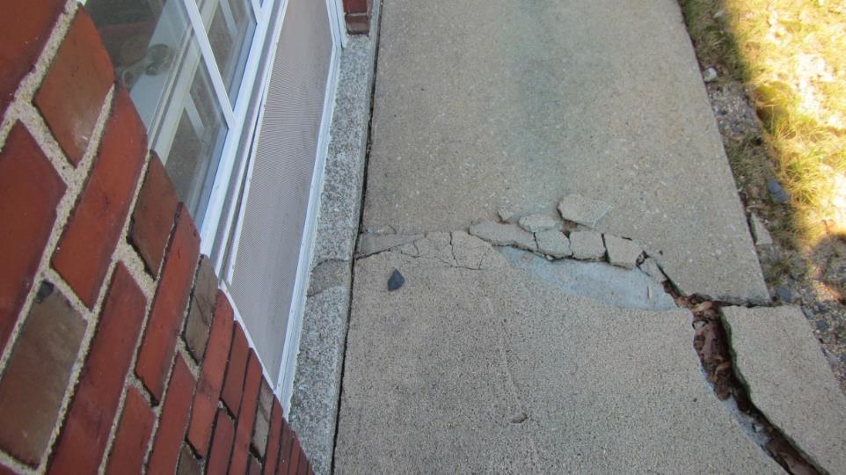
Cracks in apron with apron tilted towards building exterior wall

Location/ Room | Carbon  Dioxide  (ppm) | Carbon Monoxide  (ppm) | Temp  (°F) | Relative  Humidity  (%) | PM2.5  (µg/m³) | VOCs  (ppm) | Occupants  in Room | Windows  Openable | Ventilation |  | Remarks
 |  |  |  |  |  |  |  |  | Supply | Exhaust
Background (outside) | 395 | ND | 65 | 25 | 1 | ND |  |  |  |  | Windy
Room 16 office | 905 | ND | 75 | 33 | ND | ND | 3 | Y | Y | Y
42 | 573 | ND | 75 | 27 | ND | ND | 0 | Y | Y | Y | Kiln, paint stored on unit ventilator
43 | 489 | ND | 74 | 23 | ND | ND | 2 | Y | Y | Y | Plants, items stored on unit ventilator
32 | 514 | ND | 72 | 24 | ND | ND | 0 | Y | Y | Y | Carpet, items blocking unit ventilator, bowed CTs, Clorox wipes
33 | 551 | ND | 73 | 26 | ND | ND | 18 | Y | Y | Y | Bowed CTs
34 | 480 | ND | 73 | 22 | ND | ND | 0 | Y | Y | Y
35 | 521 | ND | 73 | 23 | ND | ND | 1 | Y | Y | Y | Carpet
36 | 1014 | ND | 74 | 31 | ND | ND | 18 | Y | Y | Y
30 | 547 | ND | 74 | 25 | ND | ND | 2 | N/A | Y | Y | Carpet
31 | 517 | ND | 74 | 25 | ND | ND | 0 | N/A | Y | Y | CTs missing, air purifier, throw rug
11 | 543 | ND | 74 | 22 | ND | ND | 1 | N/A | Y | Y | WD CTs
20 | 531 | ND | 74 | 21 | ND | ND | 0 | Y | Y | Y | Plants
Cafeteria | 705 | ND | 73 | 24 | ND | ND | 2 | N/A | Y | Y
1 | 432 | ND | 74 | 15 | ND | ND | 0 | N | Y | Y | Laminator
3 | 598 | ND | 73 | 23 | ND | ND | 0 | Y | Y | Y | Carpet below grade
4 | 1162 | ND | 73 | 30 | ND | ND | 26 | Y | Y | Y | Carpet below grade
5 | 703 | ND | 73 | 24 | ND | ND | 2 | Y | Y | Y | Carpet below grade, throw rug on carpet
7 | 574 | ND | 73 | 22 | ND | ND | 1 | Y | Y | Y
Maintenance Room | 509 | ND | 71 | 26 | ND | ND | 0 | Y | Y | Y
9 | 733 | ND | 73 | 24 | ND | ND | 26 | Y | Y | Y
Gym/Auditorium | 538 | ND | 72 | 20 | ND | ND | 23 | N/A | Y | Y
19 | 419 | ND | 73 | 18 | ND | ND | 0 | Y | Y | Y | Plants, food on floor
21 | 531 | ND | 72 | 21 | ND | ND | 20 | Y | Y | Y
22 | 503 | ND | 73 | 22 | ND | ND | 0 | Y | Y | Y | Plants
26 | 542 | ND | 74 | 22 | ND | ND | 5 | N/A | Y | Y
10 | 517 | ND | 74 | 21 | ND | ND | 0 | N/A | Y | Y
00 | 534 | ND | 74 | 22 | ND | ND | 0 | N/A | N | N
23 | 836 | ND | 74 | 26 | ND | ND | 15 | Y | Y | Y
24 | 682 | ND | 73 | 19 | ND | ND | 21 | Y | Y | Y
12/Library | 549 | ND | 74 | 22 | ND | ND | 21 | N/A | Y | Y
13 | 663 | ND | 74 | 26 | ND | ND | 0 | Y | Y | Y | Plants
14 | 778 | ND | 73 | 27 | ND | ND | 0 | Y | Y | Y
39 | 584 | ND | 74 | 26 | ND | ND | 0 | Y | Y | Y | Air purifier, air freshener plug-in
27 | 591 | ND | 74 | 24 | ND | ND | 7 | N/A | Y | Y | Ceiling-mounted unit ventilator, signs of condensation
28 | 494 | ND | 74 | 25 | ND | ND | 0 | N/A | Y | Y
28 (outer) | 559 | ND | 74 | 25 | ND | ND | 1 | N/A | Y | Y | Several air purifiers
38 | 900 | ND | 74 | 28 | ND | ND | 0 | Y | Y | Y | Carpet, vents blocked
37 | 460 | ND | 73 | 20 | ND | ND | 0 | Y | Y | Y | Plants
29 | 503 | ND | 74 | 23 | ND | ND | 0 | N/A | Y | Y | Air purifier
41 | 588 | ND | 74 | 24 | ND | ND | 0 | Y | Y | Y
Principal’s Office | 663 | ND | 73 | 26 | ND | ND | 2 | Y | Y | Y
Nurses Office | 661 | ND | 75 | 25 | ND | ND | 1 | Y | Y | Y
18 | 619 | ND | 74 | 26 | ND | ND | 1 | Y | Y | Y

Location | Air Temp  (°F) | Relative Humidity  (%) | Dew Point  (°F) | Floor Temp  (°F) | Bowed Ceiling Tiles? | Carpeted? | Floor to Air Temp  Difference  (°F) | Comments
Background (outdoors) | 68 | 88 | 64 |  |  |  |  | Clear skies, sunny
Cafeteria | 74 | 24 | 34 | 74 |  |  | 0
1 | 74 | 15 | 23 | 66 |  |  | 8
3 | 74 | 24 | 32 | 67 |  |  | 7
4 | 74 | 24 | 32 | 68 |  |  | 6
5 | 74 | 25 | 36 | 67 |  |  | 7
7 | 74 | 22 | 22 | 67 |  |  | 7
Facility supervisor | 71 | 27 | 27 | 64 |  |  | 7
9 | 73 | 24 | 24 | 61 |  |  | 12
Gymnasium | 72 | 21 | 21 | 59 |  |  | 13 | Membrane floor
Hallway connecting gym to school | 73 | 21 | 21 | 74 |  |  | -1 | 7 water-damaged ceiling tiles, carpet rippled, exterior door

- The service life is the median time during which a particular system or component of … [an HVAC] … system remains in its original service application and then is replaced. Replacement as building characteristics or energy prices (ASHRAE, 1991), maintenance cost, and changed system requirements due to such influences as building characteristics or energy prices (ASHRAE, 1991).

