Health Safety Net (HSN) Special Circumstances &
Bad Debt Web Application User Guide

March 6, 2013

Revision History
August 28, 2008 | Initial release
January 2012 | Updates and Signature Page
November 5, 2012 | Added process for submission of bad debt applications.
November 30, 2012 | Updated column header names and birth date format for bad debt applications.

Table of Contents

1. Overview 1
1.1 Introduction 1
1.2 INET User Registration 1
2. Step by Step Process to File 1
2.1 Log In to INET 1
2.2 INET Main Menu 3
2.3 Special Circumstances Home Page 4
2.4 Filing a New Application 4
2.4.1 Medical Hardship 5
2.4.2 Confidential Minors and Battered/Abused 6
2.5 Applicant General Information 6
2.6 Family Members 7
2.7 Income Information 8
2.8 Medical Expenses 10
2.9 Additional Information 11
2.10 PDF All 11
2.11 Eligibility Verification 12
2.12 Facility Calculation 12
2.13 Submit Application 14
3. Existing Application 15
5. Bad Debt Applications 16
5.1 How to Access the Bad Debt Application 16
5.2 How to Manually Submit an Application 17
5.2.1 Required Information 18
5.2.2 Non-U.S. Residents 19
5.2.3 No Patient Information 20
5.3 How to Batch Upload Applications 21
5.4 How to Export Applications 21
5.5 How to View Applications 22
5.5.1 Search Applications by Application ID 22
5.5.2 Search Applications by Name 22
5.5.3 Search Applications by SSN 23
5.5.4 Display All Applications 23
5.5.5 Batch File CSV File Format 23
5.6 Duplicate Applications …………...…………………………………………… 27
5.7 Races …………………...………...…………………………………………… 28
5.8 States ………………………………………………………………………….. 29

Overview
This is a user guide for filing a Special Circumstances Application or Bad Debt Application using the Health Safety Net’s INET Web application. Questions involving the submission of a special circumstances application or bad debt application should be directed to HSN’s Help Desk at (800) 609-7232 or hsnhelpdesk@state.ma.us.

Introduction
The HSN has deployed a web application for collecting Special Circumstances Applications electronically. Beginning on November 1st, 2012, electronic collection of Bad Debt Applications will also occur. Providers must connect to the HSN’s “INET” web site at: https://dhcfpinet.hcf.state.ma.us/ to submit these applications.

A new menu item under the Special Circumstances Filing Applications menu item has been added for accessing bad debt applications. Please note that additional references in this guide to the phrase “Special Circumstances Web Application” will be abbreviated as “SPECIR”.

INET User Registration
Users who will enter data and submit SPECIR or bad debt applications must be registered for the INET application. Users may submit a request to the HSN for registration. After a registration request for adding new INET user is processed, the registered user will receive the login credentials via email.
To add or delete new INET users contact the HSN Help Desk at (800) 609-7232 or hsnhelpdesk@state.ma.us.

Step by Step Process to File
The following describes all the necessary steps to complete and submit the SPECIR electronically.

Log In to INET
Log in to INET at https://dhcfpinet.hcf.state.ma.us/ and use the login credentials provided by the HSN.
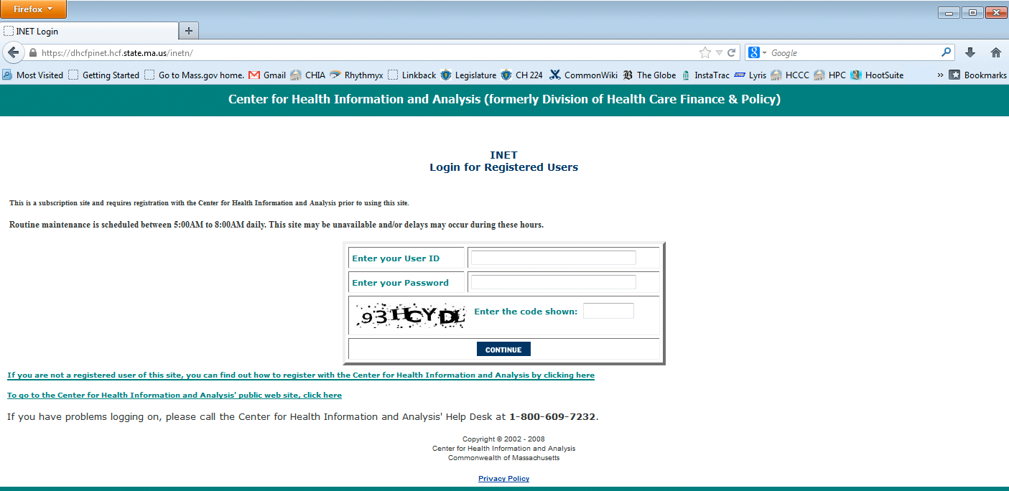

- Caution: Inactivity for 20 minutes will cause the internet session to time-out, and you will lose any unsaved data!

INET Main Menu
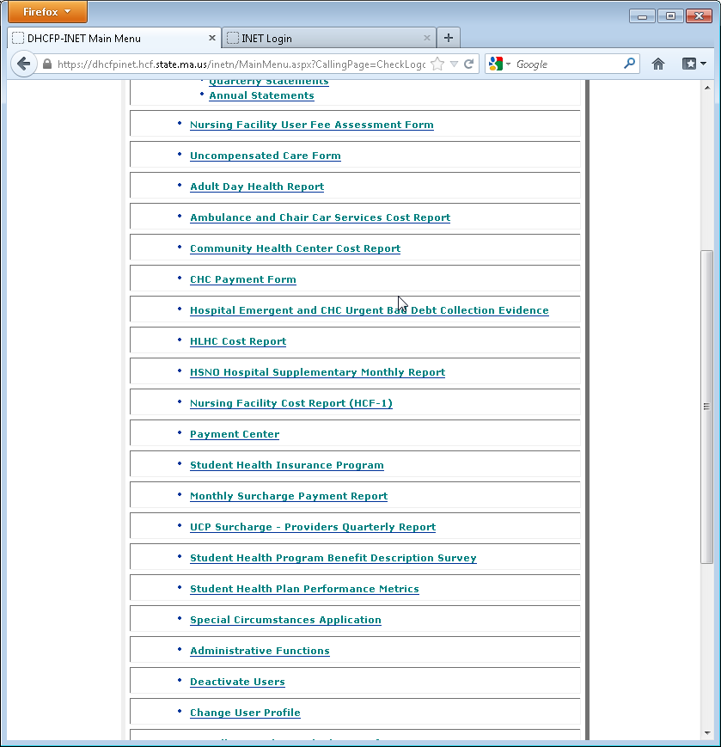

After a successful login, the INET main menu will be displayed. Click the “Special Circumstances Application” menu choice to proceed.

Special Circumstances Home Page
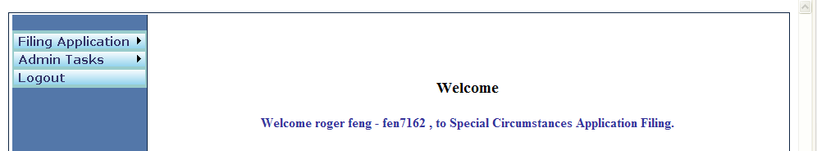
External Users will see two menu items in the left pane: “Filing Application” and “Logout”.
“Filing Application” is described in 2.4. ”Admin Tasks” is for use by the Health Safety Net only.
The “Logout” link exits SPECIR and INET and returns the user to the INET Login.

Filing a New Application
To create a new application, click the “Filing Application/New Application” menu in the left pane.
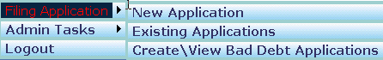
Select/Enter appropriate information in the “Create Special Circumstances Application” screen and click “Create Application” button.
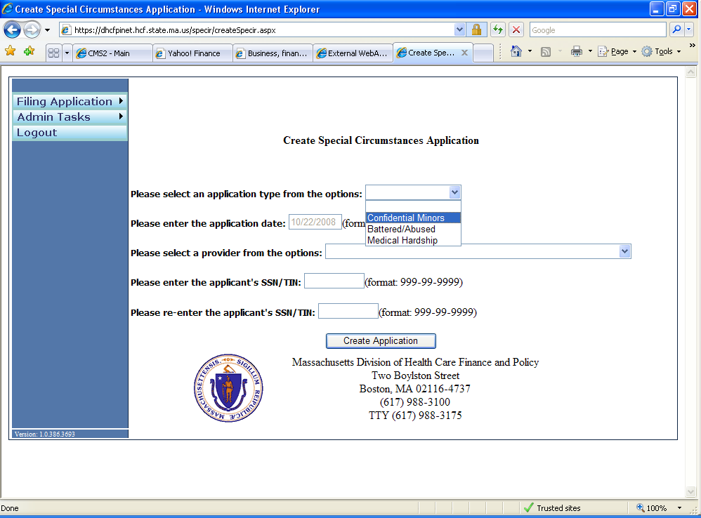
Applications can be submitted for Medical Hardship, Confidential Minors and Battered/Abused.
The SSN/TIN field is required. If a person has no SSN or TIN, please fill in 999-99-9999 or 000-00-0000

Medical Hardship
The following describes all the necessary steps to complete and successfully submit a Medical Hardship Application electronically:
- Enter the “Applicant General Information”.
- Enter the “Family Members Information”.
- Enter the “Income Information”.
- Enter the “Medical Expenses Information”.
- Enter the “Additional Information”.
- Make sure steps 1 through 5 are completed successfully. Enter the “Eligibility Verification” information.
- Before proceeding to step 1, make sure all the data entered from Step 1 through Step 6 are correct. Enter the “Facility Calculation”.
- This is the last step for completing a “Medical Hardship” application. If the applicant appears eligible for Medical Hardship, “Submit Application” submenu will appear in the “Facility Use Only” main menu. Enter the “Submit Application” information.
- Print the completed application in PDF format.
- Applicant or person completing the application on behalf of applicant must sign and date the application. In addition, the user must add the name of the submitter to the provider acknowledgement and send it along with the supporting documentation to the Health Safety Net.

Confidential Minors and Battered/Abused
The following describes all the necessary steps to complete and successfully submit a Confidential Minors or Battered/Abused Application electronically:
- Enter the “Applicant General Information”.
- Enter the “Family Members Information”. Not applicable for Confidential Minors.
- Enter the “Income Information”.
- Enter the “Additional Information”.
- Enter the “Eligibility Verification”.
- Before proceeding make sure all the data entered from Step 1 through Step 5 are correct. Enter the “Facility Calculation”.
Enter the “Submit Application”.

Applicant General Information
Once a new application is created, the “Applicant General Information” page appears as a default data entry screen as shown below.
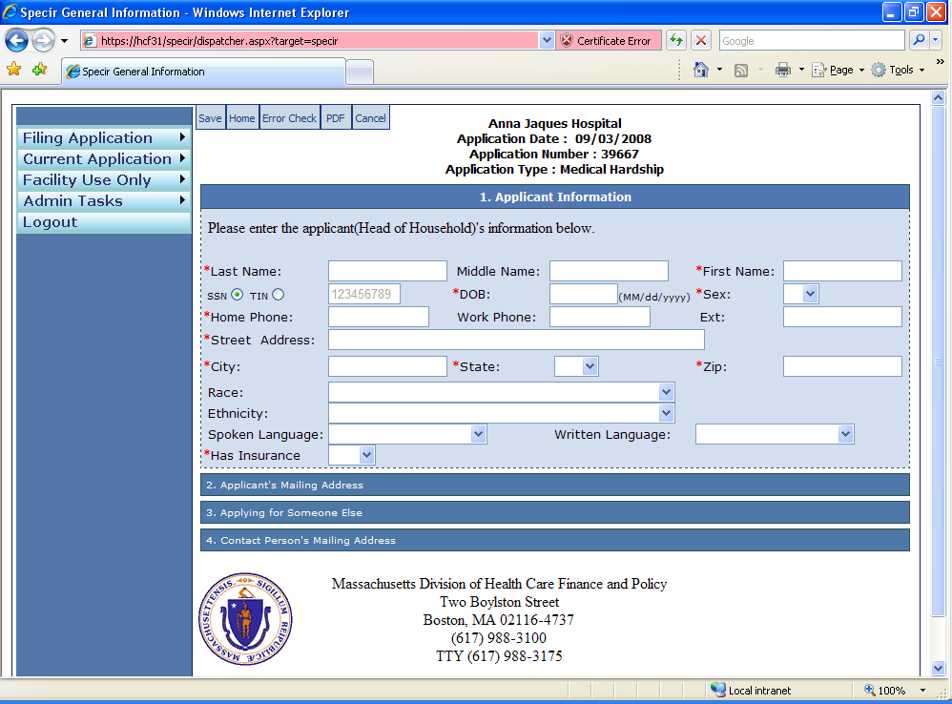

The user can also get to the “Applicant General Information” page via the “Current Application” left pane menu.
- The user must enter data in all required fields (*) in the first tab “1. Applicant Information”.
- If applicable, enter data in tabs “2. Applicant’s Mailing Address”, “3. Applying for Someone Else” and “4. Contact Person’s Mailing Address”.
- Save by clicking on the blue “Save” button 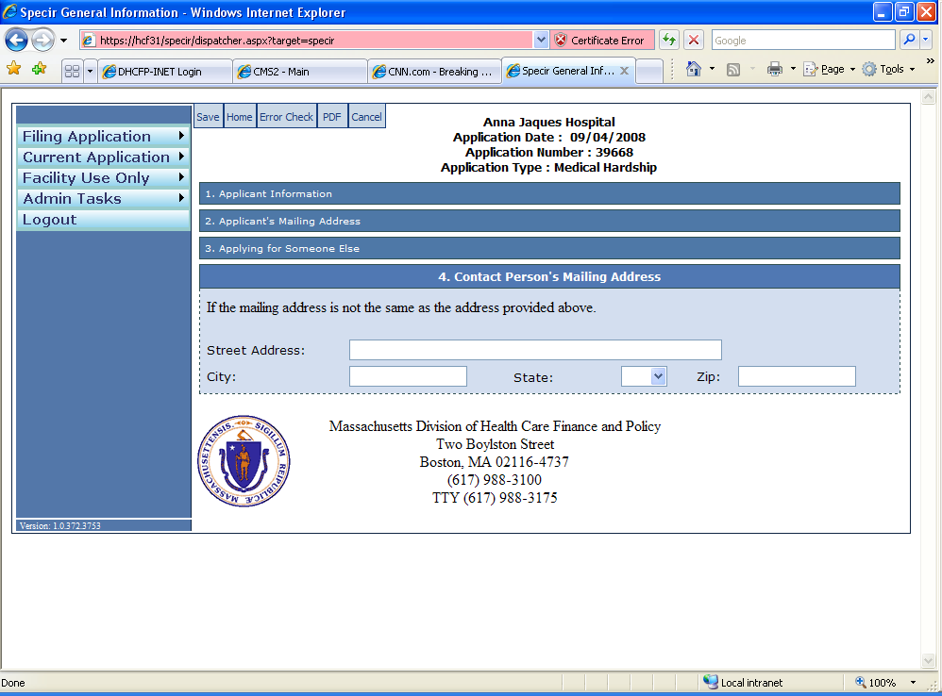 on the “Applicant General Information” screen.
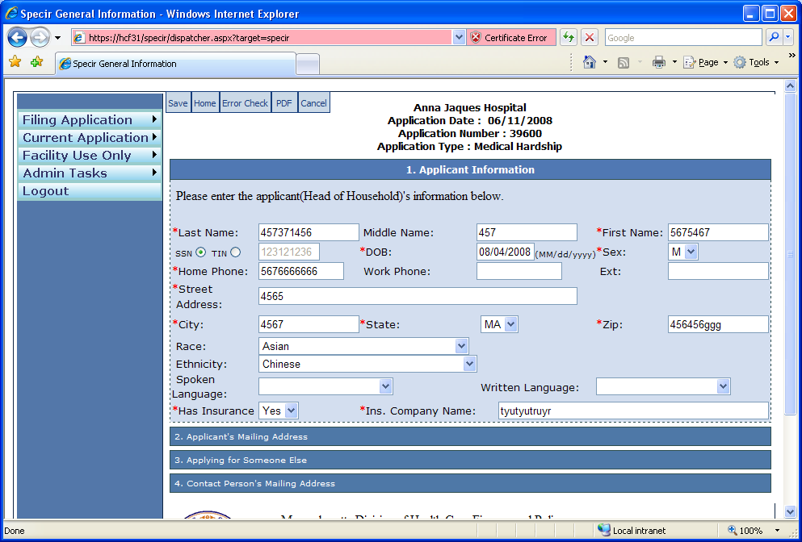

Family Members
Select the “Family Members” submenu from the “Current Application” menu as shown below.
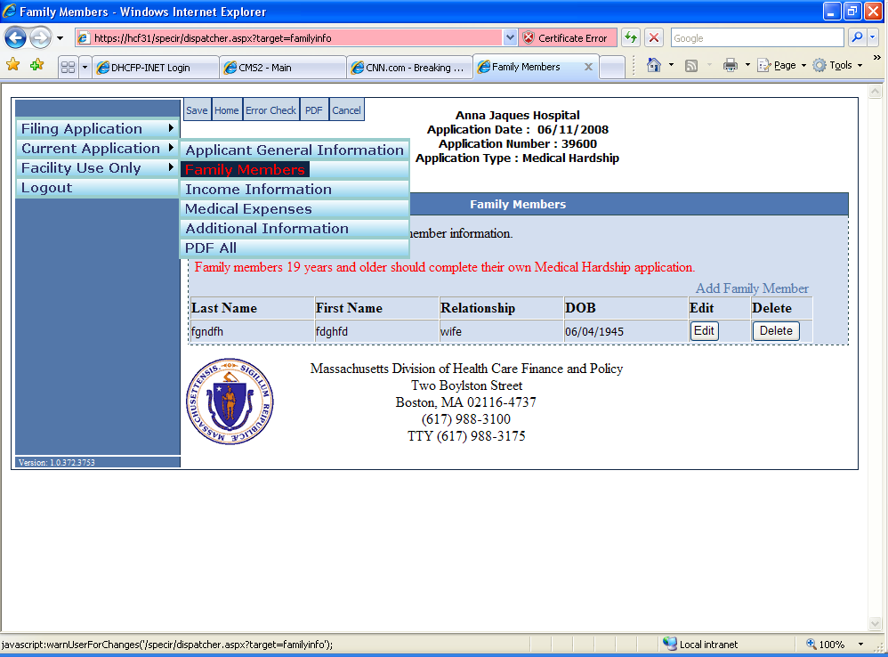

- To add a family member, click the “Add Family Member” link on the “Family Members” screen as shown in the example below.
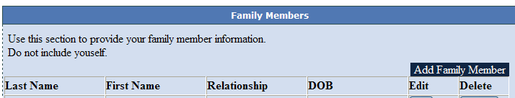

- Enter all the required (*) family member’s information and all applicable optional information in the “Family Member Detail” screen as shown in the example below and click “OK” button to save the data.
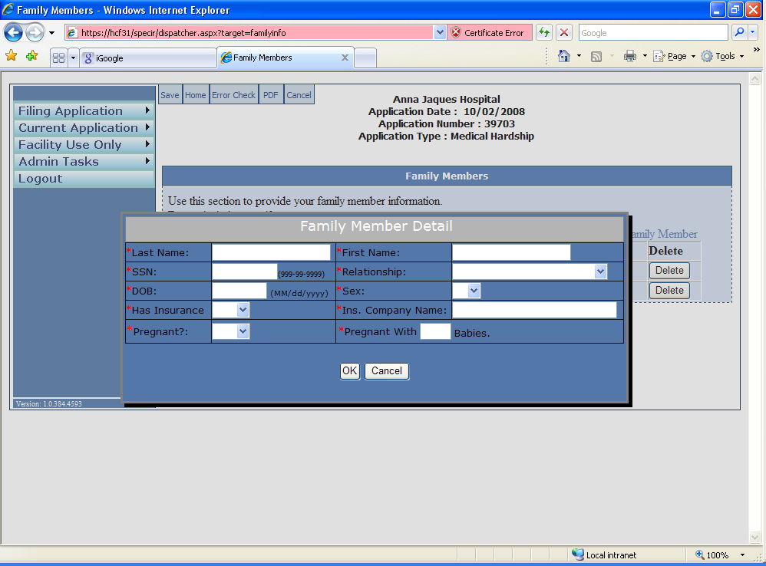

- To edit or delete a family member’s information click the corresponding “Edit” or “Delete” button in “Family Members” screen as shown below.
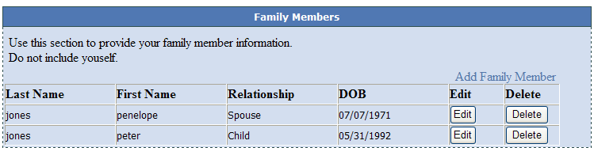
- Save by clicking on the blue “Save” button on the “Family Members” screen.

Income Information
Select the “Income Information” submenu from the “Current Application” menu as shown below.
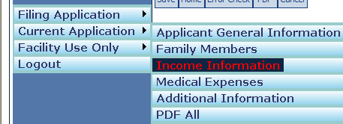
The user needs to enter all applicable income information – Earned Income and Unearned Income.

Earned Income
- To add an earned income, click the “Add Earned Income” link on the “Income” screen as shown in the example below.
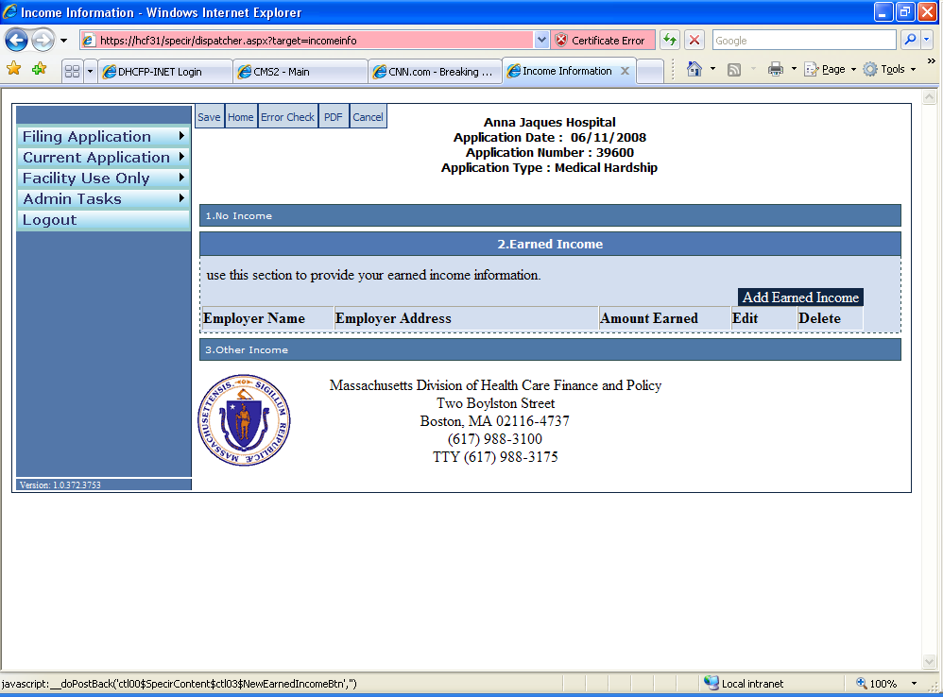

- Enter all the required (*) earned income information and all applicable optional information in the “Earned Income Detail” screen as shown in the example below and click “OK” button to save the data.
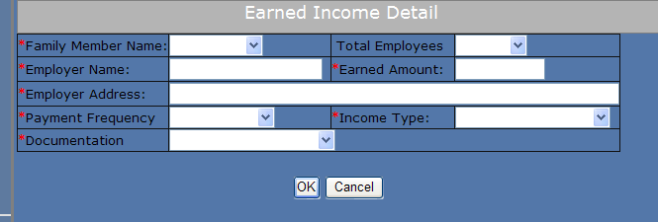

- To edit or delete a Earned Income information click the corresponding “Edit” or “Delete” button in “Earned Income” screen as shown below.
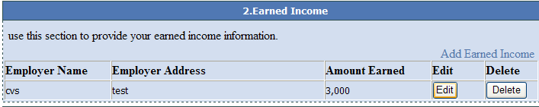
- Save by clicking on the blue “Save” button on the “Income” screen.

Unearned Income
- To add other income, click the “Add Unearned Income” link on the “Income” screen as shown in the example below.
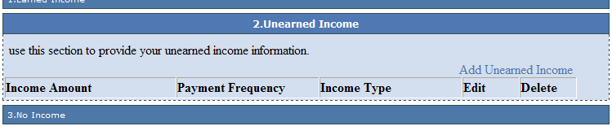

- Enter all the required (*) unearned income information in the “Unearned Income Detail” screen as shown in the example below and click “OK” button to save the data.
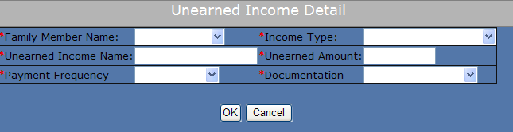

- To edit or delete a Unearned Income information click the corresponding “Edit” or “Delete” button in “Unearned Income” screen as shown below.
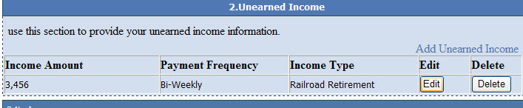
- Save by clicking on the blue “Save” button on the “Income” screen.

Medical Expenses
This section is applicable for Medical Hardship application.
Select the “Medical Expenses” submenu from the “Current Application” menu as shown below.
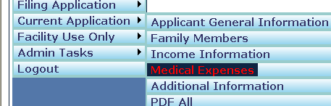
The user needs to enter all applicable medical expense information.

To add a medical expense, click the “Add Medical Expense” link on the “Medical Expenses” screen as shown in the example below.
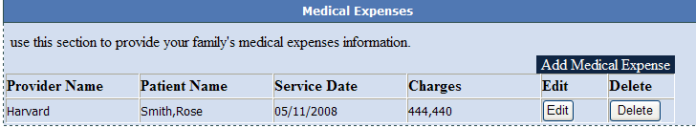

- Enter all the required (*) medical expense information in the “Medical Expense Detail” screen as shown in the example below and click “OK” button to save the data.
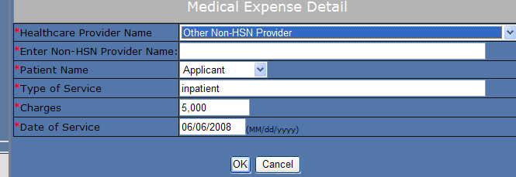

- To edit or delete a Medical Expense information click the corresponding “Edit” or “Delete” button in “Medical Expenses” screen as shown below.
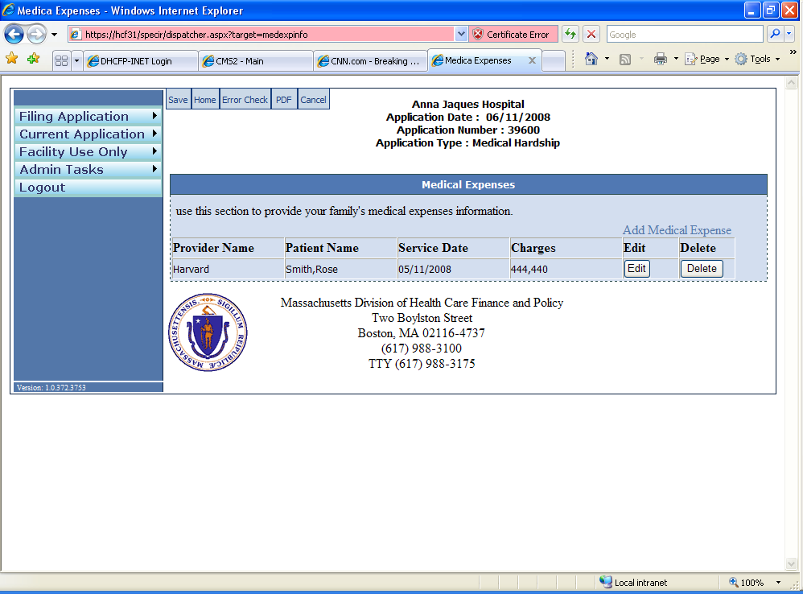

- Save by clicking on the blue “Save” button on the “Medical Expenses” screen.

Additional Information
Select the “Additional Information” submenu from the “Current Application” menu as shown below.
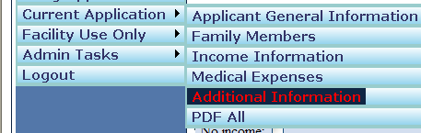

- Enter any additional information in the provided text area in the “Additional Information” screen. The comments here that relate to this application.
- Save by clicking on the blue “Save” button on the “Additional Information” screen.

PDF All
Select the “PDF All” submenu from the “Current Application” menu as shown below.
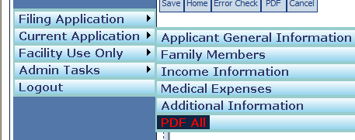
Selecting the “PDF All” link generates a PDF file of the filed special circumstances application. The user will have the option to either “Save” or “Open” the PDF.
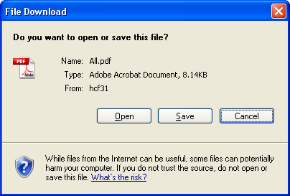

Eligibility Verification
Select the “Eligibility Verification” submenu from the “Facility Use Only” menu as shown below.
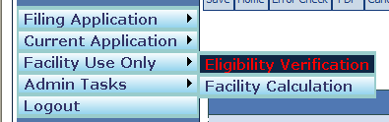
- The user must enter data in all required fields (*) in the second tab “2. Residency Documentation”.
- Save by clicking on the blue “Save” button on the “Eligibility Verification screen” screen.

Facility Calculation
Select the “Facility Calculation” submenu from the “Facility Use Only” menu as shown below.
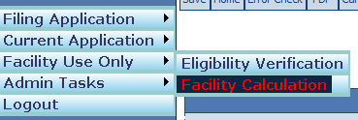

Medical Hardship
Medical Hardship eligibility will be determined by the HSN and not within this application. This application will be used to enter Medical Hardship applications.

The following section is an example of a “Medical Hardship” determination within the Facility Calculation Tab of the Facility Use Only subsystem. This section contains the following tabs:

General Information: Displays demographic information of the applicant.

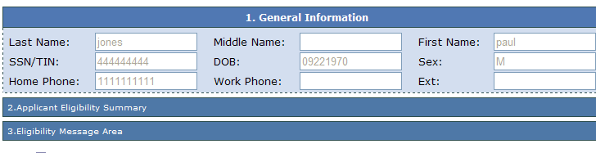

Applicant Eligibility Summary: Family Size, Family Income, % of Federal Poverty Level (FPL). The provider MUST click the “Calculate” button to determine eligibility. Any time the provider makes changes to the schedules, the provider must click the “Calculate” button to update information.

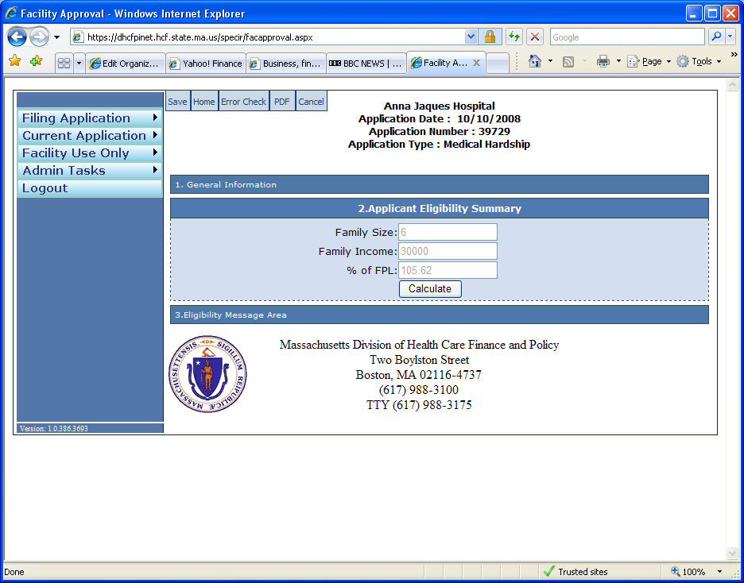

Eligibility Message Area: This area displays appropriate messages once the “Calculate” button in the “Applicant Eligibility Summary” has been clicked.

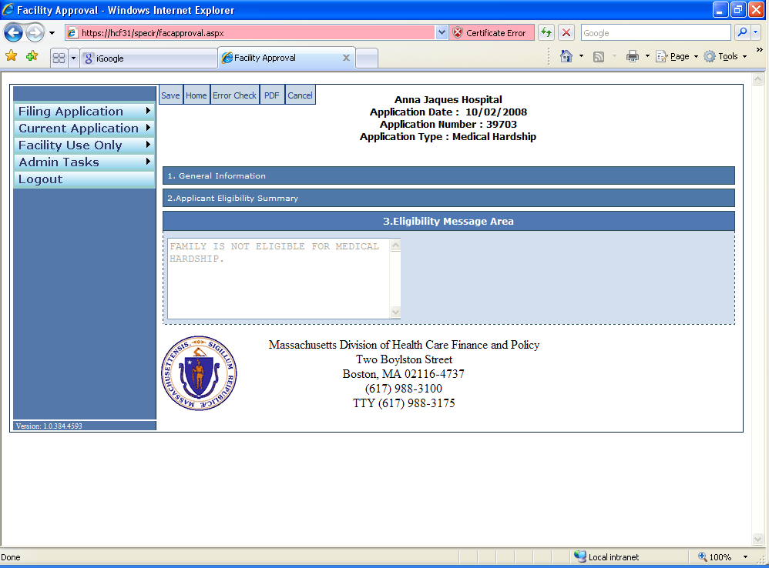
Save by clicking on the blue “Save” button on the “Facility Calculation” screen.

Confidential Minors, Battered/Abused

The following section is an example of a “Confidential Minors, Battered/Abused” determination within the Facility Calculation Tab of the Facility Use Only subsystem. This section contains the following tabs:

General Information: Displays demographic information of the applicant.

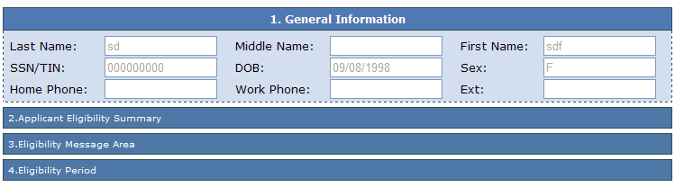

Applicant Eligibility Summary: Family Size, Family Income, % of Federal Poverty Level (FPL), HSN Partial Deductible. The provider MUST click the “Calculate” button to determine eligibility.

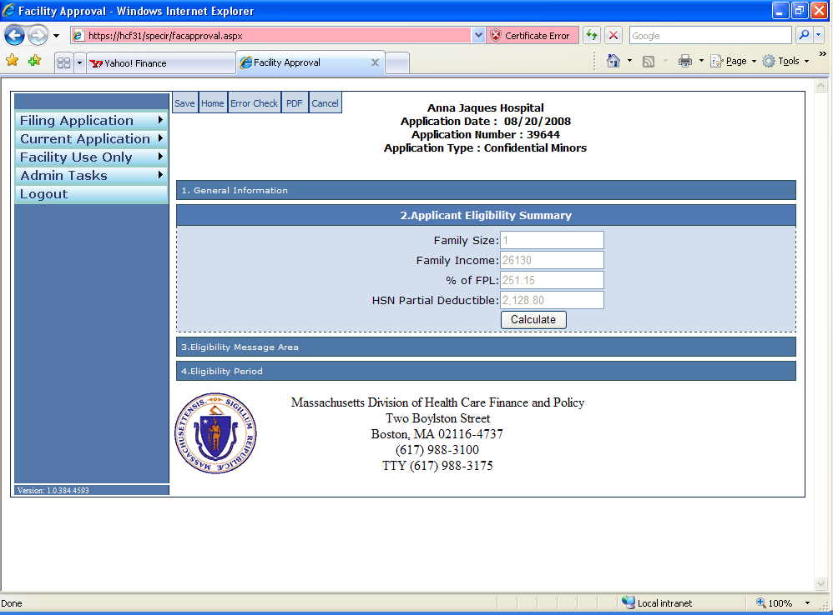

Eligibility Message Area: This area displays appropriate messages once the “Calculate” button in the “Applicant Eligibility Summary” has been clicked.

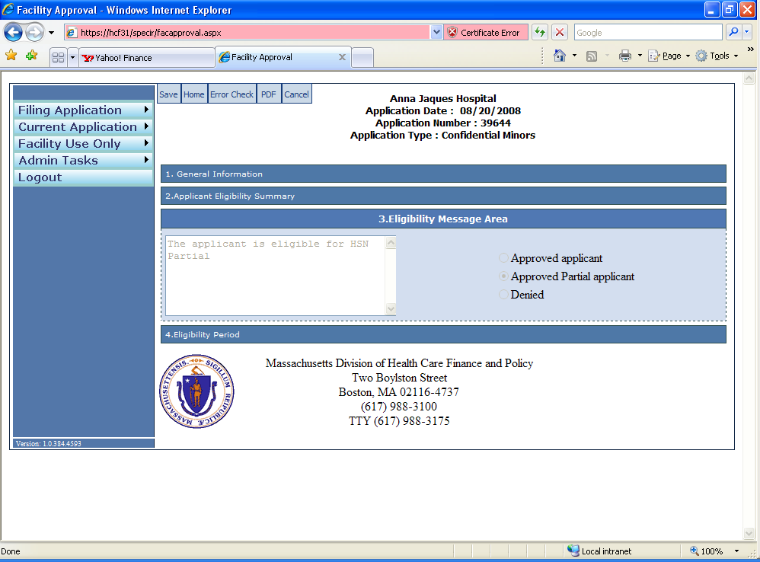

Eligibility Period: Submit Date, Determination Date, Eligibility Begin Date and Eligibility End Date are pre-populated.
Save by clicking on the blue “Save” button on the “Facility Calculation” screen.

Submit Application
This is the last step for completing a SPECIR application.
NOTE: For Medical Hardship application the “Submit Application” submenu will appear in the “Facility Use Only” main menu ONLY if the applicant appears eligible for Medical Hardship.
If the submit application tab does not appear, the registered user should revisit each page of the application and click the “Save” button. The “Submit” button will appear.

The following describes all the necessary steps to complete and successfully submit a SPECIR Application electronically:
- Verify that all the sections in the “Current Application” menu are completed and saved.
- Verify that all the sections in the “Facility Use Only” menu are completed, eligibility is calculated and information is saved.

Select the “Submit Application” submenu from the “Facility Use Only” menu as shown below.
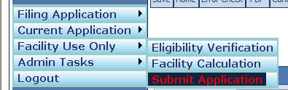

- Acknowledge the accuracy of the application by checking the Submitter’s acknowledgement checkbox.
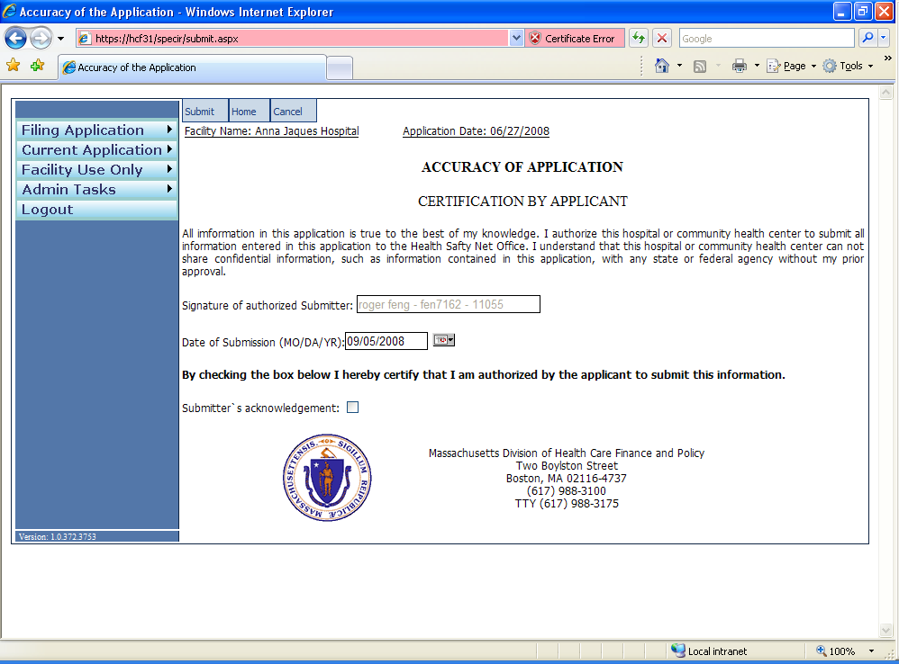
- Submit by clicking on the blue “Submit” button on the top left side of the “Acknowledgement” screen.

Existing Application
The following describes all the necessary steps to edit/update an already created and saved application. The provider that has been submitted cannot be edited unless a reopen request is granted. See Section 4 for details.
- Log in to the INET web application if not already logged in. (See Section 2.1, 2.2, 2.3)
- Select “Existing Applications” submenu from the “Filing Application” main menu
- Select the provider from the list provided.
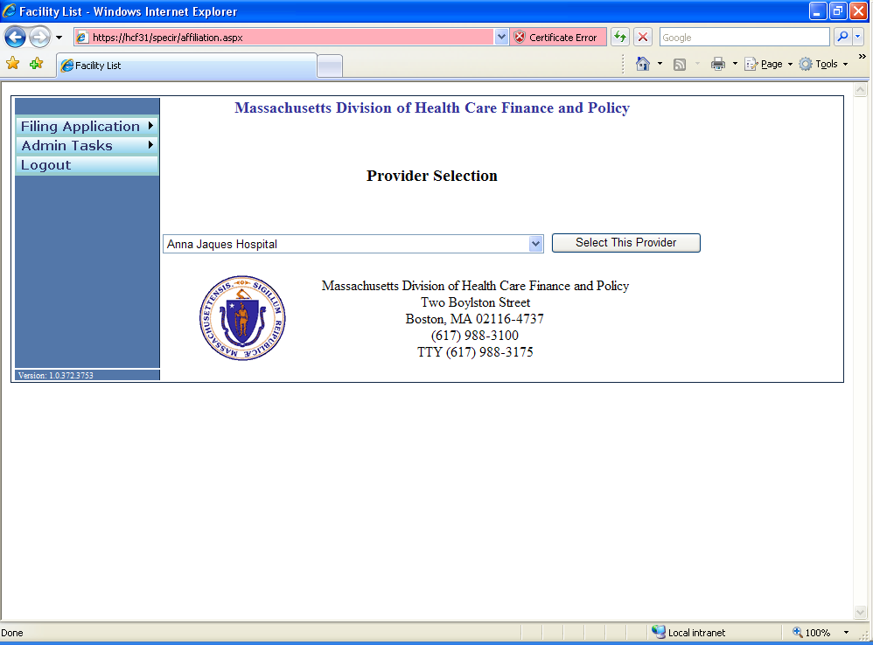

- Click the “Application ID” from the displayed application list.
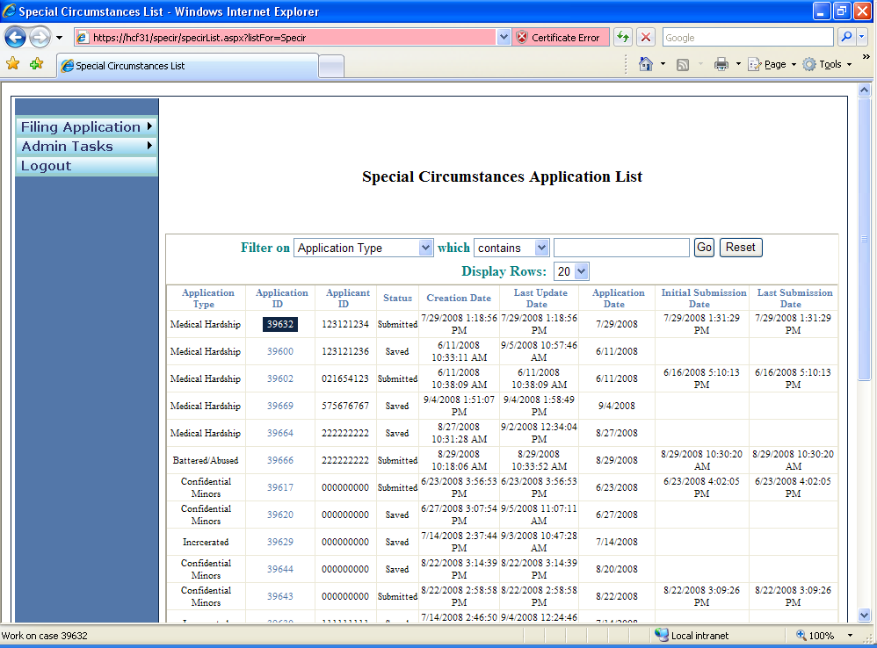
- Follow steps as needed to edit applicant information

Bad Debt Applications
This section describes how to:
- Access the bad debt web application.
- Submit bad debt applications.
- Batch upload multiple applications.
- Export existing applications to a CSV file.
- View existing applications.

How to Access the Bad Debt Application
You must be registered with the INET system in order to enter Bad Debt applications. If you are not registered with INET please go to INET User Registration and follow the steps in that section to register. Once registered, follow these steps to log in to INET and navigate to the Bad Debt application.
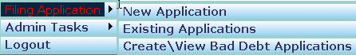

- Log into INET as described in 2.1 Log in to INET.
- Click on Special Circumstances Application menu item. See 2.2 INET Main Menu.
- INET System displays the Special Circumstances Welcome page.
- Click on Filing Application in the left menu.
- Click on Create\View Bad Debt Applications.
- The INET system displays the Bad Debt Welcome web form.
- Once you are on the Bad Debt Welcome web form you can:
    - Submit a new application.
    - View existing applications.
    - Batch upload applications.
    - Export applications to a CSV file.

    - Return to the INET Main menu.

How to Manually Submit an Application
This section describes how to manually enter bad debt applications.
Bad debt applications should be submitted ONLY in those instances where a patient does not have an existing member id. Providers must ensure that all patient information is submitted for a referred eligibility record to be created.
Upon logging on to the main screen of the bad debt application, providers will see 3 radio buttons. One of the buttons must be selected in order for an application to be processed. NOTE: The application will default to the “None of the above” button.

- None of the above – this button should be selected when a provider has all required information (as noted in 5.2.1) for an individual residing in the United States.
- By selecting this option, provider affirms that patient is not a resident of the United States – this button should be selected when a provider is submitting a bad debt application for a patient who is not a resident of the United States (please refer to section 5.2.2 below).
- By selecting this option, provider affirms that they have exhausted all efforts and have been unable to capture patient information – this button should be selected when a provider does not have patient information as noted in section 5.2.3 below.

Required Information
Providers should have all of the following pieces of information available prior to entering a bad debt application.
- First name
- Last name
- Middle Initial
- Street Address
- City
- State
- Zip Code
- Social Security Number
- Birth Date
- Race
- Gender

Once you have collected required patient information, providers can enter the application following these steps:
- Log into INET and navigate to the Bad Debt application as described in How to Access the Bad Debt Application.
- Click on New Application menu item.
- The Bad Debt system displays the initial page of the application.
- Select the provider you want to use for this application.
- The Bad Debt system automatically fills in the current date for the application date.
- Click on Submit.
- The Bad Debt system displays page 2 of the application.
- Enter the patient information into the form.
              - Enter birth date in the format mm/dd/yyyy.
Enter SSN in the format 000-00-000 or 000000000.
Enter a 5-digit zip code.
- Click on Submit button.
- The Bad Debt system validates the patient information. If errors are detected, the system displays error messages below each field with an error. Correct these errors and then click on the Submit button again.
- The Bad Debt system checks for duplicate applications by comparing the application entered to existing applications in the Bad Debt system. When a duplicate application is detected the Bad Debt system displays an error message. Update the application and attempt to submit it again. See Duplicate Applications below for more information.
- When the patient information is valid the Bad Debt system saves the patient information in the Bad Debt system and displays a confirmation page indicating the information was successfully saved.
- Providers needing to enter more applications should click on New Application and repeat the process.

Non-U.S. Residents
There may be cases where a patient has a non-U.S. (foreign) address. For these cases only, providers should perform the following steps.
- Log into INET and navigate to the Bad Debt application as described in How to Access the Bad Debt Application.
- Click on New Application.
- The Bad Debt system displays page 1 of the application.
- The Bad Debt system automatically fills in the application date with the current date.
- Select the provider you want to use for this application.
- The Bad Debt system displays page 2 of the application.
  - The system populates Address, city, state and zip code fields with the provider’s address information. NOTE: HSN staff may, at any time, request written proof from a provider verifying that a patient is not a resident of the United States.
- Enter the patient’s name, SSN and birth date. When the patient doesn’t have an SSN enter 000000000.
- Select the gender of the patient.
- Select the race of the patient.
- Click Submit.
- The Bad Debt system validates the information you entered. If any patient information is invalid, the Bad Debt system displays error messages below the fields with errors.
- The Bad Debt system checks for duplicate applications by comparing the application you entered to existing applications in the Bad Debt system. When a duplicate application is detected the Bad Debt system displays an error message. Update the application and attempt to submit it again. See Duplicate Applications below for more information.
- When all patient information is valid, the Bad Debt system saves the patient information in the Bad Debt system and displays a confirmation page indicating the information was successfully saved.

No Patient Information
There may be cases where a provider does not have any patient information to submit a Bad Debt application. These cases should be rare and occur only after a provider has performed due diligence and exhausted all available means of trying to collect patient information. For these cases only, providers should perform the following steps.

- Log into INET and navigate to the Bad Debt application as described in How to Access the Bad Debt Application.
- Click on New Application.
- The Bad Debt system displays page 1 of the application.
- The Bad Debt system automatically fills in the application date with the current date.
- Select the provider you want to use for this application.
- The Bad Debt system displays page 2 of the application.
- Check the 1st checkbox at the top of the web form labeled: “By checking this box, provider affirms that they have exhausted all efforts and have been unable to capture patient information.”
- The Bad Debt system fills in the first name, last name, street address, city, state, and zip code with the name and address of the provider you selected on page 1 of the application.
- The Bad Debt system fills in 000000000 for the SSN.
- Enter the estimated birth date of the patient.
- Select the gender of the patient.
- Select the race of the patient.
- Click Submit.
- The Bad Debt system validates the information you entered. If any patient information is invalid, the Bad Debt system displays error messages below the fields with errors.
- When all patient information is valid, the Bad Debt system saves the patient information in the Bad Debt database and displays a confirmation page indicating the information was successfully saved.
- HSN BAD DEBT CLAIMS FOR THE CASES ABOVE (WHERE PATIENT INFORMATION IS NOT AVAILABLE) SHOULD NEVER BE SUBMITTED UNLESS A PROVIDER HAS SUBMITTED A BAD DEBT APPLICATION AS NOTED ABOVE.

5.3

How to Batch Upload Applications
This section describes how to batch upload multiple applications.
- Prepare a CSV file containing the Bad Debt applications to be uploaded based on the table titled Batch File CSV File Format below.
- Log into INET and navigate to the Bad Debt application as described in How to Access the Bad Debt Application.
- Click on Batch File Upload menu item.
- Select the provider you want to submit these applications for.
- Click on the Browse button and browse to the Bad Debt CSV file on your system that you created in step 1.
- Click on Upload button.
- The Bad Debt system reads and validates the CSV file. When errors are detected the Bad Debt system displays those errors at the bottom of the page. Correct the problems and attempt to upload the CSV file again.
- The Bad Debt system checks whether any of the records in your batch upload file matches existing applications in the system, or matches other records in the batch upload file. When duplicates are detected the Bad Debt system displays error messages at the bottom of the page. In this case no records are uploaded from the batch upload file. Remove or correct the duplicate applications and try uploading the batch file again. See Duplicate Applications below for more information.
- When no errors are detected the Bad Debt system saves the Bad Debt applications in the database and displays a message indicating the number of applications successfully read from the CSV file and saved into the database.
- NOTE: Batch upload applications cannot be submitted for cases where no patient information is available or for patients with a foreign address.

5.4 How to Export Applications
This section describes how to export the applications submitted to HSN to a CSV file.
- Log into INET and navigate to the Bad Debt application as described in How to Access the Bad Debt Application.
- Click on Export Applications menu item.
- Click on Export button.
- The Bad Debt system retrieves all applications you submitted to HSN, generates a CSV file, and sends the CSV file to your browser.
- Your browser should display a dialog box at the bottom of your browser with the question: “Do you want to open or save BadDebtApplications.csv from <Computer-Name>?” where <Computer-Name> is the name of your computer.
- If you want to save the CSV file to your download folder click on save.
- If you want to save the CSV file to a folder other than your download folder click on the down arrow in the Save button and select Save As.
- Internet Explorer displays a Save As file dialog box.
- Select the folder you want to save the CSV file to.
- Change the file name if you desire to rename it.
- Click on the “save” button to complete the download and save the CSV file to your computer.

How to View Applications
This section describes how to view applications submitted to HSN.
- Log into INET and navigate to the Bad Debt application as described in How to Access the Bad Debt Application.
- Click on Existing Applications.
- The Bad Debt system displays all applications you entered into the system.
- You can search for applications by Application ID, First Name, Last Name, or SSN.
- You can page through the applications by clicking on the Previous or Next clicks at the top or bottom of the applications data grid.
- Click on View button on the row of the application you want to view. The Bad Debt system will display the application information. You will not be able to edit the application information.

Search Applications by Application ID
- Select Application ID in the Field drop down list.
- Select the appropriate matching operation in the Operation drop down list.
- Enter the application id into the criteria text box.
- Click on Search.
- The Bad Debt system searches for and displays the specified application.

Search Applications by Name
- Select First Name or Last Name in the Field drop down list.
- Select how you want the Bad Debt system to match on the name in the Operation drop down list.
- Enter the patient’s first name or last name into the criteria text box.
- Click on Search.
- The Bad Debt system locates the desired applications by matching on the first or last name and displays the records it finds.

Search Applications by SSN
- Select SSN in the Field drop down list.
- Select the desired matching operation in the Operation drop down list.
- Enter the SSN with or without hyphens: 000000000 or 000-00-0000 into the criteria text box.
- Click on the Search button.
- The Bad Debt system locates the desired applications by looking for matching SSNs and displays the records it finds.

Display All Applications
To display all applications you entered into the system:
- Click on Display All button.

Batch File CSV File Format
You must follow these rules when creating a CSV Batch File:
- Create the CSV file using a text editor like notepad or you may generate the CSV by a software program.
- The first record in the CSV must contain the column headers as shown in the table below.
- The column header names must be separated by a comma.
- The column header names must be spelled exactly as shown in the table below.
- The column header names must use the case exactly as shown in the table below. For example, for “last name” the name must be “Last Name”.
- The column headers must be listed in the order shown in the table below.
- The 2nd and subsequent records must contain the patient records you want to submit to HSN as Bad Debt applications.
- You must create separate CSV batch files for each provider for which you desire to submit Bad Debt applications.
- The number of characters in each data item must be less than or equal to the maximum length of the field as listed in the Length column in the table below.
- You must separate data items with a comma.
- You must surround each data item with double quotes.
- You can put as many records into the CSV file as you desire as long as they are for one provider.
- You may give the file any name you desire.
- The file extension must be csv. Example: BadDebts.csv.

Column | Column Header | Length | Required? | Description
A | Last Name | 20 | Yes | The patient’s last name.
B | First Name | 15 | Yes | The patient’s first name.
C | Middle Initial | 1 | No | The patient’s middle initial.
D | Street Address | 30 | Yes | The patient’s street address.
E | City | 30 | Yes | The patient’s city.
F | State | 2 | Yes | Two letter state abbreviation. Use Code from States table below.
G | Zip | 5 | Yes | 5-digit zip code.
H | Birth Date | 8 | Yes | Format YYYY-MM-DD.  Example: If the person was born on May 12, 1956 the birth date is formatted 1956-05-12.  The birth date must be equal to or greater than January 1, 1912.
I | Gender | 1 | Yes | M or F.
J | SSN | 9 | Yes | You may leave out hyphen between the number groups or may use hyphens:  Examples:  000000000  000-00-0000
K | Race | 6 | Yes | Use the Code from the Races table below. Example: When the patient is Caucasian put WHITE into this column.

Duplicate Applications
This section describes how the Bad Debt system detects and reports duplicate applications during manual application data entry and batch upload operations.
You should review your applications prior to entering or batch uploading them to ensure they do not match any applications you previously entered or batch uploaded.
An application is considered a duplicate if the data fields below match corresponding fields in existing applications in the Bad Debt system or match records in a batch upload if you are submitting applications via the batch upload process:
- First name
- Middle initial
- Last name
- Date of Birth
- SSN
When you manually enter an application the Bad Debt system compares your manually entered application to existing records in the Bad Debt system. When a duplicate is detected the Bad Debt system displays an error message and aborts saving the application. Update the application and try submitting it again.

When you batch upload application the Bad Debt system compares the batch upload file records with existing records in the Bad Debt system and compares the batch upload file records to other records in the same batch upload file. When one or more duplicate applications are detected the Bad Debt system displays an error message for each duplicate batch file upload record. The Bad Debt system aborts the entire batch upload and doesn’t save any records to the system.

This section explains the life cycle of a reopen request.

5.7 Races
Use these codes for the Races column in the Batch Upload CSV File.
Description | Code
Race Unknown | UNKNOW
Asian or Pacific Islander | ASIAN
Black-Not of Hispanic Origin | BLACK
Hispanic | HISPAN
American Indian or Alaskan American | INDIAN
Interracial | INTER
Caucasian | WHITE

States
Use these codes for the State column in the Batch Upload CSV file.
Full State Name | Code
Alaska | AK
Alabama | AL
Arkansas | AR
Arizona | AR
California | CA
Colorado | CO
Connecticut | CT
District of Columbia | DC
Delaware | DE
Florida | FL
Georgia | GA
Guam | GU
Hawaii | HI
Iowa | IA
Illinois | IL
Indiana | IN
Kansas | KS
Kentucky | KY
Louisiana | LA
Massachusetts | MA
Maryland | MD
Maine | ME
Michigan | MI
Minnesota | MN
Missouri | MO
Mississippi | MS
Montana | MT
North Carolina | NC
North Dakota | ND
Nebraska | NB
New Hampshire | NH
New Jersey | NJ
New Mexico | NM
Nevada | NV
New York | NY
Ohio | OH
Oklahoma | OK
Oregon | OR
Pennsylvania | PA
Puerto Rico | PR
Rhode Island | RI
South Carolina | SC
South Dakota | SD
Tennessee | TN
Texas | TX
Utah | UT
Virginia | VA
Virgin Islands | VI
Vermont | VT
Washington | WA
Wisconsin | WI
West Virginia | WV
Wyoming | WY

