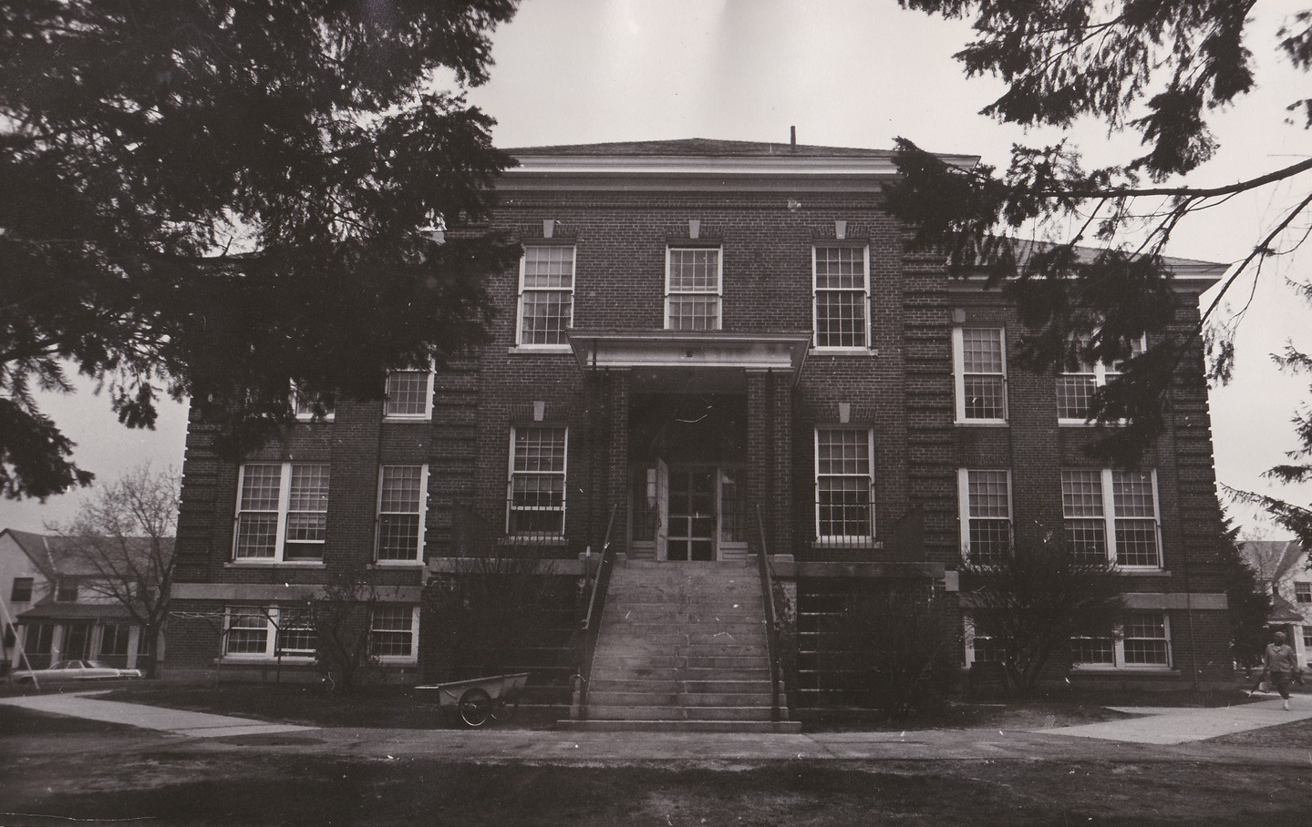

Welcome to the State Commission on State Institutions

The History of State Institutions in Massachusetts

State Schools: In the 1800s it was common for people to keep disabled family members at home instead of sending them to school, but the Massachusetts government didn't agree with this practice. A commission, much like this one, was formed with Dr. Samuel Gridley Howe as its leader. He and his team went around Massachusetts and counted the number of disabled individuals who were not being educated and they found there were hundreds.

Samuel Gridley Howe asked if he could work with some of these disabled children at his school; the Perkins School for the Blind. The students did so well that Massachusetts gave Dr. Howe money to open a school for them in Boston. In 1887, the school moved to Waltham: the first state school for the disabled.

By 1922 there were three state schools; the Walter E. Fernald State School in Waltham, Wrentham State School, and Belchertown State School. Thousands of children and adults were sent to these places. There were too many people in them and many were treated badly. The residents were referred to as "inmates." In the 1970s, people sued the state. A judge made the state clean up the institutions. Many closed.

Belchertown State School closed completely in 1991 followed by the Fernald in 2014. Wrentham Developmental Center and the Hogan Regional Center are still open with many fewer people.

State Hospitals: Massachusetts was also a leader in trying to care for people with mental illness. In the early 1800s, the state started to build big hospitals (also called asylums) so that people would be supported. Just like the state schools, these places started with good intentions. A friend of Dr. Howe's named Dorothea Dix fought to make sure that people with mental illness were treated well. But just like the state schools, state hospitals became so big they could not be run well. The state tried to open more and more of them but stopped in the early 1930s after they finished building the Metropolitan State Hospital. By the 1970s, thousands of people were living in asylums. Many were kept in them for their whole lives. At that time people sued the state. Courts said that the state had to improve conditions. Eventually, most of the hospitals were shut down. Today, only one large one remains and it is known as the Tewksbury Hospital.

The Commission

Today, many people do not know this story even though it is very important. There are a lot of people around the state who lived in these institutions and never got to tell their stories. The places where these institutions used to be, are now empty and falling down or being made into something new. They almost never tell the story of what happened. Sometimes it seems like people want to forget the story, and sometimes they are not respectful of what happens to these places after they closed. Nobody has asked disabled people what we think they should do to make sure this history is remembered.

The saddest place where this happens is at cemeteries where people who died at the institutions were buried. Most of their graves do not have their name on them. That is not fair or good. In 2020, disabled people came together from across the state and wrote a law to make sure that people do not forget this story. They created our commission and they wanted the commission to do a few very important things:

1. Find out the names of all the people buried in the cemeteries where these institutions were.
2. Find out if people who died at these institutions are buried in other places that we do not know about.
3. Find out where all of the stories from these institutions are kept, and whether people get to see those stories or not.
4. Come up with a plan for the state to tell the story of these institutions in the future so that it is never forgotten (like a museum, or stories to tell in schools, or a memorial).

What makes this commission very special, is that it is led by disabled people, and many of the members are disabled people. That has never happened anywhere in the world. Last year, the state voted to allow us to create our commission and they gave us $145,000 to support us. We have until June 1, 2025 to finish our work and tell everyone what we have found.

Every person who is on this commission has a part to play and together we will be able to tell a very important story for the first time.